**ACCEPTANCE LETTER**

**Dear**

We are glad to inform you that your abstract titled as below has been accepted as an

Online Presentation to be presented at The 4th international City, Environment and

Health Congress

**Title**

Please do not hesitate to contact us for any further assistance you may need. The

4~~rd~~ th international City, Environment and Health Congress will be held on 17-18 - 19 April

2025. ~~We look forward to your participation and wish you and the entire participants~~

~~a successful, fruitful, and joyful Congress~~ We look forward to your participation and wish you and all participants a successful, productive, and joyful Congress.

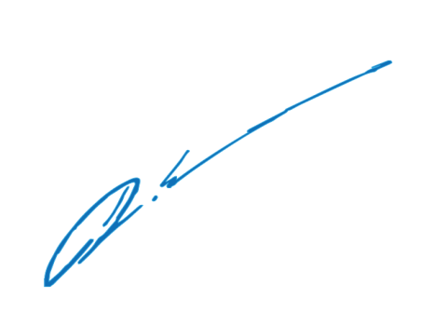Sincerely,

**Prof. E. Didem Evci Kiraz**

Chair of the Congress