**ACCEPTANCE LETTER**

**Dear**

We are glad to inform you that your abstract titled as below has been accepted as

an Online Presentation to be presented at The 3rd International Health and Climate

Change Congress

**Title**

Please do not hesitate to contact us for any further assistance you may need. The The 3rd International Health and Climate Change Congress will be held on 17-18-19 April 2025. We look forward to your participation and wish you and all participants a successful, productive, and joyful Congress.

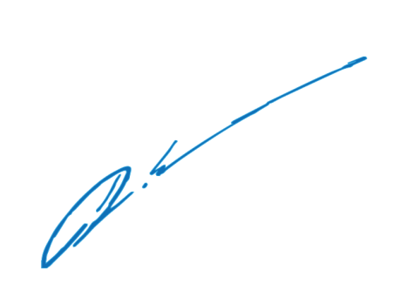Sincerely,

**Prof. E. Didem Evci Kiraz**

Chair of the Congress