**ARIMA-Based Time Series Analysis and Data Mining Fusion for Short-Term Compressive Strength Forecasting in Geopolymer Mortar**

***Yildiran YILMAZ1,[[1]](#footnote-1)\*[C:\Users\Abdullah\AppData\Local\Microsoft\Windows\INetCache\Content.Word\ORCID-iD_icon-16x16.gif](https://orcid.org/xxxx-xxxx-xxxx-xxxx), Talip ÇAKMAK2[C:\Users\Abdullah\AppData\Local\Microsoft\Windows\INetCache\Content.Word\ORCID-iD_icon-16x16.gif](https://orcid.org/xxxx-xxxx-xxxx-xxxx)***

*1 Department of Computer Engineering, Recep Tayyip Erdogan University, Fener, Rize TR53100, Turkey yildiran.yilmaz@erdogan.edu.tr (Corresponding Author) ORCID: 0000-0002-5337-6090*

*2Department of Civil Engineering, Recep Tayyip Erdogan University, Fener, Rize TR53100, Turkey talip.cakmak@erdogan.edu.tr*

|  |
| --- |
| **Abstract**  With a primary focus on leveraging time-series analysis and data mining methodologies, this paper delves into the realm of geopolymer mortars, an eco-friendly and energy-efficient construction material. The target of the study is to specify the variables that affect the compressive strength of geopolymer mortars and then utilize those variables to estimate the mechanical property (compressive strength (CS)) of mortars in the future. The study analyzed the effects of factors such as compressive strength, obsidian, glass waste, fly ash, and heat on the CS of mortar. ARIMA model is adeptly employed to forecast the short-term compressive strength of geopolymers endowed with five distinct properties and subjected to varying temperatures. A 30-day compressive strength prediction was made based on the 28 day compressive strengths. As a result of the analysis, the highest RMSE, MAE, MAPE and R2 values were obtained as 1.207, 0.983, 0.025 and 0.941, respectively. Those results emphasize how well-sophisticated statistical modelling approaches could be employed to understand and estimate the dynamics of compressive strength in geopolymer mortars. |
| Keywords: Forecasting, Time series Analysis, ARIMA Model, Geopolymer, Obsidian, Data mining |

1. **Introduction**

Geopolymer mortars are building materials that are of increasing interest and use in the contemporary construction industry. They are an environmentally friendly and energy-efficient building material developed as an alternative to traditional cement-based mortars [1]. A study by Ahmed et al. [2] concentrated on the application of geopolymer, notably fly ash (FA), which has been created as a ordinary Portland cement substitute due to the substantial carbon dioxide releases that the cement production labour has been producing lately. They developed various scale models to anticipate the mechanical property(CS) of fly ash based geopolymer mortar using test sets obtained from the literature. In their study, various data sets with different mixing ratios, different maturation times (from 1 to 28 days) and distinct maturation temperatures were used. Three different models including LR, MLR and NLR models were developed and these models were evaluated by statistical evaluations such as R2, RMSE, SI, OBJ and MAE. The results of the investigation showed that the NLR model outperformed the LR and MLR models. For the NLR model, the values of R2, RMSE, SI, and OBJ are 0.933, 4.294 MPa, 0.138, and 4.209, in that order. In another study [3], Wu et al. analysed the alkali equivalent (AE) and water glass modulus (WGM) effects of immersion experiments using artificial seawater. During 270 days, 300 samples underwent recurrent performance tests and an artificial immersion in saltwater. Mass loss and uniaxial compressive strength (UCS) were used as metrics for operation assessment, whereas AE (3–15%) and WGM (1.0–1.8) were utilized as motivating components. Furthermore, utilizing the experimental data, a support vector regression (SVR) model was created, and it demonstrated accurate prediction within a month or two. The authors in [4] conducted a contrast study on normal and self-compacting geopolymer mortar based on mixtures of fly ash - ground granulated granulated blast furnace slag (GGBFS). The experiments included fresh properties, hardening properties and compressive strength tests. An artificial neural network (ANN) model advanced using the Tensorflow approach was used to forecast the compressive strength. Their model was trained on 150 data sets obtained from the literature and validated on data sets obtained in the laboratory. Manikandan et al. [5] considered the mechanical and compressive strength properties of geopolymer concrete. The authors in [5] examined how different ratios of polypropylene (PP) fibres and rice husk ash (RHA) impacted the compressive and mechanical strength of geopolymer mortar. Using input factors including the RHA ratio, the density of sodium hydroxide (NaOH) liquid, and the quantity of polypropylene fibre, they also developed an artificial neural network (ANN) model to predict these features. As a consequence of the findings, it is possible to investigate the potential of geopolymer mortar for structural restoration and to determine whether it can be used to repair structural elements. Prior research mentioned so far has primarily focused on small-scale laboratory tests, which may not fully reflect performance in real-world settings. In fact, the compressive strength of geopolymer mortars is unique owing to the special chemical reactions of the materials they contain [6]. The dataset used in our study includes compressive strength (CS), obsidian (OB), glass waste (GW), fly ash (FA), and HEAT as important properties for determining the compressive strength of geopolymer mortars. Understanding and predicting the effects of these properties on mortar compressive strength is crucial for building more sustainable and reliable structures in the construction industry. Our research aims to identify the elements that contribute to the compressive strength of geopolymer mortars and utilize these factors to predict the mortar's compressive strength in the future. To accomplish this, we have outlined the following contributions.

* This study explores the impact of variables which is such as fly ash (FA), glass waste (GW), obsidian (OB), and compressive strength (CS) on the compressive strength of mortars.
* By analyzing the data set, we have successfully developed a 30-day forecast model for compressive strength using the ARIMA (1,0,0) method. We will discuss the performance of our model in the following sections.
* The results obtained can contribute to the development of strategies for a more effective use of geopolymer mortars in the construction industry. Furthermore, the ability to predict compressive strength allows for more reliable planning of construction projects. This research aims to provide a basic reference for future building material developments and sustainable construction practices.

1. **Related Works**

Geopolymer mortars are a special type of material that stands out as sustainable and durable building materials. Previous studies in this field have focused on the strength properties of mortars, compressive strength and various production parameters [7]. Experimental studies on the strength properties of geopolymer mortars have proposed optimized blends to improve the compressive strength of mortars by studying the interaction of different components of the material [8]. In previous research, the effects of mortar components on the strength have been studied. The models used for the strength prediction of geopolymer mortars generally include regression analysis and time-series models [9], [10]. Some studies have emphasized the use of artificial intelligence-based models to understand the complex interactions that determine mortar properties and predict the future strength [11]. Chen et al. [12] determined the average profile depth using GEP to check the conformity of road surfacing used in the accreditation of car tires to the ISO 10844 standard. The highest R2 value of 0.74 was obtained in the analysis of the data obtained from 54 samples depending on different parameters. Shagadan et al. [13] used ANN algorithm to estimate the compressive strength values depending on material factors. In the study, the compressive strengths obtained from silica fume with different milling times were predicted. The highest R2 value in the study was obtained as 0.61 from the RBF neural network algorithm. Thiyagarajan et al. [14] performed time series analysis for the detection of microbial corrosion due to sewage temperature. They used different algorithms such as ARIMA, Prophet, ETS and Baget. In the 12-hour analysis, the ARIMA model showed the best prediction performance with an MAE of 0.1848 and the ETS model showed the lowest performance with an MAE of 0.1457. Ariza et al. [15] used different algorithms such as ANN, Markov Process, HMMs and Semi-Markov process to predict the deterioration process of infrastructure. As a result of the time series analysis, Semi-Markov process showed the best performance with 0.6086 MAE value and ANN algorithm showed the lowest performance with 0.3154 MAE value. Although models in strength prediction often provide an overview, there is a need for more detailed predictions for specific application conditions. Some earlier models may be sensitive to changes in certain parameters, which may affect the overall prediction accuracy. To address the shortcomings in the previous literature, this study utilized the ARIMA (1,0,0) model to forecast the mechanical property of a specific geopolymer mortar for a period of 30 days. This study aimed to provide a basis for understanding the effects of specific properties (OB, GW, FA, and HEAT) on strength and to develop more specific prediction models for use in field conditions. The results provide practical guidance to researchers and industry experts who wish to evaluate the long-term performance of geopolymer mortars and optimize the use of the material.

1. **Materials and Methods**

Figure 1 demonstrates the comprehensive experimental workflow and analysis of the findings of the study. Distinct types of binders such as obsidian, waste glass and fly ash were mixed with 12 M NaOH and CEN standard sand to obtain geopolymer composite mortar samples. The mortars were kept in the molds for 24 hours under room conditions in order not to deform while the mortars were removed from the mold by taking the required setting. The demoulded specimens were subjected to 4 different temperature cures 75, 90, 105 and 120 °C for 72 hours. Mechanical tests were carried out on certain days to obtain compressive strength values. After obtaining the required results, a dataset was created for forecasting analysis.

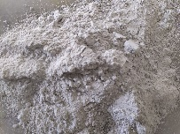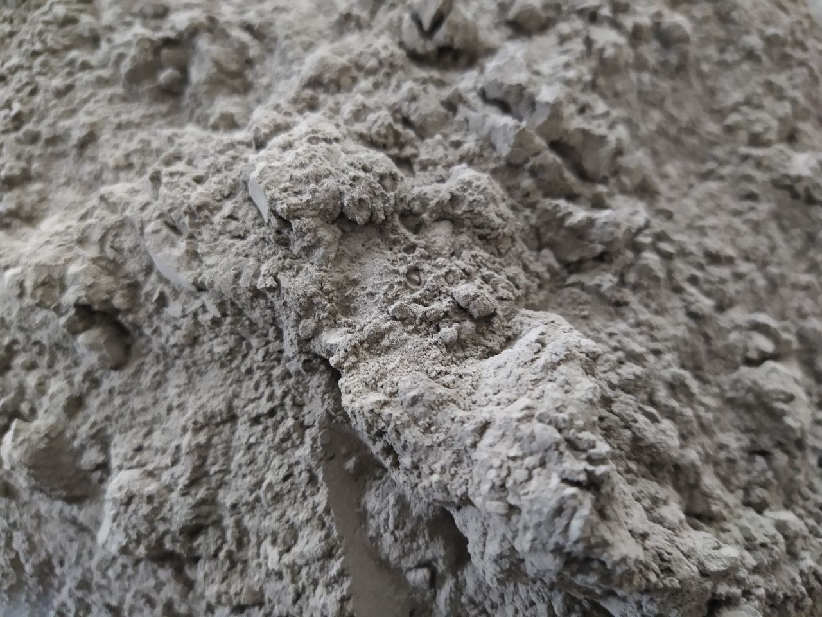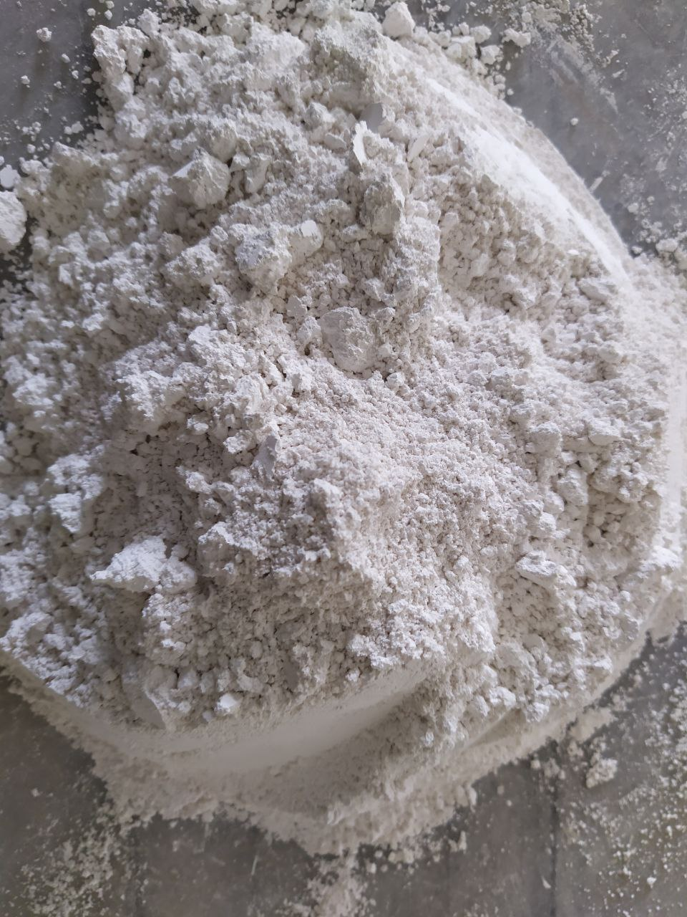

**Precursors**

**Mixing and Curing**



**Glass Waste**

**Fly Ash**

**Obsidian**

**Heat Curing**

**Mechanical Test**

**Model Generation**

**Result Obtained**

**MAE**

**Forecasting Model (ARIMA Method)**

**MAPE**

**R-Squared**

**ANALYSİS**

**RMSE**

**AIC**

**BIC**

**PROCID**

**Figure 1.** Flow chart of general process

* 1. **Description of Dataset and Evaluation Metrics**

The dataset forms the basis of research focused on forecasting the compressive strength of geopolymer mortar. This dataset contained 88 different samples, and each sample had five different properties. These attributes numerically represent the specific properties and components of the geopolymer mortar. CS (compressive strength) is a numerical variable that signals the compressive strength of a geopolymer mortar. OB is a numerical variable indicating the percentage of obsidian in the geopolymer mortar. GW represents the amount of glass waste in the mortar. FA indicates the fly ash content. Fly ash is an vital factor that affects the chemical composition of mortars. Heat indicates the temperature at which the material is exposed. Temperature is another critical factor that affects the properties of mortar. The days were numerical variables representing the day on which the experiment was performed. In addition, the prediction results were obtained using the ARIMA (1,0,0) model. The metrics used to evaluate the performance of this model are as follows:

The RMSE (Root Mean Square Error): Determines how much the model's predictions deviate from the actual values. A lower RMSE indicates better forecasting performance. The average of the absolute variations between the actual and anticipated values is known as the mean absolute error, or MAE for short. The average absolute error rate given as a percentage is displayed by the MAPE (Mean Absolute Percentage Error) calculation. PROCID represents the processing time of the prediction model. R2 (R-squared) measures how well the model fits. The closer it is to 1, the more successful the model is. AIC (Akaike Information Criterion): It is a criterion that evaluates statistical model quality. Lower AIC values show better models. Bayesian Information Criterion (BIC): Like the AIC, it is a criterion that evaluates model quality. Lower BIC values indicate better models. This dataset and the forecasting model results provide a valuable resource for understanding the factors affecting the compressive strength of geopolymer mortar and for improving future compressive strength predictions.

* 1. **ARIMA Based Forecasting Method**

In this study, the ARIMA (1,0,0) model was used to obtain the 30-day forecasts. Time-series data analysis and value prediction using ARIMA models are robust statistical techniques [16]. In the selection of the ARIMA model, the parameters (p, d, q), autocorrelation, and autocorrelation squared plots were analyzed to determine the trend and stationarity levels in the dataset. Our analyses led to the conclusion that the ARIMA (1,0,0) model was the best fit and can accurately represent the dataset's stationarity levels and has a first-order autoregressive term (AR(1)).

In order to train the ARIMA model, first, the dataset was converted to a format suitable for time-series analysis and the days in the dataset were used as the time-series index. The dataset was then split into training and test datasets at 80% and 20% accuracy, respectively. The ARIMA (1,0,0) model was applied to the training data and the parameters of the model were estimated. Our forecasting model was able to predict future values using the patterns learned from the training data. The performance of the model is evaluated using a test dataset.

1. **Results and Discussion**

This study evaluated the performance of a time-series model for predicting Geopolymer Mortar Compressive Strength (CS). The model was trained using the ARIMA (1,0,0) algorithm. The 30-day forecasting results and performance evaluation metrics of the model are presented below.

**Table 1.** Performance evaluation results of the time-series analysis

|  |  |  |  |  |  |  |  |
| --- | --- | --- | --- | --- | --- | --- | --- |
| **Curing Temperature** | **RMSE** | **MAE** | **MAPE** | **POCID** | **R2** | **AIC** | **BIC** |
| 75 °C | 1,207 | 0,983 | 0,025 | 100 | 0,941 | -8,842 | -12,8 |
| 90 °C | 1,237 | 1,003 | 0,03 | 100 | 0,94 | -8,545 | -12,5 |
| 105 °C | 0,739 | 0,603 | 0,017 | 100 | 0,941 | -10,1 | -14,1 |
| 120 °C | 0,254 | 0,193 | 0,006 | 100 | 0,93 | -13,4 | -17,3 |

After the model was successfully trained on the training data, a 30-day forecast was performed. The forecast results are listed in Figure 2.

|  |
| --- |
| b  a  Project Path: C:\Users\asuspc\Desktop\time series analysis for FT.opju PE Folder: /time series analysis for FT/Folder1/ Short Name: Graph1 Project Path: C:\Users\asuspc\Desktop\time series analysis for FT.opju PE Folder: /time series analysis for FT/Folder1/ Short Name: Graph1  c  d  Project Path: C:\Users\asuspc\Desktop\time series analysis for FT.opju PE Folder: /time series analysis for FT/Folder1/ Short Name: Graph1 Project Path: C:\Users\asuspc\Desktop\time series analysis for FT.opju PE Folder: /time series analysis for FT/Folder1/ Short Name: Graph1 |

**Figure 2.** Actual and predicted data plot of geopolymer mortars exposed to various temperatures a)75 °C, b) 90 °C, c) 105 °C, d) 120 °C.

The evaluation of the model according to the success metrics reveals a very positive result. The high R-squared value shows how well the model explains the data. The RMSE and MAE values indicate how close the model's predictions are to the true values, while the MAPE value measures the percentage error rate. In the structure of the time-series dataset, there are three features ("CS," "OB," "GW," "FA," "HEAT," and "Days") and a target variable ("CS (forecast)"). The data is organized into four sets. CS (forecast)" represents the dependent variable that was forecasted.

These results suggest that the ARIMA (1,0,0) model is an effective tool for forecasting Geopolymer Mortar Strength (CS). However, future studies can further examine the reliability of the results obtained by comparing a larger data set and different models.

**3.1 Discussion**

The main focus of this paper examine the 30-day strength prediction using the geopolymer mortar dataset. The ARIMA (1,0,0) model provided an excellent fit with a high R2 value of 0.941. This shows how well the model fits the actual data set and its predictions are reliable. RMSE and MAE values are quite low (1,207 and 0,254, respectively). This shows how close the model's predictions are to the true values. The AIC and BIC values are -8,8426 and -12,8. Low AIC and BIC values show that the model is appropriate for explaining the dataset and that adding more complexity is not necessary. MAPE Value was measured at 0,025, which can be considered a low error rate. The PROCID value was measured at 100. The higher value of this metric may indicate that the model may be inadequate in predictions in some cases. This study shows that the model used may be inadequate for certain situations. Future research could consider the use of more complex models or different methods. In order to improve the model's performance and generalizability, a bigger data set might be employed. With an emphasis on the strength predictions generated on the geopolymer mortar dataset, our study looked at the time series model's achievements and shortcomings. Future researchers can use the obtained results as a useful foundation to enhance and expand prediction models in this area.

1. **Conclusion**

The investigation we conducted attempted at boosting a model used to anticipate geopolymer mortar compressive strength. By applying the ARIMA (1,0,0) model to a dataset of 83 samples, the results obtained included an RMSE of 1.207, MAE of 0.983, MAPE of 0.025, PROCID of 100, and R2 of 0.941. Our findings demonstrated that the ARIMA model developed in this study exhibits high accuracy and efficiency in predicting the compressive strength of geopolymer mortars over a 30-day period. The low RMSE and MAE values indicate that the model's predictions are close to the actual values, while the high R2 value highlights the model's strong explanatory power.

Although this study provides a preliminary step towards predicting the one-month term of the compressive strength of geopolymer mortars, some recommendations for future research are as follows. Using a larger data set can increase the generalization ability of the model and include a wider variety of conditions. In addition to the existing features, adding variables such as environmental factors and weather conditions can improve the model's forecasting ability. These recommendations can guide future researchers to expand knowledge in this area and develop more robust prediction models.

**References**

1. Asadi, Iman, et al. "Phase change materials incorporated into geopolymer concrete for enhancing energy efficiency and sustainability of buildings: a review." Case Studies in Construction Materials 17 (2022): e01162.
2. Ahmed, Hemn Unis, et al. "Statistical methods for modelling the compressive strength of geopolymer mortar." Materials 15.5 (2022): 1868.
3. Wu, Yingjie, et al. "Time-Varying Pattern and Prediction Model for Geopolymer Mortar Performance under Seawater Immersion." Materials 16.3 (2023): 1244.
4. Ardhira, P. J., and Dhanya Sathyan. "A comparative study of normal and self-compacting geopolymer mortar and its strength prediction using tensor flow approach." Materials Today: Proceedings 65 (2022): 1046-1055.
5. Manikandan, P., et al. "An Artificial Neural Network Based Prediction of Mechanical and Durability Characteristics of Sustainable Geopolymer Composite." Advances in Civil Engineering 2022 (2022).
6. Dash, P. K., Parhi, S. K., Patro, S. K., & Panigrahi, R. (2023). Influence of chemical constituents of binder and activator in predicting compressive strength of fly ash-based geopolymer concrete using firefly-optimized hybrid ensemble machine learning model. Materials Today Communications, 37, 107485.
7. Ahmad, A., Ahmad, W., Chaiyasarn, K., Ostrowski, K. A., Aslam, F., Zajdel, P., & Joyklad, P. (2021). Prediction of geopolymer concrete compressive strength using novel machine learning algorithms. Polymers, 13(19), 3389.
8. Tanyildizi, H. (2021). Predicting the geopolymerization process of fly ash-based geopolymer using deep long short-term memory and machine learning. Cement and Concrete Composites, 123, 104177.
9. Lokuge, W., Wilson, A., Gunasekara, C., Law, D. W., & Setunge, S. (2018). Design of fly ash geopolymer concrete mix proportions using Multivariate Adaptive Regression Spline model. Construction and Building Materials, 166, 472-481.
10. Kurt, Z., Yilmaz, Y., Cakmak, T., & Ustabaş, I. (2023). A novel framework for strength prediction of geopolymer mortar: Renovative precursor effect. Journal of Building Engineering, 76, 107041.
11. Dao, D. V., Ly, H. B., Trinh, S. H., Le, T. T., & Pham, B. T. (2019). Artificial intelligence approaches for prediction of compressive strength of geopolymer concrete. Materials, 12(6), 983.
12. Shih-Huang Chen, Cheng-Kai Huang, Dita Adelafani, Yi-Yang Cheng, The preliminary study of the forecasting model between surface texture and various material parameters for the ISO 10844 test track, Case Studies in Construction Materials, Volume 19, 2023, e02523, ISSN 2214-5095, https://doi.org/10.1016/j.cscm.2023.e02523.
13. A. Shaqadan, I. Alshalout, M. Abojaradeh, R. Al-kasasbeh and A. Al-Khatib, "Developing Artificial Neural Networks Model for Concrete Mix Design," 2022 International Engineering Conference on Electrical, Energy, and Artificial Intelligence (EICEEAI), Zarqa, Jordan, 2022, pp. 1-5, doi: 10.1109/EICEEAI56378.2022.10050473
14. K. Thiyagarajan, S. Kodagoda ve N. Ulapane, "Beton Kanalizasyon Borusu Yüzey Sıcaklığının Kısa Süreli Zaman Serisi Tahmini", 2020 16. Uluslararası Kontrol, Otomasyon, Robotik ve Görme Konferansı (ICARCV), Shenzhen, Çin, 2020, s. 1194-1199, doi: 10.1109/ICARCV50220.2020.9305439
15. Santamaria Ariza M, Zambon I, S. Sousa H, Campos e Matos JA, Strauss A. Comparison of forecasting models topredict concrete bridge decks performance.Structural Concrete. 2020;21:1240–1253. https://doi.org/10.1002/suco.201900434SANTAMARIA ARIZAET AL.1253
16. Shumway, R. H., Stoffer, D. S., Shumway, R. H., & Stoffer, D. S. (2017). ARIMA models. Time series analysis and its applications: with R examples, 75-163.

1. \* Corresponding author. *e-mail address: yildiran.yilmaz@erdogan.edu.tr* [↑](#footnote-ref-1)