IoT Based Safety and Security System for a Building: System Development and Testing

Athir Ali Abdullah Salim Al Alawi, Muhammad Nauman Bashir
Department of Electronics and Communications Engineering, Middle East College, Oman

ABSTRACT
Security systems of the 21st century are facing challenges of the multi-dimensions such as cost-effectiveness, reliability, and efficiency. Internet of things (IoT) is an emerging norm of technology to easily transfer data and reduce human efforts, and errors and offers a wide range of attractive features. IoT can be used to observe the actions and decide the conditions when alarms should be generated and when data can be transmitted. In this work, we have designed and developed a safety and security system to monitor buildings and detect the temperature, humidity, gas leakage, and fire/flame. The designed system detects the motion of the intruder using the PIR sensor and takes the images using ESP32-CAM, and sends them to the owner of the building by E-mail to alert about the intrusion. On routine, it sends alarms to the website and mobile application using the IoT at regular intervals to make a log and in case of gas leakage or fire, it generates a sound alarm. The article presents the design and analysis phases by simulating the circuit and implementing hardware using discrete components. The defined test points are tested under various scenarios and results are compared.
Keywords: IoT; PIR; Passive Infrared Sensor; ESP32-CAM; ThingSpeak; Thingview
INTRODUCTION
Safety is the condition of protection from internal dangers and potential harms (Morgan, 2021). Ensuring safety, can safe the lives of individuals, provides them with a calm environment free of fear to practice their private and working lives naturally so they can perform well in their field of work and strive to further develop the country. In addition, it's known that with the presence of technology, it can be exploited in a way that benefits the individual and society as a whole. Also, connecting things, devices, or anything to the Internet of Things (IoT) to control and monitor them remotely to facilitate human life. Therefore, exploiting and using it in this field allow and help in solving security problems such as self-preservation, private property, and so on. IoT is described as linking any device to the Internet, with devices and objects with embedded sensors connected to an Internet of Things platform that integrates data from various devices and uses analytics to share the most useful information with applications tailored to specific needs (Clark, 2016). The idea of the project is to design an IoT-based device that contains several sensors connected to a website and a program to monitor it remotely. Where it includes a motion sensor (PIR Sensor) to know and detect the presence of any movement in the place to enhance the protection of the location or site. Also includes temperature and humidity (DHT11), fire/flame (Flame Sensor), and gas (MQ2 Sensor) sensors, so that these sensors sense the changes and show them to the user by using ESP32-CAM (it is a camera module that consumes a low-power and is based on ESP32). The device can monitor remotely by the Internet of Things (IoT) linked to the E-mail, Thingspeak website, and Thingview app (considered a free source app).
With the existence and persistence of the Covid-19 virus, the government of the Sultanate of Oman has imposed a partial ban several times to limit the spread of this virus. Whereas, at the time of prohibition, it noticed an increase in the rates of robbery and intrusion into homes from unwanted intruders such as thieves. Several regions in the Sultanate of Oman witnessed home storming and theft during this period, which led to a feeling of fear among people. Thus, to reduce the percentage of thefts, this project will help with that and spread security and safety in the community. In addition, arresting intruders before the occurrence of the robbery or other incidents that lead to the violation of the property. The need for such a project is to limit and prevent violations of private and public properties and solve problems before they occur, which allows and helps the owner of the place to be reassured and not feel anxious while he/she is away from his/her home or place of currency. As this project will also help to monitor, track and remain mindful of what is occurring in the location, it will be easier to handle and fix the issue before it happens as soon as possible.
RELATED WORK
While designing the embedded system, a range of literature was reviewed. The study done by Taryudi, Davin Bagas Adriano, and Wahyu Apsari Ciptoning Budi (2018) aims to create and develop integrated systems for home protection and surveillance that incorporate a variety of sensors and security systems. Where the authors used two Arduino-nano and NodeMCU ESP8266 controllers to build and create integrated home security and surveillance system using the Internet of Things (IoT). A PIR sensor can detect intruders, rain can be detected, temperature and humidity can be monitored by a DHT-22 sensor, and alerts can be sent to the mobile every few minutes when the stove is switched on. The state of the house is also controlled and monitored remotely, including the temperature, humidity, and burner flame. The electronic equipment inside the house can also be operated by remote lamps/lights and solenoid valves to serve as actuators. An RFID card and a digital PIN code are mounted on the door and the home is monitored remotely through the Internet. In the home security part, the system can detect the RFID card attached to the notification system and send an email to family members, as well as use a password to unlock the door. In the monitoring system part, the temperature and humidity of the room, the flame on the stove, rain conditions, the presence of intruders, as well as the control of the AC lights and solenoid valve as actuators can all be monitored on the smartphone screen remotely over the internet by the Blynk app.
Another study which their article entitled “HSEPM: Home Security and Efficient Power Management” by Ruby Dinakar, Deepthi U Singh, and Mohammed Abbas (2018). There is a significant increase in the rate of crimes and thefts and high electricity bill prices due to ineffective use of electrical energy, which means leaving the lights on in places where they are not present and areas where they are not required. Internet of Things is one of the fields of technology that has made people's lives easier by linking and connecting machines, such as controllers and sensors, and monitoring them remotely. The advantage of this project or proposal that was presented by the writers/researchers combines two things: providing home surveillance, automated lighting control, tracking/monitoring, and remote control from anywhere in the world. It also overcomes several defects of the current system such as: reducing and eliminating the need to connect the console with mobile phones, having a high bandwidth for smooth connectivity, and increasing computing power for higher data processing with the aid of the Raspberry Pi's built-in 1.2 GHz, thereby allowing for future upgrades, and others. Where, by integrating the Internet of Things and Raspberry PI, this device will be built that provides and combines the system with an alarm to identify intruders and alert the owner via e-mail. As well as an automatic operating system, ensuring that the lights will be turned on and off (control the lights) in this project, the lights will be switched on and off depending on the user's/person's movement. Where the passive infrared sensor PIR was used as a motion sensor to detect the intruder and responsible for the protection/security and automatic monitoring of lighting.
Another study done by Eslam F. Galal, Moataz M. Elsherbini, and Hala M. Abdel-Kader in 2019 is about wireless sensor networks based on NodeMCUs (IoT/WiFi Modules). This work combined sensor alarms with the Blynk server and GSM module. Furthermore, the use of NodeMCU, a lightweight, compact unit, and low-cost device, combines the WiFi ESP8266 module with a microcontroller on a single board. Because of its long-range and high bandwidth, this device relies on a WiFi network for wireless transmission rather than Zigbee. The wireless sensor nodes are simple to mount anywhere inside the home. The main goal of this research/study is to create and design an economical, reliable energy-efficient, long-range, and widely accessible protection device that uses NodeMCUs (Internet of Things units), sends SMS to a pre-defined cell phone number using GSM modems, and Blynk servers to alert the intrusion, burglary, gas leakage and the presence of fire. The user can control and monitor the system by using the Blynk app or by sending SMS. In this research, an inexpensive wireless security system with an Internet of Things module has been designed to protect humanity from burglary, gas leaks, and fire accidents. The system's major features are intruder, gas leakage, and fire detection. Two different ways of Internet communication and GSM were employed to link the proposed system to the user. When a suspicious event happens, the Blynk cloud and Blynk application are utilized to warn the user worldwide through notice and email. In addition, the system includes an IP camera that is used to inspect the insured property when the system sends a message to the owner, before taking action in the case of false alerts.
Another study was done by Mayuresh Kharade, Shubham Katangle, Ganesh M. Kale, S. B. Deosarkar, and S. L. Nalbalwar, in 2020. This study designs a device that monitors and improves the air quality index in the industrial environment to take fire safety measures for employees and helps to monitor the environment in the industrial area with high efficiency. In general, an ESP8266 NodeMCU controller that supports and is compatible with wifi is used. The air quality monitoring sensor (MQ135), temperature and humidity (DHT11) for environmental parameters, and the flame sensor that uses infrared for protection are all attached to the controller. In addition, I2C OLED is used as a display unit. This device connects to Thingspeak's cloud storage through the Blynk (Internet of Things Platform) app. If the temperature rises above a certain level, the air coolers will be activated by a portable switch controlled by the Blynk software. Temperature, humidity, and ppm values are sent to the Thingspeak server, where they are shared with the microcontroller via the built-in wifi module. If a fire is observed and detected, the fire alarm connected to the relay is activated, allowing staff to take the appropriate measures. Thingspeak is a storage network that displays saved, stored, and computed data in graphical form. The microcontroller was programmed using the Arduino IDE software framework. This study's device which was designed in this study can calculate fire safety measures in an industrial environment, allowing for the creation of a secure and trouble-free workspace.
METHODOLOGY
This system contains various functional blocks and they are executed through inputs, outputs, and operations/processes shown in the diagram, which are operated by linking and connecting to a power supply as elaborated in figure 1. These are the PIR sensor, buzzer, DHT11 sensor, MQ2 sensor, and flame sensor. In addition, a website named Thingspeak, an application named Thingview, and E-mail are used.
Figure 1
Block diagram of the system
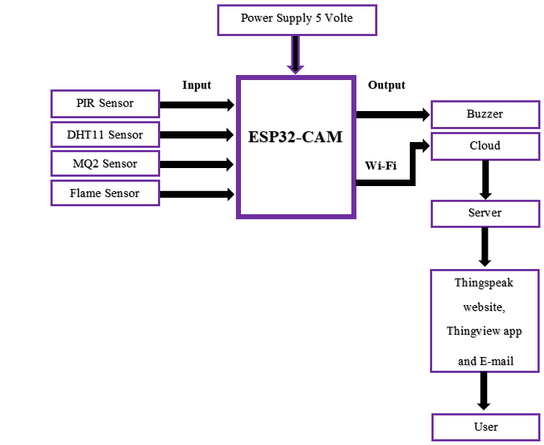
Through a microcontroller which is ESP32-CAM, the inputs and outputs are linked and connected to each other. All inputs are connected to a microcontroller, which governs or controls the operation of the system. Where the motion sensor (PIR) detects any movement, the temperature and humidity sensor (DHT11) detects the temperature and humidity, the gas sensor (MQ2) detects a gas leak (for example carbon dioxide, liquefied petroleum gas, propane, and hydrogen), and the flame sensor to detect about the presence of flame or fire. All sensors are connected to a microcontroller, where the microcontroller collects and analyzes the data and then takes a specific action. If any movement is detected, the motion sensor will sense that and send a signal to an ESP32-CAM microcontroller, which takes a picture of the intruder. However, ESP32-CAM does not have a serial interface, built-in programmer, and a USB port for computer communication and programming. Therefore, Future Technology Devices International Limited adapter "FTDI" will be used as an external interface for programming it. The data then moves to the cloud, and the ESP32-CAM is connected to the Wi-Fi where this system/device is located. A server that is linked to the cloud and the application is created, after that; a notification arrives at the user that contains the intruder's image. The E-mail will be used to recall the image.
As for the other sensors, the readings for temperature, humidity, gas, and flame are transmitted to the ESP32-CAM microcontroller unit, where this unit analyzes and collects the data. Then, it is sent to the cloud and this data is called in the form of digital indicators for the four parameters; Temperature, humidity, gas, and flames on the Thingspeak website and Thingview app screen. In the event, there is a gas leak or flame the buzzer will work. Figure 2 shows a flowchart of the system. Initially, the system is configured for both the security and safety system to be ready to receive any task. The input data is Motion Sensor (PIR), Temperature and Humidity Sensor (DHT11), Gas Sensor (MQ2), and Flame Sensor, where the role and tasks are to sense and detect any change or event. Initially, the system will be initialized; the system will run and wait a few seconds until all the components are working properly. In addition, the Wi-Fi module will be configured so that there will be a Wi-Fi connection, allowing the microcontroller is ready to receive data from inputs and send data to the user (owner of the building).
Figure 2
Flow chart of the system
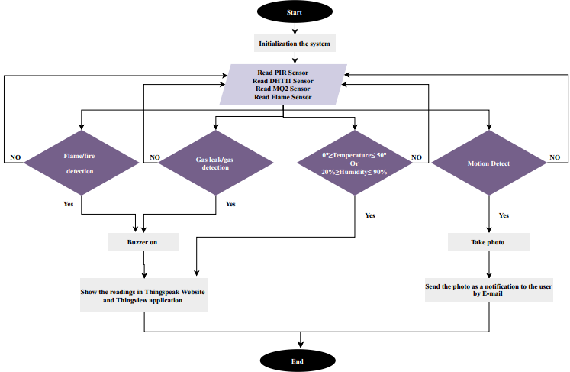
After that, all sensors will be read at the same time after they are ready to receive commands and detect. The decision for a PIR Sensor, if movement is detected by the intruder through the PIR sensor, a signal will be sent and a picture of the intruder will be taken, and then the photo will be sent by E-mail in the form of a notification to the user. If not, the process is repeated and again read the PIR Sensor until motion is detected. The decision temperature and humidity, if the temperature is between 0 degrees to 50 degrees or the humidity is between 20% to 90%, the sensor will sense that, and readings for both temperature and humidity will show on the Website (Thingspeak) and application (Thingview). Where the process is repeated continuously.
The decision for Gas and Flame sensors, if a gas leak, flame, or fire is detected, the buzzer will be triggered /on and readings will show on the Website (Thingspeak) and application (Thingview). Where the process is repeated continuously. After receiving the E-mail and displaying the data and readings on the website and the application, the process will end and start again reading the inputs again, as the process is continuous.
RESULTS DISCUSSION
Figure 3 shows the functional block diagram for the system, which explains the process and the idea of ​​the system more clearly, as follows:
§ In the event of there is movement (for example, a thief entering the place), the PIR sensor detects the movement and sends a signal to the microcontroller (ESP32-CAM), where it takes a picture of the thief. After that, the microcontroller connects to the Wi-Fi by the Wi-Fi router of the place and sends the picture to the user by E-mail.
§ For other sensors, the same process is done and all sensor variables and data of temperature, humidity, gas, and flame are recorded and stored on the ThingSpeak website. Where the user can monitor these changes through the website as well Thingview app.
To test the system, simulation programs Tinkercad and Arduino IDE software were used. In addition to hardware testing on the breadboard. Where the Tinkercad does not contain all the components of the project, it has been replaced by other components for the purpose of clarifying the idea, and it is known that the simulation results are not real.
Figure 3
The functional block diagram for the system of project
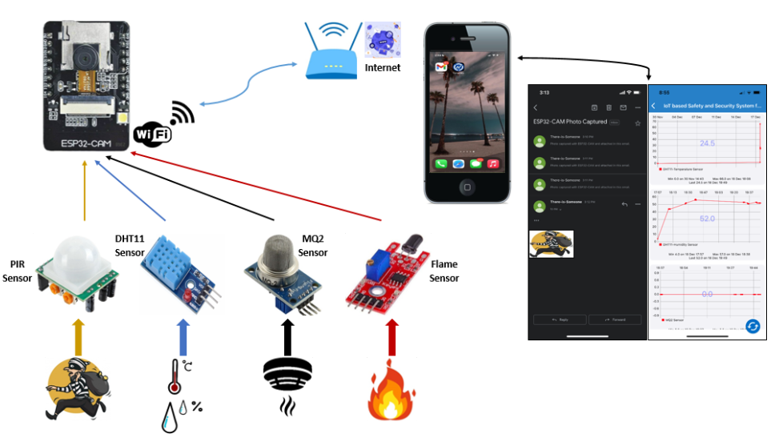
For hardware testing figure 4 shows the circuit diagram of the hardware components that are connected to the breadboard. As shown in figure 5, the circuit diagram of the project in Tinkercad, all sensors have been tested as shown in the Serial Monitor. As one of an objective of this project, in the case of the presence and detection of the intruder using the PIR sensor, the sensor will send a signal to the ESP32-CAM. The ESP32-CAM will receive the signal and collect the data and prepper to take the image. After taking the image, the process of sending an E-mail will be done and a notification will be sent to the owner of the place (the user) with the image of the intruder through his/her E-mail, figure 6 shows that. For other objectives of this project, where the results and readings of the sensors (DHT11, MQ2, and Flame) will show on the ThingSpeak website and Thingview app, where the user/owner can monitor the temperature, humidity, gas, and flame through the website and app, as shown in figures 7 and 8.
Figure 4
The circuit diagram of the project connected on the breadboard
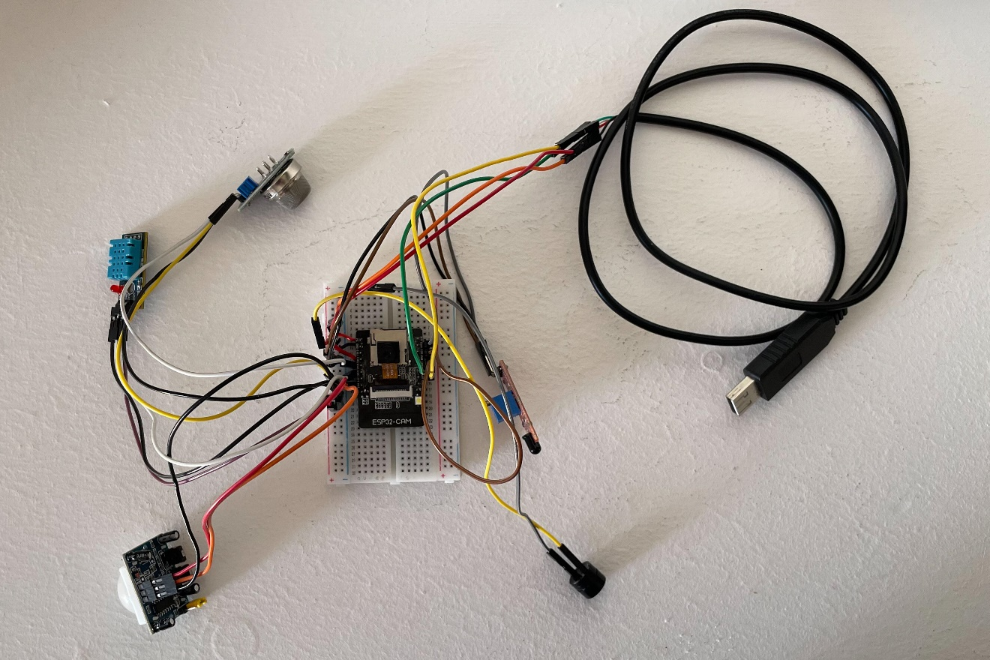
Figure 5
The circuit diagram of the project in Tinkercad
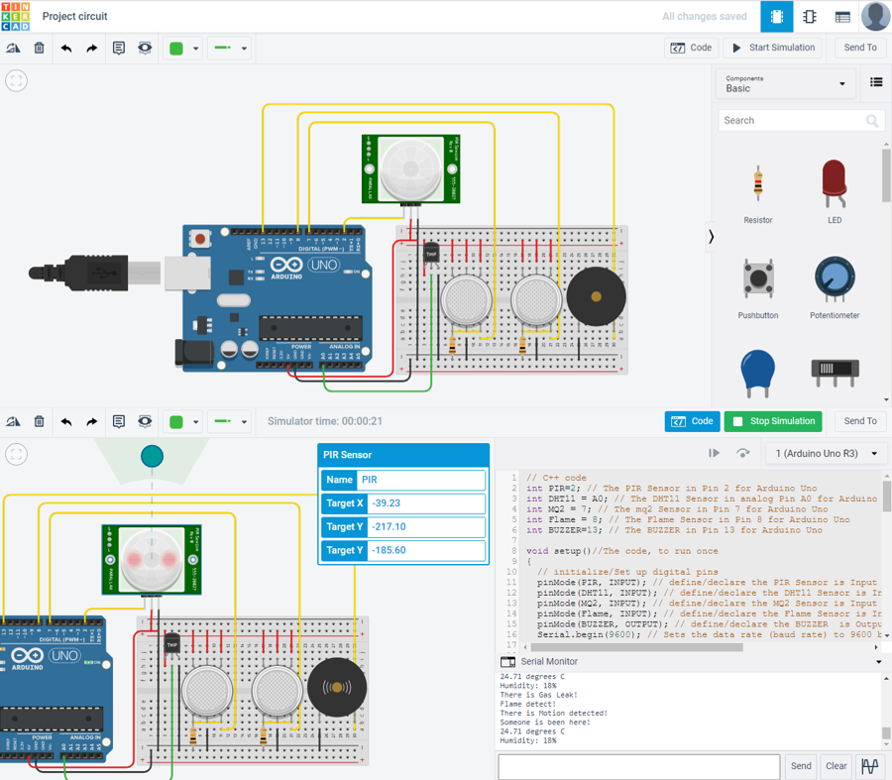

Figure 6
The results of sending a photo of an intruder to the user/owner by E-mail
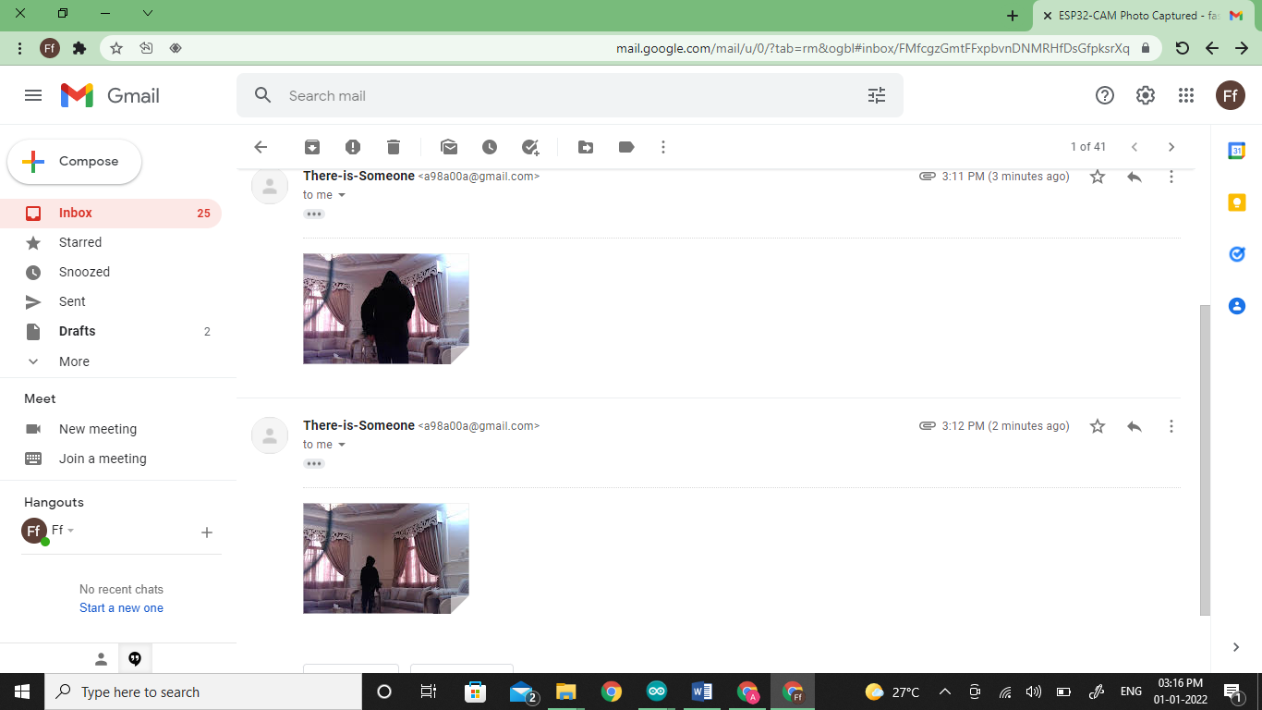

In general, the system performs as expected and required during the testing procedure. If the motion was detected by the PIR sensor, an e-mail was sent. During the testing, the time it took to receive a notification from the e-mail was not long, it took less than half a minute. Additionally, the ThingSpeak website and Thingview application display the readings for each of the three sensors namely, DHT11, MQ2, and Flame. As for displaying the readings on the site and the program, once there is a good connection to the Wi-Fi network, it will not take long to display them. However, the opposite can lead to taking a long time to receive email and display readings.
Figure 7
The result of DHT11, MQ2, and Flame sensors in the ThingSpeak website
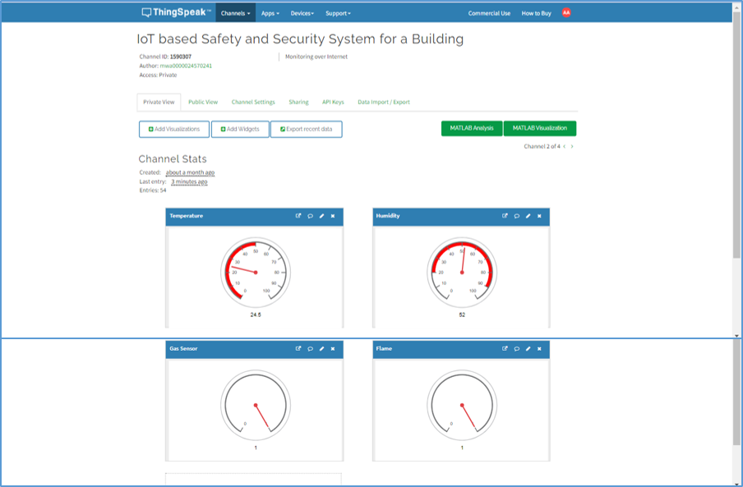

Figure 8
The result of DHT11, MQ2 and Flame sensors in the Thingview program
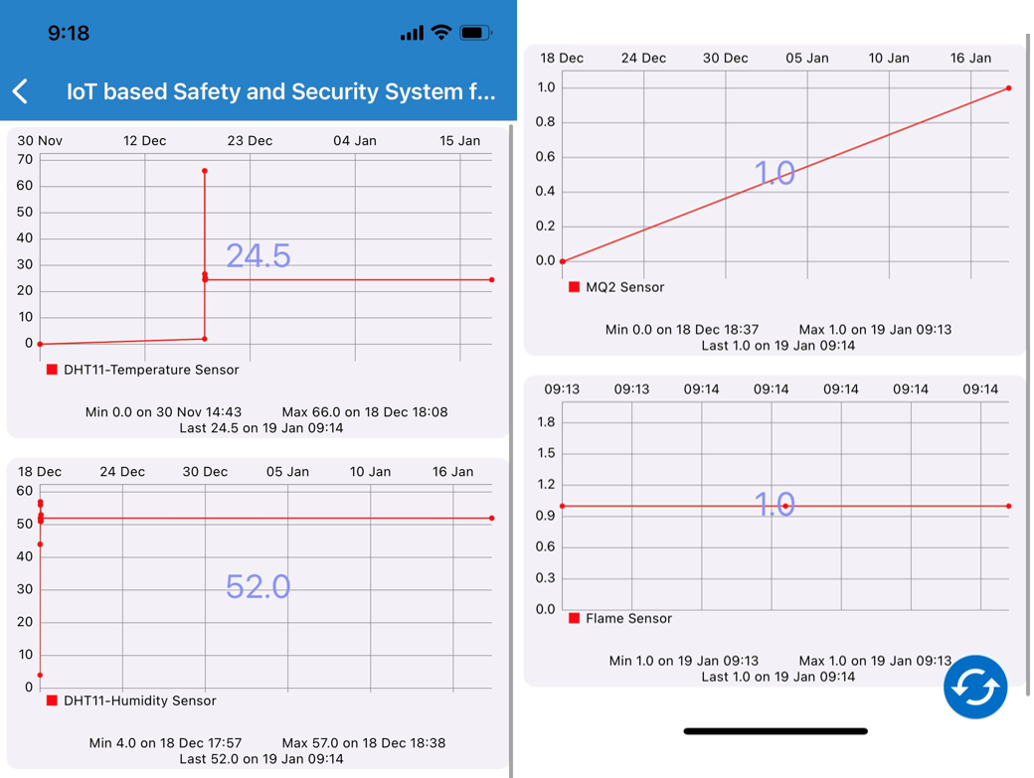

CONCLUSIONS
With the existence of technology, it is necessary to take advantage of it in solving issues and problems in many areas, the most important of which is the field of security and safety, which benefits the individual, and society as a whole. In addition, using the Internet of things and linking them to devices to make devices modern and keep pace with the times and development, which facilitates people's lives. This project aims to design a building safety and security system using the Internet of Things (IoT) for a remote monitoring device on the user's phone using the E-mail, Thingview app, and will the ThingSpeak website. In the security field, where the system can be used to protect from burglaries and thieves. In the field of safety, the system can be used to remotely monitor changes through the ThingSpeak website as well as the Thingview application that occur for both temperature and humidity, gas, and flame/fire periodically. The results were obtained and they were consistent with the project's objectives. As the result of this project, if an intruder is detected, he/she will be photographed and then send his/her photo to the user by E-mail, where the user will get a notification containing the intruder's photo. In addition, readings for temperature, humidity, gas, and flame/fire will be recorded and the user will be able to monitor the readings via the website and the app. In the event of a gas leak or fire, the people around the system/device will be alerted by a sound made by the Buzzer.
ACKNOWLEDGMENT
The conducted research is supported by Middle East College Muscat. The authors are extremely grateful and would like to thank the department of Electronics and Communication Engineering as well as those who supported this research directly or indirectly.
REFERENCES
- Clark, J. (2016, November 17). What is the Internet of Things, and how does it work? IBM Business Operations Blog. https://www.ibm.com/blogs/internet-of-things/what-is-the-iot/
- Cote, A., Nautiyal, M., Tit, M., & Beaulac, H. (2019, November 27). Project management methodologies, methods, and frameworks. Paymo. https://www.paymoapp.com/blog/project-management-methodologies/
- Dinakar, J. R., Singh, D. U., & Abbas, M. M. (2018, May). HSEPM: Home Security and Efficient Power Management. In 2018 3rd IEEE International Conference on Recent Trends in Electronics, Information & Communication Technology (RTEICT) (pp. 1076-1082). IEEE.
- F. Galal, E., M. Elsherbini, M., & M. Abdel-Kader, H. (2019). Economic wireless home security system using iot module. JES. Journal of Engineering Sciences, 47(6), 807–821. https://doi.org/10.21608/jesaun.2019.115747
- Kharade, M., Katangle, S., Kale, G. M., Deosarkar, S. B., & Nalbalwar, S. L. (2020). A NodeMCU based Fire Safety and Air Quality Monitoring Device. In 2020 International Conference for Emerging Technology (INCET) (pp. 1-4). IEEE.
- Morgan, J. (2021). Difference Between Safety and security. Differencebetween.Net. http://www.differencebetween.net/language/words-language/difference-between-safety-and-security/
- Regulwar, G., Deshmukh, P. R., Tugnayat, R. M., Jawandhiya, P. M., & Gulhane, V. S. (2010). Variations in V Model for Software Development. International Journal of Advanced Research in Computer Science, 1(2).
- Taryudi, Adriano, D. B., & Ciptoning Budi, W. A. (2018). Iot-based integrated home security and monitoring system. Journal of Physics. Conference Series, 1140, 012006. https://doi.org/10.1088/1742-6596/1140/1/012006

