**COVID and Cross-Cultural Management: Is There Synergy or Discord across West- vs. East-Developed and Newly Industrialized Economies?**

Yu-Feng L. Lee

Department of Economics, Applied Statistics, and International Business

New Mexico State University

M.S.C. 3CQ, P. O. Box 30001

Las Cruces, NM 88003-8001, U.S.A.

E-mail: [wlin@nmsu.edu](mailto:wlin@nmsu.edu)

Shravya Dharba

Department of Management, College of Business

New Mexico State University

M.S.C. 3DJ, P. O. Box 30001

Las Cruces, NM 88003-8001, U.S.A

Email: [sdharba@nmsu.edu](mailto:sdharba@nmsu.edu)

Saba Rudsari

Department of Management, College of Business

New Mexico State University

M.S.C. 3DJ, P. O. Box 30001

Las Cruces, NM 88003-8001, U.S.A

Email: [rudsari@nmsu.edu](mailto:rudsari@nmsu.edu)

**Abstract**

The unprecedented Corona Virus Disease (COVID-19) since its outbreak in late 2019 has affected most economies and lives worldwide in many ways. While everyone has tried to find a way to respond to the crisis, it is still challenging for us to understand how this virus is developed, how it can be effectively calmed, and, if needed, co-exist with human life without unrepairable harm, and where it will take us. The shocks from this contagion are real and tremendous as they not only require immense resources to fight against the virus, but they also give us an ordeal to learn to be resilient and work together for a global relief. The speed of COVID recovery does not only rely on the tangible infrastructure such as medical rescue and public-health administration, along with the stimuli from the economic and financial mechanism, it also pivots on whether a nation could lead its citizens to move forward cohesively based on, somewhat intangible but powerful, its cultural norms and common belief.

As coronavirus is invisible, making it especially hard to predict and trace, it increases challenges for public-health administrators and front-line medical workers to exercise disease control effectively. When COVID epicenters shifting from East to West were fast-evolving and elusive, some thought that most countries might face the same threat and pace of virus spread given its menacing infectivity. It was somewhat tamped down in the East after the first few months, followed by a rigorous attack like a "wild-fire" in the drought across the West. Inspecting two groups of developed and newly industrialized economies (NIEs) across these regions, where each suffered different degrees of COVID invasion by different disease responses, this study aims to analyze cross-cultural practices founded on the Hofstede cultural classification. In the empirical findings, it is believed that effective pandemic control is most likely resulted from a collaborative culture, reflected in *long-term orientation*, *low individualism*, *high power distance*, *relative masculinity*, and *low self-indulgence*, where all citizens of a country adopt early and inclusive compliance of state-mandated safety measures. Contrastingly, the risks of failing intervention due to any form of civil defiance may prevail in a contrary and uncooperative culture. Policy-makers of public and private sectors are therefore recommended to identify and assess the anomalies and successes in the West- vs. East-epidemic prevention and control so that as facing the forthcoming or post-COVID crisis management, they could consider weighing in the pragmatic cultural traits for intervention effectiveness.

**Introduction**

The novel coronavirus (COVID-19) infection has been reported and emerged since December 2019 from Wuhan, China. With the rapid spread rate, relentless severity, and excessive level of disease, on March 11, 2020, when the number of confirmed cases approached 20,000 patients with almost 8,000 deaths in 160 countries, the World Health Organization (WHO) declared COVID-19 a global pandemic. In mid-2020, WHO reported that seventy-three countries faced risk of stock-outs of antiretroviral (ARV) medicines, while twenty-four countries said retaining either a critically limited stock of ARVs or disruptions in the supply of these life-saving medicines.

During the acute epidemic, while some countries encountered significant dilemmas and failed to adequately response to the pandemic, others seemed able to combat the pandemic and overcome the daunting challenges more successfully, as witnessed in New Zealand, Australia, Iceland, Norway, Uruguay, Switzerland, and South Korea in their outbreak repressions (*Coronavirus Pandemic (COVID-19) - Statistics and Research*, 2020). Economies like Taiwan and Hong Kong detected the COVID threat early, given their pandemic battle and lesson learned from the Severe Acute Respiratory Syndrome (SARS) in 2003, were able to strategically and proactively manage COVID infectivity to maintain relatively low case and death rates as opposed to some ‘steep climbs’ of casualty from Western economies such as the U.S., Netherlands, Belgium, and Sweden (*CDC COVID Data Tracker*, 2020; Jennings, 2020)

The ongoing pandemic prompted all countries worldwide to exercise preventive measures from practices of personal hygiene and face-covering to publicly mandated social distancing, stay-home order, and business closure and curfew to prevent the crisis from deteriorating. Facing various new guidelines and unexpected norms, people reacted either proactively or with degree of resistance. Ironically, the COVID contagion appeared not only a global health calamity, which relies on tangible infrastructure such as medical equipment and supply, economic and business stimulus, and socioeconomic aids to diminish its impact. It also hinged on the intangible factor such as national culture, which guides people to act and work in hopes of increasing disease control and prevention. Founded on Hofstede's cultural framework (Hofstede, 2011; Hofstede & Bond, 1984), this paper therefore aims to study cross-country cultural practices across developed and newly industrialized economies (NIEs) of the West and the East. Facing some countries’ proactivity whilst others acted reactively in COVID pandemic management, we hope to shed light on the fact that a desirable or detrimental public health outcome is realistically related to one’s cultural traits, in addition to all the physical efforts. After all, the ongoing COVID crisis has created significantly unrepairable human loss and profound impact on human life. It is a ‘wake up’ call to wide-ranging policy makers to review their organizational structures and managerial tactics in order to prepare themselves in the state of emergency and conquer the challenges in the time of uncertainty.

**Literature Review**

**COVID vs. East & West Culture**

Culture represents a broad and complex concept with which scholars of various disciplines have suggested different definitions. Cultural elements primarily have been maintained and passed along generations, as people would revert to them during challenging times (Furlong & Finnie, 2020). Greet Hofstede, the Dutch social psychologist, defines culture as the shared values that distinguish a group of people from another (Hofstede, 1980). It also is linked to the values and beliefs which typically affect people's perception, interpretation, and response in the time of difficulties. (Brochet et al., 2019; Chui & Kwok, 2008; Kashima, 2019; Nguyen et al., 2017; Rodriguez et al., 2007). According to Borg (2014) and Gaygısız et al. (2017), the cultural elements have an essential effect on managing infection behavior, as it likewise is attested by Huynh (2020) that the practice of cultural dimension tends to affect the outcome of COVID-19 pandemic in the measure of social distancing.

Based on the Hofstede cultural system, countries from different regions or with different histories and heritages exhibit different cultural characteristics. For instance, De Vaus et al. (2017) claimed how people in Eastern and Western culture cope with negative emotions influenced by their cultural traits. People of the East typically show more flexibility in encountering negative emotions as opposed to those of the West. In the presence of COVID-19, Wang (2021) studied the effectiveness of social distancing claiming that government stringency rather than nature culture created more impact on citizens to abide by the public mandate. Benedikt Frey et al. (2020) revealed that in individualistic societies people devote less attention to the lockdown restrictions, while Huynh (2020) and Im & Chen (2020) suggested the country with a higher 'uncertainty avoidance index' show a significant tendency and promptness to follow social distancing guidelines (also see Deschepper et al., 2008). Likewise, Gokmen et al. (2021) suggested that ‘individualism’ and ‘self-indulgence’ presumably increase the risk of COVID infectivity, while a ‘power-distance’ culture tends to repress the disease spread.

**COVID Verity – Cultural Practice Affects COVID-crisis Management.**

Although many said coronavirus does not choose who and where one is – rich or poor, male or female, young or old, powerful or weak, public or private, or domestic or foreign, the disease infectivity and its control do somewhat reflect in national practice of culture. So, *does culture play a role in a country’s COVID-crisis management?* Certainly. Since the outbreak of COVID, in economies such as China, Hong Kong, South Korea, Japan, Taiwan, and Singapore, although they faced initial intensities of outburst where some surged with confirmed cases and sudden high deaths (in hundreds, except thousands in China), the sign of worsening was quickly under control after first couple or few months reacting to the instant state-intervention. In contrast, in Western countries including the Ireland, Switzerland, United States, the Netherlands, Sweden, and Belgium, virus spread was lagged a couple months after rising in the East but not effectively contained as it progressed gravely like a ‘wild fire’ across the drought. As COVID is new to every country where mostly none is prepared for its inception, on the same urgency of generating immediate medical hardware and taskforce to the rescue while facing alike resource shortages and challenges, countries which could promptly and effectively respond to the crisis and curb the casualty must rely on the factor, other than the hardware and utility infrastructure, such as the ‘software’ in one’s culture (Hofstede et al., 2010). Such software in cultural traits reflecting whether a government could work cohesively with its citizens in all aspects (e.g. maintaining political, economic, and social orders; comprehensive mandates followed by complete civil compliances) becomes crucial to fight against and control the contagion. When many argued that the interim months after Eastern outbreak should supply enough time for the Western nations (especially the well-developed ones given their resource endowments) to prepare themselves for the potential hit, which nonetheless ended up with disappointing crisis response, it is deemed to be the fact of culture – to say the least, the political one, as some of the bureaucrats appeared over-confident disbelieving their shortfalls in conquering the virus-war.

**Theoretical Paradigm**

Culture has been defined in different ways in the literature. For instance, Hofstede (2001) has defined culture as the *“collective programming of the human mind that distinguishes the members of one group or category of people from another”*, whereas Matsumoto (2000, p.24) definedculture as *“a dynamic system of rules – explicit and implicit – established by groups to ensure their survival, involving attitudes, values, beliefs, norms, and behaviors, shared by a group but harbored differently by each specific unit within the group, communicated across generations, relatively stable but with the potential to change across time.”* Essentially, culture endogenizes human behavior, while how human acts reflects underlying culture.

**Hofstede Framework**

Hofstede cultural system consists of six dimensions: *long- versus short-term orientation*, *individualism versus collectivism*, *high versus low power distance*, *strong versus weak uncertainty avoidance*, *indulgence versus self-restraint*, and *masculinity and femininity*. Each dimension classified in high versus low score with corresponding cultural behavior is summarized as follows.

***Individualism versus Collectivism***Individualism represents the “loosely knit social framework in which people are supposed to take care of themselves” while collectivism suggests “a preference for a tightly-knit framework in society in which individuals can expect their relatives or members of a particular ingroup to look after them in exchange for unquestioning loyalty” (Insights, H. (2021); Shao et al., 2020). The loosely knit people in an individualistic culture value hard work and promote entrepreneurial risk-taking resulting in invention and innovation. In contrast, tightly knit people in a collectivistic culture are expected to integrate themselves into solid and cohesive ingroups with unwavering loyalty (Dong & Lee, 2007). A high score of individualism implies individuals to be concerned with personal issues and has the tendency to show a “very positive sense of self-worth; personal success, uniqueness and open emotional expression” (Parker et al., 2009).

***Long- versus Short-term Orientation*** Otherwise known as *Confucian dynamism* (Hofstede & Bond, 1988), this dimension refers to “achievement versus nurturing”, indicating the extent to which a culture emphasizes personal achievement and materialism versus interpersonal relation and quality of life (Wild et al., 2006, Dong & Lee, 2007). Long-term orientation in a high-scored culture refers to future-oriented values as it emphasizes persistence and thrift, while short-term orientation focuses on short-passed and present values, tradition, and fulfillment of social obligations (Shao et al., 2020).

***Power Distance***Power distance is defined as the extent to which a society accepts that power in organizations is distributed unequally (Hofstede, 1980; Shao et al., 2020). A high-scored culture would foster the hierarchical ranks between supervisors and subordinates in an organization, whereas low power distance endorses flat management with shared power among individuals.

***Masculinity versus Femininity***Masculinity and femininity reflect the gender role in a society and how each gender is valued and treated as a whole. A high masculine society in high score describes society’s tendency toward strong egos, as one would give pride to status and achievement. It supports a dominant, assertive, and competitive culture which strives for material success. A low-scored feminine culture on the contrary is inclined to be service-oriented and concerned with interpersonal care and non-material quality of life (Jackofsky et al., 1988), as it emphasizes affable working condition, security, open expression of emotion, and intuition rather than rational decision making (Shao et al., 2020).

***Uncertainty Avoidance*** This cultural trait refers to a society’s tolerance for uncertainty and ambiguity. A high score in uncertainty avoidance indicates the society attempts to avoid uncertain situations by establishing clear formal rules, providing better career stability, and not tolerating deviant behaviors. The contrast society scored low would be more inclusive, flexible to changes, and have fewer rules and policies in place, while accepting disagreements and tolerating different opinions (Shao et al., 2020; Dong & Lee 2007).

***Indulgence versus Restraint*** Indulgence refers to the degree to which a society values personal desire and “a society that allows relatively free gratification of basic and natural human desires related to enjoying life and having fun” (Hofstede, 2011). A high-scored society suggests high indulgence reflecting in “a higher percentage of happy people”, “a perception of personal life control”, and “high importance of leisure and having friends”, as it also encourages the fulfillment of human desires with enjoyment (Hofstede, 2011). People in such culture tends to develop technology more rapidly and inspire creativity against a restraint society which tends to suppress gratification of desires and discourage innovation.

**Data and Methodology**

Of this analysis, a total of 12 developed or Newly Industrialized Economies (NIEs) are assessed, from Singapore, Hong Kong, Taiwan, Japan, South Korea, and China (which is in the rank of nearly or second-tier NIEs) of the East, to a pair-matched Western counterpart including the United States, Ireland, Switzerland, the Netherlands, Sweden, and Belgium, which suffers murky COVID-19 impact. These sample countries (economies) are chosen thanks to their medium to high annual GDP (per capita) performances in the measure of purchasing power parity (PPP) reported by International Monetary Fund (IMF Country Information. (2021)), as each of them also suffers different degrees of COVID-19 attack. Even if China is in the developing rank with comparably lower GDP per capita, it is included due to its largest world population share, which represents unneglectable share of the Eastern culture.

Data of the COVID-19 confirmed cases and total deaths across the sample economies are extracted from the WHO website (*WHO Coronavirus (COVID-19)*) from early March 2020 at the initial spread in the West to March 10, 2021. The number of cases and deaths each based on per hundred thousand people is estimated by dividing the total number of cases and deaths, respectively, for each country’s population. The infection rate is computed by dividing the total number of confirmed cases by country population expressed in percentage. The cultural scores of these countries are extracted from the Hofstede cultural website (Insights, H. (2021)). The main methodological structure of COVID-crisis versus cultural management is qualitative-based and centered on the Hofstede cultural classification system.

**Empirical Findings**

*Preliminary statistics and analysis of COVID across regions*

Table 1 presents the COVID development across the sample economies from the East and West as of March 10, 2021, where the number of infected cases and deaths are observed. The GDP per capita on the Purchasing Power Parity (PPP) measure of each economy is also included to classify the level of economic development (e.g. high vs. low income, or developed vs. newly industrialized), as it also reflects in the related world ranks. Among the Eastern economies, Japan has the greatest number of infected cases of 443,001 confirmed cases with 8,402 deaths, followed by China’s 102,172 cases with 4,849 deaths. Taiwan is considered ‘COVID clean’ with the least number of infected cases at less than a thousand (i.e. 978 cases) with the minor fatality of ten deaths. Among the Western economies, nonetheless, the United States suffers the greatest infectivity with 29,286,134 cases and still rising and a worrisome increase in death of 530,821, followed by the Netherlands with 1,154,257 cases and 16,127 deaths. Ireland is considered ‘COVID clean’ in Europe with one of the least confirmed cases (225,179) and one of the lowest deaths (4,509).

Given the total population of the Eastern sample economies at 1,686,400,682, the Eastern regional infection rate is 0.0004%, compared with 0.085% of the total population of Western sample economies over 383 million. A total of 709,942 infected cases and 15,127 deaths has been recorded in the East contrasted to a total of 32,740,182 infected cases and 597,028 deaths in the West. As a result, Western COVID casualties in virus confirmation and death are 46 times and 39 times greater, respectively, over those in Eastern economies.

Figures 1(a) and 1(b) show the number of weekly % change in infected cases and deaths among the Eastern economies. China had a sharp increase in the number of cases and deaths in the beginning of the COVID outbreak of late 2019 as the first epicenter. As more weeks progressed, a drop in the number of weekly cases and deaths indicated a possibility and hope of disease control, thanks to the cross-state social and business lockdown, cross-border travel ban, and strict public COVID regulations and safety protocols including social distancing, face masking, and restrictive social gathering. Later, a peak in the number of cases and deaths occurred in S. Korea which was centered in the capital city (Seoul) and its surrounding area where half of S. Korea resides. Such case and death spikes in December 2020 were believed due to the prolonged pandemic wearing out S. Koreans’ patience of whom some resumed their public life by self-relaxing COVID safety rules resulting in swift virus spread. Reactively, S. Korean government was then imposing national-level advanced closedown after its first emergency in February 2020 in the city of Daegu with a virus cluster under a mega religious gathering (Covid pandemic (2021)).

Figures 2(a) and 2(b) display the similar study of weekly % change in the cases of infection and death across Western countries. As an old saying of ‘birds of a feather flock together’, all six nations suffered simultaneously with high COVID incident over a month spike, then like having a ‘roller-coaster’ ride heading a waterfall-like case and death downfall, which was also thanks to the wide-ranging, although reactive, pandemic lockdown in social life and businesses, international travel ban or restriction, and the lagged public safety order. A second wave followed between the 30th and 35th weeks boosting virus cases and deaths due to the invasion of some new COVID variants and others related to the political riots and protests of individuals’ congregation and some Western nationals who were self-relaxing social distancing protocols appearing ‘pandemic fatigue’. The ascent fortunately was subsided following the announcement of vaccination plans and implementations in U.S. and Europe after a few weeks.

*Hofstede cultural evidence of Eastern and Western Economies*

As demonstrated in Figures 3(a) and 3(b), regional culture across Eastern economies has shown its uniqueness and characteristics following the Hofstede cultural system. In sum, across Western and Eastern economies, it is observed that nationals of the West tend to maintain relatively lower power distance, higher individualism, more short-term focus, relative femininity, and higher self-indulgence. In particular, the Swedish endorses low power distance with flat interpersonal relationship, favors feminine society in harmony, adopts flexibility and changes (in low uncertainty avoidance), and encourages self-interest pursuit, as opposed to the Belgians who support hierarchical difference, adheres to existing rules and avoid changes, and are fairly long-term oriented. On the contrary, Eastern citizens across Japan, China, and the East Asian NIEs are typically long-term oriented, collective and group-centered, highly power-distant, relatively masculine, and self-restraint. Nevertheless, specifically, Japanese disfavors distinct power ranks, encourages self-interest quest, follows patriarchal guidance in its male-dominated society, and prefers existing norms while discrediting changes, as opposed to the Singaporeans who enjoy high power distance, follow collective and in-group goals, and are inclined to adopt new rules and norms.

*COVID and Hofstede culture combined: What can the COVID regulators learn from cross-regional cultural practices?*

Since the coronavirus outbreak, only scant literature attests the implication of cultural perspective on the pandemic prevention and control. Gokmen et al. (2021) suggested that Hofstede’s ‘individualism’ and ‘self-indulgence’ pose positive impact on the increasing rate of total COVID-19 cases per million (IRTCCPM) across Europe, while a ‘power-distant’ culture is observed to lead to negative IRTCCPM, meanwhile leaving ‘masculinity’, ‘uncertainty avoidance’, and ‘long-term orientation’ insignificantly improving COVID. Similarly, in a pre-COVID study by Deschepper et al. (2008), ‘power distance’ and ‘uncertainty avoidance’ play positive and impactful roles than other Hofstede dimensions in European antibiotic use, suggesting that European patients tend to respect the ‘power order’ from their physicians to avoid the consequential risks otherwise.

In this qualitative study across Western and Eastern economies, it is detected that the comparatively effective control reflecting in Japan’s, China’s, and the East Asian Tigers’ low COVID case and death rates has resulted at least in part from their regional cultural practice, which may serve as a pragmatic example for other counterpart regions to assess and reflect in their pandemic management. East Asian low ‘individualism’ conventionally suggests that its people value collective and in-group culture, which prioritizes social altruism over those of the individuals. In the implication of COVID control which needs national-level collective collaborations, a less-individualistic society is deemed to follow the state order more closely for public safety as a whole, presumably ending in lower virus contagion and spread.

‘Long-term orientation’ is also an Eastern cultural norm, which describes individuals to be forward-looking and ‘patient’ for their future while willing to endure ‘present’ sacrifice, as opposed to the mindset of short-term focus on present enjoyment. In the COVID intervention, future-oriented East Asians may mostly aim at their long-term welfare and therefore more likely to adhere to pressing public safety protocols. As contrary to Western relaxed lifestyle which may reflect in loose state-order compliance, Eastern people are apt to endure present sacrifice (e.g. complete face-masking) to prevent any short-run disadvantages so as to safeguard their long-run prosperity.

As concluded in Gokmen et al. (2021), ‘power distance’ is influential in pandemic prevention across Europe. Distinct power in a culture is suggested to increase virus containment, while a ‘flattened’ power or ‘squeezed’ hierarchy tends to deteriorate disease control. In Eastern economies, high power distance keeps people in different ranks and ‘distances’, counter to the abridged hierarchy in Western societies. In the presence of COVID, Eastern nationals follow normative power gap by complying state safety regulations to avoid further lockdown and hence conceivably contribute to restrain the plague from aggravating.

Adoption of ‘self-indulgence’ is alerted to invite more virus infection (Gokmen et al., 2021). Parallel to the outcome of ‘individualism’, self-indulgence emphasizing one’s interest pursuit and freedom of choice may lead to lax compliance of public decrees. Across Japan, China, and East Asian NIEs, practical conservatism confines the quest of such desire persuading their citizens to support and follow the societal goals, as it shows in the process of COVID relief where less-emphasized self-hedonism is customarily endorsed by civil subservience in face-masking and social-distancing over public life.

‘Masculinity’ in Hofstede’s cultural setting receives higher score in the Eastern region. Even if according to Deschepper et al. (2008) and Gokmen et al. (2021), medical exercise and public health management in general are unlikely to be affected under masculine or feminine practice of a culture, Eastern masculinity seems adjoining to the male-dominated custom popularly across East Asia. Of a patriarchal society, male-dominance tends to exercise ‘power’ and ‘hierarchical order’ relatively easy. Consequently, like that of ‘high power distance’, in the time of COVID management, East Asians would abide by the public commands for disease control as they are to follow the patriarchal orders.

Finally, ‘uncertainty avoidance’ reveals the degree of cultural acceptance in changes. As claimed by Deschepper et al. (2008), citizens of a high uncertainty-avoiding culture are observed to follow existing rules while dishonoring changes. Between Eastern and Western economies, the Hofstede score of regional uncertainty avoidance is rather indifferent, indicating both regions with comparable mentality in facing uncertainty and perceiving changes. Even so, facing the novelty of COVID and its unknown development which needs congregated efforts to minimize the crisis impact, residents in the East and the West are encouraged to adopt necessary changes when needed and be flexible and open for the COVID-tempering outcome, as presented in the low uncertainty avoidance of Singapore, Hong Kong, and China of the East, and Sweden and Ireland in Europe.

**Policy Recommendation**

The purpose of this study is to assess how cultural differences between Eastern and Western economies impact the public health crisis management and outcome. Given above cross-regional cultural analysis and implication of ongoing coronavirus spread, it is important that policy makers, while developing strategies for disease control and prevention through medical, fiscal, and monetary responses, take each country’s cultural inheritance into account for pandemic management. Based on Hofstede’s cultural indexes of developed and Newly Industrialized Economies (NIEs) across the East and the West, low COVID case and death rates of East Asia are deemed to be at least in part attributed to its cultural practices of long-term orientation, collectivism, high power distance, low self-indulgence, relative masculinity, and impartial uncertainty avoidance, as opposed to those practiced in the U.S. and Europe. Though cultural idiosyncrasy and difference are natural across regions which promotes cross-cultural learning and should be appreciated while cultural ethnocentricity should be discouraged, during the prolonged process while some may experience epidemic-fatigue, it becomes critical that nations should not only work and coordinate jointly, but also learn from one another in cultural traits to combat the virus for a global relief.

As the Western governments may ponder on the low virus case and death rates across the East while accessing how its positive COVID preventive outcome is achieved, it is important to realize that disease control and prevention rely on collective action of a nation, while considering cultural contexts of (1) long-term orientation by which citizens could undertake short-term sacrifice such as complying with public face-masking, social-distancing, and other safety mandates for long-term sustainability, (2) low individualism by which citizens prioritize societal goals to act collectively protecting one another for COVID containment, (3) high power distance by which citizens adopt state safety codes with complete civil compliance, (4) relative masculinity by which citizens follow patriarchal-like state orders to foster and achieve COVID safety, and (5) low self-indulgence by which citizens promote collective pursuit of social altruism rather than searching for individualistic interest.

**Conclusion**

The unprecedented COVID pandemic has interfered all aspects of human life publicly or privately around the globe. Many studies have been conducted to provide advices on COVID-related medical rescue and public health crisis management concurrently with national monetary and fiscal plans to alleviate the economic and business disturbances, whereas scant analysis was laid on cross-cultural impact on the pandemic management. This study acknowledges the importance of national or regional capacity in tangible infrastructure including medical remedy and economic and financial stimuli for disease relief, while it stresses the intangibility of cultural exercises contributing to crisis recovery and sustainability.

From the Hofstede cultural paradigm across Western and Eastern economies, it is believed that effective pandemic control is most likely resulted from a collaborative culture, reflected in *long-term orientation*, *low individualism*, *high power distance*, *relative masculinity*, and *low self-indulgence*, where an early and inclusive compliance of state-mandated safety measures is adopted by all citizens, whereas the risks of failing intervention due to any form of defiance may prevail in a contrary and uncooperative culture. Policy-makers of public and private sectors are therefore recommended to identify and assess the anomalies and successes in the West- vs. East-epidemic prevention and control so that as facing the forthcoming or post-COVID crisis management, they could consider weighing in the pragmatic cultural traits for intervention effectiveness.

Table 1: COVID-19 Data for Eastern and Western Economies

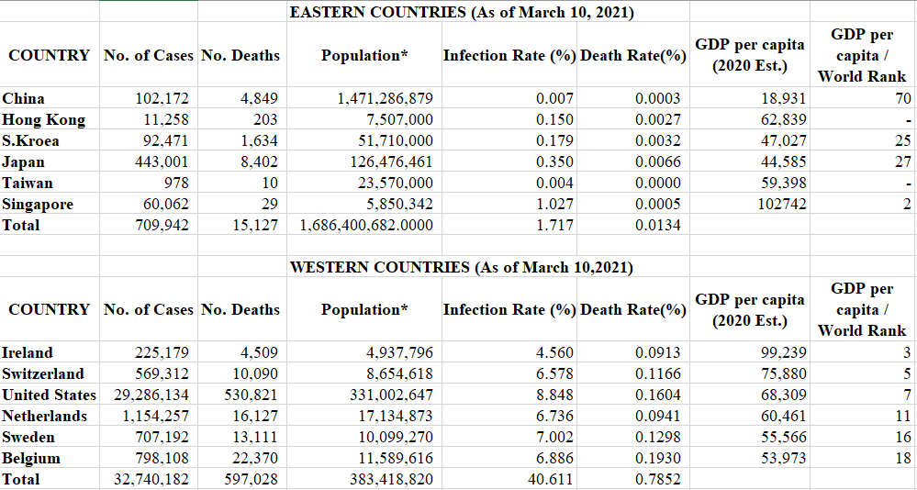

Figure 1(a): Eastern Economies - Weekly % Change in Number of Cases

Figure 1(b): Eastern Economies - Weekly % Change in Number of Deaths

Figure 2(a): Western Economies - Weekly % Change in Number of Cases

Figure 2(b): Western Economies: Weekly % Change in Number of Deaths

Figure 3(a): Hofstede’s Dimensions across Eastern Economies

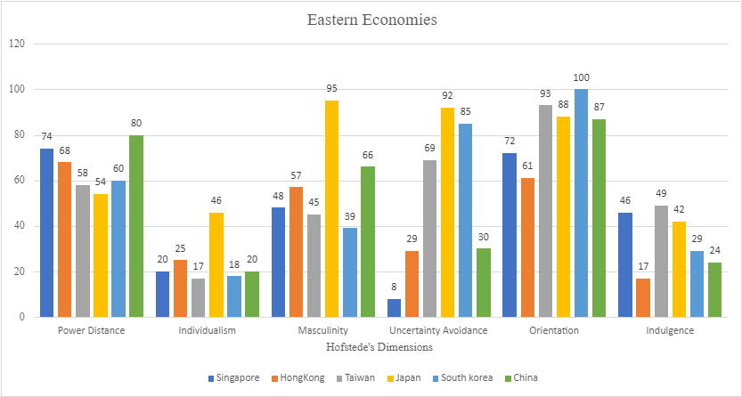

Figure 3(b): Hofstede’s Dimensions across Western Economies

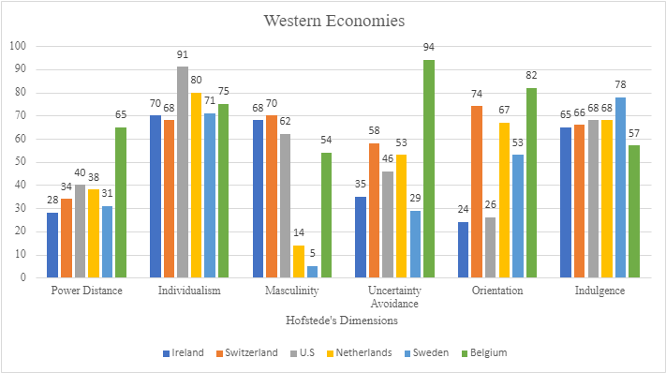

**References**

*Anatomy Of A COVID-19 Conspiracy Theory*. (n.d.). July 10, 2020. Retrieved April 14, 2021, from https://www.npr.org/2020/07/10/889037310/anatomy-of-a-covid-19-conspiracy-theory

*Anatomy Of A COVID-19 Conspiracy Theory*. (2021).

Benedikt Frey, C., Chen, C., & Presidente, G. (2020). Democracy, Culture, and Contagion: Political Regimes and Countries Responsiveness to Covid-19. *Covid Economics*, *18*, 1–20.

Borg, M. A. (2014). Cultural determinants of infection control behaviour: understanding drivers and implementing effective change. . *. Journal of Hospital Infection*, *86*(3), 161–168.

Brochet, F., Miller, G. S., Naranjo, P., & Yu, G. (2019). Managers’ cultural background and disclosure attributes. *The Accounting Review*, *94*(3), 57–86.

*CDC COVID Data Tracker*. (2020). https://covid.cdc.gov/covid-data-tracker/#datatracker-home

Chui, A. C. W., & Kwok, C. C. Y. (2008). National culture and life insurance consumption. *Journal of International Business Studies*, *39*, 88–101.

*Coronavirus Pandemic (COVID-19) - Statistics and Research*. (2020). https://ourworldindata.org/coronavirus%0A

Covid pandemic (2021) - Covid pandemic: South Korea sees record rise in daily cases. Retrieved 17 April 2021, from https://www.bbc.com/news/world-asia-55285305

De Vaus, J., Hornsey, M., Kuppens, P., & Bastian, B. (2017). Exploring the east-west divide in prevalence of affective disorder: a case for cultural differences in coping with negative emotion. *Personality and Social Psychology Review*.

Deschepper, R., Grigoryan, L., Lundborg, C. S., Hofstede, G., Cohen, J., Van Der Kelen, G., & Haaijer-Ruskamp, F. M. (2008). Are cultural dimensions relevant for explaining cross-national differences in antibiotic use in Europe? Health Services Research, 8(1), 1-9.

Dong, Q., & Lee, Y. F. L. (2007). The Chinese concept of face: A perspective for business communicators. Journal of Business & Society, 20(1/2), 204-216.

Etehad, M. (2020). *Some world leaders embrace face masks, others reject them*. https://www.latimes.com/world-nation/story/2020-05-22/world-leaders-face-masks-coronavirus

Furlong, Y., & Finnie, T. (2020). Culture counts: The diverse effects of culture and society on mental health amidst COVID-19 outbreak in Australia. *Irish Journal of Psychological Medicine*, *37*(3), 237–242. https://doi.org/10.1017/ipm.2020.37

Gaygısız, Ü., Lajunen, T., & Gaygısız, E. (2017). Socio-economic factors, cultural values, national personality and antibiotics use: A cross-cultural study among European countries. *Journal of Infection and Public Health*, *10*(6), 755–760.

Gokmen, Y., Baskici, C., & Ercil, Y. (2021). The impact of national culture on the increase of COVID-19: A cross-country analysis of European countries. International Journal of Intercultural Relations, 81, 1-8.

Hofstede, G. (1980). *Culture’s Consequences: International Differences in Work-Related Values*. Sage.

Hofstede, G. (2011). Dimensionalizing cultures: the Hofstede model in context. *Psychology and Culture*, *2*(1), 8.

Hofstede, G., & Bond, M. (1984). Hofstede’s culture dimensions: an independent validation using Rokeach’s value survey. *Cross-Cultural Psychology*, *15*(4), 417–433.

Hofstede, G., & Bond, M. H. (1988). The Confucius connection: From cultural roots to economic growth. Organizational dynamics, 16(4), 5-21.

*How to Protect Yourself & Others*. (2021). https://www.cdc.gov/coronavirus/2019-ncov/prevent-getting-sick/prevention.html

Huynh, T. L. D. (2020). Does culture matter social distancing under the COVID-19 pandemic? *Safety Science*, *130*, 104872. https://doi.org/10.1016/j.ssci.2020.104872

Im, H., & Chen, C. (2020). *Social Distancing Around the Globe:Cultural Correlates of Reduced Mobility*.

IMF Country Information. (2021). Retrieved 17 April 2021, from https://www.imf.org/en/Countries

Insights, H. (2021). National Culture. Retrieved 16 April 2021, from https://hi.hofstede-insights.com/national-culture

Jackofsky, E. F., Slocum Jr, J. W., & McQuaid, S. J. (1988). Cultural values and the CEO: Alluring companions? Academy of Management Perspectives, 2(1), 39-49.

Jennings, R. (2020). *How Cultural Differences Help Asian Countries Beat COVID-19, While US Struggles*. https://www.voanews.com/covid-19-pandemic/how-cultural-differences-help-asian-countries-beat-covid-19-while-us-struggles

Kashima, Y. (2019). *What is culture for? In D. Matsu- moto & H. C. Hwang (Eds.)* (2nd ed.). Handbook of culture and psychology ,Press, Oxford Uni- versity.

*List of countries by GDP (PPP) per capita*. (n.d.). Retrieved April 14, 2021, from https://en.wikipedia.org/wiki/List_of_countries_by_GDP_(PPP)_per_capita%0A

Matsumoto, D. (2000). *Culture and psychology* (2nd ed.). Pacific Grove,Brooks Cole.

*National Culture*. (n.d.). https://hi.hofstede-insights.com/national-culture%0A

Nguyen, D. D., Hagendorff, J., & Eshraghi, A. (2017). Does a CEO’s cultural heritage affect performance under competitive pressure? *Rev. Financ. Stud.*, *31*(1), 97–141.

*Opinion | The U.S.-China coronavirus blame game and conspiracies are getting dangerous*. (n.d.). Retrieved April 14, 2021, from https://www.washingtonpost.com/opinions/2020/03/17/us-china-coronavirus-blame-game-conspiracies-are-getting-dangerous/

Parker, R. S., Haytko, D. L., & Hermans, C. M. (2009). Individualism and collectivism: Reconsidering old assumptions. Journal of International Business Research, 8(1), 127.

Rodriguez, H., Quarantelli, E. L., & Dynes, R. R. (2007). *Handbook of Disaster Research*. Springer.

Shao, F., Frederick, D. J., Haggard, D. L., Haggard, K. S., & Pace, G. R. (2020). Industrial Actions and Hofstede's Cultural Dimensions. Business Management Dynamics, 9(7), 1.

*Trump mocks those wearing face masks, calling it “politically correct.”* (2020). CBS News. https://www.cbsnews.com/video/trump-mocks-those-wearing-face-masks-calling-it-politically-correct/#x

Wang, Y. (2021). Government policies, national culture and social distancing during the first wave of the COVID-19 pandemic: International evidence. *Safety Science*, *135*(October 2020), 105138. https://doi.org/10.1016/j.ssci.2020.105138

*WHO Coronavirus (COVID-19) Dashboard*. (n.d.). https://covid19.who.int/

Wild, J., K. Wild and J. Han. (2006). International Business: The Challenges of Globalization. New Jersey: Prentice Hall.