**Exploring Extracts as Lipase Inhibitors In Vitro: A Promising Approach for Obesity Management**

***Zeyad Adil Hameed HAMEED1,[[1]](#footnote-1)\*[C:\Users\Abdullah\AppData\Local\Microsoft\Windows\INetCache\Content.Word\ORCID-iD_icon-16x16.gif](https://orcid.org/xxxx-xxxx-xxxx-xxxx), Bedriye Seda KURŞUN AKTAR2[C:\Users\Abdullah\AppData\Local\Microsoft\Windows\INetCache\Content.Word\ORCID-iD_icon-16x16.gif](https://orcid.org/xxxx-xxxx-xxxx-xxxx), Şevki ADIM 3[C:\Users\Abdullah\AppData\Local\Microsoft\Windows\INetCache\Content.Word\ORCID-iD_icon-16x16.gif](https://orcid.org/xxxx-xxxx-xxxx-xxxx), Zainab Falih ALKHAZAALI4(A,B)[C:\Users\Abdullah\AppData\Local\Microsoft\Windows\INetCache\Content.Word\ORCID-iD_icon-16x16.gif](https://orcid.org/xxxx-xxxx-xxxx-xxxx)***

*1 Department of Chemistry Sciences, School of Natural and Applied Sciences, Çankiri Karatekin University, Iraq*

*2Department of Hair Care and Beauty Services, Yes¸ilyurt Vocational School, Malatya Turgut Özal University, Malatya, Turkey*

*3Department of Chemistry Sciences, School of Natural and Applied Sciences, Çankiri Karatekin University, Turkey*

*4 ADepartment of Chemistry Sciences, School of Natural and Applied Sciences, Çankiri Karatekin University, Iraq.*

*BIbn Sina University for Medical and Pharmaceutical Sciences*

|  |
| --- |
| **Abstract**  In this study, three compounds, namely 5b, 5f, and 5g, were investigated for their potential to inhibit lipase enzyme activity. The motivation behind this research stems from the increasing prevalence of obesity due to sedentary lifestyles and the consumption of high-fat and high-sugar processed foods. Obesity is associated with various health risks, and inhibiting lipase activity is considered a potential approach for managing this condition. The results indicate that all three compounds, 5b, 5f, and 5g, demonstrated a reduction in lipase enzyme activity. The concentration-dependent inhibition is clearly illustrated in the graphical representations (Figures 1, 3, and 5). These findings suggest that these compounds have the potential to be utilized in the treatment of diseases linked to lipase enzyme activity, such as obesity. The 2D interaction maps (Figures 2, 4, and 6) provide insight into the specific amino acid interactions between each compound and the lipase enzyme. Notably, hydrogen bond interactions with amino acids like GLY 76, ARG 256, PHE 77, HIS 151, and SER 152 were identified, emphasizing their role in the inhibitory process. Additionally, the red separation contacts in the interaction maps suggest that the active site of the enzyme is no longer occupied by water molecules, leading to a change in enzyme shape and the cessation of catalytic reactions. The results of this study support the potential therapeutic use of compounds 5b, 5f, and 5g in treating conditions associated with elevated lipase activity, such as obesity. Further research, including in vivo studies and clinical trials, would be necessary to validate these findings and assess the safety and efficacy of these compounds as potential anti-obesity agents. |
| Keywords: Lipase, Inhibition, Obesity |

1. **Introduction**

Our lifestyle has become more sedentary as a result of industrialization, urbanisation, and modernity. More and more of the food we eat every day is processed, fast food, which is heavy in fat and sugar for energy. Because of these shifts, the number of people classified as overweight or obese has almost quadrupled since 1975 [1]. An imbalance between caloric intake and expenditure is the primary cause of obesity, a complex and multifaceted condition. In addition to diabetes [2,3], cardiovascular illnesses [4,5], and certain malignancies [6], obesity increases the risk of additional significant diseases. Medications for obesity such as orlistat, phentermine/topiramate, naltrexone/bupropion, and liraglutide are now authorised by the FDA [7,8]. Among these medications, orlistat is unique in that it inhibits the action of human pancreatic lipase (HPL), an enzyme involved in the hydrolysis of triglycerides during fat digestion and absorption [9]. Flatulence, steatorrhea, nephrotoxicity, kidney stones, and pancreatitis are some of the unpleasant and unfavourable side effects of orlistat [7]. There have been zero new medicines approved using this technique since orlistat. There has been a lot of interest in finding drugs that block HPL as a means to restrict the digestion and absorption of dietary fats, which might lead to weight loss. The X-ray diffraction analysis of HPL (PDB ID: 1LPB) crystal structure was verified. The N and C regions of HPL, which are glycoproteins linked to colipases, include the amino acid residues 1–335 and 336–449, respectively [10,11]. Residues 247–258 in the N region form the active site, which includes the catalytic trial Ser152–Asp176–His263 (Figure 1). A disulfide bridge formed by residues Cys237 and Cys261 forms the surface loop that is the lid domain. The primary surface for colipase binding is located in the C region, which features a double-ring shape. Additionally, from amino acids 76 to 85, there are two hair-loop coils, and from amino acids 204 to 224, there is a β9-loop [10]. There are two possible states for an HPL structure: closed and open. When the enzyme is in its open form, the catalytic site is opened when the lid domain interacts via van der Waals contact with the β5-loop and β9-loop coils [12,13]. As a lipase inhibitor, a C11 alkyl phosphonate (MUP) was co-crystallized at the HPL active site [12]. Orlistat, which was authorised by the FDA, forms a covalent connection with the lipase active site in the digestive tract lumen, making it an irreversible inhibitor of pancreatic and gastric lipase [14,15].

1. **Materials and Methods**

To determine if chemicals or substances inhibit lipase activity in vitro, the lipase enzyme inhibition test is a typical tool for the lab. Enzyme lipase catalyses the hydrolysis of triglyceride ester linkages, resulting in free fatty acids and glycerol. Treatments for diseases like obesity may benefit greatly by inhibiting lipase activity. A stock solution of the product or chemical to be evaluated for lipase inhibition is prepared by dissolving it in 1 mg/mL of dimethyl sulfoxide. A variety of concentrations for the test are obtained by diluting the stock solution. Recombinant enzymes, such as human pancreatic lipase, are a source of lipase. Lipase is isolated or purified using appropriate procedures to produce the enzyme source. It is common practice to freeze the enzyme and then defrost it before to the experiment. To ensure the lipase enzyme is active in the best possible environment, a buffer system is set up. The pH of the buffer is 8.0 and it comprises Tris-HCl and NaCl. It is common practice to evaluate lipase activity using a particular substrate, such 4-Nitrophenyl decanoate. Once the substrate is dissolved in the assay buffer to the correct concentration, it is ready to use. The test sample, D.W., substrate, buffer, and lipase enzyme are all combined to make the reaction mixture. Optimising the final enzyme and substrate concentration is important. Complete inhibition of lipase enzyme activity is shown by the positive control, whereas maximal enzyme activity without any inhibitory impact is represented by the negative control. To ensure the accuracy of the data, the assay incorporates these controls. To initiate the enzyme-substrate reaction, the reaction mixture is incubated at a controlled temperature, usually 37°C, for a predetermined duration. Optimal incubation times could vary from experiment to experiment. A proper detection technique is used to evaluate the lipase enzyme activity after the incubation time. A spectrophotometer is used to measure the product production by tracking the absorbance at a given wavelength, often around 405 nm. A compound's or substance's percentage of lipase inhibition at each concentration is determined using the absorbance values that were obtained. The inhibitory concentration (IC50), which is the concentration needed to block 50% of the lipase enzyme activity, may be calculated by generating a dose-response curve.

1. **Results and Discussion**

You may see the symbols utilized in this investigation and the results obtained for these samples in Table 1.

Table 1 Reveals the sample results and the signals used

|  |  |
| --- | --- |
| Sample | Results µM |
| 5b | 210.045 |
| 5f | 173.287 |
| 5g | 135.911 |

Since 5b has been shown to reduce lipase enzyme activity, it might theoretically be used to treat pathological diseases like obesity that are linked to lipase enzyme activity. The connection between the percentage of enzyme activity and the concentration of 5b is shown graphically in Figure 1, which gives a comprehensive description of the activity. As the quantity of 5b increases, the enzyme lipase's activity decreases, as shown in the graph. The specific interactions between 5b and the enzyme's amino acids are shown by the 2D interaction map in Figure 2. Significant contributions to hydrogen bond interactions, which were shown to be critical to the binding process, were made by the following amino acids: GLY 76, ARG 256, PHE 77, HIS 151 and SER 152. Through these interactions, the inhibitory effects are increased and the binding is stabilised. In addition, the presence of red separation contacts indicates that the enzyme's active site is no longer occupied by water molecules. The outcome is that the enzyme changes shape and stops catalysing reactions. That is why 5b stops the lipase enzyme in its tracks.

Figure 1 Reduce lipase enzyme activity from the 5b

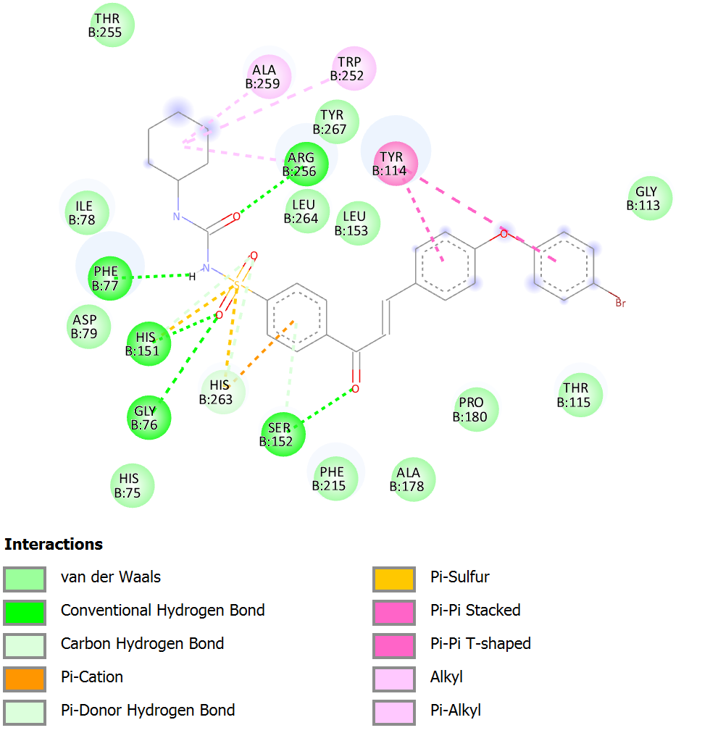

Figure 2 The 5b compound's two-dimensional structures with lipase enzyme

Since 5f has been shown to reduce lipase enzyme activity, it might theoretically be used to treat pathological diseases like obesity that are linked to lipase enzyme activity. The connection between the percentage of enzyme activity and the concentration of 5f is shown graphically in Figure 3, which gives a comprehensive description of the activity. As the quantity of 5f increases, the enzyme lipase's activity decreases, as shown in the graph. The specific interactions between 5f and the enzyme's amino acids are shown by the 2D interaction map in Figure 4. Significant contributions to hydrogen bond interactions, which were shown to be critical to the binding process, were made by the following amino acids: PHE 77 and HIS 263. Through these interactions, the inhibitory effects are increased and the binding is stabilised. In addition, the presence of red separation contacts indicates that the enzyme's active site is no longer occupied by water molecules. The outcome is that the enzyme changes shape and stops catalysing reactions. That is why 5f stops the lipase enzyme in its tracks.

Figure 3 Reduce lipase enzyme activity from the 5f

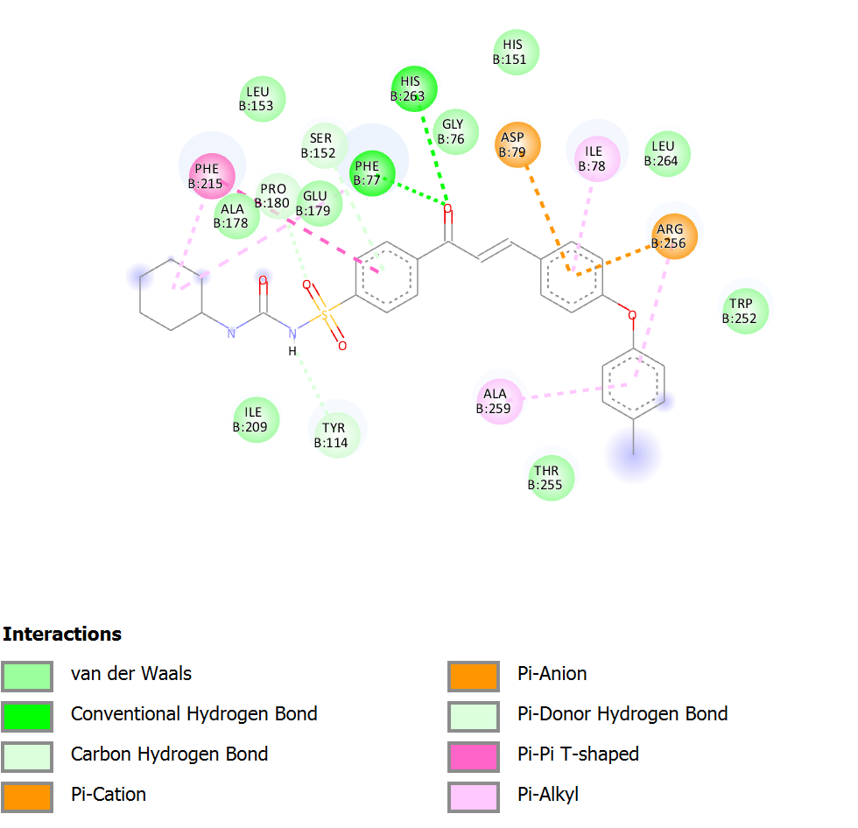

Figure 4 The 5f compound's two-dimensional structures with lipase enzyme

Since 5g has been shown to reduce lipase enzyme activity, it might theoretically be used to treat pathological diseases like obesity that are linked to lipase enzyme activity. The connection between the percentage of enzyme activity and the concentration of 5g is shown graphically in Figure 5, which gives a comprehensive description of the activity. As the quantity of 5g increases, the enzyme lipase's activity decreases, as shown in the graph. The specific interactions between 5g and the enzyme's amino acids are shown by the 2D interaction map in Figure 6. Significant contributions to hydrogen bond interactions, which were shown to be critical to the binding process, were made by the following amino acids: GLY 76, ARG 256, PHE 77, HIS 151 and SER 152. Through these interactions, the inhibitory effects are increased and the binding is stabilised. In addition, the presence of red separation contacts indicates that the enzyme's active site is no longer occupied by water molecules. The outcome is that the enzyme changes shape and stops catalysing reactions. That is why 5g stops the lipase enzyme in its tracks.

Figure 5 Reduce lipase enzyme activity from the 5g

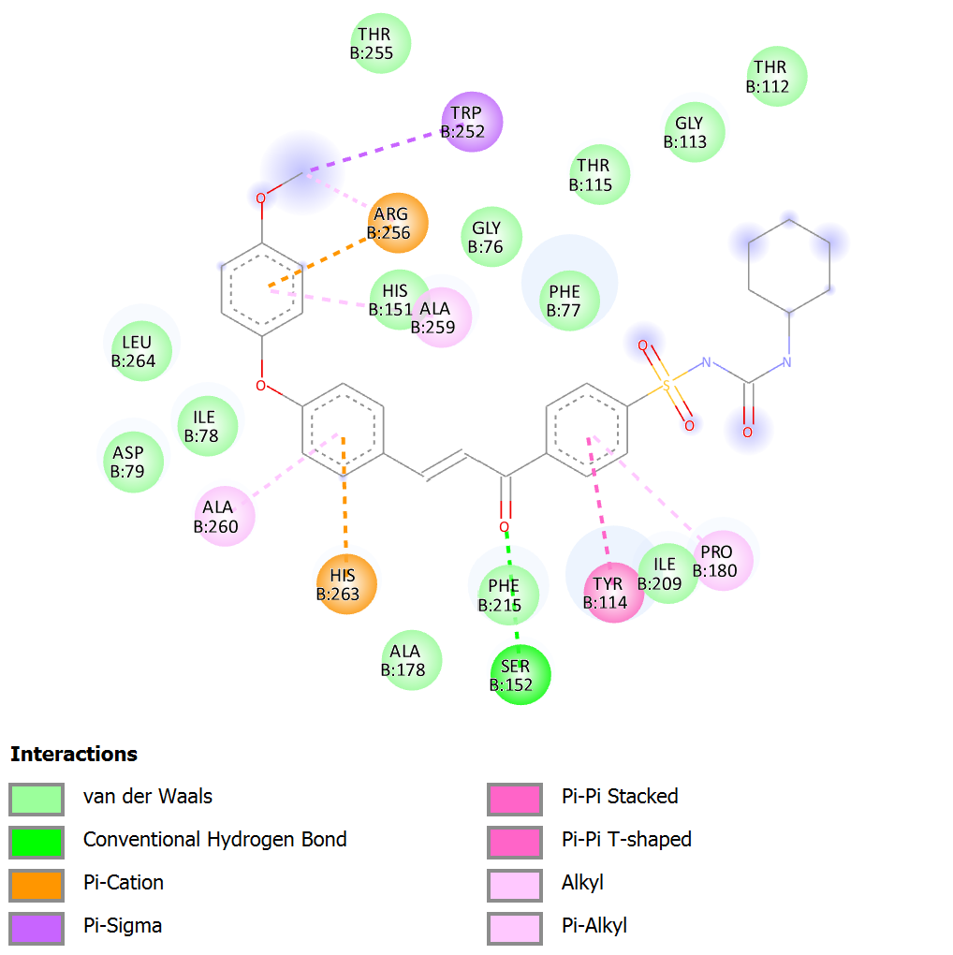

Figure 6 The 5g compound's two-dimensional structures with lipase enzyme

1. **Conclusion**

Three substances, 5b, 5f, and 5g, were studied for their ability to suppress lipase enzyme activity in this research. This opens up a new possibility for the management of obesity and other disorders associated with high lipase activity. The three drugs inhibited lipase activity in a concentration-dependent manner. The inhibitory mechanism was emphasised by the 2D interaction maps, which showed hydrogen bond interactions with certain amino acids. Enzyme catalytic activity was disrupted due to the displacement of water molecules from its active site, as shown by the red separation contacts. Compounds 5b, 5f, and 5g show promise as a treatment for obesity and other diseases linked to increased lipase activity, according to these results. To confirm these findings and evaluate the safety and effectiveness of these chemicals as anti-obesity drugs, more study is essential, such as clinical trials and in vivo investigations. People afflicted with lipase-related disorders may soon be able to enjoy better health and a higher quality of life thanks to this research, which is a giant leap forward in the quest for new treatment approaches.

**References**

1. Keaver, L., Xu, B., Jaccard, A., & Webber, L. (2020). Morbid obesity in the UK: A modelling projection study to 2035. *Scandinavian journal of public health*, *48*(4), 422-427.
2. Bell, J. A., Kivimaki, M., & Hamer, M. (2014). Metabolically healthy obesity and risk of incident type 2 diabetes: a meta‐analysis of prospective cohort studies. *Obesity reviews*, *15*(6), 504-515.
3. Abdullah, A., Peeters, A., de Courten, M., & Stoelwinder, J. (2010). The magnitude of association between overweight and obesity and the risk of diabetes: a meta-analysis of prospective cohort studies. *Diabetes research and clinical practice*, *89*(3), 309-319.
4. Wilson, P. W., D'Agostino, R. B., Sullivan, L., Parise, H., & Kannel, W. B. (2002). Overweight and obesity as determinants of cardiovascular risk: the Framingham experience. *Archives of internal medicine*, *162*(16), 1867-1872.
5. Lu, Y., Hajifathalian, K., Ezzati, M., Woodward, M., Rimm, E. B., Danaei, G., & D'Este, C. (2014). Metabolic mediators of the eff ects of body-mass index, overweight, and obesity on coronary heart disease and stroke: a pooled analysis of 97 prospective cohorts with 1.8 million participants.
6. Calle, E. E., & Thun, M. J. (2004). Obesity and cancer. *Oncogene*, *23*(38), 6365-6378.
7. Daneschvar, H. L., Aronson, M. D., & Smetana, G. W. (2016). FDA-approved anti-obesity drugs in the United States. *The American journal of medicine*, *129*(8), 879-e1.
8. Woodard, K., Louque, L., & Hsia, D. S. (2020). Medications for the treatment of obesity in adolescents. *Therapeutic Advances in Endocrinology and Metabolism*, *11*, 2042018820918789.
9. Pilitsi, E., Farr, O. M., Polyzos, S. A., Perakakis, N., Nolen-Doerr, E., Papathanasiou, A. E., & Mantzoros, C. S. (2019). Pharmacotherapy of obesity: available medications and drugs under investigation. *Metabolism*, *92*, 170-192.
10. Winkler, F. K., d'Arcy, A., & Hunziker, W. (1990). Structure of human pancreatic lipase. *Nature*, *343*(6260), 771-774.
11. Lowe, M. E. (1997). Structure and function of pancreatic lipase and colipase. *Annual review of nutrition*, *17*(1), 141-158.
12. Egloff, M. P., Marguet, F., Buono, G., Verger, R., Cambillau, C., & van Tilbeurgh, H. (1995). The 2.46. ANG. resolution structure of the pancreatic lipase-colipase complex inhibited by a C11 alkyl phosphonate. *Biochemistry*, *34*(9), 2751-2762.
13. van Tilbeurgh, H., Egloff, M. P., Martinez, C., Rugani, N., Verger, R., & Cambillau, C. (1993). Interfacial activation of the lipase–procolipase complex by mixed micelles revealed by X-ray crystallography. *Nature*, *362*(6423), 814-820.
14. Heck, A. M., Yanovski, J. A., & Calis, K. A. (2000). Orlistat, a new lipase inhibitor for the management of obesity. *Pharmacotherapy: The Journal of Human Pharmacology and Drug Therapy*, *20*(3), 270-279.
15. Hadvary, P., Sidler, W., Meister, W., Vetter, W., & Wolfer, H. (1991). The lipase inhibitor tetrahydrolipstatin binds covalently to the putative active site serine of pancreatic lipase. *Journal of Biological Chemistry*, *266*(4), 2021-2027.

1. \* Corresponding author. *e-mail address: .zeyad95adil@gmail.com* [↑](#footnote-ref-1)