**BY**

**HAYDER HAMEED KADHIM SHUBBAR**

**ÇANKIRI**

# CORRELATI0N BETWEEN G6PD ENZYME AND BREAST CANCER

# ABSTRACT

Breast cancer is a complex, heterogeneous disease and one of the most common female cancers worldwide. Although great progress has been achieved in early diagnosis and systemic therapy of breast cancer in recent years, metastasis remains a major obstacle in the effective treatment of breast cancer. In breast cancer. One of the most important metabolic pathways that participate in these processes is the pentose phosphate pathway (PPP), which synthesizes the nucleotide precursor ribose-5-phosphate and produces the reduced form of the nicotinamide adenine dinucleotide phosphate (NADPH), an essential cofactor required for the synthesis of lipids and the maintenance of the antioxidant systems, such as the reduced glutathione pool. Thus, it has been proposed that the activation of the PPP could be regarded as a hallmark of cell transformation. Glucose-6-phosphate dehydrogenase (G6PD), the rate-limiting enzyme of the PPP **,**The purpose of this study is to investigate the function of this enzyme in breast cancer cell metabolism and to explore this potential as therapeutic targets. In our study, we chose breast cancer cells because they heavily rely upon PPP to manage oxidative stress and survive.

## Keywords: G6PD, Pentose Phosphate Pathway, Brest cancer

**INTRODUCTION**

The pentose phosphate pathway (PPP) also known as the hexose monophosphate shunt or phosphogluconate pathway, branches from glycolysis at the first committed step, which is catalyzed by hexokinase and consumes glucose-6-phosphate as a primary substrate

Subsequently, it was found that individuals who are susceptible to hemolytic anemia display genetically inherited reduced activity of glucose-6-phosphate dehydrogenase (G6PD), which catalyzes the first committed step in the PPP. In red blood cells the PPP is the exclusive source of NADPH, which is required for the generation of reduced GSH, a major scavenger of reactive oxygen species (ROS). Therefore, attenuated PPP activity renders red blood cells more vulnerable to oxidants and reagents that interfere with the PPP(Alving *et al. 1956*).

The first and rate-limiting enzyme of PPP is G6PD, is found in the cytoplasm of red blood cells and guards against oxidative damage (Luzzatto L and Arese *et al. 2018*). NADPH and ribose 5-phosphate are abundantly produced by PPP for use in a variety of cellular synthesis processes, including the production of sterols and aliphatic acids. Additionally, this route makes sure that glutathione (GSH) is reduced, which strengthens antioxidant defense and encourages cell growth(Yang HC, *et al. 2016*). Clinical G6PD deficient patients are more likely to experience aberrant lipid metabolism, chronic non-spherical red blood cell hemolytic anemia, infection or drug-induced hemolysis, and newborn jaundice (Luzzatto L and Seneca E *et al. 2014*). Additionally, it has been previously shown that G6PD mutations are the primary cause of several disorders, including chronic hemolytic anemia(Longo L, Vanegas *et al. 2002*). It has been demonstrated that G6PD expression is greater in tumor cells than in healthy cells and that this expression is related to the overall survival of tumor patients (Yang HC, Wu *et al. 2016*). Additionally, multiple studies have shown elevated G6PD activity in a variety of cancers, such as bladder cancer, endometrial carcinoma, prostate cancer, kidney cancer, stomach cancer, cholangiocarcinoma, colon adenocarcinoma, lung cancer, cervical cancer, ovarian carcinoma, hepatocellular carcinoma (HCC), glioma, pancreatic cancer, and mela noma(Ho HY, Cheng *et al. 2014*). The current review focused on the mechanism underlying the involvement of G6PD in carcinogenesis and tumor formation based on the results of earlier studies because it is predicted that G6PD would gain more attention in the future with relation to cancer.

G6PD is a clerical enzyme that can be found in all tissues and organs. The first description of the physiological function and consequences of G6PD was published in 1931. (Stanton RC *et al. 2012*). More than 400 biochemical and more than 200 genetic variations of G6PD have been identified thus far (Minucci A, Moradkhani *et al.2012*). The PPP is a metabolic process that runs parallel to glycolysis and catalyzes the dehydrogenation of G6P to create 6-phosphogluconate. G6PD is a crucial enzyme in this system. A number of chemical processes convert 6-phosphogluconic acid into 6- phosphofructose, that can then go through the aerobic oxidation pathways or the glycolytic process. PPP serves three crucial purposes. i) The only way to use glucose to make ribose 5-phosphate is through PPP, which provides the building blocks for in vivo synthesis of nucleic acids. PPP can stabilize and protect DNA, making cancer cells more resistant to the harm caused by chemoradiotherapy ([Ramos-Montoya](https://www.spandidos-publications.com/10.3892/or.2020.7803#b23-or-44-06-2325) *et al. 2006).*

When compared to normal cells, cancer cells frequently have higher nutritional requirements and energy flow rates. It has previously been established that controlling tumor cell metabolism may have an impact on the cancer's prognosis. Three fundamental metabolic processes are necessary for cancer cells to divide quickly: ATP generation, macromolecular production, and cell assembling, as well as a favorable cellular redox environment(Tong X, Zhao *et al. 2009*). By converting NADP+ to NADPH in the PPP, G6PD plays a crucial function in preserving a proper redox potential in cells; its dysregulation leads to insufficient antioxidant defense (Frederiks WM *et al. 2010*).

**Laboratory Equipment**

|  |
| --- |
| Human G6PD ELISA Kit  Refrigerators  Deep freeze  Centrifuge |
| Incubator |
| Syringe |
| Pipettes |
| Test Tubes |

**RESULTS**

Figure 1 shows the active region selected in docking studies. The active site is the binding site of NADPH. The amino acid residues and interaction types with which NADPH interacts are given in Figure 2.The figure 3 shows the level of G6PD enzyme.

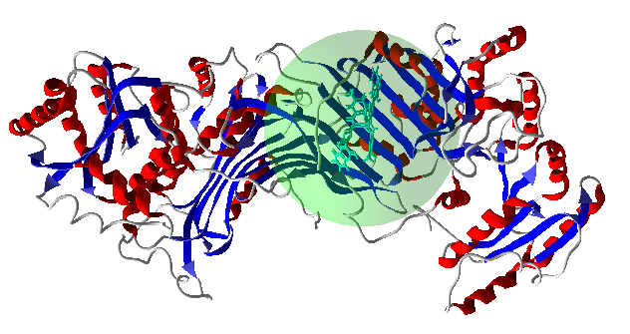

**Figure 1** G6PD structure and docking area

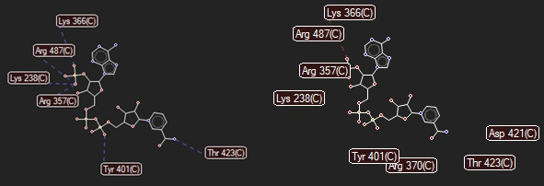

**Figure 2** Amino acids and interaction patterns with which NADPH interacts at the 6PGD active site

**The result of serum G6PD**

**Figure 4.3** The level of G6PD

**References**

Alving AS, et al. Enzymatic deficiency in primaquine-sensitive erythrocytes. *Science.*1956;124(3220):484–485

Frederiks WM, Bosch KS, Hoeben KA, van Marle J and Langbein S: Renal cell carcinoma and oxidative stress: The lack of peroxisomes. Acta Histochem. 112:364–371. 2010.

Ho HY, Cheng ML and Chiu DT: Glucose-6-phosphate dehydrogenase-beyond the realm of red cell biology. Free Radic Res. 48:1028–1048. 2014.

Longo L, Vanegas OC, Patel M, Rosti V, Li H, Waka J, Merghoub T, Pandolfi PP, Notaro R, Manova K and Luzzatto L: Maternally transmitted severe glucose 6-phosphate dehydrogenase deficiency is an embryonic lethal. EMBO J. 21:4229–4239. 2002.

Luzzatto L and Arese P: Favism and Glucose-6-phosphate dehydrogenase deficiency. N Engl J Med. 378:60–71. 2018.

Luzzatto L and Seneca E: G6PD deficiency: A classic example of pharmacogenetics with on-going clinical implications. Br J Haematol. 164:469–480. 2014.

Minucci A, Moradkhani K, Hwang MJ, Zuppi C, Giardina B and Capoluongo E: Glucose-6-phosphate dehydrogenase (G6PD) mutations database: Review of the ‘old’ and update of the new mutations. Blood Cells Mol Dis. 48:154–165. 2012.

Ramos-Montoya A, Lee WN, Bassilian S, Lim S, Trebukhina RV, Kazhyna MV, Ciudad CJ, Noé V, Centelles JJ and Cascante M: Pentose phosphate cycle oxidative and nonoxidative balance: A new vulnerable target for overcoming drug resistance in cancer. Int J Cancer. 119:2733–2741. 2006.

Stanton RC: Glucose-6-phosphate dehydrogenase, NADPH, and cell survival. IUBMB life. 64:362–369. 2012.

Yang HC, Wu YH, Liu HY, Stern A and Chiu DT: What has passed is prolog: New cellular and physiological roles of G6PD. Free Radic Res. 50:1047–1064. 2016.