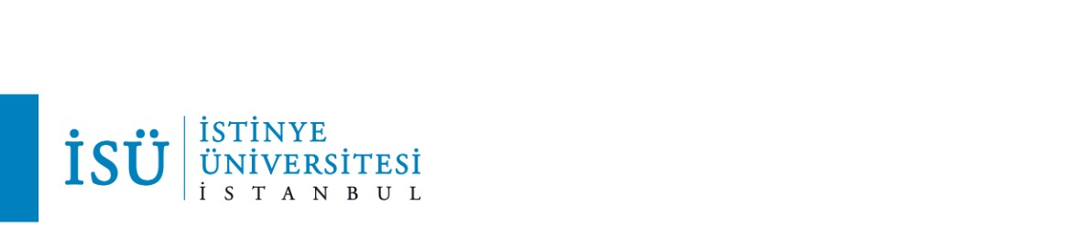

Nevzat Alp Büyükyüksel

**Cool on Snapchat, not done on Instagram? A study about emerging adults’ motives**

**for the sharing of alcohol posts on different social media platforms.**

**Abstract**

The use of social networking sites (SNS) became a widespread behavior among emerging adults in recent years (Auxier & Anderson, 2022). The continuous access to SNS has significantly changed the ways of identity construction as social media provide emerging adults with the opportunity to create desirable identities, including drinking identities (Ridout et al., 2012). In addition, the use of alcohol seems to be a prevalent risk factor since it can pave the way for developing addictive behaviours with the influence of social media for emerging adults who often share alcohol references portraying fun drinking events on their social media platforms (Brown & Murphy, 2018; Geusens & Vranken, 2021). Previous studies have examined emerging adults’ motivations for posting alcohol-related content on SNS, however, most research has focused on Facebook or SNS in general, thereby neglecting other and more popular platforms for the portrayal of alcohol. Therefore, building on Uses and Gratifications theory and the previous literature by Hendriks et al. (2017), this research understood what motivations do emerging adults have while posting different alcohol posts on different SNS. Moreover, the research also discovered the motivations behind emerging adults to go on social media while being drunk. To examine these motivations, go-along interviews were conducted in Belgium with 20 emerging adults who were between the ages 21-and 26 (*M= 22.85,* SD= 1.68). *Go-along* methodology was used since it was relevant to go through the platforms that were significant for emerging adults to find more relevant information about their alcohol posts (Niland et al., 2014). As mentioned in the study by Vanherle and colleagues (2021), go-along interviews are derived from the ethnographic walk along research method where the participants are interviewed while walking through places significant to themselves. Exploring these motivations will, in turn, add significant information about emerging adults’ motivations to post alcohol content on different SNS and will give insights into emerging adults’ motivations to go through social media while being drunk further expanding the literature.

Keywords: Young adults, Alcohol Posts, Social Networking Platforms

**References**

Auxier, B., & Anderson, M. (2022, January 31). *Social media use in 2021*. Pew Research Center: Internet, Science & Tech. Retrieved April 6, 2022, from hrps://www.pewresearch.org/ internet/2021/04/07/social-media-use-in-2021/

Brown, R., & Murphy, S. (2018). Alcohol and social connectedness for new residential university students: Implications for alcohol harm reduction. *Journal of Further and Higher EducaCon*, *44*(2), 216–230. hrps://doi.org/10.1080/0309877x.2018.1527024

Geusens, F., & Vranken, I. (2021). Drink, share, and comment; wait, what did I just do? understanding online alcohol-related regret experiences among emerging adults. *Journal of Drug Issues*, *51*(3), 442–460. <hrps://doi.org/10.1177/0022042621994542>

Hendriks, H., Gebhardt, W. A., & van den Putte, B. (2017). Alcohol-related posts from young people on social networking sites: Content and motivations. *Cyberpsychology, Behavior, and Social Networking*, *20*(7), 428–435. <hrps://doi.org/10.1089/cyber.2016.0640>

Niland, P., Lyons, A. C., Goodwin, I., & Huron, F. (2014). see it doesn’t look pretty does it? "young adults" airbrushed drinking practices on Facebook. *Psychology & Health*, *29*(8), 877–895. <https://doi.org/10.1080/08870446.2014.893345>

Ridout, B., Campbell, A., & Ellis, L. (2012). off your face(book): Alcohol in online social identity construction and its relation to problem drinking in university students. *Drug and Alcohol Review*, *31*(1), 20–26. hrps://doi.org/10.1111/j.1465-3362.2010.00277.x

Vanherle, R., Beullens, K., & Hendriks, H. (2021). The spiral of positive feedback: GO-along interviews about adolescents perceptions of and reactions to alcohol posts on social media. *Journal of Drug Issues*, *52*(1), 31–46. https://doi.org/10.1177/00220426211041408