**Analysis of the composition of Amaranth oil of the "Marhamat" variety grown in Andijan**

Muydinjon Muminov

Andijan State University

e.mail : [muminov_mm@mail.ru](mailto:muminov_mm@mail.ru)

**Abstract.** The results of the analysis of cold-pressed amaranth oil obtained at Oil press CA59G (AEN Engineering GmbH & Co) are presented. The compositions of amaranth oil at the Korea laboratories ( Institute of Industrial Technologies and Institute of Rare Metals) have been determined

Keywords:  *Amaranth oil, cold-pressed, Squalene, mass spectrometry, Diffraction Analysis, retention time.*

To determine the composition of the analyzed, the analysis was carried out in two separate ways: The oil was analyzed in liquid form using a Gas chromatography–mass spectrometry (GC-MS). Whereas the dry extract of the oil was analyzed using X-ray diffraction (XRD). The results are given in the following sections.

1. **Gas chromatography–mass spectrometry (GC-MS)**

GC-MS is a powerful analysis tool used to determine different specimen within a substance by separating each individual component on the basis of mass difference. This technique can be used to determine an unknown sample and is favorably used in forensic science to determine presence and absence of any particular substance.

The sample analysis conditions for the test are given as follows:

# 1.1. Analysis conditions:

Equipment: Agilent 7890A, 5975C GC-MS Column: HP-5MS (30 m * 0.25 mm * 0.25 µm) Injection Temperature: 250oC

Injection amount: 1 µl, Split ratio 10:1 Carrier gas: He, 1.0 mL/min

Oven conditions: 40oC (5 min) – 10oC / min – 280oC (5 min) Ion Source Temperature: 230oC

Ionization method: EI mode (70 eV)

Molecular weight range: Scan mode (30-500 m/z) Solvent Delay: 3 min

# 1.2. Results

The figure 1 shows the measurement results. Apart from the background peak, five distinct peaks were observed. All the peaks were observed between 26 to 31 minutes of retention time. Furthermore, four of the five peaks were of minor constituents while one peak was of major constituent.

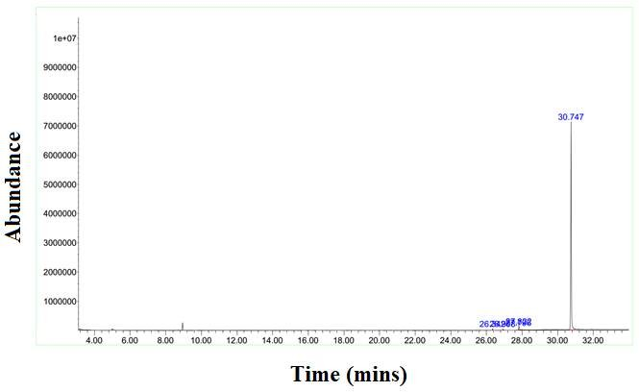

Figure 1 Chromatogram of the Amaranth Oil

# 2. Search and Match

After acquiring the chromatogram, each peak was separately analyzed and matched using CAS database. Figure 2-6 shows mass spectrograph along with the matched specie labeled for each spectrograph

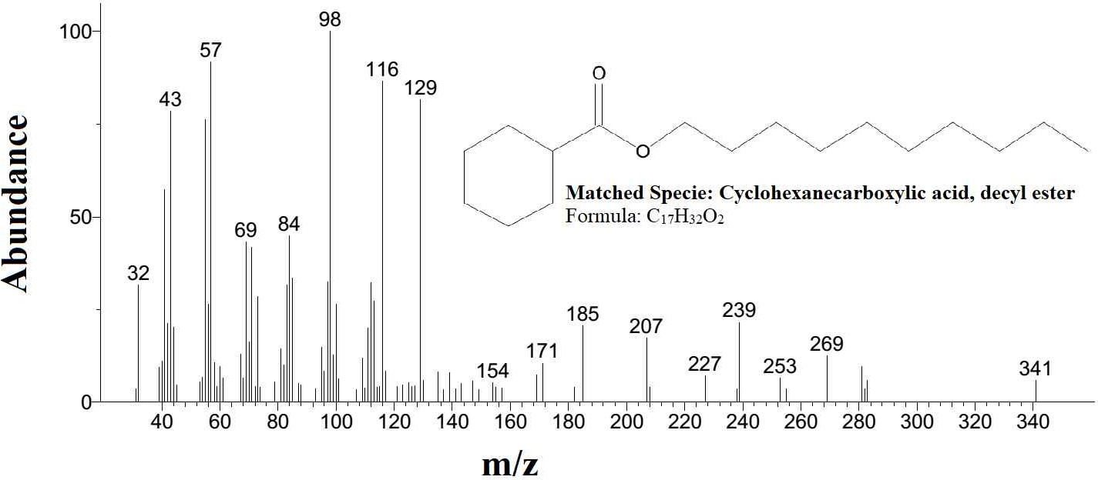

Figure 2 Analysis of peak observed at retention time of 26.34 minutes

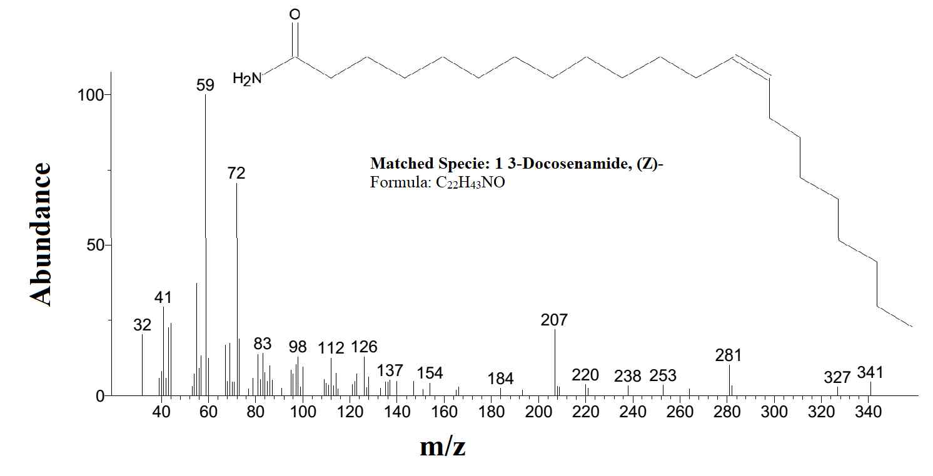

Figure 3 Analysis of peak observed at retention time of 26.91 minutes

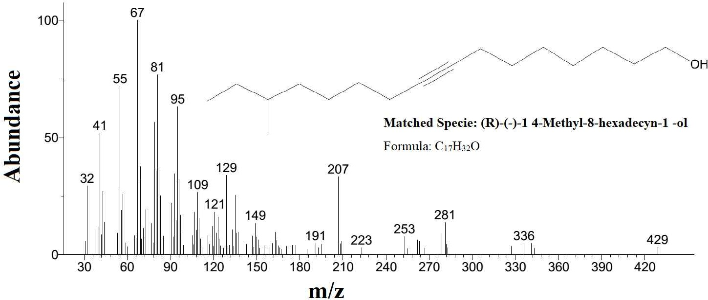

Figure 4 Analysis of peak observed at retention time of 27.79 minutes

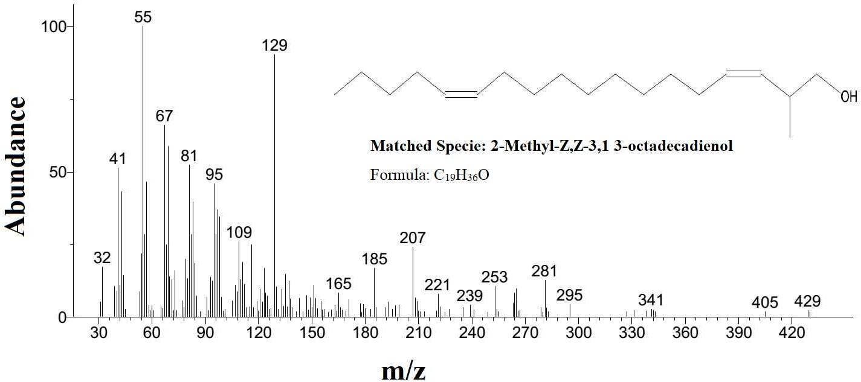

Figure 5 Analysis of peak observed at retention time of 27.82 minutes

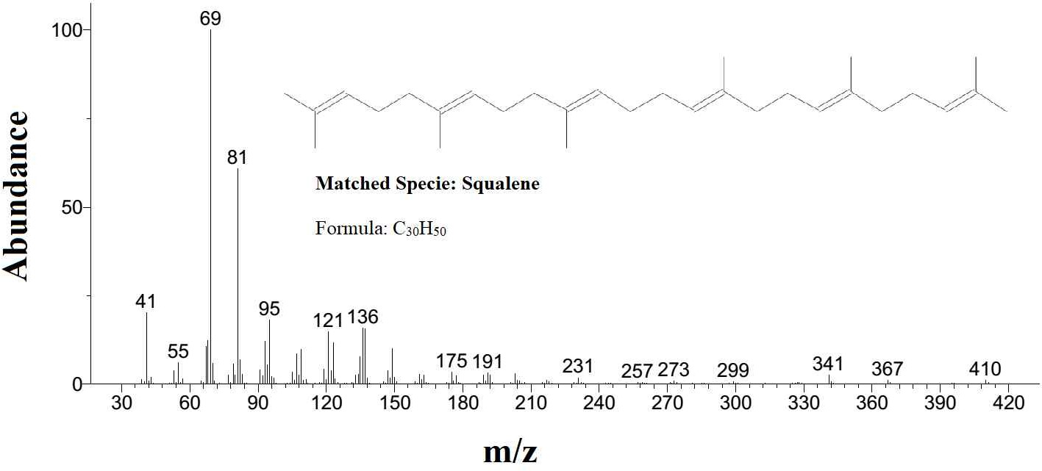

Figure 6 Analysis of peak observed at retention time of 30.75 minutes

The below table lists the five elements matched with the observed GC-MS results.

Table 1 Summary of the GC-MS results.

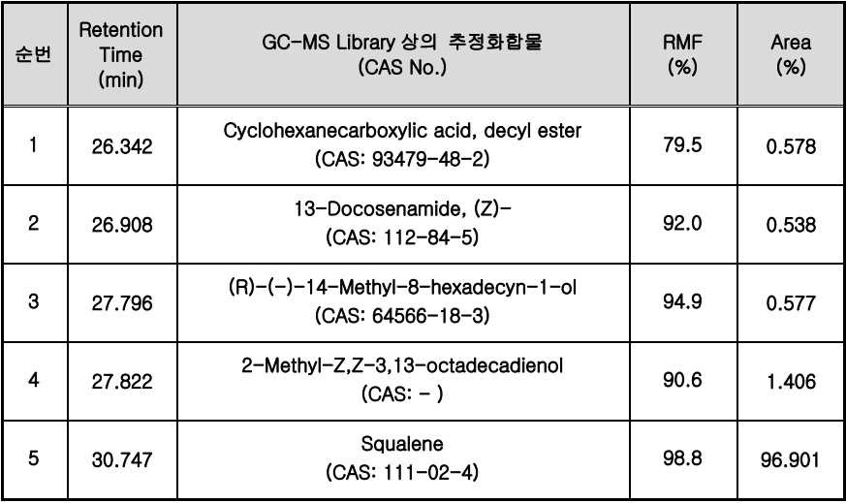

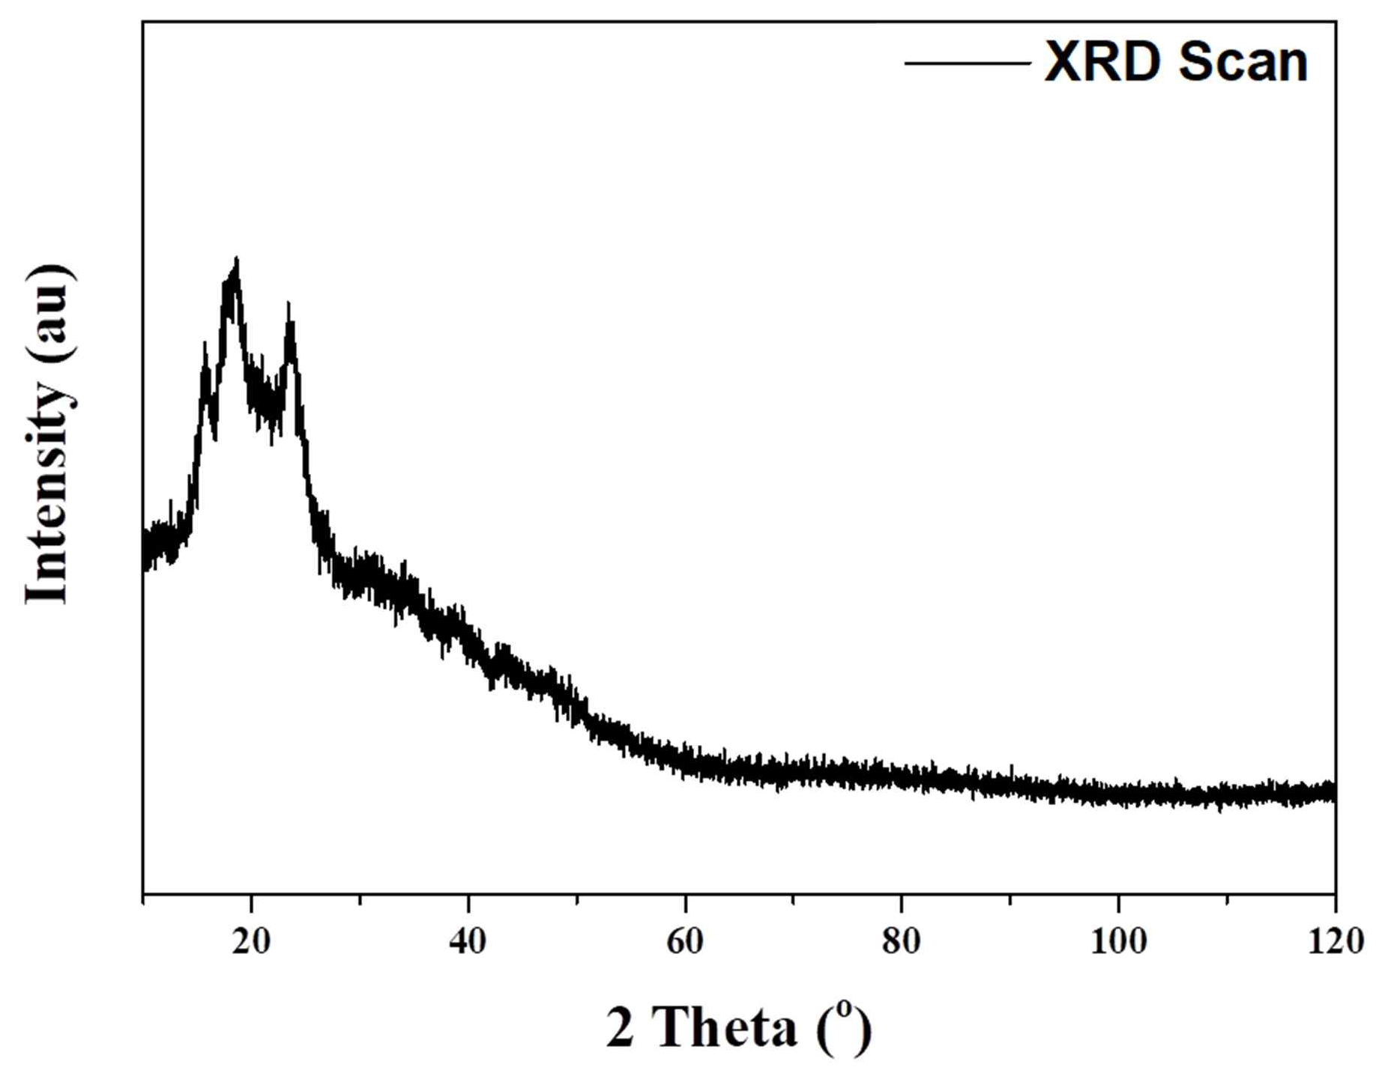3 . X-Ray Diffraction Analysis

Figure 7 XRD scan of the dried extract of the oil

The XRD scan of the dried oil extract is shown in the above figure. The diffraction pattern is typical for semi crystalline organic compound.

**Conclusions**

The results confirm that Squalene is the main compound present in the sample, constituting ~97% of the sample. Other four elements are also mentioned in the table along with the percentage. For Cyclohexanecareboxylic acid, decyl ester, the RMF factor is quite low. As we know, if the RMF factor is less than 90%, the reliability of the match is quite low. However other species have RMF greater than 90% showing good reliability

# Acknowledgement

The author expresses deep gratitude to the employees of the laboratories "KITECH" (Korean Institute of Industrial Technologies) and "KIRLM” (Korean Institute of Rare Metals) for the analysis of amaranth oil of the “Marhamat” variety

# References

1. Sagdullaev Sh., Gusakova S., Muminov M. et al. Modern technologies for processing raw materials on the example of amaranth // Abstract of the 12th National Symposium on the Ear of Natural Organic Chemistry July 28-31, 2018, Kunming (China). p. 32
2. Muminov M.M. et al. Chemical composition of amaranth growing in Uzbekistan Uzbek Biological Journal, 2017,17-21
3. Muminov M.M. et al. The effect of introduction on the composition of seed oil and cake of grain varieties Amaranth hypochondriac. Journal- Chemistry of Natures. soedin., 2017
4. Muminov M.M. et al. Introduction experience in the composition of seed oil and pulp of Amaranhus hupochondiacus Cereal varieties. 2017. Chemistry of natural compounds 53(5)/pp/839-842.
5. Olimzhonov S., Ziyavitdinov J., Muminov .M. Comparative chemical composition of seeds of amaranth varieties introduced in Uzbekistan. Nova Biotechnol Chim (2020) 19(1): 61-69 DOI 10.36547/nbc.v19i1.578

ORCID: <https://orcid.org/0009-0005-4261-1744>