**NEP 2020: Need for change and adaptation**

Sonal Ulal Sarkar

PhD. Research Scholar

Dr. Parinita Ratnaparkhi

Waymade College of Education

CVM University

**Abstract**

The declaration of the new National Education Policy has led to an efflux of excitement flowing through teachers, parents, students, administration, and the country in general, as everyone’s excited to see how this policy shapes the individuals who come out of the education system and the impact it has on the society as a whole. The entire decision seems to be reforming for the betterment of the education system. The aim of this study is to find the need for change and further adapting the revised policy from teachers’ point of view.

The conscious effort that NEP has taken is one of the steps towards advancement and progression in this dynamic and ever-changing world we are all a part of. Technology and skills lose significance and relevance by the time you’re done polishing and perfecting them. One needs to make themselves malleable and personify the qualities of a sponge, by making sure to not let inactiveness be an impediment in their journey to succeed in life. The NEP steps up to this task by keeping creativity and innovation in its acumen and making it an imminent priority. The purpose of the study is to investigate about the teachers’ opinion regarding the need for change and adaptation in the new revised education policy. The approach can also be featured as one that’s global by how many ideas and concepts seemed to have been borrowed from foreign education systems, and by gauging the success and failure of our education system against theirs and finding the best of the two worlds. The population sample of this study is 50 in-service teachers of Gujarat state. The investigation includes an opinionnaire through which teachers can extend their opinion about the need for change and adaptation in the new education policy. The results may be found that teachers have different opinions related to the changes brought by the government.

To get the best out of this policy and make the most of it, the teachers on first hand need to enter with an open mind and be flexible, so that they can easily adapt to the changes and different innovations that are going to take place in the years to come.

**Keywords:** Efflux, Reforming, Adapting, Revised, Malleable, Impediment, Innovation, Acumen, Imminent, Opinion.

**Introduction:**

Education is an important aspect in one’s life. It is the key to success in the future and to have many opportunities in our life. Education has many benefits for people. For instance, it illuminates a person’s mind and thinking. It helps students to plan for work or pursue a higher education while graduating from university. Education helps people think, feel, and behave in a way that contributes to their success, and improves not only their personal satisfaction but also their community. In addition, education develops human personality, thoughts, communicating with others and prepares people for life experiences. It makes people have a special status in their own society and everywhere they live in. I believe that everyone is entitled to have education ‘’from cradle to grave’’. First of all, education gives us the chance of having a good career in our life. We can have plenty of chances to work at any workplace we wish. In other words, opportunities for a better employment can be more and easy. The highly educated we are the better chance we get. Moreover, education polishes our mind, reinforces our thoughts, and strengthens our character and behaviours toward others. It prepares us with information in various fields in general and our specialization in particular; especially what we need to master in our job career. Therefore, without education we may not survive properly nor have a decent profession. Furthermore, education grants us a good status in society. As educated people, we are considered as a valuable source of knowledge for our society. Having education helps us teach others morals, manners and ethics in our society. For this reason, people deal with us in a considerable and special way for being productive and resourceful. In addition, education makes us a role model in society when our people need us to guide them to the right way or when they want to take a decision. Thus, it is an honour for us to serve our community and contribute towards its advancement. In fact, being educated is an advantage to help our people and build a good society. Besides, it is very well-known that having self-confidence is always generated from education. It is a great blessing for us to have self-confidence which leads to many advantages and success in life. For example, it helps us manage specific tasks, tackle life’s challenges and maintain positive stands. Additionally, having self-confidence is typically based on proper education; paving the path for us to success. Accordingly, self-confidence makes us aware of how well we perform a task or a range of actions. In short, being educated is undoubtedly being self-confident and successful in life. All in all, education is the process of acquiring knowledge and information that lead to a successful future. As discussed above, there are a lot of positive traits of having education; such as having a good career, having a good status in society, and having self-confidence. Education makes us view obstacles as challenges to overcome with no fear; facing new things. It is the main factor behind successful people and the merit of developed countries. Therefore, education is deemed a real success behind any future success.

Policies help define rules, regulations, procedures and protocols for schools. All of these are necessary to help a school run smoothly and safely and ensure that students receive a quality education. Students, teachers and staff members deserve to feel physically and psychologically secure in their environment. In order to create this environment, [policies](https://www.graniteschools.org/legal/policies/) are created and instated that establish safety standards for the physical environment and mental state of students and staff.

The National Education Policy 2020 has been introduced at the right time, to complement the mission and vision of creating quality institutions, a culture of innovation, and a highly skilled workforce. It was high time that we initiated a process to transform the Educational Institutions in India, and provide them the ability to attain a certain level, that they can be compared to the best policies in the world.

The [National Education Policy 2020](https://digitallearning.eletsonline.com/2020/09/hsnc-university-lauds-the-national-education-policy-2020/) , launched on 29 July 2020, describes the vision of India’s new education system. NEP 2020 focuses on five pillars: Affordability, Accessibility, Quality, Equity, and Accountability – to ensure continual and quality learning. It has been drafted keeping in mind the needs of the citizens as a demand for knowledge in society and economy called for a need to acquire new skills on a daily basis. Thus, providing quality education and creating lifelong learning opportunities for all, leading to full and productive employment and decent work as enlisted in United Nations Sustainable Development Goals 2030, forms the thrust of NEP 2020. The new policy replaces the previous National Policy on Education, 1986 and forms a comprehensive framework to transform both elementary and higher education in India by 2040.

The NEP 2020 calls for key reforms in both school and higher education that prepare the next generation to thrive and compete in the new digital age. Thus, there is much emphasis upon multidisciplinary, digital literacy, written communication, problem-solving, logical reasoning, and vocational exposure in the draft.

**Keywords:**

**Efflux: “**A thing that flows out; [outflow](https://www.collinsdictionary.com/dictionary/english/outflow); [emanation](https://www.collinsdictionary.com/dictionary/english/emanation).”

**- Collins dictionary**

**Reforming**: “Reform consists of changes and improvements to a law, social system, or institution. A reform is an instance of such a change or improvement.”

**- Collins dictionary**

**Adapting**: “To make suitable to [requirements](https://www.collinsdictionary.com/dictionary/english/requirement) or conditions; adjust or modify fittingly.”

**- Collins dictionary**

**Revised**: “To look over again in order to correct or improve.”

**- Merriam Webster Dictionary**

**Malleable**: “Capable of being altered or controlled by outside forces or influences.”

**- Merriam Webster Dictionary**

**Impediment**: “Something that makes progress or movement difficult and impossible.”

**- Cambridge Dictionary**

**Innovation**: “The introduction of new things, ideas or ways of doing something.”

**- Oxford leaners dictionaries**

**Acumen**: “Acumen is the ability to make good [judgements](https://www.collinsdictionary.com/dictionary/english/judgment) and [quick](https://www.collinsdictionary.com/dictionary/english/quick) [decisions](https://www.collinsdictionary.com/dictionary/english/decision).”

**- Collins dictionary**

**Imminent**: “Happening very soon.”

- **The Britannica Dictionary**

**Opinion**: “A view or judgement formed about something, not necessarily based on fact or knowledge.”

**- Oxford Dictionary**

**Statement of problem**

The title of the present study is NEP 2020: Need for change and adaptation.

In the present study a survey was conducted to know the opinion of In-Service Teachers of Gujarat State regarding the changes and adaptability of the New Education Policy.

**Variable**

1. **INDEPENDENT VARIABLE**

**In- Service teachers of Gujarat State**

1. **DEPENDENT VARIABLE**

**Opinionnaire**

**Importance of the study**

The present research will help the reviewers to know about the transition in the new policy. It will help to know that the New Education Policy, which has been schemed by the Government of India would really be able to take our nation to the different level or not. It will help to know the pros and cons of the policy. The study would guide the reviewers about the possible solutions to avoid any chaos which normally occurs during the transitional phase. The present research will give an idea about the challenges faced during the implementation of the policy. It would help the reviewers to know about the probable outputs due to the changes. The opinion of the teachers that will be collected by the researcher will give an idea about the views of them regarding different aspects of the policy.

**Objectives of the study**

Objectives describe the expected implications or contributions arising from the study. The ultimate objectives contribute to the justification of why research on the problem is required. Objectives indicate the variables that will be examined and measured.

The objectives of the present study are as under

* To measure the opinion of teachers regarding the various aspects of NEP.
* To make future reviewers identify of the changes and adaptability related to different approaches mentioned in the New Education Policy 2020.

**Research Design**

One of the important steps of any scientific research is to prepare a research design that deals with the selection and the development of the components of the research. It is a blueprint of the whole research process. It is a mapping strategy that essentially includes sampling, methodology, tools and techniques of analysis of the data. Thus, research design suggests the effectiveness of the research process and that how a satisfactory way could be reached.

**Population**

In research, population refers to the group under the study with some specific characteristics. This group may comprise of people, objects, material or even the documents.

The population in any research is the description of the elements that is to focus the study. The elements can be persons, organizations, objects, etc. that focus the study. Thus population means a group of people, objects or individuals.

In the present study the In-Service teachers of Gujarat form the population of the study.

**Sample**

Most of the educational phenomena consist of a large number of units. It would be impossible, to test, to interview or observe each unit of the population under control condition in order to arrive at principle giving universal validity. Some populations are so large that their study would be expensive in term of time, money, effort and man power sampling is the process by which relatively small number of individuals, objects or events are selected and analyzed in order to find out something about the entire population from which it is selected. It helps to reduce expenditure, save time and energy, permit measurement of greater scope or produce greater precision and accuracy. Sampling procedures provide generalization on the basis of a relatively small proportion of the population.

The representative proportion of the population is called a sample. To obtain a representative sample, the researcher selects each unit in a specific way under controlled conditions.

In the present study, 60 In-Service teachers of Gujarat were selected by Convenient Sampling Technique.

**Tools**

To develop a tool, it is necessary to consider its area of application, type of tool, level of students, objectives, hypothesis, variables and the type of data researcher want for the study. During the selection of the available standardised tool, researcher should take care that it should be valid, reliable, and satisfy the objectives of the research and deliver researcher the type of data researcher wants. The tools can be a standardised test which is readily available. If the standardised test is not available which can measure the variables, then such type of test is to be created. The test is to be formed by keeping in view the standard.

In the present study, the researcher has constructed an opinionnaire with five-point rating scale.

**Method**

The researcher shall prepare an opinionnaire with 15 questions with five-point rating scales. Participants were 60 In- Service teachers of Gujarat State. In the present research, looking at the economy of time, money and energy the Survey method shall be used with the help of Google form.

**Data Collection**

Measurement process is employed to identify the variables. Data are collected for both variables as well as attributes which are gathered in term of frequency and scores. Scores is the Numerical description of an individual with regards to some characteristics for variable. Data depend on the type of instrument employed for its measurement. Which test yield the data in the form of scores, questionnaires provide data. Data are things with which we think of both data and facts are used in educational research.

In the present study, the researcher shall collect the data with the help of Google Form consisting of 15 questions and five rating scale.

**Data Analysis and Interpretation**

Analysis of the data means studying the organized material in order to discover inherit facts. The data studied from as many angles as possible to explore the new facts. Analysis requires an alert flexible and open mind. It is worthwhile to prepare a plan of analysis before the actual collection of data.

Following are the interpretations for the present study

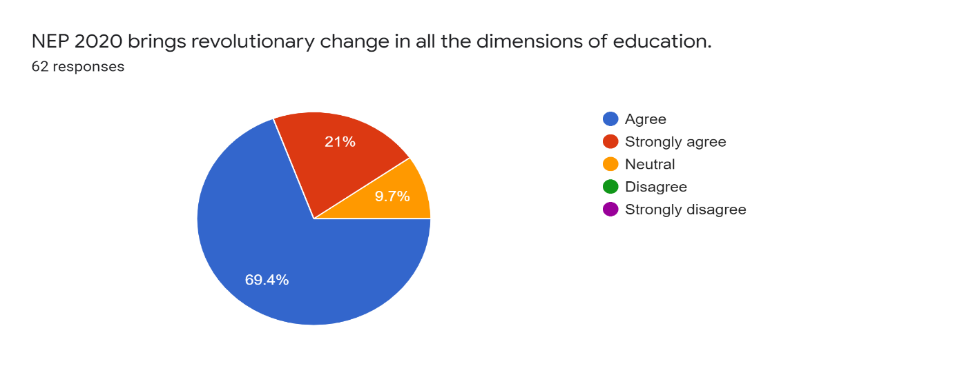

Interpretation: 69.4% respondents agree to the statement.

21% strongly agree to the statement.

9.7% are neutral towards the thought.

Finding: No teacher completely disagrees or strongly disagrees towards the thought. It indicates that the changes brought by the NEP-2020 will be favorable and adaptable.

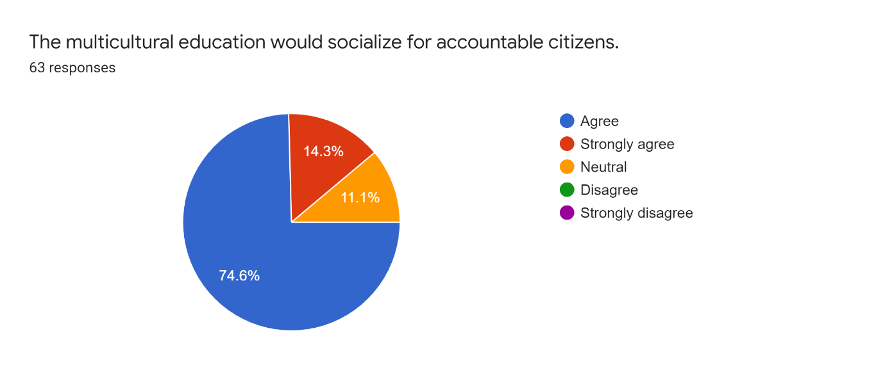

Interpretation: 74.6% respondents agree to the statement.

14.3% strongly agree to the statement.

11.1% are neutral towards the thought.

Finding: No teacher completely disagrees or strongly disagrees towards the thought. It indicates that the changes brought by the NEP-2020 will be favorable and adaptable.

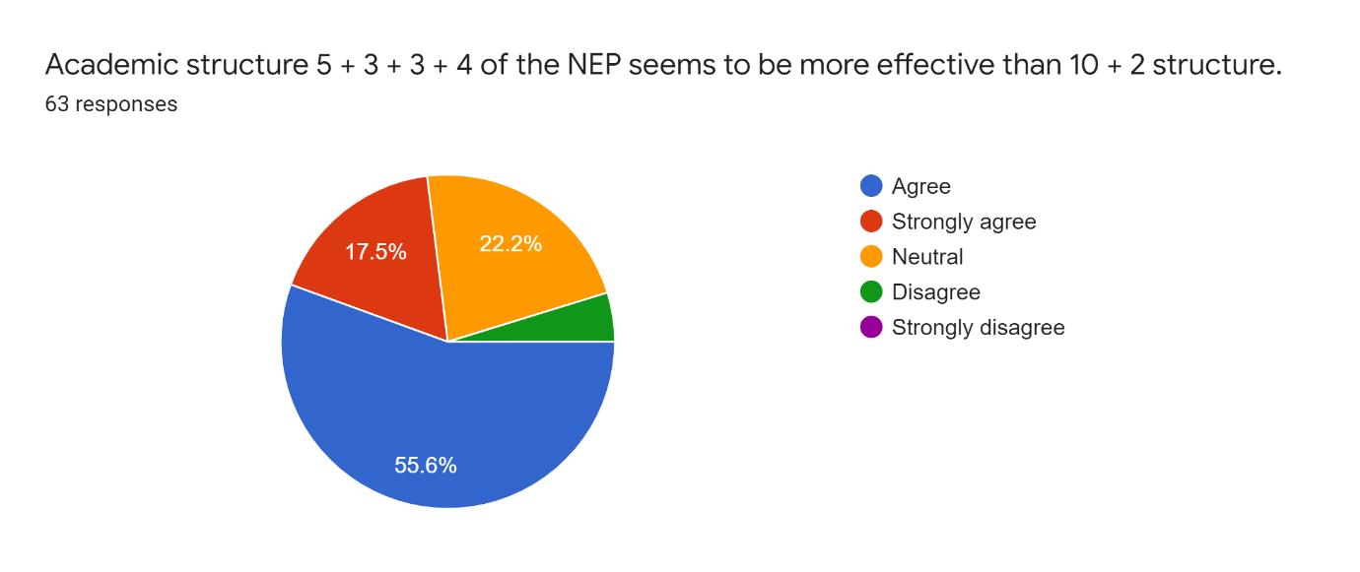

Interpretation: 55.6% respondents agree to the statement.

17.5% strongly agree to the statement.

22.2% are neutral towards the thought.

Finding: 4.7% disagree towards the thought. It indicates that few respondents still favor the old academic structure.

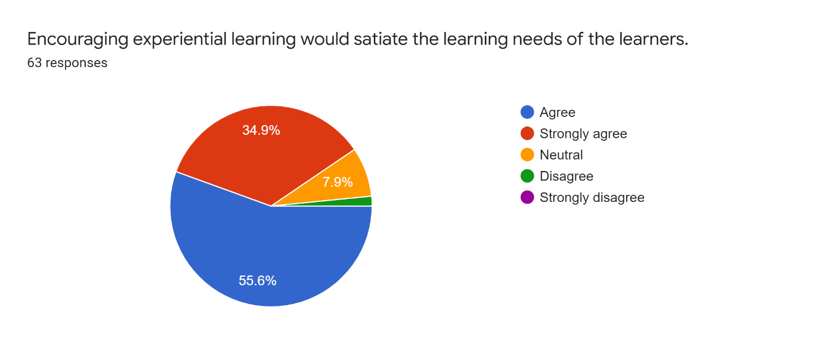

Interpretation: 55.6% respondents agree to the statement.

34.9% strongly agree to the statement.

7.9% are neutral towards the thought.

Finding: Very few teachers completely disagree towards the thought. It indicates that the overall development of the learners is possible if the modern methods of teaching are adopted.

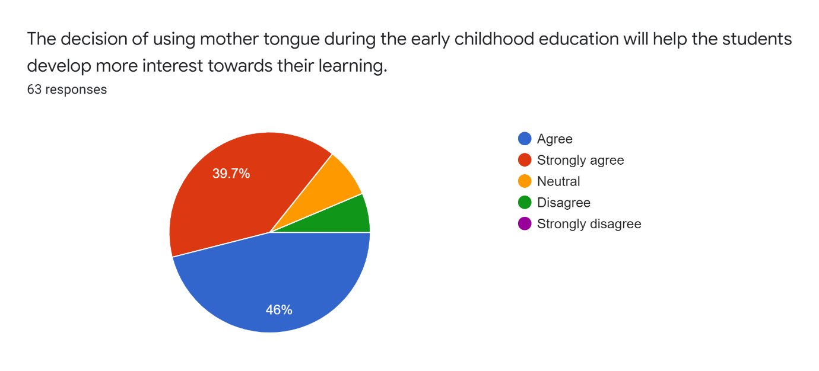

Interpretation: 46% respondents agree to the statement.

39.7% strongly agree to the statement.

7.15% are neutral towards the thought.

Finding: 7.15% teachers completely disagree towards the thought. It indicates that many respondents are in favor of using mother tongue during primary schooling.

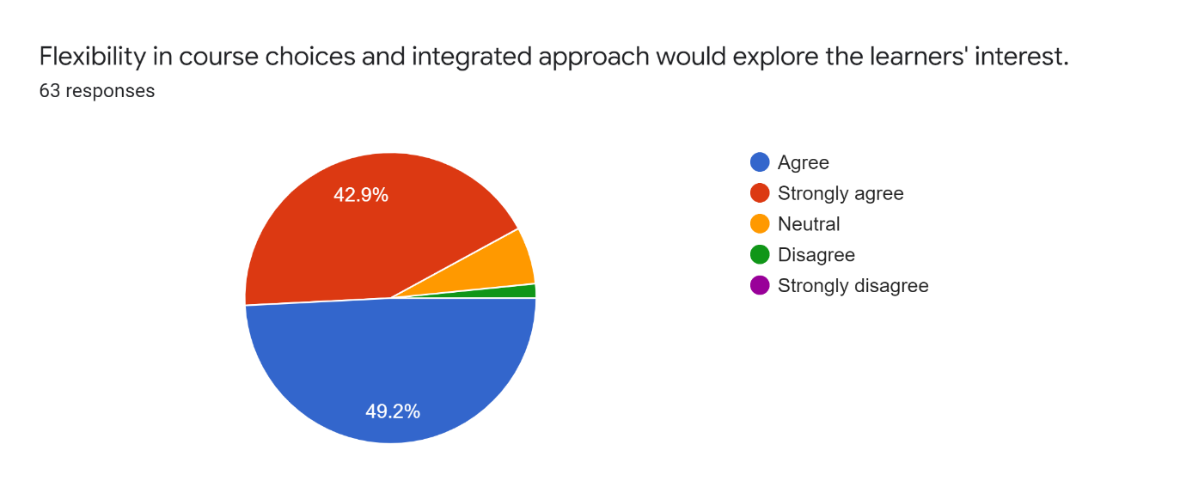

Interpretation: 49.2% respondents agree to the statement.

42.9% strongly agree to the statement.

15.1% are neutral towards the thought.

Finding: Very few teachers completely disagree towards the thought. It indicates that the changes brought by the NEP-2020 will be favorable and adaptable.

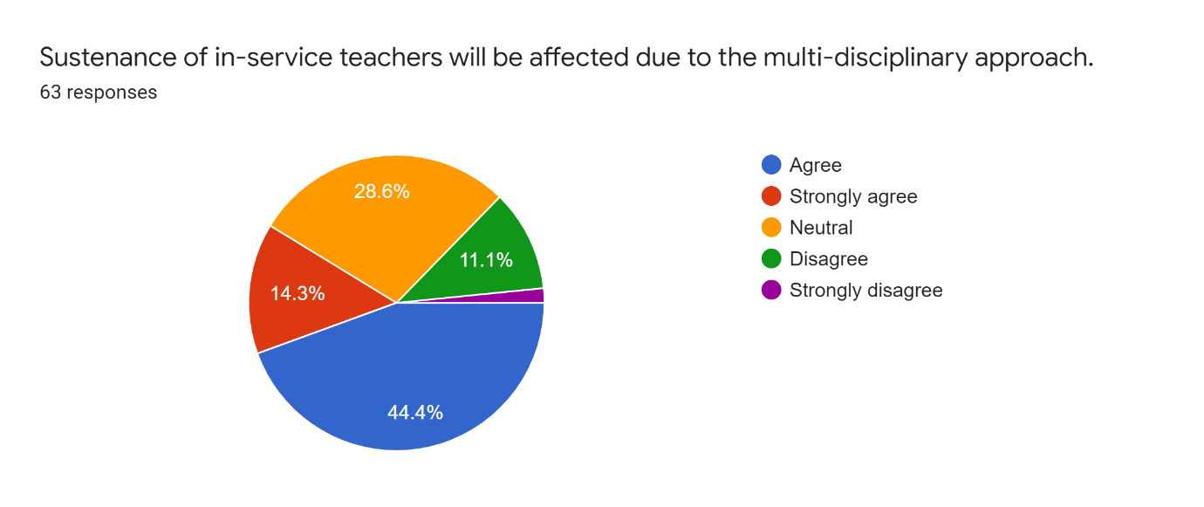

Interpretation: 44.4% respondents agree to the statement.

14.3% strongly agree to the statement.

28.6% are neutral towards the thought.

11.1% disagree towards the thought.

Finding: Maximum respondents are not sure about the sustenance of teachers due to multi-disciplinary approach.

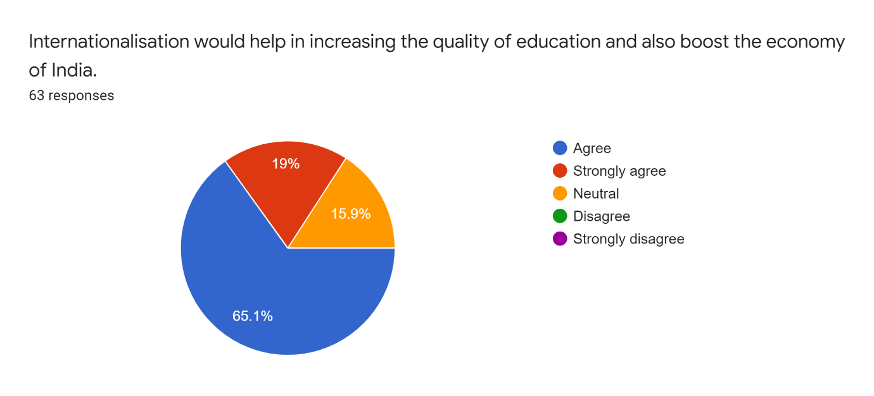

Interpretation: 65.1% respondents agree to the statement.

19% strongly agree to the statement.

15.9% are neutral towards the thought.

Finding: No teacher completely disagrees or strongly disagrees towards the thought. It indicates that the changes brought by the NEP-2020 will be favorable and adaptable.

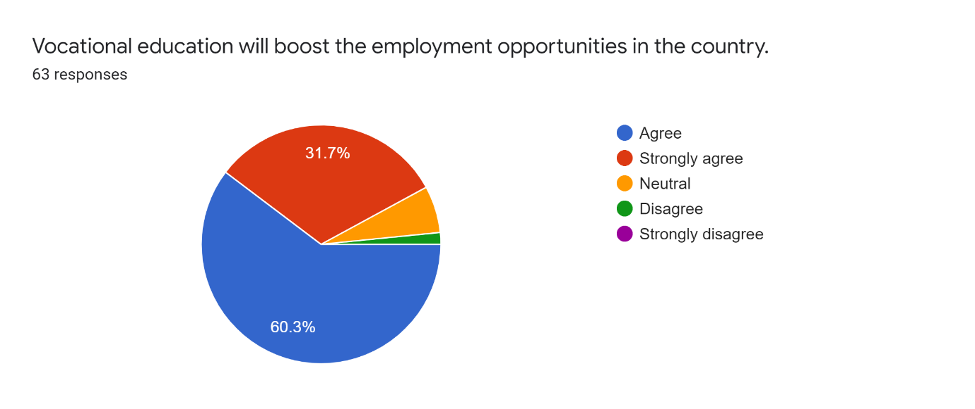

Interpretation: 60.3% respondents agree to the statement.

31.7% strongly agree to the statement.

11.1% are neutral towards the thought.

Finding: No teacher completely disagrees or strongly disagrees towards the thought. It indicates that the changes brought by the NEP-2020 will be favorable and adaptable.

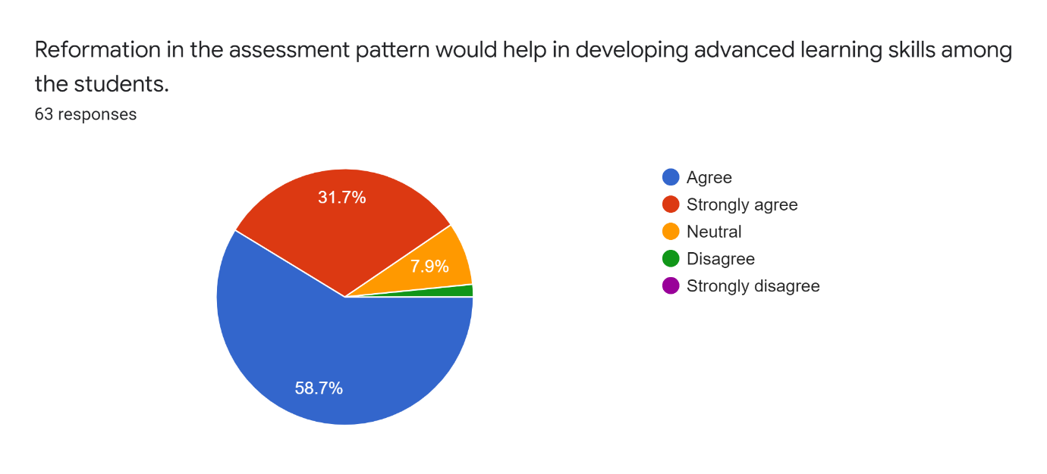

Interpretation: 58.7% respondents agree to the statement.

31.7% strongly agree to the statement.

7.9% are neutral towards the thought.

Finding: Many respondents agree to the fact of reformation in the examination pattern.

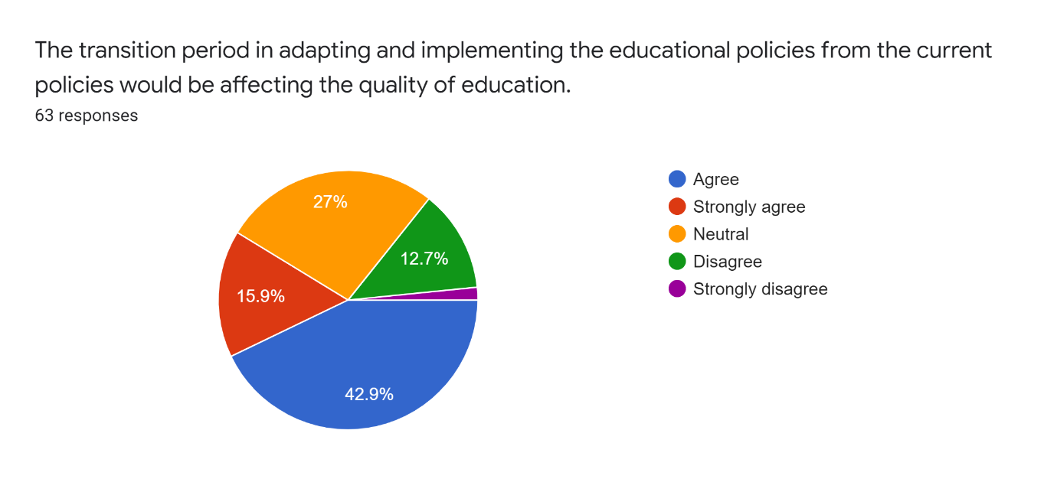

Interpretation: 42.9% respondents agree to the statement.

15.9% strongly agree to the statement.

27% are neutral towards the thought.

12.7% completely disagree.

Finding: Maximum respondents are agreeing to the fact that quality of education would be affected due to the transition.

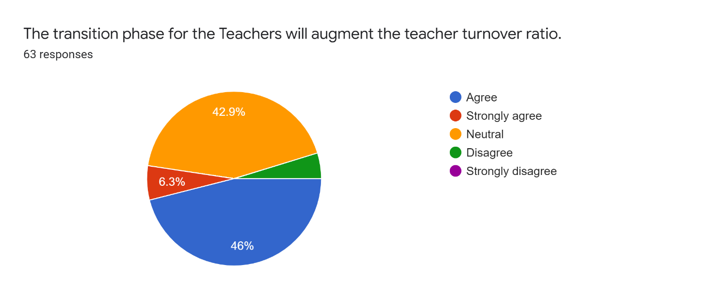

Interpretation: 46% respondents agree to the statement.

6.3% strongly agree to the statement.

42.9% are neutral towards the thought.

Finding: Many teachers are not sure about the future prospects of teaching profession.

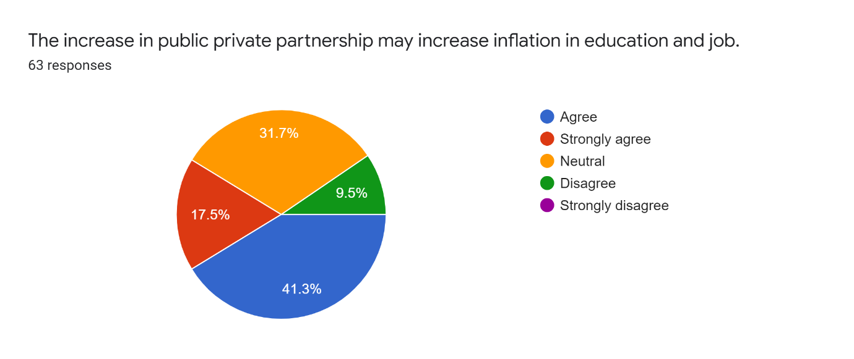

Interpretation: 41.3% respondents agree to the statement.

17.5% strongly agree to the statement.

31.7% are neutral towards the thought.

9.5% are disagreeing to the thought.

Finding: There are mixed responses about this factor.

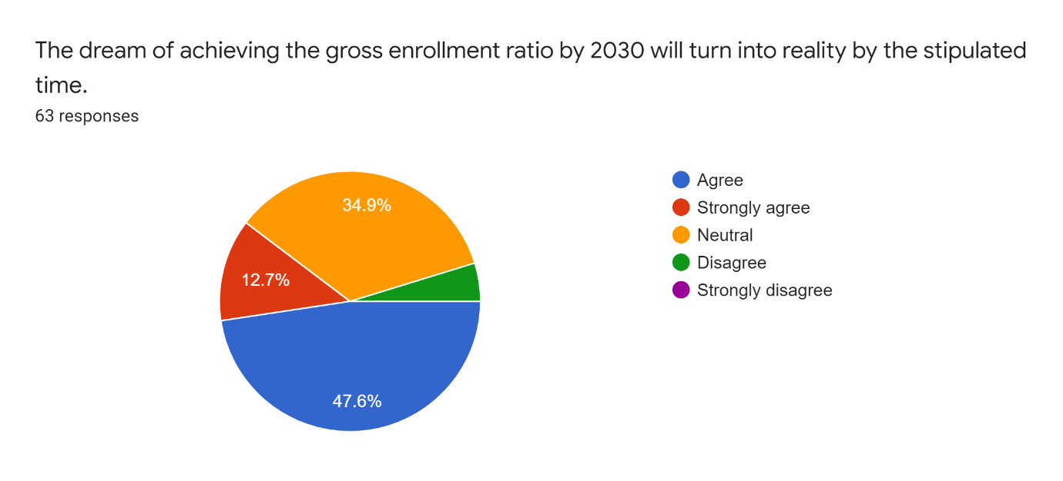

Interpretation: 47.6% respondents agree to the statement.

12.7% strongly agree to the statement.

34.9% are neutral towards the thought.

4.8% disagree to the statement.

Finding: It could be observed that many respondents are not sure about how long it will take for the gross enrollment ratio to be achieved.

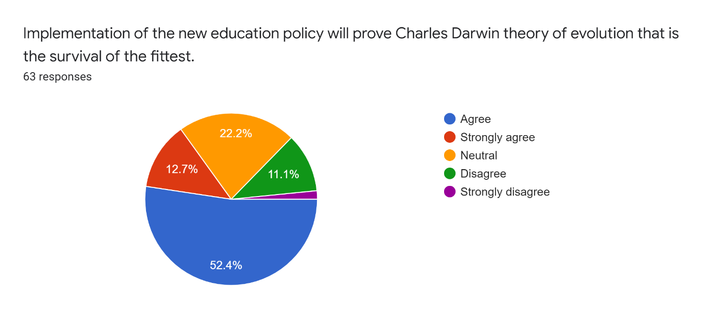

Interpretation: 52.4% respondents agree to the statement.

12.7% strongly agree to the statement.

22.2% are neutral towards the thought.

11.1% are in disagreement and very few strongly disagrees.

Finding: More than half respondents agrees to the statement that implementation of the policy would take time and adequate indulgence is a tough target to achieve.

**Conclusion**

The present chapter forms the brief background of National Education Policy-2020 along with the aspects under the study. It is to create an awareness amongst the educated ones for future sustenance. It will further contribute in making them aware of the changes and adaptability in the field of education. The opinion given by the teachers will give a brief picture about the comprehensiveness of the policy.

**References**

How National Education Policy 2020 can be a lodestar to transform future generation in India.

Kishore Kumar,Ajai Prakash,Krishanveer Singh

First published: 25 September 2020 <https://doi.org/10.1002/pa.2500>

Khatak, Sunita & Wadhwa, Naman & Kumar, Rajesh. (2022). NEP,2020-A Review cum

Survey Based Analysis of Myths and Reality of Education in India. XII. 12-22.

National Education Policy 2020: A Step towards Technology Driven Education and Self- reliant India Anand Mohan Jha1 Department of Chemistry, M. L. T. College,

Saharsa, B. N. Mandal University, Madhepura, Bihar, India Amrit Kumar Jha2 Post

Graduate Department of Psychology, C. M. College, L. N. Mithila University,

Darbhanga, Bihar, India Sanjeev Kumar Jha3 Department of Chemistry, M. L. T.

College, Saharsa, B. N. Mandal University, Madhepura, Bihar, India.

TILAK, J. B. G. (2014). Private Higher Education in India. Economic and Political Weekly,

49(40), 32–38. http://www.jstor.org/stable/24480821

<https://ezyschooling.com/parenting/expert/nep-2020-need-to-adapt>

https://digitallearning.eletsonline.com/2021/09/national-education-policy-2020-reforms-in-higher-education