**Internet of Things for Management Information Systems:**

**Application Areas and Challenges**

**Şükrü Mustafa Kaya**

**Istanbul Aydın University, Anadolu Bil Vocational Schoo,** **Computer Technologies**

**Address: Istanbul Aydın University, Florya Campus, Beşyol Mah. İnönü Cad. No: 38**

**Küçükçekmece / Istanbul/ Turkey**

**GSM: 05452055701**

**[mustafakaya@aydin.edu.tr](mailto:mustafakaya@aydin.edu.tr)**

**Orcid No: 0000 0003 2710 0063**

**Corresponding Author: Vildan Bayram**

**Istanbul Aydın University, Anadolu Bil Vocational School**

**Address: Istanbul Aydın University, Florya Campus, Beşyol Mah. İnönü Cad. No: 38**

**Küçükçekmece / Istanbul/ Turkey**

**GSM: 05355097222**

**vildanbayram@aydin.edu.tr**

**Orcid No: 0000 0001 7526 6485**

**Internet of Things for Management Information Systems:**

**Application Areas and Challenges**

**Abstract**

Due to the rapid spread of digitalization throughout the world, process management differs in production, logistics, finance, marketing and similar areas in business life as well as in social life. This rapid change has a great impact on business management and as a result, the need for information management systems is increasing day by day. The developments in sensor technology and the widespread use of the internet in recent years force businesses to update their information management systems. One of the main issues that push information management systems to update is examined under the heading of Internet of Things. Internet of Things technology affects social life through smart applications as well as the business world. Today, internet of things (IoT) applications is used intensively in many fields such as health, agriculture, industry, education and urbanization. In this study, the concept, scope and application areas of the internet of things for information management systems are examined. The results obtained from the literature review and the examined IoT applications are discussed and it is tried to determine what kind of updates the information management systems need.

**Keywords:** Internet of Things, Management Information Systems, IoT Application,

1. **THE INTERNET OF THINGS (IoT)**

The concept of Internet of Things – “IoT” was first introduced in 1999 at the AutoID laboratories of the Massachusetts Institute of Technology. At the World Summit on the Information Society held in 2005, the International Telecommunication Union – ITU Internet Report 2005: "Internet of Things" has officially proposed the definition of the Internet of Things by publishing the report. Intensive studies are carried out in many institutions and organizations around the world on the concept of the Internet of Things. In line with these studies, different definitions of the concept of internet of things emerge. The basis of the concept of the internet of things is that every object in our environment has sensors, mobile phones, etc., through a unique addressing system. It is based on their ability to interact and cooperate with each other in order to perform a common function using technologies (Zeynep T.,2018). Marjani M. et al. (2017), defines IoT as creating a platform for sensors and digital devices to communicate seamlessly in an intelligent environment and ensuring that information is shared between platforms in an appropriate way. Al-Fuqaha A. et al. (2015), defines IoT as "IoT is a set of systems that control or regulate physical objects' seeing, sensing, thinking and decision making, data sharing, and communication with each other."

Recent developments in different wireless technologies position IoT as the new revolutionary technology that takes advantage of all the opportunities offered by internet technology. As an indicator of this situation, it is a technology that has established itself with its applications in smart cities interested in developing smart systems such as smart offices, smart retail, smart agriculture, smart water, smart transportation, smart health and smart energy (Al Nuaimi E., et al., 2015). While IoT platforms are being formed, many sensors such as temperature, pressure, vibration, sound, light, odor integrated into objects are used to detect physical properties and conditions in the real world. These devices used to collect data detect the data and transmit this data using embedded communication devices. Continuous communication of objects and devices is carried out through various wireless technologies such as Bluetooth, WiFi, ZigBee, WSN, LPWAN and cellular network (Kaya Ş.M., et al., 2021b). These communication devices control data and receive commands from remotely controlled devices by directly integrating with the physical world through computer-based systems to improve living standards. More than 50 billion devices, including sensors, smartphones, laptops, and game consoles, are expected to connect to the Internet through various heterogeneous access networks enabled by technologies such as radio frequency identification (RFID) and wireless sensor networks (Atzori et al., 2010). In general, an IoT system is a system that contains a large number of IoT devices, IoT infrastructures, services, applications and generates raw data to other information management systems, which can be organized into four layers: sensing, network, service and interface. Classic IoT layers are presented in figure1. (Li S., et al., 2015; Kaya Ş.M., et al, 2021b).

**Figure 1:** Traditional IoT layers

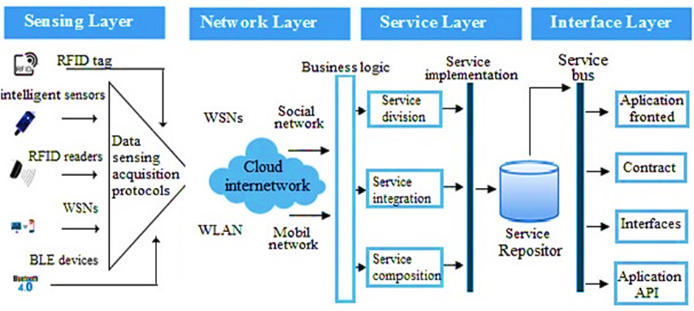

**Reference:** Kaya Ş. M., Erdem A., & Güneş A., (2022)

* **Sensing Layer:** It includes sensing devices such as smart sensors, radio frequency identification (RFID) and client components of IoT to detect and obtain information.
* **Network Layer:** It is the layer that supports the connection infrastructure with the Internet and other devices.
* **Service Layer:** It is the layer where the process of providing and managing services to users or other applications is seen.
* **Interface Layer:** Provides an interface to users or other services (Li S., et al., 2015).

1. **APPLICATION AREAS OF THE INTERNET OF THINGS**

Apart from industry, IoT technology continues to develop in many different areas that make our life easier and increase our quality of life, such as health, smart urbanization and smart agriculture. A few examples of IoT application areas are presented below.

**2.1 Smart Health Application**

IoT applications in healthcare are increasing day by day. This situation increases the trust in IoT day by day, facilitates access to health services, increases the quality of care and most importantly reduces the cost of health services (Kulkarni and Sathe,2014; Bayram, 2022). IoT-based health systems are classified as acute care, community-based care and long-term care (Laplante, et al., 2018).

• **Acute care:** It refers to the paid health services provided by health professionals in hospitals and similar health institutions.

• **Community-based care:** delivered in a home setting where the patient lives in their own home or someone else's home and the caregivers are paid professionals or unpaid family members or friends (Kaya Ş.M., et al., 2021c).

• **Long-term care:** Refers to nursing homes or nursing homes or other skilled care facilities where patients stay for weeks, months, years, or for the rest of their lives. (Kulkarni and Sathe,2014). IoT systems developed for healthcare are classified as systems that monitor people, monitor objects, and monitor both people and objects. (Laplante, et al., 2018).

**• Monitoring people:** means monitoring patients, caregivers and family members with IoT devices. Telemetry monitors, as shown in Figure 2, measure core body temperature, blood pressure, urine output, blood sugar ratio with ECG devices and provide real-time reports to the relevant experts. (Yılmaz E., 2017)

**• Object Monitoring:** The tools and equipment that medical devices and healthcare personnel will need are to be followed instantly and to prevent difficulties in emergencies.

**• Monitoring people and things:** Detects the volume and overall use case of healthcare environments and classes of IoT applications (Kaya Ş.M., et al., 2021b).

**Figure 2:** Patient Monitoring System

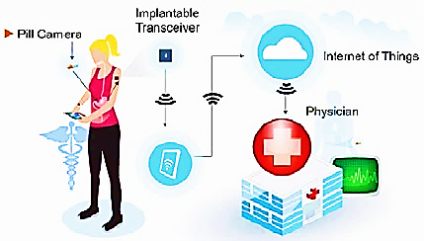

**Reference:** Kaya, Ş. M., (2021)

**2.3 Smart City Applications**

The concept of the “Smart City” has become immensely popular in scientific literature and international politics. Several researchers have developing an idea for smart city building, visualizing intelligent city building in three layers. (Samih H.,2019); The layer one is the “detection layer” where different data is collected from various data sources such as cameras, mobile devices, sensors and sensor network. The layer two, the "Network Layer", is responsible for transferring the data gathered from the first layer to data warehouse and is called the "Application Layer", The third tier contains applications for analyzing and processing big data located in the data storage center. (Samih H.,2019).

A smart city structure consists of three layers. The first is the sensing layer, which includes a crucial mass of mobile phones and sensors connected by high-speed communication networks. The second layer consists of custom applications. It is the network layer that requires the right tools to turn raw data into alerts, information and action. The third layer is the application layer used by cities, companies and the public. (Özdemir U.,2019)

**2.3 Smart Home Applications**

A smart home, also called a connected home or e-home, is a living environment with highly advanced automated systems. A smart home looks "smart" because its daily activities are monitored by a computer. A smart home incorporates many technologies through the home network to improve the quality of life. The smart home consists of highly advanced automated systems to control and monitor lighting and temperature, home appliances, multimedia devices and security systems, and many other functions (Malchee & Maheshwary 2017).

A smart home suitable for the general structure of the smart home shown in Figure-3 means a home that will respond to actions and changes in or near it. Devices on the network must be accessible regardless of user subjects. This means that the user should be able to intervene from anywhere and control and monitor other parameters, and the IoT offers this possibility. (Chittibabu, et al. .2019).

**Figure 3:** Smart Home

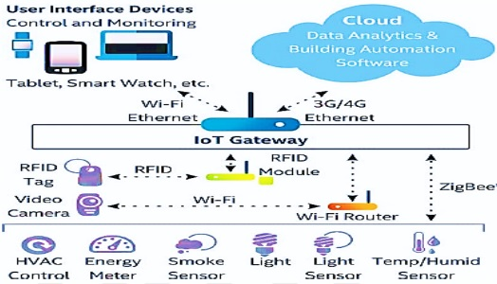

**Reference:** Kaya, Ş. M., (2021)

**2.4 Smart Agriculture Applications**

Smart agriculture benefits from sensor technologies that are widely used in industries. Regarding smart agriculture, with special sensors, it collects data about soil and crop activities, animal behavior, machine condition, storage tank and field activities at long distances and produces results that will support the farmer to make the right decision by making it meaningful. (Katırcıoğlu, 2019). Every aspect of traditional farming methods is completely changing as agricultural applications use the latest sensors and IoT technologies. Currently, the seamless integration of wireless sensors and IoT in smart agriculture takes agriculture to levels previously unimaginable. Smart farming practices and IoT are helping to advance solutions to many traditional farming problems such as drought response, yield optimization, land suitability, irrigation and pest control. (Ayaz, et al., 2019; Bayram, 2022).

1. **BUSINESS INFORMATION SYSTEMS**

Businesses need realistic and accurate information in order to survive, achieve their strategic goals and gain competitive advantage. They obtain information from a wide variety of sources, and combine this information with experience and foresight to reach the header. Businesses subject the research results or information they obtain to analyzes related to the subject they need. In this way, the basic basis of business decisions, that is, solid and accurate reports are obtained. Business decisions are the milestones that determine the future of businesses. Businesses achieve success or failure as a result of these decisions. Every decision mechanism works very meticulously and tries to make the right decision that will minimize the risk of the business.

Today, the rapid development of information technologies has changed economic activities and ways of doing business as well as affecting our way of life. Collecting and storing information, using and sharing it when necessary makes working life easier (McCall & Lynn, 2008; Koçel, 2020). In addition, thanks to increased enterprise resource planning (ERP), the shortening of the product life cycle and the reshaping of customer demands and the increase in demand for better functional production have also increased the need for information (Malone, 2002). Information for a business is provided by the knowledge of the employees and the information entering the organization (Phan, 2003). Information technologies provide businesses with the necessary equipment to manage and process information. Programs have been developed for various information systems to be used in functions such as production, management, human resources, finance, marketing and accounting in enterprises. These programs have also transformed the processes in business and management activities.

Information systems are computer-based systems and assist the decision-making process. A computer-based information system generally consists of software, hardware, personnel, files, and procedures. The interaction of these elements is used to process data and provide information for decision makers (Kane et al., 2015; Bayram, 2022; Gökçen, 2007; Demirhan, 2002). Also, most businesses use information technology to redefine business processes to gain competitive advantage (Phan, 2003; Baltzan, P. & Phillips, A., 2014; Gündoğmuş & Köroğlu, 2017):

* **Data** are raw facts derived from events or objects. Prior to the use of information management systems, managers collected and analysed data manually. Manual methods were complex and time-consuming processes. Managers who do not have enough data rely on their intuition and foresight when making business decisions. Managers using information systems collect, analyze and report large amounts of data, which helps them make more successful business decisions.
* **Information** is the transformation of data in line with the desired purpose and making it usable**.** Having the right information at the right time is the key to success for businesses. Incorrect information can lead businesses to extinction. People using the same information may make different decisions depending on how they interpret or analyze the information. Knowledge depends on how and for what purpose those who use it.
* **Business Intelligence (BI)** is information gathered from multiple sources, such as contractors, subcontractors, customer circles, competitors, partners and different industries, that analyses the current situation, new trends and patterns for meaningful decision making. BI manipulates multiple unknowns, and in some cases hundreds of variables, including exchange rates, weather forecasts, and fluctuating components such as fuel prices.
* **Head information** includes the abilities, knowledge, and proficiency combined with the knowledge and intelligence that create a person's knowledgeable means. They use BI as well as personal experience to access header information.

**Figure 4:** The Differences Among Data, Information, Business Intelligence, and Knowledge

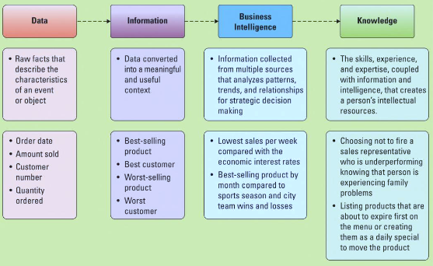

**Reference:** Baltzan, P., & Phillips, A. (2014).

Businesses have the following functions (Miles, 2016; Güney, 2020; Koçel, 2020; Baltzan, P., & Phillips, A., 2014):

* Management: Manages the process of converting or transforming or resources into goods or services.
* Production ve Sales: Performs the function of producing and selling goods or services.
* Finance: Deals with strategic financial issues including money, banking, credit, investments, and assets.
* Human resources: Maintains policies, plans, and procedures for the effective management of employees.
* Marketing: Supports sales by planning, pricing, and promoting goods or services.
* Accounting: Records, measures, and reports monetary transactions.

The success of the business depends on the work of the departments in harmony with each other. If we accept the business as a system, all parts of this system should work properly and form the whole in interaction with each other. A problem that may occur in any function of the enterprise will adversely affect other functions of the enterprise.

**Figure 5:** Departments Working Together

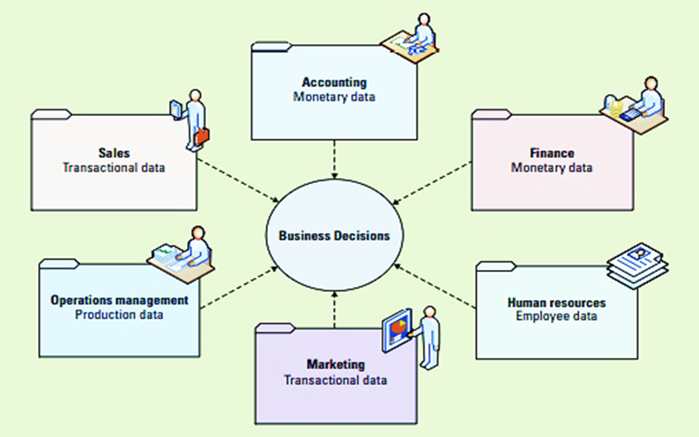

**Reference:** Baltzan, P. & Phillips, A. (2014)

Marketing must analyze production and sales data to come up with product promotions and advertising strategies. The company needs to understand the production's sales forecasts to determine its production needs. Sales need to rely on information from operations to understand inventory, place orders and forecast consumer demand. All departments need to understand the accounting and finance departments' knowledge for budgeting. For the firm to be successful, all departments must work together as a single unit that shares common information and at the same time performs the operations of its own unit. (Miles, 2016; Koçel, 2020; Baltzan, P., & Phillips, A., 2014).

As can be seen, business functions continue their activities in line with the information obtained from inside and outside the business. Today, the development of information technologies has both diversified and facilitated the ways in which businesses reach information. Information systems are used for data for each function, customer information, sales information, information on competitors' activities, and data on national and international trade. Thus, it is ensured that the business processes of the enterprise are carried out quickly, easily and with less effort with realistic information.

1. **EFFECTS OF IOT ON INFORMATION MANAGEMENT SYSTEMS**

In modern industries, information produced by sensors embedded in machine tools, cloud-based solutions and business management has totaled more than 1000 Exabytes per year and is expected to increase in the coming years (Mourthzis, et al., 2016). Intelligent machines have proven to be more accurate than humans at the operations involved in communicating and continuously capturing data from a distributed industrial IoT platform. These data enable industries to identify their problems earlier and save time and money by supporting the world. These smart businesses are constantly improving how to collect, transmit and analyze vast amounts of industrial data. (Saqlain, et al., 2019). The emergence of the industrial IoT environment is revolutionizing nearly all aspects of modern industry. Industrial IoT applications are examined in four main categories: infrastructure, supply chain, process control and maintenance. (Bloom, et al., 2018).

**• Substructure:** Intelligent devices can make the infrastructure more flexible; sensors monitor energy consumption through infrastructure facilities that have been made reliable, efficient and flexible, and increase security with surveillance and physical access control by operating systems such as lighting, air conditioning and heating (Kaya Ş.M., et al., 2022).

**• Supply chain:** Tracking sensors such as RFID sensors allow suppliers, shipping companies and retailers to track products as they pass through the supply chain. Monitoring sensors, such as RFID sensors, allow suppliers, shipping companies and retailers to track products as they pass through the supply chain.

**• Process control:** The development of big data analytics to predict future failures is a key enabler to reduce plant downtime.

**• Maintenance:** An important factor in the efficiency of production lines. Effective maintenance reduces downtime and energy consumption, especially in power-hungry equipment such as motors that leak large energy when operated in faulty conditions (Kaya Ş.M., et al., 2021b).

IoT technology identifies objects, people, images such as buildings and logos with the help of embedded sensors that detect and transmit changes. Thanks to near field communication, it allows users to take action by shaking their mobile phones in front of a compatible scanner. It allows payments by phone in public transport, airlines, retail and healthcare. IoT devices generate, store and use customer information, behaviors, attitudes, traits and personalities. IoT technology can improve customer service and productivity as it generates and uses various types of information (Yusof, et. al., 2020).Misuse of personal information in the IoT environment poses a risk. In addition, there will be privacy concerns in the sharing of information. Data protection and privacy through legal laws will play a leading (Dutton, 2014).

As a result of IoT technology, producing and using big data or information provides great advantages to businesses. It enables data and information to be made public and businesses can make decisions by improving their access to information (Brous et al., 2015). It also increases productivity with applications such as information, analysis, automation and control (Eric & Brett, 2017). Managing the big data generated by the IoT is a challenge. Proper data management provides benefits such as quickly finding and using structured and unstructured data for a company. It helps people with daily task and routine. It enables customers to self-serve, reduces labor and labor costs and improves data quality, reduces system error and improves process performance, helps improve service quality. Increases system reliability and productivity by helping processes become more reliable, versatile and faster (Fleisch, et al., 2006).

In order to use this technology in any information system, there must be a computer, internet and network technology infrastructure. The ease of transferring data and information in an Internet-connected network can save time. More efficient in terms of sharing information as well as money. It enables automation of daily tasks without human intervention. It reduces the quality of services and the level of human error. We should not forget that IoT can also increase the risk of data leakage. Confidential information may not be secure and can be easily accessed by third parties. Network security should also be a high priority, as there are devices that generate and use data. A single gap or malfunction can affect the entire system. The need for human labor is greatly reduced by automating every task. This will have a direct impact on employability (Shahroom & Hussin, 2018). In order to provide a good process management, both technology and security must be managed in parallel. Regardless of the field of activity, all businesses show continuity as much as they can adapt to the digital age. Active use of information management systems is inevitable for sustainable business management. Developments in sensor technologies trigger the updating of information management systems and increasing their capacity. Just as businesses need information to make sound decisions, information management systems also need manageable and meaningful data. One of the methods of obtaining manageable, meaningful data is the internet of things systems. Businesses that benefit from the Internet of Things-based information management systems gain a great competitive advantage in terms of business generation and management as they can meet today's needs. The effects of the internet of things and sensor technologies on business management and information management systems should be considered in their positive and negative aspects. In addition to the positive contributions of developing digital technologies to information management systems, it is also necessary to respond to the threats that need to be taken. Otherwise, a digital architectural design that is not designed according to the requirements may turn into a process that leads businesses to shrinkage with the protection of personal data, anomaly data production, unnecessary R&D activities, information pollution and many similar uncertainties.

**CONCLUSİON**

In this study, the concept of internet of things, which has become widespread with the development of sensor technologies and affects daily life in every sense, is examined and examples related to its application areas are given. In addition to the literature review, sample application areas are examined and as a result, the effects of the concept of internet of things on information management systems are focused. When the literature studies and the application areas of the internet of things are examined, it is seen that the concept of IoT increases its impact day by day in many different areas such as industry 4.0, smart agriculture, smart urbanization, wearable tracking systems, smart automotive, smart health services and social IoT. While businesses that can benefit from these developments at the optimum level continue their development by gaining competitive advantage, organizations that lag behind digital developments and cannot adapt to the age have to stop their activities. Organizations that can continue their development by making use of the Internet of Things and similar digital technologies are organizations that have a healthy information management system infrastructure and can manage these systems. An information management system that can produce healthy and meaningful information should follow all these developments and produce meaningful data to decision-making bodies in a consistent, accurate and timely manner. The reports created by the information management systems that are behind the developments cause the managers to make wrong decisions, and an unmanageable chaos environment occurs. Digital developments have both positive and negative effects on information management systems. Copyright arrangements are required in many cases to transfer ownership of data generated by digital technologies. Open IoT systems can threaten ownership and control of this data. Prevention of data misuse and other IoT manipulation threats should not be overlooked. It is necessary to have special security or operating procedures to handle robust data in the IoT space. As a result of users interfering with the raw data received over the IoT, the fact that the data kept in the information management systems does not reflect the facts causes the IoT systems to become a threat. This situation becomes extremely important for information security. Serious studies should be carried out on how to use IoT technologies with maximum efficiency. In order for the raw data and information produced to be reliable, social awareness about digital platforms should be increased. Also, the continuity of the data processing cycle from raw data production to data transfer process and reaching the end user should be ensured.

**REFERENCES**

Al-Fuqaha A., Guizani M., Mohammadi M., Aledhari M., & Ayyash M. (2015). İnternet of things: A survey on enabling technologies, Protocols and Applications. *IEEE Communications Surveys & Tutorials,* DOI: 10.1109/COMST.2015.2444095

Ayaz M., Ammad-uddin M., Sharif Z., Mansour A., &Aggoune M., (2019). *Internet-of-Things (ıot) based smart agriculture: towards making the fields talk*. DOI 10.1109/ACCESS.2019.2932609, IEEE Access.

Baltzan, P., & Phillips, A. (2014). *E-book: business driven information systems*. McGraw Hill.

Bayram, V. (2022). Applıcatıons of Blockchaın Technologıes in the World. (İçinde: Blockchaın In Fınance, Marketıng and Others). Nobel Bilimsel Eserler, 251-266.

Bloom G., Alsulami B., Nwafor E., & Bertolotti I.C. (2018). *Design patterns for the ındustrial ınternet of things.* IEIIT, Italian National Research Council (CNR). Torino, Italy 978-1-5386-1066-4/18/$31.00 ©2018 IEEE

Chittibabu R., Kumar K. K., Vikas K., & Reddy G.M., (2019). Smart home using Internet of Things (IoT). *International Journal of Innovative Technology and Exploring Engineering* (IJITEE) ISSN: 2278-3075, Volume-8, Issue-6S3, April 2019

Demirhan, D. (2002). İşletmelerde stratejik bilgi sistemleri yönetimi ve rekabet üstünlüğü elde edilmesindeki rolü. *Ege Academic Review*, 2(2), 117-124.

Dutton, W. H. (2014). Putting things to work: social and policy challenges for the ınternet of things. *Info,* 16(3), 1–21.

Eric, L., & Brett, M. (2017). Making sense of Internet of Things platforms. *Retrieved from* <https://www.mckinsey.com/business-functions/mckinsey-digital/ourinsights/making-sense-of-nternet-of-things-platforms>. Accessed: 07.08. 2022

Fleisch, E, Sarma, S., & Subirana, B. (2006). *High- resolution management.* IESE Alumni Magazine, 13.

Gökçen, H. (2007). *Yönetim bilgi sistemleri*. Palme Yayınları, No: 422, Ankara.

Gündoğmuş, M. E., & Köroğlu, Ç. (2017). Pazarlama bilgi sistemi ile muhasebe bilgi sistemi arasındaki ilişkinin stratejik pazarlama muhasebesi açısından incelenmesi: X otel işletmesinde uygulama*. Muhasebe ve Denetime Bakış*, 16(50), 1-20.

Güney, S. (2020). *Yönetim ve oganizasyon el kitabı*. Nobel Akademik Yayıncılık, İstanbul.

Kane, G. C., Palmer, D., Phillips, A. N., & Kiron, D. (2015). Is your business ready for a digital future?. *MIT Sloan Management Review*, 56(4), 37.

Katırcıoğlu M., (2019). IoT tabanlı akıllı tarım sisteminde kullanılan kablosuz sensörlerinin güvenliğinin incelenmesi ve saldırılara karşı gerçek ortamdaki etkisi. İstanbul Şehir Üniversitesi, *Fen Bilimleri Enstitüsü Bilgi Güvenliği Mühendisliği,* ABD.

Kaya, Ş. M., (2021a). A smart data pre-processing approach for effective management of healthcare big data on IoT edges, *Istanbul Aydın University, Graduate School of Natural and Applied Sciences,* Department of Computer Engineering, PhD Thesis.

Kaya, Ş. M., Erdem A., & Güneş A., (2021b). A smart data pre-processing approach to effective management of big health data in IoT edge. *Smart Homecare Technology and TeleHealth*, 8, 9-21.

Kaya, Ş. M., Güneş A., & Erdem A. (2021c). A smart data pre-processing approach by using ml algorithms on iot edges: a case study. *In 2021 International Conference on Artificial Intelligence of Things (ICAIoT)* (pp. 36-42). IEEE.

Kaya Ş. M., Erdem A., & Güneş A., (2022). *Anomaly detection and performance analysis by using big data filtering techniques for healthcare on IoT edges*, Sakarya University Journal of Science Institute 26 (1), 1-13

Koçel, T. (2020). İşletme yöneticiliği, İstanbul: Beta Yayıncılık.

Kulkarni A., &Sathe S., (2014). Healthcare applications of the internet of things:A review. *International Journal of Computer Science and Information Technologies*, Vol. 5 (5), 2014, 6229-6232

Laplante P.A., Kassab M., Laplante N.L., & Voas J.M. (2018). Building caring healthcare systems in the Internet of Things. *IEEE Systems Journal*, Volume:12, Issue:3

Li S., Raymond K.K., Sun Q., Buchanan W.J., & Cao J. (2015). IoT forensics: Amazon echo as a use case. *Journal of Latex Class Files*, Vol. 14,

Malchee T., Maheshwary P., (2017). *Internet of Things (IoT) for building Smart Home System*. International conference on I-SMAC (IoT in Social, Mobile, Analytics and Cloud) (I-SMAC 2017)

Malone, D. (2002). Knowledge management: A model for organizational learning. *International Journal of Accounting Information Systems*, 3(2), 111-123.

Marjani M., Nasaruddin F., Gani A., Karım A., Hashem I.A. T., Sıddıqa A., & Yaqoob I. (2017). *Big IoT data analytics: Architecture.* Opportunities, and Open Research Challenges, DOI:10.1109/access.2017.2689040

Mccall, M., & Lynn, A. (2008). The effects of restaurant menu item descriptions on perceptions of quality, price, and purchase intention. *Journal of Foodservice Business Research*, 11(4), 439-445.

Miles, J. A. (2016). *Yönetim ve organizasyon kuramları*. Nobel Akademik Yayıncılık Eğitim Danışmanlık Tic. Ltd. Şti.

Mourthzis D., Vlachou E., & Milas N. (2016). *Industrial big data as a result of IoT adoption in manufacturing*. 5th CIRP Global Web Conference.

Özdemir U. (2019). Akıllı şehir uygulamalarının karşılaştırmalı analizi. Kocaeli Üniversitesi Fen Bilimleri Enstitüsü Bilgisayar Mühendisliğ, Kocaeli.

Phan, D. D. (2003). E-business development for competitive advantages: A case study. *Information & Management*, 40(6), 581-590.

Saqlain M., Piao M., Shim Y., & Lee J.Y. (2019). Framework of an IoT-based industrial data management for smart manufacturing. *Journal of. Sensor*. Actuator Networks. 2019, 8, 25; doi:10.3390/jsan8020025

Samih H. (2019). Smart cities and internet of things. *Journal Of Informatıon Technology Case and Applıcatıon Research,* 2019, Vol. 21, No. 1, 3– 12.

Shahroom, A. A., & Hussin, N. (2018). Industrial revolution 4.0 and education. *International Journal of Academic Research in Business and Social Sciences,* 8(9), 314-319.

Yılmaz E. (2017). *Internet of Things based battery management systems applications.* M.Sc. Thesis Department of Electronics and Communications Engineering Program of Electronics. Yildiz Technical University Graduate School of Natural and Applied Sciences

Yusof, A. M., Hussin, N., Azman, K. A., Amran, N., Daud, S. C., & Tarmuchi, N. R. (2020). The Internet of Things (IOT): Impacts on information management field. *International Journal of Academic Research in Business and Social Sciences.* 10(11), 1208-1216.

Zeynep T. (2018). *Nesnelerin interneti için hareketlilik yönetimi.* Istanbul University Graduate School of Natural and Applied Sciences, Department of Computer Engineering, PhD Thesis.