THE USAGE OF RICE HUSK ASH IN THE MATERIALIZATION OF CEMENT SAND BRICKS: IMPACT AND POTENTIAL

Yap Tek Hong, Choong Chee Guan and Masniza Yusof
Department of Mechanical Engineering, Politeknik Tuanku Syed Sirajuddin, Pauh Putra,
02600 Arau, Perlis, Malaysia
Corresponding Author’s Email: yap@ptss.edu.my

ABSTRACT:
The population of Malaysia is expected to grow to 36.09 million in 2030 and to 40.55 million in 2050. Therefore, the increasing of population of people directly will increases the housing demand and also increases the demand of building material such as bricks. Thus, this study was conducted to study the mechanical and physical properties of cement brick from the disposal of rice husk ash (RHA) to produce environmental friendly bricks. The composition of the cement, sand, and RHA by weight ratio varies from 1:6:0, 1:5:1, 1:4:2, 1:3:3, 1:2:4, 1:1:5 and 1:0:6 added to the arrangements. The mixture will leave at room temperature in 28 days to allow become dry at ambient temperature and mechanical and physical properties were conducted to evaluate the properties of these mixtures. The results showed that the replacement of RHA indicates an increasing compressive strength as the strength starts to increase from by weight ratio varies from 1:5:1, 1:4:2, 1:3:3 to 1:2:4 i.e. 15.73 MPa, 15.18 MPa, 12.15 MPa and 11.92 MPa respectively compared to original brick. The percent of water absorption range from 7.7 % to 69.4 % and started to increase as the weight ratio of RHA which show more permeable compared to control brick. The density of the brick were decrease from 1.705 g/cm3 to 0.474 g/cm3 with increasing of the RHA ratio. The finding show that the density of RHA brick decrease while the water absorption and compression strength to increase as the RHA content is increased. Thus, the weight ratio of RHA in the composition significantly affect the properties of this RHA brick. Recycling RHA as a substitute for raw materials could help prevent the depletion of nonrenewable resources, reduce waste disposal, and prevent the exhaustion of natural resources.

KEYWORDS: Rice Husk Ash; Cement Sand Bricks; Housing; Recycling Material; Waste

1.0 INTR ODU CTION
The Malaysian development sector is quickly changing to keep up with the country's expanding population. The prediction states that there will be more people on the planet than 8.5 billion in 2030, 9.7 billion in 2050, and 11.1 billion in 2100. All of these commodities will see large increases in demand, including food, water and river supplies. (Sadigov, 2022). It is no secret that governments throughout the globe are concerned about housing growth, especially in developing nations. Thus, the building sector is growing as more individuals are looking for a home. Developers, especially contractors, have increased their need for building materials such as bricks to accommodate the growing demand for houses.

Since 8000 BC, bricks have been a common building and construction material, and burnt clay bricks date back to 4500 BC (Arshad & Pawade, 2014).Brick is one of the substances already known by the general public as a building material. This may be observed in the large number of people who buy bricks for the brick home business. Bricks are also commonly used to construct to solve community existence issues in building housing, buildings, retaining partitions, fences to solve the community living issues. Malaysian houses and structures are improving at an increasing rate. As a result, the need for construction materials is increasing every day. One of the most often used construction materials is clay brick, which is used to make home walls. Utilization of clay bricks in production how to plot, expand, and renovate a good method to tackle the problems of life desire. Currently, the production of brick able to be fabricated by others alternative material in with the addition of various materials. One method is to mix the basic components with rice husk ash, which is waste from the burning of rice husk.

Rice husk comes from industry or agriculture. The residual inorganic byproduct known as rice husk ash (RHA), which is produced when the rice husk (hulls) from the milling process is burned within the boiler, contains highly reactive silica in its mass (Das et al., 2020). RHA, or rice husk ash, is a waste product that is dumped in vast quantities and causes serious pollution. As a result, a variety of agricultural and industrial wastes were put to use in place of cement, fine aggregate, coarse aggregate, and reinforcing materials in the construction industry (Jittin et al., 2020). In order to meet the growing demand for construction materials, particularly as an additive in the production of low-cost concrete blocks, rice husk ash is also employed in the cement and construction sectors (Mor V, 2013). Malaysia should decrease or stop the production of as much of these garbage as it is able to. The various varieties of rice husks can be seen in Figure 1.
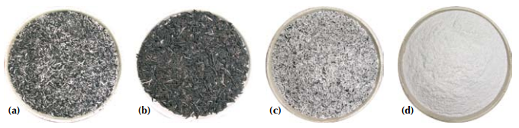

Figure 1: (a) Black chars suited for the production of activated carbon produced when rice husk is burned in a fluidized bed combustion engine, (b) Amorphous rice husk ash with 6 weight percent residual carbon appropriate for making sodium silicate (water glass), (c) Amorphous rice husk having a residual carbon content of 2.0 weight percent, (d) The siliceous rice husk ash product, which is pure, amorphous, and contains 0.2 weight percent of residual carbon and is suited for the synthesis of aerogel.

Beside that, the clay brick is limited due to the difficulty in obtaining clay and its high cost. This brick will be utilised in lieu of the clays brick and significantly less expensive. Further more, the application of the rice husk ash as a biodegradable materials have the opportunity to innovate in brick and to avoid harm to the environment and human health. Recycling of wastes as natural aggregates is a practical business strategy that is also regarded as being environmentally friendly (Sadek, 2012). In order to create environmentally friendly brick, the goal of this research is to examine cement brick made from rice husk ash used for disposal. This study focuses on compositions with seven distinct weight ratios of cement, sand, and rice husk ash. The brick specimens underwent tests for compressive strength, water absorption, and density, and the results were quantified and characterised.

2.0 METHODOLOGY
The flow chart for design of experiment as in Figure 1 shows the steps used to complete this project from the start until end (refer to Figure 2).

Figure 2: Process Design of Experiment
Raw Materials.
The rice husk ash were collected from a local rice-milling company in Kangar, Perlis. After the collection, the rice husk ash were dried under the sun light until it is completely dried. Then, the rice husk ash then sieved using vibratory sieve shaker machine to identified sieving size in the British Metric series (BS410:1976). The rich husk ash was then stored in sealed plastic bags at room temperature until it was used in the experiments (refer to Figure 3).

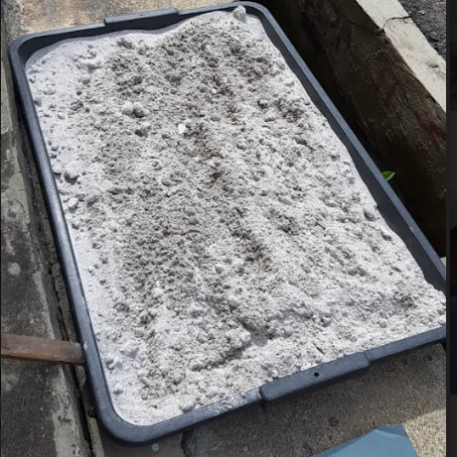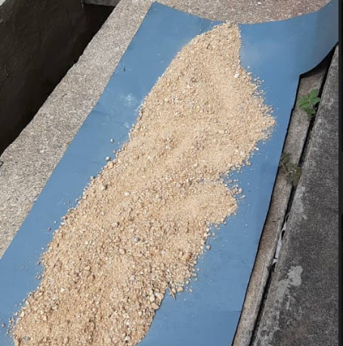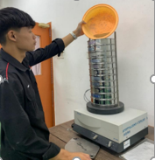
(a) (b) (c)
Figure 3: Preparing of raw material for RHA brick (a) Rice Husk Ash (b) Silica Sand and (c) sieving process

Preparation of rice husk ash (RHA) bricks.
In the mixing process, hand mixing was used. The RHA brick was prepared using cement, sand and RHA. To ensure that the combinations are well mixed with the RHA, water is added. Sand and RHA were combined with cement in weight ratios ranging from 1:6:0 to 1:5:1, 1:4:2, 1:3:3, 1:2:4, 1:1:5, and 1:0:6. For ten minutes, the hand drill mixer was used to mix the ingredients (Bosch CSB 550 RE, Germany). Bricks are prepared using a moulding procedure that makes them uniformly sharp and reliable. A wooden mould was created to create RHA bricks that meet the specifications of MS 27 and have dimensions of 225 mm in length, 113 mm in breadth, 75 mm in thickness, and 50 mm in diameter and height (Jabatan Kerja Raya Malaysia, 2005). After that, the mixtures of cement, sand and RHA were poured into the brick mould. The mixtures were allowed to set and cure into solids at room temperature for a period of 28 days after the surface of the mould was completed with a trowel (refer to Figure 4).
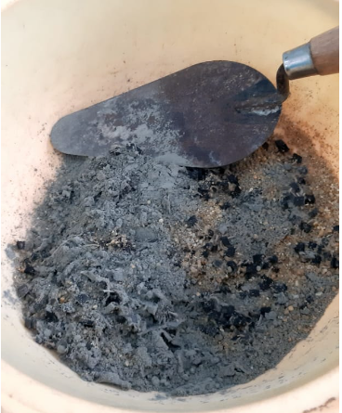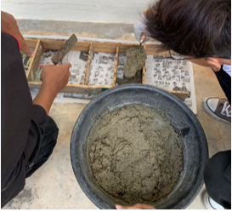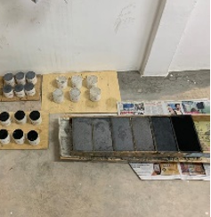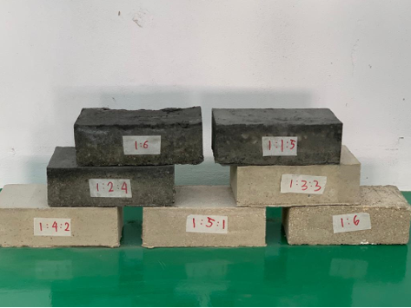
(a) (b) (c) (d)
Figure 4: Preparing of RHA brick (a) Mixing Process (b) Casting of Mixture into mould and (c) Shaping process (d) RHA brick samples

Compression testing of RHA brick samples.
To obtained the compressive behaviour of RHA brick, samples were prepared for the compression test. The compression test determines how a material reacts when it is compressed, squashed, crushed or flattened under a compressive load. The test was conducted using a Compact Motorised Concreta Compression Machine (ELE Compact-1500). Three samples are used to test each brick specimen individually, and the load upon crushing is recorded for each sample. Each sample's compressive strength was measured, and average values were calculated. The specimens' dimensions were examined in accordance with ASTM C67 (refer to Figure 5).

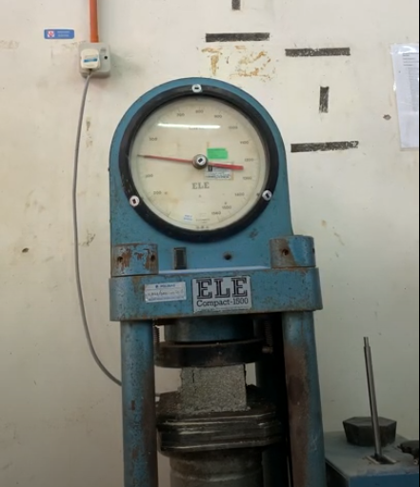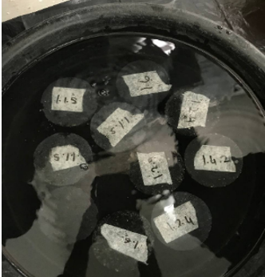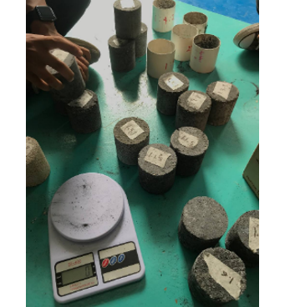
(a) (b) (c)
Figure 5: Testing on brick (a) compressive strength through a Compact Motorised Concreta Compression Machine (b) water absorption test and (c) density test

Water absorption test.
The water absorption test calculates the percentage of water absorption for RHA bricks based on weight. Under the sun, the samples were dried. After that, use a digital balance to weigh the cool brick (W1). The dry brick was submerged in clean water for 24 hours for the test, which was conducted at room temperature. The brick was taken out and immediately protected from wet and weight with a cloth (W2). The water that the brick absorbed is what caused the weight difference. Calculations were made to determine the percentage difference between dry and wet bricks.

Water absorption in percent (%) = (W2 – W1) x 100. Eq 1

Density Test
The digital balance was used to determine the density test, which measures the mass per unit volume for RHA brick. A RHA brick's density is calculated using its weight in air (Wa) and water (Ww), where the densities of the two media are equal to 0.9975 g/cm3 and insignificant, respectively. The difference between the brick's weight in air and water and its weight in water is used to calculate the RHA brick's volume. Thus, the formula for calculating brick density, ρc, is:

Brick density, ρc (g/cm³) = (Wa)/[(Wa – Ww)/ ρw]
= (ρw Wa)/ (Wa – Ww) Eq 2

3.0 RESULTS AND DISCUSSION

The outcome of changing the compression stress for various RHA brick samples produced is depicted in Figure 6(a). The results showed that when the RHA content rose, the compression stress decreased. As demonstrated, a significant weight percentage of RHA in reinforcement has the maximum compression stress and produces better results than RHA contents of 1:6:0, 1:3:3, 1:2:4, 1:1:5, and 1:0:6. This weight ratio is followed by 1:4:2. The compression strength for RHA brick with weight ratio of 1:1:5 and 1:0:6 started to decrease as the weight ratio of RHA increase. The bonding strength of the RHA in the brick are touch properly by the RHA and there are more bonding one another and as the same time reduce the density of the compositions. The results show that the weight ratio 1:5:1 RHA for the sample giving the best value of 15.73 MPa compared to the control sample by weight ratio 1:6:0 RHA with a value of 11.01 MPa. The additional of the RHA can improve the compression stress of the brick.

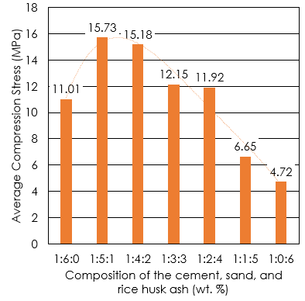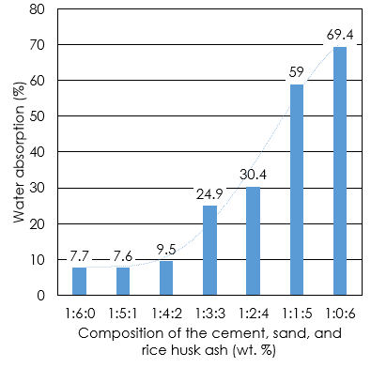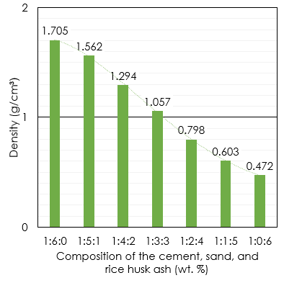
(a) (b) (c)
Figure 6: Effect of rice husk ash on (a) Compression Stress, (b) Water absorption and (c) Density with different composition of cement, sand, and rice husk ash (wt. %)

The value of the percentage of water absorption of various weight percentages for the RHA brick specimens produced is shown in Figure 6(b). According to the findings of a water absorption test that measured the amount of water absorption in relation to the weight percentage of RHA, the level of water absorption ranges from 7.6% to 69.4%. Inversely, when RHA content rises, so does the proportion of water absorption. The weight ratio 1:0:6 RHA had the highest water absorption, while the weight ratio 1:5:1 RHA had the lowest, 7.6%. RHA brick is likely to draw moisture, which could compromise the brick's dimensional stability.

The value of density (g/cm3) for the brick specimens generated at various weight percentages of RHA is shown in Figure 6(c). The density test result made it crystal evident that when the RHA weight content rose, the density of RHA brick decreased. The RHA brick's density declined from 1:6:0 to 1:0:6 wt.%, as illustrated, and the lowest density ever measured was 0.47 g/cm3. When compared to a sample with the highest weight percentage of RHA in the composition, the 1:6:0 wt% of RHA brick had the maximum density. RHA has greater voids and room within the composites, which is why there is a reduction. Denser than the RHA bricks with more RHA was the RHA brick with more sand. According to the aforementioned findings, the RHA decreased the value of density of the brick.

4.0 CONCLUSION

This work was studied the mechanical properties mechanical and physical properties of cement brick from the rice husk ash were incorporated with sand and cement to produce environmental friendly bricks. According to the study's findings, the ideal composition for RHA was reached at a weight ratio of 1:5:1. The test result shown that the mixture that characterizes resistance to the mechanical load. The compression test showed that 1:5:1 weight ratio of RHA brick has the compression strength of 15.73 MPa with the lowest value water absorption level i.e. 7.6% and acceptable density value of 1.561 g/cm³ compared to the control sample from 1:6:0 with 1.561 g/cm³. The utilization of RHA with sand and cement significantly enhance the mechanical property of cement brick such as compression strength, besides that improved the water absorption level and density of the brick. This RHA when managed properly can be transformed into a beneficial material to become as environmentally friendly products, furthermore provides an alternative disposal method to reduce the agricultural waste. This reviewed approach of creating waste-derived bricks is helpful in offering a feasible and sustainable solution.

5.0 REFERENCES

Arshad, M. S., & Pawade, D. P. Y. (2014). Reuse of natural waste material for making light weight bricks. International journal of scientific & technology research, 3(6).

Das, S. K., Mishra, J., Singh, S. K., Mustakim, S. M., Patel, A., Das, S. K., & Behera, U. (2020). Characterization and utilization of rice husk ash (RHA) in fly ash - Blast furnace slag based geopolymer concrete for sustainable future. Materials Today: Proceedings, 33, 5162–5167.

Jabatan Kerja Raya Malaysia. (2005). Standard Specifications For Building Works (2005 Edition).

Jittin, V., Bahurudeen, A., & Ajinkya, S. D. (2020). Utilisation of rice husk ash for cleaner production of different construction products. In Journal of Cleaner Production (Vol. 263). Elsevier Ltd.

Mor V, D. R. (2013). Utilization of Rice Husk and Their Ash: A Review. In RJCES (Vol. 1, Issue 5).

Sadek, D. M. (2012). Physico-mechanical properties of solid cement bricks containing recycled aggregates. Journal of Advanced Research, 3(3), 253–260.

Sadigov, R. (2022). Rapid Growth of the World Population and Its Socioeconomic Results. Scientific World Journal, 2022.

