***The correlation between uremic toxins with CRP level in patients with chronic kidney disease***

***Zainab Abdulkareem Ahmed 1, Volkan EYUPOGLU 2***

1. Graduate School of Natural and Applied Sciences, Chemistry, Çankırı Karatekin University, Çankırı, Turkey
2. Graduate School of Natural and Applied Sciences, Chemistry, Çankırı Karatekin University, Çankırı, Turkey

# Abstract

The kidneys play an important role in fluid control as well as the removal of harmful waste products which known as (uremic toxins). Our study was focused on the measurement the concentrations of some uremic toxins which accumulates in the blood of the patients with chronic kidney disease. The concentration of blood urea, serum creatinine and protein bound uremic toxin (indoxyl sulfate) were measured and the results is compared with results of samples taken from healthy people (control group). Then, correlation between uremic toxins with CRP was studied. The results showed that the levels of uremic toxins were significantly higher (P <0.05) in patients’ group than in healthy group. The results were respectively (132.49± 32.59), (5.72± 1.57) and (1.432 ± 0.392). Also, the mean of CRP was measured and the findings showed, the CRP concentration was significantly higher (P <0.05) in patients (15.32 ± 6.48) compared to the control group (1.02 ± 0.48). The correlation between uremic toxins and CRP also determined, there were positive correlation between each of blood urea, serum creatinine and indoxyl sulfate concentration with CRP.

***Keywords****: uremic toxins, CRP, chronic kidney disease.*

# 1. Introduction

The kidneys play an important role in fluid control as well as the removal of harmful waste products which known as (uremic toxins) [1]. Chronic kidney disease (CKD) is defined as defective kidney structure or function that lasts more than three months and has health consequences [2]. Chronic kidney disease (CKD) is one of the worldwide public health problems. Kidney disease, which develops when kidneys damaged for various reasons become untreatable, results in the loss of nephrons, renal dysfunction or structural damage to the kidneys [3]. In the developing world, the exact number of people with chronic renal failure who require renal replacement treatment (RRT) is unknown. In contrast to the developed world, the majority of underdeveloped countries lack kidney registries [4]. In the United States, approximately one in three adults aged 65 years or older has chronic kidney disease (CKD), which is defined as a glomerular filtration rate (eGFR) of less than 60 mL/min/1.73 m2. Most patients with CKD do not progress to advanced stages of the disease because death precedes progression to end-stage renal disease (ESRD) [5]. The retention of many solutes ordinarily discharged by healthy kidneys causes uremic syndrome. Although hemodialysis can relieve many of these anomalies, it should be noted that dialysis can exacerbate or even worsen some uremic consequences [6]. Uremic toxins are defined as organic or inorganic substances, that accumulate in the body fluids of patient with acute or chronic kidney disease and impaired kidney function. They collectively contribute to the diverse clinical manifestations of the uremic syndrome [7]. The uremic syndrome is characterized by the retention of many solutes that would normally be released by the kidneys, but in case of kidney failure these substances or solutes (uremic toxins) are accumulated and interfered with biological activity [8]**.** In case of advanced CKD and kidney failure, dialysis can remove tiny water-soluble uremic toxins but not intermediate molecules or protein-bound uremic toxins. Hemodialytic removal of protein-bound chemicals, such as indoxyl sulfate (IS) is difficult due to their high protein-binding properties [9]. Hemodialysis (HD) is the conventional procedure used worldwide to remove metabolic wastes. The creatinine and urea levels have been routinely monitored to estimate kidney function and effectiveness of the HD process [10]. Because of IS capacity to attach to proteins, forming large molecular weight its elimination by hemodialysis is less efficient than that of non-protein bound uremic toxins [11]. IS, based on its physiological concentration in serum, has been demonstrated to have antioxidant effects, balancing oxidative stress in CKD. In patients with CKD and end-stage renal disease (ESRD), increased IS buildup contributes significantly to CV risk. IS significantly enhances superoxide production in endothelial cells while attenuating vasorelaxation mediated by sodium nitroprusside via the AhR and NOX activation [12]. On the other hand, the CKD group had a significantly elevated median serum level of hsCRP in comparison to the control group without CKD. In 20-65% of ESRD patients (pre-dialysis, hemodialysis, and peritoneal dialysis), serum CRP levels are elevated. The increase in blood CRP and other acute-phase proteins is caused by underlying factors that cause acute phase responses and the activation of the inflammatory cascade [13]. The findings of some studies in this regard, indicated that the inflammatory process in chronic kidney disease (CKD) begins prior to dialysis and is not only caused by dialysis, as the CKD patients in the study had not yet undergone dialysis treatment. There was a strong positive association seen between CRP and serum creatinine, as well as a negative correlation with estimated GFR. This study identified that Estimated Glomerular Filtration Rate (GFR) was a significant predictor of C-reactive protein (CRP) levels in kidney failure [14]. This study demonstrated a positive correlation between decreased renal function and inflammation, as indicated by elevated CRP levels, in patients with chronic kidney disease.

# 2. Materials & methods

## 2.1 Sampling

Our study was performed on two groups of participants, the patients’ group was composed of 100 patients with kidney failure. The ages of the patients ranged from 13-79 years and they were treated with dialysis in Kirkuk General Hospital. The study also included measurement of the aimed parameters of samples taken from control group which consist of 50 healthy individuals who haven’t any disease, with the same demographic properties, in order to compare the results. Each participant in this study had five milliliters of blood drawn from a vein without the use of a tourniquet. The blood sample was placed into sterile test tubes. After coagulation, the samples were placed into the centrifuge and spun at 3000 rpm for 15 minutes until the serum could be extracted. The biochemical measurements of blood urea, serum creatinine, indoxyl sulfate and CRP were performed.

## 2.2. Estimation of Kidney Function Tests

The concentration of serum creatinine and blood urea were measured by using a commercially available assay kits from (AGAPPE, Switzerland).

**2.4. Indoxyl Sulfate Assay**

The sandwich enzyme-linked immune-sorbent assay technology was used in this kit. 96-well plates were pre-coated with capture antibody. As detecting antibodies, biotin conjugated antibodies were utilized. Following that, the standards, test samples, and biotin conjugated detection antibody were added to the wells and rinsed with wash buffer. HRP-Streptavidin was used. Wash buffer was used to remove added and unbound conjugates. HRP enzymatic activity was visualized using TMB substrates. reaction. TMB was catalyzed by HRP to create a blue product that became yellow after the addition of an acidic stop solution. The yellow density is related to the amount of sample collected in the plate. In a laboratory, measure the O.D. absorbance at 450 nm. The concentration of the target parameter can then be estimated using a microplate reader.

**2.5. CRP**

C-reactive Q is a quantitative turbidimetric test used for the measurement of C-reactive protein (CRP) concentration in human serum or plasma. Latex particle in the reagent coated with specific anti-human CRP agglutinates with samples containing CRP when mixed together. An absorbance change happens due to the agglutination, and this absorbance is dependent upon the CRP concentration of the patient sample that can be measured by comparison from a calibrator of known CRP concentration.

## 2.6. Statistical Analysis

The data was statistically analyzed using Minitab, a statistical analysis software, and Excel, a computer for making spreadsheets. The data were presented as mean and standard deviation. The current study used statistical analysis tools, specifically the Dunkin' multiple test and the ANOVA test, to compare the arithmetic means of the experimental groups to look for potential significant changes.

# 3. Results & Discussion

The levels of uremic toxins were significantly higher in patients with CKD than in the control group, as showen in the table 3.1

|  |  |  |  |
| --- | --- | --- | --- |
| **Uremic toxins** | **Patints group** | **Control group** | **P.value** |
| **Urea** | 132.49± 32.59 | 31.58± 12.86 | P<0.05 |
| **Creatinine** | 5.72± 1.57 | 1.06 ± 0.29 | P<0.05 |
| **Indoxyl sulfare** | 1.432 ± 0.392 | 0.842 ±0.075 | 0.0001 |

The urea levels in these patients (132.49± 32.59) were significantly higher (P<0.05) compared to the control group (31.58± 12.86), also the creatinine levels in the patients (5.72± 1.57) were significantly elevated (P<0.05) compared to the control group (1.06 ± 0.29). our findings also showed that, the indoxyl-sulfate concentration was found to be significantly higher (P <0.05) in patients (1.432 ± 0.392) compared to the control group (0.842 ±0.075). Increased levels of blood urea and serum creatinine are widely recognized as reliable markers of compromised kidney function in individuals with chronic kidney disease (CKD), and there is widespread agreement among medical professionals regarding their significance in evaluating renal health. The metrics mentioned are commonly employed to assess kidney function in persons with diabetes and hypertension who are at a higher risk of developing chronic kidney disease [15]. The renal excretion, tubular secretion, and breakdown of creatinine are reduced in patients with chronic kidney disease (CKD), leading to an increase in creatinine levels. Furthermore, consumption of meat and protein supplements results in elevated levels of serum creatinine. Another factor contributing to elevated levels of creatinine is the use of drugs that impede the release of creatinine in the renal tubules and reduce the breakdown of creatinine by the gastrointestinal tract [16], [17]. Indoxyl-sulfate is produced in healthy individuals by the degradation of tryptophan by the microbiota residing in the colon. It is then removed by the kidneys and discharged in the urine. Hemodialysis effectively eliminates a significant number of uremic toxins from the bloodstream. Nevertheless, IS, due to its strong protein affinity, cannot be eliminated through the utilization of this approach [18]. The toxicity of IS can arise from its interaction with proteins [19].

## 3.2. CRP

The CRP concentration was significantly higher (P <0.05) in patients (15.32 ± 6.48) compared to the control group (1.02 ± 0.48). The study was carried out on a group of 100 individuals with chronic kidney disease (CKD) to investigate the importance of C-reactive protein in this condition. There was a strong positive association seen between CRP and CKD. In addition, CRP has a negative correlation with the estimated GFR. This study identified that Estimated Glomerular Filtration Rate (GFR) was a significant predictor of C-reactive protein (CRP) levels in CKD [14]. This study demonstrated a positive correlation between decreased renal function and inflammation, as indicated by elevated CRP levels, in patients with chronic kidney disease (CKD).

## 3.3. The correlation between uremic toxins and CRP

The results of our study also showed that, CRP level is significantly correlated with each one of the measured uremin toxin concentrations. There were positive correlation between CRP levels with urea, creatinine and indoxyle sulfate, the r value of each correlation were (0.6748, 0.756 and 0.718 respectively.

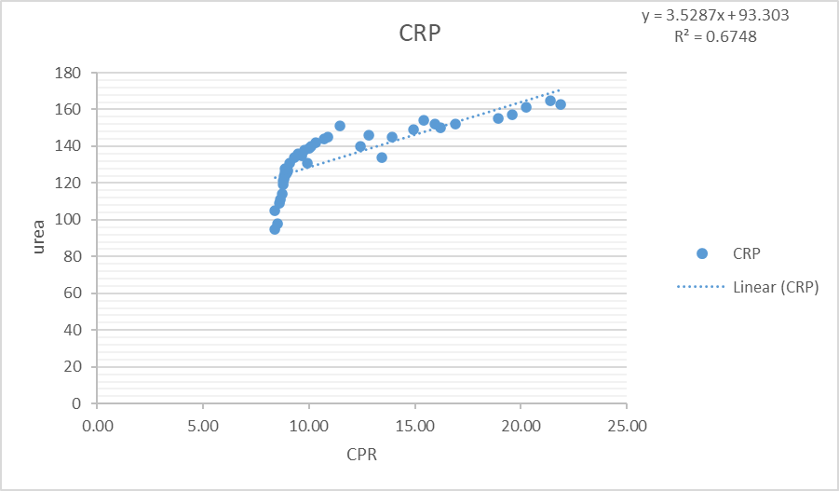

Figure 1. the correlation between CRP level and ureaconcentrations

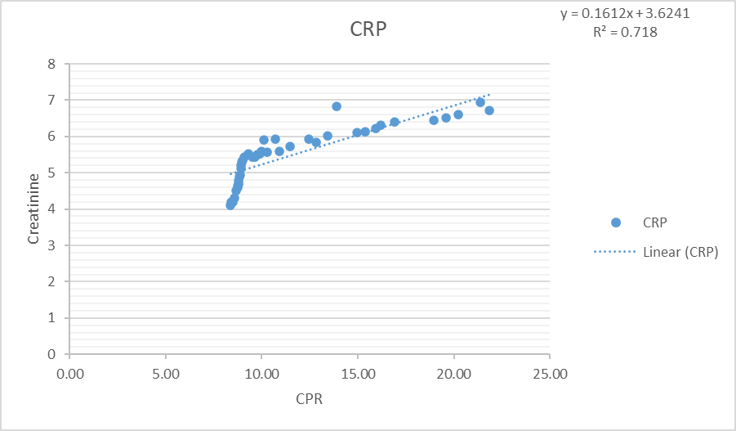

Figure 2. the correlation between CRP level and creatinineconcentrations

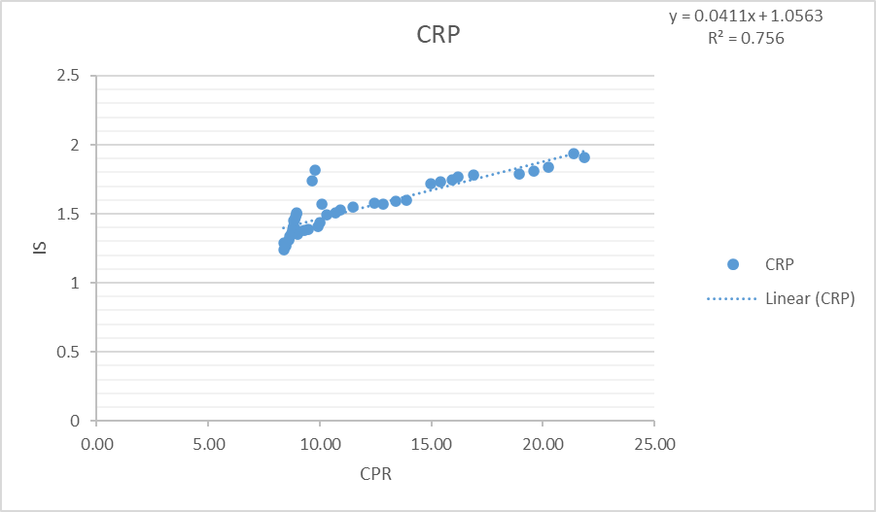

Figure 3. the correlation between CRP level and indoxyl sulfateconcentrations

**4. Conclusions**

Chronic kidney failure is strongly associated with the levels of creatinine and urea, which are regarded as the initial laboratory tests for assessing renal function. Chronic renal failure leads to changes in the levels of indoxyl-sulfate, which can be regarded as an indicator of kidney failure based on the findings of the present investigation. The recent investigation revealed that chronic renal failure leads to elevated levels of inflammatory markers such as CRP. In addition, we can conclude from the results of this research, that high uremic toxins concentration leads to inflammatory reactions.

# References

1. Evans M. Prognosis and progression in chronic kidney disease. Institutionen för klinisk vetenskap/Department of Clinical Sciences; 2010 Sep 17.
2. Gaitonde DY, Cook DL, Rivera IM, Eisenhower DD. Chronic Kidney Disease: Detection and Evaluation [Internet]. Vol. 96. 2017. Available from: [www.aafp.org/afp](http://www.aafp.org/afp).
3. Yildirim N, O. 70 YAŞ VE ÜZERİNDEKİ KRONİK BÖBREK HASTALARINDA FİBROBLAST GROWTH FAKTÖR-23 VE β-2 MİKROGLOBÜLİN DÜZEYİNİN ÖLÇÜLMESİ VE YAŞAM KALİTELERİNİN DEĞERLENDİRİLMESİ. 2020.
4. Kher V. End-stage renal disease in developing countries. Kidney Int. 2002;62(1):350–62.
5. Dalrymple LS, Katz R, Kestenbaum B, Shlipak MG, Sarnak MJ, Stehman-Breen C, et al. Chronic kidney disease and the risk of end-stage renal disease versus death. J Gen Intern Med. 2011 Apr;26(4):379–85.
6. Himmelfarb, J. (2005). Hemodialysis complications. American journal of kidney diseases, 45(6), 1122-1131.
7. Richard J. Glassock, Shaul G. Massry, Chapter 6 - Uremic toxins: an integrated overview of classification and pathobiology, Editor(s): Joel D. Kopple, Shaul G. Massry, Kamyar Kalantar-Zadeh, Denis Fouque, Nutritional Management of Renal Disease (Fourth Edition), Academic Press, 2022.
8. Duranton F, Cohen G, De Smet R, Rodriguez M, Jankowski J, Vanholder R, Argiles A, European Uremic Toxin Work Group. Normal and pathologic concentrations of uremic toxins. Journal of the American Society of Nephrology: JASN. 2012 Jul;23(7):1258.
9. Lin YT, Wu PH, Tsai YC, Hsu YL, Wang HY, Kuo MC, et al. Indoxyl sulfate induces apoptosis through oxidative stress and mitogen-activated protein kinase signaling pathway inhibition in human astrocytes. J Clin Med. 2019;8(2).
10. Ragi, N., Pallerla, P., Babi Reddy Gari, A. R., Lingampelly, S. S., Ketavarapu, V., Addipilli, R., ... & Sripadi, P. (2023). Assessment of uremic toxins in advanced chronic kidney disease patients on maintenance hemodialysis by LC-ESI-MS/MS. Metabolomics, 19(3), 14.
11. Niwa T. Role of Indoxyl Sulfate in the Progression of Chronic Kidney Disease and Cardiovascular Disease: Experimental and Clinical Effects of Oral Sorbent AST-120. Therapeutic Apheresis and Dialysis. 2011 Apr;15(2):120–4.
12. Lu, C. L., Zheng, C. M., Lu, K. C., Liao, M. T., Wu, K. L., & Ma, M. C. (2021). Indoxyl-sulfate-induced redox imbalance in chronic kidney disease. Antioxidants, 10(6). <https://doi.org/10.3390/antiox10060936>
13. Razeghi, E., Parkhideh, S., Ahmadi, F., & Khashayar, P. (2008). Serum CRP levels in pre-dialysis patients. Renal Failure, 30(2), 193–198. <https://doi.org/10.1080/08860220701810539>
14. Pravin B, Tushar D, Vijay P, Kishanchnad K. Review on Citrullus colocynthis. Int. J. Res. Pharm. Chem. 2013;3(1):46-53.
15. Al-Obaidy F, Yazdani F, Mohammadi FA. Intelligent testing for Arduino UNO based on thermal image. Computers & Electrical Engineering. 2017 Feb 1;58:88-100.
16. Pandya D, Nagrajappa AK, Ravi KS. Assessment and correlation of urea and creatinine levels in saliva and serum of patients with chronic kidney disease, diabetes and hypertension–a research study. Journal of clinical and diagnostic research: JCDR. 2016 Oct;10(10):ZC58.
17. Webster AC, Nagler EV, Morton RL, Masson P. Chronic kidney disease. The lancet. 2017 Mar 25;389(10075):1238-52.
18. Itoh, Y.; Ezawa, A.; Kikuchi, K.; Tsuruta, Y.; Niwa, T. Protein-bound uremic toxins in hemodialysis patients measured by liquid chromatography/tandem mass spectrometry and their effects on endothelial ROS production. Anal. Bioanal. Chem. 2012, 403, 1841–1850.
19. Saldanha, J.F.; Yi, D.; Stockler-Pinto, M.B.; Soula, H.A.; Chambert, S.; Fouque, D.; Mafra, D.; Soulage, C.O. Determination of the binding properties of the uremic toxin phenylacetic acid to human serum albumin. Biochimie 2016, 125, 53–58.