**Materials and Methods**

**Casuistry**

For the study, consecutive samples of peripheral blood or bone marrow with EDTA were collected from patients of both genders, aged over 15 years, with suspected AL and who had been treated at Baghdad Teaching Hospital (BTH), Iraq, in the period from September 2021 to July 2022. Before collecting the samples, the Free and Informed Consent Term (ICF) was signed, according to the Ethics Committee for Research in Human Beings at BTH.

In total, consecutive samples were collected from 92 patients with suspected AL. However, only patients with a final diagnosis of AL were included in the study, without a history of previous treatment of AL and who had their medical records available for consultation. Thus, nine patients who were not diagnosed with AL, three patients with recurrence of AL and five patients who did not have their medical records searched were excluded from the study, as they were not available. Therefore, 75 samples of patients diagnosed with AL were included in the study, of which 37 were from peripheral blood and 38 from bone marrow. The diagnosis of AL was based on the morphological, immunophenotypic, cytogenetic and molecular evaluation of the leukemic cells. Subclassification was performed according to the World Health Organization Classification criteria for Hematopoietic and Lymphoid Tissue Tumors.

To verify the role of the *mdr*/MDR profile as a tool for detecting minimal residual disease, OM samples were collected from the patients included in the present study after the end of the first cycle of induction chemotherapy. Altogether, it was possible to evaluate the expression levels of MDR genes and proteins in 32 samples of bone marrow.

After collection, the samples were divided into three parts (Figure 1). One part was used for RNA extraction, for the synthesis of complementary DNA (cDNA) and for semiquantitative RT-PCR assays. In cases where there was an indication at the time of diagnosis of a specific subtype of AL with cytogenetic alterations, the cDNA synthesized at this stage was also used to perform the search for the following translocations: TL-1, TL-2, TL-3 [t(15;17)(q22;q21)] and TL-4. The second part of the sample was used to perform the protein expression assays by flow cytometry and the third part for DNA extraction and the performance of assays to identify the presence of mutations in the FMS3 gene and in the JAK2 gene.

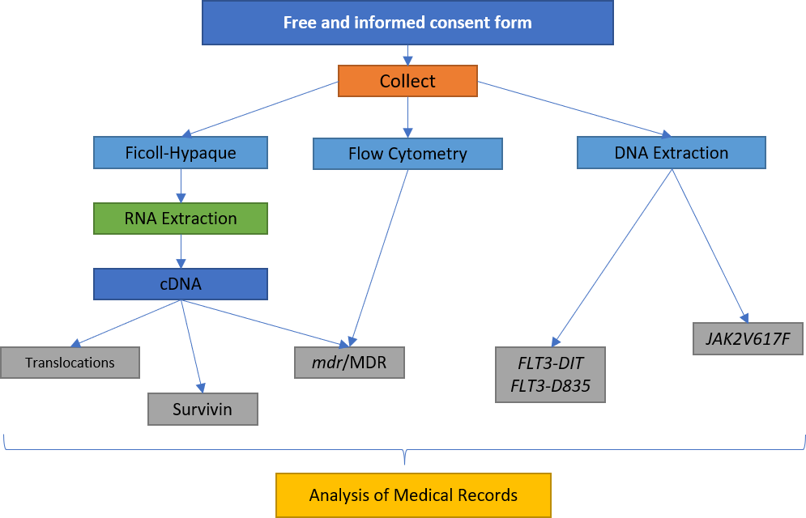

Figure 1 – Processing flowchart of peripheral blood or bone marrow samples.

After collection, part of the sample was used for RNA extraction, complementary DNA (cDNA) synthesis, semiquantitative RT-PCR assays and, when indicated, the investigation of t(8;21)(q22) translocations, TL-2, TL-3 and TL-4. A second part of the sample was used for flow cytometry assays and another part for DNA extraction and the research for the presence of mutations in the FMS3 gene and in the JAK2 gene. TCLE – Free and Informed Consent Term.

In addition to molecular biology and flow cytometry assays, a search was performed on medical records to obtain clinical data and other laboratory data from patients. The following data were collected from the medical records: age, WBC and LDH levels at diagnosis, gender, immunophenotype, karyotype, final diagnosis, occurrence of deaths and presence or absence of MRD after induction therapy. The absence of MRD was considered to be the occurrence of complete hematological remission, that is, the presence of 5% or less of blasts in the OM, reestablishment of normal hematopoiesis (return to normal values ​​of hemoglobin, leukometry, differential leukocyte count and platelet count). and absence of extramedullary disease after induction therapy.

**Reagents**

All reagents for cell culture, molecular biology assays and DNA extraction were purchased from Sigma Aldrich. The RNA extraction kit was purchased from Thermo Fisher and the Ficoll-Hypaque (density 1077 g/m3) from Thermo Fisher. Anti-CD34 and anti-CD45 monoclonal antibodies were purchased from Thermo Fisher Scientific; anti-ABCB1 and anti-ABCC1, from Thermo Fisher Scientific; anti-LRP, from Millipore; and the Alexa Fluor 488, from Thermo Fisher Scientific. The fixation and permeabilization kit were purchased from Thermo Fisher Scientific (USA).

**Controls of Molecular Biology Assays**

Human AL cell lines were cultured and used as positive controls for RT-PCR assays. As a positive control for the expression of *abcb1*/ABCB1, the AML strain of human origin K562-Lucena was used. The Jurkat human ALL lineage was used as a positive control for the expression of abcc1/ABCC1 and *lrp*/LRP. As a control of survivin transcription and the presence of TL-2 the AML strain of human origin K562 was used. For translocations TL-1, TL-3 (TL-3) and TL-4 (TL-4), the AML strain of human origin was used as a positive control. Kasumi1, NB4 and ME-1, respectively.

Cells were maintained in appropriate cell culture bottles containing DMEM (Dulbecco's Modified Eagle's Medium) or RPMI1640 (Roswell Park Memorial Institute 1640 Culture Medium) medium supplemented with 10% fetal bovine serum, 100 U/mL penicillin, 100 μg/mL streptomycin sulfate and 10 mM HEPES buffer (4-(2-hydroxyethyl)1-piperazinyl-ethanesulfonic acid) at pH 7.4. The cells were kept in an oven with a humid atmosphere at 37 ºC containing 5% CO2. To carry out the experiments, the number of viable cells was evaluated by the Trypan Blue dye exclusion method (0.5%) and only samples with viability greater than 80% were used.

In the PCR reactions for the detection of mutations in the FMS3 and JAK2 gene, samples from patients previously identified as carriers of these mutations were used as positive controls.

**RNA Extraction**

Total RNA was extracted from mononuclear cells from patients diagnosed with AL using the QIAamp RNA Blood Mini Kit according to the manufacturer's instructions.

Briefly, mononuclear cells were obtained by density gradient difference from peripheral blood or bone marrow. For this, the samples were diluted in phosphate buffer (PBS) in a proportion of 2:1 (1 mL of sample for 0.5 mL of PBS). After dilution, the sample was placed on 4 mL of Ficoll-Hypaque (density 1077 g/m3) and centrifuged at 300 g for 30 minutes. The interphase with the mononuclear cells was transferred to a conical tube, suspended in 10 ml of PBS buffer and centrifuged at 200 g for 10 minutes. After centrifugation, the supernatant was discarded and the cells were washed again with PBS. At the end of the washes, the cells were suspended in 3 ml of erythrocyte lysis buffer, provided by the kit, and incubated on ice for 15 minutes. After incubation, the cells were subjected to centrifugation at 400 g for 10 minutes at 4 °C. Mononuclear leukocytes were lysed using 600 µL of lysis buffer, provided by the kit, and 0.1% β-mercaptoethanol. The leukocyte lysate was transferred to the QIAshredder column and centrifuged at 10,000 g for 2 minutes. The column was discarded and 600 µL of 70% ethanol was added to the filtrate. The entire lysate was transferred to a QIAamp column and subjected to a new centrifuge at 10,000 g for 15 seconds. The QIAamp column was washed twice with wash buffer provided by the kit. After washing, 50 µL of RNase-free water (provided by the kit) was added to the column and it was subjected to a final centrifugation at 10,000 g for 1 minute. The filtrate containing the total RNA was stored at -80°C to be later used for cDNA synthesis.

**Complementary DNA Synthesis**

RNA quantification was performed by fluorimetry using the Qubit™ Quantitation Platform (Invitrogen) and its quality was assessed by visualizing ribosomal RNA (rRNA) bands in 2% agarose gel electrophoresis. Good quality samples were considered to be those that did not show a trace below the rRNA bands and whose 28S rRNA band had twice the intensity of the 18S rRNA band.

For cDNA synthesis, from 1 μg to 5 μg of total RNA were added in 0.2 mL microtubes. Possible contaminating DNA in the samples was eliminated by DNase digestion. To this end, 1 µL of DNase (1 U/µL), 1 µL of reaction buffer and water treated with diethyl pyrocarbonate (DEPC-water) were added to the total RNA until the volume was 10 µL. After 15 minutes digestion at room temperature, DNase was inactivated by 1 µL of EDTA (25 mM) and incubated for 10 minutes at 65 °C.

After DNase inactivation, the samples were subjected to a 5-minute incubation at 70 ºC, followed by an incubation on ice for 5 minutes. After incubation on ice, 15 µL of mix solution was added to each sample tube containing: 5 µL of 5x first strand buffer (250 mM Tris-HCl, pH 8.3; 375 mM KCl; 15 mM MgCl2), 2 μL of DTT (0.1M), 2 μL of random hexamers (100 ng/μL), 0.4 μL of dNTP mix (100 mM each), 0.5 μL of RNAse (40 U/μL), 0.5 μL of reverse transcriptase (200 U/μL) and water-DPEC q.s.p. to 15 μL. The samples were then taken to the thermocycler (Mastercycler Personal, Eppendorf) and subjected to the following schedule: 25 °C for 5 minutes, 37 °C for 60 minutes and 90 °C for 5 minutes. At the end of programming, the samples were incubated on ice for 5 minutes. The cDNA samples were measured by fluorimetry using the Qubit™ Quantitation Platform (Invitrogen) and stored in a freezer at minus 20 ºC to be later used in assays to detect the transcription of resistance genes and to investigate the presence of chromosomal translocations.

**Detection of Gene Transcription of *abcb1*, abcc1, *lrp* AND survivin BY Semi quantitative RT-PCR**

The evaluation of gene transcription of resistance proteins was performed using the semiquantitative RT-PCR technique. The oligonucleotide primers or primers pairs (Table 1) used to assess the transcription of *abcb1, abcc1, lrp and survivin* were previously described by Tomiyasu, et al. (2012) and glyceraldehyde-3-phosphate dehydrogenase (GAPDH) transcription was used for band normalization.

Table 1 – Sequence of primers for the detection of *abcb1, abcc1, lrp* and survivin.

|  |  |  |
| --- | --- | --- |
| Gene | Sequência | product size |
| *abcb1* | 5’–CCGCAAGTTTACCTGCAGG–3’ | 157bp |
| 5’–GCTCCTAACTTCTGAGGTTCA–3’ |
| *abcc1* | 5’–TGGGGGACTGTCACGAAT–3’ | 260bp |
| 5’–AGGCCGAATATGACTTCCC–3’ |
| *lrp* | 5’–GTCGGGCAGCTCGTCGGTGTTCTG–3’ | 240bp |
| 5’–GCCTGGGTCTGTCTCTTGCCTTGG–3’ |
| *survivin* | 5’–GCATCCTGGACTTCTCAACACC–3’ | 393bp |
| 5’–CCCATGGAGCTGCATCAGCCA–3’ |
| *GAPDH* | 5’–CCCGTCTTCGAGAAACCATGA–3’ | 330bp |
| 5’–TCTGGGATGTATGAGGCAGG–3’ |

All reactions were prepared with a final volume of 50 μL. PCR reactions with primers for *abcb1* and *lrp* were performed. The samples were initially denatured at 94 °C for 5 minutes and then subjected to the ideal reaction conditions for each pair of primers. At the end of the PCR cycles, a final extension was performed at 72°C for 10 minutes. The ideal reaction conditions and the number of cycles used were established in previous tests carried out at the Laboratory of Experimental Oncology and Hemopathies (LOEH) so that the PCR ended in the exponential phase of the amplification. The PCR products were electrophoresed in 2% agarose gel at 100 volts for 30 minutes and stained with ethidium bromide. The bands were visualized in a transilluminator (HOEFER-MacroVue UV-20) under UV light of 320 nm (Figure 2) and photographed with the gel photo-documentation system (DOC-PRINT®, Biosystems). The size of the fragments was estimated by comparison with the 50 bp molecular size marker.

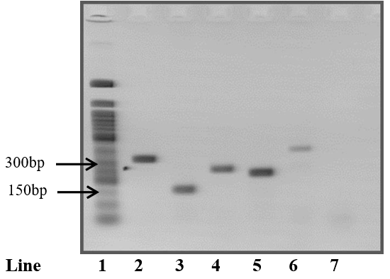

Figure 2 – Representative 2% agarose gel of polymerase chain reaction (PCR) positive controls for detection of *abcb1* (K562-LUCENA), abcc1 (Jurkat), *lrp* (Jurkat) and survivin (K562). [Line 1 – Molecular size marker 50 bp; Line 2 – PCR product with primers for gapdh (330 bp); Line 3 – PCR product with primers for *abcb1* (157 bp); Line 4 – PCR product with primers for abcc1 (260 bp); Line 5 – PCR product with primers for *lrp* (240 bp); Line 6 – PCR product with survivin primers (393 bp); Line 7 – Negative control with water.]

The mean intensity of each band was assessed by the digital analysis program. The intensity of the *abcb1*, abcc1, *lrp* and survivin gene bands was divided by the intensity of the gapdh normalizing gene. Results were reported in the form of relative transcription.

**Research of Translocations TL-1, TL-2, TL-3 & TL-4**

The search for chromosomal translocations was performed using the RT-PCR technique followed by nested PCR. The primers (Table 2) and the PCR conditions used for the investigation of chromosomal translocations were those described by the BIOMED-1 program.

Table 2: Sequence of primers for the investigation of chromosomal translocations.

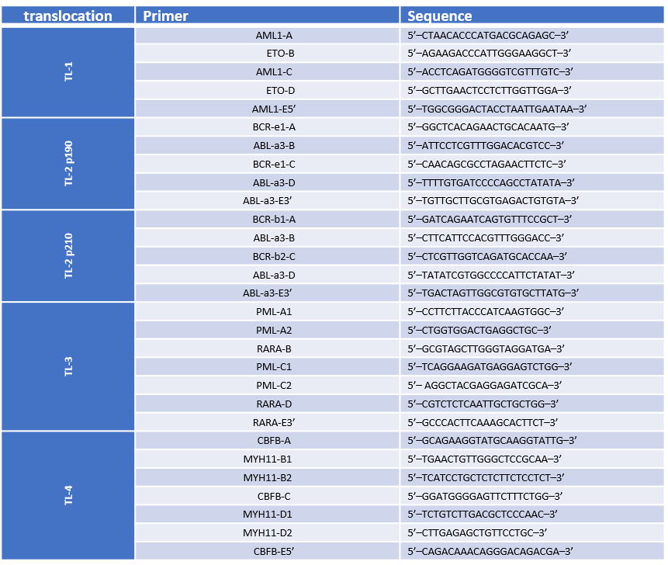

For the first PCRs of all chromosomal translocations, primers coded as A (sense) and B (antisense) were used. To avoid releasing false positive results, in parallel with the first PCR, a confirmatory PCR was performed with primers C (sense) and E3' (antisense), with the exception of TL-1 and inv (16)(p13;q22) in which the confirmatory primers used were those coded as E5' (sense) and D (antisense). Nested PCRs were performed using primers encoded with C (sense) and D (antisense).

Reactions were prepared with a final volume of 50 μL. The PCR stock solution was prepared. The nested PCR reactions were performed under the same conditions, except that, instead of genomic DNA, 1 µL of the amplification product of primers A and B from the first PCR was used as a template. The reaction conditions were: initial denaturation at 95 °C for 30 seconds, followed by 35 cycles of denaturation at 95 °C for 30 seconds, annealing at 65 °C for 1 minute and extension at 72 °C for 1 minute. The PCR product was electrophoresed in 2% agarose gel at 100 volts for 30 minutes and stained with ethidium bromide. The bands were visualized in a transilluminator under UV light of 320 nm. The size of the fragments was estimated by comparison with the 50 bp molecular size marker (Table 3).

Table 3: Expected size of PCR products for the investigation of chromosomal translocations, according to the pair of primers used.

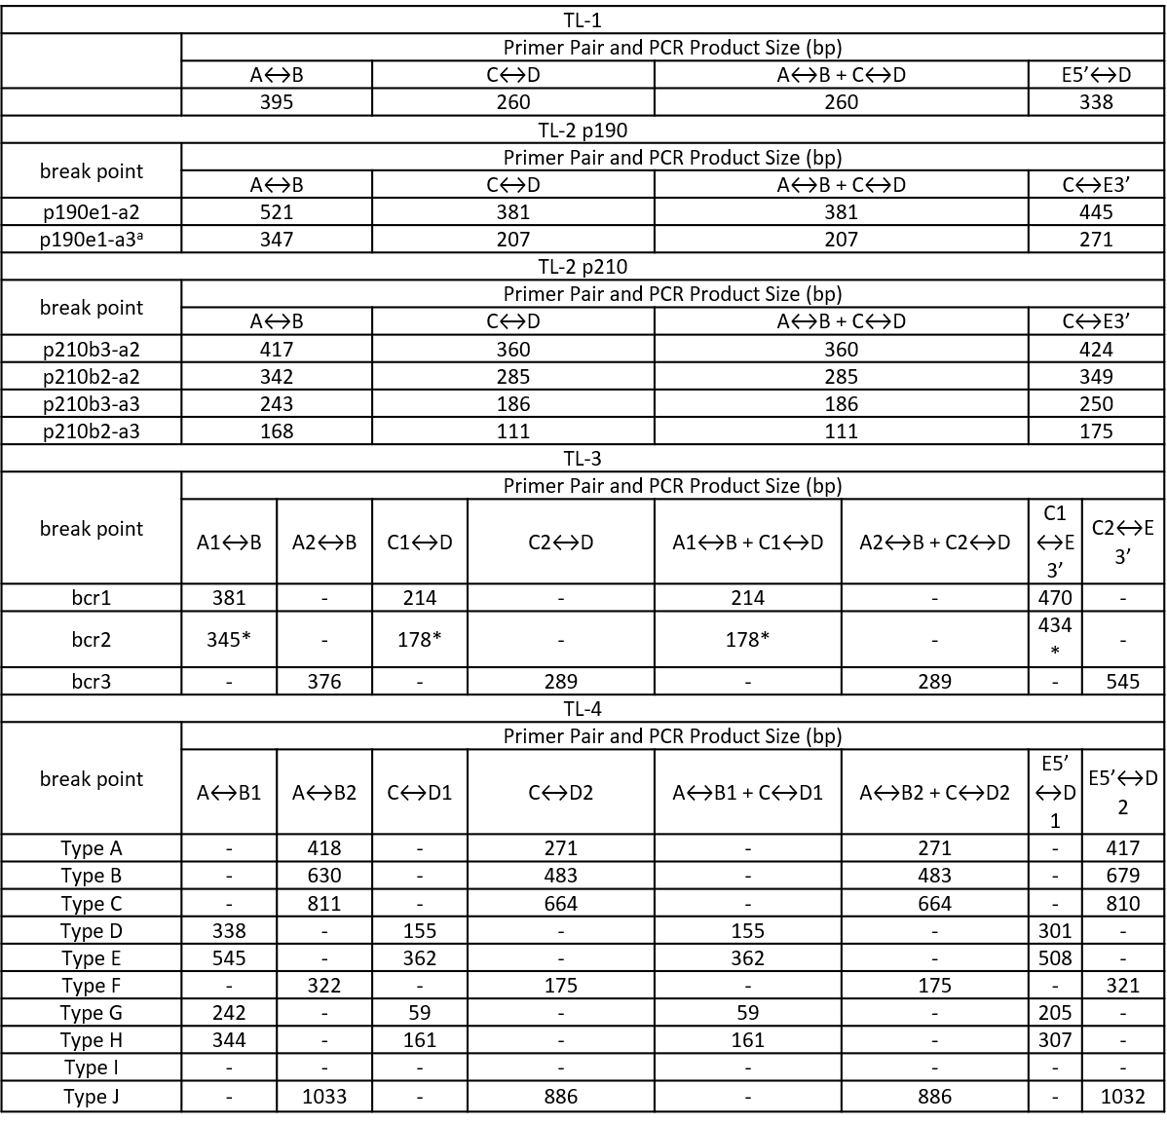

bp – Base pairs;(–): not applicable. *The size of the product is variable due to the variability of exon 6 breakpoints in the PML gene.

**DNA Extraction**

DNA extraction was performed using a 5 M guanidine isothiocyanate solution. For that, 200 μL of peripheral blood or bone marrow were transferred to a microtube containing 1 mL of 5 M guanidine isothiocyanate solution and subjected to vortex homogenization. The sample was then kept under continuous stirring at room temperature for 12 hours overnight. After incubation, 50 μL of acidified silica dioxide solution was added to the microtube and the sample was homogenized by inversion for 5 minutes. Afterwards, the sample was centrifuged at 1000 g for 1 minute at room temperature and the supernatant was discarded. The DNA-containing silica pellet was then washed twice with 500 µL of 5M guanidine isothiocyanate wash solution, twice with 500 µL of 70% ethanol and once with 500 µL of ultra pure acetone. Between each wash, the supernatant was removed after the sample was centrifuged at 1000 g for 1 minute at room temperature. At the end of the last wash, acetone residues were removed by evaporation in a thermoblock (Thermomixer compact, Eppendorf) at 56 °C for 10 minutes. The sample was rehydrated with 25 μL of Tris-EDTA Buffer (10 mM Tris.HCl, pH 6.4; 1 mM EDTA, pH 8.0) and again incubated in thermoblock at 56 °C for 10 minutes under agitation. Afterwards, the sample was centrifuged at 2,600 g for 5 minutes and the supernatant containing the genomic DNA was transferred to a new microtube with a capacity of 0.6 mL and frozen at minus 20 °C for later use in the assays for mutations in genes FMS3 and JAK2.

**Research for Mutation in the FMS3 Gene**

**Detection of the Mutation in the FMS3 Gene of the DIT Type**

For the detection of FMS3-DIT, the amplification of exons 14 and 15 of the FMS3 gene was performed.

Reactions were prepared with a final volume of 50 μL. The PCR mix solution was prepared as follows: 100 ng to 1 µg of genomic DNA, 5 µL of concentrated 10X buffer for Taq DNA polymerase (20 mM Tris-HCl, pH 8.4; 50 mM KCl), 1.5 μL MgCl2 (50 Mm), 0.4 μL dNTP mix (100 mM each), 2 μL primer sense (5'-GCATTTAATATGAAGCAGCCAGG-3') and antisense (5'- CTTGTAACAGCATTTTCCGGCAC-3') (10 µM each), 0.25 µL of Taq DNA polymerase (5 U/μL) and ultra-pure water q.s.p to 50 μL.

The reaction conditions were: A total of 35 cycles of denaturation at 94°C for 30 seconds, annealing for 1 minute at 61°C and 72°C for 2 minutes, followed by a final extension of 72°C for 8 minutes at the end of the process. It was stained with ethidium bromide after electrophoresis in a 12 percent polyacrylamide gel for 90 minutes at 80 volts. Under 320 nm UV transilluminator light, the bands could be seen. In order to estimate the fragment size, we used a molecular size marker (100 bp) as a reference.

In the absence of the FMS3-DIT mutation, just one band with 329 bp was detected, which was consistent with the wild-type gene. The FMS3-DIT homozygous and heterozygous forms of the mutation were associated with the presence of a second, larger band (up to 400 bp) or the absence of the 329 bp band when one or two larger bands were present ( Figure 3).

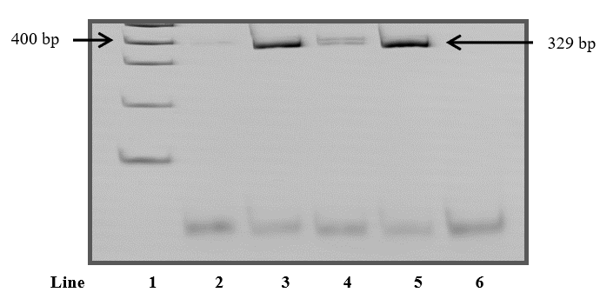

Figure 3 : 12% polyacrylamide gel representative of polymerase chain reaction (PCR) products for the detection of the FMS3-DIT mutation.[ Line 1 – 100 bp molecular size marker; Line 2 – Homozygous patient sample with a band compatible with the FMS3-DIT mutation; Line 3 – Patient sample without a band compatible with the FMS3-DIT mutation; Line 4 – Positive control (Sample from a heterozygous patient known to be positive for the FMS3-DIT mutation); Line 5 – Negative control with DNA (Patient sample known to be negative for the FMS3-DIT mutation); Line 6 – Negative control with water.]

**Detection of the Mutation in the FMS3 Gene of Type D835**

To detect the FMS3-D835 mutation, exon 20 amplification of the FMS3 gene was performed followed by an enzymatic digestion with EcoRV. Reactions were prepared with a final volume of 50 μL. The reaction conditions were: initial denaturation at 94 °C for 3 minutes, followed by 35 cycles of denaturation at 94 °C for 30 seconds, annealing at 66 °C for 1 minute and extension at 72 °C for 2 minutes, with a final extension of 72 °C for 8 minutes. Before enzymatic digestion, the success of amplification was verified by performing electrophoresis in a 2.5% agarose gel at 100 V for 30 minutes. The gel was stained with ethidium bromide and the bands were visualized on a transilluminator under UV light of 320 nm. The size of the fragments was estimated by comparison with the 50 bp molecular size marker. Samples that showed a single band with 114 bp were subjected to digestion with EcoRV.

Enzymatic digestion was prepared with a final volume of 15 μL and was performed. A 20 percent polyacrylamide gel was incubated at 70 V for 90 minutes with the reaction at 37 °C, and the digestion products were seen. In order to see the bands, the gel was stained with ethidium bromide and the UV light of 320 nm was used. The molecular size marker of 50 bp was used to assess the size of the fragments. Samples without the FMS3-D835 mutation were fully digested and showed two bands (68 bp/46 bp). Samples homozygous or heterozygous for the FMS3-D835 mutation were not digested or were partially digested, respectively. Thus, homozygous samples showed a single undigested band (114 bp) and in heterozygotes three bands resulting from partial digestion (114 bp/68 bp/46 bp) were observed (Figure 4).

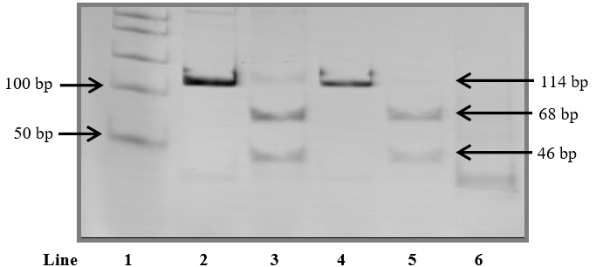

Figure 4: Representative 20% polyacrylamide gel of polymerase chain reaction (PCR) products for FMS3-D835 mutation detection.[Line 1 – 50 bp molecular size marker; Lane 2 – Patient sample with bands compatible with the FMS3-D835 mutation before digestion with EcoRV; Lane 3 – Sample from a heterozygous patient with bands compatible with the FMS3-D835 mutation after digestion with EcoRV; Lane 4 – Patient sample without bands compatible with the FMS3-D835 mutation before digestion with EcoRV; Lane 5 – Patient sample without bands compatible with the FMS3-D835 mutation after digestion with EcoRV; Line 6 – Negative control with water.]