**Exploring the Lipid Profile Parameters in the Serum of Iraqi Leukemic Patients**

***Basma Jawad AMEEN 1,[[1]](#footnote-1)\*[C:\Users\Abdullah\AppData\Local\Microsoft\Windows\INetCache\Content.Word\ORCID-iD_icon-16x16.gif](https://orcid.org/xxxx-xxxx-xxxx-xxxx), Volkan EYÜPOĞLU 2[C:\Users\Abdullah\AppData\Local\Microsoft\Windows\INetCache\Content.Word\ORCID-iD_icon-16x16.gif](https://orcid.org/xxxx-xxxx-xxxx-xxxx), Ahmed Fadhil Neama ALSHANON 3[C:\Users\Abdullah\AppData\Local\Microsoft\Windows\INetCache\Content.Word\ORCID-iD_icon-16x16.gif](https://orcid.org/xxxx-xxxx-xxxx-xxxx)***

*1 Department of Chemistry Sciences, School of Natural and Applied Sciences, Çankiri Karatekin University, Iraq*

*2Department of Chemistry Sciences, School of Natural and Applied Sciences, Çankiri Karatekin University, Turkey*

*3Plant Biotechnology department, Center of Biotechnology Research, Alnahrain University, Iraq*

|  |
| --- |
| **Abstract**  This study investigates the potential differences in lipid profile parameters between Iraqi leukemia patients and healthy controls to understand their association with the disease and its progression. The study included 200 Iraqis, including 150 leukemia patients. 50 healthy individuals aged 6–68 were the control group. Medical patient got six milliliters of blood collected from Al-Yarmuk Teaching Hospital. Lipid profile test showed that leukemia patients had higher cholesterol, triglycerides, and VLDL (239.7, 40.53, and 189.2) than controls (170.8, 20.68, and 104.9) but no significant differences in HDL or LDL. This study suggests potential alterations in lipid profile parameters in Iraqi leukemia patients, which may contribute to understanding the disease's mechanisms and developing personalized treatment approaches. Further research is needed to confirm these findings and elucidate the complex interplay between lipid metabolism and leukemia pathogenesis. |
| Keywords: Leukemia, Lipid Profile, Cholesterol, Iraqi |

1. **Introduction**

Leukemia is a cancer of the hemopoietic tissues characterized by an increase of aberrant white blood cells (WBCs) in the bone marrow [1]. The bone marrow produces all blood cells. in order to maintain the required number of blood cells. Bone marrow is a spongy substance found within bones. In adults, a tiny number of stem cells, which can give rise to aberrant cells and induce bone marrow failure, They're in charge of creating 120,000 WBC and three million red blood cells per seconds [2]. When leukemia cells die, they continue to reproduce rapidly, creating new leukemic cells that might gather and choke healthy blood cells. The primary methodThe bone marrow assay or numerous full blood counts are used in determining the presence of leukemia. If concerns appear, both of these examinations are performed. However, on rare cases, blood examinations might not produce reliable results for leukemia or might not indicate if the patient is thought of having leukemia. That occurs either while leukemia is just starting to progress or after it has reached remission [3]. In certain circumstances, further procedures, such as a lymph node biopsy, may be utilized to identify and investigate particular forms of leukemia [4]. After the diagnosis is made  more focused assays are carried out to establish the extent of liver and kidney destruction, such as blood chemistry testing., in addition to the patient's response to treatment with chemotherapy, such as reticulocyte numbers and blood sample analysis, iron investigations, including Fe. in Iraq, accounting for 8.97% of all new cancer diagnoses. The most prevalent of them was leukemia (10499), which accounts for 29.65% of all cases, on average, 524 kids are diagnosed with leukemia each year. Leukemia accounted for 2088 (30.94%) of all pediatric cancer cases from 2000 to 2004, this number slightly decreased to 2174 (30.50%) from 2005 to 2009, then increased to 3020 (32.82%) from 2010 to 2014, and finally decreased to (3217) 25.60% from 2015 to 2019. According to the World Health Organization, leukemia was the third most prevalent illness in 2020, with 1545 fatalities and 2027 new cases (WHO 2020). Oxidants are known to contribute to several phases of carcinogenesis [5]. OS is linked to a number of medical conditions, including infection, inflammation, exposure to UV and gamma radiation, and an increase in mutation frequency [6] and acute promyelocytic leukemia [7]. Mild OS is signified by elevated levels of anti-oxidant enzymes, which is an adaptive protective response, and enhanced free radical production, notably the production of superoxide anion in leukemia patients [8]. OS has been linked to the development of cancer in several studies [9]. Endogenous oxidants can play a role in several stages of malignant transformation and are thought to be major naturally occurring carcinogens [10]. ROS have the ability to cause chromosomal and genetic changes, which can lead to cancer formation in multistep carcinogenesis [11]. AdditionallyROS can activate intercellular secondary messengers, which can alter a range of cellular processes such as apoptosis, gene expression, and cell development [12]. OS begin the carcinogenesis process by activating kinases and denaturing DNA via chromosomal protein poly ADP-ribosylation [13]. OFR frequently causes cell damage and may have.

1. **Materials and Methods**

The collection of blood was performed in Al- Yarmuk Teaching Hospital and Medical and Health in Baghdad 150 samples were collected from Patients were diagnosed with leukemia by a consultant medical staff at center. their ages rangedwere between 6 years to 68 years. All patients were attended to the laboratoryof hospital in order to diagnosis and treatment. To act as a control group, fifty healthy males and females were examined. Their ages ranged from 6 to 68 years. None of them had any clinical or lab indication of an illness that might have an impact on the measurement parameters. After cleaning the skin with 70% alcohol and drawing blood from each patient's vein, the blood was allowed to clot for about 30 minutes at room temperature before being centrifuged for 5 minutes at 3000 (rpm) to separate the serum and then transferred into additional tubes. In total, 150 patients and 50 controls had their blood samples drawn. To assess the quantities of chemical components in the blood, clinical chemistry employs chemicals. It is particularly helpful for tracking organ function and early illness diagnosis. Blood and urine are the most typical specimens utilized in clinical chemistry. The typical blood tests and things that can be measured using UV/Vis spectroscopy instruments.In this program note, the LAMBDATM 465 UV/Vis Spectrophotometer and UV LabTM software were used to detect the quantity of cholesterol in human serum using an enzymatic approach. concept of Cholesterase hydrolyzes the cholesterol esters in the sample. Cholesterol oxidase then converts the liberated free cholesterol into 4-cholesteren-3-one and H2O2. Hydrogen peroxide (H2O2) is converted into a quantifiable red quinoneimine compound with an absorbance of 500 nm. Triglycerides are measured by enzymes in either plasma or serum through a series of related processes in how triglycerides are digested to produce glycerol. Then, glycerol is exposed to oxidation using glycerol oxidase, and one of the byproducts, H2O2, is identified as being associated with cholesterol. The absorbance is calculated at 500 nm. Regional atherosclerotic and CHD-risk-raising illnesses can be recognized by high blood triglyceride levels. High triglycerides are related to an increased risk for coronary artery disease (CAD) among persons who have other risk factors, such as low levels of HDL cholesterol, specific patient groups with higher levels of apolipoprotein B, and those with LDL kinds that may be particularly atherogenic. Borderline overnight levels of triglycerides, which are those below 200 mg/dL, are regarded to be ideal., High is 400–1,000 mg/dL, Very High is >1000 mg/dL, and Low is 200–400 mg/dL. Extremely elevated levels of triglycerides ought to be investigated and dealt with right away since they can cause pancreatitis. Although the value is applied to determine the level of low density lipoprotein (LDL)-cholesterol concentrations, triglycerides are evaluated as well. Using the Direct HDL method. For a direct HDL test, serum is utilized. The basic concept of the approach is as follows. According to the assay's requirements, a taking up reagent is utilized to interact with the material's apoB-containing lipoproteins and make them non-reactive with the enzyme cholesterol reagent. As a result, when the test conditions are satisfied, the procedure effectively eliminates the lipoproteins that contain apoB, leaving just HDL-chol. Roche/Boehringer-Mannheim Diagnostics is where the reagents are bought. The method uses sulfate alpha-cyclodextrin in the presence of Mg+2, which forms complexes with apoB-containing lipoproteins, as well as polypropylene glycol-coupled cholesterol levels esterase and cholesterol oxidase as substrates for the detection of HDL cholesterol. According to the following connection, LDL cholesterol is estimated from measured values of total cholesterol, triglycerides, and HDL cholesterol. Very low-density lipoproteins (VLDL), LDL, and HDL are the three main lipoprotein fractions that contain the majority of the circulating cholesterol. Total cholesterol is the sum of VLDL, LDL, and HDL cholesterol. As a result, this mathematical equation could used to determine the value ofVLDL.

1. **Results and Discussion**

First, cholesterol levels were assessed. The patients had elevated cholesterol levels. based on the outcomes we came up with. The findings demonstrate that there were considerable gains. According to Figure 1, the cholesterol values in the healthy control and patient were (170.8 and 239.7), Pg/ml respectively (P=0.0009). The percentage in difference between the healthy group and the sufferers was 71%, as it explained below.

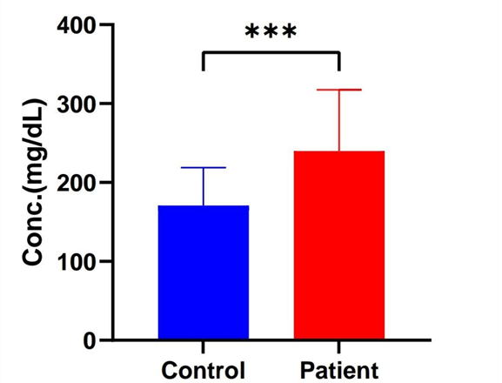

Figure 1 Cholestoral concentration in different studied groups

Also, an increase in VLDL levels was observed, according to the obtained resultsThere was significant differences (P=0.0043) between control leukemia patients and it was (58.7and55.78) Pg/ml respectively. as it showen in Figur 2.

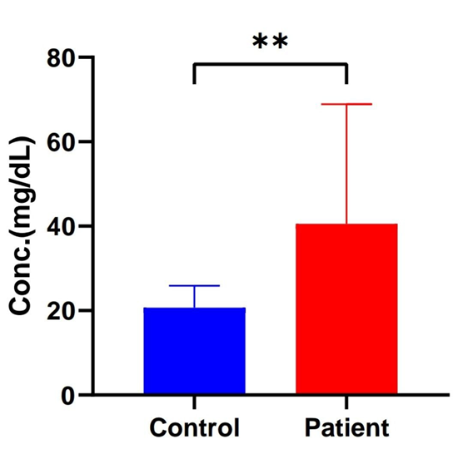

Figure 2 VLDL concentration in different studied groups

There were also similar results in the Estimate of triglycerides, where there was a clear increase in triglyceride levels. According to the results obtained (P=0.0028)and the difference between control and leukemia patient was (104.9and 189.2) Pg/ml Figure 3.

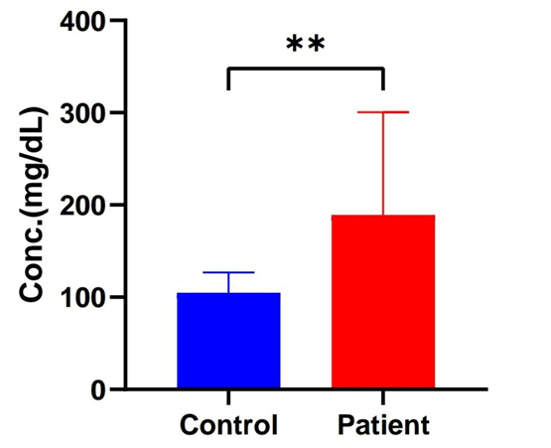

Figure 3 Triglyceride concentration in different studied groups

while While the result was different in HDL and LDL.from obtained data there is no significant differences in HDL(P= 0.8254)and the HDLlevel in patien group Not a clear difference For the healthy group (55.78 and 58.70) Pg/ml as it shown in Fiuger 4.

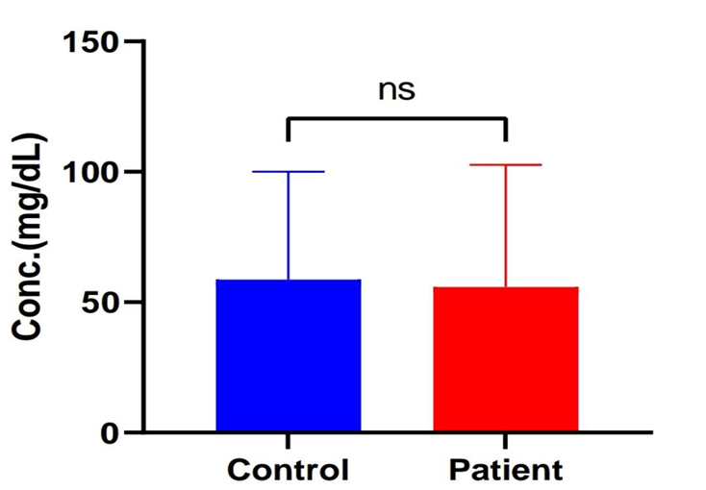

Figure 4 HDL concentration in different studied groups

The result in LDL was similar to HDL Also, there was no significant difference (P= 0.4082) and LDL value is comparing with the healthy control and it was(112.4and 99.90) Pg/ml as it shown in Figure 5.

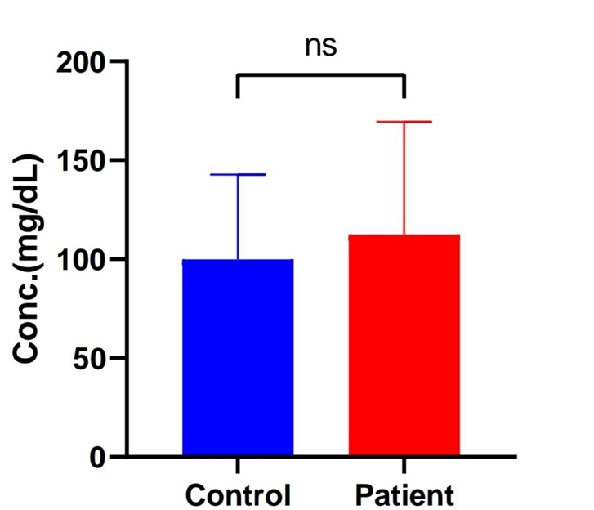

Figure 5 LDLconcentration in different studied groups

First of all, for cholesterol compared to those in good health. With a rise in tumor stage, the amount of cholesterol decreases even more [14]. On the other hand, 75% of patients attending a clinic of Chronic Lymphocytic had elevated cholesterol levels [15]. According to reports, CLL patients are more likely to survive if they use cholesterol-lowering medication and had hypercholesterolemia before their diagnosis [16]. Numerous molecules related to cholesterol metabolism were shown to be dysregulated in blood cancer cells at the cellular level. When compared to control, lympho-cytes from people with chronic lymphocytic leukemia express more LDLR, SREBP-2, and the nu\clear cholesterol channel protein PBR. As a result, cholesterol accumulation was also ``discovered in the cytoplasm and nucleus [17]. It was observed in most studies that the increase in VLDL and TG was associated with most patients with leukemia. Taking chemotherapeutic medicines such as asparginase may cause lipid problems. Asparginase has been shown by [18]. to result in hypertriglyceridemia, in their study, plasma LDL was considerably raised following treatment with asparginase. Additionally, it has been shown that AML patients have much smaller amounts of lipoproteins with a high density than acute lymphocytic leukemia (ALL) patients do.

1. **Conclusion**

The comprehensive investigation into the lipid profile and oxidative stress parameters in the serum of Iraqi leukemic patients sheds light on the intricate relationship between leukemia and systemic metabolic alterations. The findings underscore the potential impact of leukemia on lipid metabolism and oxidative stress, providing valuable insights into the underlying pathophysiological mechanisms. The observed changes in lipid levels and oxidative stress markers could serve as potential diagnostic and prognostic indicators, aiding in the development of targeted therapeutic strategies. Moreover, this study emphasizes the importance of exploring novel avenues for intervention and management that extend beyond traditional approaches, offering new perspectives for improving the overall health outcomes of Iraqi leukemic patients. Future research endeavors should continue to unravel the intricate interplay between leukemia, lipid metabolism, and oxidative stress, paving the way for innovative approaches to enhance patient care and treatment efficacy.

**References**

1. Attar, M. N. 2022. The role of the guanine nucleotide exchange factors DOCK2 and DOCK5 in acute myeloid leukemia and their interactions with epigenetic regulation. Staats-und Universitätsbibliothek Hamburg Carl von Ossietzky.
2. Bosi, A. and Bartolozzi, B. 2010. Safety of bone marrow stem cell donation: a review. Transplantation Proceedings, 42(6): 2192–2194.
3. Suttorp, M., Schulze, P., Glauche, I., Göhring, G., von Neuhoff, N., Metzler, M., Sedlacek, P., de Bont, E. S. J. M., Balduzzi, A. and Lausen, B. 2018. Front-line imatinib treatment in children and adolescents with chronic myeloid leukemia: results from a phase III trial. Leukemia, 32(7): 1657–1669.
4. Quinquenel, A., Aurran-Schleinitz, T., Clavert, A., Cymbalista, F., Dartigeas, C., Davi, F., de Guibert, S., Delmer, A., Dilhuydy, M. S. and Feugier, P. 2020. Diagnosis and treatment of chronic lymphocytic leukemia: recommendations of the French CLL Study Group (FILO). Hemasphere, 4(5): 87-91.
5. Reuter, S., Gupta, S. C., Chaturvedi, M. M. and Aggarwal, B. B. 2010. Oxidative stress, inflammation, and cancer: how are they linked? Free Radical Biology and Medicine, 49(11): 1603–1616.
6. Chung, Y. J., Robert, C., Gough, S. M., Rassool, F. V, and Aplan, P. D. 2014. Oxidative stress leads to increased mutation frequency in a murine model of myelodysplastic syndrome. Leukemia Research, 38(1): 95–102.
7. Wrede, J. E., Sundram, U., Kohler, S., Cherry, A. M., Arber, D. A. and George, T. I. 2005. Fluorescence in situ hybridization investigation of cutaneous lesions in acute promyelocytic leukemia. Modern Pathology, 18(12): 1569–1576.
8. Devi, G. S., Prasad, M. H., Saraswathi, I., Raghu, D., Rao, D. N. and Reddy, P. P. 2000. Free radicals antioxidant enzymes and lipid peroxidation in different types of leukemias. Clinica Chimica Acta, 293(1–2): 53–62.
9. Zhang, B., Pan, C., Feng, C., Yan, C., Yu, Y., Chen, Z., Guo, C. and Wang, X. 2022. Role of mitochondrial reactive oxygen species in homeostasis regulation. Redox Report, 27(1): 45–52.
10. Irigaray, P. and Belpomme, D. 2020. Circulating free methylglyoxal as a metabolic tumor biomarker in a rat colon adenocarcinoma model. Molecular and Clinical Oncology, 12(4): 311–316.
11. Alhmoud, J. F., Woolley, J. F., Al Moustafa, A.-E. and Malki, M. I. 2020. DNA damage/repair management in cancers. Cancers, 12(4): 1050.
12. Checa, J. and Aran, J. M. 2020. Reactive oxygen species: drivers of physiological and pathological processes. Journal of Inflammation Research, 1057–1073.
13. Zhou, D. R., Eid, R., Miller, K. A., Boucher, E., Mandato, C. A. and Greenwood, M. T. 2019. Intracellular second messengers mediate stress inducible hormesis and Programmed Cell Death: A review. Biochimica et Biophysica Acta (BBA)-Molecular Cell Research, 1866(5): 773–792.
14. Yavasoglu, I., Tombuloglu, M., Kadikoylu, G., Donmez, A., Cagırgan, S. and Bolaman, Z. 2008. Cholesterol levels in patients with multiple myeloma. Annals of Hematology, 87: 223–228.
15. Chow, S., Buckstein, R. and Spaner, D. E. 2016. A link between hypercholesterolemia and chronic lymphocytic leukemia. Leukemia and Lymphoma, 57(4): 797–802.
16. Mozessohn, L., Earle, C., Spaner, D., Cheng, S. Y., Kumar, M. and Buckstein, R. 2017. The association of dyslipidemia with chronic lymphocytic leukemia: a population-based study. JNCI: Journal of the National Cancer Institute, 109(3): 1856-1858.
17. Sankanagoudar, S., Singh, G., Mahapatra, M., Kumar, L. and Chandra, N. C. 2017. Cholesterol homeostasis in isolated lymphocytes: A differential correlation between male control and chronic lymphocytic leukemia subjects. Asian Pacific Journal of Cancer Prevention: APJCP, 18(1): 230.
18. Demirci-Çekiç, S., Özkan, G., Avan, A. N., Uzunboy, S., Çapanoğlu, E. and Apak, R. 2022. Biomarkers of oxidative stress and antioxidant defense. Journal of Pharmaceutical and Biomedical Analysis, 209: 114477.

1. \* Corresponding author. *e-mail address: .........@.....* [↑](#footnote-ref-1)