**THE INHIBITION EFFECTS INVESTIGATION OF METAL COMPLEXES WITH COUMARIN SCHIFF BASE ON G6PD ACTIVITY**

***Zeyad Adil HAMEED,\*[C:\Users\Abdullah\AppData\Local\Microsoft\Windows\INetCache\Content.Word\ORCID-iD_icon-16x16.gif](https://orcid.org/0000-xxxx-xxxx-xxxx), Prof. Dr. Ümmühan Özdemir ÖZMEN [C:\Users\Abdullah\AppData\Local\Microsoft\Windows\INetCache\Content.Word\ORCID-iD_icon-16x16.gif](https://orcid.org/0000-xxxx-xxxx-xxxx), Assoc. Prof. Dr. Şevki ADEM [C:\Users\Abdullah\AppData\Local\Microsoft\Windows\INetCache\Content.Word\ORCID-iD_icon-16x16.gif](https://orcid.org/0000-xxxx-xxxx-xxxx)***

*Turkey, Çankırı, Çankırı Karatekin University, Natural and Applied Sciences, Department of Chemistry*

*Turkey, Ankara, Gazi University, Natural and Applied Sciences, Department of Chemistry*

*Turkey, Çankırı, Çankırı Karatekin University, Natural and Applied Sciences, Department of Chemistry*

|  |
| --- |
| **Abstract**  The G6PD enzyme is the primary focus of this investigation. Cancer cells cannot survive or spread without G6PD. A G6PD deficit of less than one percent has no influence on the onset or progression of cancer. Inhibition of G6PD, which regulates cell growth and division, has a negative impact on cell development. Glucometabolism definition of cancer In order to synthesize NADPH and DNA, cancer cells rely on G6PD. NADPH and DNA synthesis are both inhibited when SIRT2 is turned on. G6PD is activated by Ras, Src, and PI3K/AKT in cancer cells. Glioma, lung, and ovarian cancers are all known to have G6PD (ROS). G6PD has an impact on treatment outcomes. In bladder cancer, BCG expression is linked with a bad prognosis. G6PD may be used to predict glioma treatment sensitivity and risk. In this study, we investigated the effect of some Schiff bases and their complexes on G6PD activity in vitro by spectrophotometric methods. In addition, potential attachment patterns were estimated using the Molegro Virtual Docker software. Lead complexes have been shown to inhibit it. The IC50 value of Pd(5MCTS)2 as a G6PD inhibitor was 13.59 μM. And the docking analysis gave a score of -159.521 on the MolDock scale. |
| Keywords: Coumarin, Schiff base, Metal complexes, G6PD, Inhibition |

1. **Introduction**

Cancer metabolism is characterized by increased glucose intake and poor lactate breakdown despite the presence of normal oxygen tension. There are a number of recent studies that have shown that the pentose phosphate pathway (PPP) plays an important part in the "Warburg effect" because of its function in recognizing both intracellular and extracellular signals. In light of this, the pathway's diverse roles and the dual-step nature of its response sequence are highlighted. In fact, the initial PPP oxidative phase is preferentially augmented under redox stress in order to increase NADPH equivalents for antioxidant responses. RNA and DNA are synthesized by bio-reductive syntheses, which result in high NADPH levels, when significant quantities of d-ribose-5-phosphate (R5P) are combined with high levels of bio-reductive syntheses and other coenzymes such as NADH, FADH2, and NADPH [2]. Warburg discovered glucose-6P dehydrogenase in 1931, and since then, PPP has been viewed as an intracellular pathway with a rate-limiting phase mediated by this enzyme (G6PD). PPP role in cancer metabolism was the primary focus of most studies on this enzyme, which indicated that G6PD activity is necessary for the survival and proliferation of cancer cells cultured *in vitro*. A G6PD deficit of less than one percent does not seem to have a significant impact on cancer incidence or progression in live persons , despite the fact that many cancers are more likely to be fatal in people with a G6PD deficiency. The sluggish pace of cytosolic PPP in delivering the enormous quantities of NADPH and R5P needed by actively proliferating cells should be bypassed by developing an alternative mechanism based on these epidemiological data. This enzyme, known as H6PD, is located in the endoplasmic reticulum of practically all eukaryotic cells and is capable of oxidizing a significant number of both phosphorylated hexoses and free hexoses (thus the alternative name of glucose dehydrogenase). New study shows that H6PD activity is elevated in many cancer types, adding to their proliferative and migrating potential, despite the fact that its function in glucose breakdown has been overlooked [3].

1. **Materials and Methods**

Solutions used in activity measurement: 1 M Tris-HCl (pH= 8.0): 0.6057 g (5 mmol) of Tris was dissolved in 90 mL of distilled water. The pH was adjusted to 8.0 with HCl solution. Then the total volume was made up to 50 mL with water. 6 mM 6PGA: 9.1 mg (0.3 mmol) of 6PGA was taken and dissolved in some water. The volume was made up to 5 mL with water. 2mM NADP+ Solution: 7.6 mg of NADP+ (0.1 mmol) was taken and dissolved in some water. The volume was made up to 5 mL with water. Inhibitor stock solutions:Stock solutions were prepared by dissolving the compounds in DMSO at 1mg/mL.

Molecular docking studies: The 3D structures of the compounds whose inhibition effects were determined were downloaded from the PubMed (https://pubchem.ncbi.nlm.nih.gov) web page in sdf format. The crystal structure of the human 6PGD enzyme was downloaded from the Protein Data Bank web page in pdb format [1].

Docking protocol for Molegro Virtual Docker: The protein has been imported into the program. Water molecules on the crystal structure of the protein and heteroatoms other than the ligand were removed. Molecules were transferred to the program (Molegro 2019). The binding site of NADPH was determined for docking. X:16.05, Y:-90.18, Z:-90.79 coordination center and an area of 19 Å were chosen for docking as the docking area. The program was set to make 10 docking attempts for each ligand. The highest MolDock Scores were considered.

**3. Results and Discussion**

The inhibitory effect of three different compounds against the G6PD enzyme was investigated. Results obtained in vitroand in silico are presented in Table 1.

**Table 1** The effects of compounds on G6PD enzyme activity

|  |  |  |  |  |
| --- | --- | --- | --- | --- |
| Compounds | G6PD  IC50 µM | MolDock Score | Rerank Score | HBond |
| Pd(3MeOCTS)2 | 8.453012 | -172.867 | -74.5334 | -1,8399 |
| Pd(3TbCTS)2 | 17.32868 | -127.828 | -106.631 | 0 |
| Pd(5mCTS)2 | 13.59112 | -126.251 | -104.616 | -2.0394 |

Pd(5MCTS)2 compound exhibited inhibitory effects against G6PD enzyme with 13,59 µM IC50 value. % activity – [Pd(5MCTS)2] graph was presented in Figure 1 and 2D interactions maps was given in Figure 2. According to the docking results, it was determined as -159.521 MolDock scores.

**Figure 1**  Pd(5MCTS)2 compound % activity – [Pd(5MCTS)2] graph G6PD enzyme activity

When the 2D interaction map with the enzyme is examined, Lya366 and Arg370 amino acids made hydrogen bond interactions with Pd(5MCTS)2. In Figure 2, we notice the presence of hydrogen bonds, which are represented by the blue lines, and separating interactions, which are represented by the red lines.

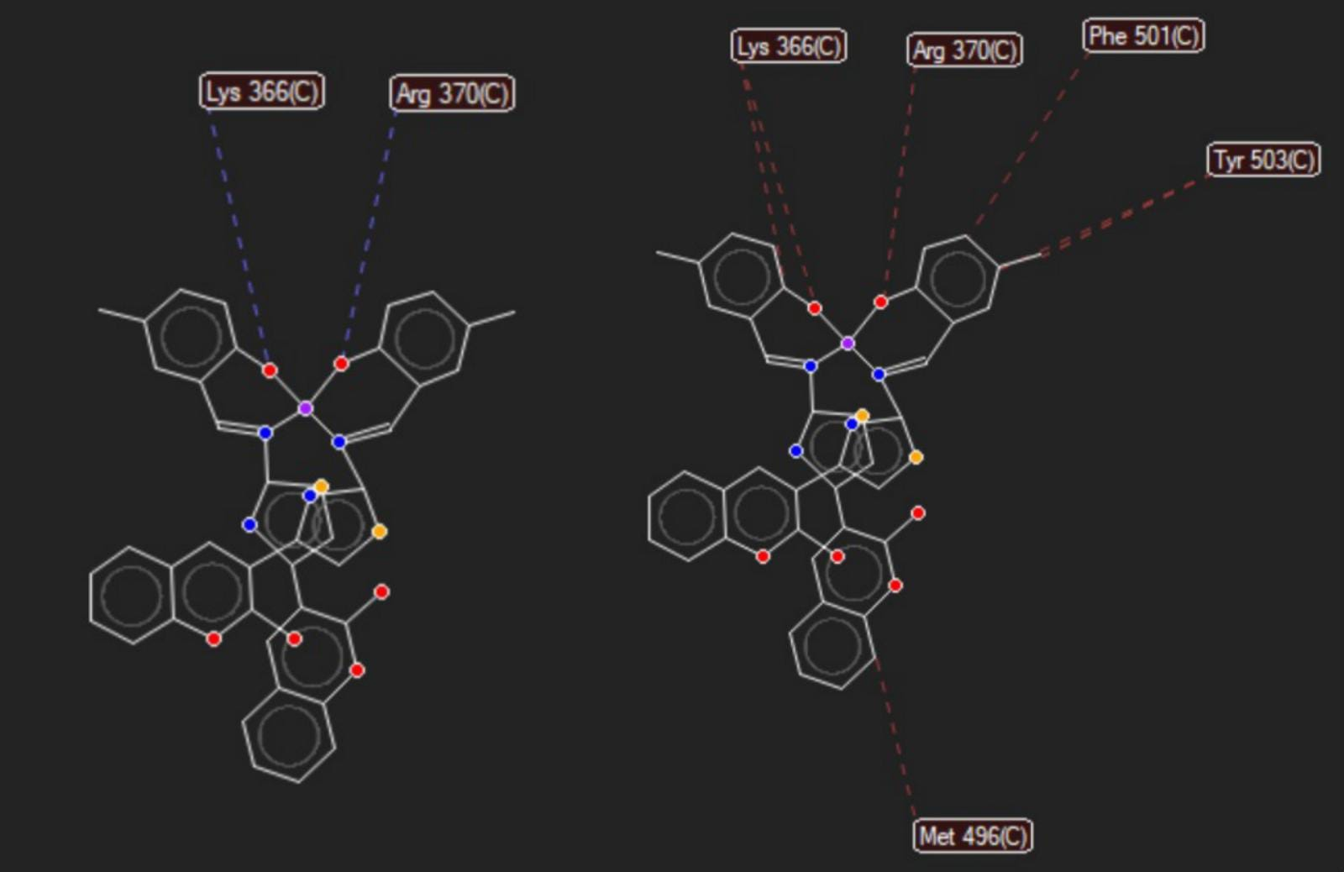

**Figure 2** The interactions of Pd(5MCTS)2  with the active region of G6PD

Pd(3MeOCTS)2compound exhibited inhibitory effects against G6PD enzyme with 8,45 µM IC50 value. % activity – [Pd(3MeOCTS)2] graph was presented in Figure 3 and 2D interactions maps was given in Figure 4. According to the docking results, it was determined as -159.521 MolDock scores.

**Figure 3** Pd(3MeOCTS)2compound % activities – [Pd(3MeOCTS)2] graph G6PD enzyme activity

When the 2D interaction map with the enzyme is examined, Tyr503 amino acids made hydrogen bond interactions with Pd(3MeOCTS)2. In Figure 4, we notice the presence of hydrogen bonds, which are represented by the blue lines, and separating interactions, which are represented by the red lines.

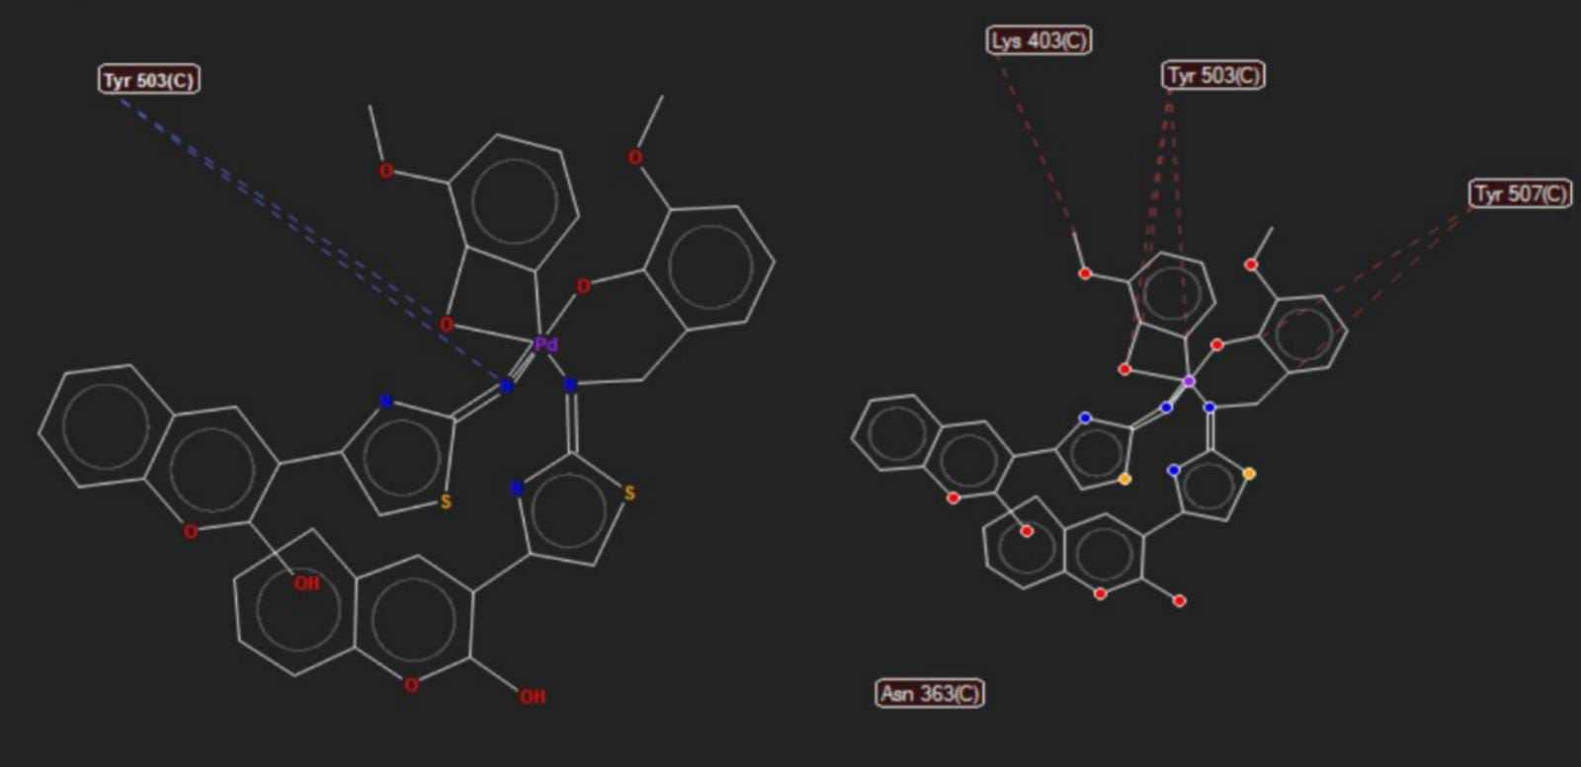

**Figure 4** The interactions of Pd(3MeOCTS)2 with the active region of G6PD

Pd(3TbCTS)2 compound exhibited inhibitory effects against G6PD enzyme with 17,32 µM IC50 value. % activity – [Pd(3TbCTS)2] graph was presented in Figure 5 and 2D interactions maps was given in Figure 6. According to the docking results, it was determined as -159.521 MolDock scores.

**Figure 5** Pd(3TbCTS)2 compound % activities – [Pd(3TbCTS)2] graph G6PD enzyme activity

When the 2D interaction map with the enzyme is examined, Tyr 503 and Asn 363 amino acids made hydrogen bond interactions with Pd(3TbCTS)2. In Figure 6, we notice the presence of hydrogen bonds, which are represented by the blue lines, and separating interactions, which are represented by the red lines.

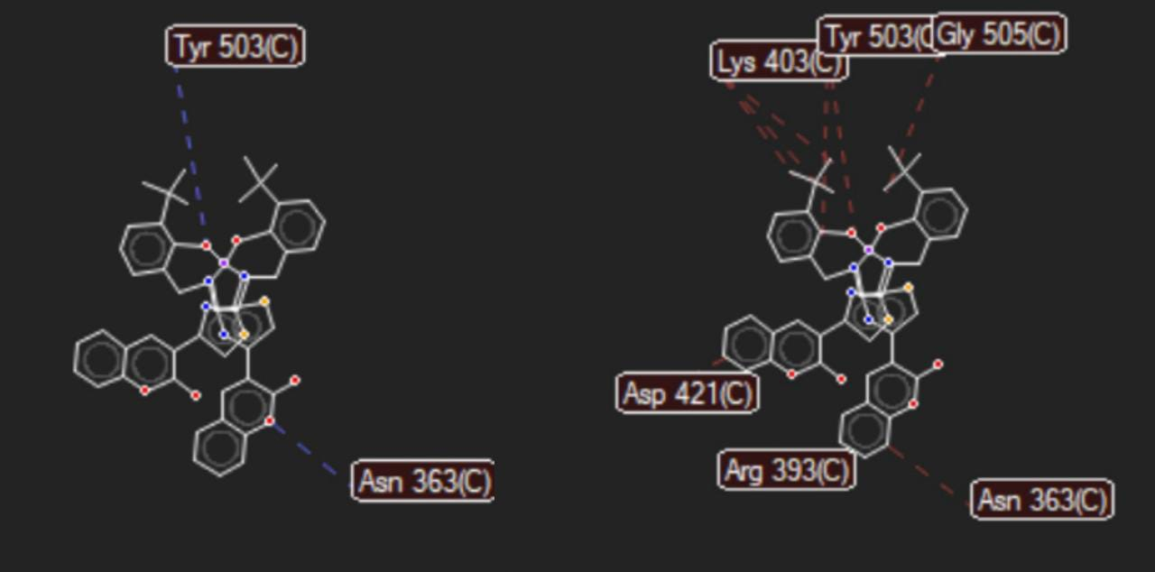

**Figure 6** The interactions of Pd(3TbCTS)2 with the active region of G6PD

**DISCUSSION**

The relationship between the G6PD enzyme and cancer is in order to control the development and death of cells, G6PD plays an important role in signaling. Tumors and malignancies are associated with faulty activation of G6PD in rapidly expanding cancer cells. If G6PD is a therapeutic target, it opens up the possibility that current anticancer drugs can be combined with it to combat cancer resistance. Methods using G6PD inhibitors in the form of chemical or molecular inhibitors have commonly been developed. G6PD inhibitors are developed on the basis of metabolic modification. To avoid fast transformation, tumor cell proliferation, metastatic spread, as well as heterogeneity, redox homeostasis and protein-protein interactions are critical. We can explore the role of G6PD in cancer.

**References**

1. Au, S. W., Gover, S., Lam, V. M., and Adams, M. J. 2000. Human glucose-6-phosphate dehydrogenase: the crystal structure reveals a structural NADP+ molecule and provides insights into enzyme deficiency. Structure., 8: 293-303.
2. Senesi, S., Csala, M., Marcolongo, P., Fulceri, R., Mandl, J., Banhegyi, G. and Benedetti, A. 2010. Hexose-6-phosphate dehydrogenase in the endoplasmic reticulum., 391:1–8.
3. Tsachaki, M., Mladenovic, N., Štambergové, H., Birk, J. and Odermatt, A. 2018. Hexose‐6‐phosphate dehydrogenase controls cancer cell proliferation and migration through pleiotropic effects on the unfolded‐protein response, calcium homeostasis, and redox balance. The FASEB Journal., 32: 2690-2705.