**THE INHIBITION EFFECTS INVESTIGATION OF METAL COMPLEXES WITH COUMARIN SCHIFF BASE ON 6PGD ACTIVITY**

***Nadia Murshed ABED,\*[C:\Users\Abdullah\AppData\Local\Microsoft\Windows\INetCache\Content.Word\ORCID-iD_icon-16x16.gif](https://orcid.org/0000-xxxx-xxxx-xxxx), Prof. Dr. Ümmühan Özdemir ÖZMEN [C:\Users\Abdullah\AppData\Local\Microsoft\Windows\INetCache\Content.Word\ORCID-iD_icon-16x16.gif](https://orcid.org/0000-xxxx-xxxx-xxxx), Assoc. Prof. Dr. Şevki ADEM [C:\Users\Abdullah\AppData\Local\Microsoft\Windows\INetCache\Content.Word\ORCID-iD_icon-16x16.gif](https://orcid.org/0000-xxxx-xxxx-xxxx)***

*Turkey, Çankırı, Çankırı Karatekin University, Natural and Applied Sciences, Department of Chemistry*

*Turkey, Ankara, Gazi University, Natural and Applied Sciences, Department of Chemistry*

*Turkey, Çankırı, Çankırı Karatekin University, Natural and Applied Sciences, Department of Chemistry*

|  |
| --- |
| **Abstract**  This work is focused on the 6PGD enzyme. Without 6PGD, cancer cells are unable to thrive or spread. The beginning or course of cancer is not affected by a 6PGD shortage of less than one percent. Delaying or stopping cell growth and division may have a detrimental effect on the development of cells. Definition of cancer based on glucometabolism Cancer cells depend on 6PGD to produce NADPH and DNA. When SIRT2 is activated, it reduces NADPH production as well as DNA synthesis. In this research, 10 different compounds were tested for their inhibitory effects on the 6PGD enzyme.. OPP enzymes are now being considered as prospective therapeutic targets because of their close ties to tumor metabolism. The importance of 6-Phosphogluconate dehydrogenase (6PGD), PPP's third oxidative decarboxylase, in carcinogenesis and redox homeostasis has been well shown in recent years. 6PGD upregulation enhances cancer cells' proliferative and metastatic capacity by providing them with a metabolic and defense edge. In this work, we used spectrophotometric techniques to examine the impact of several Schiff bases and their complexes on 6PGD activity in vitro. The Molegro Virtual Docker program was also used to assess probable attachment patterns. Inhibition of the 6PGD enzyme by Pt3TbCTS. With a docking score of -212.732 on MolDock, this interaction was poorly matched. Hydrogen bonds were formed between Ser480 and Pt3TbCTS in the enzyme's three-dimensional interaction map |
| Keywords: Inhibition, Metal complexes, Coumarin, Schiff base, 6PGD |

1. **Introduction**

Mutations in DNA, epigenetic alterations, malfunctioning enzymes, and misaligned signaling pathways all contribute to the multifaceted hyperproliferative nature of cancer (Vander *et al.* 2017).With an average of 1,670 deaths per day in the United States in 2018, cancer has overtaken heart disease and stroke as the most prevalent cause of death in the country's health care system. The fatal weapon's weight Illness is expected to rise in the next years. Six basic physiological alterations that are often recognized as cancer hallmarks may be used to describe cancer biology. Refusing to be stimulated by angiogenesis and other apoptotic processes and resisting the spread of invasion and metastasis by anti-growth signals is a learned ability. Cancerous cell populations have certain properties (Sarfraz *et al.* 2018). They must learn these six key skills before they may conquer their environment. Take control of your own destinies The metabolic rewiring has been documented recently. a novel characteristic of cancer. Metabolism rewired is a phrase used to describe a person's capacity to increase their metabolic flow by various alterations to their metabolic and signaling systems. Because cancer cells rely on the glycolytic process rather than the more efficient and effective oxidative route, this metabolically changed state profile is one of the most essential elements of this metabolically altered state profile (Liberti and Locasale 2016) Here, the issue of why cancer cells adopt these less successful routes is at stake. Cancer cells' malignant activity is controlled by a combination of reprogrammed pathways and metabolic activities. components of macromolecules such as protein structure and energy production (ATP), redox regulators (NADPH), and reducible enzymes. There may be a link between these metabolic intermediates and cancer cell proliferation. Why are malignant cells able to consume more glucose?. Tumors get their nutrition from a multitude of places. Carbohydrate, amino acid, and other metabolic pathways that branch out from the primary glycolytic route. Overexpression of lipid metabolism in cancer cells has been shown (Cho *et al.* 2018). There are two primary branches to the pentose phosphate pathway: The glycolytic cascade is the initial step in the process. It serves as an intermediary. structure and NADPH in the growth of cancer cells NADPH homeostasis plays a critical role in cancer cells' capacity to flourish in the presence of ROS and metabolic stress, as shown by many longitudinal lines of evidence. NADPH homeostasis is thereby being rewired in the organism. An intriguing advance is the use of ROS-induced cell oxidation in cancer treatment NADPH is synthesized in the third phase of the PPP as a consequence of the conversion of 6-phosphogluconate to ribulose by 6PGD. In humans, the expression of 6PGD has increased in many malignancies. In the battle against deadly illnesses like cancer, a focus on 6PGD might be beneficial. This review has made an attempt to provide new insights on the history, characteristics, and participation of 6PGD in cancer in this enzyme. 6PGD has also been linked to metastasis in research. Chemoresistance, medication resistance, and 6PGD as an inhibitor, as well as cancer biomarker studies in the future (Lin *et al.* 2015).

1. **Materials and Methods**

This approach may be used to measure enzyme activity: The reaction with NADP+ shows that 6-phosphogluconate dehydrogenase is responsible for the reduction of 6-phosphogluconate. During the enzymatic process, NADPH is formed. NADPH is well-known for its ability to absorb light with a wavelength of 340 nm. The increase in NADPH at 340 nm was utilized to measure the activity of the enzyme (Beutler 1971). In order to assess activity, a 96-well microplate was used. Components of activity measurement are listed in Table 1.

**Table 1** The 6PGD enzyme activity testing procedure

|  |  |  |
| --- | --- | --- |
|  | The cuvette must be regulated | Cuvettes for testing |
| A ready supply of | Volume (µL) | Volume (µL) |
| 1 M Tris-HCl | 50 | 50 |
| 2 mM NADP+ | 20 | 20 |
| D.W | 100 | 100 |
| Enzyme | 10 | 10 |
| ***An incubation period of ten minutes*** | | |
| 6 mM 6PGA | - | 20 |

N-benzylindole derivatives were shown to be very strong inhibitors and activators of enzymes in this study. In the reaction medium, the substrate concentrations (G6P and 6PGA) were 6.25, 15.30, 62.5, and 90 M with or without inhibitor. As illustrated in Figure 1, three fixed dosages of N-benzoylindole derivatives were added to the reaction medium, which resulted in a total reaction volume of 1 mL. The G6P/6PGA IC50 value was calculated by determining the activity of G6P/6PGA at various inhibitor doses. Enzyme activity was found to be 100 percent in the absence of any chemicals. Plots of enzyme activity percentage vs compound concentration were used to establish the IC50 values (concentrations that reduce enzyme activity by 50%).

This analysis was based on the crystal structure of 6PGD (PDB code: 5UQ9). In BIOVIA Discovery Studio 2017 R2 (DS) software, the NADP+ binding site as soon as it was positioned in the area. There is van der Waals contact, electrostatic connection as well as hydrogen bond interaction when the ligand binds to the receptor.

**3. Results and Discussion**

An investigation into the inhibitory effects of three different substances on the 6PGD enzyme was conducted. Table 2 displays the in vitro and in silico results.

**Table 2** Compounds' impact on enzyme 6PGD activity

|  |  |  |  |  |  |
| --- | --- | --- | --- | --- | --- |
| Name | Ligand | IC50 values  µM | MolDock Score | Rerank Score | HBond |
| Pt(3TbCTS)2 | Unknown 1\_9 | 16.91 | -212.732 | -82.2137 | -2.53156 |
| Pt(5MCTS)2 | Unknown 1\_8 | 20.09 | -199.994 | -150.161 | -2.04248 |
| Pt(3MeOCTS)2 | Unknown 1\_7 | 17.68 | -190.794 | -118.784 | -4.14846 |

The 6PGD enzyme was inhibited by the Pt3TbCTS molecule. Figure 4.3 displays Pt3TbCTS graphs, whereas Figure 1 displays 3D interaction maps. MolDock's docking score was -212.732 out of 100. According to the enzyme's 3D interaction map, Ser480 amino acids interacted through hydrogen bonds with Pt3TbCTS. Figure 2 shows the existence of hydrogen bonds, which are shown by the light green lines in the diagram.

**Figure 1** Chemical activity percentage [Pt3TbCTS] – [Pt3TbCTS] graph 6PGD enzyme

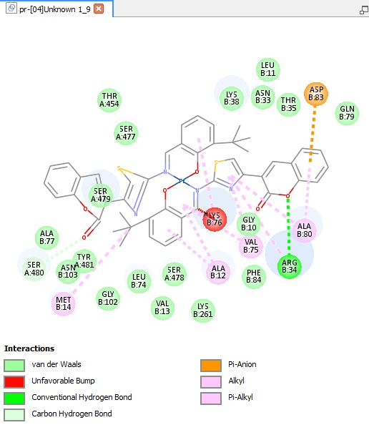

**Figure 2** Pt3TbCTS and 6PGD's active area interact

The 6PGD enzyme was inhibited by the Pt(5MCTS)2 molecule. Figure 3 showed Pt(5MCTS)2 graphs, whereas Figure 4 depicted 3D interactions maps. MolDock scored -199.994 out of 100 in the docking results. The enzyme's 3D interaction map shows that Asn 103 amino acids connected with Pt(5MCTS)2 through hydrogen bonds. Light green lines in Figure 4.6 indicate the presence of hydrogen bonding.

**Figure 3** Chemical activity percentage [Pt(5MCTS)2] – [Pt(5MCTS)2] graph 6PGD enzyme

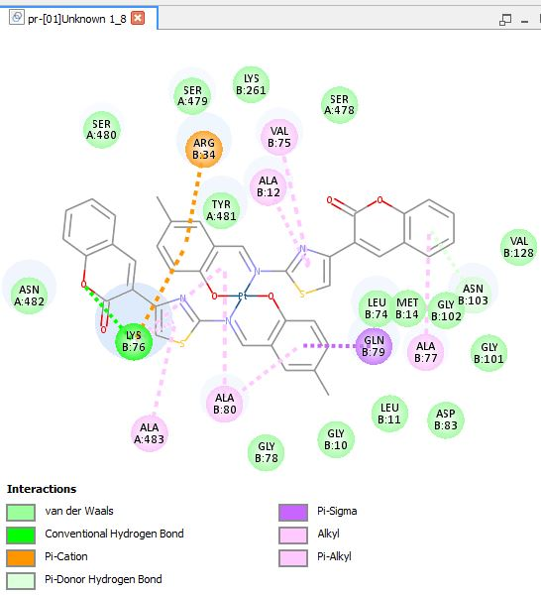

**Figure 4** Pt(5MCTS)2 and 6PGD's active area interact

The 6PGD enzyme was inhibited by the Pt(3MeOCTS)2 molecule. Figure 5 showed Pt(3MeOCTS)2 graphs, whereas Figure 6 depicted 3D interactions maps. MolDock docked with a score of -190.794 out of 100. According to the enzyme's 3D interaction map, Asn33 and Lys 76 amino acids interacted through hydrogen bonds with Pt(3MeOCTS)2. Figure 4.8 shows the existence of hydrogen bonds, which are shown by the light green lines in the diagram.

**Figure 5** Chemical activity percentage [Pt(3MeOCTS)2] – [Pt(3MeOCTS)2] graph 6PGD enzyme

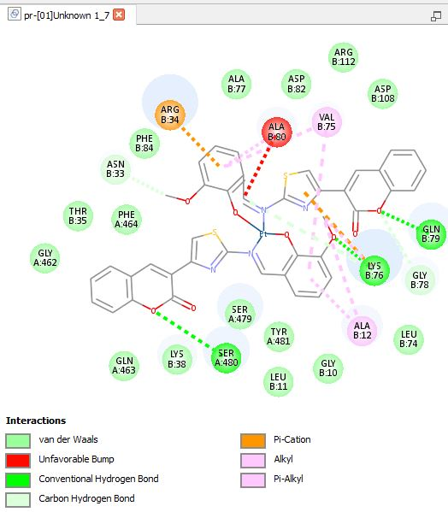

**Figure 6** Pt(3MeOCTS)2 and 6PGD's active area interact

**CONCLUSIONS**

Recent studies have identified this new biological molecule, 6PGD as a promising cancer treatment target. The proliferation, survival, and metastasis of tumor cells may be boosted by 6PGD's reprogrammed tumor bioenergetics, according to several studies. In addition, overexpression of 6PGD leads to the development of chemoresistance in cancer cells. The mechanism of chemo-drug resistance has yet to be discovered, though. Is the elevated phosphorylation of 6PGD due to EGFR-mediated EGFR activation a factor in chemoresistance? Is it possible that 6PGD-mediated alterations in the expression of p53 contribute to cancer cell resistance? Future research should focus on this.Future studies should concentrate on 6PGD's nonenzymatic and protein–protein interactions in order to create and ensure the effectiveness of new inhibitors of 6PGD. Nonenzymatic actions of 6PGD are crucial to the cell's regular functioning, but how substantial are they? PGAM1 has been shown to interact with 6PGD, thus we should think about how these two metabolic pathways are intertwined. Existing 6PGD inhibitor biosafety profiles and side effects, as well as metabolic-dependent toxicity, must be explored. The utilization of 6PGD as a therapeutic target requires more research. That's why we need to keep an eye out for new avenues of research in order to get a complete understanding of the function of 6PGD in cancer progression.

**References**

1. Vander Heiden, M. G. and Berardinis, R. J. 2017. Understanding the intersections between metabolism and cancer biology. Cell., 168(4): 657-669.
2. Sarfraz, I., Rasul, A., Hussain, G., Hussain, S. M., Ahmad, M., Nageen, B. and Ali, M. 2018. Malic enzyme 2 as a potential therapeutic drug target for cancer. IUBMB life., 70(11): 1076-1083.
3. Liberti, M. V. and Locasale, J. W. 2016. The Warburg effect: how does it benefit cancer cells. Trends in biochemical sciences., 41(3): 211-218.
4. Cho, E. S., Cha, Y. H., Kim, H. S., Kim, N. H. and Yook, J. I. 2018. The pentose phosphate pathway as a potential target for cancer therapy. Biomolecules and therapeutics., 26(1): 29.
5. Lin, R., Elf, S., Shan, C., Kang, H. B., Ji, Q., Zhou, L. and Chen, J. 2015. 6-Phosphogluconate dehydrogenase links oxidative PPP, lipogenesis and tumour growth by inhibiting LKB1–AMPK signalling. Nature cell biology., 17(11): 1484-1496.