**A New Era in Human Settlement Problemmatics:**

**Our New Life in a New Celestial World:**

**Priorities, Problems and Possible Solutions**

**Mehmet Emin Özel*, Edwin Budding**, Osman Demircan**, Yılmaz Akyıldız***, Ali Akdemir**\*\*\*\*

(*Çukurova Univ. UZAYMER, Adana;**ÇOMÜ(e), Çanakkale; ***METU(e), Ankara; ****Arel Univ., Istanbul)/Turkey

**Abstract:**

We are at the treshold of establishing new settlements in nearby celestial bodies. Our next move is to the Moon. It may take place in less than few (2-3) years. This makes it an urgent planning problem to re-consider the logistics priorities in such a rather hostile environment. We do have some past experience. However, in terms of longer term, deeper, almost absolute isolation we can say, we have almost no past experiences in such a high risk task for such long durations. Experiences gained in some earthly space enterprices such as the cooperative efforts in **International Space Station** as well as the international management rules declared by **United Nations** like the **Moon and Space Treaties** or the **Antarctic Agreement** will surely help in many respects. We also feel that, developements in the area of Artificial Intelligence (AI) is an area to help to the success of space settlers in their daring tasks. All such possible overlaps of existing topics and developments need to be extensively explored and used, in the light of aims of our conference.

Key words: Space Settlements, space confinement experiments, Biosphere-2, Antarctic confinemnt problems, small space confinement problems

1. **Introduction**

New human-inclusive longer term settlements to be established, starting from Moon (later, on Mars) is expected to have their own rules of adminitration and conduct. There are also some existing international treasties and experiences of cooperation and conduct which may help to the success of the tasks. However, the successful management of such a truly long-duration (>> several years..) isolation and continuing to funtion with succesful coordination may need/create new rules, new practices. One thing that comes to mind is the need to be on stricter scientific priorities.

Our experiences gained on Earth or near-Earth environments are expected to help for such new undertakings. Among such exercises we can enumarate

1. Biosphere-2 experiments in Arizona;
2. 500-days of isolation of small group of “astronauts simulating a Mars fight” experiment;
3. International Space Station (ISS) management and health experiences of diverse groups, under (partial?) isolation and the inter-community relations for various durations and mix of peoples;
4. One-week long Apollo Moon human-landing experiences and others

and more importantly,

1. the theories developed, accumulation of practices, experiences and knowledge in the management of human organizations of various scales and conditions, under variour earthly conditions and environments (which is the main topic of present conference).

Now, we can pay a nearer look at some the different-looking conditions and earlier practices that have arised under true or simulated livings in space or near-space environments.

* 1. **Biosphere-2 isolation experiments**

“**Biosphere-2**” was a special set of buildings and structures built (between 1986-1989) to conduct experiments planned to simulate an artificial ecosystem (*vivarium*) for maintaining human life in outer space environments such as the Moon or Mars. The facility is located at Oracle- Arizona USA, on an area of 12,700 m2. It was aimed to function, fully independent of **Biosphere-1** (the Earth).

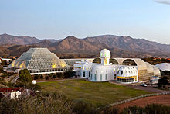 **General view of Biosphere-2 building area after its completion, in 1990, at Oracle, Arizona, USA.**

After its completion, two seperate experiments of **long time isolation** (under Earth’s gravity conditions) were conducted. **The first one** was run between 1991-1993 with 8 people to live in this closed and sealed environment. The aim was to gain experience and knowledge about the use and maintanence of a closed biospheres for future  [space colonization](https://en.wikipedia.org/wiki/Space_colonization). **A second experiment** with a shorter term duration was also conducted in March-September 1994.

According to reports, both attempts ran into problems like

1. amounts of food and oxygen were getting lower and lower (contrary to expectations);
2. many animals and plants[1] included in the experiment were dying off (though this was expected since the project used a strategy of deliberately "species-packing" anticipating losses as the biomes developed);
3. (unexpected levels of) group dynamic tensions among the resident crew, and a power struggle over management and in the direction of the project.

Especially the last item was decisive in terminating the experiments. Nevertheless, their closure set world records in closed ecological systems, agricultural production, health improvements with the high nutrient and low caloric diet the crew followed, and insights into the self-organization of complex biomic systems and atmospheric dynamics….

“A strategy of ‘**species-packing**’ was practiced to ensure that food webs and ecological function could be maintained if some species did not survive. **The**[**fog desert**](https://en.wikipedia.org/wiki/Fog_desert)**area** became more [chaparral](https://en.wikipedia.org/wiki/Chaparral) in Other details of the conduct for the interactions of various bioms and environmental networks (more details can be obtained from the webite) were as follows:

character due to condensation from the space frame. **The savannah** was seasonally active; its biomass was cut and stored by the crew as part of their management of carbon dioxide. **Rainforest** [pioneer species](https://en.wikipedia.org/wiki/Pioneer_species) grew rapidly, but trees there and in the savannah suffered from [etiolation](https://en.wikipedia.org/wiki/Etiolation) (low-level lighting conditions)n  and weakness caused by lack of [stress wood](https://en.wikipedia.org/wiki/Reaction_wood), normally created in response to winds in natural conditions. [**Corals**](https://en.wikipedia.org/wiki/Coral) reproduced in the ocean area, and crew helped maintain ocean system health by hand-harvesting algae from the corals, manipulating calcium carbonate and pH levels to prevent the ocean becoming too acidic, and by installing an improved [protein skimmer](https://en.wikipedia.org/wiki/Protein_skimmer) to supplement the [algae turf scrubber](https://en.wikipedia.org/wiki/Algae_scrubber) system originally installed to remove excess nutrients. **The mangrove area** developed rapidly but with less [understory](https://en.wikipedia.org/wiki/Understory) than a typical [wetland](https://en.wikipedia.org/wiki/Wetland) possibly because of reduced light levels. Nevertheless, it was judged to be a successful analogue to the Everglades area of Florida where the mangroves and marsh plants were collected.”

“Biosphere 2, because of its small size and buffers, and concentration of organic materials and life, had greater fluctuations and more rapid [biogeochemical cycles](https://en.wikipedia.org/wiki/Biogeochemical_cycle) than are found in Earth's biosphere.Most of the introduced [vertebrate](https://en.wikipedia.org/wiki/Vertebrata) species and virtually all of the [pollinating insects](https://en.wikipedia.org/wiki/Pollinators) died, though there was some reproduction of plants and animals. Insect pests, like [cockroaches](https://en.wikipedia.org/wiki/Cockroach), flourished. Many insects had been included in original species mixes in the biomes but a globally invasive tramp ant species  ([*paratrechina longicornis*](https://en.wikipedia.org/wiki/Paratrechina_longicornis)*)*, unintentionally sealed in, had come to dominate other ant species. The planned ecological succession in the rainforest stress of the system and strategies to protect the area from harsh incident sunlight and salt aerosols from the ocean area worked well, and a surprising amount of the original biodiversity persisted. Biosphere 2 in its early ecological development was likened to an island ecology.”

As can be seen, there has been many lessons learned about how to build interacting species networks and shortcomings of such undertakings, mostly due to the limited size of the Biosphere-2 area and volume and other conditions. However, inter-human relations and management in such not-so-harsh conditions (i.e., with relativly security –they are still on Earth and urgent help is easy to reach- and quite large volume of ecological volumes involved), have shown (un)expected conflicts not resolved internally (for more iteration, see also section 3, below).

**1.2 Antarctic isolation experiences**

The **Antarctic**  is the [polar region](https://en.wikipedia.org/wiki/Polar_regions_of_Earth)  around the Earth’s [South Pole](https://en.wikipedia.org/wiki/South_Pole). It includes the main continent of [Antarctica](https://en.wikipedia.org/wiki/Antarctica), and the [island territories](https://en.wikipedia.org/wiki/List_of_Antarctic_and_Subantarctic_islands) located on the [Antarctic Plate](https://en.wikipedia.org/wiki/Antarctic_Plate).  The region covers about 1/5th the [Southern Hemisphere](https://en.wikipedia.org/wiki/Southern_Hemisphere), of which 14 million km2 is the surface area (40% larger than Europe) of the continent itself. All of the land and [ice shelves](https://en.wikipedia.org/wiki/Ice_shelf) south of [60°S latitude](https://en.wikipedia.org/wiki/60th_parallel_south) are administered under the [**Antarctic Treaty System**](https://en.wikipedia.org/wiki/Antarctic_Treaty_System) **(ATS)**.

The **Antarctic Treaty** and related agreements, collectively known as the Antarctic Treaty System (ATS), regulate [international relations](https://en.wikipedia.org/wiki/International_relations) with respect to [Antarctica](https://en.wikipedia.org/wiki/Antarctica). It is the Earth's only [continent](https://en.wikipedia.org/wiki/Continent) without a native human population. It was the first [arms control](https://en.wikipedia.org/wiki/Arms_control) agreement established during the [Cold War](https://en.wikipedia.org/wiki/Cold_War), setting aside the continent as a scientific preserve, establishing freedom of scientific investigation, and banning [military activity](https://en.wikipedia.org/wiki/Military_activity_in_the_Antarctic). Since September 2004, the [**Antarctic Treaty Secretariat**](https://en.wikipedia.org/wiki/Antarctic_Treaty_Secretariat), implemenying the treaty system, is headquartered in [**Buenos Aires**](https://en.wikipedia.org/wiki/Buenos_Aires)**, Argentina.** The convention (The Agreement)   is managed through an international commission headquartered in [**Hobart**](https://en.wikipedia.org/wiki/Hobart)**, Australia.** It decides also, annual [fishing](https://en.wikipedia.org/wiki/Fishing) quotas, licenses and international inspectors on the fishing vessels, as well as [satellite](https://en.wikipedia.org/wiki/Satellite) surveillance of the entire region.

Present inhabitants of the continent are a few thousand transient [scientific](https://en.wikipedia.org/wiki/Science) reseach and other personnel working on tours of duty, lasting several months at the several dozen [research stations](https://en.wikipedia.org/wiki/Research_stations_in_Antarctica) maintained by various countries[2]. However, the region is visited by more than 40,000 tourists annually, the most popular destinations being the [Antarctic Peninsula](https://en.wikipedia.org/wiki/Antarctic_Peninsula) area (especially the [South Shetland Islands](https://en.wikipedia.org/wiki/South_Shetland_Islands)) and [South Georgia Island](https://en.wikipedia.org/wiki/South_Georgia_(island)).

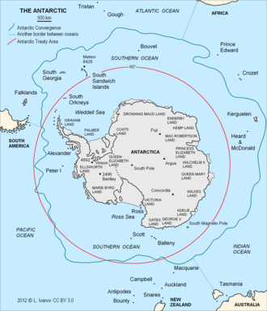

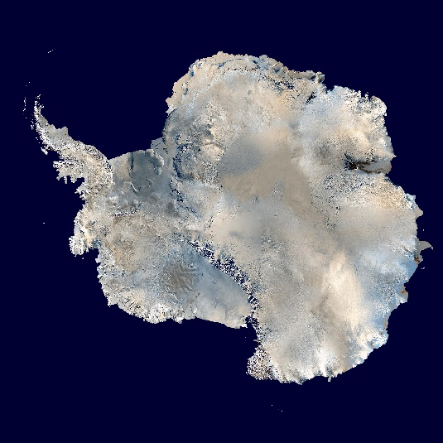

**(Left) Images from various remote sensing satellites are combined to obtain the picture indicating not only the ice–covered surface of Antarctic, but also, some of its topography. Antarctic Peninsula is the pointed extention towards South America, in the middle-upper left of the image. (Right) Stations on Antarctic continent where human settlements exist (as points with names) as well as the jurisdiction boundary of ATS (red circle, South of -60 degrees latitute) are noted with adopted names of sea and land regions. Blue-green closed line around the main land is the continental shelf. The Horseshoe Island (where Turkish Antarctic Station will be established), can be seen as seperated from Antarctic Peninsula on the map. On the image, celand is connected to the peninsula due to heavy snow and bridge forming during each Antarctic winter.**

Living in Antarctic includes long durations of confinement and isolation conditions for groups of scientists and service personnel. The study of this phenomenon is known as "**the** [**confined environment psychology**](https://en.wikipedia.org/wiki/Confined_environment_psychology)" ([*cf.*](https://en.wikipedia.org/wiki/Cf.) [environmental psychology](https://en.wikipedia.org/wiki/Environmental_psychology)), and it was known to be a serious challenge. In the events, often crews split into two or several factions. Much of the evidence for isolated human groups comes from psychological studies of scientists over-wintering in [Antarctic](https://en.wikipedia.org/wiki/Antarctic) research stations. Results of one such relatively “controlled” experiment includes, other than the valuable cooperative effotrs, a stabbing of one scientist by his rival fellow. It shows the severity of confilict levels even among such elite groups. All such conflicts will be discussed in the next section.

### **3.Group dynamics: psychology, conflict, and cooperation**

Although the examples cited above may not fully represent what will be encountered in the coming space confinement conditions, they may still teach us about how to manage such groups and possible conflicts.

### **3.1 Biosphere-2 isolation experiments results**

In the mentioned termination event above, crisis arised before the mission was half over. The group inside had split into two factions so that, people who had been intimate friends had become implacable enemies, barely on speaking terms. The factions inside formed from a rift and power struggle between the joint venture partners on how the science should proceed, as biospherics or as specialist ecosystem studies (perceived as reductionist). The faction that included Poynter felt strongly that increasing research should be prioritized over degree of closure. The other faction backed project management and the overall mission objectives. Debate resulted a portion of the Scientific Advisory Committee (SAC) to resign. This became a new at the Time magazine, One author  wrote: "Now, the veneer of credibility, already bruised by allegations of tamper-prone data, secret food caches and smuggled supplies, has cracked... the two-year experiment in self-sufficiency is starting to look less like science and more like a $150 million stunt". In fact, the SAC was dissolved because it had deviated from its mandate to review and improve scientific research and became involved in advocating management changes. A majority of the SAC members chose to remain as consultants to Biosphere 2. The SAC's recommendations in their report were implemented including a new Director of Research, allowing import/export of scientific samples and equipment through the facility airlocks to increase research and decrease crew labor, and to generate a formal research program.

Undoubtedly the lack of oxygen and the calorie-restricted, nutrient-dense diet contributed to the low morale of people inside. One faction feared that the other group were prepared to go so far as to import food, if it meant making them fitter to carry out research projects. They considered that would be a project failure by definition.

In the result, it was seen that, isolated groups tend to attach greater significance to group dynamic and personal emotional fluctuations common in all groups. Some reports from polar station crews exaggerated psychological problems. So, although some of the first closure team thought they were depressed, psychological examination of the biospherians showed no depression and fit the explorer/adventurer profile with both women and men testing very similar to astronauts. One of the psychologists noted, "If I was lost in the Amazon and was looking for a guide to get out, and to survive with, then the biospherian crew would be top choices."

With all the conlicts and rivaling attepts, the general feeling is that the crew continued to work together as a single team to achieve the experiment's goals, mindful that any action that harmed Biosphere 2 might imperil their own health. This is in contrast to other expeditions where internal frictions can lead to unconscious sabotage of each other and the overall mission. All of the crew felt a very strong and visceral bond with their living world. They kept air and water quality, atmospheric dynamics and health of the life systems constantly in their attention in a very visceral and profound way. This intimate "metabolic connection" enabled the crew to discern and respond to even subtle changes in the living systems. “Appreciation of the value of biosphere interconnectedness and interdependency was appreciated as both an everyday beauty and a challenging reality", one biospherian later acknowledged "I don't like some of them, but we were a hell of a team. That was the nature of the factionalism... but despite that, we ran the damn thing and we cooperated totally".

### **3.2 Antarctic isolation experiments results**

In a 2010 paper titled “*Antarctica and Interpersonal relationships among station members*” (Paul et al, 2010), a criminal act during a long duration isolation (14 months) of 23 individuals (scientists and service personnel) in an Antarctic station is reported. Such events are quite clear example of the psychological stress and challenge on persons who are living and working in isolated, confined, and extreme environments for long periods of time. A short accout of the event reported above, was announced in the web site of Portogal Polar Early Science Committee (APECS) by one member (Quinteiro, 2018), as follows:

“Very recently, the media were flooded by the story of a polar scientist who stabbed a colleague at an Antarctic Station. Situations like this one are a very clear example of the psychological challenge of living and working for long periods of time in an isolated, confined, and extreme environment. For the teams of scientists who are going to spend the winter in an Antarctic station, the interpersonal relationships that happen among the people living inside the base are fundamental to guarantee the group's well-being and the accomplishment of the daily tasks.

However, the way these interpersonal relationships evolve over the whole duration of the campaign seems to undergo a significant change about halfway through the mission. Indeed, the analysis of the inter-personal behaviors of 23 individuals who spent 14 months at a station in Antarctic suggests that during the first half of the campaign there was a tendency to increase and improve relationships within the base, and that from the beginning of the second half of the campaign there was a deterioration in the quality of interpersonal relationships that were already established. On one hand, the members of the base demonstrate that they need to relate and feel connected to other people, on the other, they want to do so without having to interact much or establish a stronger affective connection.

Curiously, this deterioration or cooling of interpersonal relationships does not necessarily happen because people within the base develop bad relationships and conflict. What seems to happen is that the need to establish deeper interpersonal relationships, in which individuals talk about their feelings or feel cherished decreases over time, which could be a kind of mechanism of adaptation to life in isolation. As a consequence, if on one hand the interaction between base members becomes less frequent, on the other hand each individual seems to become more competent to manage their own relationships and this is critical to the success of the campaign

1. **New Priorities in highly hostile environments**

We will restrict our discussion only to the results of two experiments detailed above, leaving aside others mentioned in section above in the “Introduction”.

These two examples show that, although cooperation with a foreseen goal of achievement may help to overcome the conflicting interests among group members, unexpected severe ones (like stabbing action) may lead to criminal acts, which are harder to deal with. One solution to reduce tensions and conflitcs could be to keep everybody involved with their tasks urgently needed for survival f all. For example, converting what is available in the environment into useful and usable materials is among such goals.

At Moon, a very imported in-situ resource available is water ice mixed with lunar soil (called “regolith”). As is well known, water has a molecular structure made of 2 hydrogen atoms and 1 oxygen atom, therefore, has the chemical formula H2O. If water could be succesfully seperated from the lunar soil, then, this will not only provide drinking water thru evaporation and condensation, but also provide, thru electrolysis, molecular oxygen (O2), the most important constituent of air we breathe.

Existance of ice in such un-lit locations of Moon were already proposed since 1980’s and, later, discovered by Moon-orbiting satellites (using spectroscopic signature of ice) in certain craters in and near polar regions where the sunlight never reaches. The source of ice is considered to be the comets orbiting the Sun and, from time to time, hitting the surface of the Moon since about 4 billion years. Comets are mostly made up of various ices such as water, carbon dioxide and ammonia, mixed with some dirt and regolith type of material. Those hitting the Moon and falling into such un-lit locations are expected to preserve their ice contents due to very low temperetures (down to -180 C). There is also the possibility that certain valleys and flat lands may contain ice below the regolith (lunar soil), as has been the case in Mars.

Now that we have to take care of some more basic needs than housing and food, we need a carefull prior planning for such basic needs as air and water security. In the short run, probably they will be brought from Earth. But, in the long run, water and air supplies, as well as food need to be created/grown on the location, using what is available in the environment.

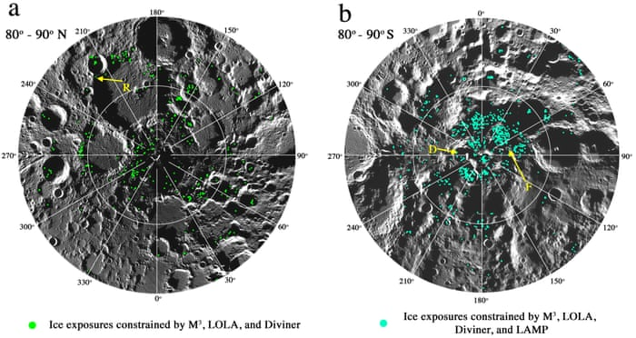

**These NASA maps of North (left) and South poles of moon indicates positions of water molecules (color) on the surface of several craters. Planners of Artemis Lunar Landing Missions have announced a possible position for a permanent base, near one of such ice deposits ain the South Pole regions. Inner circles in each map denote +85°N and -85°S latitudes around the poles.**

1. **Lessons from the Theories and Practices of “Managemnt of Organizations” studies and conculusions**

In many respects, the aimed space isolation ‘experiments’ on Moon (and eventually, on Mars) by small number of human crews in limited space and resources environments have several analog experiences or cases in or near-Earth environments, as discussed above. However, there will be one important difference factor waiting for them: No hope of help or emergency aids will be available for the crew, for time intervals longer than any earlier ‘analog’ cases. This duration will be no less than several months for Moon and several years for Mars.

Could this factor alone create a “game changer” effect and teach us many new facets of “management of organisation” practices not encountered before? This is entirely possible. Therefore, **results and theoretical aspects of our “management” disipline accumulated in the past and to be presented in this conference**, will have relevance to the expansion of the field as well as great benefits to those players of management in the new space environments.

**References**

Paul, F.J., Mandal, M.K., Ramachandran , K., and Panwar, M.R. (2010), “Interpersonel behaviour in an isolated and confined environment”, *Environment and Behaviour*, 42(5), 707-717. (*and other releted wikipedia sources*). (doi:10.1177/0013916509336889)

Quinteiro, P., 2018, <https://apecsportugal.wixsite.com/apecsportugal-en/post/isolation-in-antarctica> (*and other related internet and wikipedia sources*.)

1. Some of the domestic animals that were included in the agricultural area during the first mission included: 4 African [pygmy goats](https://en.wikipedia.org/wiki/Pygmy_goat) and 1 billy goat; 35 hens and 3 roosters (a mix of Indian jungle fowl ([*Gallus gallus*](https://en.wikipedia.org/wiki/Gallus_gallus)), [Japanese silky bantam](https://en.wikipedia.org/wiki/Silkie), and a hybrid of these); 2 sows and 1 boar [Ossabaw dwarf pigs](https://en.wikipedia.org/wiki/Ossabaw_Island_hog); and [tilapia](https://en.wikipedia.org/wiki/Tilapia) fish grown in a rice and [azolla](https://en.wikipedia.org/wiki/Azolla) pond system originating millennia ago in China.
2. Turkey is also in the process of establishing a scientific research station, in an island called Horse-shoe Island which is in the region, so called, the Antarctic Peninsula, an extention of the continent nearing to the South America.