IRSTI 14.25

***Chernigovtseva O.J.1, Dalbergenova L.Y.2, Pristupa Y.N.3***

1doctoral student, department of the English language and methods of teaching, faculty of philology and pedagogies, Sh.Ualikhanov Kokshetau University, Kokshetau, 020000, Republic of Kazakhstan. E-mail:[chernigovtsevao@inbox.ru](mailto:chernigovtsevao@inbox.ru), https://orcid.org/0000-0001-8431-2893.

2PhD, department of the English language and methods of teaching, faculty of philology and pedagogies, Sh.Ualikhanov Kokshetau University, Kokshetau, 020000, Republic of Kazakhstan.

E-mail: ljasatdal@mail.ru, <https://orcid.org/0000-0002-9558-148X>

3D.Sc. (pedagogy), professor, associate professor, Institute of additional vocational training of social workers, Moscow, 119435, Russian Federation.

E-mail:[pristupa-mhpi@yandex.ru](mailto:pristupa-mhpi@yandex.ru), <https://orcid.org/0000-0001-8363-8496>

**ANALYSIS ON MOTIVATION OF STUDENTS IN NON-LINGUISTIC EDUCATIONAL PROGRAMS**

*Abstract. Motivation is considered one of the key factors influencing success in learning a foreign language. This article presents the results of an empirical study on the problem of motivating students in non-linguistic educational programs to learn a foreign language. The purpose of the study is to identify the type and level of motivation for learning English among students in non-linguistic educational programs. The study involved 84 first-year students of Sh.Ualikhanov Kokshetau University. Analysis was carried out using a questionnaire developed based on the method for assessing the motivation in learning a foreign language (Attitude / Motivation Test Battery by R. Gardner).*

*Keywords: higher education, non-linguistic University, foreign language learning, motive, motivation, motivation to learn a foreign language, instrumental motives, integrative motives, analysis.*

INTRODUCTION

In the modern age and with the wide spread of globalization, the English language has become an important link in connecting people and serving universal communication for many purposes [1, 15]. According to Zhang, there is a discrepancy between skills acquired by university students and skills essentially required by employers in the real world. It is important to have the knowledge of language’s vocabulary, grammar, and syntax is important; but it has to be accompanied with pragmatic and practical skills, such as communicative, teamwork skills, problem-solving, planning skills, selfmanagement, in addition to technological skills to cope with the increasing communication demands in an internationalized environment. [2, 67]

Teaching these core skills, as proven by earlier studies, necessitates implementing many strategies and procedures, such as roleplaying, working in groups, and performing written and oral tasks; for example, reports, memos, job interviews and presentations, among others. In addition, students should know how to research, organize and schedule tasks, manage time, develop plans and strategies, and solve problems in the target language. [3, 43] Thus, it is required from students to be subjected to case studies, decision-making tasks, and problem-solving methods pertaining to their field. Moreover, students must know how to plan, organize portfolios, self-assess, and use technological tools in the target language to effectively communicate information and accomplish the assigned tasks and projects. All these skills allow students to manage their education. And, this is one side of the issue.

From the other side, fluency in a foreign language significantly increases competitiveness of specialists, as foreign language communicative competence is an important component of a specialist’s professional competence in any sphere.

Nowadays, Kazakhstani Universities are faced with the necessity to provide high-quality language training to students as well as with the need to create psychological and pedagogical conditions conducive to improving the effectiveness of training.

However, this is hampered by the fact that the majority of non-linguistic students have a low level of motivation to learn a foreign language, which directly affects the success of students' educational activities. [4, 134]

MAIN PART

In modern psychological and pedagogical literature, there are many approaches to the definition of motivation. The nature of this phenomenon and its structure are described in the works of A.N. Leontiev, E.N. Turetsky, L.M. Fridman, R.W. Schmidt, Abulkhanova-Slavskaya, H.A. and other scholars. [5-8]

In psychological science, there is still no single prevailing opinion in understanding the essence of motivation and its role in the regulation of behavior, nor in understanding the relationship between motivation and motive. In many works, these two concepts are used as synonyms.

In accordance with the concept of A.N. Leontiev, the author of one of the most well-formed theories of motivation, motives are considered as objectified needs, where this need is specified in given conditions and in the activity it is directed to. A.N. Leontiev considers the essence of motivation as an object that meets this need. [5, 38]

There are different points of view on the problem of determining the motive. L.I. Bozhovich considers that motives are the internal position of the individual. [9, 54] I.A. Zimnyaya defines a motive as an impulse that leads to an action. [10, 14] Markova A.К. considers that motives are connected with the outer needs of an individual. [11, 87]

Let us characterize the existing types of motivation that provide interested learning. Researchers identify two types of motivation in learning the English language: external and internal.

P.M. Yakobson considers external motivation as the basis for students to master a foreign language, and this basis may be the prospect of participating in some events, for instance. The second type of external or extrinsic motivation is narrow-personal. It defines the attitude to mastering a foreign language as a way of self-affirmation, and sometimes as a way to personal well-being. In this case various motives are possible. For example: "I want to learn English as I want to work in a foreign company". External motivation is related to the needs of students in their external well-being, including the desire to avoid troubles. The motivation that a person carries within himself, regardless of the external environment, is called internal. [12,73]

Internal motivation relates to students’ attitude to the educational material and to the educational process. This means that the student consciously masters the knowledge and skills that are important and valuable to him [13, 97].

Thus, motivation being a set of various actions that encourage students to achieve results is the most important pushing element in the process of mastering a foreign language. It is a part of the subjective world of the student, which is determined by his|her own motives and ideas, perceived by his|her needs. [14, 99] This is why it may be difficult to create motivation from outside. [15, 5]. The teacher can only indirectly influence it, creating the prerequisites and forming the foundations based on which the students have a personal interest in the work. The teacher should determine the level and type of motivation in order to work out the motivational means and realize their purposes. [16]

R. Gardener identifies three components of the motivation in learning a foreign language. They are: 1) the effort to achieve the goal (time, spent on learning the language and perseverance of the student); 2) the desire to achieve the goal (how strong the desire of a learner is to learn the language); 3) and a positive attitude to the goal (emotional attitude to the language learning process) [17].

R. Gardner defines instrumental and integrative motivation to learning a foreign language: instrumental motivation is associated with practical reason for learning a foreign language, while integrative motivation is mostly connected with the interest in the culture of the language under study and the desire to communicate with people who speak this language [18]. In this connection internal motives bring personal meaning into actions, while external ones encourage activities in order to reach results. [17, 12]

In order to form these types of motivation a complex of external and internal motives should be considered. [18] At the same time, it is necessary to distinguish:

1) what major motives students have; 2) if the students' are interested in foreign language learning ​​and their attitude to learning English in particular; 3) difficulties that the students encounter when learning a foreign language.

The purpose of the investigation is to determine the level of instrumental and integrative motivation and analyze the difficulties the students have while learning a foreign language.

The research is based on R. C. Gardner’s Attitude/Motivation Test Battery (AMTB) for use with students studying English as a foreign language. The original questionnaire includes 104 questions but the version adapted for the present research contains 31 questions. The questions are subdivided into three blocks in accordance with the aims of the research and the type of information to be obtained.

The answers (according to the Likert scale) had options “strongly disagree”, “disagree”, “moderately disagree”, “moderately agree”, “agree”, and “strongly agree".

As a result of the study, the following data were obtained.

The study involved 84 first-year students of Sh.Ualikhanov Kokshetau University, studying the following educational programs: "Information technologies" (28), “Information Systems” (27), “Physics and mathematics” (10), “Systems Engineering” (19).

From the table below it can be seen that most of the students in general are interested in learning foreign languages. 24% of participants strongly agree with the statement "I would like to be fluent in several foreign languages”, 20% - agree and 30% - partially agree. 28% of the respondents give positive answer and agree with the statement “I study English with a bigger interest comparing to other subjects”. The figure proves that learning a foreign language is of importance to the respondents. 29% of respondents agreed and 20% partially agreed with the statement “I like to study English” which underlines the positive attitude to learning the English language.

Table 1 - Interest in foreign languages in general and attitudes towards learning English

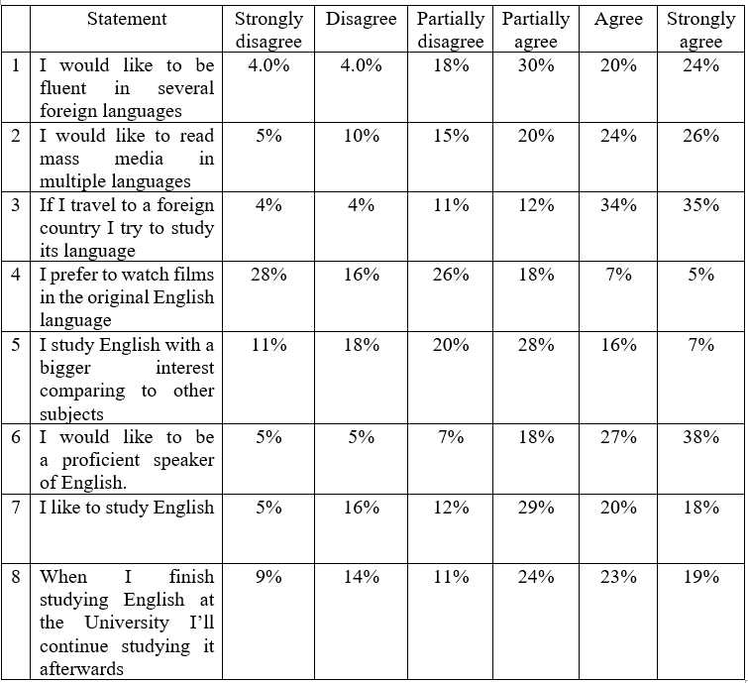

Table 2 presents the results of the study on integrative motivation for learning a foreign language. The English language is important for students as a means of communicating with English-speaking friends/colleagues. Most of the respondents agree with this statement. In addition, the biggest number of students (45%) agree with the statement that “Studying English is important because it will allow me to be more at ease with people who speak English.” The statement “When I finish studying English at the University I’ll continue studying it afterwards” with 26% of positive answers But at the same time 29% of respondents partially agree with the statement “I have a strong desire to know all aspects of English” and a considerable percentage (21%) of answers shows the polar attitude to learning English.

The high percentage of negative answers to the statement “I am interested in the culture and traditions of English-speaking countries” (23% - disagree) demonstrates the low level of interest in the culture. From one hand, the high percentage of disagreeing respondents may be partially conditioned by the current situation in the world. While on the another hand this might witness the prevailing influence of other cultures (for example, Korean and Japanese anime series, video games based on them etc.) popular among young people nowadays. Al in all the analysis demonstrates the average level of integrative motivation.

Table 2 - Integrative motivation

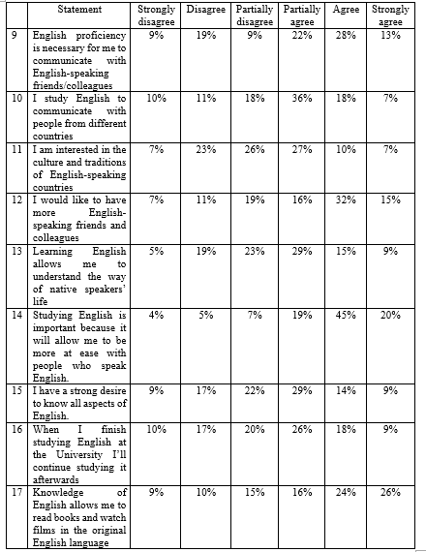

From Table 3 it can be seen that the most significant instrumental motives are:

* Communicative motives are proved by 31% of the respondents agreeing with the statement “I study English so that I can travel comfortably”. 28% of the respondents agree and 30% strongly agree with the statement “Studying English is important because it will allow me to meet and converse with more and varied people.”
* High academic motives are detected by the high percentage of agreeing respondents with the statement “The knowledge of English is necessary for me to continue my professional studies”: 23%% partially agree, 25%% agree and 23% strongly agree;
* High level of professional motives testify that a foreign language is learned on the basis of certain benefits, such as gaining a prestigious job in the future, expanding career opportunities: 18% of the respondents partially agree, 26% agree and 32% strongly agree with the statement that the knowledge of English is necessary to get a good job, to live or work abroad;
* High level of personal motives, (the motive of self-affirmation, the motive of prestige, and the motive of achievement) is confirmed with a larger percentage of respondents agreeing with the statements “studying English is important because it will make me more educated.” (23% partially agree, 33% agree and 20% strongly agree);
* Several statements testify negative motives of studying the English language. For example, 23% agree 16% strongly agree with the statement “I have to learn English because without it I won't be able to get my diploma.”

It is interesting to note the respondents admit that their parents feel they should continue studying English all through school with 33% agreeing and 22% strongly agreeing respondents. Thus, the influence of the family is pretty strong in making choice.

Table 3 - Instrumental motivation

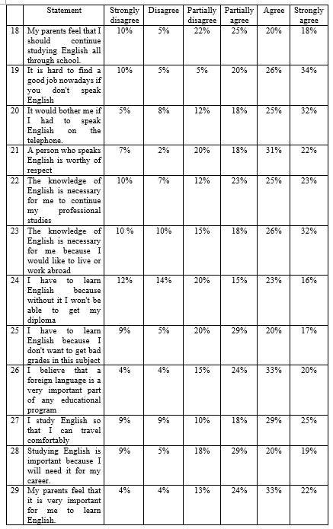

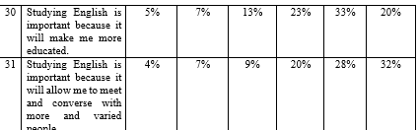

Figure 1 shows the competencies of the English language and their distribution according to the degree of complexity of working on them. The biggest difficulties that occur are connected with listening (22 people). One third of the students’ surveyed (28 people) have difficulties with reading comprehension. Listening and reading remain the most difficult language skills.

While writing and speaking are shown as the competencies the students have the fewest troubles with.

**The difficulties in learning the English language**

CONCLUSIONS

The overall results of the study show an average level of motivation to studying the English language by students in non-linguistic educational programs. Attention should be paid to the difficulties occurring in reading English sources (texts), as well as the watching video content although students demonstrate a high level of interest in these activities.

The analysis of the integrative motivation allows to conclude that it is necessary to create conditions for communication with native speakers. In terms of instrumental motivation, the study helped to identify a group of dominant motives, and they are professional, academic, narrow personal, communicative including negative ones. Based on the data received, it has been detected that the level of integrative motivation is lower than the level of instrumental motivation.

This fact indicates that the practical value of studying English is more important to students for it serves as a means of intercultural communication and a tool to expand opportunities for career growth or getting a prestigious job.

The results obtained may be important for the optimization of the educational process and the effective teaching of students in non-linguistic educational programs.

REFERENCES

1. Abulkhanova-Slavskaya, H.A. (1989). "To Sergei Rubinstein birth centenary: A profile of Sergei Rubinstein's life and work". *The Soviet Journal of Psychology*. 10 (5): 16–28.
2. Akhmetova M., Kunanbayeva S., Kassymbekova M. (2021) “Development of Metalanguage Competence through Content and Branch Training” // *Rupkatha Journal* 176 on Interdisciplinary Studies in Humanities (ISSN 0975-2935) Scopus. - Vol. 11, № 2. – 11 P.
3. Ariadna Sánchez-Hernández, Júlia Barón (2022) “Teaching second language pragmatics in the current era of globalization: An introduction” *Sage Perspectives,* [*Volume 26, Issue 2*](https://journals.sagepub.com/toc/ltra/26/2)*, available at:* [*https://journals.sagepub.com/doi/abs/10.1177/13621688211064931*](https://journals.sagepub.com/doi/abs/10.1177/13621688211064931)
4. Dörnyei, Z. (2020). *Innovations and challenges in language learning motivation*. London: Routledge.
5. Fridman L. M., Turetsky E. N. *How to learn to solve problems*. - M, 1989, 418p.
6. G. Crookes, R. Gardener (1991) “Motivation: reopening the research agenda” *Language Learning*, 41 (4), pp. 469-512
7. Gardner, R.C. & Lambert, W.E. (1972). “Motivational variables in second language acquisition.” *In R.C. Gardner & W. Lambert (eds.) Attitudes and motivation in second language learning*. (pp. 119-216). Rowley, MA: Newbury House.
8. Leontiev A.N. Psychological issues of consciousness of teaching // Izvestiya APN RSFSR. - M., 1947. - Issue. 7.
9. Long, Nguyen & Le, Tuyen. (2020). “Factors affecting Non-English Majored Students’ Motivation in Learning EFL at Tertiary Level.” *International Journal of English Literature and Social Sciences*. 5. 1631-1645. 10.22161/ijels.55.44.
10. Markova A.К. (1984) “Availability of educational material as one of the factors for reducing the overload of schoolchildren” *Soviet pedagogy*. - 1984. - No. 11.
11. Parsons R., Hinson S., D. Brown (2000) *Educational Psychology: A Practitioner-Researcher Model of Teaching* Wadsworth Publishing; 1st edition, 560p.
12. R.W. Schmidt “The Role of Consciousness in Second Language Learning”, *Applied Linguistics*, Volume 11, Issue 2, June 1990, Pages 129–158
13. Shaaban, K. (2018). Challenges of Teaching English in Tertiary Education in the Arab World.Availableat:https://web.aou.edu.lb/research/Documents/Articel_2_by_Professor_Kassem_Shaaban.pdf
14. Soprana, V. (2017). A theoretical outline of the importance of cross-cultural and pragmatic awareness in the business scenario. BERT: *Porto Alegre*, 8(1): 101-121. Available at: [*http://dx.doi.org/10.15448/2178-3640.2017.1.27462*](http://dx.doi.org/10.15448/2178-3640.2017.1.27462)*.*
15. Tolstykh N.N. (2019) “The Theory of L.I. Bozhovich: Personality, Mind, Individuality” Cultural-Historical Psychology 15(2):85-90
16. Yakobson P.M. Selected psychological works. - M. - Voronezh, 1998.
17. Zhang, L., & Atkin, C. (2010). Conceptualizing Humanistic Competence in the Language Classroom by TJP--A Chinese Case. *International Education Studies*, 3(4), 121-127.
18. Zimnyaya I. A. (2010) *Pedagogical psychology: a textbook for universities: a textbook for students of higher educational institutions studying in pedagogical and psychological areas and specialties* / I. A. Zimnyaya. - 3rd ed., revision. - Moscow: Publishing House of the Moscow Psychological and Social Institute; Voronezh: MODEK, 447 p.