**IMPACT OF RISK MANAGEMENT RELATED TO PRODUCT LIFE CYCLE IN MEDICAL DEVICE INDUSTRY IN MALAYSIA**

**by**

**Gurjit Singh s/o Harbans Singh**

**Supervisor & Co-Supervisor: Assoc Prof Dr. Anbalagan & Dr. Arivalan**

**Journal Submitted**

**for the Degree of Doctor of Business Administration**

**School of Business and Administration Wawasan Open University**

**2022**

**Abstract**

The conceptual paper is based on the impact of risk on effective risk management interventions being carried out in the Medical devices industry of Malaysia. The research is specifically based on quantitative assessment in which 400 experts shall be approach and a statistical connection to be obtained. For this purpose, the core independent variables of risks such as product life cycle (pre-market, placing to market and post market) shall be evaluated to determine its strong impact related to the effective risk management and desired outcomes can be attained related to it.

The current research is based on the identification of the risk management level and its impact on the production and development of the medical devices in the Malaysian context as Malaysia recently emerges as the market of producing medical devices, therefore, it is significant to adopt the current quantitative study to identify the risk levels during product life cycle involved in Malaysian medical technology industry. The aim of the research is to identify the risk factors and the best practices which can help in avoiding the risk level to the maximum level in the utility of the medical devices. The literature highlighted that risk is not always in the same manner in each product cycle, the risk differ in terms of the product life cycle stages and also the risks have been categorized differently which makes the impact of risk different. The research is done with the aim of using the primary questionnaire as the tool to gather data from experts in the field, the questionnaire will help in further proceeding with the quantitative analysis of the response of the experts about the level of risks involved during product life cycle of medical devices in Malaysian context as the responses are collected from Malaysian experts of medical industry. However the overall research is going to be a great input for the manufacturing companies as well as the researchers to identify the key risk factors and to work on improving the conditions of using the medical devices to avoid the risk level involved during its product life cycle.

**CHAPTER 1. INTRODUCTION**

* 1. **Introduction**

Risk is the state where the decision has more than one possible outcome and where the probability of each risk is known or can be estimated. The probability of a possible outcome can be examined based on a previous meeting or based on an assessment of the market. The more pronounced the fluctuation (i.e. the greater the number and scope) of possible outcomes, the greater the risk associated with the decision or action in a given situation (Pongrac & Majić, 2015). While risk is a cornerstone of business, especially in the medical device industry, it's important to know how to manage risk by making informed decisions based on current medical device analysis. It is generally important to understand the information as it helps to identify and understand possible open doors, but also limits the risk of participating in projects without inclusion. Without a lack of understanding of information and correct information exploration strategies, the most well-known outcomes can become an obstacle for the organization (Pongrac and Majić, 2015).

The strategy represents the practical and real qualities of the existing or configured equipment, firmware, programming or a combination as developed in the technical documentation and finally achieved in a product in the medical device industry (Rusu, 2019). Configuration Management (CM) is one of eight threads in the overall engineering management process of building and maintaining alignment between a product's actual, useful, and capabilities with its requirements, plans, and functional data over its industrial lifetime (Stjepandić et al., 2020). CM applied to a framework's pattern of existence provides visibility and control over its performance and properties. CM verifies that a frame is going according to plan and is detected and captured in sufficient detail to support its intended life cycle (Figure 1). It guarantees the verticality of the structure over time (Stark, 2019).

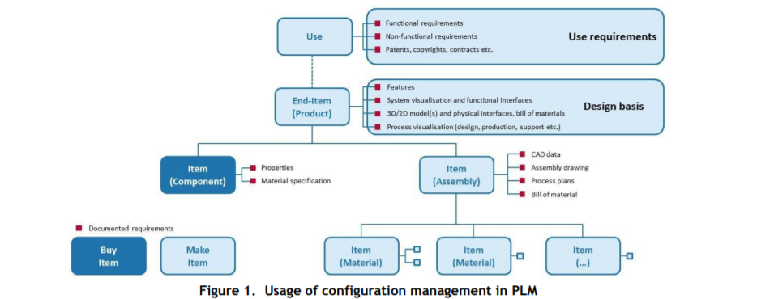

CM (Configuration Management) cares as much as possible about the number and cost of changes: (1) linking, tracking and shaping information collections throughout their life cycle and in their operating environment, (2)) conducts a reliable study of the overall clarity and Impact on progress or adaptation, (3) Automate and embed the change management method in the projects to be developed and in large-scale production (Stark, 2019). One of the powerful tools for decent configuration management is isolation. It is a suitable method to meet customer requirements with a wide range of product ranges and customization from remarkable to standard. Insulation can meet technical perspectives with business perspectives. The use of specific innovations offers far-reaching inspiration for every development plan and every organization that wants to use this world view. (Ostrosi et al., 2014).

**CHAPTER 2. LITERATURE REVIEW**

**2.1 Product Lifecycle Management:**

The product life cycle protects confirmation that proposed changes are methodically considered to mitigate antagonistic influences. Changes to the framework are identified, proposed, evaluated and implemented with a standardized approach that ensures consistency. Proposed changes are seen as opposed to their expected impact on the overall framework. CM confirms that the changes have been made as recommended and that the stuff and framework documentation reflects their actual strategy.

A complete CM program includes strategies for storing, tracking, and updating all frame data on a part, module, subsystem, and frame premise (Stark, 2019). CM is the act of informing the product launch details, checking and archiving the changes in these details. CM is an appropriate discipline to ensure the quality and long-term support of enigmatic products through predictable differentiators and convincing verification and control of all this data. ISO 10007:2003 (ISO, 2003) provides guidelines for the use of design management in an association. In line with the entire product lifecycle, it outlines responsibilities and specialists for design, cycle and readiness management and the four configuration exercises: identification, change control, strategy state calculation and strategy review (Stark, 2019).

In this way, many organizations use configuration management to ensure compliance, ensure the accuracy of target achievement, and improve performance throughout a product's lifecycle. The measured product configuration strongly maintains CM by bringing complexity to a lower level. Different associations can create, work on and maintain interoperable medical frameworks and related components. Such frameworks can be built using scenario ideas that focus on working with scenario-based recycling and relic setting when the scenario is used to build multiple frameworks (Hatcliff et al., 2018). From a business perspective, modularity should be visible as a business method to effectively plan and organize confusing products, systems and administrations as an excuse for the project. At present, measured quality can be seen as an important development philosophy within the product process for a range of product service and product system design plans (Sun et al., 2017).

The harmonization of different product variants does not entail the risk that money-related benefits are not coordinated by a comprehensive control method. Separate product cost plans can also be configured by dividing the product family into non-proprietary modules to help calculate costs (Raudberget et al., 2019). In this way, projects use strategy management to create compliance, ensure accuracy in meeting goals, and improve performance throughout a product's lifecycle. The idea of ​​a sophisticated product is intended to extend the design freedom of illustrators and frame designers. The most effective way to plan intelligent modules is an important point in planning intelligent products. Consequently, the further development of intelligent interdisciplinary collaboration and distributed stages can more easily address the problem of dealing with idiosyncrasies and variations.

The multi-agent worldview can potentially respond to this test and prepare for inventive breakthroughs in a powerful environment marked by significant changes and developments. The plan for an isolated product is supposed to determine a problem of interdependence based on the framework. The plan given must be the result of a normal and intelligent planning process, where decisions, isolated or simple, are examined in a timely manner in light of the technical needs and the expected strategy. Another task in evaluating the specific function is to increase the feasibility of the foreclosure, which must be met by all subsequent business processes (e.g., change management, risk management).



The product lifecycle or PLM (Product Lifecycle Management) is a control cycle from the source from planning and production to control and disposal. PLM integrates people, information, processes and business frameworks and provides the central data flow for organizations. At the same time, PLM frameworks help associations to approve the extension of complexity and design of new product improvement tasks for serious companies around the world (Guo and Zeng, 2010; Immonen and Saaksvuori, 2008). Poor quality information in the time spent on product launch is a major contributor to increased costs (Wu et al., 2011; Porter and Rayner, 1992; Snieska et al., 2013; Dahlgaard et al. al., 1992 Modarress and Ansari, 1987 Mar 1989).

The number of parts in each of today's products and the complexity of their form continue to increase. This pattern is visible in all companies. This is far from an uncommon case when the number of product parts is not just in the thousands, but in the thousands or even six figures (automotive, marine, aerospace and aerospace industries) (Gecevska and Stojanova, 2013). That is why it is important to maintain the risk of failure throughout the entire life cycle of any product. The degree of simplicity of changes in individual phases is shown in Figure 2.

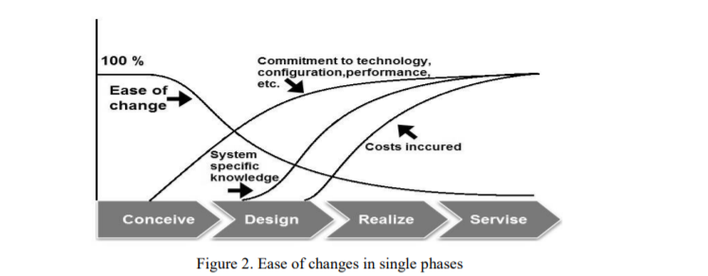

Product Lifecycle Management (PLM) is generally understood as an idea for the production, handling, storage and retrieval of information, data and in a perfect world of information throughout the life cycle of a product from idea or inception to its removal or improvement. PLM stands in the industry as one of the core ideas to meet various business requirements in the medical device industry in terms of compliance, high simplicity, rapid availability and high sense of all product information during a product lifecycle (Pfouga et al., 2018). These requirements also relate to financial aspects such as cost control and revenue development, to the actual product such as development, serious value, time-to-market, quality and high efficiency, and to management perspectives such as consistency, product risk management, product and documentation. . PLM is implemented through the deployment of IT frameworks such as Product Data Management (PDM) frameworks and ensures a high degree of interoperability of related applications. With PLM, modern organizations strive for benefits in shorter cycles, lower costs, and better quality while avoiding errors and misunderstandings. In the current PDM framework, the overall design of an isolated product is planned in a condensed product structure (Baylis et al., 2018; Bruun et al., 2015).

Election or estimate items are initially maintained in the PDM framework register in a manner consistent with all remaining items, i.e. records such as: B. Expert files with points of comparison. The only difference with standard item handling is the organization of the products as invoices. By leveraging variations in product structures, PDM frameworks can check bills of materials unbiased for requirements with arbitrary and fluctuating positions. This approach makes sense for product improvements rather than manufacturing and subdivision, as explicit parts lists are required for each variant of the product to be shipped. In addition, there is a risk that the information processing becomes extremely confused while the performance of the framework is sacrificed, especially in the case of a large number of product variants. To determine these conflicts, the current PDM framework is achieved through the Variation Supervisor module (Riascos et al., 2015).

All data such as (parts, design and cycles) runs in the base module. Due to the variations, the terms are derived from the theme and clone modules. For risk management, the clarity of the risk assessment in relation to one party (e.g. FMEA) with a specific product variant is crucial. This can be achieved by an application that performs the FMEA calculation for each part of the product structure and then creates a product FMEA by analyzing each variation using appropriate product FMEA reports. The concept of mass customization is characterized by a business methodology that uses an isolated plan for complex contributions of products and administrations organized according to need to achieve the best adaptation to the explicit needs of the customer (Stark, 2016). For the most part, one can recognize a fixed and a variable area of ​​product design, where the required and freely configurable freedom is given to individual services. Product customization is often supported by strategic frameworks (Custódio et al., 2018). Coordination of risk management support techniques such as FMEA is also conceivable.

**2.2 Risks in the conception stage:**

At the beginning of a product's lifecycle, it is always the customer who communicates their needs, and these needs must be listened to. There is no universal voice of the customer (VOC), everyone is exceptional and vastly different. Customers have different needs. Multiple needs can arise even within one purchasing unit (Pol and Merlo, 2008; Ciegis et al., 2009; Hung, 2006). This large number of votes needs to be thought through and adapted to promote a truly fruitful product. For a better understanding of the customer's needs, it is necessary to talk to him, in which it is important to distinguish the basic requirements of the customer. First, it is important to characterize the assumptions, respond to technical requests and then admonish and censor the actual cycle of product development or evaluation of a model plan, etc. The general requirements should be broken down into more explicit details: the customer should be asked to fully explain and communicate their requests until they are withdrawn.

Such practices often lead the architects behind deep mechanical products to crucial discoveries that comfort and strength are often more important to the customer than the latest innovation. In addition to the communicated wishes of the customer, you also need to recognize implicitly. Needs that are considered to be presumptions and therefore not mentioned can be distinguished by the skills tree strategy. Once all customer needs have been registered, they must be properly aligned. In fact, the voice of the customer is CTC's contribution. Customer Core (CTC) are quantifiable product performance principles that are critical to customers. The basic issues for the customer are those of particular interest to the customer, characterized by the most common way of evaluating the voice of the customer through techniques ranging from general description to meeting to focus of the meetings.

CTC provides a simple strategy for prioritizing and determining the relevant information needs throughout the cycle. CTC stuff is reflected in the Critical to Quality (CTQ) standards. At this point, CTC and CTQ are then inputs for further risk analysis, such as the Delphi strategy. The next contribution to the initial risk analysis of the entire product lifecycle is a dataset from Lessons Learned. Suggestions for participation that others can learn from to work on their achievements. It could be provided by information from DPM (Data Product Management, ERP (Enterprise Resource Planning), CRM (Customer Relationship Management) and SCM (Supply Chain Management). It is important to determine if there is a comparable product and which risks and how they arose were managed, then countermeasures should be taken at this point that correspond to the current product or ultimately improvements. As mentioned above, the input for the initial absolute risk analyzes should be the CTC, CTQ and Lessons Learned dataset, as shown in Figure 4.

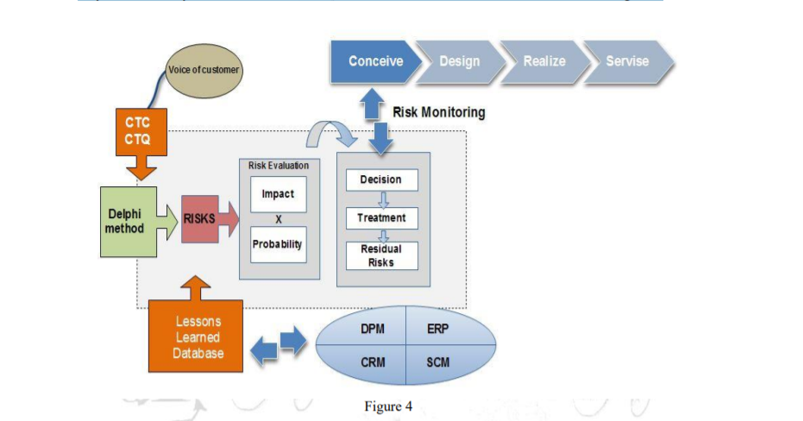

It is always difficult to estimate risk when there is little or no data. This complicates risk assessment at an early stage of the product life cycle. Nevertheless, risk analysis is an important and integral part of new product development. Therefore, the risk management process must be adapted to each stage of the product life cycle. The procedure in the concept phase is shown in figure 5. Every risk analyst starts with risk identification. The means for correctly identifying risks may differ. It is recommended to use tools such as Delphi. In addition to these methods, there is the Lessons Learned database, where information must be obtained about the risks of previously comparable products. In the next step, all identified risks are structured in a table and possible effects are described. It is complicated to assess or measure risks in the early stages of the product life cycle.

In the absence of real-time data, it is desirable to use methods such as the analytic hierarchy process for influences and Markov chains for probability assessment. A specific countermeasure or treatment can also be used for the Lessons Learned database. Consequently, the risk value is calculated to determine the priority of the baseball field diagram. If the prioritization requires treatment, the risk is reduced, avoided or transferred. If not, the risk is accepted. After treatment, all countermeasures should be reviewed and risks remeasured to determine if there is no residual risk. Risk monitoring afterwards is crucial. The risk management process in the design phase is shown in Figure 5.

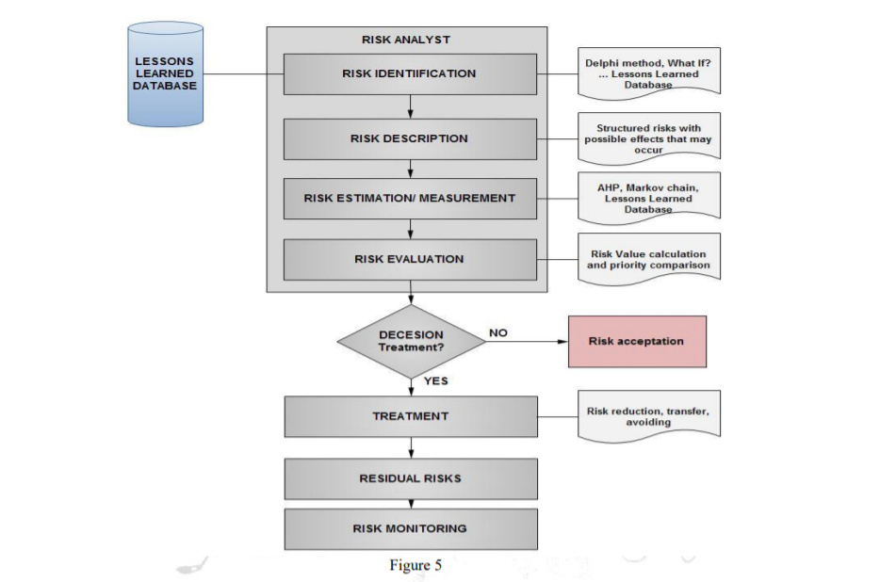

It is easy to make changes at this stage. In subsequent phases of the product, the risk and ease of change diminish and the cost of change quickly rebuilds as the product focuses on specific innovation, configuration, and performance. It is therefore necessary to distinguish all risks in the two initial phases, where changes and countermeasures are still quite conceivable. Unidentified risks during the recognition and management period can jeopardize the monetary realization of the entire product (Qi, 2008; Korecky and Trnkovsky, 2011).

**2.3 Risks in the design phase:**

A plan risk assessment is the demonstration of the safety of the expected risks in the plan cycle, whether in a point plan, further investigation or possible iteration, approval and a team plan (Markeset and Kumar, 2001). It provides a broader assessment of a plan beyond the CTQs, eliminating potential errors and reducing the impact of expected errors. It therefore makes sense to classify the risk factors in meetings and independently monitor the risks at each meeting based on the magnitude of the risks (quote). The classifications are divided into: R - active, H - people, P - process, T - innovation and O - other. Conspiracy to control risk in the configuration period is shown in Figure 6. Risks identified and residual risks with accepted risk assessments from the trade-off phase are deferred and reassessed in the plan period for potential escalation.

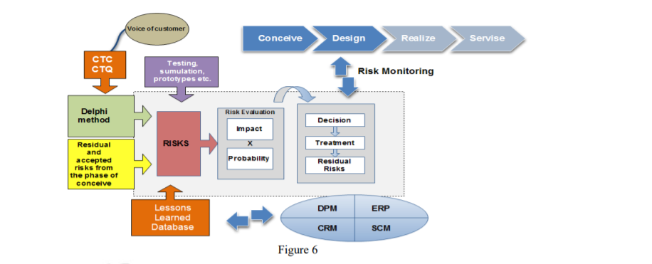

Using models and replicas, this can be an impressive way of distinguishing the medical device from the risk prospects of new products. The simulation of the treatment of the product and its introduction into the work area is also important.

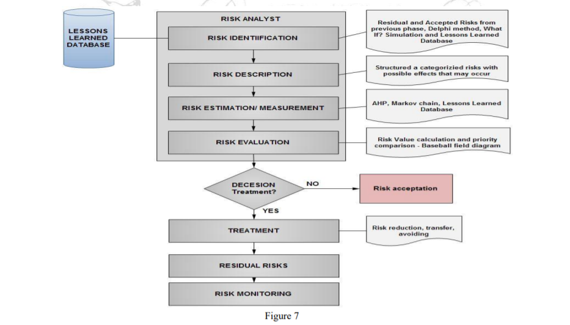

To better understand the client's needs, it's a good idea to make an appointment with a client and present the model. At that time, it is possible to change it according to the customer's needs. Because of the way the customer interacts with the model, you are likely to notice other potential risks. Basic conceptualization with a customer is crucial. In addition, it is still important to follow CTQ, CTC and VOC as a contribution to the Delphi technique. At this stage, information management is easier to use and information from DPM, ERP, CRM or SCM should be used in the Lessons Learned dataset to reflect as much as possible on the risks of previous or previously similar projects. The entire risk management system during the accrual period is shown in figure 7.

**2.4 Risk monitoring:**

When verifying risks, errors, increases in risk or errors in countermeasures can be identified. The moment this happens, it is important to take immediate steps towards him. From the outset, it is important to see if this problem has occurred before and what countermeasures have been taken. If this is the case, the countermeasure should be examined and improved or replaced. If not, then the analysis of the state of affairs should begin.

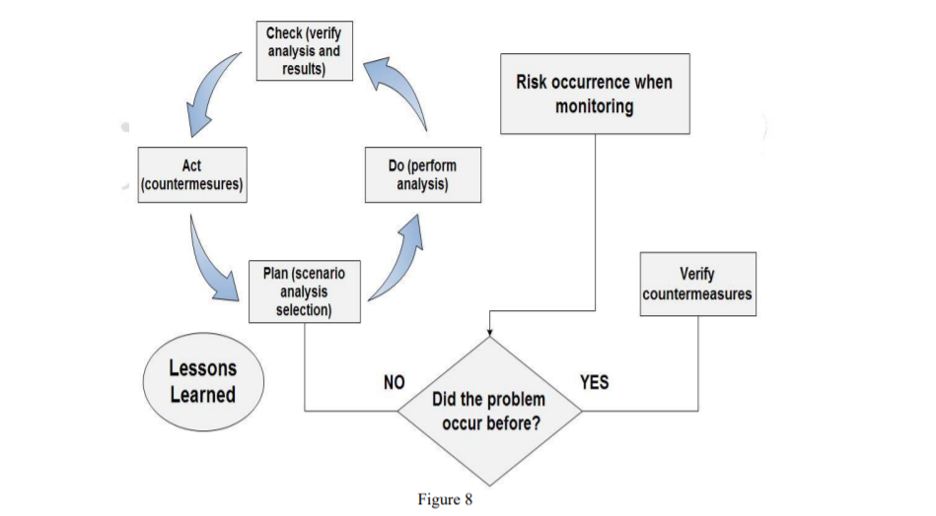

The analysis interaction depends on the PDCA cycle, where P treats a research decision as a plan. The summary of the standard analysis for the event analysis is given in Table 4. D as in Do refers to the conduct of the study, C as in Check where the secondary effects of the selected analysis are confirmed and finally An as in law, here the countermeasure is executed. This cycle is a constant interaction. Therefore, the deficiency or risk and the countermeasures are recorded in the dataset with experience. The complete cycle is shown in Figure 8.

**CHAPTER 3. RESEARCH METHODOLOGY**

* 1. **Theoretical Framework**

In this study risk management and sub variable of the risk management will be considered as the dependent variables while as the product life cycle and its phases will be considered as the independent variable of the study.

**Independent variables Dependent Variables**

**PRODUCT LIFE CYLE PHASES:**

Conceive

Design

Realize

Service

**RISK MANAGEMENT:**

Risk Evaluation

Risk Monitoring

Risk Implementation

H01

H01

* 1. **Proposition**

The key proposition been generated out of the literature review, below proposition will be tested in the this research to confirm whether they are acceptable or applicable in the current health sector context or not;

H01 : Product life cycle of the medical device do not have any significant impact on the Risk management.

## **Chaper 4. Methodology**

## **4.1 Research design**

As far as the research design is concerned, the researcher has focused upon descriptive design. The focus is primarily on descriptive research design because it enables the researcher to evaluate the topic of interest in a way that the core variables are statistically compared and contrasted in a proficient manner. Moreover, the choice related to the descriptive research design comes into play whenever a particular situation is under consideration. The present consideration on which the overall outcomes are required to be achieved tend to include the situation in which the risk management and the basis of effective risk management in the medical device industry is required to be kept intact. The research design has been backed up by a survey strategy. The motive is to carry out survey in this research study because the attitude and perception of the respondents is to be depicted in a timely manner. Not only this, the motive is to carry out real-time information so that desired outcomes can be attained. The role of survey strategy is influential because it allows the entities to be proactive in their approach. Furthermore, the time horizon through which the core activities are to be carried out is considered as cross sectional research. The research tends to be carried out in one time as the data collection and evaluation process for the survey is specifically based upon evaluating the responses for one particular time period. From a broader context, it can be indicated that the diverse range of responses related to the risk management can be gathered at one point of time and a diverse range of information can be generated related to it.

## **4.2 Unit of analysis**

As far as the unit of analysis is concerned, the experts involved in the medical devices industry of Malaysia have been approached. The sample size of the number of experts is considered to be 400. The reason why the experts have been chosen as a viable sampling frame is that the experts tend to transform their interest and can pave the way for wide range of information being generated related to the topic of interest. The depiction of the effectiveness of the risk management can be determined proactively with the help of the experts and they can clarify the pathway through which the risk elements associated with the entities and the actual outcomes related to the risks can be extracted in a timely manner. The overall outcomes being attained in this regard is somehow crucial because the choice of experts can enable the researcher to enhance the credibility of the findings.

## **4.3 Sampling design**

As far as the sampling design is concerned, the choice of probability sampling with the help of Delphi technique has been considered noteworthy. The inclusion of Delphi technique is evident in circumstances when the role of experts is considered noteworthy. The choice of being an expert certainly matters a lot and the overall outcomes being attained are somehow favorable in this regard. Moreover, the role of Delphi technique is influential because it is a systematic approach to be carried out while dealing with the sampling frame under consideration. The option of Delphi technique is evident in circumstances when the existing knowledge base is limited. Moreover, the choice of probability sampling comes into play when there is optimum chance for each and every expert to be a part of the discussion and their views related to the risk management and the adjustment related to it can be managed accordingly and in a timely manner.

## **4.4 Data collection methodology and analysis**

The first and foremost influential intervention is of the primary data collection methodology. The researcher has been keen on exploring the views of the respondents through online interactivity; therefore, they have been provided with a questionnaire instrument in which 65 statements tend to exist. Out of the 65 statements, 16 statements are related to the demographic part; whereas, 49 statements are associated with the variable section. As there are seven core variables involved in the research study; so, it is important to identify the overall basis of the outcomes. For this purpose, the core independent variables tend to include the *development of medical devices, product life cycle, risk tool, device risk class, awareness of risk and device utility;* whereas, the dependent variable tend to include the risk management in medical device industry. So, all the core variables have been included; however, for these variable, 7 statements each are evaluated as evident from the appendix displayed below. The evaluation of the responses related to the descriptive or variable section is somehow based on the element of Likert scale. The use of Likert scale has been noteworthy in this regard as the overall survey is managed effectively through this. The Likert scale has been based on a 5 point scale out of which the focus is primarily on the values. The value of 1 depicted a stronger agreement; whereas, the value of 5 reflected upon a stronger disagreement. Other than this, the use of SPSS has been considered noteworthy as the researcher has included the use of statistical software to reach towards a consensus and desired outcomes are attained related to it.

* 1. **Conclusion**

Right mindfulness, considering and subsequent risk management toward the start of the project can mean a different saving at its movement or the end. Risk management all through the whole product lifecycle is gradually turning into a standard practice, however proper strategies and systems are not generally utilized in medical device industry. This study offers a potential way how to treat risk in the primary periods of the product lifecycle where is as yet conceivable to roll out critical improvements without brought about costs that would impressively jeopardize the monetary accomplishment. Recognized risks can be utilized for a decision whether to proceed with the production of the product or roll out critical improvements in medical device industry. Playing out this analysis can bring about moderation of property, wellbeing or the environment misfortunes. This contextual investigation empowers a superior perspective on the issue of risk management of the product lifecycle and shows a potential method of utilization (Stark, 2019).

Further analysis will be committed to next product lifecycle deliberately eases to make an exceptional strategy. Always expanding monetary, time and subjective requests power current organizations and project groups to consider every conceivable risk and their results which may have lethal effects. Right mindfulness, considering and subsequent risk management toward the start of the project can mean a numerous saving at its movement or the end. Risk management all through the whole product lifecycle is gradually turning into a standard practice, yet fitting strategies and methods are not dependably utilized in medical device industry. This study offers a potential way how to treat risk in the primary periods of the product lifecycle where is as yet conceivable to roll out critical improvements without caused costs that would extensively jeopardize the monetary accomplishment. Recognized risks can be utilized for a decision whether to proceed with the production of the product or roll out critical improvements. Playing out this analysis can bring about alleviation of property, wellbeing or the environment misfortunes in medical device industry (Rusu, 2019).

**REFERENCES**

Baylis, K., Zhang, G. and McAdams, D.A. (2018), “Product family platform selection using a Pareto front of maximum commonality and strategic modularity”, Research in Engineering Design, Vol. 29, pp. 547-563. <https://doi.org/10.1007/s00163-018-0288-5>

Bruun, H.P.L. et al. (2015), “PLM system support for modular product development”, Computers in Industry, Vol. 67, pp. 97-111. <https://doi.org/10.1016/j.compind.2014.10.010>

Ciegis, R., Ramanauskiene J., &Startiene, G. (2009) Theoretical Reasoning of the use of Indicators and Indices for Sustainable Development Assessment.InzinerineEkonomika-Engineering Economics(3), 33-39.

Custódio, D.T. et al. (2018), “Variant product configuration of industrial air handling units in a MTO environment”, International Journal of Advanced Manufacturing Technology, Vol. 95, pp. 1025-1037. <https://doi.org/10.1007/s00170-017-1171-7>

Dahlgaard, J. J., Kristensen, K., & Kanji, G. K. (1992).Quality Costs and Total Quality Management.Total Quality Management, 3, 211-221. <http://dx.doi.org/10.1080/09544129200000029>

Flood, D. et al. (2015), “A roadmap to ISO 14971 implementation”, Journal of Software: Evolution and Process, Vol. 25 No. 5, pp. 319-336. <https://doi.org/10.1002/smr.1711>

Gecevska, V.; Stojanova, T. &Jovanovski, B.(2013).Product Lifecycle Management Tools, Annals of Faculty Engineering Hunedoara,Vol.1, 219-222.

Guo, Q., & L. Zeng.(2010). Analysis on risk management based on the method of FMEA of EPC general contractor projects. Management and Service Science (MASS), International Conference, 1 - 4. Harvard Business School. (2010). Improving Business Processes: Expert Solutions to Everyday Challenges. Boston, MA: Harvard Business School Publishing.

Hatcliff, J. et al. (2018), “Challenges of distributed risk management for medical application platforms”, 2018 IEEE Symposium on Product Compliance Engineering (ISPCE), 14-16 May 2018, https://doi.org/10. 1109/ISPCE.2018.8379270 ISO (2003),

Hsia, T.C., Chen, S.C., Tsai, R.K. & Huang, S.C..(2011). Using Systematic Innovation Process (TRIZ Method) to Improve the Manufacturing Technology of Platelet Agitators, 21st International Conference on Flexible Automation and Intelligent Manufacturing: FAIM 2011, Taiwan, 5.

Hung, R. Y.Y. (2006). Business Process Management as Competitive Advantage: A Review and Empirical Study. Total Quality Management, 17(1), 21-40. <http://dx.doi.org/10.1080/14783360500249836>

Immonen A.&Saaksvuori A..(2008) Product Lifecycle Management, Berlin, Springer. Korecký, M. &Trkovský.V. (2011). Management rizikprojektů: se zaměřenímnaprojekty v průmyslovýchpodnicích. Praha: Grada Publishing.

ISO (2012), ISO 14971 (2012), Medical device s. Application of risk management to medical device s (Standard for the application of risk management to medical device s), International Organization for Standardization, Geneva.

ISO (2018), ISO 31000 (2018), 05 Risk management - Guidelines, International Organization for Standardization, Geneva.

ISO 10007 (2003), Quality management systems — Guidelines for configuration management, International Organization for Standardization, Geneva.

Lämmer, L. et al. (2015), “Product Lifecycle Management”, In: Stjepandić, J. (Ed.), Concurrent Engineering in the 21st Century: Foundations, Developments and Challenges, Springer International Publishing, Cham, pp. 389-420, <https://doi.org/10.1007/978-3-319-13776-6_16>

Markeset, T., Kumar U. (2001). R&M and Risk-Analysis Tools in Product Design to Reduce Life-Cycle Cost and Improve Attractiveness, PROCEEDINGS Annual RELIABILITY and MAINTAINABILITY Symposium: IEEE., 1-7.

Modarress, B., & Ansari, A. (1987).Two New Dimensions in the Cost of Ouality.International Journal of Quality & Reliability Management, 4(4), 9-19. <http://dx.doi.org/10.1108/eb002886>

Ostrosi, E. et al. (2014), “Modularity: New trends for product platform strategy support in concurrent engineering”, Advances in Transdisciplinary Engineering, Vol. 1, pp. 414-423, [https://doi.org/10.3233/978- 1-61499-440-4-414](https://doi.org/10.3233/978-%201-61499-440-4-414).

Pfouga, A. and Stjepandić, J. (2018), “Leveraging 3D geometric knowledge in the product lifecycle based on industrial standards”, Journal of Computational Design and Engineering, Vol. 5 No. 1, pp. 54-67. <https://doi.org/10.1016/j.jcde.2017.11.002>

Pol, G., Merlo, C., Legardeur, J. (2008). Implementation of collaborative design processes into PLM systems, International Journal of Product Lifecycle Management, Inder-science, Vol.3, 279-294.

Pongrac, B. and Majić, T. (2015), “Business Risk Management”, Technical Journal, Vol. 9 No. 1, pp. 94-98.

Porter, L. J., & Rayner, P. (1992).Quality Costing for Total Quality Management.Institutional Journal of Production Economics, 27(1), 69-81. <http://dx.doi.org/10.1016/0925-5273(92)90127-S>

Qi. B. K. (2008) Engineering Project Management. Thirdedition. Dalian: Dalian University of Technology Press ,2, 6-7.

Raudberget, D. et al. (2019), “Developing agile platform assets – exploring ways to reach beyond modularisation at five product development companies”, Int. Journal of Agile Systems and Management, Vol. 12 No. 4, pp. 311-331. <https://doi.org/10.1504/IJASM.2019.104588>

Riascos, R. et al. (2015), “Digital Mock-up”, In: Stjepandić, J. (Ed.), Concurrent Engineering in the 21st Century: Foundations, Developments and Challenges, Springer International Publishing, Cham, pp. 355- 388. <https://doi.org/10.1007/978-3-319-13776-6_13>

Rusu, M. (2019), “The configuration management requirements for aviation, space and defense organizations”, INCAS Bulletin, Vol. 11 No. 1, pp. 239-253, <https://doi.org/10.13111/2066-8201.2019.11.1.19>.

Snieska, V., Daunoriene A. &Zekeviciene, A. (2013). Hidden Costs in the Evaluation of Quality Failure Costs. InzinerineEkonomika-Engineering Economics, 24(3), 176-186. <http://dx.doi.org/10.5755/j01.ee.24.3.1186>

Stark, J. (2016), Product Lifecycle Management (Volume 2): The Devil is in the Details, 3rd edition, Springer International Publishing AG. <https://doi.org/10.1007/978-3-319-24436-5>

Stark, J. (2019), Product Lifecycle Management (Volume 4): The Case Studies, Springer Nature, AG, Switzerland. <https://doi.org/10.1007/978-3-030-16134-7>

Stark, J. (2011). Product Lifecycle Management: 21st Century Paradigm for Product Realisation, London: Springer

Stjepandić, J., Wognum, N. and Verhagen, W.J.C. (2020), Systems Engineering in Research and Industrial Practice. Foundations, Developments and Challenges, Springer Nature, AG, Switzerland. https://doi.org/ 10.1007/978-3-030-33312-6

Sun, J. et al. (2017), “Modularization of Product Service System Based on Functional Requirement”, Procedia CIRP, pp. 301-305. <https://doi.org/10.1016/j.procir.2017.03.038>

Teferra, M.N. (2017), “ISO 14971 - Medical device Risk Management Standard”, International Journal of Latest Research in Engineering and Technology (IJLRET), Vol. 3 No. 3, pp. 83-87.