A PORTABLE SOLAR POWERED WATER FILTER SYSYEM: PROPOSAL STUDY

Choong Chee Guan*1, Lim Chee Yeu 1, Muhammad Isfarhan Razali 1, Muhammad Syazwan Haikal Ahmad Ibnu Malek 1 & Nurul Yasmin Batriyia Samsuri1

1 Department of Mechanical Engineering, Politeknik Tuanku Syed Sirajuddin,

Pauh Putra, 02600 Arau, Perlis, Malaysia.

* Corresponding Author Email: [dr.choong@ptss.edu.my](mailto:dr.choong@ptss.edu.my)

# ABSTRACT:

The water system in the hostel produces poor-quality tap water, which is unfit for the students to drink. Traditional water filters take a while to filter the water and are inefficient in providing clean water to many kids. The PDCA cycle was used as the foundation for the creation of a portable solar-powered water filter system to address this problem. Water filters, solar panels, water pumps, brackets, and other materials were used to construct the system, which was created using the Inventor software. The hostel's water supply is a potential issue because it can include impurities that render the water unsafe for drinking. The portable solar-powered water filter device provides the student with clean, safe water, enhancing their quality of life. The water filter, which efficiently removes contaminants from the water, is powered by the solar panel and draws water from a dependable source. The filter contains activated carbon, silica sand, zeolite, and mineral sand. Clean water will be effectively produced with this procedure. As it can be advertised in the larger corporate sector to offer clean water to communities, this project has the potential to be commercialized.

**KEYWORDS:** *Water Filter; Portable; Solar; Pump*

# 1.0 INTRODUCTION

Modern life is dependent on electricity, particularly AC power. Electricity is necessary for people to use and charge their technological devices. However, AC power has its restrictions and is difficult to get in far-off places. For instance, a water pump needs a power source to run, yet in the wilderness it might be impossible to find AC electricity. Water pumps can be powered by diesel generators, but their upkeep and operation are costly. Consequently, my research will investigate the more affordable and environmentally friendly option of using solar energy to run water pumps. The power output of the solar panel must be evaluated to identify the kind of solar panel needed to power a 12V DC water pump. Even though the solar panel's voltage is higher than the water pumps, a voltage regulator or DC-DC converter can step down the solar panel's output to 12V so that the water pump is powered.

A mechanical tool called a water pump is used to transport water from one place to another. There are many uses for water pumps, from moving water for irrigation, livestock, and industrial processes to pumping water from wells for domestic consumption. Several fuels, including electricity, diesel, petrol, and solar energy, can be used to power water pumps. They are available in various shapes and sizes, ranging from tiny hand-operated pumps to massive industrial pumps. The impeller, a revolving part that propels the water, and the motor or engine that drives the impeller are the two essential parts of a water pump. There are numerous kinds of pumps as well, each with its own unique characteristics, such as centrifugal pumps, submersible pumps, and diaphragm pumps. While utilizing a renewable energy source, using solar energy to power water pumps can dramatically lower operating and maintenance costs. Because they have more moving parts and are vulnerable to wear and tear over time, AC-powered water pumps may require more maintenance.

**Figure 1**: Project Dimensions

# METHODOLOGY

The process flow as in Figure 2 shows the steps used to complete this project from the start until end.

**Figure 2**: Design and Development Process

Based on Figure 2, firstly, solar panel absorbs sunlight, and the solar controller regulates the voltage and current from solar panel. Then, solar controller will output a steady current to charge battery. Switch on the buck converter to connect the battery and water pump and the output of buck converter to power the water pump. After that, the water pump will start operating to pump water. The power requirements of the pump, the size and capacity of the solar panel, and the storage capacity of the battery system must all be carefully considered when designing a solar panel system to power a water pump.

**Figure 3**: Process flow the Portable Solar Powered Water Filter System

By referring to Figure 3, firstly, two different intakes, which are made up of direct pipes and other water sources, allow water to enter the water pump. The water pump will then start working to pull water from the water supply. filter. Water is delivered to the water filter by the water pump through a hose. The flexible hose and sufficient water pressure from the water pump are used to sustain the water's flow as it enters the water filter through an input. Following that, the water is forced through every filter by a water pump. Clean water will eventually be produced from the water that passes through all the filters. When building a solar panel system to power a water pump, it is important to take the power requirements of the pump, the size and capacity of the solar panel, and the storage capacity of the battery system into consideration.

# RESULTS AND DISCUSSIONS

**Table 1**: Result Comparisons of Two Portable Water Filter System

|  |  |  |
| --- | --- | --- |
| **NAME** | **MULTI LAYER WATER FILTER SYSTEM** | **DETACHABLE WATER FILTER SYSTEM** |
| **PICTURE** |  |  |
| **PROCEDURE** |    * Pour hostel & cafe water; and * Wait until water is being filtered |    * Pour hostel & cafe water; and * Wait until water is being filtered |
| **TDS READING** | Hostel Water  Before: 44  After (final): 89  Cafe Water  Before: 41  After (final): 72 | Hostel Water  Before: 44  After (final): 89  Cafe Water  Before: 41  After (final): 72 |
| **pH READING** | Hostel Water  Before: 6.76  After (final): 7.61  Cafe Water  Before: 6.53  After (final): 7.77 | Hostel Water  Before: 6.76  After (final): 9.19  Cafe Water  Before: 6.53  After (final): 9.20 |
| **CHLORINE TESTER SPECIAL** | Color change to clear | Color change to clear |
| **DISCUSSION** | * The thicker the diameter of the filter, the better the quality of water is produced. * Filter needs to be changed to improve TDS and pH readings. * Materials needs to be applied into the filter: Peat moss & humic acid | * The thinner the diameter of the filter, the water quality will not be changed drastically. * Filter needs to be changed to improve TDS and pH readings. * Materials needs to be applied into the filter: Peat moss & humic acid |
| **STANDARDS** | pH and Water | U.S. Geological Survey |  |

From Table 1, the TDS of the water throughout the tap water from the hostel and café at PTSS does not improve is because the arrangement of the material is incorrect. The activated carbon layer is too thick compared to the others that it slowed down the flow rate of water through the filter and reduced its effectiveness in removing contaminants. Next, the pH water does not improve as well because there are two materials with mineral sand and zeolite that does not help the filtration process to improve the pH level. So, the materials must be changed. Both materials are not acidic, so it will not change the pH level when the water is undergoing the filtration process. After that, the tap water from both places’ changes to no color because of activated carbon that had improved the taste and odor throughout the filtration process. Lastly, Celsius and Fahrenheit have no changes.

Based on the results from the detachable water filter system data collected, there is better reading of TDS and pH over the water from hostel and water from café of PTSS. That is because larger multimedia water filters can produce cleaner water than smaller ones because they have more filtering media and a larger surface area, which increases the amount of time the water spends in contact with the media. As a result, pollutants and impurities are removed from the water more successfully. The size of the detachable water filter system has a smaller surface, thickness, and diameter. Overall, the results are still not the best. That is because of the material selection.

From the findings above, activated carbon, zeolite, silica sand, and mineral sand are commonly used in water filtration to get rid of contaminants and poisons. Each of these filter media serves a specific purpose during the process, increasing the effectiveness of the filtering system. One of the adjustments that must be made is the substitution of peat moss and humic acid for other materials. Mineral sand and silica sand will take the place of both ingredients. Peat moss could slightly reduce the pH of water due to its acidic nature. Peat moss releases organic acids as it filters water because it is constituted of partially decomposed organic material. These organic acids may slightly reduce the pH of the water. In water treatment applications, it is important to carefully monitor the amount of humic acid present because it can have an acidic influence on water and potentially lower pH. Figure 4 shows the proposed prototype of the portable solar powered water filter system.

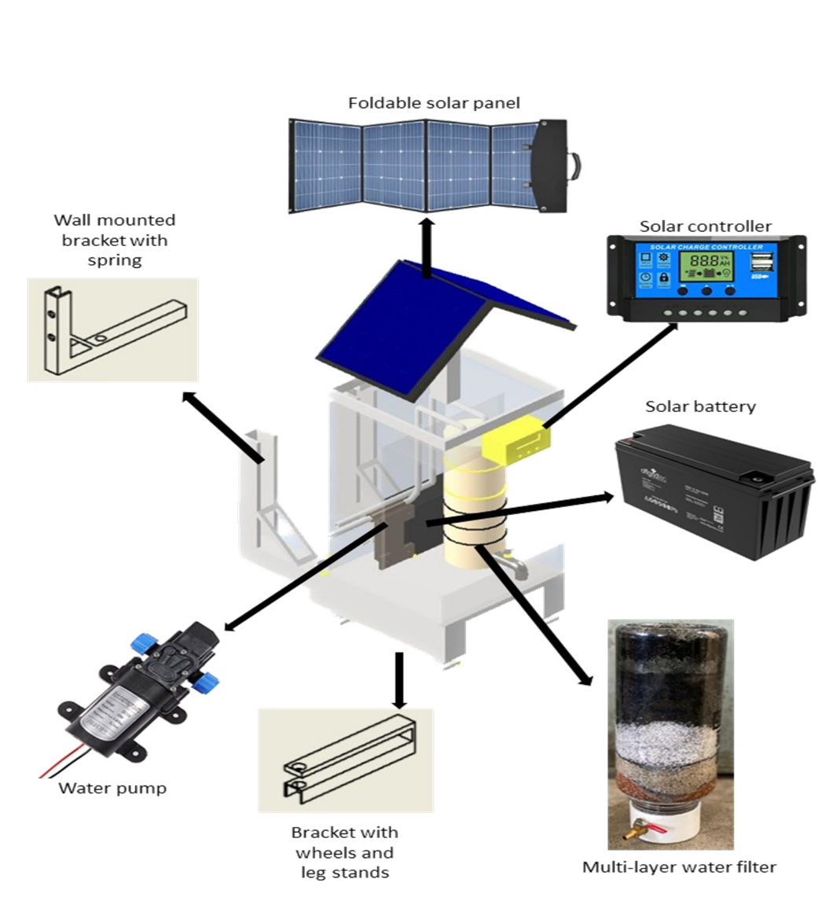

**Figure 4**: A Proposed Prototype of the Portable Solar Powered Water Filter System

# 4.0 CONCLUSIONS

A dependable, long-lasting, and affordable option for supplying clean and safe drinking water is what is anticipated when a water pump is operated using solar energy to circulate through a water filter. The water pump can run continuously without relying on fossil fuels or grid electricity by utilizing solar energy as a renewable and abundant source of power, making it a dependable and sustainable solution for powering water filtration systems. Solar-powered water pumps are not only good for the environment, but they can also save money in the long run. The water pump has very low ongoing costs because there are no fuel or electricity bills, even though there may be upfront installation costs. Due to the potential for financial savings, solar-powered water pumps are a viable choice for supplying clean water. Solar power is a reliable, healthy, and sustainable form of energy that does not harm the environment or the water supply. By employing solar energy to power the water pump, it can reduce the negative effects on the environment and the carbon footprint associated with conventional energy sources, so boosting environmental sustainability.

With a portable solar water filter, the hostel's location should have access to clean, secure drinking water. The water pump is powered by solar energy, making the filter ideal for use in remote locations like camping, the wilderness, etc. By eliminating contaminants, germs, viruses, and other potentially harmful elements, the filter should render the water fit for human consumption. In the filtering process, materials designed to remove contaminants from water, such as ceramic filters, activated carbon, and others, are routinely utilized. Overall, it is expected that a portable solar-powered water filter will be a realistic choice for producing clean drinking water in regions where traditional water treatment methods are unavailable or prohibitive. It offers a sustainable solution for students who need access to clean water while they are on the go.

# BIBLIOGRAPHIES

Chowdhury, A., & Chowdhury, S. A. (2021). Design and Performance Testing of a Multimedia Filtration System for Municipal Wastewater Treatment in Rajshahi City Water treatment using low-cost technology View project Bituminous Mix Design View project. February. https://doi.org/10.13140/RG.2.2.22465.07523

Kurniawan, A. P., Nahdi, M. S., & Aisah, S. (2021). Modifikasi Biosand Filter Pasir Gumuk Sebagai Upaya Pengolahan Air Sungai Gadjahwong Yogyakarta. BIOSFER: Jurnal Biologi Dan Pendidikan Biologi, 6(1), 6–11. https://doi.org/10.23969/biosfer.v6i1.4135

Mohapatra, D., Padhee, S., & Jena, J. (2018). Design of Solar Powered Battery Charger: An Experimental Verification. 2018 IEEE International Students’ Conference on Electrical, Electronics and Computer Science, SCEECS 2018, February 2018. https://doi.org/10.1109/SCEECS.2018.8546929

Odugbose, B., Adeyemi, H. O., Adetifa, B., & Babalola, A. A. (2021). Design of Solar Powered Water Pumping System for Irrigation in. FUW Trends in Science & Technology Journal, 5(January), 956–962.