**Does Melatonin Kill Human Brain Cancer Cells?**

**Introduction**

School biology, like no other academic discipline, allows you to demonstrate the cognitive power of the unity of a systematic, structural-level and historical approach to natural phenomena.

I like study biology and do research

Now I will explain my research project about melatonin and cancer cells.

**Summary**

In our study, it is suggested that the protective effect of melatonin may also be effective in different types of cancer.

**2. Melatonin and Cancer**

As studies in the literature have shown, melatonin stimulates antioxidant enzymes, prevents lipid peroxidation and protects brain tissue from oxygen-derived free radicals.

**3. Hypothesis**

Based on this, it was hypothesized in this study that melatonin would also be effective in brain cancer cells and would kill cancer cells.

**2.1.Materials**

U87mg cells:

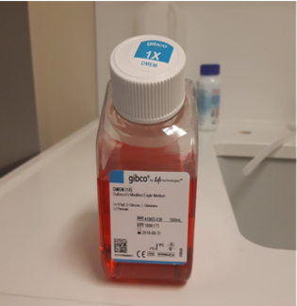

Cell nutrient medium:

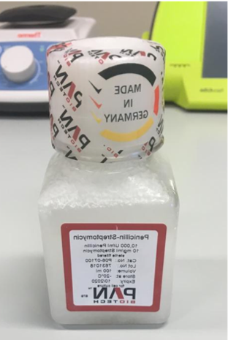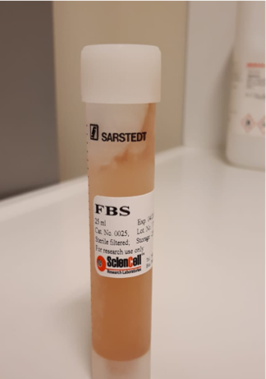

Fetal bovine serum and Penicillin/streptomycin:

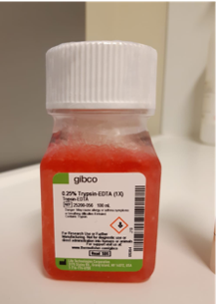

Trypsin:

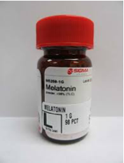

Melatonin: The melatonin substance used in our study was mixed into the cell nutrient medium in 3 different doses and given to the cells.

Propidium iodide dye:

Presto blue:

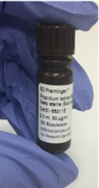

2.2. Methods  
2.2.1. Cell Culture Method

Cell culture makes it possible to grow cell lines obtained from tissues or commercially available by providing the necessary conditions for use in research.

2.2.2. Propidium Iodide (PI) Staining Method

The PI dye stains the DNA of dead cells, giving a red color under a fluorescent microscope.

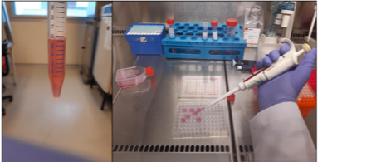

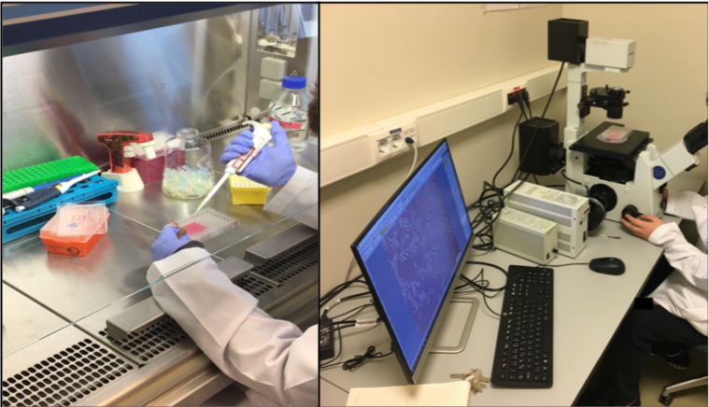

2.2.3. Presto Blue Method

After the pictures taken with PI staining, the cell medium was decanted and presto blue dye was added to the new cell medium at a dilution of 1/10 (20 μl).

2.2.4. Analysis of Data

In our study, we worked with 5 samples in each group.

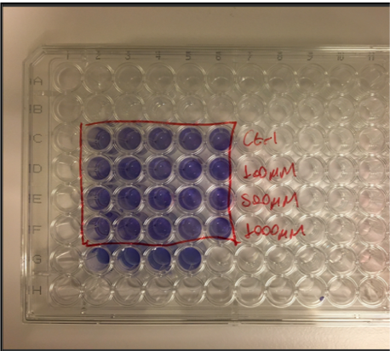

.

3. Findings  
3.1.PI Staining Findings

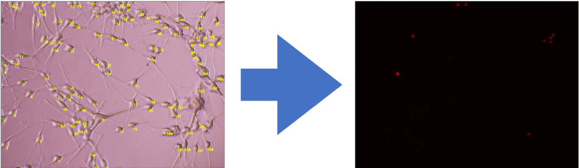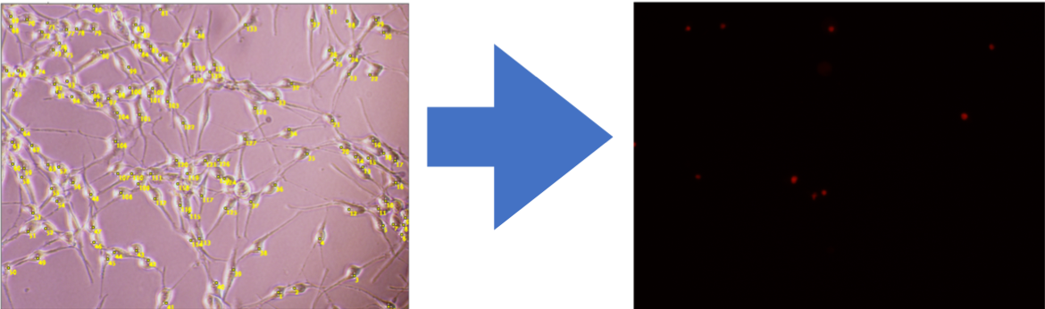

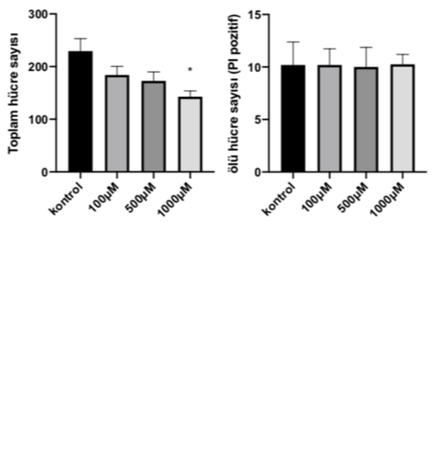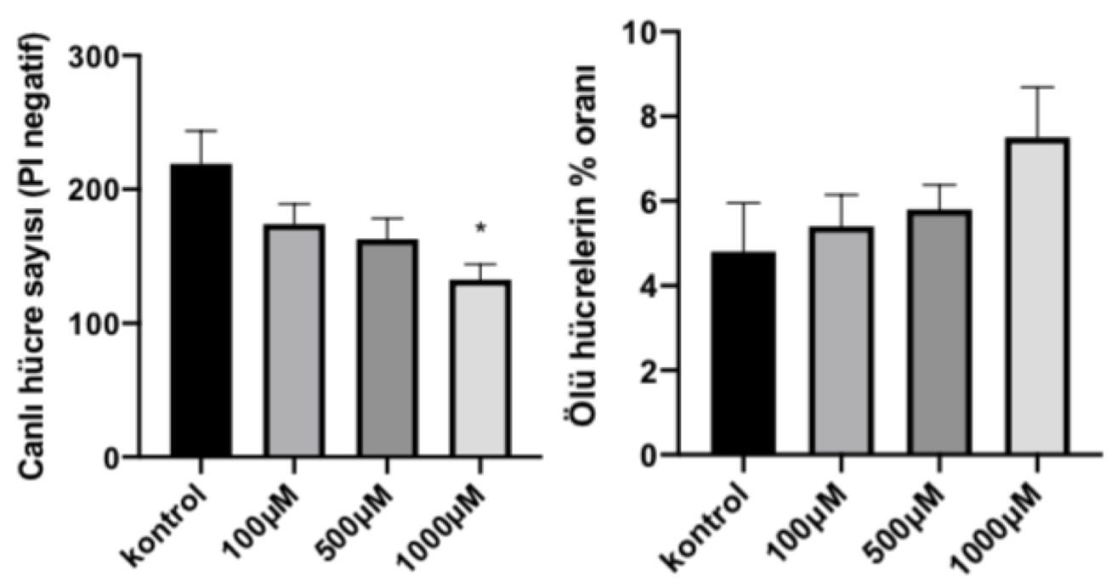

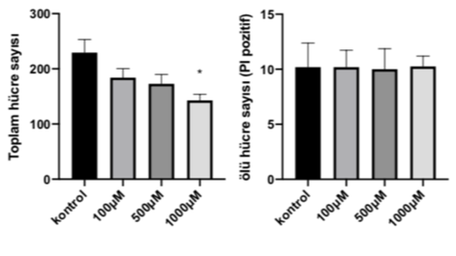

According to these analyses, melatonin at a dose of 1000 μM significantly reduces the number of viable cells and the total number of cells (p>0.05). This effect was not observed for other doses. Similarly, no effect was observed in the number of dead cells and the percentage of dead cells. As we see in the graphs, there is a decreasing number of viable cells and total cell number with increasing dose. Although the number of dead cells does not change, the percentage of dead cells increases with increasing dose.

3.2. Presto Blue Findings

