***M.Zh. Tussupbekova, L.K. Meirambekova, D.M. Akizhanova***

*Astana, Kazakhstan*

*L.N. Gumilyov Eurasian National University*

## STRATEGIES OF BLENDED LEARNING IN TEACHING EFL FOR HIGHER SCHOOL STUDENTS IN KAZAKHSTAN

## Abstract

This paper presents the practice of teaching English in higher schools. The experiment implies studying learning management systems, educational platforms and instruments to define the main strategies of blended learning. The learning management system handles all aspects of the learning process and serves as a core of all educational instruments to monitor the whole education process of the university. With the introduction of educational platforms and instruments there was a survey to identify the perspectives of blended learning. There were 53 students from Information Technologies, Construction, Mathematics and Nuclear Physics specialties. It was revealed that the most productive platform in teaching EFL is MOODLE, Google classroom with well-known video tools MS Teams, ZOOM, Webex, and Google Meet; instruments (Bandicam, Edpuzzle, Mentimeter, QR code, Calameo, Google forms, Power Point) are useful in learning and teaching EFL, because each of them is effective in developing writing, reading, listening and speaking skills. The important strategies of blended learning in teaching English are to use multiple types of innovative technologies, to keep traditional methods simultaneously, to vary assessments, to mix groups, and to prepare a digital curriculum.

Keywords: English, instrument, learning, offline, online, platform, strategy, teaching

## Introduction

Before today the world was in the captivity of various dangerous situations and faced with new strains of horrifying diseases. The history of the world stamped the tracks of COVID in its pages and made changes in all fields of human activities. Moreover, the educational system started to find new ways of teaching and working. Humanity was transferred to distance learning: education, meetings, seminars, conferences. This situation presents opportunities not only to study, but understand the positive and negative sides of living and learning. The Ministry of education and science of the Republic of Kazakhstan updated testing services, teacher training, information systems in all educational institutions. The main task of the Ministry and institutions was to teach teachers and pupils (students) to provide educational materials, send assignments, evaluate and give feedback. In his speech, the Minister of education and science of Kazakhstan A. Aimaganbetov noted that distance learning supposes the use of several methods and tools simultaneously. During the quarantine, the Ministry provided free access to Kazakhstani electronic platforms as Bilimland (domestic IT company), Kundelik (e-diary), Daryn (educational system), IMektep (interactive educational platform). Higher schools of Kazakhstan have started to improve their learning management systems in order to use all online possibilities for learning and assessing.

L.N. Gumilyov Eurasian National University has started to employ its own learning management systems (LMS) with various distance learning technologies since 2000. LMS handles all aspects of the learning process. LMS Platonus in ENU is the main tool for teachers and students to work and monitor the whole education process of the university. With the help of Platonus, teachers and students collect and present all necessary data, track progress, assess individual and organizational learning goals, supply course materials and instructions to write scientific thesis. ENU works on online learning platforms such as MOODLE, Google classroom, Platonus with well-known video tools MS

Teams, ZOOM, Webex, and Google Meet.

The aim of this research is to analyze the perspectives of blended learning in teaching English as a foreign language. This research is based on theoretical and practical aspects of mixed learning. It presents qualitative analysis on the following questions:

Q 1 – What kind of online learning platforms are productive in teaching English in higher schools?

Q 2 – What educational technologies are useful in teaching English to develop writing, reading, speaking, and listening?

Q 3 – What are the main strategies of blended learning in teaching EFL in higher schools?

## Literature review

Online learning is associated with e-learning, web-based learning, distance learning, and blended learning. Moreover, online learning gives rise to new types of learning mixing them together. Blended learning is a combination of online and offline types. Blended learning refers to the teaching- learning activity that takes place in a face-to-face interactional e-learning setting (Graham, 2013). Lim defines blended learning as a learning process that integrates two or more diverse learning strategies, methods and techniques in order to maximize the learning effect and learning environment (2016). Blended learning is the combination of lectures and multimedia that can create a whole new learning experience for the students (Mantyla, 2001).Thus, blended learning can combine both the advantages of offline and online education. Singh characterizes the concept of blended learning in the integration of learning space, self-directed learning and cooperative learning; learning patterns and learning content (Singh, 2003). Eventually, the goal of blended learning is to first provide students with various learning methods that correspond to their learning styles, and secondly to expand their learning opportunities by delivering the learning content through different methods.

According to previous research on the blended learning model carried out by Kim and Choi, among face-to-face classes, online classes and blended classes (2004). Blended classes showed the highest student achievement and higher satisfaction and participation when compared to online and face-to-face class groups. Moreover, Shin implemented a university course using e-learning, blended learning and traditional classes (Shin, 2006).

Blended learning at offline universities provided a solution to supplement the offline or e- learning environments. The integration of the two classroom settings was devised for the teachers’ convenience and for its low cost and high effectiveness. However, it also reduced the learning opportunities for learners’ in terms of face-to-face interaction (Baek, 2003). However, blended learning at offline universities can make up for the loss of learning opportunities through online learning by using web-based discussion classes.

Teaching and learning English using blended learning has many advantages. It supports strong multimedia tools; provides diverse interaction opportunities; allows for contact with English cultures; makes graded classes possible; encourages self-directed learning (Tham, 2011).

In other words, learning English provides students with diverse learning activities and materials according to their linguistic level, selfdirected learning is an essential learning experience as learners choose the activities appropriate for their level and are able to control their learning pace. In this context, the web-based learning environment which provides an individualized language learning setting suitable for each learner’s situation is extremely important and if face-to-face interaction which allows for real communication is integrated here, an ideal model of self-directed learning would be created. The type of blended learning where individualized learning is conducted online and interaction is experienced through offline classrooms is rapidly expanding as the new form of English education.

Blended learning is mostly used in examination-oriented courses such as TOEFL or IELTS. Cho points out the factors influencing the effects of blended learning such as content factors, teaching

strategies, and teacher factors should be closely scrutinized and a systematic classroom strategy for blended learning should be established (Cho, 2003).

# Patrick and Powell state “online learning has the potential to transform teaching and learning by redesigning traditional classroom instructional approaches, personalizing instruction and enhancing the quality of learning experiences' (Patrick, 2009). Online teaching and learning offer not only education quality improvement but also a solution to the problems faced by traditional teaching and learning. Online teaching and learning also provide facilities for both students and institutions with traditional teaching and learning. Xu explains “from the student perspective, the convenience of online learning is particularly valuable to adults with multiple responsibilities and highly scheduled lives; thus, online learning can be a boon to workforce development, helping adults to return to school and complete additional education that otherwise would not fit into their daily routines (Xu, 2013). From an institutional perspective, online modalities allow colleges to offer additional courses or course sections to their students, increasing student access to (and presumably progression through) required courses”. Furthermore, Means explain “online learning has become popular because of its potential for providing more flexible access to content and instruction at any time, from any place (Means, 2013). Ni states “student grade distribution does not present significant differences between online and face-to-face classes in this study” (Ni, 2013).

In this research, blended learning is considered to provide students with a meaningful learning environment for elevating English language proficiency, and to maximize both the advantages of online and offline classes. As for online, students are able to access the course materials on the website at any time, and whenever they need; that is, “self-paced learning” is made possible (Akkoyunlu, 2008). However, in offline classes, collaborative learning can help students interact with their classmates for more language practice.

## Methods

This study is conducted in L.N. Gumilyov Eurasian National University. There are 53 students from natural sciences departments who participate in this research. Students are introduced with the research questions, aim of this research and the principles of doing this experiment. The principles include voluntary participation, informed consent, anonymity, confidentiality, and results communication. The questionnaire is presented online on Google forms platform. This platform enables users to download the results and facilitate an analysis of data.

## Results and discussion

This part of this research presents qualitative analysis on the following questions:

Q 1 – What kind of online learning platforms are productive in teaching English in higher schools?

Q 2 – What educational instruments are useful in teaching English to develop writing, reading, speaking, and listening?

Q 3 – What are the main strategies of blended learning in teaching EFL in higher schools?

Integration of online classes with offline classes in blended learning will help provide the 21st century students with various learning methods based on their needs, and enable them to approach knowledge through diverse media while reducing time and space constraints. Thus, blended learning is actively developed and applied in the educational process of L.N. Gumilyov Eurasian National University.

# This research presents two periods of study in L.N. Gumilyov Eurasian National University (online and offline). Teaching staff scrambled to set up remote learning options for more than 20000 students. This situation speeded up fast changes in the educational system. Teachers faced challenges with moving the materials online, choosing digital platforms to deliver course materials to all students, making notes and distributing video lectures, and focusing in-person time to interact with students. Shifting online education shows the positive changed attitude of teachers and students towards learning. In this period, online education is a supplement to offline education. In fact, 58% of students have faced online educational platforms before pandemic participating in courses, seminars, online tests etc. (Figure 1).

42%

58%

Yes

No

Figure 1- The percentage of students using online educational platforms (%)

# Moreover, students know many programs to use in learning and teaching. There are various educational technologies, but each of them has their own functions. The analysis shows the most useful technologies in teaching and learning are PowerPoint and Google Forms (Figure 2).

Power Point

22.06

15.37

1.06

6.36

5.83

6.89

2.12

Google Forms

Calameo

QR code

Mentimeter

Edpuzzle

Bandicam

0 5 10 15 20 25

Figure 2 - The most useful technologies in English teaching and learning (%)

# Power Point is usually used to introduce a new lecture or lesson, make presentations,

prepare projects etc. Presentations of the new topic with pictures, graphs and multimedia keep the class interesting and students attentive (Jones, 2003). The result of an informal survey of students and teachers about the usefulness of Powerpoint in English classes shows that presentations increase the ease of understanding of the topic presented.

# Another educational instrument which is often used by teachers is Google forms. Google Forms are used to gather data, receive feedback to students and teachers, test students, evaluate students’ works, and see the results of teaching and learning. In other words, Google forms can be used in various ways to increase classroom environment benefits. Google forms allow assigning a survey before starting learning English in order to know about students’ previous experiences, their level of knowledge, interests, preferable learning styles, and identify misconceptions. Moreover, tests and quizzes in Google forms are graded automatically and students can view their answers (Picture 1).

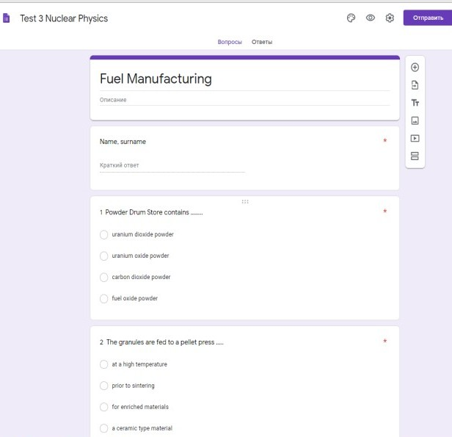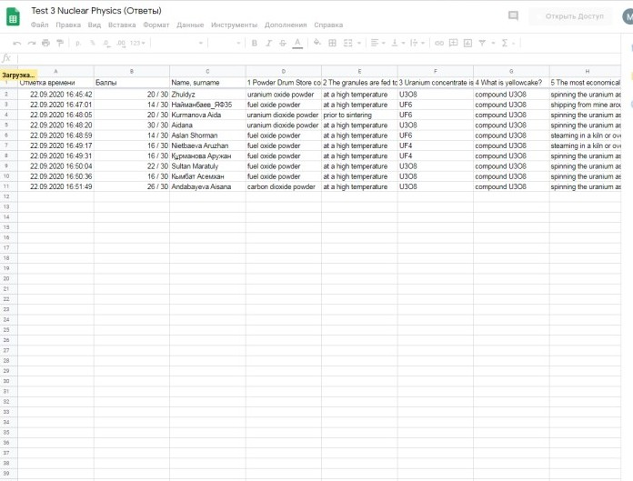

Picture 1 - Test and students’ results in Google forms

# The considered educational instruments and technologies can be used in online and offline learning. Our experience indicates that online learning is more flexible than offline. Teachers support students via mail and online chat systems (whatsapp, telegram, face time etc.).

Thus, blended learning means not only mixing of online and offline education activities, but educational platforms and instruments. During the pandemic, blended learning is increasingly introduced in educational systems throughout the world. The right strategies of blended learning depend on teaching activities. Our practice determines the right strategies of blended learning which provide the exact amount of balance of online and offline English teaching:

# to have an opportunity to use multiple types of innovative technologies (free teaching resources, online discussion groups, teacher-led debates, home-grown educational materials etc.);

1. to incorporate technologies for reinforcement the students’ knowledge (preparing own video, pass online questionnaire or interview, interactive games);

# to introduce with new ideas and techniques (flipping the classroom, differentiated work with students, independent students’ work);

1. to keep and follow traditional methods simultaneously (lecture, seminars, classroom discussion);

# to vary assessments and make special evaluation cards with schedules (measuring students’ comprehension, digital quizzes, paper-based assessment, writing essays, end- course assignments, presentations, self-assessment and peer*assessed assignments);

1. to mix group of students to do various additional assignments (group projects, online collaboration);

# to prepare digital curriculum (teaching materials, digital lessons, hands-on activities, guided notes, formative and summative assessments).

## Conclusion

This study presents theoretical and practical analysis of using blended learning in teaching EFL for students of higher schools. The captivity of various dangerous situations during the pandemic made big changes in the educational system. All educational establishments transferred to blended learning and started to update their education services, teacher training, learning management systems (LMS). Learning management system became the main platform to provide teachers and students with educational materials, assignments, reflection, and evaluation.

The research of analyzing the perspectives of blended learning was provided in LMS Platonus at Eurasian national university. All necessary data and the progress of students were available on the Platonus system. *The most productive platform in teaching EFL is MOODLE, Google classroom with well-known video tools MS Teams, ZOOM, Webex, and Google Meet.* All of these platforms provided students with various learning methods that correspond to their learning styles, and secondly to expand their learning opportunities by delivering the learning content through different methods. Google Classroom allows the teacher to organize a lesson using the applications presented. The teacher has the ability to create a specific individual class to teach students, send assignments, organize master classes and discussions, perform individual and group assignments in the system and attach the completed work, evaluate the work, send feedback to students to make corrections, write comments, and grade (assess).

On the basis of theoretical and practical analysis of online and offline learning we concluded that blended learning allows for contact with culture, traditions, customs; makes graded classes possible; encourages self-directed learning. In other words, blended learning provides students with diverse learning activities and materials according to their linguistic level, self-directed learning is an essential learning experience as learners choose the activities appropriate for their level and are able to control their learning pace. Despite challenges during the pandemic, **s**hifting online education shows the positive changed attitude of teachers and students towards learning. 30 students out of 53 have worked online and knew how to work online. Moreover, students knew many educational instruments that can be used in online learning and teaching. 42 students out of 53 use PowerPoint actively in their study, 29 students faced with the questionnaire on Google forms platform. Power Point is usually used to introduce a new lecture or lesson, make presentations, and prepare projects. Google Forms are used to gather data, receive feedback to students and teachers, test students, evaluate students’ works, and see the results of teaching and learning. As it was revealed, only 11 (Mentimeter), 12 (Qr code), 13 (Edpuzzle) students know about these instruments. Mentimeter involves creating interactive presentations, polls, quizzes, voting, and getting instant feedback. The uniqueness of the Edpuzzle tool is ability to create own videos and develop various tasks. This tool allows inserting a video, trimming a fragment, recording own voice, voice-over, insert audio commentary, developing and adding assignments

# on the material. The instructor can schedule collaborative work with students, set deadlines for assignments, view statistics on assignments and results. The main task of the teacher when working with Edpuzzle is a careful selection of video material in accordance with the thematic focus and the current cultural realities of the country of the target language. In teaching English, teachers often use this tool to check words and expressions or select associations on a particular lexical topic as an update of the background knowledge at the reflection stage. Bandicam and Calameo instruments were new for students to work and use. Calameo is a very convenient tool for collaborative work with students in a distance format. Calameo contains all the necessary learning materials, such as teaching materials for the discipline being studied, main and additional sources, students’ works, presentations, essays, reports and creative works. This tool increases reading interest with its colorful and user-friendly interface. It allows students to mark points of interest, turn pages, and zoom in on images and presentations. *All of these instruments are useful in learning and teaching EFL, because each of them is effective in developing writing, reading, listening and speaking skills.* These educational instruments can be used in online and offline learning. Our experience indicates that online learning is more flexible than offline. Teachers support students via mail and online chat systems (whatsapp, telegram, face time etc.). Thus, blended learning means not only mixing of online and offline education activities, but educational platforms and instruments. During the pandemic, blended learning is increasingly introduced in educational systems throughout the world. This study presents the following strategies of blended learning which provide the exact amount of balance of online and offline English teaching (*to use multiple types of innovative technologies, to keep traditional methods simultaneously, to vary assessments, to mix groups, to prepare digital curriculum*).

## REFERENCES

Akkoyunlu, B., &Soylu, M. Y. (2008). A study of student's perceptions in a blended learning environment based on different learning styles.

Baek, S. (2003). A study on the possibility of applying blended learning to design education. *Journal of Korean Society of Design Science*, *16*(4), 443-452.

Graham, C. R. (2013). Emerging practice and research in blended learning. In *Handbook of distance education* (pp. 351-368). Routledge.

Jones, A. M. (2003). The use and abuse of PowerPoint in Teaching and Learning in the Life Sciences: A Personal Overview. *Bioscience Education*, *2*(1), 1-13.

Kim, D. M., & Choi, C. (2004). Developing future leaders at Hyundai Motor Company through blended learning. *Industrial and Commercial Training*.

Lim, C., Cho, Y. H., & Kim, S. (2016). Partnerships and innovation for blended learning at Seoul National University, Republic of Korea. *Blended learning for quality higher education: Selected case studies on implementation from Asia-Pacific*, 211-232.

Lim, D. H., & Morris, M. L. (2009). Learner and instructional factors influencing learning outcomes within a blended learning environment. *J. Educ. Technol. Soc.*, *12*(4), 282-293.

Mantyla, K. (2001). *Blending e-learning*. American Society for Training and Development.

Means, B., Toyama, Y., Murphy, R., &Baki, M. (2013). The effectiveness of online and blended learning: A meta-analysis of the empirical literature. *Teachers college record*, *115*(3), 1-47.

Ni, A. Y. (2013). Comparing the effectiveness of classroom and online learning: Teaching research methods. *Journal of public affairs education*, *19*(2), 199-215.

Patrick, S., & Powell, A. (2009). A Summary of Research on the Effectiveness of K-12 Online

Learning. *International Association for K-12 Online Learning*.

Shin, S. B., & Han, H. J. (2006). Strategy and Effect on Interdisciplinary Project-based Learning based Blended Learning. *The Journal of Korean Association of Computer Education*, *9*(4), 25-34.

Singh, H. (2021). Building effective blended learning programs. In *Challenges and Opportunities for the Global Implementation of E-Learning Frameworks* (pp. 15-23). IGI Global.

Tham, K., &Tham, C. (2011). Blended learning-A focus study on Asia. *International Journal of Computer Science Issues (IJCSI)*, *8*(2), 136.

Xu, D., &Jaggars, S. S. (2013). The impact of online learning on students’ course outcomes: Evidence from a large community and technical college system. *Economics of Education Review*, *37*, 46-57.