**Tyrosinase Inhibitors: Uncovering Tyrosinase Inhibitors In Vitro for Skin Hyperpigmentation Management**

***Zeyad Adil Hameed HAMEED1,[[1]](#footnote-1)\* [C:\Users\Abdullah\AppData\Local\Microsoft\Windows\INetCache\Content.Word\ORCID-iD_icon-16x16.gif](https://orcid.org/xxxx-xxxx-xxxx-xxxx), Bedriye Seda KURŞUN AKTAR2[C:\Users\Abdullah\AppData\Local\Microsoft\Windows\INetCache\Content.Word\ORCID-iD_icon-16x16.gif](https://orcid.org/xxxx-xxxx-xxxx-xxxx), Şevki ADIM 3[C:\Users\Abdullah\AppData\Local\Microsoft\Windows\INetCache\Content.Word\ORCID-iD_icon-16x16.gif](https://orcid.org/xxxx-xxxx-xxxx-xxxx)***

*1 Department of Chemistry Sciences, School of Natural and Applied Sciences, Çankiri Karatekin University, Iraq*

*2Department of Hair Care and Beauty Services, Yes¸ilyurt Vocational School, Malatya Turgut Özal University, Malatya, Turkey*

*3Department of Chemistry Sciences, School of Natural and Applied Sciences, Çankiri Karatekin University, Turkey*

|  |
| --- |
| **Abstract**  Tyrosinase has attracted a lot of interest as a potential inhibitor target since it is an enzyme that plays an important role in human melanogenesis as well as in the enzymatic browning of fruits and fungi. Complex chemical and enzymatically catalysed events are involved in melanogenesis, the process that leads to melanin synthesis. The purpose of this research is to find tyrosinase inhibitors in both natural and manmade compounds. Also discussed are the possible medicinal uses of these inhibitors in avoiding fruit enzymatic browning and skin hyperpigmentation, two undesirable results. Synthetic compounds (5d, 5e, 5f, and 5g) were tested for their inhibitory effect on mushroom tyrosinase using a microtiter plate reader. Compounds 5d, 5e, 5f, and 5g exhibited inhibitory effects on tyrosinase activity, and the results showed that the inhibition was concentration dependent. Additional information on the binding sites of these synthetic compounds with the tyrosinase active site was gleaned from molecular docking experiments. The inhibitory effects of compound 5d were highlighted using enzyme activity testing and visual depictions, indicating its potential as a tyrosinase inhibitor. To highlight the inhibitory mechanism, a two-dimensional interaction map was used to demonstrate critical hydrogen bond interactions with certain amino acids. There was a concentration-dependent reduction in tyrosinase activity when compounds 5e, 5f, and 5g were tested. Important hydrogen bond interactions were highlighted in the interaction maps, suggesting that the chemicals may be able to stabilise binding and increase inhibitory effects. Our research adds to the growing body of knowledge on potential new tyrosinase inhibitors for use in skin lightening and antibrowning foods. The research highlights the need of studying the molecular interactions between tyrosinase and synthetic inhibitors in order to create anti-hyperpigmentation medicines that work. To confirm these chemicals' medicinal potential, further study may include in vivo tests and clinical trials. |
| Keywords: skin hyperpigmentation, Tyrosinase, Activity enzyme |

1. **Introduction**

Because tyrosinase is essential for both human melanogenesis and the enzymatic browning of fruits or fungi, tyrosinase inhibitors have occupied much attention over the last few decades. The term "melanogenesis" refers to the series of events that culminate in the creation of melanin, a kind of dark macromolecular pigment. Chemical and enzymatically catalysed processes work together to produce melanin [3] and [4] have recently updated the biosynthetic route for melanin synthesis in numerous living forms, which was first revealed by [1] and [2]. Tyrosinase catalyses the first stage of tyrosine oxidation to dopaquinone, which initiates melanogenesis. Melanin production is limited by this first step since, at physiological pH values, the rest of the reaction cascade may continue spontaneously [5]. The auto-oxidation process transforms the following dopaquinone into dopa and dopachrome. Tyrosinase may oxidise dopa to dopaquinone, which is another substrate of the enzyme. The final result of the dopachrome synthesis, eumelanin, is generated via a sequence of oxidation reactions involving dihydroxyindole (DHI) and dihydroxyindole-2-carboxylic acid (DHICA). The presence of glutathione or cysteine causes dopaquinone to be transformed to glutathionyldopa or cysteinyldopa, respectively. After that, pheomelanin is created. Allomelanin is the name given to "melanin" that does not include tyrosine but does contain phenolic monomers, such as eumelanin or pheomelanin. In a similar vein to melanogenesis, oxidative polymerization is often associated with the browning process in fungi and fruits. Allomelanin differs primarily in that it is built on various quinoid building blocks rather than dopaquinone-derived motifs, which are the major monomers in its structure. An essential function of melanin is to shield the skin from the sun's damaging ultraviolet (UV) rays. Our phenotypic look is also determined by melanin. While melanin primarily serves as a sun protection factor for human skin, an excess of melanin in certain areas, leading to darker patches, might be considered an aesthetic issue. Furthermore, it is not desired for fresh fruits, drinks, veggies, and mushrooms to undergo enzymatic browning [6]. After harvest, browning happens to many crops, including mushrooms, lowering their market value. Enzymatic browning of fruits and hyperpigmentation of human skin are both undesirable outcomes. These findings have prompted scientists to look for novel, highly effective tyrosinase inhibitors for application in food antibrowning and skin lightening products. While previous reviews have addressed certain tyrosinase inhibitors [7-9], this article provides a summary of recently identified tyrosinase inhibitors derived from both natural and synthetic sources. Conversely, there has been tremendous advancement in our understanding of melanocyte biology and the mechanisms behind melanin formation in recent years, which has led to new opportunities in the pharmacologic treatment of skin hyperpigmentation. There are various ways to treat hyperpigmentation, such as blocking tyrosinase catalytic activity, tyrosinase mRNA transcription, tyrosinase glycosylation, maturation, degradation, transfer, and inflammation-induced melanogenic response, skin turnover, and interference with melanosome maturation and transfer. In light of this, several studies have thoroughly examined a plethora of depigmenting or whitening chemicals created using these different methods [10–16]. Therefore, these directed methods for treating hyperpigmentation are not included in this study.

1. **Materials and Methods**

According to earlier reports, we used a microtiter plate reader to detect the inhibitory activity of the mushroom tyrosinase enzyme at 492 nm [18]. Enzyme activity test reaction medium (250 mL) included 100 mL of various chemical concentrations in addition to 0.5 mM L-DOPA in 50 mM phosphate buffer (PH 6.8). The reaction was carried out for 7 minutes at a temperature of 37 °C. The chemicals were diluted to the appropriate concentration after dissolving in 1 mg/mL DMSO. Every time, we ran the controls without inhibitors but with DMSO in the reaction medium. The IC50 values, which represent the doses at which an inhibitory effect on tyrosinase activity was seen, were used to express the compounds' inhibitory effects. A molecular docking investigation was conducted using the Molegro Virtual Docker programme to try to understand the likely binding positions of the synthetic chemicals with the tyrosinase active site [19]. Access to the X-ray crystal structure of tropolone-cocrystallized tyrosinase from Agaricus bisporus (2Y9X)[17] was made possible via the RCSB Protein Data Bank. The MarvinSketch programme was used to build the 3D models of compounds 5d, 5f, 5e, and 5g. After importing the protein into Molegro Virtual Docker, the crystal structure was water-extracted and optimised to fill in any amino acid gaps in preparation for docking. By calculating all of the coordinates to tropolone, the binding site for tiny compounds might be characterised. For each molecule, ten docking experiments were run. Then, the conformations that scored the highest were chosen to investigate the interaction details in the Discovery Studio 2021 Client.

1. **Results and Discussion**

The symbols used in this study and the findings for these samples are shown in Table 1.

Table 1 Discloses the signals used and the outcomes of the sample

|  |  |
| --- | --- |
| Compounds | Results µM |
| 5d | 76.170 |
| 5e | 36.290 |
| 5f | 203.867 |
| 5g | 36.674 |

In theory, 5d may be utilised to treat pathological disorders like skin hyperpigmentation that are associated with tyrosinase enzyme activity, as it has been shown to inhibit tyrosinase enzyme activity. Visualising the relationship between enzyme activity % and 5d concentration, Figure 1 provides a thorough explanation of the activity. The graph clearly shows that the enzyme tyrosinase's activity diminishes as the amount of 5d rises. Figure 2 shows a two-dimensional interaction map that shows the particular interactions of 5d with the amino acids of the enzyme. Amino acids MET 257 all played important roles in hydrogen bond interactions, which are essential for binding. These interactions stabilise the binding and enhance the inhibitory effects. Also, when you see red separation contacts, it means that water molecules have left the enzyme's active site. The enzyme undergoes a conformational shift and subsequently ceases to catalyse processes. For that reason, 5d inhibits tyrosinase activity.

Figure 1 Minimise 5d tyrosinase enzyme activity

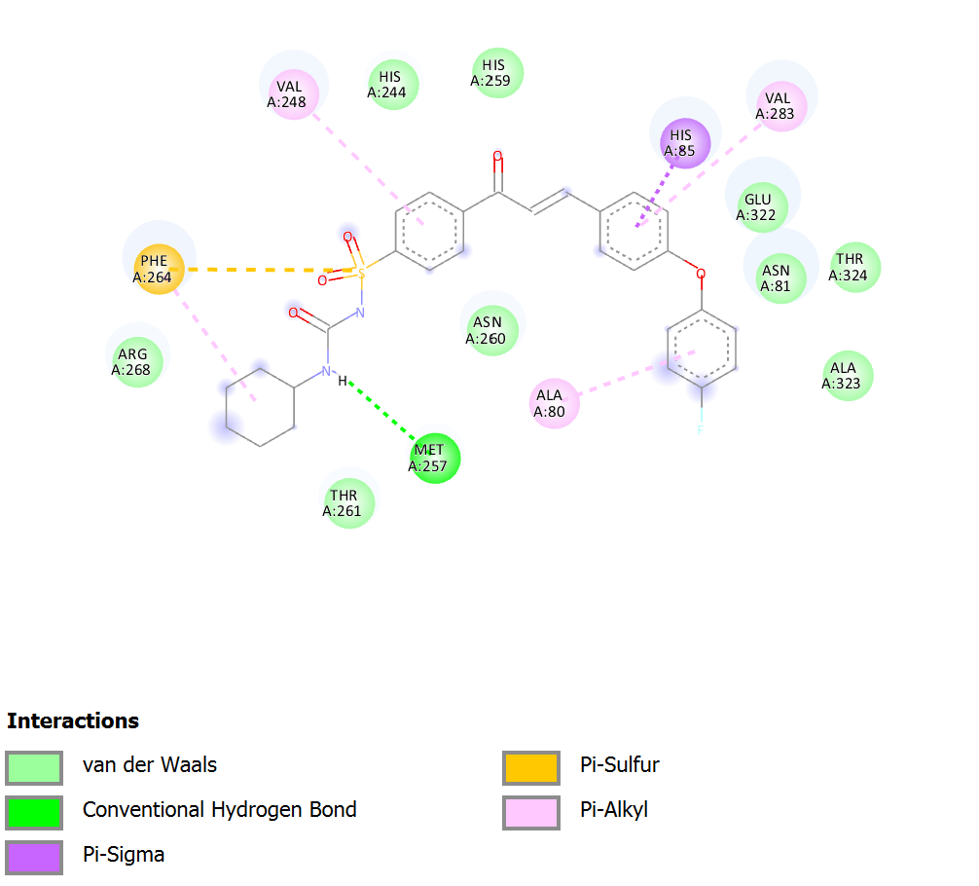

Figure 2 The tyrosinase enzyme and the 5d molecule's two-dimensional structures

In theory, 5e may be utilised to treat pathological disorders like skin hyperpigmentation that are associated with tyrosinase enzyme activity, as it has been shown to inhibit tyrosinase enzyme activity. Visualising the relationship between enzyme activity % and 5e concentration, Figure 3 provides a thorough explanation of the activity. The graph clearly shows that the enzyme tyrosinase's activity diminishes as the amount of 5e rises. Figure 4 shows a two-dimensional interaction map that shows the particular interactions of 5e with the amino acids of the enzyme. Amino acids ARG 268, HIS 85 and GLU 322 all played important roles in hydrogen bond interactions, which are essential for binding. These interactions stabilise the binding and enhance the inhibitory effects. Also, when you see red separation contacts, it means that water molecules have left the enzyme's active site. The enzyme undergoes a conformational shift and subsequently ceases to catalyse processes. For that reason, 5e inhibits tyrosinase activity.

Figure 3 Minimise 5e tyrosinase enzyme activity

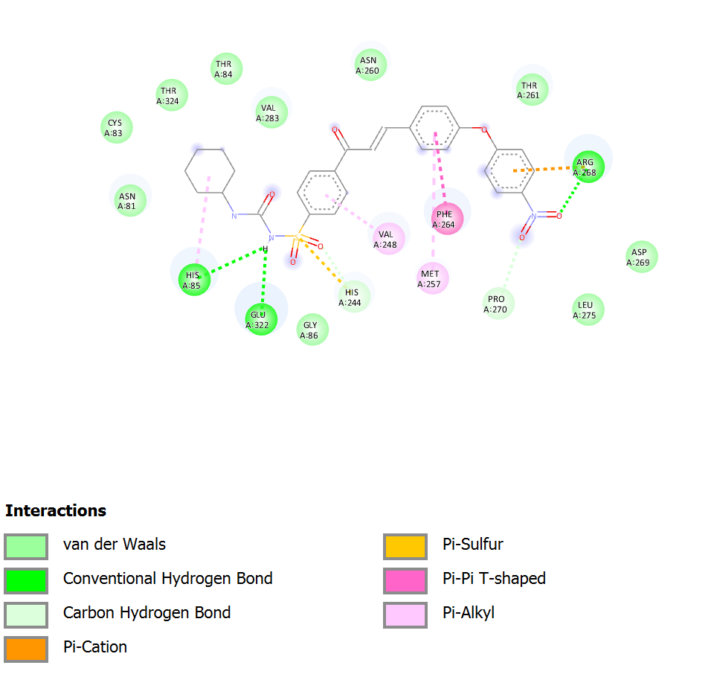

Figure 4 The tyrosinase enzyme and the 5e molecule's two-dimensional structures

In theory, 5f may be utilised to treat pathological disorders like skin hyperpigmentation that are associated with tyrosinase enzyme activity, as it has been shown to inhibit tyrosinase enzyme activity. Visualising the relationship between enzyme activity % and 5f concentration, Figure 5 provides a thorough explanation of the activity. The graph clearly shows that the enzyme tyrosinase's activity diminishes as the amount of 5f rises. Figure 6 shows a two-dimensional interaction map that shows the particular interactions of 5f with the amino acids of the enzyme. Amino acids ARG 268 all played important roles in hydrogen bond interactions, which are essential for binding. These interactions stabilise the binding and enhance the inhibitory effects. Also, when you see red separation contacts, it means that water molecules have left the enzyme's active site. The enzyme undergoes a conformational shift and subsequently ceases to catalyse processes. For that reason, 5f inhibits tyrosinase activity.

Figure 5 Minimise 5f tyrosinase enzyme activity

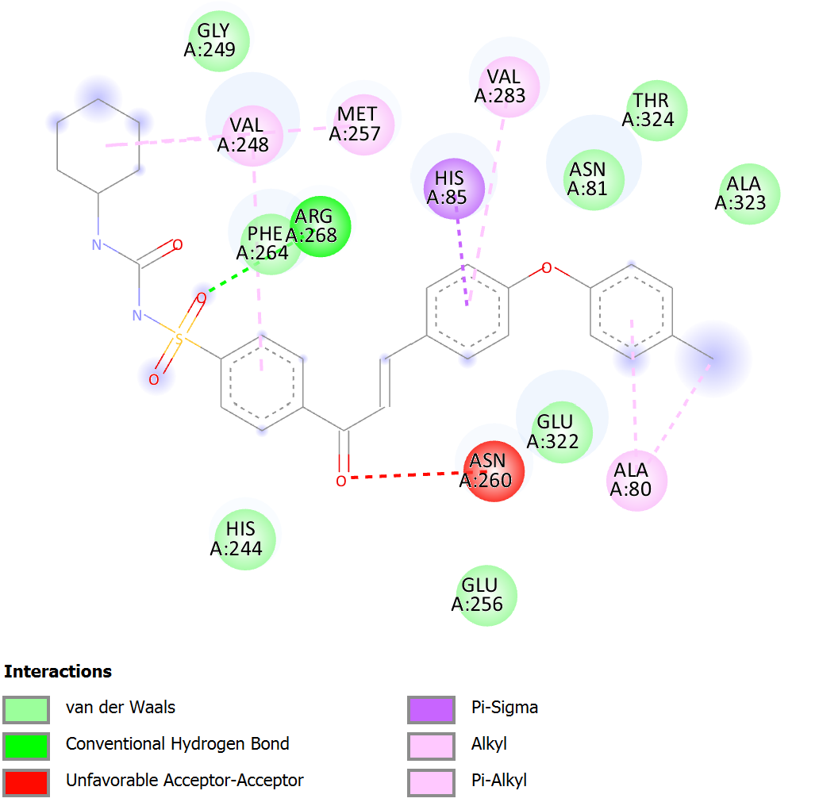

Figure 6 The tyrosinase enzyme and the 5f molecule's two-dimensional structures

In theory, 5g may be utilised to treat pathological disorders like skin hyperpigmentation that are associated with tyrosinase enzyme activity, as it has been shown to inhibit tyrosinase enzyme activity. Visualising the relationship between enzyme activity % and 5g concentration, Figure 7 provides a thorough explanation of the activity. The graph clearly shows that the enzyme tyrosinase's activity diminishes as the amount of 5g rises. Figure 8 shows a two-dimensional interaction map that shows the particular interactions of 5g with the amino acids of the enzyme. Amino acids ARG 268 all played important roles in hydrogen bond interactions, which are essential for binding. These interactions stabilise the binding and enhance the inhibitory effects. Also, when you see red separation contacts, it means that water molecules have left the enzyme's active site. The enzyme undergoes a conformational shift and subsequently ceases to catalyse processes. For that reason, 5g inhibits tyrosinase activity.

Figure 7 Minimise 5g tyrosinase enzyme activity

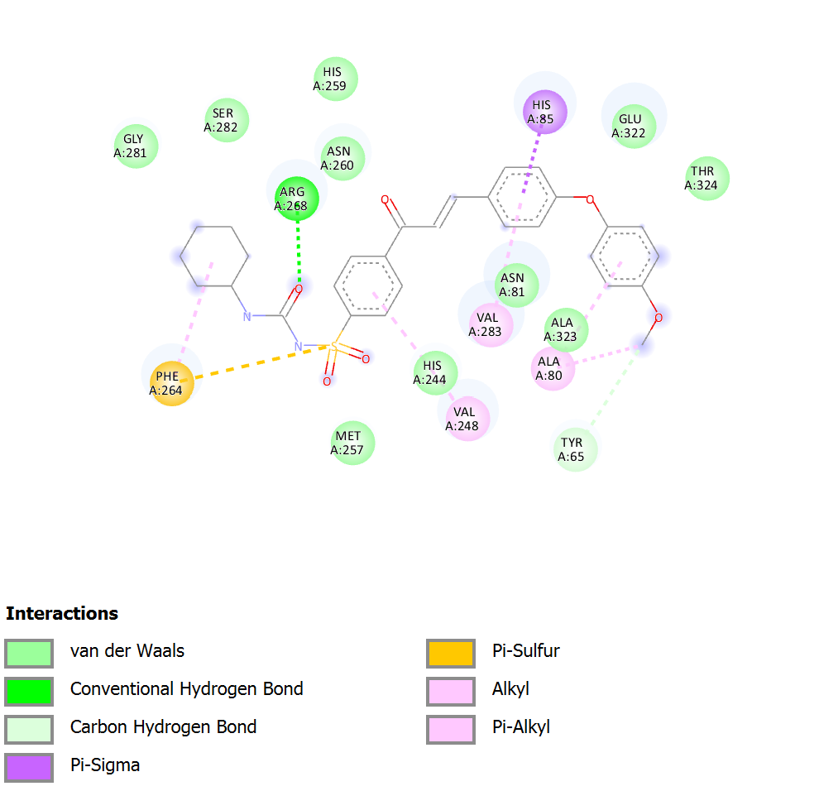

Figure 8 The tyrosinase enzyme and the 5g molecule's two-dimensional structures

1. **Conclusion**

Pursuing remedies for skin hyperpigmentation and fruit browning has found tyrosinase, an enzymatic browning enzyme and essential enzyme in melanin formation, to be an enthralling target. This research investigated the possibility of four synthetic chemicals (5d, 5e, 5f, and 5g) acting as tyrosinase inhibitors; the findings showed promise for use in food and cosmetics. The potential effectiveness of these four compounds as tyrosinase inhibitors was suggested by their concentration-dependent suppression of activity. To further understand where these chemicals attach to the active site of tyrosinase, molecular docking studies were conducted. Enzyme activity assays and visual renderings indicated compound 5d's powerful inhibitory effects. Its significant inhibitory activity may be based on the hydrogen bond interactions shown by a two-dimensional interaction map with certain amino acids. Even though it was less pronounced than in 5d, compounds 5e, 5f, and 5g showed tyrosinase inhibition. Hydrogen bond interactions were highlighted in their interaction maps as a possible optimisation target for improved inhibition. Potential tyrosinase inhibitors for skin whitening and antibrowning uses have been greatly enhanced by this study. The results highlight the need for further research into the molecular interactions between tyrosinase and synthetic inhibitors in order to develop more efficient therapies for hyperpigmentation. These findings hold great promise, but to confirm the chemicals' medical potential and guarantee their safety and effectiveness, more study is essential. This research should include in vivo tests and clinical trials. This work opens up new possibilities for the creation of tyrosinase inhibitors, which might lead to better skin whitening products and ways to reduce food browning caused by enzymes.

**References**

1. Raper, H. S. (1928). The aerobic oxidases. *Physiological Reviews*, *8*(2), 245-282.
2. Mason, H. S. (1948). The chemistry of melanin: III. Mechanism of the oxidation of dihydroxyphenylalanine by tyrosinase. *Journal of Biological Chemistry*, *172*(1), 83-99.
3. Cooksey, C. J., Garratt, P. J., Land, E. J., Pavel, S., Ramsden, C. A., Riley, P. A., & Smit, N. P. (1997). Evidence of the indirect formation of the catecholic intermediate substrate responsible for the autoactivation kinetics of tyrosinase. *Journal of Biological Chemistry*, *272*(42), 26226-26235.
4. Schallreuter, K. U., Kothari, S., Chavan, B., & Spencer, J. D. (2008). Regulation of melanogenesis–controversies and new concepts. *Experimental dermatology*, *17*(5), 395-404.
5. Halaban, R., Patton, R. S., Cheng, E., Svedine, S., Trombetta, E. S., Wahl, M. L., ... & Hebert, D. N. (2002). Abnormal acidification of melanoma cells induces tyrosinase retention in the early secretory pathway. *Journal of Biological Chemistry*, *277*(17), 14821-14828.
6. Artés, F., Castaner, M., & Gil, M. I. (1998). Enzymatic browning in minimally processed fruit and vegetables. *Food Science and Technology International*, *4*(6), 377-389.
7. Rescigno, A., Sollai, F., Pisu, B., Rinaldi, A., & Sanjust, E. (2002). Tyrosinase inhibition: general and applied aspects. *Journal of Enzyme Inhibition and Medicinal Chemistry*, *17*(4), 207-218.
8. Kim, Y. J., & Uyama, H. (2005). Tyrosinase inhibitors from natural and synthetic sources: structure, inhibition mechanism and perspective for the future. *Cellular and molecular life sciences CMLS*, *62*, 1707-1723.
9. Parvez, S., Kang, M., Chung, H. S., & Bae, H. (2007). Naturally occurring tyrosinase inhibitors: mechanism and applications in skin health, cosmetics and agriculture industries. *Phytotherapy Research: An International Journal Devoted to Pharmacological and Toxicological Evaluation of Natural Product Derivatives*, *21*(9), 805-816.
10. Briganti, S., Camera, E., & Picardo, M. (2003). Chemical and instrumental approaches to treat hyperpigmentation. *Pigment cell research*, *16*(2), 101-110.
11. Rendon, M. I., & Gaviria, J. I. (2005). Review of skin‐lightening agents. *Dermatologic surgery*, *31*, 886-890.
12. Draelos, Z. D. (2007). Skin lightening preparations and the hydroquinone controversy. *Dermatologic therapy*, *20*(5), 308-313.
13. Parvez, S., Kang, M., Chung, H. S., Cho, C., Hong, M. C., Shin, M. K., & Bae, H. (2006). Survey and mechanism of skin depigmenting and lightening agents. *Phytotherapy Research: An International Journal Devoted to Pharmacological and Toxicological Evaluation of Natural Product Derivatives*, *20*(11), 921-934.
14. Solano, F., Briganti, S., Picardo, M., & Ghanem, G. (2006). Hypopigmenting agents: an updated review on biological, chemical and clinical aspects. *Pigment cell research*, *19*(6), 550-571.
15. Ando, H., Kondoh, H., Ichihashi, M., & Hearing, V. J. (2007). Approaches to identify inhibitors of melanin biosynthesis via the quality control of tyrosinase. *Journal of Investigative Dermatology*, *127*(4), 751-761.
16. Zhu, W., & Gao, J. (2008, April). The use of botanical extracts as topical skin-lightening agents for the improvement of skin pigmentation disorders. In *Journal of Investigative Dermatology Symposium Proceedings* (Vol. 13, No. 1, pp. 20-24). Elsevier.
17. Ismaya, W. T., Rozeboom, H. J., Weijn, A., Mes, J. J., Fusetti, F., Wichers, H. J., & Dijkstra, B. W. (2011). Crystal structure of Agaricus bisporus mushroom tyrosinase: identity of the tetramer subunits and interaction with tropolone. *Biochemistry*, *50*(24), 5477-5486.
18. Yırtıcı, Ü., Ergene, A., Atalar, M. N., & Adem, Ş. (2022). Phytochemical composition, antioxidant, enzyme inhibition, antimicrobial effects, and molecular docking studies of Centaurea sivasica. *South African Journal of Botany*, *144*, 58-71.
19. Thomsen, R., & Christensen, M. H. (2006). MolDock: a new technique for high-accuracy molecular docking. *Journal of medicinal chemistry*, *49*(11), 3315-3321.

1. \* Corresponding author. *e-mail address: .zeyad95adil@gmail.com* [↑](#footnote-ref-1)