**Performance Evaluatıon Of Graphene Oxıde Synthesıs from Graphıte By Hummers Method**

***Haluk KORUCU 1 [C:\Users\Abdullah\AppData\Local\Microsoft\Windows\INetCache\Content.Word\ORCID-iD_icon-16x16.gif](https://orcid.org/0000-0001-6763-3249)Esra YILMAZ MERTSOY 1 Mohammad Ruhul Amin BHUİYAN 2*** ***Enes BEKTAŞ 1 Ahmet YARTAŞI 1* Aboubakar Ibrahım MOHAMED 1 Tabarek Salam MAJEED 1 Mahdı Mohamed DAHER 1 Mahad Ousleyeh ALI 1**

***1 Department of Chemical Engineering, Faculty of Engineering, Çankırı Karatekin University, Uluyazı, Çankırı 18100, Turkey***

***2Department of Electrical and Electronic Engineering, Islamic University, Kushtia 7003, Bangladesh***

|  |
| --- |
| **Abstract**  The purpose of this study was to evaluate how well the use of acetic and propionic acids performed in the Hummers technique of graphene oxide production in place of phosphoric acid. Three trials were conducted using the Hummers method to ascertain the effects under the same conditions and using just phosphoric acid, acetic acid, and propionic acid. Particle size distribution analyses, Zeta Potential, surface area measurement with BET, and structure characterisation with FTIR were all used to characterize the effects. Explosions occasionally occurred during the propionic acid experiment due to the fast and exothermic reaction mechanism, which had an adverse effect on the oxidation mechanism. The effective synthesis of graphene oxide was achieved through controlled oxidation in the presence of phosphoric and acetic acids. Using phosphoric acid and the traditional Hummers TOUR method, the best outcome was achieved between these two compounds. Using the graphite sample as a reference, the recovery rates for surface area, particle size, and zeta potential were found to be -19.72%, 39.95%, and 61.50%, respectively. The FTIR measurements showed that the synthesis of graphene oxide using acetic acid and propionic acid was successful, whereas the synthesis using propionic acid was not successful. |
| Keywords: Graphene Oxide, Hummers TOUR Method, Acetic Acid, Propionic Acid, Phosporic Acid |

1. **Introduction**

Graphene-based materials have become a focal point of significant interest among scientists in recent years. This is primarily due to graphene's exceptional properties such as high surface-to-volume ratio, superior conductivity, and high mechanical strength. These remarkable attributes make graphene-based materials versatile in various fields, including biosensors [1], fuel cells, energy storage devices, protective coatings, integrated circuits (ICs), biomedical applications such as drug/gene delivery systems, and wastewater management [2]. Graphene oxide (GO) synthesis involves adding graphite to concentrated acid in the presence of an oxidizing agent. While there are several methods for GO synthesis, some of these methods have disadvantages. Although the mechanical exfoliation method is attractive for producing high-quality GO, its feasibility for large-scale production poses a drawback [3]. Thermal exfoliation and chemical vapor deposition (CVD) methods[4] are considered other GO production methods, but chemical oxidation, particularly methods like Brodie, Staudenmaier, Hummers, Modified Hummers, and Tour, stands out as the most popular GO production method [5] Among chemical oxidation methods, various approaches such as Brodie, Staudenmaier, Hummers, Modified Hummers, and Tour have been developed. In 1958, Hummers and Offeman introduced a synthesis method based on the reaction of graphite with potassium permanganate (KMnO4) and concentrated sulfuric acid (H2SO4). In their studies, Marcano and colleagues replaced NaNO3, which causes toxic gases in the Hummers method, with H3PO4, doubling the amount of KMnO4 used [6]. Hummers method is a widely recognized approach for the synthesis of graphene oxide (GO), a crucial precursor in the production of graphene-based materials. In this method, phosphoric acid (H3PO4), acetic acid (CH3COOH), and propionic acid (C2H5COOH) play vital roles in the oxidation and exfoliation processes. The use of phosphoric acid aids in the intercalation of graphite layers, facilitating subsequent exfoliation. Acetic acid, with its oxidizing properties, contributes to the formation of functional groups on the graphene surface, promoting the hydrophilicity of GO. Propionic acid, being a carboxylic acid, participates in the oxidation of graphite and assists in achieving the desired functionalization. Phosphoric acid, as a strong dehydrating agent, facilitates the removal of water molecules during the reaction, preventing the re-stacking of graphene layers. Acetic acid serves as a carbon source, contributing to the functionalization of graphene by introducing carboxylic groups. Propionic acid, with its longer carbon chain, adds complexity to the functional groups on the graphene oxide surface. The synergistic action of these acids in the Hummers method results in a well-defined graphene oxide structure, making it a versatile material for various applications in nanotechnology, electronics, and biomedical fields. Overall, the strategic use of phosphoric, acetic, and propionic acids in the Hummers method ensures the successful synthesis of graphene oxide with tailored properties for specific applications. In this study, graphene oxide synthesis using the Hummers method in the presence of phosphoric acid, acetic acid and propionic acid were performed. The reduced graphene oxide samples were analyzed by different characterization techniques such as zeta potential measurement and particle size distribution analysis, FTIR analysis, surface area measurement.

1. **Materials and Methods**

The purpose of this study was to assess how well propionic acid, acetic acid, and phosphoric acid performed in the Hummers technique of graphene oxide synthesis. The performance of phosphoric acid, acetic acid, and propionic acid in the synthesis of graphene oxide was assessed in three separate tests that were conducted for this purpose, all of which were conducted under identical conditions. This study aimed to assess the efficacy of propionic acid and acetic acid using the Hummers Tour method's phosphoric acid reference experiment. sing the Hummers method, the temperature was maintained at 5°C in a double-walled glass reactor using a circulated water bath for all three experiments. Two grams of graphite sample, 50 milliliters of H2SO4, and 20 milliliters each of phosphoric, acetic, and propionic acids were added, and the mixture was mixed for sixteen hours. Subsequently, the mixes were combined for six hours at 95°C while 50 milliliters of distilled water was added. The mixture was allowed to cool after the time, and 5 ml of H2O2 and 5 ml of HCl acid were added to them to stop the process. Every test solution was transferred to five-liter containers and cleaned using the decantation method until the pH reached three. After being centrifuged, cleaned, and baked at 60°C, the samples were dried. Structure characterization using FTIR, surface area measurements using BET, dimensional analysis with dispersion property, and Particle Size Distribution with Zeta Potential were carried out to assess the performance of the generated graphene oxide samples. Table 2.1 lists the quality standards that were established for the graphene oxide characterization process.

**Table 2.1** Quality criteria of Graphene Oxide Synthesis by Hummers Method

|  |  |  |  |  |
| --- | --- | --- | --- | --- |
| **Quality Criteria** | **Symbol** | **Explanation** | **Information** | **The goal for GO** |
| **1** | FTIR | Characatarizaton of the structure | Functional groups |  |
| **2** | PB | Particle Size | Feature improvement | Larger is better |
| **3** | ZP | Zeta Potential | Stable distribution | Smaller is better |
| **4** | BET | Surface Area | Degree of porosity | Larger is better |
|  |  |  |  |  |
|  |  |  |  |  |

1. **Results and Discussion**

The graphite Hummers method yields FTIR graphs of graphene oxide samples, as shown in Figure 3.1. The results showed that the vibration peak C=O at 1721 cm-1, the vibration and deformation peaks of the O-H groups at 3391 cm-1 and 1410 cm-1, the stress peak C-O at 1221 cm-1, the stress peak C-O at 1046 cm-1, and the stress peak C=C at 1680 cm-1 were observed at 1620 cm-1 in graphene oxide samples synthesized with phosphoric acid and acetic acid in the FTIR-ATR analysis pattern. The graphene oxide structure in the propionic acid experiment showed almost the same peaks as the graphite structure, which was not observed. The presence of oxygen-containing functional groups suggests that graphene oxide synthesis is successful for phosphoric and acetic acids but failed for propionic acid, according to the results of FTIR research.

C-O-C

O-H

C=O

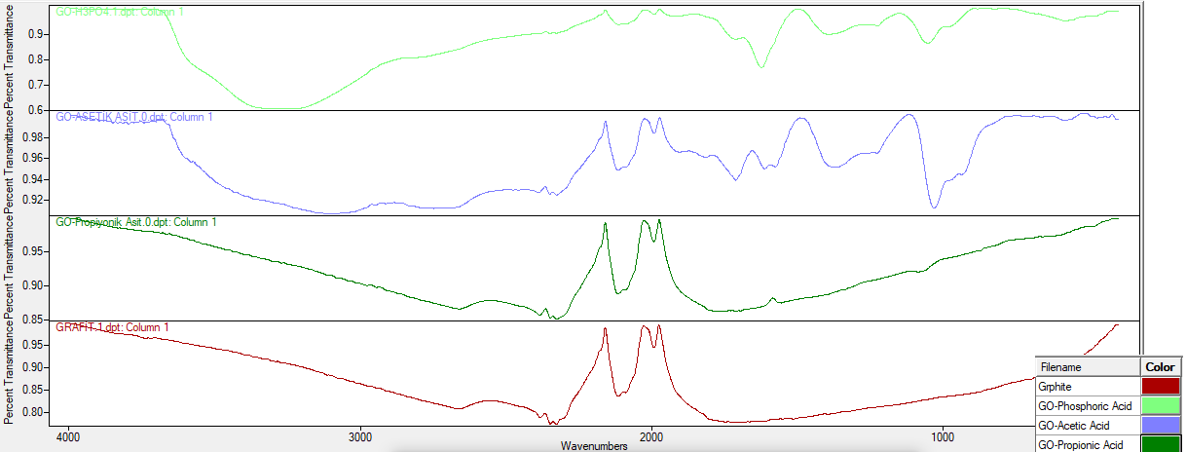

C-O

C=C

**Fig 3.1.** FTIR images of graphite and graphene oxide samples

BET surface area measurements of produced graphene oxide and graphite samples are shown in Figure 3.2. In the process of synthesizing graphene oxide from graphite, there has been a decrease in surface area, when a rise is anticipated. The reason for the huge surface area is the creation of a porous structure; in graphene oxide samples, a component that plugs their pores may have caused a drop in surface area.

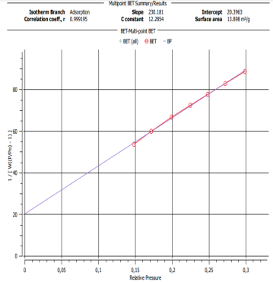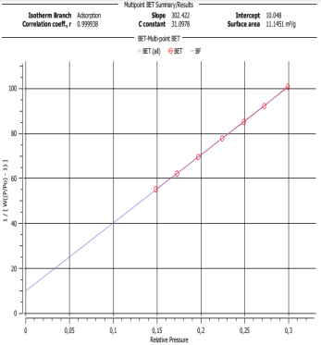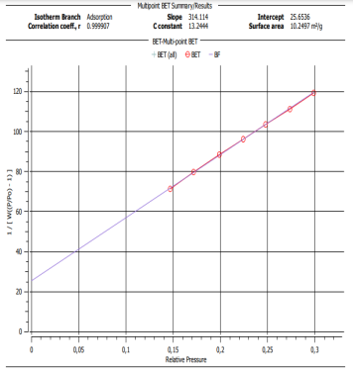 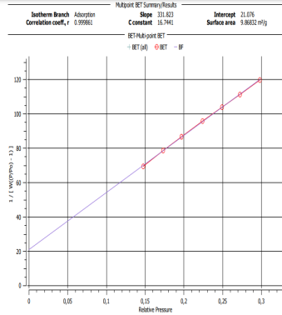

9,87 m2/g

GO-Propionic Acid

GO-Acetic Acid

GO-Phosporic Acid

1O,25 m2/g

13,89 m2/g

11,15 m2/g

Grphite

**Fig 3.2.** BET images of graphite and graphene oxide samples

 

Grphite

ZP=-34,4 m V

PS=290nm

GO-Phosporic Acid

PS=483nm

ZP=-21,3 m V

 

ZP=-22,5 m V

PS=542,65nm

ZP=-27,7 m V

PS=358,99nm

GO-Propionic Acid

GO-Acetic Acid

**Fig 3.3.** Zeta Sizer and Particle Size Results of Graphite and Graphene oxide Samples

Figure 3.3 displays the findings of the particle size and Zeta Potential analyses. Propionic acid synthesis showed a negative effect on the particle size value, whereas phosphoric acid and acetic acid synthesis showed an improvement in the values with the creation of graphene oxide. Figure 3.3 displays the findings of the particle size and Zeta Potential analyses. In the synthesis of phosphoric acid and acetic acid, the values improved with the generation of graphene oxide; however, in the synthesis of propionic acid, there was a negative effect on the particle size value.

**Table 3.1** Recovery ratios reference-concrete between Reduced graphene oxide-concrete

|  |  |  |  |  |  |  |  |  |
| --- | --- | --- | --- | --- | --- | --- | --- | --- |
|  | **Answers** | **Refa**  **Grphite** | **GO-Phosporic Acid** | **GO-Acetic Acid** | **GO-Propionic Acid** | **Recovery Rate GO-Phosporic Acid (%)** | **Recovery Rate GO-Acetic Acid (%)** | **Recovery Rate GO-Propionic Acid (%)** |
|  | BET (SA-m2/g) | 13,89 | 11,15 | 10,25 | 9,87 | **-19,72** | -35,51 | -28,94 |
| ZP ( ZP-mV) | -21,3 | -34,4 | -27,7 | -22,5 | **61,50** | 23,10 | **5,63** |
| ZP (PS-nm) | 483 | 290 | 359 | 543 | 39.95b | 25,67 | **-12,42** |
|  |  |  |  |  |  |  |  |

*Calculation of the % recovery rate of the experiment performed reference graphite*

*b ((11,15-13,89) / 13,89)\*100 =-19,72( Negative Value means a decrease)*

According to the findings from this investigation, the synthesis using propionic acid was unsuccessful because the exothermic reaction in the propionic acid experiment was uncontrolled and oxidation was not possible due to intermittent explosions. The production of acetic acid was successful and the experiment was completed without any problems. Acetic acid has behaved similarly to phosphoric acid in the manufacture of graphene oxide. Since acetic acid is more cost-effective and environmentally friendly than phosphoric acid, it can be used in the processing of graphene oxide instead of phosphoric acid.

**Acknowledgment**

This research was carried out with the support of the Scientific Research Project (MF081123B33) funded by Çankırı Karatekin University. Author thank to Çankırı Karatekin University, Scientific Research Project Management Unit (ÇAKÜ-BAP).

**References**

[1] Y. Bai, T. Xu, and X. Zhang, “Graphene-based biosensors for detection of biomarkers,” *Micromachines*, vol. 11, no. 1, 2020, doi: 10.3390/mi11010060.

[2] K. Thakur and B. Kandasubramanian, “Graphene and Graphene Oxide-Based Composites for Removal of Organic Pollutants: A Review,” *J. Chem. Eng. Data*, vol. 64, no. 3, pp. 833–867, 2019, doi: 10.1021/acs.jced.8b01057.

[3] S. Some *et al.*, “High-quality reduced graphene oxide by a dual-function chemical reduction and healing process,” *Sci. Rep.*, vol. 3, no. Figure 1, pp. 1–5, 2013, doi: 10.1038/srep01929.

[4] Palomba, M., Carotenuto, G., & Longo, A. (2022). A Brief Review: The Use of L-Ascorbic Acid as a Green Reducing Agent of Graphene Oxide. Materials, 15(18), 6456..

[5] Darabi, R., Karimi-Maleh, H., Akin, M., Arikan, K., Zhang, Z., Bayat, R., ... & Sen, F. (2023). Simultaneous determination of ascorbic acid, dopamine, and uric acid with a highly selective and sensitive reduced graphene oxide/polypyrrole-platinum nanocomposite modified electrochemical sensor. Electrochimica Acta, 457, 142402..

[6] V. Agarwal and P. B. Zetterlund, “Strategies for reduction of graphene oxide – A comprehensive review,” *Chem. Eng. J.*, vol. 405, no. September 2020, p. 127018, 2021, doi: 10.1016/j.cej.2020.127018.