**Effect Of Pressure On Optoelectronic Properties of Ir3ZrC Compound**

***Yasemin Öztekin ÇİFTCİ[[1]](#footnote-1)\*[C:\Users\Abdullah\AppData\Local\Microsoft\Windows\INetCache\Content.Word\ORCID-iD_icon-16x16.gif](https://orcid.org/xxxx-xxxx-xxxx-xxxx), İlknur Kars DURUKAN[C:\Users\Abdullah\AppData\Local\Microsoft\Windows\INetCache\Content.Word\ORCID-iD_icon-16x16.gif](https://orcid.org/xxxx-xxxx-xxxx-xxxx)***

*1 Science Faculty, Physics Department, Gazi University, Ankara, Turkey*

*2Science Faculty, Physics Department, Gazi University, Ankara, Turkey*

|  |
| --- |
| **Abstract**  Ever since their discovery by Russian mineralogist Perovski in 1839, perovskite materials have been the subject of extensive study. This diverse class includes various structures like perovskite, antiperovskite, inverse perovskite, double perovskite, and anti-double perovskite, each characterized by unique compositions and coordination geometries. Ternary nitrides or carbides with a cubic antiperovskite structure fall into a distinct class of materials described by the general formula AXM3 or M3AX, where A represents a main group III-V element, X stands for carbon or nitrogen, and M is a transition metal. Our focus in this study is on the compound Ir3ZrC, which adopts an antiperovskite structure, belongs to the Pm3m space group, and exhibits a cubic arrangement. Using the first-principles method with Density Functional Theory (DFT), we conducted a comprehensive theoretical analysis of the compound. This investigation delved into the effects of pressure on its structural, electronic, and optical properties. Understanding how compounds deform under compression and the consequent changes in their physical and chemical characteristics is crucial for comprehending the nature of solids, given the importance of pressure as a key parameter. We compared lattice constants, volumes, bulk modulus, and its first derivative under pressure with both experimental and theoretical data at zero pressure, providing a detailed analysis of their variations. The values of the studied compound at zero pressure were consistent with literature values, and Ir3ZrC demonstrated stability according to Born criteria across different pressure values. Furthermore, its electronically metallic nature was maintained even under the influence of pressure. In conclusion, we utilized the complex dielectric function to explore the optical properties of Ir3ZrC, presenting a thorough evaluation of optical parameters under pressure. The study not only examines the pressure effect but also investigates the optical properties of the perovskite cubic compound Ir3ZrC for the first time, contributing valuable data for experimental studies and enriching the existing literature. |
| Keywords: : DFT, B2 structure, electronic properties, elastic, properties, vibrational properties |

1. **Introduction**

Antiperovskites have become a subject of widespread interest due to their distinct physical, chemical, and thermodynamic properties. Representing electronically inverted perovskites, they constitute a growing class of versatile materials, offering an active and promising research field for materials scientists. The inverse counterparts, antiperovskites X3BA, are derivatives of electronically inverted perovskites, with A as a cation located at (0, 0, 0), B (C, N) at (1/2, 1/2, 1/2), and the transition metal atom X at (0, 1/2, 1/2). The ideal antiperovskites exhibit a cubic structure with the Pm-3m space group [1].

The unique coordination environment of cation X, characterized by the X-X distance and linear two-fold coordination, plays a pivotal role in determining crystal field strength. Their inherent structural flexibility, accommodating diverse elements from the periodic table, has garnered substantial research interest on a global scale [2]. Recent progress in antiperovskite research has unveiled exceptional properties, including giant magnetoresistance (GMR), nearly zero temperature coefficients of resistivity, and magnetostriction. These properties position them as promising candidates for various industrial applications, particularly in magnetic field sensors used for data reading in hard disk drives, biosensors, and microelectromechanical systems (MEMS). Furthermore, owing to their favorable thermoelectric properties, antiperovskites hold potential for addressing the energy crisis through electricity generation and solid-state refrigeration [3].

A decade ago, the authors of [4] predicted a diverse range of new ternary carbides, denoted as M3AC, utilizing empirical structural criteria for evaluating the stability of cubic antiperovskites. This assessment, based on the tolerance factor (t), determined whether the sizes of octahedral voids in closely packed M3A crystals could accommodate B, C, or N atoms. In the specified tolerance factor interval (0.899 < t < 1.123), it was suggested that four Ir-based Ir3MC carbides—Ir3TiC, Ir3ZrC, Ir3NbC, and Ir3TaC—could potentially exist. It is imperative to underscore that the empirical methodology employed in this context does not yield substantive insights into the intrinsic physical properties of the envisioned materials. Rather, it is contingent upon the judicious selection of constituent elements based on their fitting atomic radii. However, the projected distinctive electronic and magnetic attributes of Ir3MC compounds emanate from the intricate interplay within the antiperovskite structure, wherein two sub-lattices are configured, featuring open-shell 5d-(3d,4d)-atoms. The technological significance of Ir3MC compounds is premised on the inclusion of the platinum-group metal Ir, renowned for its exceptional hardness, coupled with carbon. The heightened attention directed towards carbides and nitrides of platinum group metals (M = Ru, Rh, Pd, Os, Ir, Pt) has gained momentum, notably subsequent to the successful synthesis of platinum monocarbide PtC under high pressure and temperature conditions utilizing the laser-heated diamond anvil cell technique, as documented by Ono et al. [5]. This focus is distinctly oriented towards materials exhibiting potential superior hardness and minimal compressibility. These considerations derive from the guiding principle that prospective ultra-hard materials should amalgamate concise and robust covalent bonds, involving 2p-atoms such as B, C, or N, with the heightened valence charge density characteristic of transition metal compounds [6-8]. Moreover, given the chemical stability and notably high melting point (circa 2454o C) of iridium, materials encompassing Ir-based alloys and compounds are of particular interest for applications necessitating extreme temperature resilience.

Here, we have studies pressure effects on structural, electronic and optical properties of Ir3ZrC compound using first-principles methods.

1. **Materials and Methods**

In this investigation, we conducted structural optimizations, electronic property calculations, and evaluations of optic properties using the Vienna ab initio simulation package (VASP) code [9-11], based on density functional theory. For describing exchange and correlation effects, the Perdew-Burke-Ernzerhof (PBE) [12] generalized gradient approximation (GGA) [13] was implemented. Electron-ion interactions were addressed using the all-electron projector augmented-wave (PAW) [14] method, treating the valence electrons of B, C, and N atoms (2s²2p¹, 2s²2p², and 2s²2p³, respectively).To maintain total energy convergence at around 2 meV/atom, we utilized a plane-wave kinetic energy cutoff of 800 eV and 18 × 18 × 18 k-point grids under the Monkhorst-Pack scheme [15].

1. **Results and Discussion**
   1. **Structural and ElectronicProperties**

The Ir3ZrC anti-perovskite compound exhibit an ideal cubic structure characterized by the space group (Pm-3m). In this structure, X ions are situated at the corner positions, carbon resides at the body center, and Rh occupies the face center of the cube. The specific Wyckoff positions for these elements are Zr: 1a (0,0,0); C: 1b (1/2,1/2,1/2); Ir: 3c (1/2,1/2,0), respectively as seen in Fig.1. To determine the equilibrium lattice constants, geometric optimizations calculation were performed using full relaxations by minimizations of energies. Table 1 includes some experimentally reported lattice constants for comparative purposes. Our computed lattice parameter is comparable with the values reported in Ref. [16], attributed to the utilization of the GGA functional. The total energy of the unit cell is calculated by varying the unit-cell volume(see Fig.2). Subsequently, the computed total energies plotted against volume are fitted using Murnaghan's equation of state (EOS) [17]. This fitting process is crucial for determining fundamental ground state properties, including the equilibrium lattice constant (𝑎₀), bulk modulus (𝐵₀), and ground state unit cell energy (𝐸). These parameters are presented in Table 1, along with theoretical results.The determined bulk modulus for Ir3ZrC as 260.78 GPa is lower than compared to values in [16]. The pressure derivative of bulk modulus, indicative of resistance to volume change under mechanical effects, is 4.54.

**Table.1** Structural parameters for Ir3ZrC

|  |  |  |  |  |
| --- | --- | --- | --- | --- |
|  | a(A) | B(GPa) | B’ | Etot (eV)/atom |
| This study | 4.169 | 260.76 | 4.54 | -44.61 |
| Theory [16] | 4.164 | 266.5 | - | - |

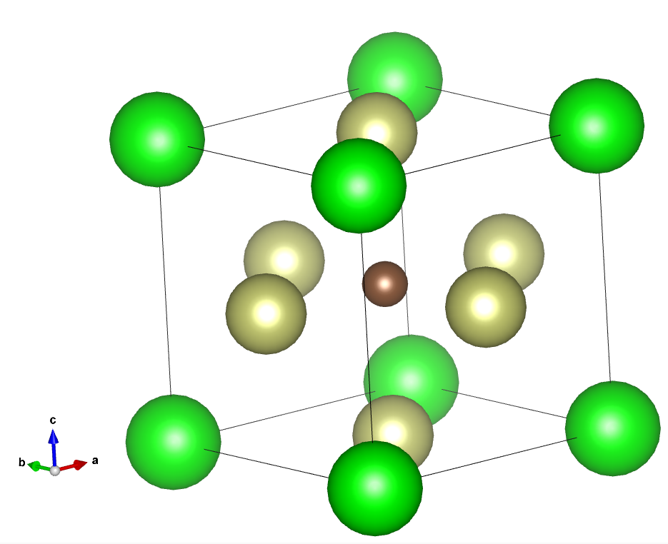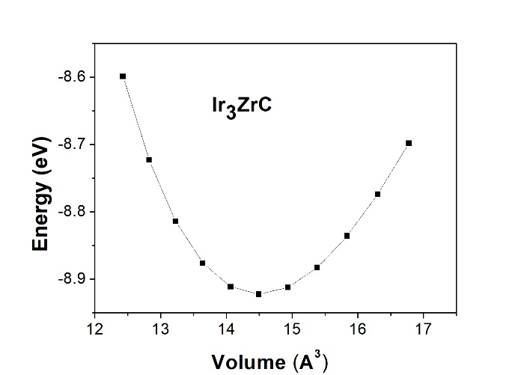

**Figure. 1** Unitcell of Ir3ZrC **Figure.2** Energy- volume curves for Ir3ZrC

The technological relevance of solid-state materials hinges significantly on the intricate behavior exhibited by valence and conduction electrons within the material matrix. This behavior, in turn, is intricately tied to the energy dispersion characteristics (E(k)) within the Brillouin zone. Our investigative focus is dedicated to the computational analysis of the electronic band structure of Ir3ZrC, leveraging an optimized crystal structure for precision. Illustrated in Figure 3 are the electronic energy dispersion curves under varying pressures along high-symmetry directions within the Brillouin zone of Ir3ZrC. By aligning the Fermi level at 0 eV, the metallic nature of Ir3ZrC becomes evident, with overlapping valence and conduction bands suggesting electron conductivity proximate to the Fermi level, as showcased in Figure 3. The distinctive features discerned in the presented band structure unequivocally affirm the existence of multiple bands with diverse degrees of dispersion intersecting the Fermi level, thereby corroborating the metallic character of the Ir3ZrC ternary compound. Bands exhibiting heightened dispersion along the M and R directions underscore their pivotal role in influencing charge transport properties, whereas those intersecting the Fermi level in the vicinity of the Г-X and Г-L directions display reduced dispersion. The conspicuous dispersion observed in specific bands implies a diminished effective mass for charge carriers, indicative of heightened charge mobility. Noteworthy is the presence of lowly dispersive E(k) regions around the Г points, emphasizing substantial anisotropy in charge transport along distinct crystallographic directions and within the momentum space of the scrutinized material.

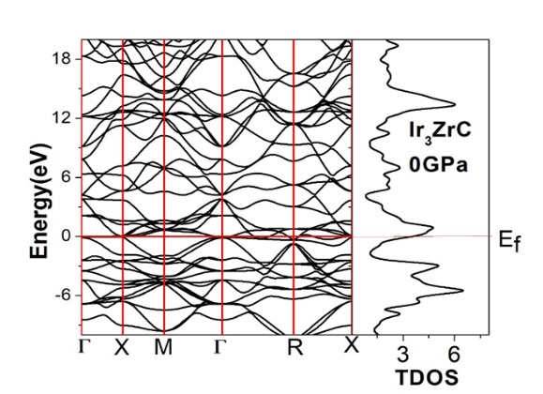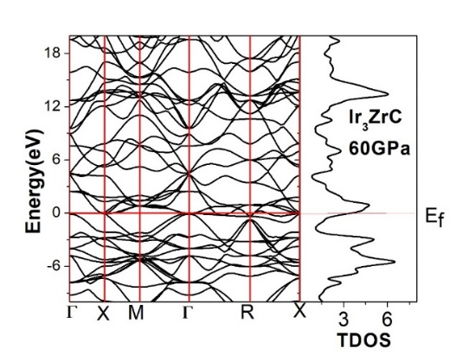

**Figure 3.** Electronic band structure for Ir3ZrC at 0GPa and 60 GPa

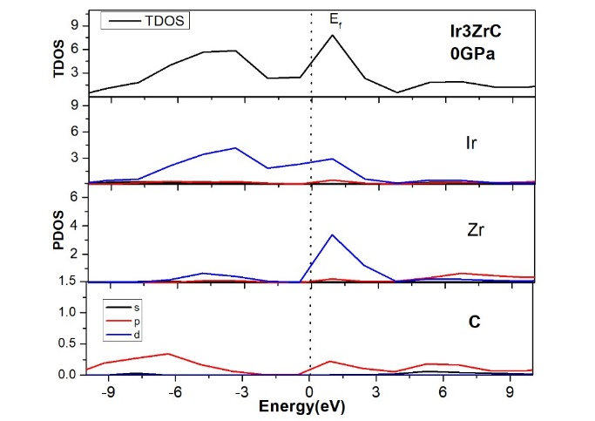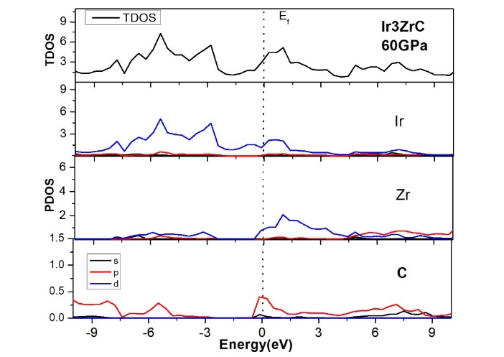

**Figure 4.** Total and partial DOS for Ir3ZrC at 0GPa and 60GPa

In Figure 4, we present the partial density of states (PDOS) for Ir3ZrC, illustrating distinct contributions from the Fermi level, valence band, and conductivity band. Examining the total density of states (TDOS) and PDOS plots for Ir3ZrC reveals that its metallic nature primarily stems from the occupancy of Ir-d, Zr-d, and C-p states at the Fermi level. Specifically, Ir-d and C-p states contribute significantly to the valence band, while Zr-d states play a major role in the conduction band. Upon scrutinizing Figure 4 at 0 and 60 GPa, we observe slight changes in the shapes of the peaks under pressure. This suggests that the structural integrity of the Ir3ZrC compound remains largely unaffected, with no discernible structural phase transformation observed under pressures up to 60 GPa. Notably, an increase in pressure leads to a noticeable shift of the peaks toward the Fermi level.

**3.3 Optical Properties**

The potential application of a material in optoelectronic devices is contingent on its optical characteristics under varying pressure conditions. In this study, we investigate the pressure-dependent optical properties, including absorption, photoconductivity, reflectivity, refractive index, and dielectric function, providing insights across various application fields. Our examination of optical spectra reveals shifts in electrical states, band constructions, bond types, and internal material structures. The Kramers–Kronig transformation enables the derivation of the frequency-dependent complex dielectric function, denoted as ε(ω) = ε1(ω) + iε2(ω), and is linked to relative permittivity.

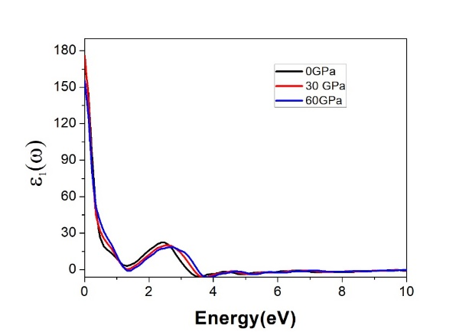 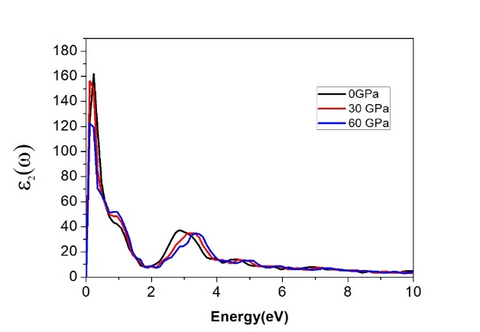

**Figure 5 .** Real and imaginary dielectric function for different pressure of Ir3ZrC

In Figures 5, the real and imaginary parts of the dielectric function for Ir3ZrC perovskites are presented under varying pressures, covering photon energies up to 20 eV. A Gaussian smearing of 0.5 eV is applied in all calculations, with the analysis focused on the [100] polarization vector. The real part exhibits an initial increase at low photon energy, followed by a rapid decline with higher photon energy. The pressure-induced perovskite displays an increased dielectric constant within the visible range. At 0, 30, and 60 GPa pressures, the static dielectric constants are measured at 170.3, 176.2, and 155.4, respectively, suggesting the potential of Ir3ZrC as a promising dielectric material. The imaginary part, indicative of optical absorption/transitions and the material's band gap, exhibits heightened values and shifted peaks towards lower incident photon energy under applied pressure. Conversely, in the higher photon energy region, the imaginary part diminishes to zero around 20 eV, indicating the material's transparency beyond this threshold. These findings provide valuable insights into the pressure-dependent optical properties of Ir3ZrC and their implications for optoelectronic devices.

In Figure 6, the real part of the refractive index is depicted, representing the phase velocity of electromagnetic wave propagation within Ir3ZrC. The maximum value of n is attributed to electron transitions from the valence to the conduction band. Peaks in the refractive index correspond to the generation of electron-hole pairs for conduction and interband optical transitions between valence and conduction bands. The fourth peak around 14.0 eV, known as the plasmon peak, arises from the collection of excitons of free carriers. These distinct responses among materials contribute to variations in their band gaps. At 0, 30, and 60 GPa pressures, the maximum refractive index values are observed at zero photon energy, suggesting potential applications of Ir3ZrC in devices such as QLEDs, OLEDs, solar cells, and waveguides. Additionally, a noticeable pressure effect is evident, with the refractive index decreasing under pressure.

Reflectivity, a pivotal optical property determining material surface characteristics for applications in optoelectronics and solar cells, is presented in Fig. 6(b). reflectivity is determined by considering the ratio of incident to reflected power. At zero pressure, reflectivity was consistently low for Ir3ZrC compound. Upon the application of pressure, reflectivity and loss function values experienced significant increases, potentially attributed to changes in structural alterations. The appearance of peaks at 4.8 eV is attributed to the inter-band transition among valence and conduction bands. In contrast, energy ranging from 35 eV to 45 eV exhibits the minimum value of reflectivity as a consequence of collective plasma resonance. The presence of L(ω) peaks below 2 eV underscores the efficiency of the Ir3ZrC component as an optical absorption layer within the visible photon spectra and infrared (IR) range. Notably, the loss function of I3ZrC remains relevant for photon energies up to 50 eV. In essence, the loss function of Ir3ZrC plays a pivotal role in its performance, underscoring its importance in the design and optimization of this materials for specific applications.

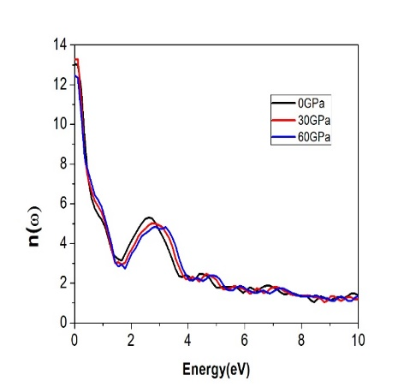 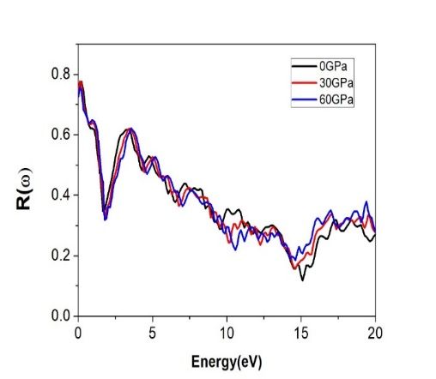 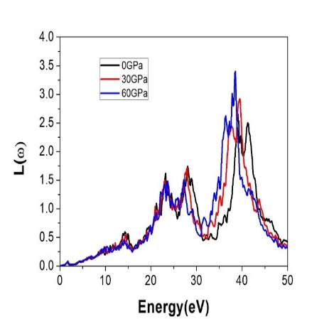

**Figure 6 .** Refractive index, reflectivity and loss function for different pressure of Ir3ZrC

1. **Conclusion**

We conducted a thorough examination of the impact of hydrostatic pressure on the structural, electronic, and optical properties of Ir3ZrC using rigorous first-principles methods. The results obtained for the structural parameters are in excellent agreement with previously reported data. Analysis of the electronic band structure and density of states unveiled the metallic nature of Ir3ZrC. Notably, an observed reduction in lattice constant was identified with an increase in hydrostatic pressure. Furthermore, as the pressure was elevated up to 60 GPa, there was a discernible upward trend in static dielectric constant, plasma frequency, and static refractive indices. These findings offer valuable insights for the comprehension and advancement of optoelectronic devices utilizing Ir3ZrC, particularly those engineered to operate effectively under varying pressure conditions..

**References**

[1] D. Cherrad, L. Selmani, D. Maouche, M. Maamache, First principles calculations on elasticity, electronic structure and bonding properties of antiperovskites ANTi3 (A= Al, in and Tl), J. Alloys Compd. 509 (2011) 4357–4362.

[2] Y. Wang, H. Zhang, J. Zhu, X. Lü, S. Li, R. Zou, Y. Zhao, Antiperovskites with exceptional functionalities, Adv. Mater. 32 (2020), 1905007.

[3] M. Bilal, S. Jalali-Asadabadi, R. Ahmad, I. Ahmad, Electronic properties of antiperovskite materials from state-of-the-art density functional theory, J. Chem. (2015) 1–11, 2015.

[4] K. S. Alexandrov, and B. V. Besnosikov. *Perovskites: present and*

*future*. Siberian Branch, Russ. Acad. Sci, Novosibirsk, 2004 *(in Russian).*

[5] S. Ono, T. Kikegawa, and Y. Ohishi, Solid State Commun. **133**, 55

(2005).

[6] R. B. Kaner, J. J. Gilman, and S. H. Tolbert, Science **308**, 1268 (2005).

[7] J. J. Gilman, R. W. Cumberland, and R. B. Kaner, Int. J. Refract. Met.

Hard. Mater. **24**, 1 (2006).

[8] J. B. Levine, S. H. Tolbert, and R. B. Kaner, Adv. Funct. Mater. **19**,

3519 (2009)

[9] G. Kresse, J. Hafner, (1993) Ab initio molecular dynamics for liquid metals, Phys. Rev. B 47 558.

[10] G. Kresse, J. Hafner, (1994) Ab initio molecular-dynamics simulation of the liquid metal–amorphous-semiconductor transition in germanium, Phys. Rev. B 49 14251.

[11] G. Kresse, J. Furthmuller, (1996) Efficiency of ab-initio total energy calculations for metals and semiconductors using a plane-wave basis set, Comput. Mater. Sci. 6 15.

[12] J.P. Perdew, J.A. Chevary, S. Vosko, K.A. Jackson, M.R. Pederson, D.J. Singh, C. Fiolhais, (1992) Atoms, molecules, solids, and surfaces: applications of the generalized gradient approximation for exchange and correlation, Phys. Rev. B 46 6671.

[13]J. P. Perdew, in *Electronic Structures of Solids'91*, Ed. by P. Ziesche and H. Eschrig (Akademie, Berlin, 1991), p. 11.

[14] G. Kresse and D. Joubert, Phys. Rev. B **59**, 1758 (1999).

[15] H.J. Monkhorst, J.D. Pack, (1976) Special points for Brillouin-zone integrations, Phys. Rev. B 13 5188

[16] ] V.V. Bannikov, I.R. Shein, D.V. Suetin, Structural, elastic and electronic properties of Ir-based carbides-antiperovskites Ir3MC (M= Ti, Zr, Nb and Ta) as predicted from first-principles calculations, Computat. Condens. Matter. 11 (2017) 60–68.

[17] F.D. Murnaghan, Proc. Natl. Acad. Sci. USA 30, 244, (1944).

1. \* Corresponding author. *e-mail address:yasemin@gazi.edu.tr.* [↑](#footnote-ref-1)