**Design and implementation of fuzzy logic-controlled smart solar tracking system**

***Zaid AL-IBRAHIME1,[1]*, prof.dr Fatih KORKMAZ2***

*1 Electrical and Electronics Engineering, University of Çankiri, Çankiri, Turkiye*

*2 Electrical and Electronics Engineering, University of Çankiri, Çankiri, Turkiye*

|  |
| --- |
| **Abstract**  This paper proposes to build a multi-axis, closed-loop smart solar tracking system capable of moving 360° horizontally and 180° vertically with a starting angle of 90° so that the system can know the start angle without the need to know the azimuth angle. In addition to the system being able to protect the photovoltaic cells from damage, it continuously changes the direction of the solar panel by 180° if the solar temperature exceeds 45°C and then returns to track after the temperature drops below that. The fuzzy logic controller will be responsible for controlling and directing all elements of the system and determining the time to move the panels so that they face direct sunlight. and collecting data using a recording unit (SD card) and storing it on a memory card, which may be accessed at any time, to verify the system's efficiency and identify weak points.  The importance of the research is using 8 sensors (LDR) programmed according to a special mathematical algorithm instead of 4. This approach allows the system to effectively handle partial shading and maintain accurate tracking even if one of the sensors malfunctions. As a result, this system exhibits a high level of tracking accuracy. The system employs two motors: a DC motor with a gearbox for horizontal rotation and a servo motor for vertical rotation. The results of this study indicate that employing a fuzzy logic controller yielded superior precision in comparison to alternative software. Additionally, the utilization of 8 LDR sensors, two motors, and a temperature sensor resulted in enhanced practical accuracy for the system, enabling it to achieve maximum photovoltaic energy output over the longest possible period of time. |
| Keywords: *Solar tracking system, LDR sensors, DC Motor, SERVO Motor, Fuzzy logic* |

1. **Introduction**

In recent decades, the focus has been on low-cost renewable solar energy technologies to reduce fossil fuel use and environmental damage. With diminishing resources, there's a need for environmentally friendly, cost-effective, and infinite energy sources. Solar energy is the best-developed renewable technology due to its accessibility, non-polluting, clean, and safe nature [1]. Researchers have developed closed-loop solar tracking systems to overcome the limitations of solar panels in wet or cloudy weather, utilizing various tracking technologies for improved efficiency [2]. A solar tracking system (STS) adjusts a solar panel's position or tilt to face the sun perpendicularly, enhancing its efficiency compared to a fixed system [3]. Previous studies have explored methods for optimizing photovoltaic energy generation. This study aims to identify and address the limitations of these previous studies in order to achieve higher accuracy. By doing so, we can increase the amount of energy obtained while also prolonging the lifespan of the solar cells. The most important differences that this study will focus on are:

Previous studies neglected the investigation of strategies to address the issue of partial shadowing or the failure of one of the Light Dependent Resistor (LDR) sensors. This study incorporated 8 Dependent Resistor (LDR) sensors that were operated by a specialized mathematical system utilizing fuzzy logic. The intelligent system in this study successfully navigated through all barriers and achieved direct perpendicularity with great accuracy. For example, the research conducted by Imron et al. utilized the solar panel's location, which is controlled by four Light Dependent Resistor (LDR) sensors, which adjust the strength of solar radiation. The control technique employed is fuzzy logic, which yields a settling time of 10 seconds and a steady-state error of 0.080%. This system enhances power output by more than 30% [4].

Previous studies have emphasized the pressing requirement to determine the azimuth angle, even when employing multi-axis tracking. To solve this issue in this study, the solar panel's initial angle was adjusted to 90 degrees relative to the horizon. Subsequently, the sensors detect the maximum light radiation without requiring knowledge of the azimuth angle. For example, the research conducted by Aprillia et al. discusses the optimization of the azimuth direction and tilt angle of photovoltaic panels at Telkom University in Bandung, West Java. The goal is to enhance the absorption of solar radiation by determining the maximum tilt angle using calculations [5].

Previous studies neglected the impact of elevated temperatures; this study addressed this issue by implementing a strategy of reorienting the panel by 180 degrees when the temperature exceeded 45 degrees Celsius. This approach was adopted due to the fact that high temperatures cause a 3% decrease in the efficiency of photovoltaic cells for every 10 degrees Celsius above their optimal operating conditions. For example, the research conducted by Huang et al. proposed a two-axis sun-tracking solar energy system using fuzzy logic as an intelligent quality policy. The system uses dual-axis solar panels for mechanical movement, with fuzzy logic controlling timing and database theory. This system is more accurate and simpler than traditional sensor systems and can reduce energy loss even in poor weather conditions, but without focusing on the impact of the high temperatures [6].

Significantly, the key distinction between this study and most comparable studies lies in the fact that, in the former, the control devices, sensors, and motors were simulated through computer programs, and tests were conducted under ideal conditions. Conversely, in this study, the testing was carried out in a practical and realistic manner, accounting for variations in the internal resistance values of the sensors. Consequently, this discrepancy in sensor readings resulted in an elevated error rate. Furthermore, elevated temperatures have an impact on the internal resistance value of the sensor. A mathematical approach has been implemented to compare the sensors and resolve this issue. For example, the research conducted by Asyadi and Muliadi used Matlab/Simulink R2018b software for simulation testing, focusing on selecting solar modules, modeling boost converters, designing FLC methods, and comparing FLC results with P&O for maximum power point [7]. Nevertheless, the project for this study has employed a sophisticated approach to guarantee that the system is fully prepared to maximize energy output, irrespective of the associated expenses, operational range, and reliability of the sensors.

1. **Materials and Methods**

The reagents, 1H-imidazole This research designed an external structure that supports the concept of the solar tracking system and is characterized by freedom of movement in all needed axes and directions. Moving the solar panel in both directions requires the use of two motors, provided that these two motors are controlled by smart devices (Arduino) that are coded in a smart language by employing fuzzy logic to boost the accuracy of the instructions controlling the system. In order to determine the necessary angle and direction, 8 (LDR) sensors were evenly positioned around the solar panel. These 8 LDRs were distributed as follows:

* 4 LDRs sensors around the corners of the solar panel
* 4 LDRs sensors in the middle of the outer ribs of the panel and between the first four sensors.

Furthermore, the utilization of specific plastic pieces to manipulate the angle of light that enters the (LDR) serves to enhance the sensitivity of the device in the intended direction, as shown in Figure 1. To enhance the precision of identifying the necessary movement direction of the solar panel, it is vital to employ specific mathematical equations, as shown below:

Horizontal LDR ERROR ((A1-A0) + (A3-A2)) / 2

Vertical LDR ERROR ((A2-A0) + (A3-A1)) / 2

Center-Horizontal LDR Error (A7)

Center: Vertical LDR ERROR (A5) (A4)

The term "error" is used to denote the value of the difference between the sensor and the other sensor in a certain direction.

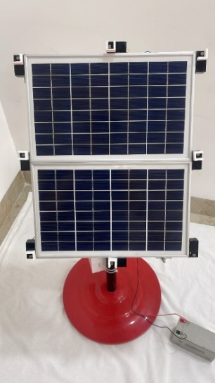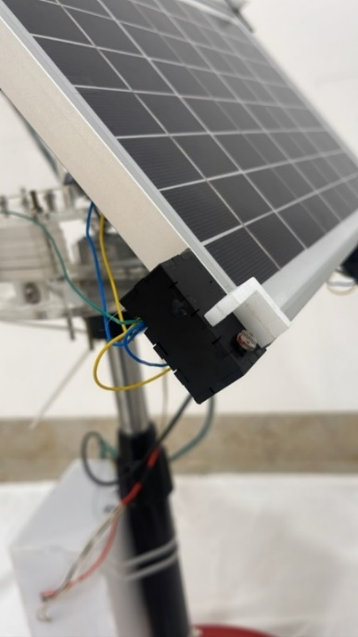

A0

A4

A1

LDR

A7

A6

A5

A3

A2

**Figure 1**. Distribution of the LDR with the specific plastic pieces of the solar tracking system used in the study (Researcher)

The distribution of 8 LDR and utilization of the mathematical algorithm above can be attributed to several fundamental reasons, with the most significant ones being:

* First: the variation in values arises from differences in the manufacturing and production processes of LDR sensors by the company. This discrepancy is primarily caused by variations in the internal resistance, resulting in different sensing and reading values for sensors under the same conditions. Consequently, this discrepancy leads to inaccuracies in the instructions sent to the horizontal and vertical motors through an Arduino device, as it becomes challenging to select the optimal angle perpendicular to the source of solar radiation as shown in Figure 2.

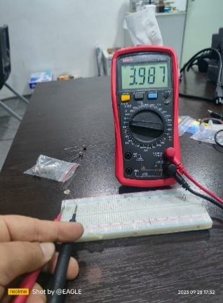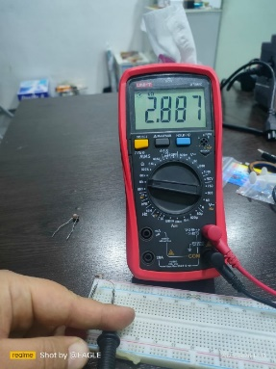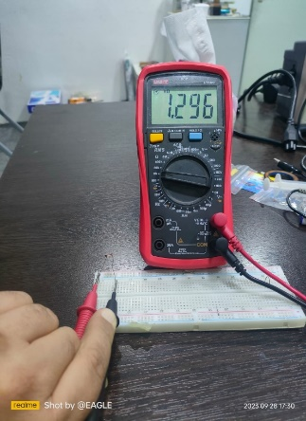

Figure 2. The difference in the value of the internal resistance for each LDR sensor, and for the same LDR sensor values used in this study (Researcher)

* Second: in the event of partial shading, the system can effectively address this issue by increasing the number of LDR sensors using the technique outlined before.
* Third: in the event of damage or malfunction in one of the LDR sensors, the system will remain unaffected due to the presence of other LDR sensors and an algorithm that can establish the necessary angle using the functioning sensors.
* Fourth: oscillation and delayed reaction in practice can be mitigated by implementing the aforementioned mathematical technique, which effectively minimizes the fluctuations caused by many and varying readings.

In addition, a temperature sensor has been installed in the solar system to prevent the photovoltaic cells from overheating and potentially causing harm. Furthermore, a rechargeable battery has been included to power the entire system. The sun-tracking device utilized in this study was devised and executed via a 3D printer. The solar tracking system utilized in this investigation comprises a solar panel, light-dependent resistor (LDR), liquid crystal display (LDC), temperature sensor, current sensor, servo motor, DC motor with gearbox, Arduino microcontroller interfaced with a micro-SD card, Arduino Mega 2560 Rev3, L298N DC Motor Driver Module interfaced with Arduino, DC-DC converter, battery, and printed circuit board (PCB). Figure 3 show the elements of the system from the front and back perspectives. Furthermore, Figure 4 illustrates the constituent parts of the system's controller box.

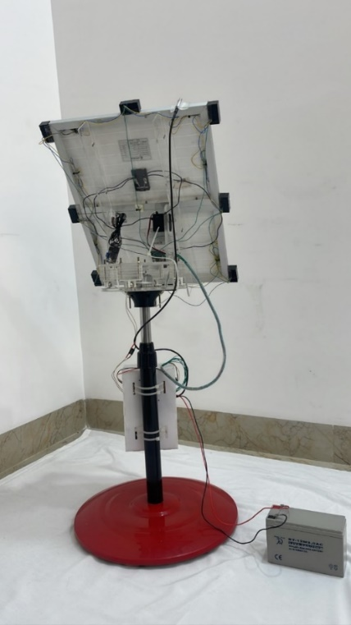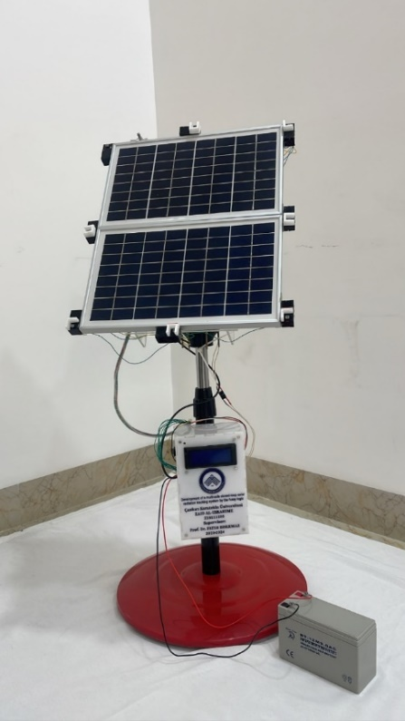

Temperature sensor with Arduino (DS18B20)

Solar panel (10 W)

Servo motor (RDS3115MG)

Y-axis

DC motor with gear box X- axis

LDR Light Sensor Module for Arduino, brand OEM

I2C LCD with an Arduino

Controller box

Battry

Figure 3. The front and back elevation of the solar tracking system used in the study (Researcher)

Arduino Mega 2560 Rev 3

DC to DC converter

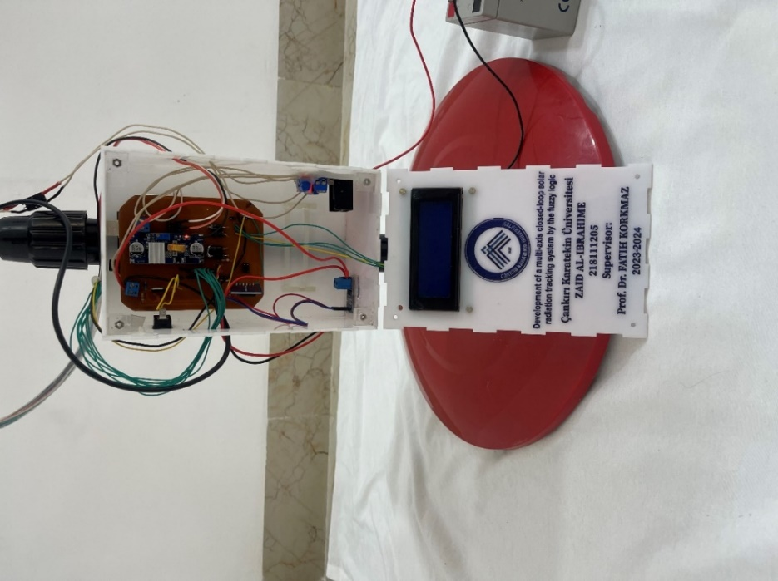

PCB

SD card with memory 2 GB

DC driver controller (L298N)

Current senser with Arduino (ACS712))

**Figure 4**. The controller box components of the solar tracking system used in the study (Researcher)

1. **Results and Discussion**

The results of the study that was conducted in Iraq, Mosul (36.405255, 43.150255), on November 5, 2023, from 8:30 a.m. to 18:00 p.m. through reading the system’s LDR sensors.

**Table 1.** Solar tracking system data utilized in this study

|  |  |  |  |  |  |  |  |  |  |  |  |  |  |  |  |
| --- | --- | --- | --- | --- | --- | --- | --- | --- | --- | --- | --- | --- | --- | --- | --- |
| Time | Temperature | A0 | A1 | A2 | A3 | A4 | A5 | A6 | A7 | V-E | H-E | C-V-E | C-H-E | mA in | V- in |
| 8:30 | 23.19 | 959 | 966 | 955 | 948 | 972 | 958 | 954 | 919 | -11 | 0 | -14 | -35 | 97 | 13.38 |
| 9:00 | 27.56 | 960 | 968 | 958 | 951 | 975 | 961 | 958 | 934 | -9 | 0 | -14 | -24 | 97 | 13.29 |
| 9:30 | 28.19 | 962 | 969 | 959 | 953 | 976 | 962 | 959 | 945 | -9 | 0 | -14 | -14 | 97 | 13.25 |
| 10:00 | 26.88 | 963 | 970 | 960 | 955 | 978 | 963 | 960 | 953 | -9 | 1 | -15 | -7 | 97 | 13.2 |
| 10:30 | 27.94 | 963 | 970 | 960 | 955 | 978 | 963 | 959 | 957 | -9 | 1 | -15 | -2 | 97 | 13.11 |
| 11:00 | 28.75 | 961 | 965 | 959 | 954 | 978 | 958 | 951 | 958 | -6 | 0 | -20 | 7 | 97 | 13.07 |
| 11:30 | 31.56 | 942 | 946 | 958 | 955 | 975 | 952 | 920 | 958 | 12 | 0 | -23 | 38 | 97 | 13.07 |
| 12:00 | 31.06 | 943 | 948 | 958 | 954 | 976 | 953 | 922 | 958 | 10 | 0 | -23 | 36 | 97 | 12.97 |
| 12:30 | 30.69 | 923 | 934 | 956 | 954 | 973 | 947 | 911 | 957 | 26 | 4 | -26 | 46 | 97 | 12.93 |
| 13:00 | 30.94 | 925 | 934 | 956 | 954 | 973 | 948 | 908 | 957 | 25 | 3 | -25 | 49 | 97 | 12.7 |
| 13:30 | 30.94 | 926 | 934 | 957 | 954 | 974 | 949 | 906 | 957 | 25 | 2 | -25 | 51 | 97 | 12.88 |
| 14:00 | 32 | 931 | 936 | 957 | 954 | 974 | 949 | 907 | 952 | 22 | 1 | -25 | 45 | 97 | 12.84 |
| 14:30 | 31.19 | 938 | 939 | 956 | 952 | 973 | 949 | 915 | 944 | 15 | -1 | -24 | 29 | 97 | 12.84 |
| 15:00 | 29.94 | 944 | 945 | 954 | 950 | 972 | 950 | 925 | 929 | 7 | -1 | -22 | 4 | 97 | 12.79 |
| 15:30 | 29 | 925 | 926 | 949 | 944 | 966 | 941 | 895 | 908 | 21 | -2 | -25 | 13 | 97 | 12.84 |
| 16:00 | 26.75 | 892 | 892 | 926 | 928 | 948 | 920 | 869 | 865 | 35 | 1 | -28 | -4 | 97 | 12.57 |
| 16:30 | 23.5 | 769 | 781 | 781 | 777 | 783 | 785 | 727 | 723 | 4 | 4 | 2 | -4 | 97 | 12.79 |
| 17:00 | 22.13 | 489 | 544 | 557 | 525 | 496 | 551 | 434 | 425 | 24 | 11 | 55 | -9 | 97 | 11.93 |
| 17:30 | 21.5 | 35 | 57 | 61 | 47 | 35 | 48 | 35 | 33 | 8 | 4 | 13 | -2 | 97 | 11.61 |
| 18:00 | 20.31 | 27 | 36 | 36 | 29 | 26 | 30 | 27 | 26 | 1 | 1 | 4 | -1 | 97 | 11.2 |

Table 1 shows the system data obtained from the SD card. It includes the recorded values of the eight LDR sensors and the temperatures experienced by the system during the practical test period. Additionally, it presents the vertical error (V-E), horizontal error (H-E), center vertical error (C-V-E), and center horizontal error (C-H-E), which indicate the panel's movement directions relative to solar radiation. These directions were determined using specialized mathematical equations based on fuzzy logic to enhance tracking precision.

**Figure 5**. The highest reading for LDR sensor value in relation to time (Researcher)

Figure 5 shows the readings from the eight LDR sensors in the smart system during the practical test, taken at various time intervals. The LDR sensors were programmed via fuzzy logic, with the value of 0 representing total darkness and the value of 1024 representing the highest level of light exposure. The system successfully monitored a collective. The highest recorded value was observed at sensor A4, reaching a peak of 978 during the time interval of 10:00 to 11:00. The lowest sensitivity value, on the other hand, was found between sensors A4 and A7, occurring at 18:00. The following conclusions can be elucidated by conducting tests on the smart system:

1. The greatest reading LDR sensor value was obtained during the system’s operating period, reaching (978 unit) out of (1024 unit), which is the ideal value for the intensity of light radiation.
2. The system was able to track the source of solar radiation without the need to know the azimuth angle.
3. Generating the greatest electrical energy for the longest possible period of time from the beginning of the system’s operation at 8:30 a.m. until 17:00 p.m., then the production capacity decreased to its lowest at 18:00 p.m. as shown in Figure 6.

**Figure 6**. Reading of 8 LDR sensor values in relation to time (Researcher)

1. If the V-E value is positive, it means that the solar panel will move toward the north, and if it is negative, it will move toward the south.
2. If the H-E value is positive, it means that the solar panel will move toward the east, and if it is negative, it will move toward the west.
3. If the C-V-E value is positive, it means that the solar radiation value directed toward the bottom of the panel is higher than the solar radiation value directed towards the top.
4. If the C-H-E value is positive, it means that the solar radiation value directed toward the west of the panel is higher than the solar radiation value directed toward its east.
5. **Conclusion**

After employing the intelligent solar tracking system on the ground, we can assert that it surpasses conventional tracking systems in terms of its superior ability to locate the sun's position and its heightened precision. This result was detected by analyzing the data collected during the practical experiment. The alignment of the system with the radiation source was achieved through a sophisticated mathematical algorithm controlled by fuzzy logic. This algorithm considered various factors, such as partial shadowing or sensor damage, to ensure accurate alignment. Furthermore, the study suggests including 8 LDR sensors, using a fuzzy logic system, constructing an exterior structure capable of rotating 360° horizontally and 180° vertically, and utilizing two motors (specifically, a DC motor with a gearbox and a servo motor). Based on the results of this study, the proposed system offers numerous benefits in an intelligent framework that allows tracking to commence without requiring knowledge of the azimuth angle. Furthermore, it provides accurate results for the maximum point of electrical power generation over an extended period of time. In addition, the system can be used to effectively manage a substantial quantity of solar panels in order to maximize the generation of photovoltaic energy.

**References**

1. Elzein, I. A. (2014). A study of Maximum Power Point Tracking Algorithm for Photovoltaic Systems Using a Fuzzy Logic Controller.‏*WIT Transaction on Engineering Sciences*, Vol.96, WIT Press.P.409-419.
2. Zakariah, A., Jamian, J. J., & Yunus, M. A. M. (2015, December). Dual-axis solar tracking system based on fuzzy logic control and Light Dependent Resistors as feedback path elements. In 2015 *IEEE* Student Conference on Research and Development (SCOReD) (pp. 139-144). IEEE.
3. Kumar, D. N., & John, M. S. (2020, August). A Review on Solar Tracking Methods. In *IOP Conference Series: Materials Science and Engineering* (Vol. 912, No. 4, p. 042045). IOP Publishing.‏
4. Imron, C., Abadi, I., Brillianti, N., Asy’ari, M. K., Nor, Y. A., & Uyun, A. S. (2020). Fuzzy Logic Controller Application for an Active Two-Axis Solar Tracking System. *In E3S Web of Conferences* (Vol. 190, p. 00004). EDP Sciences.‏
5. Aprilia, B. S., Romdlony, M. Z., Raharjo, J., & Sidik, Y. G. (2021). Fuzzy based sensorless tracking controller on the dual-axis PV panel for optimizing the power production. *JURNAL INFOTEL*, 13(4), 230-238.‏
6. Huang, C. H., Pan, H. Y., & Lin, K. C. (2016). Development of intelligent fuzzy controller for a two-axis solar tracking system. *Applied Sciences*, 6(5), 130.‏
7. Asyadi, T. M., & Muliadi, M. (2023, June). The maximum power point tracking (MPPT) on changes in radiation and temperature of solar modules based on fuzzy logic controller (FLC). *In AIP Conference Proceedings* (Vol. 2691, No. 1). AIP Publishing.‏

1. * fthkorkmaz@yahoo.com