**Molecular Docking Study against Human Lactate Dehydrogenase A Enzyme of Some Phenoxy Chalcones**

***Mohamed Ab. Khalifa IBRAHIM 1,[[1]](#footnote-1)\*[C:\Users\Abdullah\AppData\Local\Microsoft\Windows\INetCache\Content.Word\ORCID-iD_icon-16x16.gif](https://orcid.org/xxxx-xxxx-xxxx-xxxx), Zeyad Adil Hameed HAMEED2[C:\Users\Abdullah\AppData\Local\Microsoft\Windows\INetCache\Content.Word\ORCID-iD_icon-16x16.gif](https://orcid.org/xxxx-xxxx-xxxx-xxxx), Şevki ADEM 3[C:\Users\Abdullah\AppData\Local\Microsoft\Windows\INetCache\Content.Word\ORCID-iD_icon-16x16.gif](https://orcid.org/xxxx-xxxx-xxxx-xxxx)***

*1 Department of Chemistry Sciences, School of Natural and Applied Sciences, Çankiri Karatekin University, Libya*

*2Department of Chemistry Sciences, School of Natural and Applied Sciences, Çankiri Karatekin University, Iraq*

*3Department of Chemistry Sciences, School of Natural and Applied Sciences, Çankiri Karatekin University, Turkey*

|  |
| --- |
| **Abstract**  Human lactate dehydrogenase A (hLDHA), aglycolytic enzyme responsible for the conversion of pyruvate to lactate coupled with oxidation of NADH to NAD+ , plays a crucial role in the promotion of glycolysis in invasive tumorcells. Recently, hLDHA has been considered a vital therapeutic target for invasive cancers. Selective inhibition of hLDHA using small molecules holds potential prospects for the treatment of cancer and associated diseases. Consequently, significant progress has been made in the discovery of selective smallmolecule hLDHA inhibitors displaying remarkable inhibitory potencies. Molecular docking studies using Molegro Virtual Docker (MVD) provided insights into the binding affinity and interactions of the selected compounds with the Human Lactate Dehydrogenase A enzyme. Results and discussions revealed that several Phenoxy Chalcones, including 5a, 5e, 5f, 5d, 5c, 5g, 5b, 4e, 4g, 4d, 4c, 4f, 4a , and 4b, demonstrated significant affinity potantials on Human Lactate Dehydrogenase A enzyme activity. In this study Molecular docking analysis of designed molecules with hLDHA (PDB ID: 4AJP ) demonstrates that VAL30, THR 247 , GLN 99 , TYR 82 , GLY 31, ARG98 , ASN 137 , ARG 105 , and VAL 52 possessed strong interaction with the compounds. Notably, compounds 5a, 5e, 5f, 5d, exhibited strong binding affinity with key amino acids, inhibiting the enzyme's activity. In this study contributes to the understanding of the Phenoxy Chalcones potential, benefits of specific in modulating Human Lactate Dehydrogenase Aenzyme activity .The inhibitory effects of the selected compounds suggest their potential as valuable therapeutic agents for conditions associated with Human Lactate Dehydrogenase A deficiency. |
| Keywords: Lactate dehydrogenase A, Phenoxy chalcones, Docking study |

1. **Introduction**

Cancer cells rely on an enhanced rate of glycolysis, which ferments glucose into lactate, even under aerobic conditions. Otto Warburg observed the metabolic switch from oxidative phosphorylation (OXPHOS) toward aerobic glycolysis, which was initially thought to be caused by a mitochondrial defect [1] . Cancer cells present largely different bioenergetics than normal cells and are dependent on an enhanced rate of tumor glycolysis [2] . Cancer cell metabolism, specifically tumor glycolysis, has emerged as a unique cancer phenotype due to higher consumption of glucose resulting in higher lactate production in cancer cells than in normal cells even under normoxic conditions. Consequently, tumor glycolysis creates acidosis in the extracellular matrix, which facilitates tumor initiation, progression, invasion, and metastasis [3] . Enhanced rate of tumor glycolysis in cancer cells ensures their high energy and metabolite demand, resulting in excess lactate and H+ ion production, which is then transported outside the cell by MCT enzymes and establishes the lactate flux[4−6]. A very close association between cancer cell metabolism and cancer stemness was also established [7]. Cancer cells represent common characteristic features such as an enhanced rate of aerobic glycolysis, a higher rate of glucose consumption and lactate production, and an increased rate of extracellular acidosis, which can be exploited for drug development [8−11]. Therefore, tumor glycolysis is considered a novel target in search of better cancer treatment options.

1. **Materials and Methods**

Computational chemistry or as known as molecular modeling is a fascinating branch of chemistry. It uses modeling and virtual simulations to help solve chemistry modern problems. Lately, virtual screening of compound libraries has become a standard technology in modern drug discovery pipelines. In our study, to perform in-silico specific site docking, we used a powerful bioinformatics tool; Docking . In order to visualize the data, we utilized Molegro Virtual Docker

**2.1-Molecular docking**

X-ray crystal structures of proteins were obtained from ProteinDataBank for docking studies. Crystal structures with ID number 4AJP for Human lactate dehydrogenase A (hLDHA) were selected. Using the protein preparation tool of the Molegro Virtual Docker software, crystalline water molecules were taken, and missing amino acid residues were modified. The 3D conformations of the ligands to be docked were prepared and optimized on the MarvinSketch, and imported to docking software using import molecules tool. The coordinates of the ligand in the crystalline structure were chosen as the centers of the regions to interact with the molecules. Before docking, redocking was done with a crystalline ligand. The protocol with an RMSD value below two was selected for docking. The center coordinates of binding site were determined as X:4.95, Y:9.46, Z:17.94 for hLDHA. Ten docking runs were enforced for each ligand, and the best pose results were taken to evaluate the interaction diagrams. This protocol was used in subsequent docking studies. The docking results with the best scores were determined and their 2D interaction details were shown with the Discovery Studio 2021 Client software.

1. **Results and Discussion**

In this part, the most compounds were selected with Human Lactate Dehydrogenase A Enzyme , and we can see Human Lactate Dehydrogenase A Enzyme in the Figure 1. These complexes can be seen in the Table 1 and figure 2, and we will learn about them in detail in the next steps.

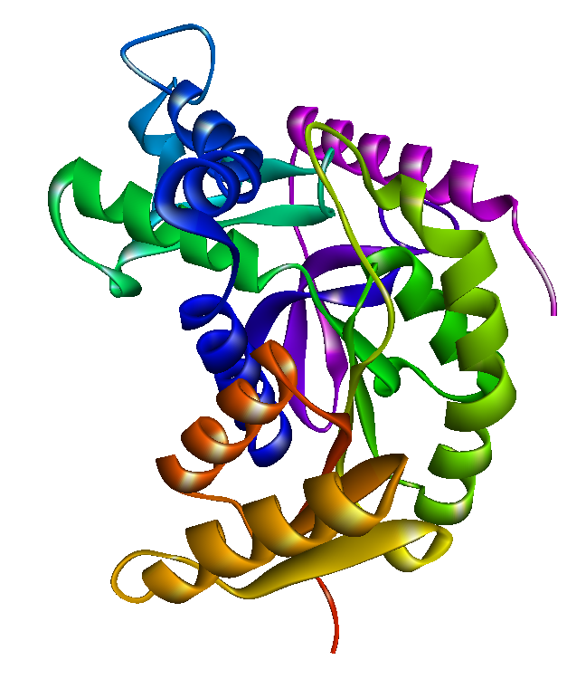

**Figure 1** Human Lactate Dehydrogenase A structure

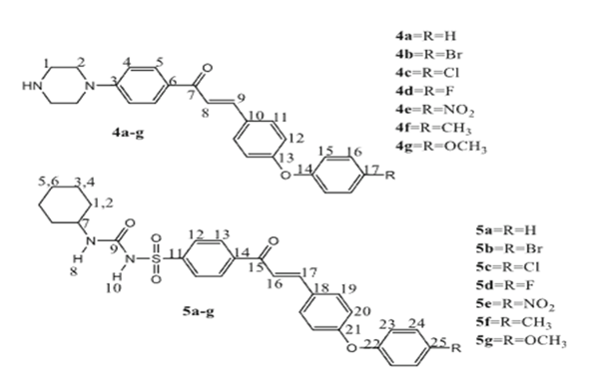

**Figure 2** Synthetic pathway of phenoxy chalcones (4a-4g) and (5a-5g)

Table 1. Presentation of findings and concluding remarks

|  |  |  |  |
| --- | --- | --- | --- |
| Ligand name | Ligand Codes | MolDockScore | HBond |
| (E)-N-(cyclohexylcarbamoyl)-4-(3-(4-phenoxyphenyl)acryloyl)benzenesulfonamide | 5a | -197.781 | -10.5125 |
| (E)-N-(cyclohexylcarbamoyl)-4-(3-(4-(4-nitrophenoxy)phenyl)acryloyl) benzenesulfonamide | 5e | -192.888 | -10.9774 |
| E)-N-(cyclohexylcarbamoyl)-4-(3-(4-(p-tolyloxy)phenyl)acryloyl)benzenesulfonamide | 5f | -189.746 | -8.30703 |
| (E)-N-(cyclohexylcarbamoyl)-4-(3-(4-(4-fluorophenoxy)phenyl)acryloyl)benzenesulfonamide (5 | 5d | -183.627 | -6.76428 |
| (E)-4-(3-(4-(4-chlorophenoxy)phenyl)acryloyl)-N(cyclohexylcarbamoyl)benzensulfonami | 5c | -180.661 | -4.66241 |
| (E)-N-(cyclohexylcarbamoyl)-4-(3-(4-(4-methoxyphenoxy)phenyl)  acryloyl)benzenesulfonamide | 5g | -179.495 | -9.46268 |
| (E)-4-(3-(4-(4-bromophenoxy)phenyl)acryloyl)-N(cyclohexylcarbamoyl)benzensulfonamide | 5b | -169.868 | -1.72758 |
| (E)-3-(4-(4-nitrophenoxy)phenyl)-1-(4-(piperazin-1-yl)phenyl)prop2-en-1-one | 4e | -159.996 | -4.62272 |
| (E)-3-(4-(4-methoxyphenoxy)phenyl)-1-(4-(piperazin-1-yl)phenyl)  prop-2-en-1-one | 4g | -155.908 | -3.84334 |
| (E)-3-(4-(4-fluorophenoxy)phenyl)-1-(4-(piperazin-1-yl)phenyl)prop2-en-1-one | 4d | -148.138 | -5.967 |
| (E)-3-(4-(4-chlorophenoxy)phenyl)-1-(4-(piperazin-1-yl)phenyl)prop2-en-1-one | 4c | -145.004 | -3.0607 |
| (E)-1-(4-(piperazin-1-yl)phenyl)-3-(4-(p-tolyloxy)phenyl)prop-2-en1-one | 4f | -144.613 | -2.98174 |
| (E)-3-(4-phenoxyphenyl)-1-(4-(piperazin-1-yl)phenyl)prop-2-en1-one | 4a | -143.227 | -5.09298 |
| (E)-3-(4-(4-bromophenoxy)phenyl)-1-(4-(piperazin-1-yl)phenyl)prop2-en-1-one | 4b | -139.964 | -2.263 |

Docking studies were conducted to investigate the inhibitory mechanism, revealing a robust binding affinity (MolDock score: -197.781) between the compound 5a and the Human Lactate Dehydrogenase A enzyme. Figure 3 depicts a 2D interaction map, elucidating the specific interactions between 5a and the enzyme's amino acids. Notably, hydrogen bond interactions emerged as vital contributors to the binding process, facilitated by , VAL30, GLY31, THR 247, ARG 98 ,and GLN 99 And it interact with van der waals with ARG105, ILE 241 , LEU108 ALA97 , SER 136 , ASN 112 , ALA237 , VAL135 , THR 94 , GLY28 , VAL 27 , ILE 115 ,GLY 26 , TYR82 ,VAL25, VAL50 , ASP51 . also interact with carbon hydrogen bond with ALA29, GLY96 . and pi-alkyl with ILE119, ALA95 , VAL52 amino acids. These interactions stabilize the binding and intensify the inhibitory effects. Additionally, the presence of red separating interactions suggests the displacement of water molecules from the enzyme's active site. Consequently, this leads to a conformational change and disruption of the catalytic activity of the enzyme. Hence, 5a obstructs the normal functioning of the Human Lactate Dehydrogenase A enzyme by binding to its active site. The potent inhibitory effects of 5a on Human Lactate Dehydrogenase A enzyme are attributed to its high binding affinity, with hydrogen bond interactions and the displacement of water molecules playing pivotal roles. These findings offer valuable insights for the development and design of potential therapeutic agents aimed at addressing diseases associated with Human Lactate Dehydrogenase A enzyme deficiency.

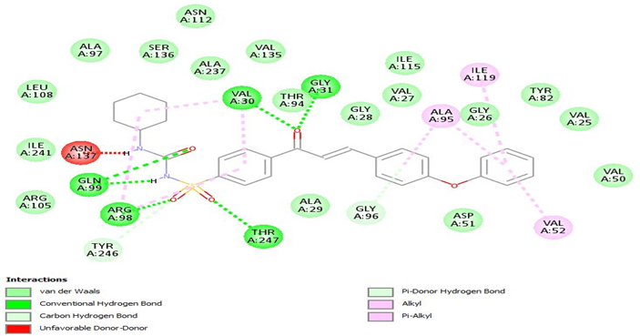

Figure 3 Two-dimensional structures in the 5a compound have been investigated

Docking studies were conducted to investigate the inhibitory mechanism, revealing a robust binding affinity (MolDock score: -192.888) between the compound 5e and the Human Lactate Dehydrogenase A enzyme. Figure 4 depicts a 2D interaction map, elucidating the specific interactions between 5e and the enzyme's amino acids. Notably, hydrogen bond interactions emerged as vital contributors to the binding process, facilitated by TYR 82 ,GLY 31, VAL30 , ARG98 , ASN 137 And THR 247, And it interact with van der waals with LEU164 , ARG168, ALA29, THR 94, GLY25, VAL25, PHE118, ILE119, ILE115,ILE 241, GLN99, ARG105 , ARG168 , LEU164 .also interact with carbon hydrogen bond with TYR246, GLY28 , GLY96 . and pi-alkyl with ILE251, ALA95 , VAL52 , HIS192 , ALA237 .And interact with pi-Anion with ASI 51.amino acids. These interactions stabilize the binding and intensify the inhibitory effects. Additionally, the presence of red separating interactions suggests the displacement of water molecules from the enzyme's active site. Consequently, this leads to a conformational change and disruption of the catalytic activity of the enzyme. Hence, 5e obstructs the normal functioning of the Human Lactate Dehydrogenase A enzyme by binding to its active site. The potent inhibitory effects of 5e on Human Lactate Dehydrogenase A enzyme are attributed to its high binding affinity, with hydrogen bond interactions and the displacement of water molecules playing pivotal roles. These findings offer valuable insights for the development and design of potential therapeutic agents aimed at addressing diseases associated with Human Lactate Dehydrogenase A enzyme deficiency.

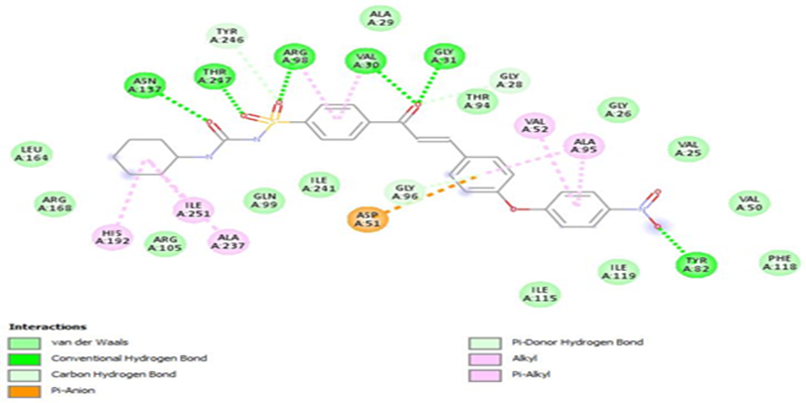

Figure 4 Two-dimensional structures in the 5e compound have been investigated

Docking studies were conducted to investigate the inhibitory mechanism, revealing a robust binding affinity (MolDock score: -189.746) between the compound 5f and the Human Lactate Dehydrogenase A Enzyme . Figure 5 depicts a 2D interaction map, elucidating the specific interactions between 5f and the enzyme's amino acids. Notably, hydrogen bond interactions emerged as vital contributors to the binding process, facilitated by ARG 105 , GLN99, ASN137 and THR 247. And it interact with van der waals with ILE53 , ILE119, GLY31, GLY 28, THR94V, ARG168 , ALA29, ILE241, ALA237 , ILE251 ,VAL135, LEU164, ASN112 , ALA97 , GLY96 , VAL27 ,GLY26 . also interact with carbon hydrogen bond with SER136 . and pi-alkyl with ARG 98, VAL30 , ALA95 , VAL52 , .And interact with pi-Anion with ASI 51, HIS 192. amino acids. These interactions stabilize the binding and intensify the inhibitory effects. Additionally, the presence of red separating interactions suggests the displacement of water molecules from the enzyme's active site. Consequently, this leads to a conformational change and disruption of the catalytic activity of the enzyme. Hence, 5f obstructs the normal functioning of the Human Lactate Dehydrogenase A Enzyme by binding to its active site. The potent inhibitory effects of 5f on Human Lactate Dehydrogenase A Enzyme are attributed to its high binding affinity, with hydrogen bond interactions and the displacement of water molecules playing pivotal roles. These findings offer valuable insights for the development and design of potential therapeutic agents aimed at addressing diseases associated with Human Lactate Dehydrogenase A Enzyme deficiency.

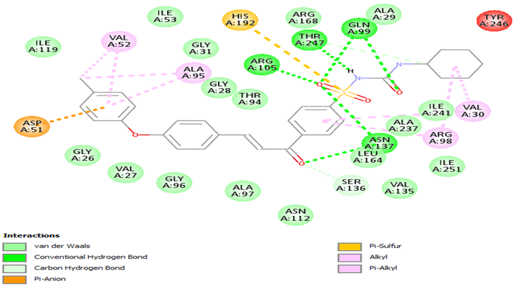

Figure 5 Two-dimensional structures in the 5e compound have been investigated

Docking studies were conducted to investigate the inhibitory mechanism, revealing a robust binding affinity (MolDock score: -183.627) between the compound 5d and the Human Lactate Dehydrogenase A Enzyme . Figure 6 depicts a 2D interaction map, elucidating the specific interactions between 5d and the enzyme's amino acids. Notably, hydrogen bond interactions emerged as vital contributors to the binding process, facilitated by VAL 52 , ASN137 and THR 247 And it interact with van der waals with TYR246, GLN99 ,ARG105 , VAL135, ALA29, THR94, GLY26,VAL 27, ILE 251 . also interact with carbon hydrogen bond with GLY28, SER136 , ILE251, TYR82, PHE118 . and pi-alkyl with ILE119, ALA95, VAL30, ARG98, ILE241 .And interact with pi-donerhydrogen bond ASP51, GLY96. in additon it react with halogen(flouorine) with ILE115, amino acids. These interactions stabilize the binding and intensify the inhibitory effects. Additionally, the presence of red separating interactions suggests the displacement of water molecules from the enzyme's active site. Consequently, this leads to a conformational change and disruption of the catalytic activity of the enzyme. Hence, 5d obstructs the normal functioning of the Human Lactate Dehydrogenase A Enzyme by binding to its active site. The potent inhibitory effects of 5d on Human Lactate Dehydrogenase A Enzyme are attributed to its high binding affinity, with hydrogen bond interactions and the displacement of water molecules playing pivotal roles. These findings offer valuable insights for the development and design of potential therapeutic agents aimed at addressing diseases associated with Human Lactate Dehydrogenase A Enzyme.

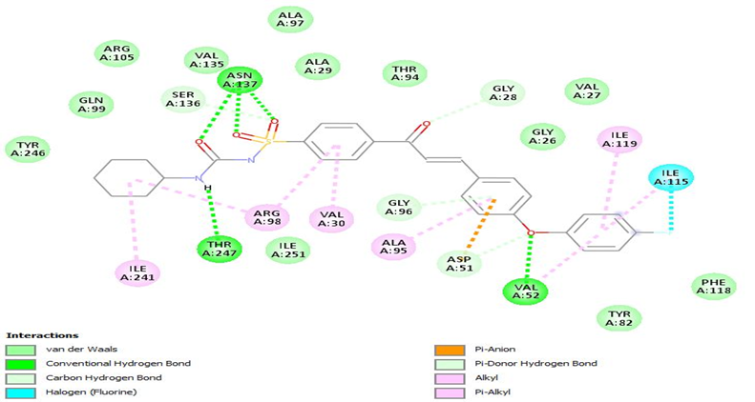

Figure 6 Two-dimensional structures in the 5d compound have been investigated.

1. **Conclusion**

In normal cells, pyruvate is converted into lactate by LDHA, which is overexpressed in most cancer cells and stem cells. This enzyme is strongly correlated with cancer initiation, development, invasion, angiogenesis, and metastasis. LDHA has shown therapeutic potential in preclinical studies, with its inhibition resulting in significant anti-proliferative effects in several cancer cells, including breast, prostate, and pancreatic cancer. A new series of Phenoxy Chalcones central scaffold based small molecules 5a, 5e, 5f, 5d, 5c, 5g, 5b, 4e, 4g, 4d, 4c, 4f, 4a , and 4b were synthesized and screened for hLDHA inhibitory activities. In silico binding affinity of these compounds was calculated against the hLDHA enzyme.The hLDHA inhibitory activities showed that compounds 85a, 5e, 5f, and 5d, have adequate inhibitory activities, which are consistent with an in silico study. Molecular docking studies depicted that the VAL30, THR 247 , GLN 99 , TYR 82 , GLY 31, ARG98 , ASN 137 , ARG 105 , and VAL 52 , amino acids of hLDHA strongly interacted with compounds through hydrogen bonding and electrostatic and hydrophobic interaction, which might play important roles in inhibitory activities.

**References**

1. Warburg, O. On the origin of cancer cells. Science 1956, 123, 309−314.
2. Hanahan, D.; Weinberg, R. A. Hallmarks of cancer: The next generation. Cell 2011, 144, 646−674.
3. Martinez-Outschoorn, U. E.; Peiris-Pagés, M.; Pestell, R. G.; Sotgia, F.; Lisanti, M. P. Cancer metabolism: A therapeutic perspective. Nat. Rev. Clin. Oncol. 2017, 14, 11−31.
4. Kumar, V.; Rani, R. Lactate dehydrogenase enzyme: An old enzyme but new viable target offers new hope in cancer therapeutics. Lactate Dehydrogenase (LDH): Biochemistry, Function and Clinical Significance 1.
5. Sharma, D.; Singh, M.; Rani, R. Role of LDH in tumor glycolysis: Regulation of LDHA by small molecules for cancer therapeutics. Semin. Cancer Biol. 2022, 87, 184−195.
6. Sharma, D.; Singh, M.; Gupta, R.; Kumar, V.; Kumar, V.; Rani, R. Intervention on lactate in cancer: A promising approach for the development of cancer therapeutics. Adv. Cancer Biol.: Metastasis 2022, 5, 100058.
7. Intlekofer, A. M.; Finley, L. W. S. Metabolic signatures of cancer cells and stem cells. Nat. Metab. 2019, 1, 177−188.
8. Menendez, J. A.; Alarcón, T. Metabostemness: A new cancer hallmark. Front. Oncol. 2014, 4, 262.
9. Jagust, P.; De Luxán-Delgado, B.; Parejo-Alonso, B.; Sancho, P. Metabolism-based therapeutic strategies targeting cancer stem cells. Front. Pharmacol. 2019, 10, 203.
10. Kumar, V.; Rani, R. Selective inhibitors of human lactate dehydrogenase A to fight against metabolic cancer: a patent landscape. Pharm. Pat. Anal. 2020, 9, 155−157.
11. Singh, M.; Afonso, J.; Sharma, D.; Gupta, R.; Kumar, V.; Rani, R.; Baltazar, F.; Kumar, V. Targeting Monocarboxylate Transporters (MCTs) in cancer: How close are we to the clinics? Semin. Cancer Biol. 2023, 90, 1−14.
12. Morris GM, Huey R, Lindstrom W, et al. AutoDock4 and AutoDockTools4: automated docking with selective receptor flexibility.J Comput Chem. 2009;30:2785-2791.

1. \* Corresponding author. *e-mail address: Ma.Kik@yahoo.com* [↑](#footnote-ref-1)