**Barriers and opportunities of e-Learning during pandemic Covid-19**

**Case study from Albania**

Dr. Elda Dollija

Department of Management, Faculty of Economy,

University “Fan S. Noli”, Korçë, Albania

[eldacollaku@yahoo.it](mailto:eldacollaku@yahoo.it)

<https://orcid.org/0000-0002-8396-2138>

***Abstract***

*The lockdown caused by pandemic COVID -19 has created an enormous disruption in the educational system worldwide. Since March 2020, suddenly, the traditional classes have been substituted by the virtual classes in higher education institutions in Albania, too. The concept of e-learning, all of a sudden, became normal to students and professors. According to literature review, e-learning offers both advantages and disadvantages to students.*

*The aim of this study is to evaluate the perceptions of the students (Department of Management, Faculty of Economy, public University “Fan S. Noli” in Korça, Albania) about the e-learning process caused by Covid-19 pandemic. The students were invited to fill in a questionnaire in google forms sent to their email address. The results of the study confirmed that the students have benefited from the advantages of the e-learning process (comfortable surroundings, increased IT skills, classes interactivity, ability to stay at home, access to online materials, more engaged and productive, learning on their own place, e-learning is attractive). On the other hand, as the literature suggests, students have perceived some disadvantages of e-learning (social isolation, poor learning conditions at home, difficulties to get concentrated, technical problems, lack of appropriate infrastructure such as computer, internet, reduced interaction with the teacher, low interactivity with the professor, lack of self-discipline). The students indicated their perceptions about the effectiveness of e-learning in terms of increasing knowledge, impact on academic results and they confessed they have enjoyed the e-learning process during the pandemic.*

***Key words:*** *Pandemic Covid-19, e-learning, advantages, disadvantages,*

1. **Introduction**

The global outbreak of the COVID-19 pandemic has affected almost all countries. The outbreak was first identified in December 2019 in Wuhan, China. Every country cautioned its citizens to take responsive care. The public care strategies have included handwashing, wearing face masks, physical distancing, and avoiding mass gathering and assemblies. In addition, the lockdown and staying home strategies are needed actions to flatten the curve and control the transmission of the pandemic.

The pandemic caused by COVID -19 has dramatically affected every field of human’s life worldwide. It has affected our daily routine. This crisis has created an enormous disruption in the educational system, too. To keep education going on, educational institutions had to quickly adapt to the situation and switch to online learning. Since March 2020, the traditional classes have been substituted by the virtual classes. The lock down process called for the necessary use of the internet and the whole infrastructure of Information and Communication Technology (ICT). The use of e-learning became indispensable to the education system all over the world.

E-learning is defined as “information and communication technologies used to support students to improve their learning” (Ellis, Ginns & Piggott, 2009). E-learning is estimated as a supplement to traditional learning and a complementary way of increasing the students' satisfaction and cost-effectiveness (Sadeghi et al., 2014), but it does not seem to substitute the classroom environment, as students find it hard to gain the same amount of knowledge they would gain in the traditional environment (Spurlock-Johnson et al., 2004).

Arkorful & Abaidoo (2014) suggest that e-learning offers both advantages and disadvantages. Students can benefit from the advantages that e-learning offers such as flexibility of time and place, cost effectiveness, access to online materials, increasing online skills, etc. On the other hand, online classes also have limitations, including problems with internet access, poor internet connection quality, and insufficient digital skills of the respondents, etc.

Since March 2020, on campus lectures have been moved 100% to virtual classes in Albania, too. It was unexpected to both students and professors. Initially, different platforms online (google classroom, meet, zoom, moody, email, etc.) were used and the students got confused. Subsequently, the situation began to stabilise. They used to unify the online platform and the whole academic plan was adapted to the online learning process. The results of the study conducted by Xhelili et al. (2020) showed that Albanian students had a more positive attitude towards the classroom learning environment. The main challenges that students faced were the unavailability of internet connection and the lack of technology devices. Another study conducted by Radha et al. (2020) concluded that E-learning has become quite popular among the students all over the world particularly, the lockdown period due to the COVID-19 pandemic.

1. **Research Method**

***2.1 Data Collection***

This study is conducted in the public university “Fan S. Noli”, in Korça, Albania. The aim of this study was to evaluate the perceptions of the students about the e-learning process they had gone through during academic years 2019-20 and 2020-21. The target group were the students of the Faculty of Economic, Department of Management. The students were invited to fill in a questionnaire in google forms sent to their email address. The questionnaire was divided into four sections. The first section included questions on student’s demographic and academic characteristics: gender, study program, year of study, address and Information Technology (IT) skills. In the second and third section students were asked about their perceptions of advantages and disadvantages of e-learning. In the last section students were asked three questions to express their perceptions about the e-learning experience.

***2.2 Results***

The questionnaire was sent via email to 77 students of the department of Management, Faculty of Economy, University “Fan S. Noli'' and 41 of them sent feedback (the response rate was 55%). The analyses of the first session of the questionnaire shows (table 1) that 54% of the respondents were female and 46% were male. 58% of the respondents were pursuing a bachelor degree and 42% were studying for a master degree. Half of the respondents live in the city of Korça, 39% of the respondents live in the districts near to Korça and only 10% live in other cities. Most of the students, 70%, declare to possess high IT skills, 29% declare medium IT skills and only 1% of the students confess to have low IT skills.

**Table 1: Demographic data**

| Sex | Male 46% | Female 54% |  |
| --- | --- | --- | --- |
| Study program | Bachelor 58% | Master 42% |  |
| Address | Korça 51% | Near Korça 39% | Other cities 10% |
| IT skills | High 70% | Medium 29% | Low 1% |

In the second session of the questionnaire the students were asked to tell how much they have perceived the benefit of each advantage using the Likert scale (from 1- disagree, to 5-totally agree). The results of the second session are shown in figure 1. As it is shown in the graphic, most of the advantages are perceived in 3-rd (moderate), 4-th (agree) and 5-th- (totally agree) scores. These scores confirm that the students have benefited from the advantages of the e-learning process during the pandemic period.

**Figure 1: Advantages of e-learning**

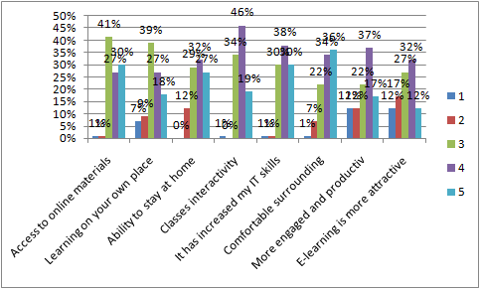

If we calculate the cumulative percentages of the 4-rth (agree) and 5-th responses (extremely agree), we can list the advantages from the most perceived to the less ones (table 2). As we can see from the table, the most perceived benefit of e-learning from the students is the comfortable surround. 70% of the students agree (score 4) and totally agree (score 5) with this advantage. The second benefit is related to the opportunity that e-learning has offered to the students to increase their IT skills. The students had to use the internet, different e-learning platforms and ICTs to have their lessons. 65% of the respondents agreed and totally agreed that e-learning has stimulated class interactivity which has been appreciated by them. The fourth and fifth advantages are related to the commodity offered by e-learning of staying at home and learning to their own places. Nearly half of the students have appreciated e-learning because it has made them more engaged and productive and it has enabled access to online materials. Finally, 44% of the respondents have found e-learning as an attractive way of learning.

**Table 2: Accumulative percentage of responses 4+5**

| **No** | **Advantage** | **Cumulative percentage 4+5** |
| --- | --- | --- |
| 1 | Comfortable surrounding | 70% |
| 2 | It has increased my IT skills | 68% |
| 3 | Classes interactivity | 65% |
| 4 | Ability to stay at home | 59% |
| 5 | Learning on your own place | 57% |
| 6 | More engaged and productive | 54% |
| 7 | Access to online materials | 45% |
| 8 | E-learning is more attractive | 44% |

In the third session of the questionnaire the students were asked to tell how much they have perceived the disadvantages of e-learning using the Likert scale (from 1- disagree, to 5- totally agree). The results of the third session are shown in figure 2. As it is shown in the graphic, most students have perceived the disadvantages of e-learning in 3-rd (moderate), 4-th (agree) and 5-th- (totally agree) scores.

**Figure 2: Disadvantages of e-learning**

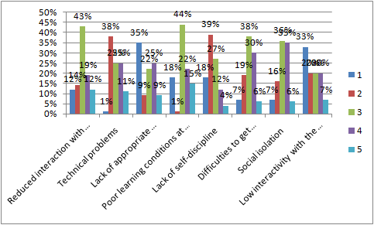

If we calculate the cumulative percentages of the 4-rth (disagree) and 5-th responses (extremely disagree), we can list the disadvantages from the most perceived to the less ones (table 2). As we can see from the table, the most perceived disadvantage of e-learning from the students is social isolation (41%). Students have suffered the isolation and the lack of contact with each other. The second disadvantage is related to the poor learning conditions at home (37% of the respondents agree and totally agree). National statistics form the Ministry of Infrastructure and Energy[1] confirm the poor expansion of the internet and ICT infrastructure especially in rural areas in Albania. Hence, students have faced the difficulties of the low-speed internet and inadequate ICT infrastructure. Additionally, students have faced technical problems which have influenced their e-learning process and their concentration. 31% of the respondents agree (score 4) and totally agree (score 5) that the e-learning process has reduced their interaction with the professor. 16% of the respondents perceive as a disadvantage the lack of self-discipline.

**Table 3: Accumulative percentage of responses 4+5**

| **No** | **Disadvantage** | **Accumulative percentage 4+5** |
| --- | --- | --- |
| 1 | Social isolation | 41% |
| 2 | Poor learning conditions at home | 37% |
| 3 | Difficulties to get concentrated | 36% |
| 4 | Technical problems | 36% |
| 5 | Lack of appropriate infrastructure (computer, internet) | 34% |
| 6 | Reduced interaction with the professor | 31% |
| 7 | Lack of self-discipline | 16% |

In the last session of the questionnaire the students indicated their perceptions about the e-learning experience. Figure 3, shows the rate of effectiveness of e-learning in terms of increasing knowledge. Most of the students (48%) considered e-learning as effective and 12 % as extremely effective.

**Figure 3: The effectiveness of e-learning in terms of increasing knowledge**

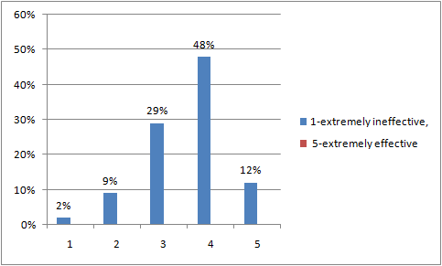

Students were further asked to rate how much they enjoyed e-learning classes during the pandemic. The results of this question are shown in figure 4. Most of the students (44%) indicated that they had enjoyed e-learning and 12% had extremely enjoyed it.

**Figure 4: How much did you enjoy e-learning classes during the pandemic**

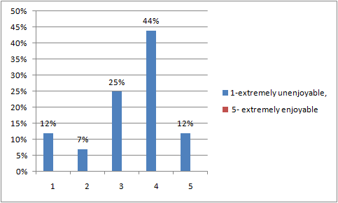

In the last question the students were asked to indicate how e-learning affected their results. For most of the students (46%) the e-learning process has had no impact on their results. For 32% of the students this process has had a positive impact on their academic results. Only 22% of the students have had worse results because of the e-learning process (figure 5).

**Figure 5: How has e-learning affected your results?**

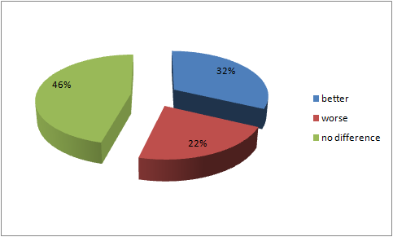

1. **Conclusions**

The study on the impact of the COVID-19 pandemic on teaching and learning across the world (Pokhrel & Chhetri, 2021) concludes that although various studies have been carried out, in the case of developing countries, suitable pedagogy and platform for different class levels of higher secondary, middle and primary education need to be explored further. The aim of this study was to evaluate the perceptions of the students of the Department of Management, Faculty of Economy, University “Fan S. Noli”, in Korçë, Albania about the e-learning process forced by the lock-down caused by pandemic Covid-19.

The results of the study confirm that the students have benefited from the advantages offered by distance learning. This way, students have benefited from a comfortable environment, ability to stay at home, and learning on their own space. The distance learning was comfortable and cost effective especially for students who lived out of Korçë. Because of the daily interaction with the internet, different online platforms, and ICT devices, students confess to have increased their IT skills. E-learning has increased class interactivity and the process has been more engaged and productive. Students have had the possibility to access online materials. All these advantages have made the e-learning process more attractive.

On the other hand, as the literature suggests, students have perceived the disadvantages of the e-learning process, too. The most perceived disadvantage is the social isolation related to the lack of contact with each-other. Despite that, the respondents confess that another disadvantage is related to the poor learning conditions at home. The transition to e-learning was unexpected and they were unprepared for it. In addition, the lack of adequate conditions has caused troubles and difficulties in getting concentrated. Technical problems have arisen because of the lack of adequate infrastructure (high speed internet, ICT devices, etc). In some cases respondents have ascertained low interactivity with the professor and lack of self-discipline.

**References**

Ellis, R. A., Ginns, P., & Piggott, L. (2009). E-learning in higher education: Some key aspects and their relationship to approaches to study. Higher Education Research & Development, 28(3), 303. Retrieved from <http://www.informaworld>. com/10.1080/07294360902839909

Arkorful, V., Abaidoo, N. (2014) The role of e-learning, advantages and disadvantages of its adoption in higher education. International Journal of Education and Research, Vol. 2 No. 12

Xhelili, P., Ibrahimi, E., Rruci, E., & Sheme, K. (2021). Adaptation and perception of online learning during COVID-19 pandemic by Albanian university students. *International Journal on Studies in Education (IJonSE), 3*(2), 103-111.

Pokhrel, S., & Chhetri, R., (2021) A Literature Review on Impact of COVID-19 Pandemic on Teaching and Learning. Higher Education for the Future, 8(1) 133–141, DOI: 10.1177/2347631120983481

Radha, R., Mahalakshmi, K., Kumar, S., (2020) E-Learning during Lockdown of Covid-19 Pandemic: A Global Perspective. International Journal of Control and Automation Vol. 13, No. 4, (2020), pp. 1088-1099

<https://www.infrastruktura.gov.al/wp-content/uploads/2020/07/National-Plan-BBand-EN.pdf>

1. <https://www.infrastruktura.gov.al/wp-content/uploads/2020/07/National-Plan-BBand-EN.pdf>