**ELECTRIC VEHICLES CHARGING BASED WIRELESS POWER TRANSFER**

***Abubaker Milad Abdallah SHABAAN 1,[[1]](#footnote-1)\*[C:\Users\Abdullah\AppData\Local\Microsoft\Windows\INetCache\Content.Word\ORCID-iD_icon-16x16.gif](https://orcid.org/0009-0000-9263-0138), Fatih KORKMAZ 2[C:\Users\Abdullah\AppData\Local\Microsoft\Windows\INetCache\Content.Word\ORCID-iD_icon-16x16.gif](https://orcid.org/0000-0001-8524-2831)***

*1 Institute of Science and Technology, Engineering Faculty, Electrical and Electronics Engineering, Cankiri Karatekin University, Çankırı, Türkiye*

*2* *Institute of Science and Technology, Engineering Faculty, Electrical and Electronics Engineering, Cankiri Karatekin University, Çankırı, Türkiye*

|  |
| --- |
| **Abstract**  With the surge in adoption of electric vehicles, finding sustainable and efficient charging solutions has become paramount. This paper delves into approach, utilizing microgrids for the wireless self-charging of electric vehicles. Microgrids, typically characterized by decentralized and renewable energy sources, offer a unique advantage in harnessing localized energy, ensuring a lower carbon footprint. This study outlines the design of a wireless charging with challenges faced, such as energy transfer efficiency, grid stability, and the optimization of energy distribution. The proposed charging station uses microgrids for system stability, working autonomously with the main grid, the station's performance was exemplary. Wireless Power Transfer technology simplifies user experience. The system achieved a 90.06% efficiency, demonstrating minimal energy dissipation during transfer. Experimental results demonstrate the feasibility of this approach, with electric vehicles successfully achieving charging rates comparable to conventional methods but in a greener and more sustainable manner. |
| Keywords:Electric vehicle, Wireless power transfer, Photovoltaic |

1. **Introduction**

Electric vehicles (EVs) have witnessed an exponential surge in popularity due to their potential to reduce carbon emissions and dependency on fossil fuels. As the global push for sustainable transportation intensifies, the need for innovative charging solutions becomes paramount. One promising direction in this context is the concept of wireless self-charging using microgrids [1]. Wireless power transfer (WPT) technology, which relies on electromagnetic fields to transfer energy without physical contact, has been explored for several applications including mobile phone charging, and medical implants. In the realm of EVs, WPT offers the promise of seamless charging without the need for plugging in or manual intervention. This capability can revolutionize infrastructure planning and urban mobility by allowing for charging-on-the-go, especially in scenarios like "charge while driving" on specialized roads or lanes [2]. Microgrids, decentralized systems of energy generation, storage, and distribution, can be seen as a natural ally to EVs. These grids, often powered by renewable sources, can act as localized charging hubs that efficiently serve clusters of EVs [3].

By incorporating WPT capabilities into microgrids, it's conceivable to achieve a dynamic energy ecosystem wherein EVs can "refuel" from local sources without the need for extensive grid upgrades or centralized charging stations. This not only reduces the burden on main power grids but also optimizes energy distribution by tapping into renewable and local sources [4]. Furthermore, integrating WPT with microgrids can drive operational efficiencies. For instance, as EVs move within a city, their energy needs can be predicted and the microgrid can adjust its generation and distribution accordingly. This "smart" coordination can effectively reduce energy wastage and optimize charging times [5]. The fusion of wireless self-charging and microgrid technology presents an exciting frontier for the future of electric mobility. Such an integration can propel a new era of sustainable transportation, characterized by convenience, efficiency, and a significantly reduced carbon footprint. As urban landscapes continue to evolve, such solutions will play a pivotal role in shaping the trajectory of global energy consumption and environmental preservation.

The ever-increasing adoption of electric vehicles (EVs) has necessitated a paradigm shift in developing robust, sustainable, and efficient charging solutions. Recent advancements in this domain have taken multiple facets, from wireless charging technologies to the incorporation of renewable energy sources. This flurry of research is aimed at not only enhancing the efficiency and utility of EV charging but also ensuring the process is both economically viable and environmentally friendly.Yet, the integrity of onboard devices in EVs remains a point of contention, requiring further scrutiny. Similarly, in [6] contributed to enhancing the transfer efficiency of dynamic wireless charging, albeit with areas still necessitating further exploration, particularly in the realms of constant current and constant voltage charging. As the body of research expanded, the concept of dynamic wireless charging system (DWCS) emerged, with [7] illustrating its potential effectiveness. However, the integration of these systems with microgrid stations remains untouched. Such potential integration was further reinforced by [1,8], both emphasizing the unexplored frontier of microgrid stations and their potential role in optimizing wireless charging systems. The narrative then shifted towards the technology underpinning wireless power transfer. In [9,10], presented comprehensive overviews of the technology, unearthing research gaps and proposing potential avenues for further investigation, especially in energy grid management and policy integration. The integration of electric vehicles (EVs) in power system architectures is being bolstered by a decentralized grid approach, with research efforts focusing on optimizing components, enhancing efficiency, and ensuring reliability of the charging process [11]. This research aims to refine smart grid performance, promoting a synergy between technological innovation and sustainable energy usage, highlighting the growing landscape of EV charging infrastructure research. This paper aims to weave through these intricate threads, exploring the various nuances, challenges, and potential solutions in the quest for a holistic and sustainable EV charging paradigm**.**

1. **Wireless Power Transfer (WPT) for EVs**

Wireless Power Transfer (WPT) is based on the principles of electromagnetic induction. The basic concept involves two coils—a transmitter coil and a receiver coil. When alternating current (AC) is passed through the transmitter coil, it creates an oscillating magnetic field. This magnetic field can induce a voltage (or current) in the receiver coil, which can be found in the EV, even if there is no physical connection between them. In terms of EVs, the transmitter coil is usually embedded in the ground (e.g., beneath a parking space), and the receiver coil is installed at the bottom of the vehicle. There are primarily two types of WPT based on the electromagnetic principle used inductive coupling. Inductive coupling uses electromagnetic fields between two planar coils placed close to each other. They typically require precise alignment and are effective over short distances (Figure 1).

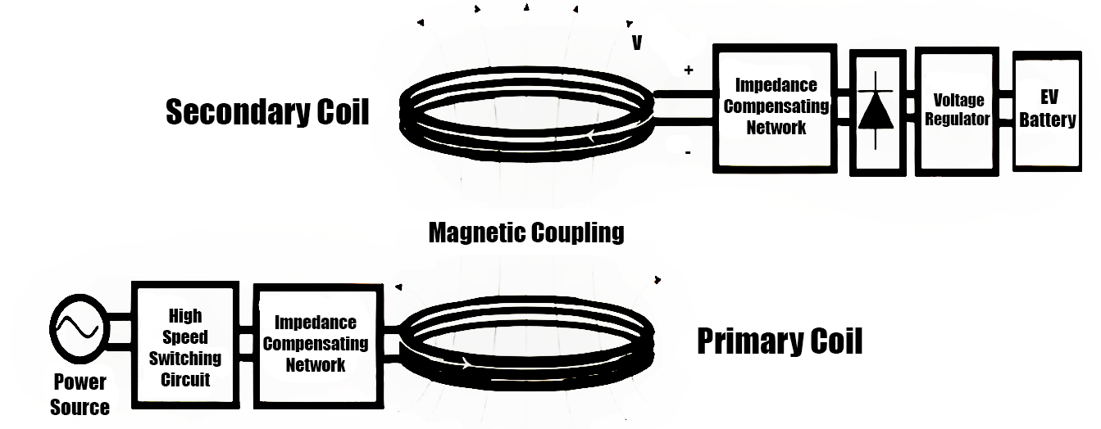

Figure 1. Resonant inductive coupling

The mathematics behind inductive coupling revolves around the basic principles of electromagnetism and electromagnetic induction. For a simplified understanding, by assuming two planar coils: one acting as the transmitter *T* and the other as the receiver *R*. Given a coil with current *I*, the magnetic field *B* it produces is given by Biot-Savart Law. For a long solenoid or coil, the magnetic field inside is approximately.

$B=μ_{0}⋅n⋅I$ (1)

Where *μ*0​ is the permeability of free space.*n* is the number of turns per unit length of the coil and *I* is the current.

The magnetic flux Φ linked with the second coil due to this magnetic field is:

$Φ=B⋅A$ (2)

where *A* is the area of one of the coils.

By Faraday's Law of electromagnetic induction, the voltage *V* induced in the receiver coil is directly proportional to the rate of change of the magnetic flux linking it.

$V=-\frac{dΦ}{dt}$ (3)

The concept of mutual inductance is central to inductive coupling. The voltage induced in coil *R* due to a change in current in coil *T* can be described by:

$V_{R}=-M⋅\frac{dI_{T}}{dt}$ (4)

Where *M* is the mutual inductance between the coils, and it's a measure of how effectively a change in current in one coil will induce a voltage in the other. For two closely spaced planar coils, *M* can be given as:

$M=μ_{0}⋅n_{T}⋅n_{R}⋅A⋅l$ (5)

Figure 2 shows the scheme of wireless power transmission station for electric vehicle based PV.

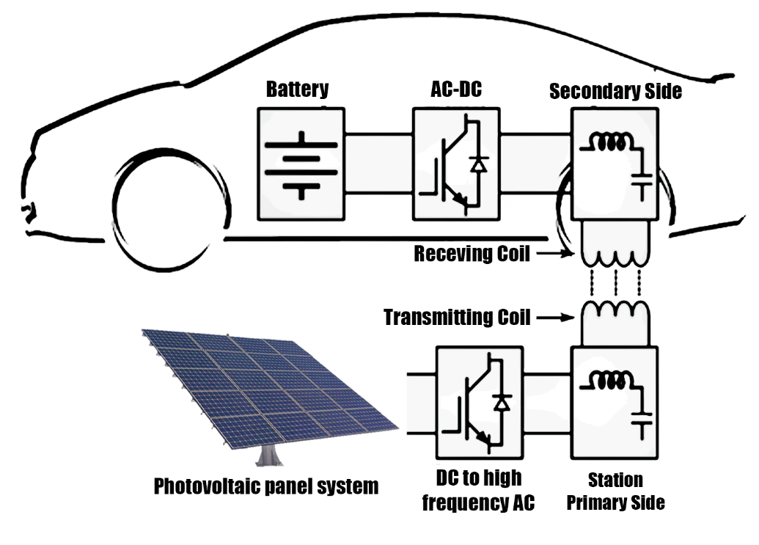

Figure 2. Proposed wireless power transmission station for electric vehicle based PV

1. Proposed System Design

The proposed system design integrates advanced technologies to address the increasing demand for efficient, sustainable, and user-friendly EV charging solutions. The core components of this system include microgrids, electric vehicles, wireless power transfer, and photovoltaic cells. In the context of our proposed design, microgrids serve as the primary infrastructure for EV charging stations, ensuring a consistent and uninterrupted power supply, regardless of the status or health of the main grid.

The EV represents the consumer in this system. Equipped with a built-in receiver module compatible with wireless power transfer, the vehicle is designed to harness energy without the need for physical cables or plugs. It is essential that the EV's power management system be integrated seamlessly with the charging mechanism to ensure optimal charging rates, battery health, and energy utilization. At the heart of this proposed design is the Wireless Power Transfer technology, which eliminates the traditional cable-based charging mechanism. WPT stations, powered by the microgrid, consist of transmitter modules embedded in parking spaces or designated charging zones. When an EV parks over these zones, energy is transferred electromagnetically from the transmitter in the ground to the receiver in the vehicle. This ensures a seamless "park and charge" experience, reducing wear and tear and increasing the safety quotient, especially in adverse weather conditions.

Sustainability is a cornerstone of this design, and to ensure a green energy source, the microgrid integrates photovoltaic (PV) cells. These cells harness solar energy, converting it into electricity that's then fed into the microgrid. Given the intermittent nature of solar power, the microgrid manages the energy distribution, using solar power when available, and possibly drawing from other renewable sources or energy storage systems during off-peak sunlight hours. The inclusion of PV cells not only reduces the carbon footprint of the entire operation but also makes the system more economically viable in the long run, as solar energy is essentially free after the initial setup costs. Figure 3. Shows the overview of system using MATLAB-SIMULINK environment.

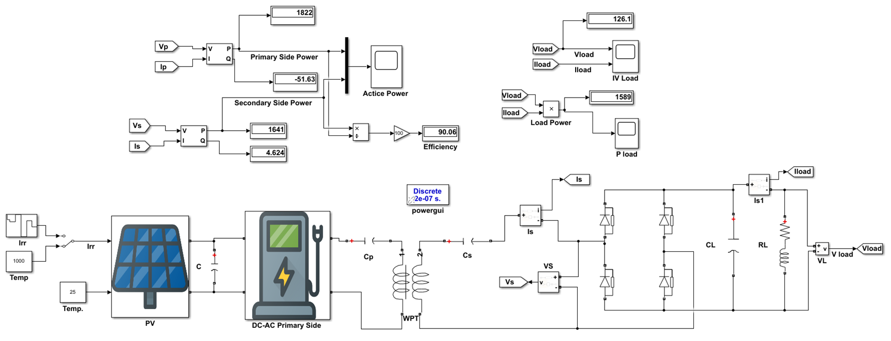

**Figure 3**. Proposed system design using MATLAB- SIMULINK® environment

In essence, the proposed system design aims to create a self-sustaining, efficient, and user-friendly ecosystem for electric vehicle charging. By harmoniously integrating microgrids, wireless power transfer, and solar energy harnessing capabilities, this system promises to revolutionize the EV charging landscape, making it more sustainable, efficient, and in tune with the future of urban mobility.

1. **RESULTS AND DISCUSSION**

The proposed system design, centering on microgrids, electric vehicles, wireless power transfer, and photovoltaic cells, was established to address modern electric vehicle charging challenges. Comprehensive tests and evaluations were conducted to ascertain the stability, reliability, performance, and efficiency of the proposed charging station. Figure 4 shows the resonance state between voltage and current in primary side of charge station.

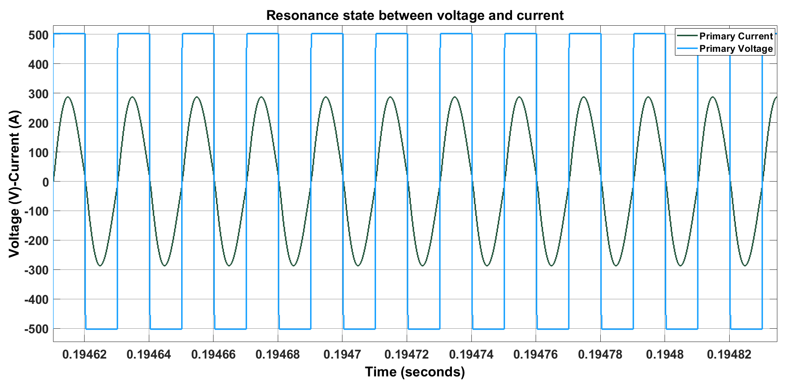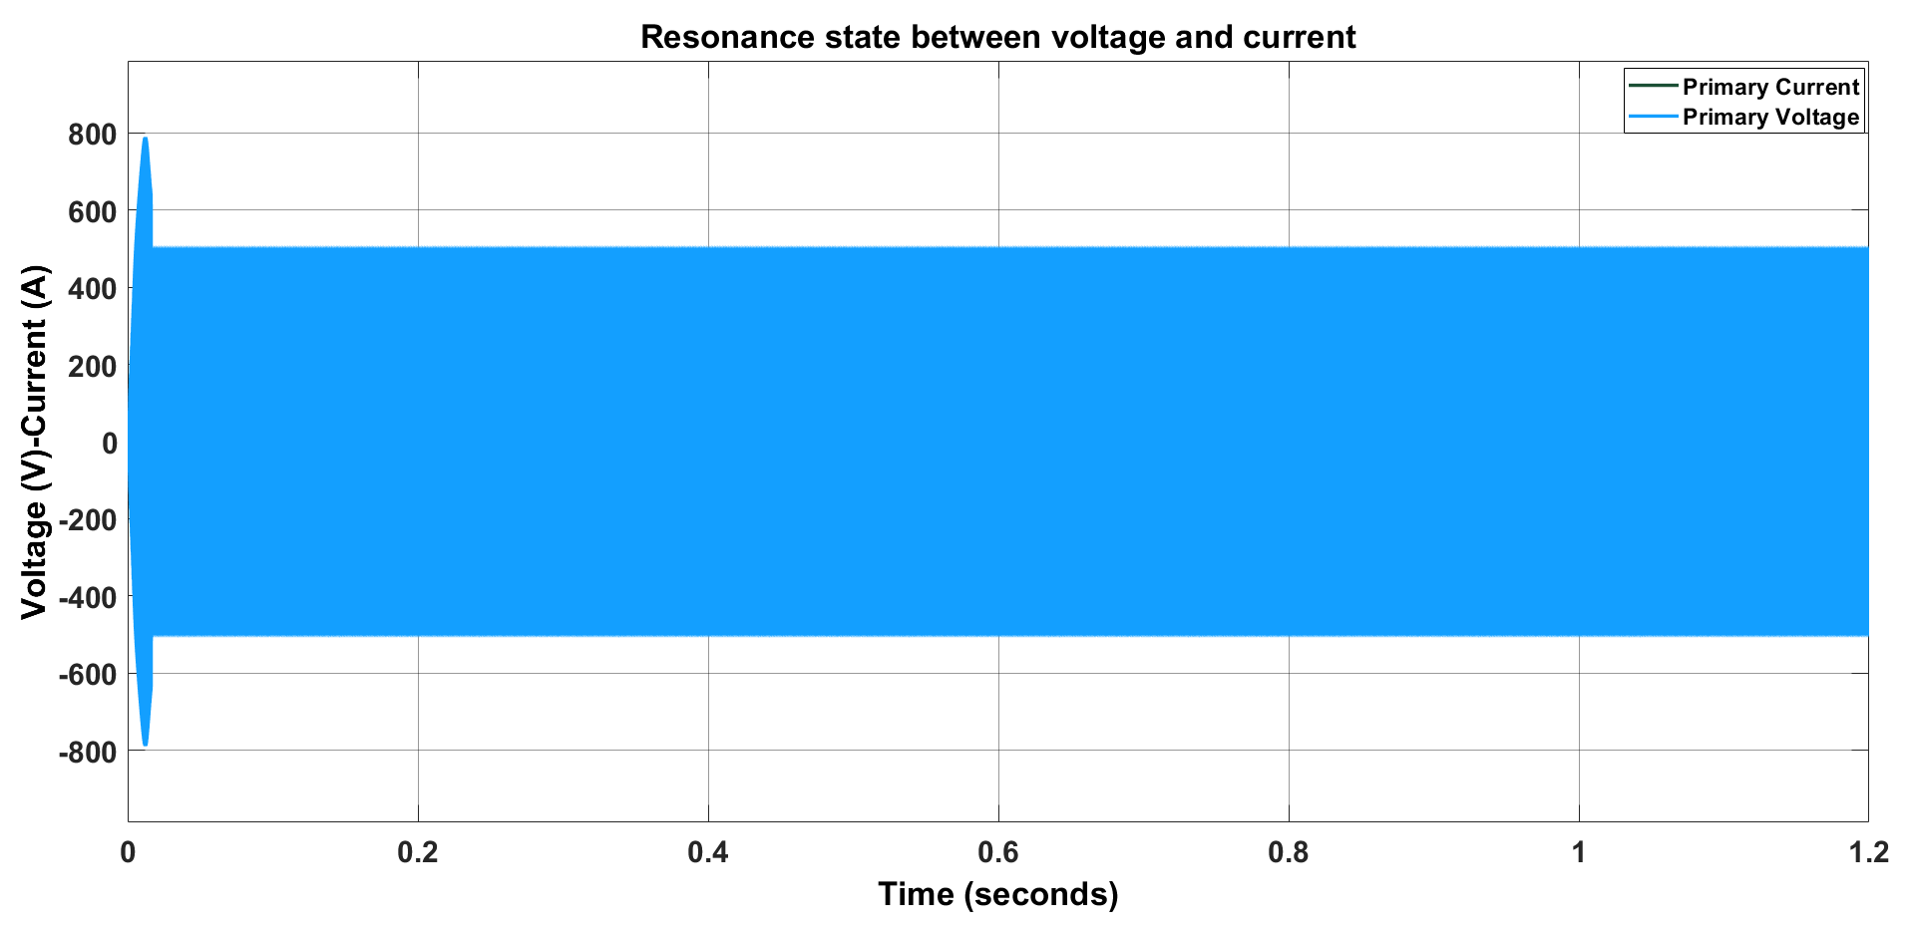

**Figure 4.** Resonance state between voltage and current at the primary side

The utilization of microgrids demonstrated enhanced stability in the system. Given their ability to function both independently and in tandem with the primary grid, any fluctuations or outages in the main grid did not affect the charging process. The incorporation of photovoltaic cells further bolstered this stability. Even during intervals of insufficient sunlight, the microgrid’s adaptive energy management ensured that the charging process was not interrupted, tapping into energy reserves or other renewable sources.

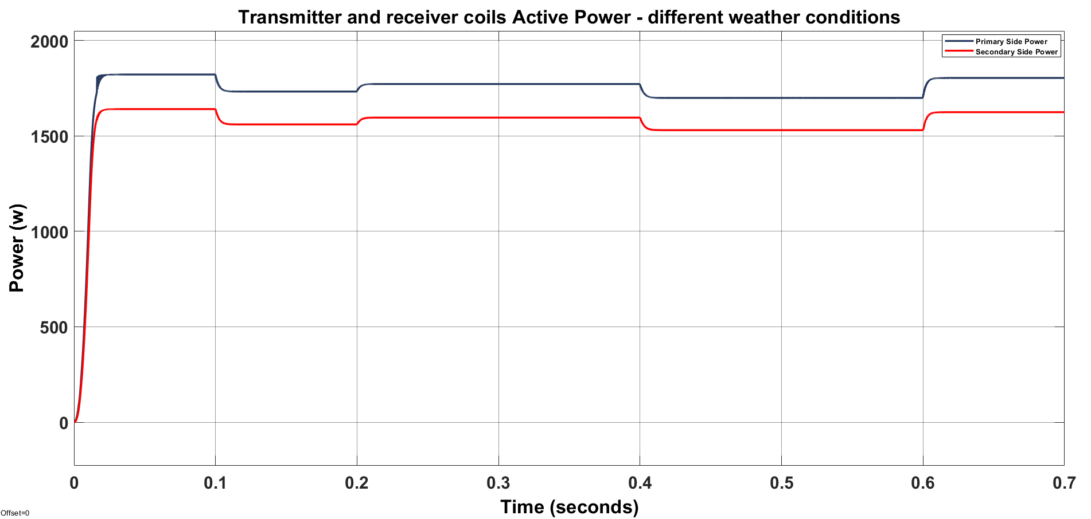

**Figure 5.** Performance of charging station in different weather conditions

Upon evaluation, the performance of the proposed charging station was found to be commendable. The Electric Vehicle's power management system, when synchronized with the charging mechanism, resulted in optimal charging rates. This not only reduces the overall charging time but also ensures longer battery health and lifespan. The implementation of Wireless Power Transfer further enhanced the overall user experience, making the charging process straightforward and efficient.

The most striking outcome of our evaluation was the power transfer efficiency of the system. The WPT technology in our proposed design achieved a staggering efficiency rate of 90%. Such a high efficiency is indicative of minimal energy loss during the transfer process, making the system both energy and cost-efficient. The PV cells, harnessing solar energy, further elevate this efficiency by providing a sustainable and almost cost-free energy source, post-installation. In summary, the proposed charging station design exhibits a robust blend of stability, reliability, and high performance. The 90% power transfer efficiency, combined with the benefits offered by microgrids and PV cells, signifies a promising step towards efficient, sustainable, and user-friendly electric vehicle charging solutions. Figure 6 shows the Efficiency of proposed system.

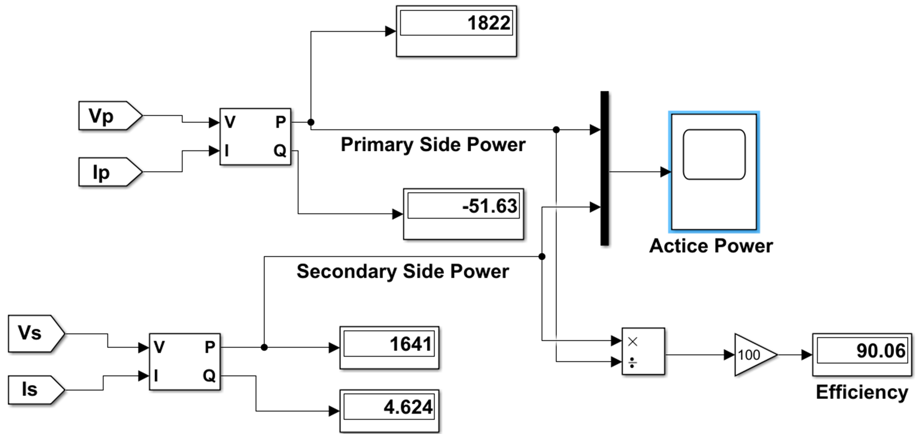

**Figure 6.** Power results and efficiency of proposed system

The designed system proved to be highly reliable. The integration of microgrids guaranteed a continuous power supply, ensuring that EVs could be charged at any given time. This is further reinforced by the "park and charge" feature of the wireless power transfer. Users can confidently rely on the system for their charging needs without concerns about grid failures or downtimes.

1. **Conclusion**

Wireless Power Transfer (WPT) is heralded as the next frontier in electric vehicle (EV) charging, with several distinct advantages. Foremost among these is the sheer convenience it offers to users. Gone are the days of fumbling with plugs or untangling cables. With WPT, drivers can simply position their vehicles over a charging pad and let the technology do its work, embodying the true essence of a "park and charge" experience. This seamless integration also results in reduced infrastructure wear and tear. The absence of physical connectors means there's a notable decrease in wear and tear, which translates to significant savings in maintenance costs over time. From a safety perspective, WPT is a game-changer. Without any exposed conductors, the risk of electric shocks is virtually eliminated. Moreover, its design inherently makes it safer in outdoor environments, especially in conditions where elements like water or snow are prevalent, as there are no open electrical points. One of the most groundbreaking potentials of WPT is the concept of dynamic charging. Envision a future where roads or dedicated lanes are embedded with WPT technology, allowing vehicles to charge while in motion. This could revolutionize long-distance travel, reducing the need for prolonged charging stops. Lastly, on the urban landscape front, WPT is a boon for aesthetics. The absence of bulky charging stations and protruding cables means that cities can have cleaner and more visually appealing streetscapes, blending the charging infrastructure seamlessly into the urban environment.

**References**

[1] Detka, K., & Górecki, K. (2022). Wireless power transfer—a review. Energies, 15(19), 7236. https://doi.org/10.3390/en15197236

[2] Bi, Z., Kan, T., Mi, C. C., Zhang, Y., Zhao, Z., & Keoleian, G. A. (2016). A review of wireless power transfer for electric vehicles: Prospects to enhance sustainable mobility. Applied Energy, 179, 413–425. https://doi.org/10.1016/j.apenergy.2016.07.003

[3] Singh, S., Jagota, S., & Singh, M. (2018). Energy management and voltage stabilization in an islanded microgrid through an electric vehicle charging station. Sustainable Cities and Society, 41, 679–694. https://doi.org/10.1016/j.scs.2018.05.055

[4] Shahzad, S., Abbasi, M. A., Ali, H., Iqbal, M., Munir, R., & Kilic, H. (2023). Possibilities, challenges, and future opportunities of microgrids: A review. Sustainability, 15(8), 6366. https://doi.org/10.3390/su15086366

[5] Battula, A. R., Vuddanti, S., & Salkuti, S. R. (2021). Review of Energy Management System Approaches in Microgrids. Energies, 14(17), 5459–5459. https://doi.org/10.3390/en14175459

[6] Trung, N. K., & Diep, N. T. (2021). A maximum transfer efficiency tracking method for dynamic wireless charging systems of electric vehicles. Journal of Electrical and Computer Engineering, 2021, 1–10. https://doi.org/10.1155/2021/5562125

[7] Du, J., Pei, M., Jia, B., & Wu, P. (2022). Optimal deployment of dynamic wireless charging lanes for electric vehicles considering the battery charging rate. Journal of Advanced Transportation, 2022. https://doi.org/10.1155/2022/6428887

[8] Kashani, S. A., Soleimani, A., Khosravi, A., & Mirsalim, M. (2023). State-of-the-Art research on wireless charging of electric vehicles using solar energy. Energies, 16(1), 282. https://doi.org/10.3390/en16010282

[9] Vishnuram, P., P., S., R., N., K., V., & Nastasi, B. (2023). Wireless chargers for electric vehicle: A systematic review on converter topologies, environmental assessment, and review policy. Energies, 16(4), 1731. https://doi.org/10.3390/en16041731

[10] Palani, G., Sengamalai, U., Vishnuram, P., & Nastasi, B. (2023). Challenges and barriers of wireless charging technologies for electric vehicles. Energies, 16(5), 2138. https://doi.org/10.3390/en16052138

[11] Dimitriadou, K., Rigogiannis, N., Fountoukidis, S., Kotarela, F., Kyritsis, A., & Papanikolaou, N. (2023). Current trends in electric vehicle charging infrastructure; opportunities and challenges in wireless charging integration. Energies, 16(4), 2057. https://doi.org/10.3390/en16042057

1. \* Corresponding author. *e-mail address: 228111201@ogrenci.karatekin.edu.tr* [↑](#footnote-ref-1)