**NDWI Analysis for Detection of Water Body Exraction of Beysehir Lake Between 1984-2024**

***Erkan KARAKOYUN3[C:\Users\Abdullah\AppData\Local\Microsoft\Windows\INetCache\Content.Word\ORCID-iD_icon-16x16.gif](https://orcid.org/xxxx-xxxx-xxxx-xxxx)***

*1 Faculty of Engineering and Architecture, Mus Alparslan University, Mus, Turkiye*

|  |
| --- |
| **Abstract**  This study investigates the long-term changes in the water surface area of Beyşehir Lake, the largest freshwater lake in Türkiye, between 1984 and 2024. Using Landsat satellite images and the Normalized Difference Water Index (NDWI), we analyze decade-interval data to monitor changes in the lake's surface area in response to climate-driven water resource pressures. Our findings show a significant decline in the lake's surface area from 658 km² in 1984 to 581 km² in 2024, marking an 11.7% reduction. This shrinkage is attributed to increased drought conditions linked to climate change, impacting local agriculture and biodiversity. Remote sensing and GIS tools prove effective for such environmental monitoring, highlighting critical trends and offering insights for local water management strategies to mitigate further decline. The outcomes emphasize the importance of sustainable water resource management in the context of global climate change and provide a basis for planning and preservation efforts in regional hydrology and agriculture. |
| Keywords: Beysehir Lake, NDWI, GIS, Remote Sensing, Landsat |

1. **Introduction**

Every species needs water to sustain their life in our world. Water is the most important component in the hydrological cycle, which includes the basic cycle of life. Therefore, if water resources are negatively affected, vital consequences may occur for living things. For this reason, it is important to protect water resources, plan them and observe their changes over time.

The increasing human population and developing industrialization increase the need for water resources over time. As a natural result of this, water resources such as rivers and lakes tend to decrease over time [1]. Due to the increasing greenhouse gas effect in the world's atmosphere, there have been changes in climate parameters such as precipitation and temperature. Türkiye is also in danger under these changing climate conditions. Due to decreasing precipitation and increasing temperatures, droughts are experienced on a regional scale. As a result of this situation, sectors such as agriculture, food, and industry are negatively affected, lakes and dams are drying up and water quality is decreasing [2].

In recent years, increasing computer technology has provided benefits to studies in many different areas. Remote sensing and geographic information systems have also increased in use in many different areas with the developing computer technology and capacity. Especially with the use of satellite images and GIS, high-resolution maps of the desired location can be created and with the help of these images, land use maps of the region can be created. There are many studies in the literature with the help of satellite images and GIS.

Normalized Difference Water Index (NDWI) [3] is a method widely used in the literature to determine the water boundaries of the region with the help of data obtained from satellite images. [4] successfully performed water body extraction using NDWI in their study. [5] investiated using NDWI for the extraction of surface water from Landsat data. [6] indicated the spatiotemporal changes of Burdur Lake between the years 1987-2000 by using NDWI, modified NDWI (MNDWI) and Automated Water Extraction Index (AWEI) from Landsat data.

In Türkiye, studies have been carried out by researchers on determining water-covered areas and monitoring their changes over the years using remote sensing and GIS ([7], [8], [6]). [7] investigated the water surface and land use changes in Mogan Lake between 1998 and 2010 using Landsat TM5 and Landsat 8 OLI\_TIRS satellite images. [6] conducted a study on Burdur Lake using time series analysis and performed water body extraction and change detection between 1987 and 2011.

In this study, the water surface changes on Lake Beyşehir, located in the lake district region of Turkiye, between 1984 and 2024 were examined using Landsat satellite images. Considering that many lakes in the region experience drought problems, it is important to know in which direction Lake Beyşehir has changed over a 40-year period with this study.

1. **Materials and Methods** 
   1. **Study Area**

Beysehir Lake is located in the lake region of Türkiye between Isparta and Konya provinces. It is the largest freshwater lake in Türkiye. 80% of the lake is located within the borders of Konya and 20% within the borders of Isparta province. It is a very important place for bird watching and many fish species live in the lake. The location of Beysehir Lake is shown in Figure 1.

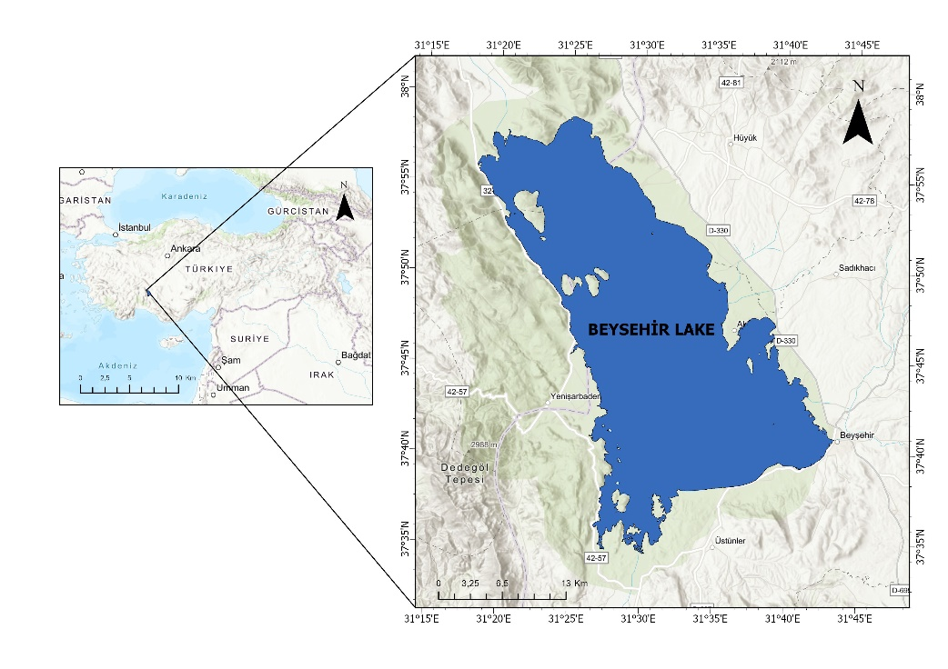

Figure 1. The location of Study Area

* 1. **Data and Methods**

The details of Landsat images obtained for this study is given in Table 1. The Landsat 9 satellite data were used for the year 2024, Landsat 8 satellite data were used for the year 2014, and Landsat 5 satellite data were used for the years 1984, 1994, and 2004. For each year that satellite images were used, the same months of that year were tried to be selected. ArcGIS Pro software was used for processing and classifying satellite images. Satellite images with low cloudiness were selected. Satellite images were selected for the study area at 10-year intervals starting from 1984 and downloaded from the United States Geological Survey (USGS) Earth Explorer site [9].

**Table 1.** Satellite description used in this study.

|  |  |  |  |  |
| --- | --- | --- | --- | --- |
| Satellite | Date | Path/Row | Cloud Cover (%) | Satellite Launch Date |
| Landsat 5 | 10-20-1984 | 178/34 | 0 | Marc 1,1984 |
| Landsat 5 | 10-16-1994 | 178/34 | 3 |
| Landsat 5 | 10-11-2004 | 178/34 | 0 |
| Landsat 8 | 10-07-2014 | 178/34 | 0.14 | Feb 11, 2013 |
| Landsat 9 | 08-07-2024 | 178/34 | 0.71 | Oct 27, 2021 |

***Normalized Difference Water Index***

The Normalized Difference Water Index (NDWI) was initially proposed by [3] to identify surface water in wetland areas and to assess the extent of surface water bodies. The NDWI is calculated for Landsat 5, Landsat 8, and Landsat 9 as Equation 1.

$NDWI=\frac{B3-B5}{B3+B5}$ (1)

First of all, in the analyses, Landsat satellite images were downloaded from NASA USGS [3] website in a way that would include Beyşehir Lake. Since the satellite images cover a very wide area, they were cropped using ArcGIS Pro software to include Beyşehir Lake and its immediate surroundings in order to increase time and program performance. The subsequent analyses were made on this cropped frame. Then, NDWI analysis was performed using the Raster Calculater function on ArcGIS Pro software. Wetlands and remaining parts were defined from the obtained images using the Reclassify function. The defined areas were calculated separately for the years 1984, 1994, 2004, 2014, and 2024 using various operations on the program, and the surface areas of Beyşehir Lake were calculated.

1. **Results and Discussion**

Beysehir Lake surface area was examined using Landsat satellite images for changes in water surface area at 10-year intervals from 1984 to 2024. Figure 2 (a, b, c, d, e) shows the Beyşehir Lake water surface area obtained by NDWI analysis for the years 1984, 1994, 2004, 2014, and 2024. In order to observe the changes between the analysis start year 1984 and 2024, the water surface maps for the years 1984 and 2024 are superimposed in Figure 2e. As can be seen from the figure, there are visible water losses especially in the northwest and southwest of Beysehir Lake.

**Figure 2.** The water surface of Beyşehir Lake by years

When we consider the Figure 2 (a,b,c,d,e) it is clearly seen that the water area of ​​Lake Beyşehir has been decreasing over the years and will reach its lowest level in 2024. Global drought and water resource losses are seen in our country, and the lake region is also affected by this situation. Table 2 shows the water surface areas of Lake Beyşehir obtained by NDWI analysis for the years 1984, 1994, 2004, 2014, and 2024, respectively. It can be seen from the table that the surface area, which was 658 km2 in 1984, decreased to 619 km2 in 1994. An increase in the water surface area was observed only in 2004 within the 10-year period analyzed. The water surface area, which was 619 km2 in 1994, was calculated as 631 km2 in 2004. Although a small change was observed between 2004 and 2014, the water surface area, which was 630 km2 in 2014, decreased to 581 km2. In the last 40-year period analyzed, the decline accelerated, especially due to the effects of climate change and drought.

**Table 2.** Changes in Beyşehir Lake Water Surface Areas over the Years

|  |  |
| --- | --- |
| Yıl | Alan (km2) |
| 1984 | 658 |
| 1994 | 619 |
| 2004 | 631 |
| 2014 | 630 |
| 2024 | 581 |

**Figure 3.** Water surface area change of Beysehir Lake between 1984-2024

In order to observe the changes in the water surface areas of Lake Beyşehir between the analyzed years 1984-2024, the changes in the water surface area by year are given in Figure 3. It is clearly seen that a serious decrease in the water surface areas was observed especially after 2014.

1. **Conclusion**

In this study, water body surface of Beysehir Lake is determined between the years 1984-2024. In order to the Landsat satellite data were used and the Normalized Difference Water Index (NDWI) analysis applied for these data. The maps were created for every 10-year interval from 1984 to 2024. From NDWI analysis, the water body surface area was found as 658 km2 which is the highest area of last 40 years while the lowest body surface area was detected in the year 2024 with 581 km2. From the year 1984 to 2024 the water surface area of Beysehir Lake decreased 11.7 %.

As a result, it is clear that the global climate change resulting in drought is adversely affecting Beysehir Lake. The observation of the changing water surface area of Beysehir Lake with remote sensing technology is an effective method in the field of water resources and agriculture. The results obtained from this study show that the water surface of Lake Beysehir has decreased over time, and it is thought that it will guide local administrators to prevent this situation.

**References**

[1] Bayrak, M., Yulu, A., & Öztürk, Y. (2022). Balıkgöl (Ağrı) Kıyılarında Arazi Örtüsü/Kullanımının Zamansal Değişimi (1989-2021). *Coğrafi Bilimler Dergisi*, *20*(1), 282–309. https://doi.org/10.33688/aucbd.1063557

[2] Kaya, Ö. A., & Kaplan, G. (2021). Uzaktan Algılama Yöntemleri İle Burdur Gölü’ndeki Alansal Değişiminin Belirlenmesi. *Doğal Afetler ve Çevre Dergisi*, *7*(1), 1–12. https://doi.org/10.21324/dacd.760805

[3] McFeeters, S. K. (1996). The use of the Normalized Difference Water Index (NDWI) in the delineation of open water features. *International Journal of Remote Sensing*, *17*(7), 1425–1432. https://doi.org/10.1080/01431169608948714

[4] Ji, L., Zhang, L., & Wylie, B. (2009). Analysis of dynamic thresholds for the normalized difference water index. *Photogrammetric Engineering and Remote Sensing*, *75*(11), 1307–1317. https://doi.org/10.14358/PERS.75.11.1307

[5] Rokni, K., Ahmad, A., Selamat, A., & Hazini, S. (2014). Water feature extraction and change detection using multitemporal landsat imagery. *Remote Sensing*, *6*(5), 4173–4189. https://doi.org/10.3390/rs6054173

[6] Sarp, G., & Ozcelik, M. (2017). Water body extraction and change detection using time series: A case study of Lake Burdur, Turkey. *Journal of Taibah University for Science*, *11*(3), 381–391. https://doi.org/10.1016/j.jtusci.2016.04.005

[7] Özçalık, H., Torun, A. T., & Bilgilioğlu, S. S. (2020). Landsat uydu görüntüleri kullanılarak Mogan Gölü ’ nün su yüzeyi ve arazi örtü değişiminin belirlenmesi. *Turkish Journal of Remote Sensing*, *2*(2), 77–84.

[8] Özelkan, E. (2020). Water body detection analysis using NDWI indices derived from landsat-8 OLI. *Polish Journal of Environmental Studies*, *29*(2), 1759–1769. https://doi.org/10.15244/pjoes/110447

[9] https://earthexplorer.usgs.gov/ (Accessed on November 2, 2024)