**ABOUT THE INFLUENCE OF ANTHROPOGENIC FACTORS ON THE FLORA OF HIGHER PLANTS OF THE BOGISHAMOL DAKHA**

**N.M. Sidikjanov, basic doctoral student, Andijan State University, Andijan.**

**F.G. Fazliddinov, master’s student, Andijan State University, Andijan.**

**R. O. Abdullaeva, master’s student, Andijan State University, Andijan.**

**Abstract.** This article provides information about the impact of anthropogenic factors on the tall plants of Bogishamol Dakha located in Andijan city. One of the main strategies for preserving biological diversity is the increasing demand for the introduction of research on problems such as selection of protected natural areas and expansion of existing areas, reduction of the impact of anthropogenic factors on natural landscapes.

**Key words:** anthropogenic, biodiversity, ­population , city, ecotism, natural flora.

Climate change in the world, ­increasing anthropogenic pressure on natural ecosystems from year to year has a negative impact on biodiversity. Today , it is of great scientific and practical importance ­to protect the areas where ­plant-populations are distributed , to assess the current state of their populations and to develop ways to eliminate factors that negatively affect them .

As the main strategy for preserving biological diversity, there is an increasing demand for implementation of researches devoted to problems such as defining and expanding the area of protected natural areas, reducing the impact of anthropogenic factors on natural landscapes. Over the last ten years, protected areas have increased to an area of more than 30 million km2 worldwide, every fifth biological species is in danger of extinction, the International Convention on Biological Diversity (1992) and the establishment of related targets are important for the protection of biological objects and determines the relevance and necessity of further improvement of practical work on its rational use. [2]

According to the Global Assessment of Biodiversity (UNEP), more than 30,000 plant and animal species are at risk of extinction today due to various environmental factors, 654 plant species have disappeared in the last 400 years. In this regard, the study of biodiversity, the registration of the composition of species in local flora, the identification and preservation of the modern status of rare species are among the urgent problems of modern botany. [1]

There are specific differences between natural flora and urban flora, and urban ecosystems are characterized by specific ecological conditions. In such areas, the influence of the anthropogenic factor is at its maximum. This situation in itself leads to a decrease in the aboriginal composition of natural species. Especially in the urban ecosystem, where the artificial ecotopes are formed, the diversity of species and their habitats will significantly change. As a result, the composition and density of non-native species increases and the intensity of phytocenotic relationships between them and aboriginal species increases. This in turn affects the population dynamics of aboriginal species.

Ferghana Valley is one of the most densely populated regions of Central Asia, and preserving the existing natural landscapes through the rule of law is of great scientific and practical importance. In this regard, the creation of protected natural areas, which have been used in practice until now, and the preservation of the flora there by expanding their areas, are considered urgent tasks. Currently, the limitation of natural landscapes in the Fergana Valley, especially in the territory of the Republic of Uzbekistan, does not allow the creation of protected areas. In such conditions, where the percentage of rare, endemic and relict species in the composition of the natural flora is high, it is important to introduce new methods of plant protection[3;4].

Year by year population growth, as a result of which the acceleration of urbanization processes has its effect on the natural ecosystem. According to K. Sh. Tojibaev (2002), T. Makhkamov (2009), one of the main anthropogenic factors is continuous grazing of livestock in one area. This situation leads to the increase of weeds in the vicinity of inhabited areas and their natural occupation of larger and larger areas, to the decrease in the productivity of meadows in the mountains and high mountains, and even to their decline [2;6].

At this point, the area of Bogishamol dakha, located in the southwest of Andijan city, can be recognized as one of the most important botanical areas in the Fergana Valley ­with its unique plant ­populations , endemic and narrow distribution species. ­In recent years, as a result of the irregular use of natural resources in the region­, the increase in the population and the process of urbanization, the development of land, the increase in the construction of production enterprises, and the ­irregular grazing of livestock, the natural plant communities and the species belonging to certain groups within them ­are seriously damaged.

At the same time, it can lead to the introduction of adventive species, and a rapid increase in their number and diversity.

It should be noted that there have been no specific researches in the area of Bogishamol dakha. One of the important tasks in the study of the flora of Bogishamol dakha is to divide it into adventitious and aboriginal fractions. In turn, it is possible to see how anthropogenic transformation affects the flora of the region.

One of the important tasks of research is to analyze the distribution of species across steep regions in modern flora. The research area is located at an altitude of 600-700 meters above sea level.

Our research was conducted in 2019-2023 in the territory of Bogishamol dakha. Species were analyzed on the basis of existing literature, conducted field research and herbarium specimens stored in the TASH fund of the Botanical Institute of the Academy of Sciences of the Republic of Uzbekistan and the international database of the Global Biodiversity Information Facility ­(https://www.gbif.org/ru/) was effectively used. determined on the international of perso

"Flora Uzbekistana", "Opredelitel rastenii Sredney Azii" were used to determine the collected plant samples. Nomenclature of taxa World Checklist of Selected Plant Families (http://wcsp.science.kew.org/ qsearch.do) Plants of the World Online (http:// www. plantsoftheworldonline.org), International Plant Name Index (www.ipni .org) and The Plant List (www.theplantlist.org) international databases. 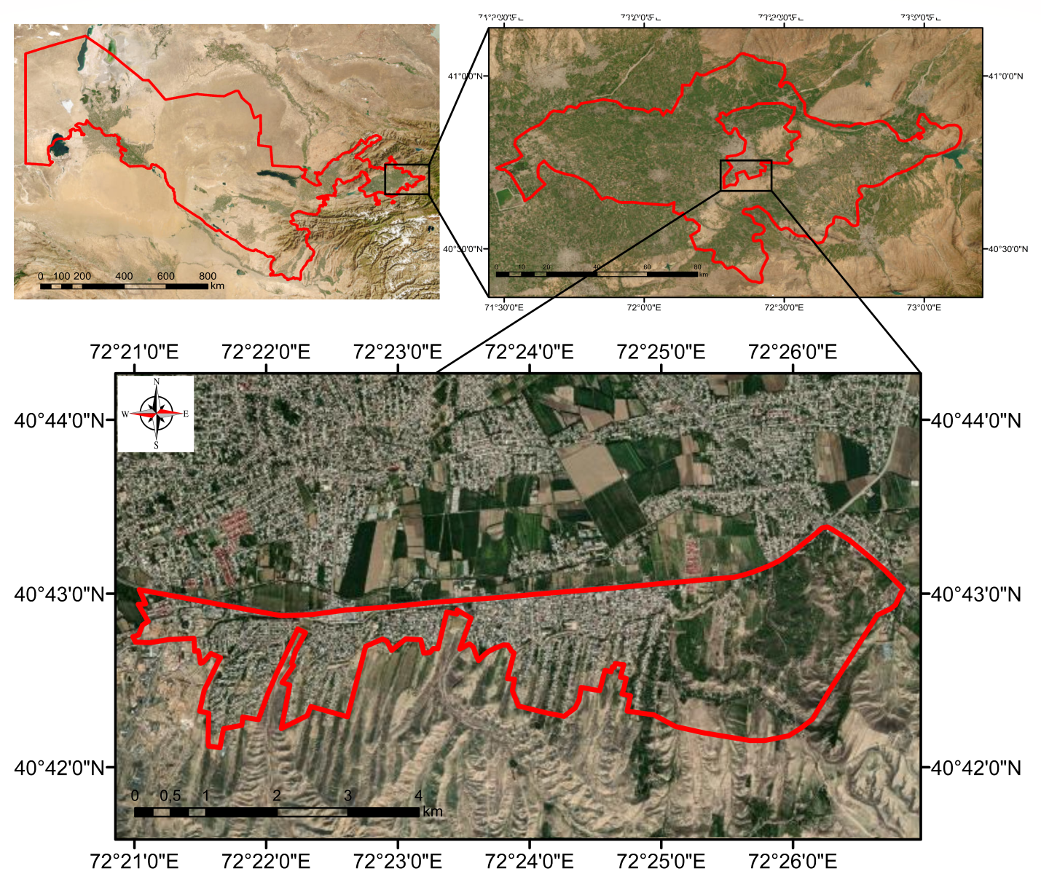

Figure 1. Area of the Bogishamol Dakha

During the research, modern GAT maps were created, reflecting the distribution of the studied species.

Determination of the floristic composition of natural ecosystems, distribution of species, modern status of rare and endangered populations is based on scientific data.

*Iris narynensis* O.Fedtsch., Tulipa ferganica Vved., Tulipa turkestanica (Regel) Regel., Gagea khassanovii Levichev & F. Karim. Ined., such endemic species grow. Observations support this. The reason for this is that it is necessary to support the Bagishamol hills under various anthropogenic influences, to develop measures for self-preservation.

**LIST OF REFERENCES USED:**

1. Madumarov T.A., Naraliev N.M. Designation of the national production base for protection of plants and protected natural areas // "Contemporary problems and solutions of preservation of biological diversity in the Fergana Valley" / Proceedings of the republican scientific and practical conference. Andijan, May 30-31, 2022 p. 303-306.
2. Makhkamov T.Kh. Ruderal flora and vegetation of the Fergana valley: Autoref. dis. ... candy. biol. science - Tashkent, 2009. - 22 p.
3. N.M. Naraliev., N.M. Sidiqzhanov. Some monocot aboriginal species distributed in the urban flora of Andijan city//Khorazm information academy newsletter-3-1/2023. 63-65b.
4. Ibrokhimova G.A. Anthropogenic transformation of the vegetation cover of the northern region of the Fergana Valley. Biol. science. Doctor of Philosophy (PhD) diss. ... abstract. Namangan, 2020.44 p.
5. Sidiqzhanov N.M., Noraliyeva N.M. On the study of monocot geophytes in urban conditions of Andijan. // "Innovative ideas, developments in input: problems, burdens and solutions" material scientific practical conference 224-229b. Andijan 2021.
6. Tojibaev K.Sh., Karimov F.I., Naralieva N.M., Gapporov F.Sh. O klyuchevyx botanicheski territory v Ferganskoy doline // Vestnik NU Uz. - Tashkent: NUUZ, 2012. - No. 3 - S. 235-237.
7. Tojibaev K.Sh. Flora of Yugo-zapadnogo Tyan-Shanya (V predelakh Republic of Uzbekistan): Autoref. dis. … doc. biol. science - Tashkent, 2010. - 35 p.
8. International Plant Names Index (www.ipni.org)
9. Noralieva N.M., Sidiqjonov N.M. Farganic and t.turkestanica types of tulips in the conditions of Andijan and nearby regions. // EPRA International Journal of Research and Development (IJRD) Volume: 6 | Edition: 12 | December 2021.

Catalog of Plant Life of the World (www.catalogueoflife.org), International Plant Name Index (www.ipni.org), Plant List (www.theplantname.com)