**Impact of Governance Corruption and Economic Growth in Sub Saharan Countries**

**Abstract**

The objective of the research is to find out how government effectiveness and control of corruption impacts economic growth in the selected SSA Countries between 2002 and 2017. In this study, we used annual GDP growth rate as dependent variable and Control of Corruption (CONC), Government Effectiveness (GEFF) and Rule of Law (RLAW) as independent variables. We used panel data for this investigation.

The result shows that control of corruption is not statistically significant but it affects the economy negatively while rule of law is statistically significant and it also affects the SSA countries negatively. Rule of Law is the only statistically significant variable that contributes to the growth rate of the SSA countries

**Key Words:** Sub Saharan African Countries, Panel data, corruption, government effectiveness

**Jel Classification:** G3 corporate finance and governance, N17, African Oceania, C33 panel data,

**1.0 Introduction**

It is good to examine countries within the same region so as to know how well they are doing. The results of the examination will enable them to know the steps to take for further growth. It should be noted that the growth of countries differ from one another. However, some of the basic factors responsible for the differences seen in economic growth across nations are population, geography, trade, culture, governance, and institutions (United Nations, 2015). Based on growth theories that are new, for sustained economic growth to occur, public governance is very essential (Bayar, 2016). Although, we do not have a precise meaning of what governance is, (Kaufmann, Kraay, and Mastruzzi, 2010) views governance as the means whereby authority in a country is exercised through traditions and institutions. Therefore, governance is seen as (i) the process of selecting, monitoring and replacing governments; (ii) the effective establishment and implementation of sound policies by the government; and (iii) the respect of citizens and the state for the institutions that govern economic and social interactions. Corruption, however, can be defined as when entrusted power is abused and used for personal gain. It can be categorized as petty, grand, and political which depends on the total sum of funds lost and the sector in which the corruption took place (Transparency International, 2018). This takes us to what we call government effectiveness.

Government Effectiveness is one of the World Governance Indicators (WGI) that measures the quality of public service perception, civil service quality and how free these concepts are from political pressure, quality of policy formulation and implementation, and government commitments capability to such policies. Other indicators of governance are political stability/absence of violence, voice and accountability, quality of regulation, rule of law, and control of corruption which measures other performances of government. This research will therefore focus on how government effectiveness and corruption affect economic growth in the SSA countries. Literature-wise, a high level of corruption is expected to lead to government ineffectiveness in any country which will in turn affect their economic growth. This was confirmed by (Omoteso & Ishola, 2014) when they carried out a study on governance, corruption and economic growth in SSA countries. They observed in their study that economically, Sub-Saharan countries have not been performing well when compared to other developing countries when looked at on an aggregate level. The reasons they gave for this underperformance was classified into two categories. One was external factors and the other was internal factors. External factors included the financial crisis that happened globally and unfavorable terms of trade among other factors. The internal factors included corruption, ethnic conflicts, and instability of the political environment, unstable and unbalanced policy regimes, civil unrest, security issues, weak institutions and complex administrative and institutional frameworks.

Haydaroğlu (2016) further explained that one of the outcomes of institutional weakness is corruption which leads to potential negative effects on the economic performance of a country. As a result of this effect, the why and outcomes of corruption have been elaborately studied in the last two decades. In this context, the problem of corruption has been a long-standing epidemic in Nigeria which is why deliberate effort needs to be made to drastically reduce the problem. Nigeria is one of the most endowed nations on the earth. Endowed with a wide range of human and natural resources. If these resources were effectively utilized, Nigeria would have been one of the leading nations of the world in terms of growth, revenue and productivity (Ovat & Bassey, 2014).

Together with some other Sub-Saharan countries like Guinea and Comoros, Nigeria ranks 148th position out of 180 countries with a score of 27 out of 100 (CPI, 2017). The closer the mark is to 0, the more corrupt the nation is. In government effectiveness, Nigeria's percentile rank is 16.35 out of 100 countries for 2017 (World Bank, 2017). On the other hand, Botswana's economy tends to be doing well in terms of corruption and government effectiveness. Botswana is the leading African country in terms of low level of corruption ranking the 34th position with a score of 61 out of 100 and also ahead of Nigeria in terms of government effectiveness with a 68.75 percentile ranking (World Bank, 2017). In addition, Rwanda is next to Botswana when it comes to the ranking in Corruption Perceptions Index. Rwanda ranks 48 out of 180 countries in Corruption Perception Index and ranks 63.46 Government Effectiveness Percentile Rank while Ghana a West African country ranks 81 out of 180 countries in Corruption Perception Index and ranks 49.04 in Government Effectiveness Percentile Rank.

This research is therefore being conducted to determine the impact of government efficiency and corruption on economic growth in the selected Sub- Saharan African countries between 2002 and 2017. The period of research is limited because of the data available.

There are many studies on the effects of government efficiency and corruption on economic growth in Africa, but few studies have been able to examine the four SSA countries in this research.

**2.0 Research Objective**

The objective of the research is to find out how government effectiveness and control of corruption impacts economic growth in the selected SSA Countries.

**3.0 Research Questions**

1. What impact does government effectiveness have on the economy of the selected SSA countries?
2. Does control of corruption impact economic growth in SSA countries?
3. What impact does rule of law have on the economy of SSA countries?

**4.0 Literature Review**

Brewer, Choi, & Walker (2007) found in their study that factors such as voice and accountability, wealth and income, and control of corruption influence the effectiveness of the government. The study was about the impact government effectiveness has on economic growth in Asia both regionally and across sub-regions using World Bank Governance Indicators.

Ishola & Omoteso (2009) picked some transitional economies to find out how economic growth is affected by corruption and some other factors that are institutional from 1990 to 2004. For the analysis, the panel data framework, random effect, fixed effect and maximum likelihood estimation techniques were used. The results of the study show that corruption has a negative effect on the considered economies which supports Mauro’s (1995) hypothesis. However, the hypothesis of Leff (1964) and Huntington (1968) could not be supported because there was no robust statistical evidence to back it up.

Omoteso & Ishola (2014) carried out a study on some Sub-Saharan African Countries for the period 2002 to 2009 to find out how economic growth has been impacted by governance indices focusing on the control of corruption using panel data, random effect, fixed effect, and maximum likelihood estimation method for the analysis. The result of the study suggests that regulatory quality and political stability significantly impact the region while government effectiveness negatively affects the region. Also, the effect of control of corruption is not obvious even though there have been several implemented anti-corruption policies. In addition, the study noted that economic growth in the region will be significantly affected if accountability and rule of law indicators are implemented simultaneously.

Nwankwo (2014) using granger causality and regression techniques, examined the effect of corruption on growth in the economy of Nigeria and discovered that the effects of corruption on economic growth are negatively significant. The variables used were the Transparency International Corruption Perception Index and Gross Domestic Product.

Bayar (2016) carried out a study on transitional economies in the European union from 2002 - to 2013 using the panel data framework, fixed effects method, chow test, OLS, BP test, and random effects technique to examine the impact of public governance on economic growth. The study estimates that corruption control had a negative impact on the SSA countries’ economies and all governance indicators caused a significant positive impact on economic growth. The weak effects observed on political stability.

Huang (2016) examined whether economic growth is negatively impacted by corruption in 13 Asian pacific countries using the bootstrap panel Granger causality approach from 1997 to 2013. The result shows that corruption had positive causality on economic growth in South Korea. And positive causality from economic growth to corruption in China was also observed. A positive causal relationship between corruption and economic growth was observed in the remaining countries. They assumed that corruption caused some benefits for economic growth.

For a sample of 130 countries, Montes & Paschoal (2016) analyzed the impact corruption had on government effectiveness and found out that countries that are less corrupt have a better quality of public service, better quality of policy adoption and formulation and the governments of such countries are more credible and committed to such policies. Also, in developed countries, the effect of corruption on government effectiveness is higher. It was also observed that countries that had higher debts and inflation were less efficient in governance. The result also suggests that the rule of law helps improve the efficiency of the government and that developing countries with more democratic regimes have a higher degree of efficiency of the government.

Alam, Kiterage, & Bizuayehu (2017) investigated the impact government effectiveness has on the economic growth of a panel of 81 countries using the System Generalized Moments Method (System GMM) technique. The paper finds out that the effectiveness of government positively affects economic growth significantly.

Pacific, Ramadan, & Gabriella (2018) used autoregression model (VAR) to investigate the effect of control of corruption on the economy of Botswana from 1996- to 2014. The results show that government effectiveness, and exports of goods and services have a positive relationship with gross domestic product growth. The Control of corruption though not significant has a positive relationship with economic growth.

Awan, Akhtar, Rahim, Sher, & Cheema (2018) carried out a study on five selected SAARC countries using panel data from 1996-to 2014. The purpose of the research was to find out the association between governance, corruption, and economic growth. Panel regression was run using the Fixed Effects Method of estimation based on Hausman specification test results. The fixed-effects model has also been used with a specific cross-section coefficient. The findings show that two institutional governance indicators, namely government effectiveness and political stability, have a positive and substantial impact on the economy of the selected SAARC countries. Economic growth was negatively impacted by Corruption. Corruption has an adverse effect on economic growth, actual scientific. In addition, the results show that the efficiency of the government has a greater influence on GDP growth in selected SAARC countries among other governance indicators. The results of the education index appeared to be important predictors of the growth of selected SAARC countries in the given period.

**5.0 Data**

The data used for this study are sourced from World Governance Indicators of the World Bank from 2002 to 2017.

**6.0 Methodology**

The econometric model used is similar to that of Pacific, Ramadhan & Gabriella (2018) and Montes & Paschoal (2016). Economic growth is proxied by Annual GDP growth rate (GDPGR) and it is expected to be impacted positively by Control of Corruption (CONC), Government Effectiveness (GEFF) and Rule of Law (RLAW). Corruption is proxied by World Governance Indicators Control of Corruption (CONC). The model is simply stated below.

GDPGR = f (CONC, GEFF, RLAW)....................................................................... (1)

The model therefore will be:

GDPGR = βo + β1 CONC + β2 GEFF + β3 RLAW + εt………………….…………........(2)

Annual GDP growth rate is the dependent variable while the independent variables are Control of Corruption, Government Effectiveness and Rule of Law. From our model above, we expect that control of corruption (β1) will impact economic growth positively and significantly, government effectiveness (β2) and rule of law (β3) is also expected to impact economic growth positively and significantly. However, if economic growth is impacted by control of corruption negatively, that will mean that the efficient grease hypothesis is present. ε is the error term while β is the coefficient. All the independent variables are measured in terms of estimates ranging from -2.5 to 2.5.

**6.1 Descriptive Statistics**

When normal skewness equals zero, then it is Mesokurtic. When Kurtosis equals three, then it is positively skewed. GDPGR is positively skewed & leptokurtic. CONC is negatively skewed & platykurtic. GEFF is negatively skewed & platykurtic while RLAW is also negatively skewed & platykurtic. GDPGR is not normally distributed while CONC, GEFF, & RLAW are normally distributed. The Mean explains the average value for each of the variables. The Median explains the middle value of each of the variables while the Maximum and Minimum explains the highest and the lowest values of each of the variables and the Standard Deviation explains to us the deviation from the sample mean respectively.

**Table1:** Descriptive statistics

|  |  |  |  |  |
| --- | --- | --- | --- | --- |
|  | GDPGR | CONC | GEFF | RLAW |
| Mean | 6.423739 | -0.045543 | -0.205461 | -0.223738 |
| Median | 6.173016 | -0.048127 | -0.098069 | -0.035065 |
| Maximum | 33.73578 | 1.216737 | 0.725896 | 0.730522 |
| Minimum | -7.652310 | -1.431231 | -1.214644 | -1.427206 |
| Standard Deviation | 4.864018 | 0.8012400 | 0.590132 | O.683849 |
| Skewness | 2.382295 | -0.139898 | -0.265048 | -0.228484 |
| Kurtosis | 17.68389 | 1.772017 | 1.803736 | 1.751787 |
| Jarque-Bera | 635.5142 | 4.229940 | 4.565467 | 4.711611 |
| Probability | 0.000000 | 0.120637 | 0.102005 | 0.094817 |
| Sum | 4.11.1193 | -2.914731 | -13.14952 | -14.31925 |
| Sum Sq. Dev. | 1490.496 | 40.56231 | 21.94010 | 29.46191 |
| Observations | 64 | 64 | 64 | 64 |

Source: Authors calculation

**Figure 1:** Trend of the Variables

**GDPGR CONC**

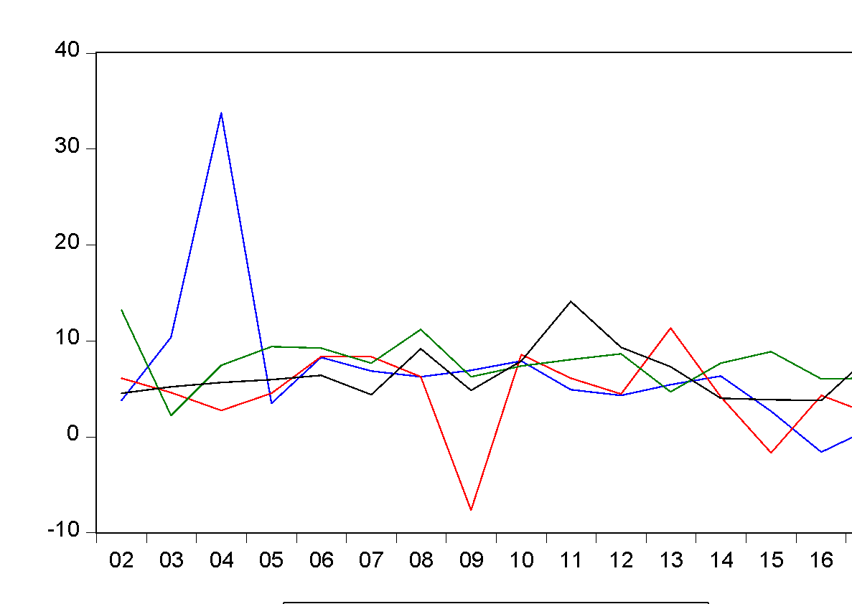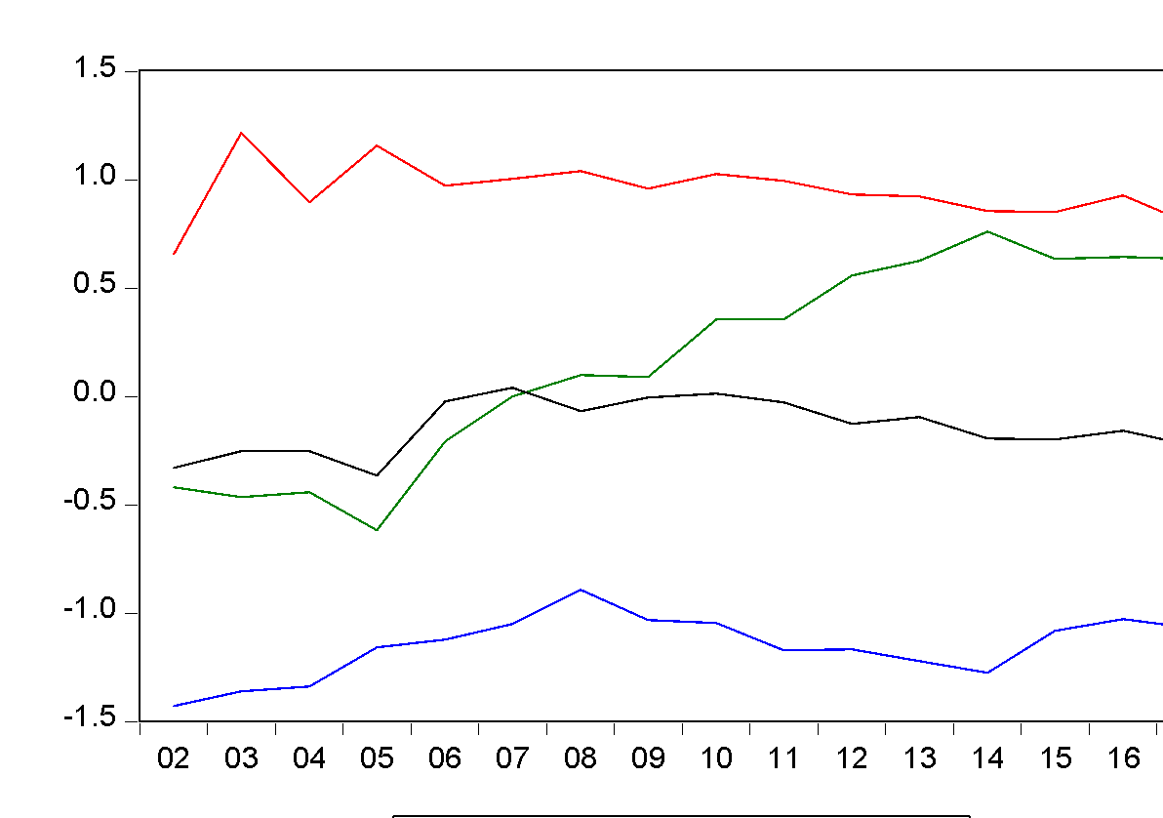

**GEFF RLAW**

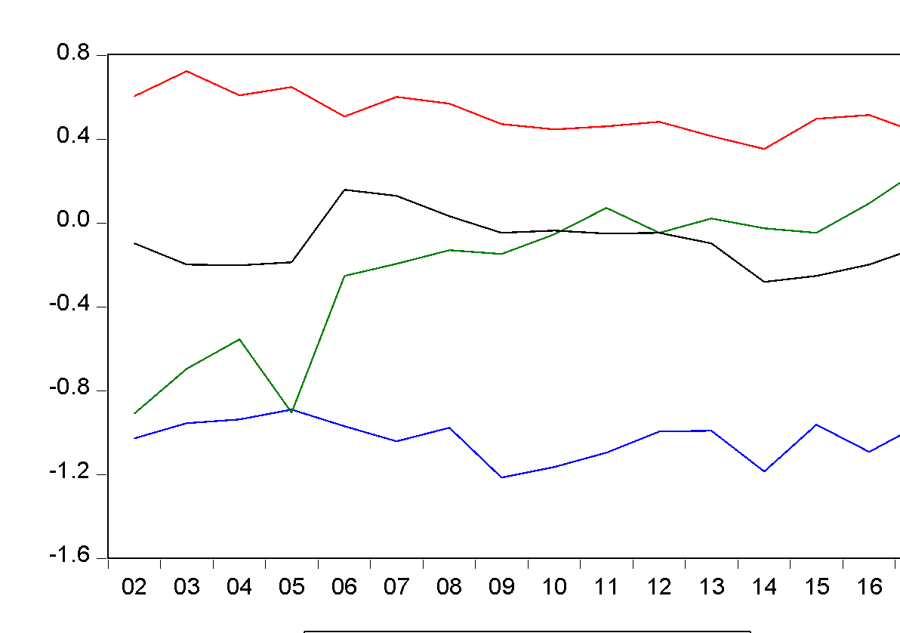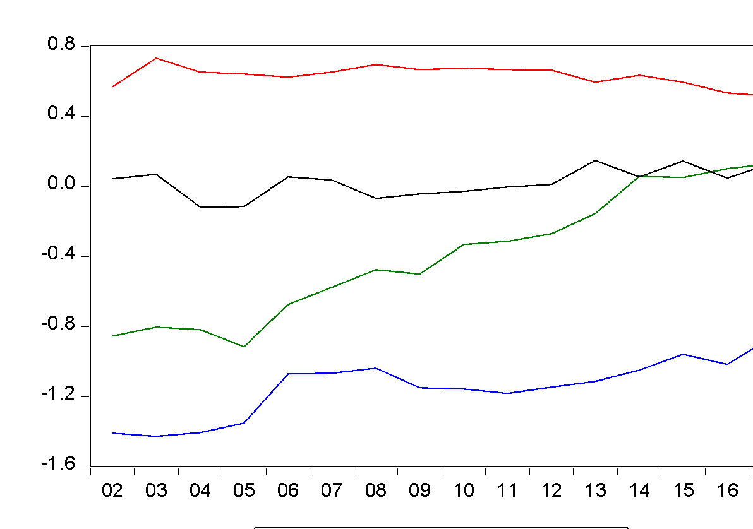

Source: Authors’ estimation

**6.3 Unit Root (Trend & Intercept)**

All parameters become stationary after the first difference see table below.

**Table 2**: The unit root analysis becomes significant for considered parameters.

|  |  |  |  |  |  |  |
| --- | --- | --- | --- | --- | --- | --- |
|  | Levin, Lin & Chu t* | | ADF – Fisher Chi Square | | Im, Pesaran and Shin W-stat |  |
| Variables | T-Statistics & Prob | | T-Statistics & Prob | | T-Statistics & Prob | Stationary |
| GDPGR | -9.69361 | 0.0000 | 40.5582 | 0.0000 | -6.16659 0.0000 | I(1) |
| CONC | 6.27742 | 1.0000 | 17.3172 | 0.0270 | -1.89030 0.0294 | I(1) |
| GEFF | -2.26685 | 0.0117 | 17.9053 | 0.0219 | -2.10442 0.0177 | I(1) |
| RLAW | -0.05632 | 0.4775 | 15.9065 | 0.0437 | -1.70435 0.0442 | I(1) |

Source: Authors’ estimation

**6.4 Unit Root (Trend)**

**Table 2: unit root**

|  |  |  |  |  |  |  |
| --- | --- | --- | --- | --- | --- | --- |
|  | Levin, Lin & Chu t* | | ADF – Fisher Chi Square | | Im, Pesaran and Shin W-stat |  |
| Variables | T-Statistics & Prob | | T-Statistics & Prob | | T-Statistics & Prob | Stationary |
| GDPGR | -3.15838 | 0.0008 | 20.9010 | 0.0074 | -2.60839 0.0045 | I(0) |
| CONC | 5.11083 | 1.0000 | 21.6268 | 0.0057 | -2.68109 0.0037 | I(1) |
| GEFF | -1.80525 | 0.0355 | 8.73646 | 0.3650 | -0.65285 0.2569 | I(0) |
| RLAW | -1.83140 | 0.0335 | 23.6812 | 0.0026 | -2.99219 0.0014 | I(1) |

Source: Authors’ estimation

**6.5 Pooled Regressions**

We analyse whether the estimated pooled OLS model is significant for the regression. Regarding the test results given in table 3, t statistics, which measures variance in the dependent variables explained by independent variables. And From the table we observe only the rule of law becomes significant and Control of corruption is not statistically significant, however; it affects the economy negatively while rule of law is statistically significant and it also affects the SSA countries negatively. It is observed from t statistics that the intercepts are all significantly different from zero.

**Table 3: pooled regression results**

|  |  |  |  |  |
| --- | --- | --- | --- | --- |
| dependent Variable | GDPGR |  |  |  |
|  | Coefficient | Std. Error | t-statistic | Prob. |
| C | 6.330701 | 0.827384 | 7.651467 | 0.0000 |
| CONC | -0.624065 | 2.485501 | -0.251082 | 0.8026 |
| GEFF | 7.710114 | 4.405212 | 1.750225 | 0.0852 |
| RLAW | -7.369082 | 2.975379 | -2.476687 | 0.0161 |

Source: Authors’ estimation

The pooled regression assumes that all the countries are the same.

**6.6 Fixed Effect Model**

The estimation of fixed effect model is in the table below given. In particular, only the variable rule of law becomes significant. But other variables' probability values are not significant.

**Table 4** Fixed Effect Model

|  |  |  |  |  |
| --- | --- | --- | --- | --- |
| Dependent Variable | GDPGR |  |  |  |
|  | Coefficient | Std. Error | t-statistic | Prob. |
| C | 4.426707 | 1.591774 | 2.780990 | 0.0073 |
| CONC | 5.106013 | 5.602257 | 0.911421 | 0.3659 |
| GEFF | 4.406333 | 4.871293 | 0.904551 | 0.3695 |
| RLAW | -14.01148 | 5.953665 | -2.353420 | 0.0221 |

Source: Authors’ estimation

**6.7 Random Effect Model**

Similarly, the Random-effect model results which are shown in the table again only become meaningful for the Rule of Law. While the rest of the variables are not significant. One interesting point is the rule of law which coefficient is positive and has an impact across the model. Other variables' coefficients are negative. It can be concluded that the rule of law is an important determinant for corruption.

**Table 5**: Random Effect Model

|  |  |  |  |  |
| --- | --- | --- | --- | --- |
| Dependent Variable | GDPGR |  |  |  |
|  | Coefficient | Std. Error | t-statistic | Prob. |
| C | 6.330701 | 0.826626 | 7.658484 | 0.0000 |
| CONC | -0.624065 | 2.483224 | -0.251313 | 0.8024 |
| GEFF | 7.710114 | 4.401176 | 1.751830 | 0.0849 |
| RLAW | -7.369082 | 2.972653 | -2.478958 | 0.0160 |

Source: Authors’ estimation

In the above two tables, random and fixed effects are interpreted. This investigation has two estimators with different properties depending on the correlation between αi and the regressors. And If the effects do not interact with the explanatory variables, the random effects (RE) estimator is consistent and efficient. In contrast, the fixed effects (FE) estimator is consistent but not efficient in this model. Again, if effects are associated with explanatory variables, the FE estimator is consistent and efficient, but the RE estimator is now inconsistent. Therefore, we need to calculate the Hausman test to determine which estimator is correct.

**6.8 Hausman Test­­_**

The Hausman test helps us to pick the preferred method to use either fixed effect model or random effect model. The preferred method to use after carrying out Hausman test is the random effect model.

**Table 6:** Hausman test

|  |  |  |  |
| --- | --- | --- | --- |
| Dependent Variable GDPGR |  |  |  |
| Test cross-section random effects |  |  |  |
| Test Summary | Chi-Sq Statistic | Chi-Sq. d.f | Prob |
| Cross-section random | 3.110092 | 3 | 0.3750 |

Source: Authors’ estimation

**7.0 Empirical Results and Discussions**

Using the pooled regression, the result shows that control of corruption is not statistically significant however; it affects the economy negatively while rule of law is statistically significant and it also affects the SSA countries negatively.

Control of Corruption is not statistically significant to explain the Annual Gross Domestic Product Growth Rate variable. However, control of corruption affects the SSA region negatively.

Government Effectiveness is not also statistically significant to explain the Annual Gross Domestic Product Growth Rate variable. However, it affects the economy positively even though not significant.

Rule of Law is the only statistically significant variable that contributes to the growth rate of the SSA countries. However, it affects the SSA countries negatively. Control of Corruption affects the economy negatively because of weak institutions in the SSA countries.

**7.1 Recommendations**

The conclusion is that governments of the SSA countries must strengthen institutions so that the variables considered can impact the economy of the SSA countries significantly and positively.

**References**

Alam, M. R., Kiterage, E., & Bizuayehu, B. (2017). Government effectiveness and economic growth. Economic Bulletin, 37(1), 222-227.

Awan, R. U., Akhtar, T., Rahim, S., Sher, F., & Cheema, A. R. (2018). Governance, Corruption and Economic Growth: A Panel Data Analysis of Selected SAARC Countries. *Pakistan Economic and Social Review*, *56*(1), 1-20.

Bayar, Y. (2016). Public governance and economic growth in the transitional economies of the European Union. *Transylvanian Review of Administrative Sciences*, *12*(48), 5-18.

CPI, (2017). Corruption Perception Index.

Haydaroğlu, C. (2016). Corruption, Institutions and Economic Growth in Sub-Saharan Africa. *International Journal of Economics and Research*, *7*, 14-26.

Huang, C. J. (2016). Is corruption bad for economic growth? Evidence from Asia-Pacific countries. *The North American Journal of Economics and Finance*, 35, 247-256.

Ionescu, L. (2014). The adverse effects of corruption on growth and development. *Economics, Management and Financial Markets*, *9*(4), 125.

Ishola, H., & Omoteso, K. (2009). Corruption and economic growth in some selected transitional economies. *Social Responsibility Journal*, 5(1), 70-82.

Ishola, M. H., & Omoteso, K. (2014). Corruption, governance and economic growth in Sub-Saharan Africa: a need for the prioritisation of reform policies", *Social Responsibility Journal*, Vol. 10 Issue: 2, pp.316-330, https://doi.org/10.1108/SRJ-06-2012-0067

Kaufmann, D., Kraay, A. and Mastruzzi, M. (2010). ‘The Worldwide Governance Indicators: A Summary of Methodology, Data and Analytical Issues’, 2010, World Bank Policy Research Working Paper no. 5430, [Online] available at http://papers.ssrn.com/sol3/ papers.cfm?abstract_id=1682130, accessed on May 10, 2015.

Montes, G. C., & Paschoal, P. C. (2016). Corruption: what are the effects on government effectiveness? Empirical evidence considering developed and developing countries. Applied Economics Letters, 23(2), 146-150.

Nwankwo, O. F. (2014). Impact of corruption on economic growth in Nigeria. *Mediterranean journal of social sciences*, *5*(6), 41.

Ovat, O. O., & Bassey, E. E. (2014). Corruption, governance and public spending in Nigeria: Implications for economic growth.

Pacific, Y. K. T., Ramadhan, A. A., & Gabriella, N. M. A. (2018). Does Control of Corruption Accelerate Economic Growth in Botswana? *Global Journal of Human-Social Science Research.*

United Nations (2015). Investing in Development. A practical Plan to Achieve the Millennium Development Goals”, Millennium Project Report to the UN Secretary General. New York. NY.