Thermodynamic and Kinetic Assessment of Cobalt II Adsorption Using Green Synthesized NiO/γ-Al₂O₃ Nanoparticles
Karim Hassan and Karim Al-Jashamy and Khalaf Df Ghadir
Bilad Alrafidain University College, Diyala, 32001, Iraq
Abstract
Disposal of heavy metals into water as a result of industrial development might cause a threating to environment. The aim of this study was to assess the uptake of Co²⁺ from aqueous solutions via NiO/ γ-Al₂O₃ nano catalysts. Main variables which affect the percentage of metal removing was assessed. It took about 50 minutes to attain equilibrium for elimination of Co⁺² ions. It was discovered that raising the adsorbate concentration and increasing the surface weight both somewhat lowered the removal of cobalt ions. The cobalt ions removal was shown to depend on temperature as removal was reduced by raising the temperature and the process is of exothermic nature. The adsorption seems to be spontaneous, exothermic, and less random according to calculated values of the thermodynamic functions (∆G, ∆H, and ∆S) of the adsorption. The data were then fitted into many kinetic models equations such as pseudo-first order / pseudo-second order / intraparticle diffusion and finally Elovich model, it was observed that pseudo-second order describe the adsorption with high correlation factor (R²) and being better than any other kinetic models.
Keywords: Thermodynamic, kinetic, Adsorption, Cobalt II, Green Synthesis, NiO/γ-Al₂O₃ nanoparticles.
Introduction
The biological processes produce large amounts of wastewater, which represent a serious threat to the survival of living things in the environment since it is contaminated with cobalt and its compounds. The compounds of cobalt are an element in environment in its mineral structural forms like arsenosols: arsenics: hydrates and even oxides (Bielański, 2020). There is a biological toxic effects of high concentrations cobalt compounds onto living organisms. Printing and ceramic industry working people that used the cobalt dyes at paints materials, anti-insect and agriculture might suffer from health problems (Bożęcka and Sanak-Rydlewska, 2018). However, ways to remove cobalt ions from aqueous media and water are done by precipitation means (Lundström et al., 2016), electrochemical technics (Jack et al., 2014; Li et al., 2017) and membrane processes (Tran et al., 2012), and most commonly used of adsorption and ion exchange (Edebali and Pehlivan, 2016; Prakash and Arungalai, 2016; Al-Saydeh et al., 2017).
Basically, the surface of the nanoparticles functionality might show a high surface area to increase both adsorption capacity and efficiency. Recently, researchers reported various nanomaterials particles for heavy metal removal by adsorption (Singh et al., 2022). Therefore, heavy metals might adsorb easily from aqueous systems using nano size metal oxides like ferric oxides, manganese, cerium and aluminum oxides. The nanomaterials particles were intensively experimented as very active and efficient absorbents for many heavy metal ions removing (Charikleia and George, 2021). Cobalt removal studies employed magnetite based nanocomposite (Saeed and Hadi, 2017). The present study aims is assessing the Co²⁺ uptake from aqueous solutions via ( NiO/ γ-Al₂O₃ ) nano catalysts.
Experimental Part
Adsorbates of Study
The Co(II) ions utilized in the study are regarded as heavy metals that need to be removed from wastewater since they are major environmental contaminants. many solutions containing amount of [50/100/150/200/ and 250] mg/L have been obtained from the standard aqueous stoke/solution of Co(II) ions (1000 ppm) by appropriately dilution with deionized water.
Adsorbent of Study
The adsorbent used is Nano NiO/γ-Al₂O₃ catalyst which was being prepared and characterized previously (Jawad and Hassan, 2021) from nickel oxide nanoparticles that was synthesized by Arundo Donaxi Leaves Extract route and alumina (γ-Al₂O₃) being prepared by co-precipitation method.
Factors Affecting the Adsorption
In this investigation, the important influencing factors were the amount of NiO/-Al₂O₃ adsorbent, influence of original concentration of Co⁺² ions, and role of temperature. To study the impact of temperature on adsorption, Co(ll) ion removal from aqueous solutions is performed in a series of adsorption experiments at various temperatures (293, 303, 313, 323, and 333K).
Metal Removal Methods
The removal percent of metal (R%) was calculated using the equation previous reported (Karthik and Meenakshi, 2015, Onundi et al., 2010).
Kinetic Adsorption of Co⁺² ions
The kinetic of cobalt ion adsorption are done using (0.1) g of prepared NiO /γ-Al₂O₃ shaking speed of [150 rpm], temperature [298 K] with at a regular time interval of (5, 15, 25, 35 and 45) min. The experiment was then repeated using the adsorbent at temperatures (308, 313, 318, 323) K and then the concentration of Co⁺² ions removed were measured as in above procedures. The order of adsorbate / adsorbent interaction was tested by using 4 kinetic models that involved the (pseudo/first order: pseudo/second order: intra particle diffusion: and finally Elovich models one) described by equations (1-4).

[ln(q_{e} –q_{t})]= (lnq_{e}) – (k₁ t)… ... 1

[t/q_{t} ]=1/(k₂ q ² )+[1/(q_{e} )]t …...2

(q_{t)} = k_{D} t^{1/2} + (constant, C)…....3
qt=βln (αβ) + βlnt ………….....4

Results and Discussion
Adsorption of Co(II) ions on NiO/ γ-Al₂O₃ NanoCatalyst
Effect adsorption on time of contact
Influence of contacting time on the Co(⁺²) ion's adsorption on (NiO/-A_{l2}O₃) revealed that the adsorption equilibrium time is almost (50) min. The percentage removal of Co⁺² ions from surfaces also decreases at the beginning of contact time before gradually increasing, with the quick initial increase in rate followed by slowing in rate at the later period may be caused by the presence of extra adsorption on the adsorbent materials sites (Saeed et al. 2005). According to Alfa et al. (2012), the first high adsorption rate may have been caused by ion exchange, which was achieved by gradual reaction between the sample ions active groups as the available empty surface positions cannot be filled easily because of repulsive force. To do so metal ions must migrate much further and also deeper into the pore where it under go or encounter much greater resistance (Srivastava et al., 2006).
Role of Amount of Adsorbent Quantity on Adsorption
Impact of adsorbent amount on the removal, Co(⁺²) ions on (NiO/γ-Al₂O₃) was investigated via different amounts quantity (0.06- 0.08- 0.1- 0.12 and 0.15)g and at 298K with the same Co⁺² ions concentration (100ppm), time of contact being (50) min. For the effect of surface amount on the absorption of metal ion, it shows that when increasing the amount of NiO/γ-Al₂O₃ prepared by the [Arundo Leaves Extract method], the removal of metals also raises, this rise declares that the increase in concentration of oxide nanoparticles increases to the % metal elemination from the surface due to surface area increase.
Effect of Original Adsorbate Amount on Adsorption
Co (⁺²) ions adsorption on NiO/y-Al₂O₃ was first investigated at optimal conditions using different initial concentrations (50-100-150-200 and 250) ppm of the aqueous solution. The data showed that initial concentration raise cause a decrease in removal. This decrease in removal percentage at higher concentrations may be due to the large number of active sites in the nanoparticle adsorbents and the small size and large surface area of ​​the nanoparticles, which contain many active adsorption sites available for adsorption (Onundi et al., 2010).
Temperature effect on adsorption
The temperature might effect on the extent of Co(II) ion adsorption on NiO/γ-Al₂O₃ was investigated at different temperatures that involved 293, 303, 313, 323 and 333K with an initial concentration of (100) mg/l, (0.1g) is quantity of adsorbent, fixed time of contact (50min). Experimental data and shape of Co (II) removing are presented (Table 1 and figure 1).
It is obvious that removal rate lower with temperature increasing. Based on these data, it can be observed that the adsorption is exothermic process in studied cases, the lowering down of the removal by adsorption raise by increasing temperature might due to the weakness of the force of interaction between adsorption surface active sites and adsorbate ions (Sheela et al., 2012).
Table 1: Temperature effect on adsorption of Co(+2) via NiO/γAl2O3
Temperature (K) | Co(II)
Temperature (K) | C_{ο} in (mg/L, ppm) | C_{t} in (mg/L, ppm) | R %
293 | 100 | 0.38 | 99.62
303 | 100 | 4.65 | 95.35
313 | 100 | 10.84 | 89.16
323 | 100 | 14.75 | 85.25
333 | 100 | 19.51 | 80.49

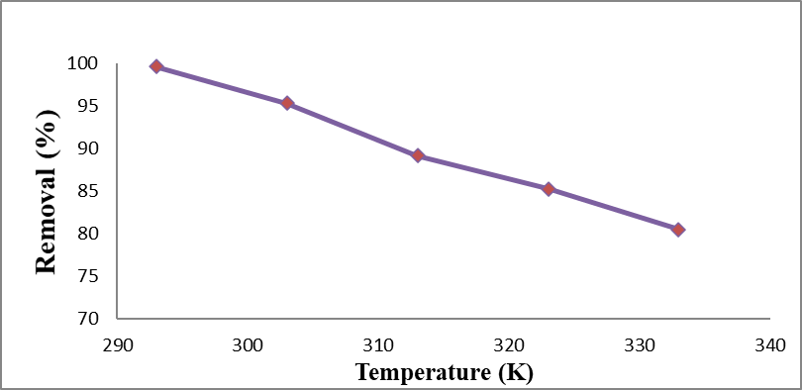
Figure 1: Relation of temperature and percent removal of Co (II) ion on NiO/ γ -Al₂O₃ nano catalyst.

Kinetics Studies of Adsorption Process for Cu⁺² and Co⁺² ions
An adsorption kinetic study was carried out using the experimental conditions with initial concentration (100 ppm), many temperatures (308- 313-318- and 323)K, 150 rpm and time intervals (5-15-25-35- and 45) minutes. C_{e} represents concentration of the ions followed the adsorption in (t) time (ppm), q_{t} is value adsorbed at t time (ppm), q_{e} is the adsorbed quantity at equilibrium (mg/g,ppm), q_{e} -q_{t} , ln(q_{e}- q_{t}), t which is time (min), t^{1/2} square root of time (min^{1/2}),data are given in tables 2, 3, 4 and 5 for a temperatures of 308,313,318 and 323 K respectively.
These data were applied for four kinetic model which are pseudo-first order, pseudo-second order, Intraparticle diffusion and Elovich models described by equations 2, 3, 4 and 5 with the plots shown in figures 2, 3, 4 and 5 at four different temperatures for the four mention models respectively.
Table 2: The adsorption data for Co (ll) ions removal with (NiO/γ-Al₂O₃) nano catalyst at 308K

Table 3: The adsorption data for Co (ll) ions removal with (NiO/γ-Al₂O₃) nano catalyst at 313K
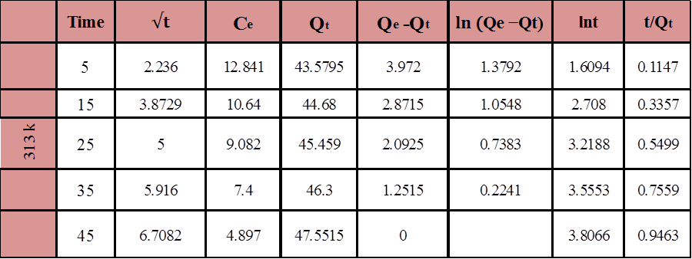

Table 4: The adsorption data for Co (ll) ions removal with (NiO/γ-Al₂O₃) nano catalyst at 318K
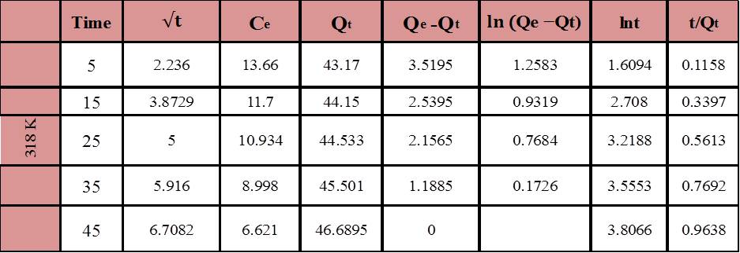
Table 5: The adsorption data for Co (ll) ion removal with (NiO/γ-Al₂O₃) nano catalyst at 323K
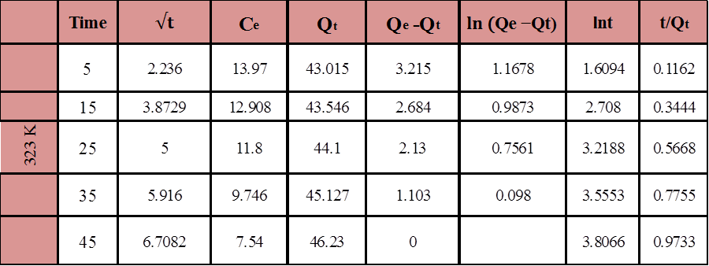

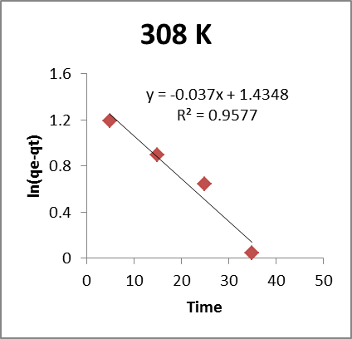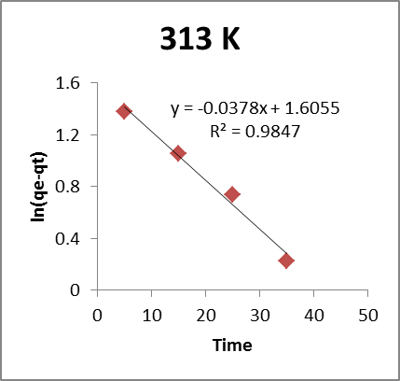
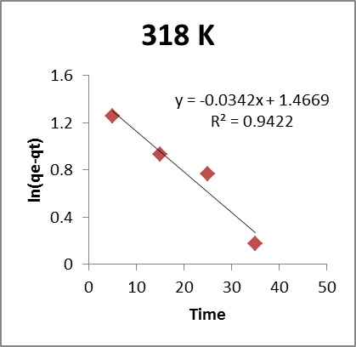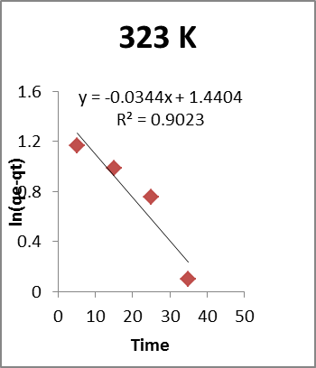

Figure 2: The Pseudo 1st – Order kinetic model due to Co⁺² adsorption on NiO/γ-Al₂O₃ nano catalyst.
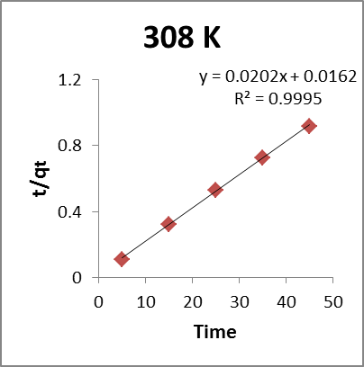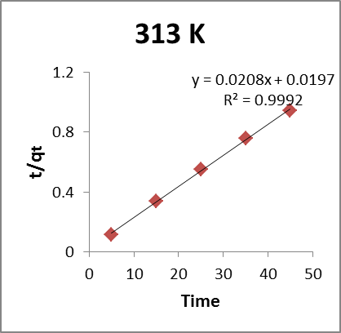
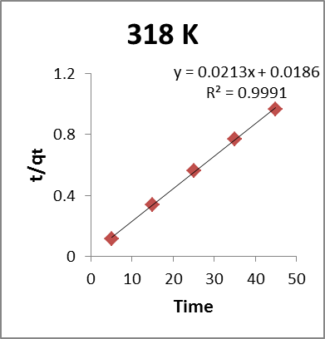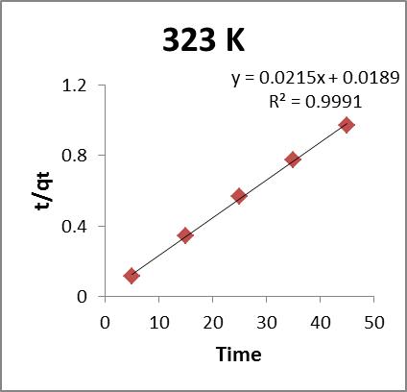
Figure 3: The Pseudo 2nd – order kinetic model forCo⁺² adsorption on NiO/γ-Al₂O₃ nano catalyst.
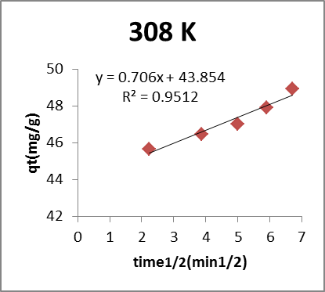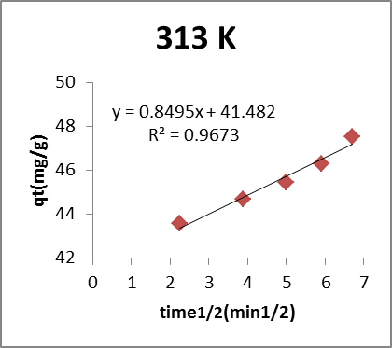
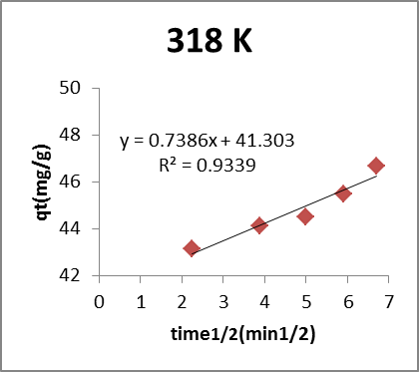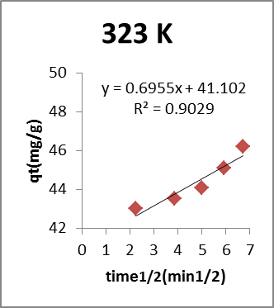
Figure (4) The intraparticle model of diffusion for Co⁺² adsorption on NiO/γ-Al₂O₃ nano catalyst.
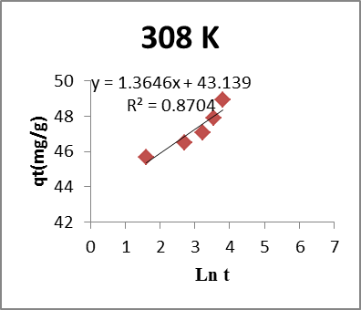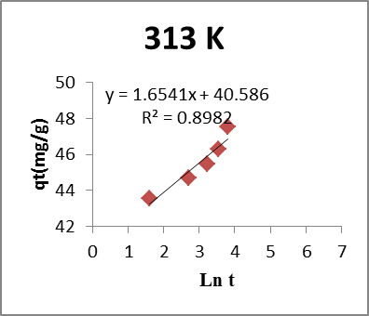
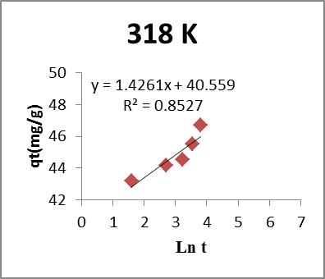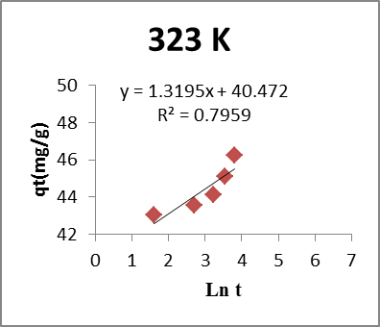
Figure 5: The Elovich Model for Co⁺² ion adsorption on NiO/γ-Al₂O₃ nano catalyst.
The values (k₁: k₂: k_{D} :k_{elovich}) and correlations coefficients of adsorption for Co(⁺²) on NiO/γ-Al₂O₃ adsorbents are given in table (6). The results show that the pseudo-2nd -order correlation coefficient is more than one of pseudo-1st, intraparticle diffusion models and even Elovich model.
Table 6: Adsorption kinetics constants for Co⁺² ions adsorption on NiO/γ-Al₂O₃ nano catalyst
T(K) | ) q _{e}( | Pseudo 1st order |  | Pseudo-2nd order |  |  | Intra particle-diffusion |  | Elovich-model
T(K) | ) q _{e}( | K₁ in 1/min | (R)² | K₂ in g/mg.min | (R)² | K_{D} in mg/g.min⁻¹ |  | (R)² | k_{elovich} in  (mg/g.s) | (R)²
308.0 | 48.9450 | -0.0370 | 0.9577 | 0.0252 | 0.9995 |  | 0.7059 | 0.9512 | 73132 | 0.8704
313.0 | 47.5515 | -0.0378 | 0.9847 | 0.0220 | 0.9992 |  | 0.8494 | 0.9673 | 74733 | 0.8982
318.0 | 46.6895 | -0.0342 | 0.9422 | 0.0243 | 0.9991 |  | 0.7385 | 0.9339 | 32029 | 0.8527
323.0 | 46.2300 | -0.0344 | 0.9023 | 0.02433 | 0.9991 |  | 0.6955 | 0.9029 | 27612 | 0.7959

Thermodynamic study of adsorption for NiO/γ-Al₂O₃ nanocatalyst
Impact of temperature on removal of Co⁺² ions from NiO/γ-A_{l2}O₃ at different temperatures that included 293, 303, 313, 323 and 333 K was tested and used to evaluate the change in the thermodynamic basis function of the free-energy; [∆G], enthalpy; [∆H] and also the entropy; [∆S] of adsorption. Equilibrium constant; [K] is well-thermodynamically explained using equation of Van ᾽t Hoff (figure 6, Table 7). The value of equilibrium constants[K] were ccomputed at any studied temperatures by (Taqe, 2015). For the Gibes-free-energy change [∆G°] it has been evaluated from according to the previous reported equation (Suzuki, 1990; Boparai, et al., 2011). Finally, values of (∆H) and (∆S) was calculated from both slope & intercept by plotting (lnk) vs (1/T) (Shakibabarough et al., 2014; Shabani et al., 2017)
Table 7: Data for temperature effect against equilibrium-constant of adsorption of Co(⁺²) ions- on NiO/γ-Al₂O₃ nano catalyst
T,K | (K⁻¹) | C_{e} | Q_{e},(mg/g) | (K,kelvin) | (lnk)
293 | 0.003355 | 0.38 | 49.81 | 262.1578 | 5.5689
303 | 0.0033 | 4.65 | 47.675 | 20.5053 | 3.0206
313 | 0.003194 | 10.84 | 44.58 | 8.225 | 2.1071
323 | 0.003095 | 14.75 | 42.625 | 5.7796 | 1.7543
333 | 0.003003 | 19.51 | 40.245 | 4.1255 | 1.4171

Figure 6: Plot of Van-᾽t Hoff adsorption plot of Co (II) by NiO/γAl₂O₃ catalyst.
The changes in [(ΔG);(ΔH); and (ΔS)] showed by table (8) in which the negative ΔG values confirm the suitability and the spontaneous nature of the adsorption process (Abdulah, 2010). Although the negative value of ∆H indicates that the adsorption of ions onto NiO/γAl₂O₃ catalysts was an exothermic process and negative [ΔS] indicates a randomness decrease at (solid-solution) interface through adsorption of ions by NiO/γAl₂O₃ catalysts.
Table (8): Values of general thermodynamic function of the adsorption for Co (II) on NiO/γ-Al₂O₃ nano catalysts under variust temperatures
Ions | Temperature in,(K) | ΔG,( KJ/mol) | ΔH,( KJ/mol) | ΔS,(KJ/mol.K)
Co⁺² | 293 | -13565.851 | -83428.87 | -243.0282
Co⁺² | 303 | -7609.3203 | -83428.87 | -243.0282
Co⁺² | 313 | -5483.2684 | -83428.87 | -243.0282
Co⁺² | 323 | -4711.0358 | -83428.87 | -243.0282
Co⁺² | 333 | -3923.3292 | -83428.87 | -243.0282

References
- Bielański A. 2020. Basics of inorganic chemistry. Scientific Publishers PWN, Warsaw (in Polish).
- Bożęcka A. and Sanak-Rydlewska S. 2018. The use of ion exchangers for removing cobalt and nickel ions from water solutions. Arch. Min. Sci., 63(3): 633–646.
- Lundström M. et al. 2016. Copper precipitation during leaching of various copper sulfide concentrates with cupric chloride in acidic solutions. Hydrometallurgy, 166:136–142.
- Jack F. et al. 2014. Electrocoagulation for the removal of copper from distillery waste streams. J. Inst. Brew,120:60–64.
- Li J et al. 2017. Functionalization of bio mass carbonaceous aerogels and their application as electrode materials for electro-enhanced recovery of metal ions. Environ. Sci.: Nano, (4) :1114-1123.
- Tran A.T.K. et al., 2012. RO concentrate treatment by a hybrid system consisting of a pellet reactor and electrodialysis. Chem. Eng. Sci., (79): 228–238.
- Edebali S. and Pehlivan E. 2016. Evaluation of chelate and cation exchange resins to remove copper ions. Powder Technology, (30): 520–525.
- Prakash N. and Arungalai Vendan S. 2016. Biodegradable polymer based ternary blends for removal of trace metals from simulated industrial wastewater. Int. J. Bio. Macromolecules. (83): 198–208.
- Al-Saydeh S. A. et al. 2017. Copper removal from industrial wastewater: A comprehensive review. J. Ind. Eng. Chem (56): 35–44.
- Singh et al. 2022.Sustainable removal of Cr(VI) using graphene oxide-zinc oxide nanohybrid: adsorption kinetics, isotherms and thermodynamics, Environ. Res, (203): 11189.
- Charikleia Prochaska and George Gallios. 2021. Nano-Adsorbents for Cobalt Removal from Wastewater, A Bibliometric Analysis of Research Articles Indexed in the Scopus Data base, Processes (9): 1177.
- Saeed Tizro and Hadi Baseri, 2017, Removal of Cobalt Ions from Contaminated Water Using Magnetite Based Nanocomposites: Effects of Various Parameters on the Removal Efficiency J. Water Environ. Nanotechnol, 2(3): 174-185.
- Jawad Nawras and Hassan Karim. 2021. Structural Characterization of NiO Nanoparticles Prepared by Green Chemistry Synthesis Using Arundo donaxi Leaves Extract, Iraqi Academics Syndicate International Conference for Pure and Applied Sciences Journal of Physics: Conference Series 1818.
- Karthik, R., and Meenakshi, S. 2015. Removal of Pb (II) and Cd (II) ions from aqueous solution using polyaniline grafted chitosan. Chem. Eng. J, (263): 168-177. ‏
- Onundi, Y.B., Mamun, A.A., Al Khatib, M.F., and Ahmed, Y.M. 2010. Adsorption of copper, nickel and lead ions from synthetic semiconductor industrial wastewater by palm shell activated carbon. Int.J. Envir. Sci & Tech., 7(4): 751-758. ‏
- Saeed, A., Akhter, M.W., and Iqbal, M. 2005. Removal and recovery of heavy metals from aqueous solution using papaya wood as a new biosorbent. Sep. Puri. Tech, 45 (1): 25-31.
- Alfa, Y.M., Hassan, H., and Nda-Umar, U.I. 2012. Agricultural waste materials as potential adsorbent for removal of heavy metals from aqueous solutions. Inter. J. Chem. Res, 2 (2): 48-54.
- Srivastava, V.C., Mall, I.D., and Mishra, I.M. 2006. Equilibrium modelling of single and binary adsorption of cadmium and nickel onto bagasse fly ash. Chem. Eng. J. 117 (1) :79-91.
- Sheela, T., Nayaka, Y.A., Viswanatha, R., Basavanna, S., and Venkatesha, T.G. 2012. Kinetics and thermodynamics studies on the adsorption of Zn (II), Cd (II) and Hg (II) from aqueous solution using zinc oxide nanoparticles. Powder Technology, 217, 163-170.
- Taqe, R.M.M. 2015. Removal of some water pollutants using newly synthesised organoclays. M.Sc. thesis, College of Science, University of Al- Mustansiriyah, Iraq.
- Suzuki, M. 1990. Adsorption engineering. Tokyo / Amsterdam: Kodansha Ltd., and Elsevier Science Puplishers B.V.
- Boparai, H.K., Joseph, M., and O’Carroll, D.M. 2011. Kinetics and thermodynamics of cadmium ion removal by adsorption onto nano zerovalent iron particles. Journal of Hazardous Materials, 186 (1), 458-465.
- Shakibabarough, A., Valinejadshoubi, M., and Valinejadshoubi, M. 2014. Useable and precautionary aspects of using nanotechnology and nano-materials in the construction industry. International Journal of Science, Engineering and Technology Research, 3 (4), 841- 847.
- Shabani, K.S., Ardejani, F.D., Badii, k., and Olya, M.E. 2017. Preparation and characterization of novel nano-mineral for the removal of several heavy metals from aqueous solution: batch and continuous systems. Arabian Journal of Chemistry, 10, 3108 - 3127.
- Abdulah, F.W. 2010. Removal of chromium(III) Ions from its Aqueous Solution by Adsorbent Surface: Charcoal, Attapulgite and Date Palm Leaflet Powder (Pinnae). M.Sc. thesis, College of Education Ibn-Al-Haitham, University of Baghdad, Iraq.

