**Effect of microwave heating on technological properties of aquafaba**

***Saif Jamal Mahdy MAHDYC:\Users\Abdullah\AppData\Local\Microsoft\Windows\INetCache\Content.Word\ORCID-iD_icon-16x16.gif, Sezin TUTA ŞİMŞEK\*C:\Users\Abdullah\AppData\Local\Microsoft\Windows\INetCache\Content.Word\ORCID-iD_icon-16x16.gif***

*Faculty of Engineerıng, Food Engineering Department, Cankiri Karatekin University, Cankiri, Turkiye*

|  |
| --- |
| **Abstract**  The production of plant-based food additives for food formulations instead of animal-based proteins gains importance due to change in eating habits, climate change and sustainability. Aquafaba is a plant-based product which is obtained by cooking or canning chickpeas in water and draining chickpea seeds. Functional properties, foaming, emulsifying and gelling, lead to the use of aquafaba as an egg replacer. However, those properties need to improve since the effect of microwave heating on functional properties of aquafaba was investigated in this study. Firstly, aquafaba samples were heated by microwave at 350 W and 600 W and no heated samples were named as control. The foaming expansion, foaming capacity and emulsifying activity index were analysed. To understand the effect of microwave heating on chemical composition, FTIR and XRD analyzes were carried out and SEM analyzes were conducted for morphological analyses. The effect of microwave heating on foaming properties was statistically insignificant (p>0.05), which of statistically significant for the emulsifying activity index after 72h (p<0.05). FTIR and XRD results showed that saponin structure may have changed after microwave heating. This study showed that promising results can be obtained about the emulsifying properties of aquafaba using moderate microwave heating. |
| ***Keywords:*** *Aquafaba, Microwave, Emulsion* |

1. **Introduction**

Plant-based proteins have received increasing attention to replace animal-based proteins in recent years. Legumes can be compared with animal proteins due to their functional properties. Fat binding, water holding capacity, solubility, gelation, foaming and emulsifying properties lead to replacing animal-based proteins with legume-based proteins. Moreover, sustainability, low price and high production capacity with low allergenicity and high nutrition content support industrial usage of legumes and legume-based proteins [1]. Canning or cooking of legume seeds results in the formation of a solution by draining legume seeds which can be used as a plant-based rheological additive for formulations. This remaining solution, aquafaba, has become a popular food ingredient [2].

Chickpea is the oldest and most used legume in the world and is an important food source in developing countries. Chickpea production was 14.8 million tons in 2017 and this amount is expected to increase to 21 million tons in 2024. Chickpea is one of the most used legumes for aquafaba production. Chickpea is processed in two steps: soaking and blanching (boiling or cooking under pressure). The remaining water which is a waste of frozen chickpea production or canning is an important aquafaba source. Recent studies showed that aquafaba obtained from chickpeas has foaming, emulsifying and gelling properties which means it is a potential egg replacer. However, the foam stability, foam expansion and emulsion activity index of aquafaba are weaker than egg white [3]. This leads to focusing the studies on the improvement of the functional properties of aquafaba using novel technologies. Heat treatment causes a change in functional properties due to secondary structure change with protein denaturation which affects the protein structures of legumes [4]. Ultrasound application to the aquafaba was reported to increase foam expansion, and foam stability and improve the emulsion activity index with better colour and textural properties as stated by Meurer et al. [3]. Alsalman and Ramaswamy [4] reported the effect of high pressure on the carbohydrate quality of aquafaba. Using high pressure strengthened the gel structure, and increased starch digestibility, and starch crystallinity significantly.

Microwaves are one of the novel technologies and electromagnetic waves with wavelengths ranging from 300 MHz to 300 GHz. In the food industry, microwaves are used for drying, sterilization, thawing, defrosting or reheating mostly. In general, domestic and industrial microwave ovens operate at 2450 MHz and 915 MHz, respectively. The direct interaction between electromagnetic waves and food provides faster and volumetric heating [5]. Heating aquafaba by microwave has not been studied or found in the literature. In the present study, the effect of microwave heating on functional, chemical and morphological properties of aquafaba was investigated. The effect of microwave heating on the functional properties of aquafaba will be important information to be used in industrial applications.

1. **Materials and Methods**

Aquafaba was obtained by draining chickpeas from commercial canned chickpeas (Tamek, Turkiye). Aquafaba samples of 100 mL were transferred to glass beakers. Microwave heating was conducted at 350 W (MW350) and 600 W (MW600) microwave power for 2 min in a household microwave oven. Untreated aquafaba samples were called as control. The initial temperature of aquafaba samples was 22°C. The final temperatures of aquafaba samples after 2 min microwave heating at 350 W and 600 W were 66.3±0.6°C and 85.7±1.5°C, respectively.

* 1. **Foaming expansion and capacity of aquafaba samples**

The foaming expansion and capacity of control and mw-treated aquafaba samples were determined according to Meurer et al. [3] with some modifications. Aquafaba samples of 20 mL were transferred to falcon tubes and homogenized by homogenizator (IKA T25, Ultraturrax, China) for 2 min. Foaming expansion was calculated using Eq. 1.

$Foaming expansion \left(\%\right)=\left(\frac{V_{f}}{V_{i}}\right)*100$ (1)

where Vf was foam volume (mL) and Vi was initial aquafaba volume (mL). Homogenized aquafaba samples were kept for 10 min and 20 min to determine foaming stability and it was calculated using Eq. 2.

$Foaming stability \left(\%\right)=\left(\frac{V_{i}-V_{t}}{V_{i}-V_{0}}\right)*100$ (2)

where V0 was liquid volume of aquafaba at t=0 and Vt was liquid volume after 10 min and 20 min.

* 1. **Emulsion stability of aquafaba samples**

Control and mw-treated aquafaba samples (20 mL) and sunflower oil (30 mL) were homogenized using homogenizator (IKA T25, Ultraturrax, China) for 2 min at 5 rpm to prepare oil in water emulsions. Emulsions were transferred to the graduated cylinder and kept for 1 h, 24h and 72h [3]. The emulsion activity index was calculated using Eq. 3.

$Emulsion activity index \left(\%\right)=\left(\frac{V_{i}}{V_{t}}\right)*100$ (3)

where Vi was initial emulsion volume (mL) and Vt was emulsion volume after 1h, 24h and 72h.

* 1. **FTIR analysis**

FTIR analyses were conducted to determine the chemical structure change of control and mw-treated aquafaba samples. Analyses were conducted between 400 cm-1 to 4000 cm-1 spectral regions by FTIR (ATR-FTIR, Bruker, Tensor 2 Bruker Optic, Germany).

* 1. **XRD analysis**

The crystal structures of control and mw-treated aquafaba samples were analyzed using X-Ray diffraction (Bruker, AXS, D8 Advance, USA). Freeze-dried aquafaba samples were compressed 1-2 mm thickness and 13 mm diameter and analyses were conducted at room temperature.

* 1. **SEM analysis**

The morphological structure of freeze-dried control and microwave-heated aquafaba samples was examined by SEM analysis. The samples, to which a special adhesive was applied to the surface, were analyzed after being coated with gold. Images were obtained at x1000 and x3000 magnifications.

* 1. **Statistical analysis**

The statistical differences between the foaming properties and emulsion activity index of control and microwave-heated aquafaba were analyzed with the Tukey test (p = 0.95).

1. **Results and Discussion** 
   1. **Functional properties of aquafaba samples**

Aquafaba contains proteins (0.95 g/100g), carbohydrates (3.61 g/100g), saponins (4.5 mg/100g) and phenolic components which are responsible functional properties of aquafaba [6]. Aquafaba foams due to its albumin, polysaccharide and saponin content. Foaming occurs thanks to the protein content, remains stable thanks to its carbohydrate content and saponins lead to form air bubbles due to its amphiphilic nature [7]. Foaming expansion and foaming stability of control, MW350 and MW600 aquafaba samples are shown in Figure 1. The differences in foaming expansion and foaming stability of control and microwave-treated aquafaba samples were statistically insignificant (p>0.05). The increase in foaming expansion of MW600 was higher than that of control and MW350 (Figure 1-a). The highest foaming stability was observed for MW350 aquafaba samples (Figure 1-b).

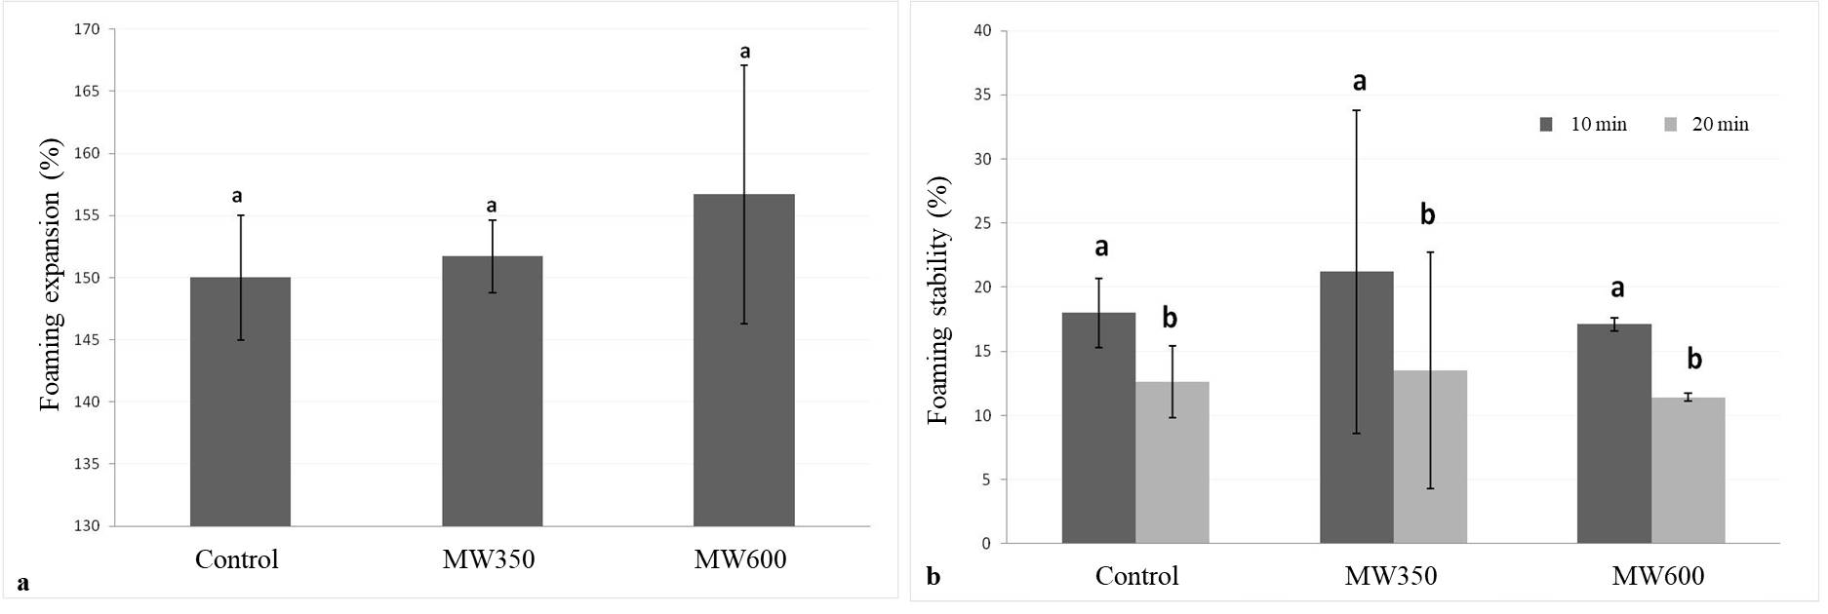

**Figure 1**. Foaming expansion (a) and foaming stability (b) of control, MW350 and MW600 aquafaba samples.

The emulsion activity index of control, MW350 and MW600 aquafaba samples are shown in Figure 2. No change was observed for the emulsion activity index of control and microwave-heated samples after 1h from emulsion preparation. Statistically significant differences were observed between MW600 and control- MW350 for emulsion activity index after 24h (p<0.05). The highest emulsion activity index was observed for MW350 and the lowest was MW600 after 24h. The emulsion activity index decreased over time for all samples. The difference between the emulsion activity index of control and MW350 was statistically insignificant (p>0.05). The lowest emulsion activity index was observed in MW600 at the end of 72 hours, the difference between MW350 and MW600 was statistically significant (p<0.05). Although statistically insignificant, moderate microwave heating at 350W led to an improvement in emulsifying properties as observed after 24 h and 72h. This may be related to partial denaturation due to temperature increase. The emulsion activity index of aquafaba is the lowest at 600W after 24 and 72 hours. The emulsion activity index decreased with the increase in microwave power. Studies have reported that emulsification and foaming capacity can increase due to improved surface properties of amphiphilic biopolymers by controlled heating of proteins and polysaccharides [8]. The temperature of aquafaba increased to approximately 85°C at 600 W while it was 66°C at 350 W. The greater temperature increment at 600 W may have increased protein denaturation rate, changes in saponins and decreased emulsion activity.

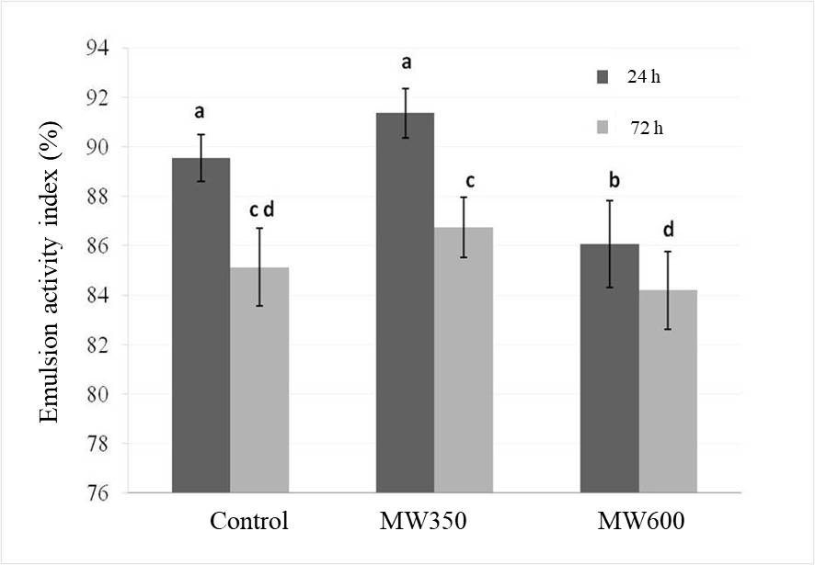

**Figure 2**. Emulsion activity index of control, MW350 and MW600 aquafaba samples.

* 1. **FTIR**

The chemical composition of aquafaba was analyzed using FTIR spectrums depicted in Figure 3. In the FTIR spectrum, peaks at ≈1600 cm-1, ≈1500 cm-1, ≈1200 cm-1 informed about Amid 1, Amid 2 and Amid 3 protein bands; and peaks at ≈3300 cm-1 and ≈3100 cm-1 were Amid A and Amid B protein bands [9]. These peaks for control and microwave-heated aquafaba samples were observed at ≈3273 cm-1, ≈2929 cm-1 for Amid A, Amid B bands and ≈1642 cm-1, ≈1551 cm-1, ≈1242 cm-1 for Amid 1, Amid 2 and Amid 3 protein bands. The intensity of these peaks changed according to aquafaba samples as seen in Figure 3 and the lowest peak density was observed for control and that of the highest for MW350. Amid A and Amid B bands could be related to the water content of samples because hydrogen bonds vibrate in this region and peaks form according to the strength of hydrogen bonds. Ertuğrul et al. [9] reported that heating the pea protein and sugar mixture by microwave led to stronger hydrogen bonds. This may be why the lowest band intensity was observed in Amid A and Amid B regions in the spectrum of unheated aquafaba samples.

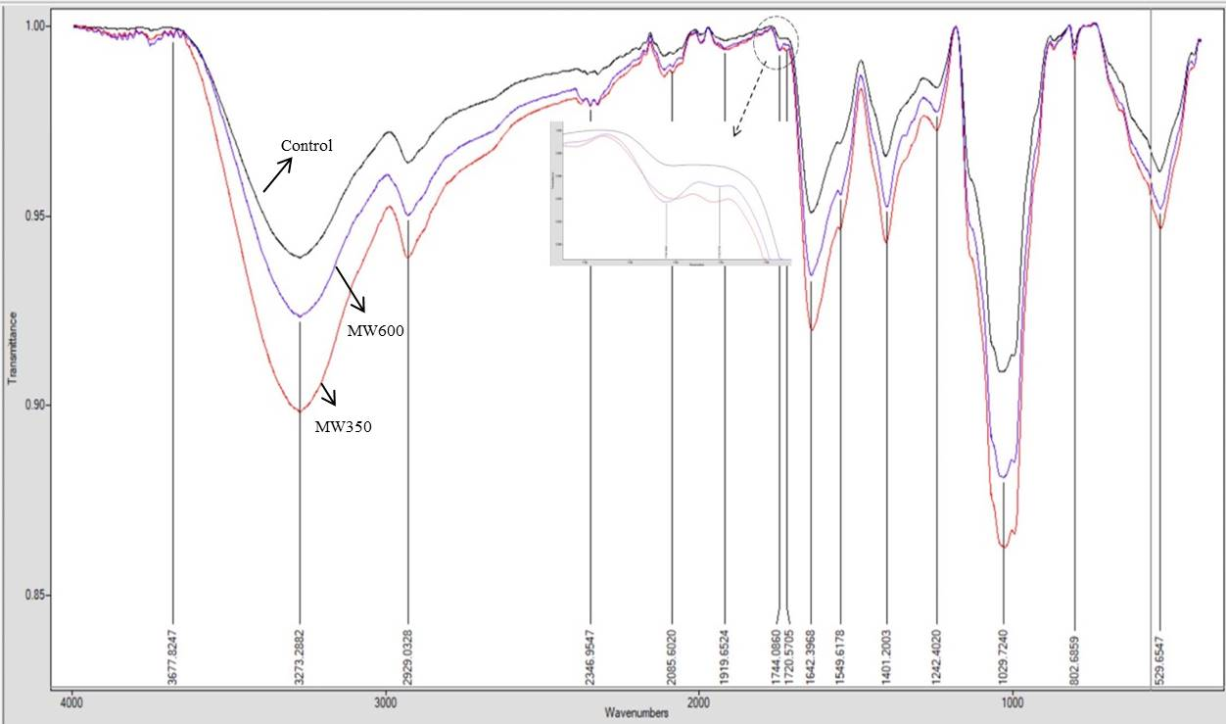

**Figure 3.** FTIR spectrum of control, MW350 and MW600 aquafaba samples.

Saponins are bioorganic compounds naturally found in plants and contain at least one glycosidic bond between the sapogenin and the sugar chain. Saponins are amphiphilic glycosides that contain lipophilic (steroid, triterpenoid or alkaloid) and one or more hydrophilic oligosaccharides (pentose, hexose, uronic acid), therefore they have surfactant properties [10]. Terpenoid saponins are characteristically observed at 3429 -3316 cm-1 (-OH), 2922-2929 cm-1 (C-H), 1619-1651 cm-1 (C=C) and 1740-1736 cm-1 (C=O), 1072-1034 cm-1 (C-O-C) in the FTIR spectrum [11]. The differences in IR bands were observed at 1740 cm-1 for control and microwave-heated samples as seen in the circled region in Figure 3. The other characteristic saponin peaks may have overlapped in the IR spectrum, but the peaks at 1740 and 1240 cm-1 provide information about the aliphatic acetyl group and the acetylation of saponins. The absence of characteristic saponin peaks may have been about acetylation as reported in Amarowicz et al. [12].

* 1. **XRD**

XRD spectrums of freeze-dried control and microwave-heated aquafaba samples are shown in Figure 4. The spectrums between 0-40° and 15-30° are Figure 4-a and 4-b, respectively. Peaks for control were observed at 27.43°, 31.72°, 45.41°and those of at 27.49°, 28.46°, 31.80°, 45.51° for MW350 and at 27.45°, 28.48°, 31.78°, 45.52° for MW600 as seen in Figure 4-a. Peaks at ≈20° were observed for control and MW600 and peaks at ≈28° split into two for microwave-treated samples in Figure 4-b. Bai et al. [13] associated the peak formation at ≈20° with the crystal region of water-soluble polysaccharides of raw and heat-treated chickpea samples. El Barky and Mohamed [14] extracted and characterized triterpenoid saponins in sea cucumber and examined extracted saponins and standard saponin solution by XRD analysis. Accordingly, they obtained sharp peaks at 31.94° and 45.7° in the extracted saponin. As seen in Figure 4.6-a, the peaks at ≈31° and ≈45° may have informed about the amount of saponin in all three samples. The peak heights observed, especially at ≈31°, are higher in microwave-treated samples. Shi et al. [15] reported that the intensity of the peaks 31° and 45° tended to increase with the increment of NaCl in native potato starch and NaCl mixture. According to this information, the diffraction peaks at 31° and 45° can also be correlated with the NaCl content of aquafaba due to using NaCl for industrial canning chickpeas. To clearly understand the effect of microwave heating on saponin, a detailed analysis should be carried out additionally.

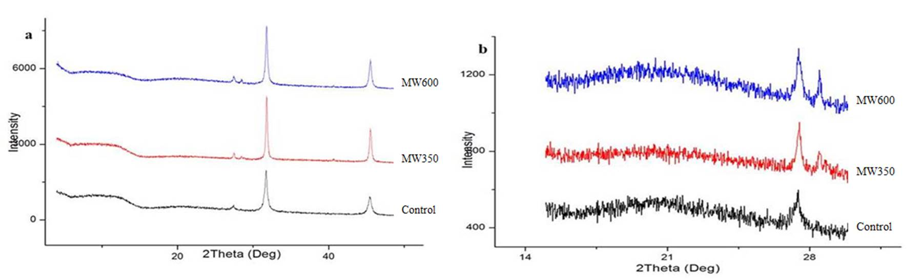

**Figure 4.** XRD spectrums of control, MW350 and MW600 freeze-dried aquafaba samples.

* 1. **SEM**

SEM images of freeze-dried control and microwave-heated aquafaba samples with x3000 and x1000 magnifications are shown in Figure 5. The control had a more compact structure and microwave heating deteriorated this compact structure and an increase in microwave power pronounced this deterioration.

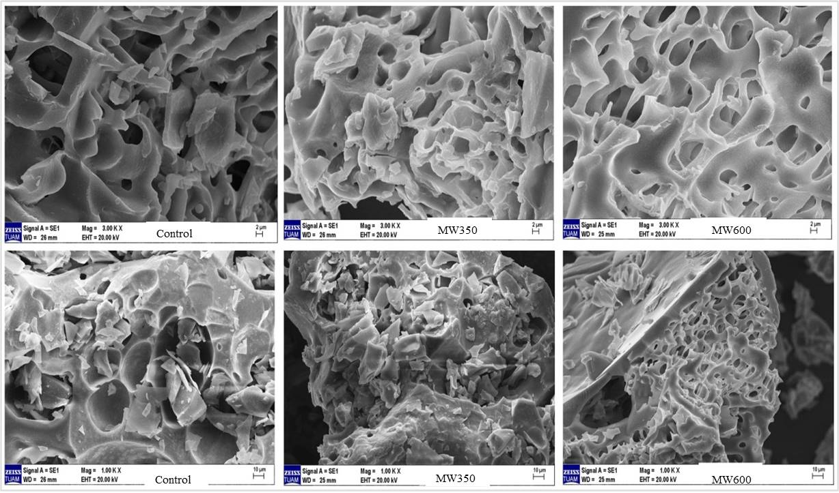

**Figure 5.** SEM images of freeze-dried aquafaba samples at x3000 (top) and x1000(bottom) magnifications.

1. **Conclusion**

In this study, the effect of microwave heating on the functional (foaming and emulsification), chemical (FTIR and XRD analysis), and morphological properties (SEM analysis) of aquafaba was evaluated. Microwave heating was observed not to affect the foaming properties of aquafaba at two power levels. The emulsifying properties of aquafaba can be improved by microwave heating. Microwave heating was seen as a potential processing method to improve emulsifying properties, especially at moderate microwave powers. Further studies need to understand microwave heating's effect on the saponin, protein and carbohydrate content of aquafaba.

**References**

1. Buhl, T. F., Christensen, C. H., & Hammershøj, M. (2019). Aquafaba as an egg white substitute in food foams and emulsions: Protein composition and functional behavior. *Food Hydrocolloids*, *96*, 354-364.
2. He, Y., Meda, V., Reaney, M. J., & Mustafa, R. (2021). Aquafaba, a new plant-based rheological additive for food applications. *Trends in Food Science & Technology*.
3. Meurer, M. C., de Souza, D., Ferreira-Marczak, L. D. (2020). Effects of ultrasound on technological properties of chickpea cooking water (Aquafaba). *Journal of Food Engineering*, 265, 109688.
4. Alsalman, F. B., & Ramaswamy, H. S. (2021). Evaluation of changes in protein quality of high-pressure treated aqueous aquafaba. *Molecules*, *26*(1), 234.
5. Tuta, S., & Palazoğlu, T. K. (2016). Finite element modeling of continuous-flow microwave heating of fluid foods and experimental validation. *Journal of Food Engineering*, *192*, 79-92.
6. Begliyev, H., Yavuz, N., & Ok, S. (2023). Effects of high‐pressure homogenization on the rheological properties of spray‐dried aquafaba powder. *Journal of Food Process Engineering*, *46*(8), e14389.
7. Stasiak, J., Stasiak, D. M., & Libera, J. (2023). The potential of aquafaba as a structure-shaping additive in plant-derived food technology. *Applied Sciences*, *13*(7), 4122.
8. Mustafa, R. & Reaney, M. J. T. (2020). Aquafaba, from food waste to a value-added product. In: Food wastes and by products: Nutraceutical and health potential, R. Campos-Vega, Oomah, B. D., Vergara-Castañeda, H. A. (eds.), pp 93 – 126. New York, Wiley.
9. Ertuğrul, U., Namli, S., Tas, O., Kocadagli, T., Gokmen, V., Sumnu, S. G. & Oztop, M. H. (2021). Pea protein properties are altered following glycation by microwave heating. *LWT*, 150, 111939.‏
10. Das, G., Sharma, A. & Sarkar, P. K. 2022. Conventional and emerging processing techniques for the post-harvest reduction of antinutrients in edible legumes. *Applied Food Research*, 100112.‏
11. Ahn, M. S., Jie, E. Y., Song, S. Y., Kim, H. S., Kim, I. J. & Kim, S. W. (2016). Simultaneous estimation of saponin contents from soybean seed using Fourier transform infrared spectroscopy and high-performance liquid chromatography analysis. *Plant Biotechnology Reports*, 10(6), 403-414.
12. Amarowicz, R., Yoshiki, Y., Pegg, R. B. & Okubo, K. (1997). Presence of two saponins in faba bean (Vicia faba L.) seeds. *Food/Nahrung*, 41(6 ), 352-354.
13. Bai, Y. P., Zhou, H. M., Zhu, K. R. & Li, Q. (2022). Impact of thermally induced wall breakage on the structural properties of water-soluble polysaccharides in chickpeas. *International Journal of Biological Macromolecules*, 208, 869-882.‏
14. El Barky, A. R. & Mohamed, T. M. (2020). Isolation, Characterization and the Biological Activity of Some Natural Components of Marine Sea Cucumber and Orange Peel. *Biomedical Journal of Scientific and Technical Research*, 27(2), 20554-20565.‏
15. Shi, M., Zhang, M., Yang, L., Li, D., Yan, Y., Huang, X., & Liu, Y. (2019). Effect of sodium chloride on the structure and properties of fried starch. *Starch - Stärke*, *71*(9-10), 1900014.