**Academic Studies Congress (ASC-2022/Spring)**

### “CHANGE & ADAPTATION”

**May 13-16, 2022**

**Osmaniye Korkut Ata Üniversitesi Rektörü, TURKEY**

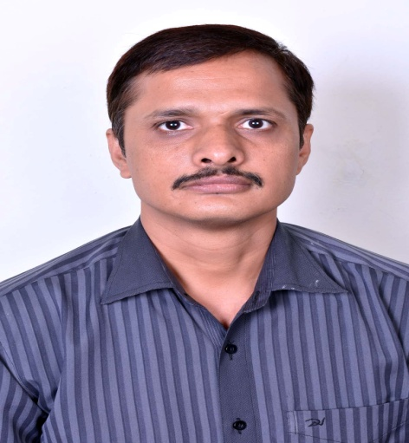Title : **Climate Change: Consequences in Paradigm Shift**

Name and Surname : **DR. VIVEKANAND JHA**

University : **Govt. Model College, Jhabua (Devi Ahilya Vishwavidyalaya, Indore, Madhya Pradesh)**

Tel : **9996136060/8965007414**

e-mail : **jha.vivekanand7@gmail.com**

CV: **Vivekanand Jha**, an Air Force veteran, is an Indian English poet, translator and editor. He divides his time between Darbhanga, Delhi and Gwalior. He has a Diploma in Electronics and Communication Engineering, Certificate in Computer Hardware and Networking, MA, UGC NET qualified and Ph. D in English. His poems and articles have featured in numerous journals and anthologies. He has authored one critical book on the poetry of Jayanta Mahapatra and edited nine critical anthologies on Indian English Writing. He has edited two poetry anthologies: (1) “The Dance of the Peacock”, featuring 151 Indian English poets, published by Hidden Brook Press, Canada, and (2) “Universal Oneness: An Anthology of Magnum Opus Poems from around the World” (360 poems by 360 poets from 60 Countries), published by Authorspress, New Delhi, India. He is the founder and chief editor of two literary journals, VerbalArt & Phenomenal Literature published by Authorspress, New Delhi, India. At present he is an Assistant Professor of English at Department of Higher Education, Madhya Pradesh, India.

**Websites:**

[www.vivekanandjha.com](http://www.vivekanandjha.com)

[www.verbalart.in](http://www.verbalart.in)

[www.phenomenalliterature.com](http://www.phenomenalliterature.com)

**Blog:** <http://www.poetvjha.wordpress.com>

**Email id:**[jha.vivekanand7@gmail.com](mailto:jha.vivekanand7@gmail.com)

**Climate Change: Consequences in Paradigm Shift**

**Dr. Vivekanand Jha**

*"The world will not be destroyed by those who do evil, but by those who watch them without doing anything."* **– Albert Einstein**

**Abstract**

Relentless efforts that we made in the field of science and technology brought about a paradigm shift in the quantum of innovation, discovery and invention at the speed of a lightening. Consequently, our lifestyles changed; we marched ahead in all walks of life and reaped a great deal of comfort. The reverberating repercussions and disastrous consequences resulting from them now seem to be tolling heavy on the thrills that these comforts provide. The term “climate change” or “global warming” is no more restricted only to the premises and ambit of the academicians, scientists and environmentalists rather it has become a buzzword and topic of yellow journalism for the common people as well - now this term is baked and chewed in every home and hearth. In the rut of seeking insatiable and indiscriminate convenience and coziness, we have positioned ourselves on such a ridge of the self-carved podium from where we can afford neither to retreat nor to advance. The paper along with some vital causes of climate change and consequences that we currently face shall depict the prices that we are going to pay if we continue to crave comfort at the cost of dispossessing the chastity of nature. In addition, it draws attention on some viable methods, measures and solutions that we shall undertake to combat the terror caused by the catastrophic change in the climate.

**Keywords:** Climate change, global warming, science and technology, nature, environment, catastrophe, climate change causes, consequences and solutions.