**Design and implementation of fuzzy logic-controlled smart solar tracking system**

***Zaid AL-IBRAHIME1,[1]*, prof.dr Fatih KORKMAZ2***

*1 Electrical and Electronics Engineering, University of Çankiri, Çankiri, Turkiye*

*2 Electrical and Electronics Engineering, University of Çankiri, Çankiri, Turkiye*

**Materials**

The reagents, 1H-imidazole This research designed an external structure that supports the concept of the solar tracking system and is characterized by freedom of movement in all needed axes and directions. Moving the solar panel in both directions requires the use of two motors, provided that these two motors are controlled by smart devices (Arduino) that are coded in a smart language by employing fuzzy logic to boost the accuracy of the instructions controlling the system. In order to determine the necessary angle and direction, 8 (LDR) sensors were evenly positioned around the solar panel. These 8 LDRs were distributed as follows:

* 4 LDRs sensors around the corners of the solar panel
* 4 LDRs sensors in the middle of the outer ribs of the panel and between the first four sensors.

Furthermore, the utilization of specific plastic pieces to manipulate the angle of light that enters the (LDR) serves to enhance the sensitivity of the device in the intended direction, as shown in Figure 1. To enhance the precision of identifying the necessary movement direction of the solar panel, it is vital to employ specific mathematical equations, as shown below:

Horizontal LDR ERROR ((A1-A0) + (A3-A2)) / 2

Vertical LDR ERROR ((A2-A0) + (A3-A1)) / 2

Center-Horizontal LDR Error (A7)

Center: Vertical LDR ERROR (A5) (A4)

The term "error" is used to denote the value of the difference between the sensor and the other sensor in a certain direction.

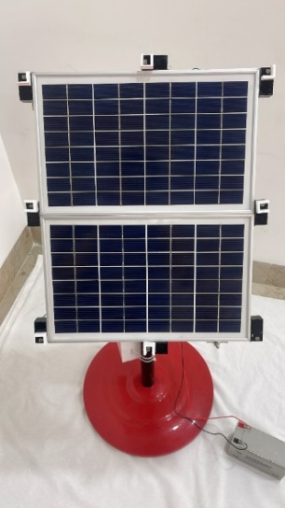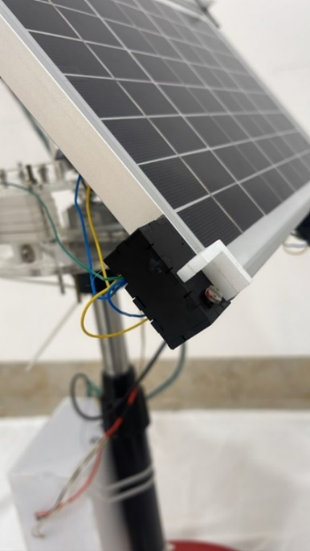

A0

A4

A1

LDR

A7

A6

A5

A3

A2

**Figure 1**. Distribution of the LDR with the specific plastic pieces of the solar tracking system used in the study (Researcher)

The distribution of 8 LDR and utilization of the mathematical algorithm above can be attributed to several fundamental reasons, with the most significant ones being:

* First: the variation in values arises from differences in the manufacturing and production processes of LDR sensors by the company. This discrepancy is primarily caused by variations in the internal resistance, resulting in different sensing and reading values for sensors under the same conditions. Consequently, this discrepancy leads to inaccuracies in the instructions sent to the horizontal and vertical motors through an Arduino device, as it becomes challenging to select the optimal angle perpendicular to the source of solar radiation as shown in Figure 2.

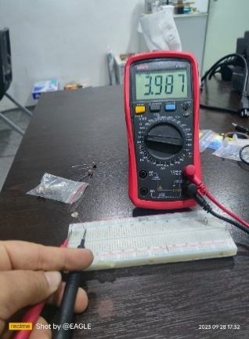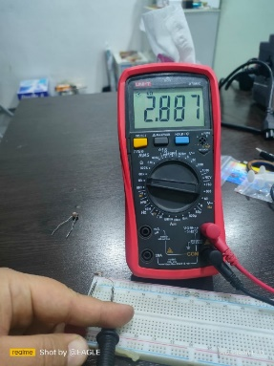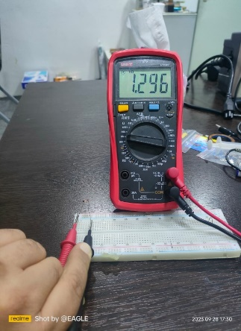

Figure 2. The difference in the value of the internal resistance for each LDR sensor, and for the same LDR sensor values used in this study (Researcher)

* Second: in the event of partial shading, the system can effectively address this issue by increasing the number of LDR sensors using the technique outlined before.
* Third: in the event of damage or malfunction in one of the LDR sensors, the system will remain unaffected due to the presence of other LDR sensors and an algorithm that can establish the necessary angle using the functioning sensors.
* Fourth: oscillation and delayed reaction in practice can be mitigated by implementing the aforementioned mathematical technique, which effectively minimizes the fluctuations caused by many and varying readings.

In addition, a temperature sensor has been installed in the solar system to prevent the photovoltaic cells from overheating and potentially causing harm. Furthermore, a rechargeable battery has been included to power the entire system. The sun-tracking device utilized in this study was devised and executed via a 3D printer. The solar tracking system utilized in this investigation comprises a solar panel, light-dependent resistor (LDR), liquid crystal display (LDC), temperature sensor, current sensor, servo motor, DC motor with gearbox, Arduino microcontroller interfaced with a micro-SD card, Arduino Mega 2560 Rev3, L298N DC Motor Driver Module interfaced with Arduino, DC-DC converter, battery, and printed circuit board (PCB). Figure 3 show the elements of the system from the front and back perspectives. Furthermore, Figure 4 illustrates the constituent parts of the system's controller box.

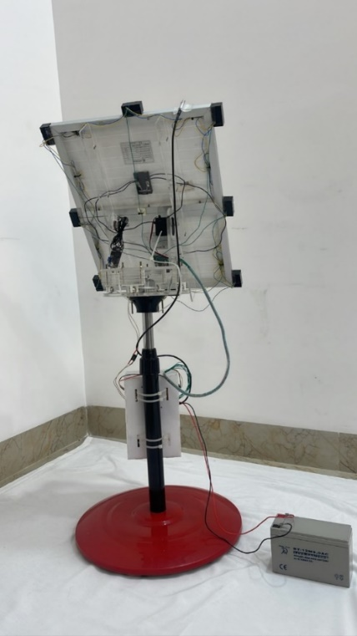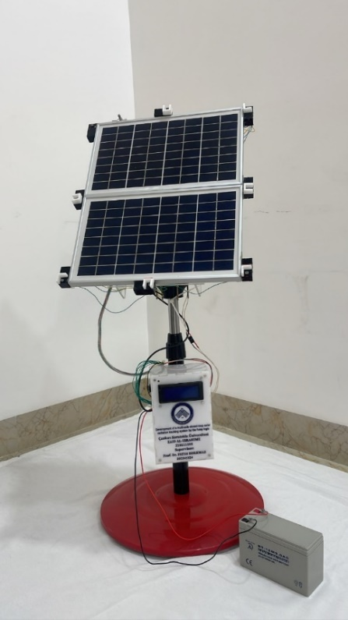

Temperature sensor with Arduino (DS18B20)

Solar panel (10 W)

Servo motor (RDS3115MG)

Y-axis

DC motor with gear box X- axis

LDR Light Sensor Module for Arduino, brand OEM

I2C LCD with an Arduino

Controller box

Battry

Figure 3. The front and back elevation of the solar tracking system used in the study (Researcher)

Arduino Mega 2560 Rev 3

DC to DC converter

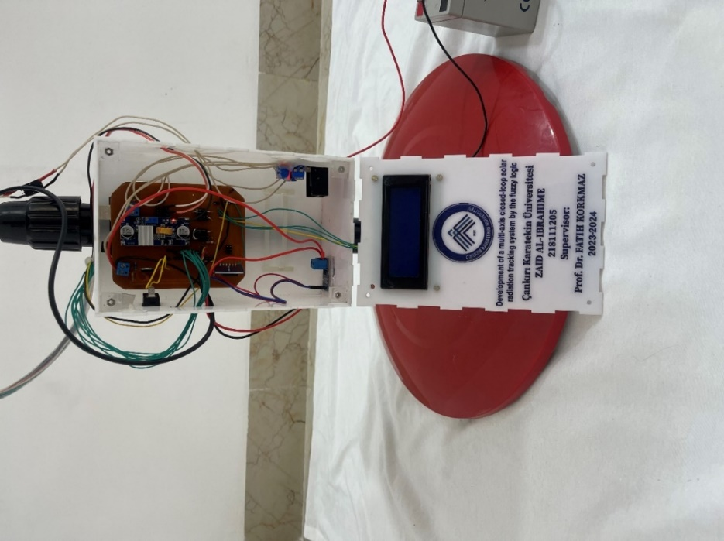

PCB

SD card with memory 2 GB

DC driver controller (L298N)

Current senser with Arduino (ACS712))

**Figure 4**. The controller box components of the solar tracking system used in the study (Researcher)

1. * fthkorkmaz@yahoo.com