**Hydrogen Production from Natural Gas**

***Dr. Zehra Gülten Yalçın,*** ***Riyadh Salah Hasan Hasan, Mustafa Dağ***

***INSTITUTE OF SCIENCE AND SCIENCE, DEPARTMENT OF CHEMICAL ENGINEERING, TR ÇANKIRI karatiken UNIVERSITY***

**Abstract**

This research paper deals with the history of gas production in Iraq, where production began in 1927, where production is classified into associated gas and free gas. In addition to the importance of the global shift from the use of fossil fuels to renewable energy because of its clear impact on improving the environment. The production of hydrogen is considered one of its most important sources. It also focuses on methods of producing hydrogen production from natural gas through the reformation of steam and methane at high temperatures. This paper also addresses the importance of hydrogen uses in the transportation sector and its effects on the environment in general.

**Keywords:** hydrogen, natural gas, carbon, associated gas

1. **INTRODECTION**

Iraq began production of natural gas in conjunction with oil production in 1927, when the flow of oil from the "Baba Karkare" field in Kirkuk and that Iraq[1], its sources of gas natural, first gas associated with oil as the product of a natural, which is characterized by its investment lack of costs, as it does not need to Exploration, drilling and extraction operations as it accompanies the extracted oil, and it only needs to extend the pipelines and marketing, he pointed out That 70 percent of Iraqi natural gas is of this type. As for the second source of Iraqi gas, it is free gas, whose investment is characterized by high costs due to the need for exploration, drilling and extraction operations, and it constitutes 30% of Iraqi gas[2] Processing natural gas in Kirkuk fields The gas associated with the oil extracted from Kirkuk fields is processed and purified in the North Gas Company, and the company aims to process the quantities of associated raw gas.(ASSOCIATED GAS) To produce Oil in the northern fields for the purpose of producing the following main products:

1. Sales gas.
2. Liquid gas (LPG).
3. Natural gasoline.
4. Sulphur.

Through a group of operations productivity is the purification of gas natural crude after extraction from the wells of gas in Kirkuk

In a range within 30-40 years coming, with demand growing rapidly from economies emerging such as China and India, then expected to reach the price of oil to the level of price high. And case the current and projected oil, dependence on imports, and emissions of second dioxide carbon resulting from fuel fossil , and the restrictions that imposed by the Convention on the Kyoto on emissions , make hydrogen is considered an alternative ready and is unlimited . The problem current is the price and the costs of infrastructure. Therefore, it will play the policies of government support as well as the sector's role key in transforming sector energy - based on oil based on alternative renewable energies and the most important of hydrogen. And the term short and medium, will meet the demand increased on hydrogen from fuel fossil, especially natural gas This method is acceptable environmentally and economically, where it can produce hydrogen at a price reasonable without emissions of second dioxide carbon in the atmosphere of air. This way to produce hydrogen without the release of second - dioxide carbon in the atmosphere of air, the production at reasonable price for the environment and the economy is also suitable. In order to achieve this, there are two basic options. The first is to produce hydrogen from natural gas as a conventional method Including the so isolated second dioxide carbon is a way to re - forming steam. You can capture the second dioxide carbon emitted.

On the ocean floor or trapped in geological formations such as oil and natural gas deposits. The second way is the decomposition of gas natural for the production of hydrogen and oxygen Pure in degrees of temperature high. Natural gas decomposition can be used as an energy carrier. Carbon can be introduced to the market Such as building materials, electricity generation and soil improvement for use in various fields. In this study of the process of producing hydrogen from through the re - formation steam traditional natural gas, hydrogen and carbon Natural Gas to the methods of decomposition Catalytic with degrees temperature high of technological, environmental and Economic aspects have been compared Approximately 50 million tons of hydrogen (H2) is produced annually worldwide, and this While a small amount of hydrogen is used in energy and heat production, a large part of it is used in industry It is used in applications [3]. 62.4% of the hydrogen in the world is ammonia (NH3) production, 24.3% for refinery and 8.7% for methanol (CH3OH) production. Itas large amount of hydrogen is required, it is usually produced by consumers and the most widespread production method is natural gas steam reform, and the world hydrogen production meets approximately 50% [4]. But the main obstacle to this technology is transformation. System emits carbon dioxide. To what the world's leading scientists have reported According to the environmental, health and community problems we are facing now, climate changes (greenhouse effect), air pollution, oxygen depletion, acid rain, ozone depletion, environmental pollution, spilled oil, noise, visual pollution, oil wars, population growth. Has been given. Climate change (greenhouse effect), which is one of the leading environmental problems,

The ways to reduce the carbon dioxide emissions that are the cause are given below [5].

(1) Restricting population growth,

(2) To improve energy conversion and utilization efficiency,

(3) Tending towards renewable energy sources such as solar, wind, hydro and geothermal,

(4) Decarbonization of fossil fuels, hydrogen producing

(5) To keep the carbon in fossil fuels by separating

Below is a histogram showing the distribution of hydrogen use by application, based on the data provided in the text. Shown are percentages for ammonia production, refining use, methanol production, and other applications

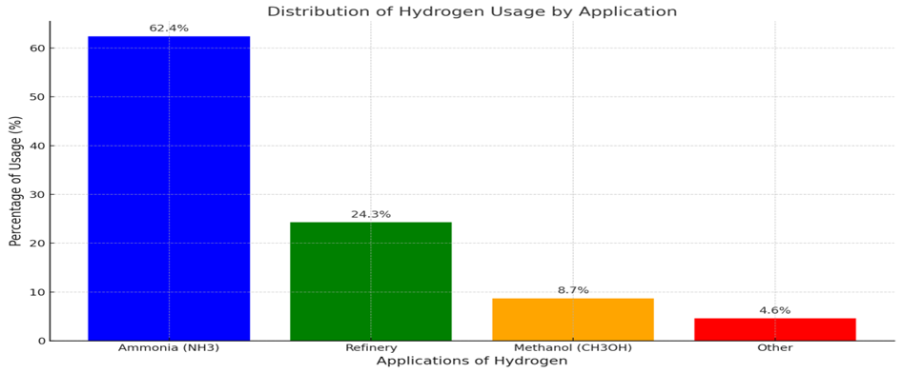

1. **Materials and Methods**

We review the two basic principles of producing hydrogen from natural gas and capturing carbon dioxide.

the Methods

(1) is the production of hydrogen by reforming the methane vapor and the released carbon dioxide

(2) Thermal decomposition of natural gas into hydrogen and carbon and its offspring

The conservation of elemental carbon processes was investigated by separation from an environmental point of view. Every two the usable areas of the hydrogen and carbon products generated in the process are also described. With the establishment of the hydrogen and carbon infrastructure proposed in this study, it is hydrogen today the processes for producing hydrogen from natural gas, which satisfy the vast majority of its production, are environmentally friendly.

**2.1. HYDROGEN PRODUCTION WITH STEAM-METHANE REFORMATION**

Three main parts in steam-methane reformation; reformation, water-gas conversion reaction and gas purification [6]. Natural gas in the feed bed as shown in Figure 1It is first desulphurized to prevent contact with the catalyst. In this step, from the product A small amount of recycled hydrogen is used

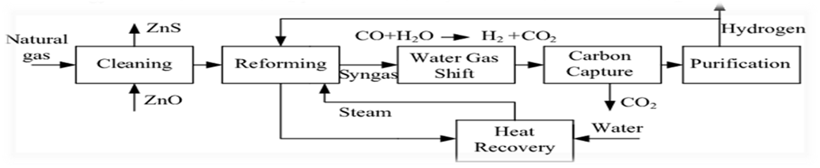

Figure 1. Block flow diagram of a hydrogen production plant with steam-methane reformation [7]

The hydrogen sulfide (H2S) compound is then extracted from the zinc oxide (ZnO) deposits and

After the preliminary treatment, the natural gas is sent to the natural gas steam regulator at a pressure of 2.6 MPa. This mixing gas is then transferred to high temperature conversion and low temperature conversion reactors. Transferred. In these reactors, the water-gas conversion reaction accounts for 92% of the carbon dioxide (CO). converts to hydrogen and purified using a pressure swing adsorption (PSA) unit.

The regulator is primarily filled with PSA gases, but some natural gas is

It is used to supply the fuel requirement of the regulator. PSA gases CO2 (55 mol%), H2 (27%

mol), CH4 (14 mol%), CO (3 mol%), N2 (0.4 mol%) and some vapor water.

Generally, the efficiency of the steam methane reforming system varies between 65-75%.

Steam-methane reforming reaction

There are many industrial methods for the production of hydrogen. But these are the necessary input depends on local factors such as the amount of ingredients and raw materials. Two processes currently in use It is the steam reforming and water-gas exchange reaction of hydrocarbons such as methane.

CH4 + H2O (1100℃) → CO + 3H2 (ΔH = +206.16 kJ / mol CH4) (1)

CO + H2O → CO2 + H2 (ΔH = - 41.15 kJ / mol CO) (2)

The water-gas exchange reaction is an exothermic, heterogeneous catalytic reaction where hydrogen and

it constitutes the most important step in ammonia production. Water-gas exchange at the same time

reaction is also used to detoxify the atmosphere. Thermodynamics and kinetics

depending on the conditions, the water-gas exchange reaction is at high (320--450 0C) and low (200-250 ° C). temperature applications are available [8]. In high temperature change reaction generally

When using iron-based catalysts, copper is generally used in the low temperature conversion reaction

based catalysts are used. The heat released by the cooling of the hot gases formed by the steam-methane reform It is used to evaporate water. By the reaction of water vapor with carbon monoxide

additional hydrogen and carbon dioxide are formed. The point to be taken into consideration; of hydrogen produced it is that only half comes from hydrocarbon and the other half from water.

**2.2. THERMOCATALYTIC SEPARATION OF METAL**

In this approach, methane is converted into carbon and hydrogen at high temperature (850-1200 ℃) in the presence of catalyst.

It is decomposed by the reaction given below.

CH4 →C + 2H2 (ΔH° = 75.6 kJ/mol)

Since this reaction is endothermic, 10% of the natural gas supply is used for the energy input requirement. Used. The main product formed as a result of the reaction is hydrogen. Carbon produced as a byproduct It is easy to separate from hydrogen because it has a granular structure. Large scale hydrogen production This technology is currently under development in terms of conversion efficiency

**2.3. Thermal energy**

Combustion chamber with hydrogen using catalytic burner and hydrogen / oxygen steam generator thermal energy is generated. Similar to other end uses, the energy in hydrogen is It produces little or no pollution even when heat is released from it. Combustion of hydrogen Although some nitrous oxide produces air pollution (due to high temperature), recent tests nitrogen oxide showed that oxide concentrations were retained in very small amounts.

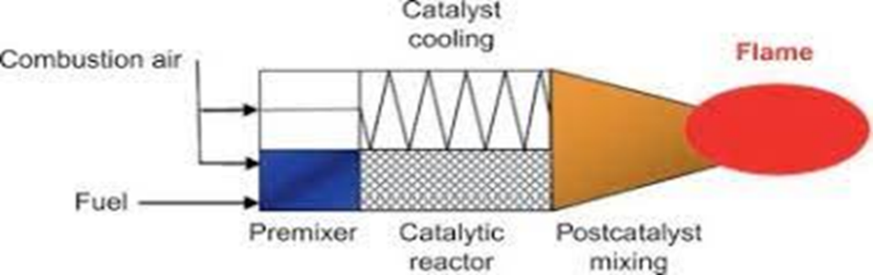

Catalytic combustion of hydrogen for heat production [8]

**2.4 HYDROGEN-CARBON INFRASTRUCTURE SYSTEM**

In this study, the proposed hydrogen-carbon infrastructure system uses energy, environment and resources to be efficient. It emphasizes the interplay between its use and economy.

For two important reasons

This infrastructure system is based on natural gas (methane) depending on:

(i) distribution for natural gas

(ii) current situation in terms of reserves as an energy source.

Looking at, natural gas supply is longer than oil supply. The hydrogen – carbon infrastructure system is shown. Using natural gas thermal separation method It is converted to high purity hydrogen (99.99% by volume) and carbon. Hydrogen While it can be used in transportation, electricity and heat energy production, carbon There are four potential areas where it can be used:

(i) building materials

(ii) carbon fuel electricity generation using batteries, where there is a small CO2 emission,

(iii)reclamation and (iv) carbon black production.

1. **The use of hydrogen**

**Transport sector**

Hydrogen fuel cell vehicles that are 3 times more efficient than internal combustion engines can be operated. 5 types of fuel cells are currently being developed. In them Proton exchange membrane (PEM) fuel cells are most suitable for transportation applications. Fuel Other cell types are phosphoric acid, alkali, molten carbonate and solid oxide fuel. Cells In addition, hydrogen gas can be used in vehicles with internal combustion engines. So is hydrogen powered vehicles, as they have a wide burning range (4% to 75%) They can use a wider range of air / fuel mixtures than working vehicles and They can operate on a fuel efficiency scheme without ignition complications [9]. The hydrogen engine, which provides 38% efficiency in total, is approximately 20% more than the internal combustion engine. It works with high efficiency. Moreover, since there is no carbon in the fuel, the combustion process It does not generate hydrocarbon or carbon dioxide emissions. Following Considering together with the reasons for hydrogen that should be considered as transportation fuel turned out to be an important end use product.

1. The national energy sustainability problem is more important in the transport sector.

2. The degree of pollution from transportation creates environmental problems.

3. The most suitable economy of renewable resource use is in the transport sector.

4. Consumer loyalty and preference in transportation is high

1. **Conclusion**

In the short and medium term, hydrogen production depends on fossil fuels, particularly in the current and construction process. It will withstand natural gas due to the ongoing pipelines. Hydrogen from natural gas, steam from methane produced by the reforming method and the carbon dioxide released with it Instead of purifying and capturing carbon dioxide, natural gas is used to heat hydrogen and carbon. Separation will be more advantageous environmentally and economically. In this context Researchers propose a hydrogen-carbon infrastructure system based on fossil fuels. Further Since the main advantage of this concept is based on the existing natural gas infrastructure system, reducing the cost of transition to the hydrogen-carbon economy. Hydrogen-carbon system hydrogen and not only prevents carbon dioxide emissions from power plants, cement and metallurgy, as carbon materials will be used instead of cement and steel It will also prevent carbon dioxide emissions caused by factories. also, hydrogen-carbon economy from the current hydrocarbon-based economy to future renewable it will serve as a bridge in the transition from energy resources to the hydrogen economy.

**RESOURCES**

[1] Morton، Michael (2006). *In the Heart of the Desert*, The Story of an Exploration Geologist and the Search for Oil in the Middle East. Aylesford: Green Mountain Press. ISBN:9780955221200.

[2] (Reda and Abdel-Aali 2015) Reda, N. C. and a. p. Abdel-Aali (2015). The oil and gas industry in Iraq: current and future trends for the period 2000-2020, Emirates Center for Strategic Studies and Research.

[3] Öztürk, M., *Investigation of Hydrogen Production Methods*, PhD Thesis, *SDU Science Institute, 2009.*

[4] Middleton, P., Larson, R., Niclas, M., Collins, B., *Renewable Hydrogen Forum*: A Summary of Expert Opinion and Policy Recommendations. Forum presented by the American

[5] Kaya, Y., et al*., A Grand Strategy for Global Warming*. Paper presented at Tokyo Conference on Global Environment, September 1989.Solar Energy Society. Washington, D.C. National Press Club, 473p, 2003.

[6] Veziroglu, T. N., Barbir, F., Hydrogen Energy Technologies. Emerging Technology

Series. Vienna, Austria: United Nations Industrial Development Organization, 122p, 1998.

[7] Spath, P. L., Mann, M.K., *Life Cycle Assessment of Hydrogen Production via Natural Gas Steam Reforming*, NREL, 2001.

[8] Baginski, O. (2009). "Crude oil prices: History, forecast, and impact on economy." Russian Journal of General Chemistry 79: 2486-2498.

[9] Öztürk, M., *Investigation of Solar Energy Chemical Reactors,* Master Thesis, Science Sciences Institute, Süleyman Demirel University, 2005.