**AUTOMATED CONVEYOR SYSTEM TRAINING KIT**

Koh Foo Hin*1, Yap Ai Tie 2 & Choong Chee Guan 3

1 Department of Mechanical Engineering, Politeknik Seberang Perai,

14000 Permatang Pauh, Pulau Pinang, Malaysia.

2 Department of Mechanical Engineering, Politeknik Kuching Sarawak,

93050 Kuching, Sarawak, Malaysia.

3 Department of Mechanical Engineering, Politeknik Tuanku Syed Sirajuddin,

Pauh Putra, 02600 Arau, Perlis, Malaysia.

* Corresponding Author Email: foo_hin@psp.edu.my

# ABSTRACT:

The title of this project was ‘Automated Conveyor System Training Kit’. The purpose of this project is to study how a system works using Programmable Logic Controller (PLC) and how to learn more about the operation of PLC in controlling the conveyor system with the function of the PLC. In this training kit prototype, the function of motor, sensor, pneumatic system was studied and analyzed. The operation of the system begins with the materials from the shelves, placed at the base plate, where the sensor will detect the object, thus activating the single acting cylinder. It will then push the material to the conveyor system. On the conveyor system, if the material is not according to size, the sensor will detect, and the single acting cylinder will push the material into the reject bin. Otherwise, when the sensor does not detect any irregular material size, the material will move until the end of the conveyor. At the end, when the material is placed on the plate, a single acting cylinder will push the plate and the material will roll into the slider. This training kit contains a PLC system which uses the pneumatic system and sensor were able to help students to understand better PLC control and pneumatic movement. Students can understand the application of PLC control system by learning the programming method. As a conclusion, this project is suitable to be used as a training kit for PLC and pneumatic teaching method.

**KEYWORDS:** *Conveyor System; Pneumatic; Programmable Logic Controller (PLC); Training Kit*

# 1.0 INTRODUCTION

A digital computer called a programmable controller, also known as a programmable logic controller (PLC), is used to automate and robotically operate electromechanical processes, such as the machinery on factory assembly lines, amusement rides, or light fixtures. PLCs are employed in numerous equipment and industries. The PLC is made for diverse input and output configurations, wide temperature ranges, immunity to electrical noise, and tolerance to vibration and impact, unlike general-purpose computers. Typically, non-volatile, or battery-backed memory is where programs that regulate machine function are kept.

PLCs can perform a variety of automated tasks. These are often manufacturing industrial processes where the cost of creating and maintaining the automation system is high in comparison to the overall cost of the automation and where changes to the system are anticipated during the system's operational life. PLCs include input and output components that are compatible with industrial pilot devices and controls; hence, there is little need for electrical design, and the design challenge is in expressing the intended order of activities. Because PLC applications are frequently highly customized systems, a packaged PLC is less expensive than a particular custom-built controller architecture.

Belt conveyors are the most widely utilized powered conveyors due to their greatest versatility and lowest cost. Since the product is moved directly on the belt, it is possible to move successfully both objects with regular and asymmetrical shapes, regardless of size or weight. Because premium belting of the finest quality decreases belt stretches and necessitates less maintenance for tension adjustments, it should only be used on these conveyors. Product can be moved along a straight path or through changes in elevation or direction using belt conveyors. They can also be employed in some applications for static buildup or packing.

The best and most relevant option for this project is a belt conveyor because it operates with less horsepower than other types of conveyors. This is because the bulk materials on the conveyor belt remain static, and as a result, just a minimal amount of energy is required to move the conveyor. The design of the Automated Conveyor System Training Kit is depicted in Figure 1.

Among the objectives of this project are: -

(i) To design and fabricate an automated training kit;

(ii) To incorporate safety features into the designed automated training kit; and

(iii) To program the automated training kit using PLC.

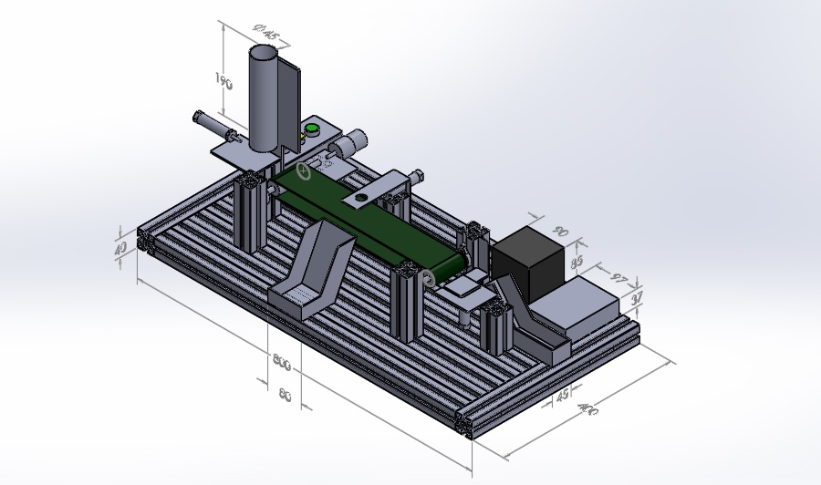

Figure 1: Project Design and Dimensions

# METHODOLOGY

This project has been completed according to the design process shown in Figure 2.

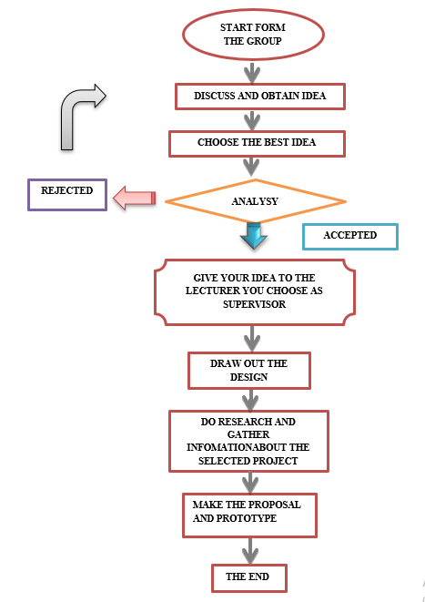

Figure 2: Design and Development Process

Several design parts were put forward to realize the idea. Subsequently, a design analysis was conducted to test the appropriate and safe design. In this part, Autodesk Inventor software was used and successfully decided the most suitable and safe design to use as shown in Figures 3 to 4 below.

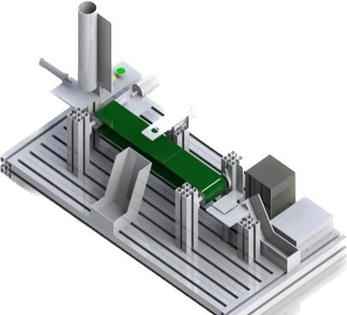

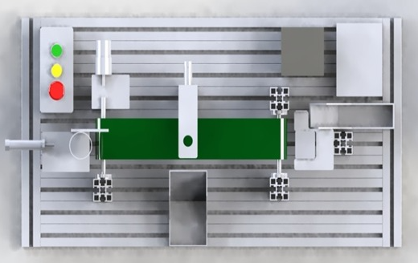

Figure 3: Isometric View Figure 4: Top View

Once the design was completed, the fabrication process was carried out as shown in Figures 5 to 7 below.

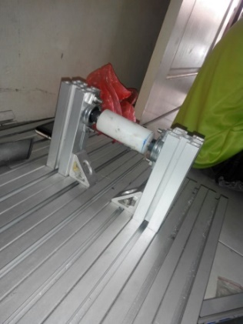

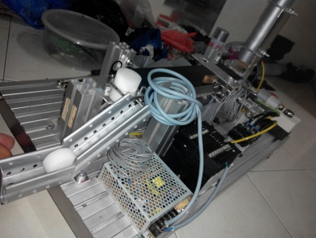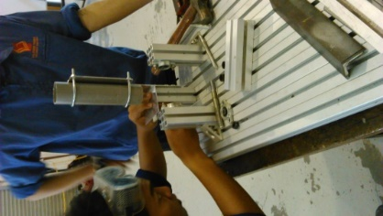

Figure 5: Base for Cylinder Figure 6: Roller Conveyor Figure 7: Sliding Plate

Firstly, all the wiring at the power supply and switches on the circuit of the project were identified. The PLC and assembled wirings need to be tested. All the wires were labeled using the color of the switch box. The push button on the switch box needs to be tested. When pushing the switch button on the switch box, the solenoid and cylinder must be working. The solenoids are labeled using S1, S2 and S3 to differentiate the functional push button of the solenoid. The solenoids were tested as when we push a green button, there is a light up on solenoids. Finally, test runs on the project were carried out to determine whether there were any errors and to make improvements. A few minor adjustments and components were polished to cut down on dust. The component for the sensors were tested to detect objects easily after running test runs. Additionally, it facilitates the project's fluid motion and flow of materials. Wiring adjustments and position of the wiring were neatly placed. The completed project is shown in Figure 8.

Figure 8: Automated Conveyor System Training Kit

# RESULTS AND DISCUSSIONS

A digital computer called a programmable controller, also known as a programmable logic controller (PLC), is used to automate and robotically operate electromechanical processes, such as the machinery on factory assembly lines, amusement rides, or light fixtures. PLCs are employed in numerous equipment and industries. The PLC is made for diverse input and output configurations, wide temperature ranges, immunity to electrical noise, and tolerance to vibration and impact, unlike general-purpose computers. Typically, non-volatile, or battery-backed memory is where programs that regulate machine function are kept. A PLC is an illustration of a hard real-time system since it must deliver output results in response to input conditions within a finite amount of time to avoid undesired activity.

This project is using the PLC CP1E, with 20 I/O units, consisting of 12 inputs and 8 outputs. The user can maximize the use of all input and output to make more activities by creating them in CX-programmer. The objectives of the project are to make and achieve the teaching and learning for the students. To achieve the teaching and learning goals, a user module was created for the student.

The module was designed to provide students with more detailed applications of PLC and project information. The module also includes the activities in our project. With the information and knowledge where students can utilize the application and function of PLC in their learning. Ladder diagrams which consist of five different types of functions were created. The ladder diagram is designed using CX-programmer.

# 4.0 CONCLUSIONS

From the questionnaires conducted, it was concluded that most students have knowledge about the training kit, but only in theory. When this training kit was introduced, students could utilize their knowledge and information about the PLC and pneumatic system. After introducing the training kit, students were able to learn about how to program a ladder diagram using the CX-programmer. Finally, the objectives were achieved from the survey findings, giving better learning, and understanding to the students.

# BIBLIOGRAPHIES

Aras, M. S. M., & Azis, F. A. (2014). ROV trainer kit for educational purposes. International journal of science and research (IJSR), 3(5).

Samanol, S. B., Hamid, S. B. A, & Ramli, M. N. B. (2014). Development of Pneumatic Trainer Kit for Polytechnic Student. Journal of Mechanical Manufacturing (J-Mfac), 1. 178-183.

Zimmerman, G. P. (2008). Programmable logic controllers and ladder logic. South Dakota: Department of Humanities South Dakota School of Mines and Technology.