**Antioxidant Properties of Lycium barbarum Extracts**

***Serap ÇETİNKAYA1 [C:\Users\Abdullah\AppData\Local\Microsoft\Windows\INetCache\Content.Word\ORCID-iD_icon-16x16.gif](https://orcid.org/xxxx-xxxx-xxxx-xxxx), Burak TÜZÜN2 [C:\Users\Abdullah\AppData\Local\Microsoft\Windows\INetCache\Content.Word\ORCID-iD_icon-16x16.gif](https://orcid.org/xxxx-xxxx-xxxx-xxxx)***

*1*

*1Department of Molecular Biology and Genetics, Science Faculty, Sivas Cumhuriyet University, Sivas, Turkey 2*

*2Plant and Animal Production Department, Technical Sciences Vocational School of Sivas, Sivas Cumhuriyet University,*

*Sivas, Turkey*

*E-mail:* [*serapcetinkaya2012@gmail.com*](mailto:serapcetinkaya2012@gmail.com)

|  |
| --- |
| **Abstract**  Lycium barbarum (Goji berry) belongs to the Lycium genus. Lycium barbarum is a plant of Asian origin and its fruit has some pharmaceutical features exerting antioxidant and anticancer effects. To this end, the functional components constitute polysaccharides, polyphenols, flavonoids, carotenoids, and their derivatives. These compounds can neutralize free radicals by affecting the maintenance of cellular homeostasis and intracellular signalling pathways. Lycium barbarum is rich in antioxidants that fight free radicals in the body. Therefore, it may help slow the aging process, reduce cellular damage, and sustain overall health. The plant also produces vitamin C which helps strengthen the immune system. GC-MS analysis was performed to determine the content of Lycium barbarum extracts. Activities of the identified molecules against antioxidant proteins, PDB ID: 1HD2, and 4Z8D, were assessed. |
| Keywords: Antioxidant, GC-MS, Lycium barbarum, Molecular docking. |

1. **Introduction**

Lycium barbarum L., is a medicinal plant, growing all over the world. It is famous with its fruit, called wolfberry or goji berry. Almost a hundred thousand tons of it is produced by China alone. This country knows this plant for almost 2,500 years. The fruit of this plant has been a traditional medicine as anti-aging, antioxidant, antidiabetic, anticancer, cytoprotective, neuroprotective, and immunomodulatory agent [1-3]. It contains carotenoids, phenylpropanoids, flavonoids, polyphenols, and polysaccharides. Its polysaccharides, vitamins, betaine and mixed extracts of goji berry elicit anti-aging effects and improve eyesight [4].

L. barbarum polysaccharides (LBPs) are a group of water-soluble glycoconjugates with a molecular weight between 10-2300 kDa and they form around 6% of dry fruit weight [5]. LBPs are the bioactive components of L. barbarum. The biological functions of LBPs appear to be complex and multifaceted.

1. **Materials and Methods**

**2.1. Polysaccharides**

Aqueous extractions at medium and high temperatures have revealed that L. barbarum L. possesses douzens of polysaccharides within a molecular range between 10 and 2300 kDa [3]. Additional means such as physical or enzymatic breakdown of the extracts have been added in some of the experimental procedures. Such treatments have seemed to increase the overall LBP yield. Some other extraction startegies have involved a combiantion of the several extraction methods [6]. Similar results have been reported from extractions with ultrasound-enhanced subcritical water [7].

In recent years sophisticated instrumental extraction approaches, involving gel permeation and ion exchange chromatography, high-performance liquid chromatography (HPLC), size exclusion chromatography (SEC), and hybrid membrane technology, have been introduced [8]. These novelties have also enabled the researchers to gather some information on the extracted LPS conformations [9,10].

**2.2. Phenolic compounds**

**2.2.1. Flavonoids and Anthocyanidins**

Flavonoids apigenin and luteolin possess 2-phenyl-1 benzopyran-4-one skeletons. L. barbarum L. flavones quercetin, myricetin, and routine, possess a 3-hydroxyflavone skeleton [11]. Routine and quercetin appear to dominate the fruit LPBs [12,13].

Extraction yield and diversity of flavonoids have seemed to differ with the solvent, water, alcohols or their combinations, commonly used in earlier efforts. Recents studeis have preferred instrumental extractions, like gas chromatography-mass spectrometry (GC-MS), and capillary zone electrophoresis (CZE), HPLC-MS (Yang et al. 2021b), and solvents such as DESs (deep eutectic solvents), and "green solvents" including cheaper and biodegradable ingradients. Extraction in DESs has resulted in very high amounts of myricetin and routine, morin [14], and a very impportant flavanone naringenin [15].

Chromene pigments anthocyanidins is the coloring agent of L. ruthenicum. In some of the studies, a good number of anthocyanins have been extracted using UPLC-Triple-TOF/MS and UPLC-Q-Orbitrap methods [16]. These results have indicated that the type and yield of anthocyanin depended on the approach chosen [10].

**2.2.2. Phenolic acids**

Lycium species appear to be very good producers of phenolic acids: gallic acid, vanillic acid, 2,4-dihydroxybenzoic, veratronic acid, benzoic acid, salicylic acid, syringic acid, protocatechuic acid, chlorogenic acid, caffeic acid, p-coumaric acid, and ferulic acid [13]. Extraction methods have generally involved sophisticated instrumentation, mainly HPLC-MS, and GC-MS as weel as electrophoresis chemiluminescence (CE-CL) with solid phase extraction (SPE) [10,17].

**2.2.3. Other phenolic compounds**

As well as Lycium fruit, its roots have aslo been used as the phenolic compound source. And so far, fruit phenolics have included cannabicin D, cannabicin E, cannabicin F, threo-cannabicin H, erythro-cannabicin H, melongenamide D, grosamide, O-hydroxybenzene acetic acid, phloretic acid, dihydroferulic acid, and ethyl dihydroferulate. In other parts of the plant phenolic acid amides N-trans-feruloyl tyramine, N-trans-feruloyl 3-methoxytyramine, lysiumite A, N-trans-p-coumaroyl tyramine, N-cis-p-coumaroyl tyramine, N-feruloyl agmatine have been found [10,13].

**2.3. Molecular docking**

Molecular docking calculations are performed to compare the biological activities of molecules against biological materials. The program developed by Maestro Molecular modeling platform (version 12.8) by Schrödinger [18] was used for molecular docking calculations. Calculations are made up of several steps. Each step is done differently. In the first step, the protein preparation module [19] was used in the preparation of proteins. In this module, the active sites of the proteins were determined. In the next step, the studied molecules are prepared. First, the molecules are optimized in the gaussian software program, then the LigPrep module [20] is prepared for calculations using optimized structures. The Glide ligand docking module [21] was used to examine the interactions between the molecules and the cancer protein after preparation. Calculations were made using the OPLS4 method in all calculations. Finally, ADME/T analysis (absorption, distribution, metabolism, excretion and toxicity) will be performed to examine the drug potential of the studied molecules. The Qik-prop module [22] of the Schrödinger software was used to predict the effects and reactions of molecules in human metabolism.

1. **Results and Discussion**
   1. **Antioxidant activity of goji leaves**

Goji leaves also appear to be a very rich source of both polyphenols and polysaccharides. Detection methods have mainly involved DPPH (free radical scavenging activity assay), TEAC (Trolox equivalent antioxidant capacity), HAPX (hemoglobin ascorbate peroxidase activity inhibition assay), and superoxide anion scavenging capacity assay. The compounds identified with the antioxidant activity mainly comprised polyphenols [23]. Here some other observations made have suggested that room temperature influenced the molecular diversity of the phenolic content [24]. Environmental samples have also been found to yield superior phenolic yields. Polysaccharides have been proven to be a significant DPPH, superoxide, and hydroxyl radicals scavengers in in vitro assays. Their in vivo antioxidant performance however remains a mystery for some of the researchers [25]. Evidence in this direction supports this concern [26]. One in vivo result however has pointed to the other direction that in diabetic rats ethyl acetate fraction of LCL could meaningfully lessen the amount of malondialdehyde at certain concentrations and increase the activities of radical scavenging enzymes, including catalase, superoxide dismutase, and glutathione peroxidase [27,28].

* 1. **The potential of goji in the food industry**

Industrial products of Goji fruit have found place in the shelves of food markets. In comparison, the leaves lag far behind and most of it is currently thrown away as waste, probably because Goji is a seasonal product and its leaves constitute a mass that is difficult to harvest and to preserve. On the other hand, the chemical composition and biological activities of Goji leave extracts, including above–mentioned compounds, flavonoids, alkaloids, polysaccharides, promise a brighter future as to its industrial use especially in bakery [29], because it can justly replace synthetic flour supplements. It can also lengthen the shelf life of meat products [30]. Calcium bind to LBLP through ionic interactions, and LBLP binds abundant calcium with uronic acid. Besides, crystallized cellulose contain high amounts of silicon and [31]. These findings might imply that Goji leaves are rich in mineral-based macromolecules [28].

Goji leaves, when used directly, can be toxic and decompose in gastrointestinal tract [32]. Encapsulation of leave extracts can avoid this problem [33]. Liposomes can also be used as efficient carriers of polyphenolic extracts [33-35].

* 1. **Molecular docking result**

The outcomes from the GC-MS analysis have unveiled a diverse array of chemical compounds within the Coriandrum sativum. Each of these compounds has been identified, and their names are meticulously presented in Table 1, offering comprehensive details for each.

Molecular docking is a computer simulation method that models the interaction of a target molecule (usually a protein) and a small molecule (ligand) [36,37]. This method is used in many areas such as drug design, understanding biological interactions and discovery of biochemical processes [38].

Essentially, molecular docking attempts to predict how a ligand binds to a target protein and how stable that binding is [39]. This is used to identify potential drug candidates or understand biological interaction mechanisms [40].

In this investigation, the effectiveness of the compounds enumerated in Table 1 was individually appraised against prostate cancer proteins via molecular docking computations [41,42]. These computations generated a multitude of parameters alongside their associated numerical values, playing a pivotal role in appraising the interactions and potential effectiveness of these compounds against prostate cancer proteins [43-45].

|  |  |  |  |  |  |  |  |  |  |  |  |  |  |
| --- | --- | --- | --- | --- | --- | --- | --- | --- | --- | --- | --- | --- | --- |
| **Table 1**. Numerical values of the docking parameters of molecule against enzymes | | | | | | | | | | | | | |
| 1HD2 | Docking Score | Glide ligand efficiency | Glide hbond | Glide evdw | Glide ecoul | Glide emodel | | Glide energy | | Glide einternal | | Glide posenum | |
| Butanal, 3-methyl | -4.14 | -0.69 | -0.32 | -10.61 | -2.73 | | -16.91 | | -13.34 | | 0.52 | | 229 | |
| 3-Hydroxy-2-butanone | -4.67 | -0.78 | -0.15 | -7.90 | -8.11 | | -21.12 | | -16.01 | | 0.15 | | 383 | |
| 2-Methyltetrahydrofuran-3-one | -4.72 | -0.67 | -0.12 | -13.12 | -1.78 | | -19.48 | | -14.90 | | 0.00 | | 221 | |
| 1-Methoxy-2-propanone | -4.29 | -0.71 | -0.39 | -10.18 | -4.20 | | -18.55 | | -14.38 | | 0.46 | | 124 | |
| 2,3-Butanediol | -3.65 | -0.61 | 0.00 | -1.77 | -13.87 | | -18.56 | | -15.65 | | 1.92 | | 267 | |
| 1-Butanol, 3-methyl- | -3.14 | -0.52 | -0.40 | -9.83 | -5.11 | | -16.84 | | -14.94 | | 1.44 | | 60 | |
| 1-Pentanol | -1.55 | -0.26 | -0.37 | -9.63 | -4.17 | | -14.48 | | -13.80 | | 1.21 | | 210 | |
| Ethyl lactate | -3.30 | -0.41 | -0.28 | -5.59 | -10.98 | | -20.40 | | -16.57 | | 0.50 | | 376 | |
| 2-Pentanone | -4.00 | -0.67 | -0.07 | -11.22 | -1.50 | | -15.57 | | -12.71 | | 1.94 | | 286 | |
| Pentanal | -2.61 | -0.43 | -0.07 | -11.65 | -1.71 | | -14.70 | | -13.35 | | 2.20 | | 287 | |
| 4Z8D | Docking Score | Glide ligand efficiency | Glide hbond | Glide evdw | Glide ecoul | Glide emodel | | Glide energy | | Glide einternal | | Glide posenum | |
| Butanal, 3-methyl | -5.41 | -0.90 | -0.32 | -12.80 | -3.08 | -21.12 | | -15.89 | | 0.01 | | 191 | |
| Acetic Acid | -3.84 | -0.96 | -0.40 | -0.72 | -7.10 | -14.48 | | -7.82 | | 0.00 | | 4 | |
| 3-Hydroxy-2-butanone | -5.28 | -0.88 | -0.30 | -10.92 | -6.44 | -22.85 | | -17.36 | | 0.20 | | 259 | |
| 2-Methyltetrahydrofuran-3-one | -5.91 | -0.84 | -0.42 | -15.62 | -1.48 | -23.29 | | -17.10 | | 0.00 | | 123 | |
| 1-Methoxy-2-propanone | -4.97 | -0.83 | -0.61 | -12.43 | -3.10 | -20.38 | | -15.54 | | 0.10 | | 371 | |
| 2,3-Butanediol | -4.57 | -0.76 | -0.84 | -13.42 | -7.75 | -26.61 | | -21.17 | | 0.62 | | 219 | |
| 1-Butanol, 3-methyl- | -4.54 | -0.76 | -0.86 | -8.74 | -6.97 | -19.10 | | -15.71 | | 1.60 | | 291 | |
| 1-Pentanol | -3.29 | -0.55 | -0.85 | -9.78 | -6.82 | -19.42 | | -16.60 | | 0.73 | | 222 | |
| Ethyl lactate | -3.76 | -0.47 | 0.00 | -14.40 | -6.55 | -25.54 | | -20.95 | | 1.03 | | 165 | |
| 2-Pentanone | -5.32 | -0.89 | -0.32 | -11.51 | -3.11 | -19.75 | | -14.61 | | 0.06 | | 285 | |
| Pentanal | -4.69 | -0.78 | -0.61 | -12.81 | -2.72 | -19.51 | | -15.53 | | 1.00 | | 27 | |

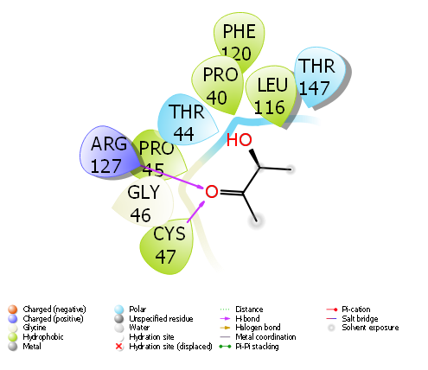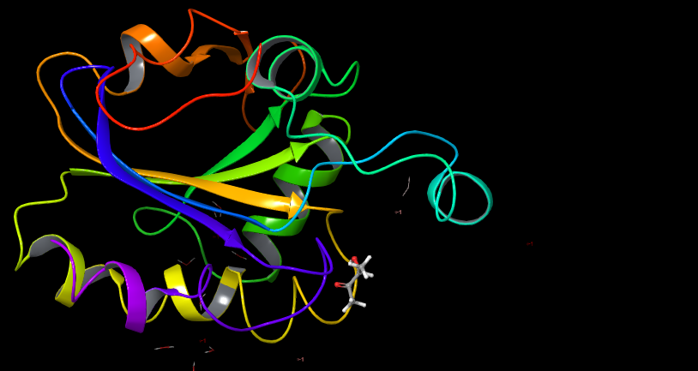

**Figure 1**. 2-Methyltetrahydrofuran-3-one's Interactions with Proteins Related to anti-oxidant protein (PDB ID: 1HD2)

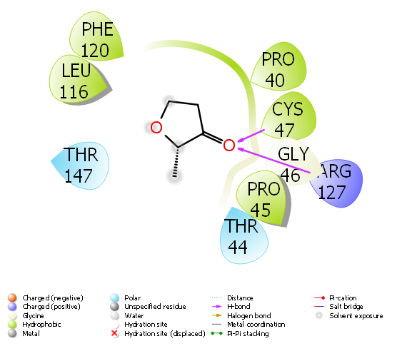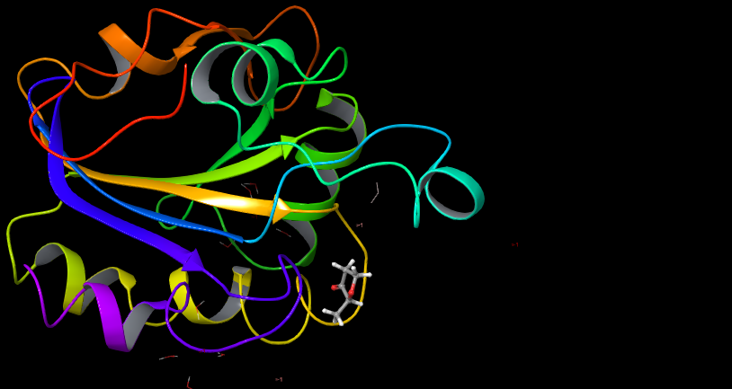

**Figure 2**. 3-Hydroxy-2-butanone 's Interactions with Proteins Related to anti-oxidant protein (PDB ID: 1HD2)

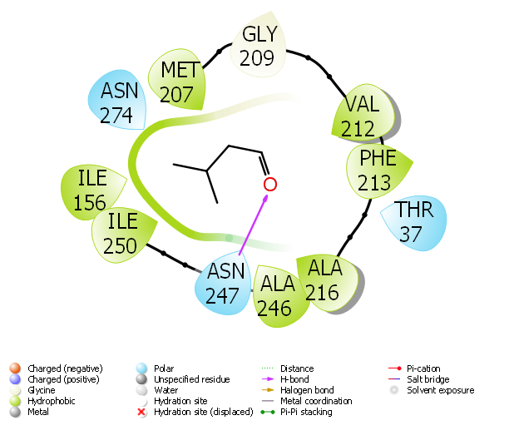 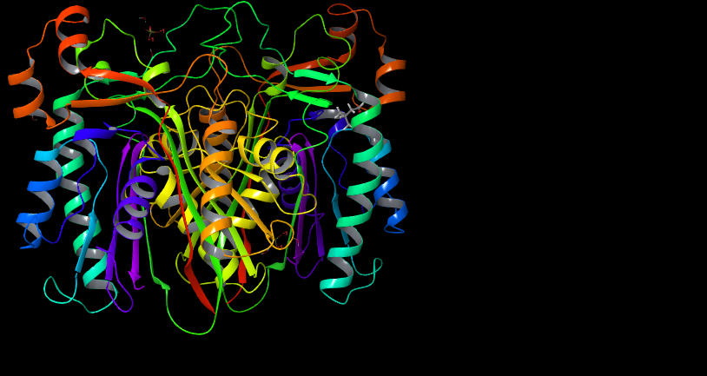

**Figure 3**. 2-Methyltetrahydrofuran-3-one's Interactions with Proteins Related to anti-oxidant protein (PDB ID: 4Z8D)

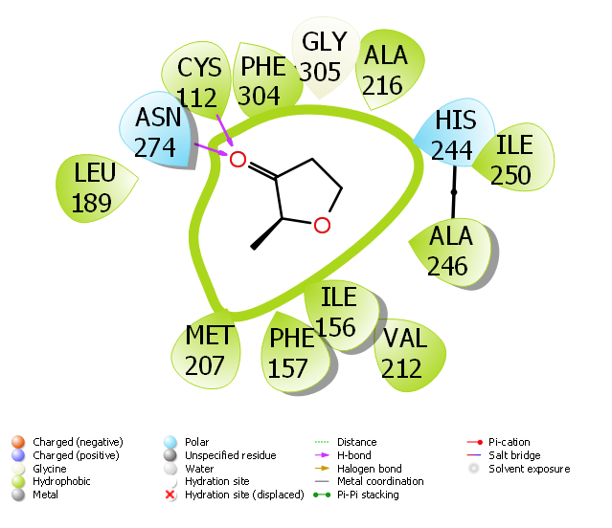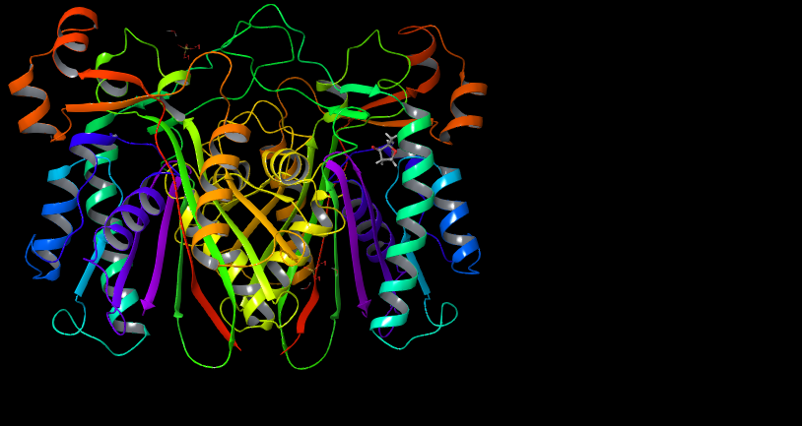

**Figure 4**. Ethyl linolenate's Interactions with Proteins Related to anti-oxidant protein (PDB ID: 4Z8D)

The docking score, a vital metric derived from the calculations, holds a pivotal role in the comparative analysis of the activities of the molecules examined in your research [46,47]. It is noteworthy that the molecule exhibiting the most negative numerical value for the docking score is regarded as having the highest activity among the tested compounds [48,49]. This parameter serves as a key tool in evaluating the potential effectiveness of these molecules in their designated roles, such as inhibiting prostate cancer proteins [50,51].

1. **Conclusion**

Goji fruit and leaves are rich in mineral-rich polysaccharides, phenolic compounds, alkaloids and minerals and exhibit various biological activities such as antioxidant, anti-inflammatory, anti-diabetic and anti-microbial activities. Moreover, the proteins obtained from Goji leaves deserve to be researched and studied. Goji leaves may be a good alternative to Goji berries for people who prefer to consume less sugar and more dietary fibre. However, before any use recommendations can be made for products based on Goji leaves, clinical evidence and strict procedures for their safety and quality are indispensable.

**References**

1. Amagase, H., & Farnsworth, N. R. (2011). A review of botanical characteristics, phytochemistry, clinical relevance in efficacy and safety of Lycium barbarum fruit (Goji). Food research international, 44(7), 1702-1717.
2. Wu, D. T., Guo, H., Lin, S., Lam, S. C., Zhao, L., Lin, D. R., & Qin, W. (2018). Review of the structural characterization, quality evaluation, and industrial application of Lycium barbarum polysaccharides. Trends in Food Science & Technology, 79, 171-183.
3. Tian, X., Liang, T., Liu, Y., Ding, G., Zhang, F., & Ma, Z. (2019). Extraction, structural characterization, and biological functions of Lycium barbarum polysaccharides: A review. Biomolecules, 9(9), 389.
4. Yao, R., Heinrich, M., & Weckerle, C. S. (2018). The genus Lycium as food and medicine: A botanical, ethnobotanical and historical review. Journal of ethnopharmacology, 212, 50-66.
5. Wang, Q., Chen, S., & Zhang, Z. (1991). Determination of polysaccharide contents in Fructus Lycii. Chin Tradit Herb Drugs, 22, 67-8.
6. Zhou, Z. Q., Fan, H. X., He, R. R., Xiao, J., Tsoi, B., Lan, K. H., ... & Gao, H. (2016). Lycibarbarspermidines A–O, new dicaffeoylspermidine derivatives from wolfberry, with activities against Alzheimer’s disease and oxidation. Journal of agricultural and food chemistry, 64(11), 2223-2237.
7. Wen, L., Zhang, Z., Sun, D. W., Sivagnanam, S. P., & Tiwari, B. K. (2020). Combination of emerging technologies for the extraction of bioactive compounds. Critical Reviews in Food Science and Nutrition, 60(11), 1826-1841.
8. Liu, J., Pu, Q., Qiu, H., & Di, D. (2021). Polysaccharides isolated from Lycium barbarum L. by integrated tandem hybrid membrane technology exert antioxidant activities in mitochondria. Industrial Crops and Products, 168, 113547.
9. Liu, W., Liu, Y., Zhu, R., Yu, J., Lu, W., Pan, C., ... & Gao, X. (2016). Structure characterization, chemical and enzymatic degradation, and chain conformation of an acidic polysaccharide from Lycium barbarum L. Carbohydrate Polymers, 147, 114-124.
10. Ma, R. H., Zhang, X. X., Ni, Z. J., Thakur, K., Wang, W., Yan, Y. M., ... & Wei, Z. J. (2022). Lycium barbarum (Goji) as functional food: a review of its nutrition, phytochemical structure, biological features, and food industry prospects. Critical Reviews in Food Science and Nutrition, 1-15.
11. Yang, L., Gao, Y., Bajpai, V. K., El-Kammar, H. A., Simal-Gandara, J., Cao, H., ... & Xiao, J. (2023). Advance toward isolation, extraction, metabolism and health benefits of kaempferol, a major dietary flavonoid with future perspectives. Critical Reviews in Food Science and Nutrition, 63(16), 2773-2789.
12. Protti, M., Gualandi, I., Mandrioli, R., Zappoli, S., Tonelli, D., & Mercolini, L. (2017). Analytical profiling of selected antioxidants and total antioxidant capacity of goji (Lycium spp.) berries. Journal of pharmaceutical and biomedical analysis, 143, 252-260.
13. Jiang, Y., Fang, Z., Leonard, W., & Zhang, P. (2021). Phenolic compounds in Lycium berry: Composition, health benefits and industrial applications. Journal of Functional Foods, 77, 104340.
14. Ali, M. C., Chen, J., Zhang, H., Li, Z., Zhao, L., & Qiu, H. (2019). Effective extraction of flavonoids from Lycium barbarum L. fruits by deep eutectic solvents-based ultrasound-assisted extraction. Talanta, 203, 16-22.
15. Bajkacz, S., & Adamek, J. (2018). Development of a method based on natural deep eutectic solvents for extraction of flavonoids from food samples. Food analytical methods, 11, 1330-1344.
16. Dong, Y., Gu, J., Wang, P., & Wen, H. (2019). Developed functionalization of wool fabric with extracts of Lycium ruthenicum Murray and potential application in healthy care textiles. Dyes and Pigments, 163, 308-317.
17. Yang, S., Han, Y., Wang, K., Wang, Y., Li, L., Li, N., & Xu, X. (2021). Simultaneous determination of four phenolic acids in traditional Chinese medicine by capillary electrophoresis-chemiluminescence. RSC advances, 11(54), 33996-34003.
18. Mocan, A., Zengin, G., Simirgiotis, M., Schafberg, M., Mollica, A., Vodnar, D. C., ... & Rohn, S. (2017). Functional constituents of wild and cultivated Goji (L. barbarum L.) leaves: Phytochemical characterization, biological profile, and computational studies. Journal of enzyme inhibition and medicinal chemistry, 32(1), 153-168.
19. Liu, S. C., Lin, J. T., Hu, C. C., Shen, B. Y., Chen, T. Y., Chang, Y. L., ... & Yang, D. J. (2017). Phenolic compositions and antioxidant attributes of leaves and stems from three inbred varieties of Lycium chinense Miller harvested at various times. Food Chemistry, 215, 284-291.
20. Harnly, J. (2017). Antioxidant methods. Journal of Food Composition and Analysis, 64, 145-146.
21. Ruskovska, T., Maksimova, V., & Milenkovic, D. (2020). Polyphenols in human nutrition: from the in vitro antioxidant capacity to the beneficial effects on cardiometabolic health and related inter-individual variability–an overview and perspective. British Journal of Nutrition, 123(3), 241-254.
22. Olatunji, O. J., Chen, H., & Zhou, Y. (2017). Effect of the polyphenol rich ethyl acetate fraction from the leaves of Lycium chinenseMill. on oxidative stress, dyslipidemia, and diabetes mellitus in streptozotocin‐nicotinamide induced diabetic rats. Chemistry & biodiversity, 14(10), e1700277.
23. Lei, Z., Chen, X., Cao, F., Guo, Q., & Wang, J. (2022). Phytochemicals and bioactivities of Goji (Lycium barbarum L. and Lycium chinense Mill.) leaves and their potential applications in the food industry: A review. International Journal of Food Science & Technology, 57(3), 1451-1461.
24. Al-Wraikat, M., Hou, C., Zhao, G., Lu, H., Zhang, H., Lei, Y., ... & Li, J. (2021). Degraded polysaccharide from Lycium barbarum L. leaves improve wheat dough structure and rheology. Lwt, 145, 111372.
25. Niu, Y., Chen, J., Fan, Y., & Kou, T. (2021). Effect of flavonoids from Lycium barbarum leaves on the oxidation of myofibrillar proteins in minced mutton during chilled storage. Journal of Food Science, 86(5), 1766-1777.
26. Song, P., Zhou, F., Li, F., Han, Z., Wang, L., Xu, J., ... & Zhang, B. (2021). Superfine pulverisation pretreatment to enhance crystallinity of cellulose from Lycium barbarum L. leaves. Carbohydrate Polymers, 253, 117207.
27. Păvăloiu, R. D., Sha’at, F., Neagu, G., Deaconu, M., Bubueanu, C., Albulescu, A., ... & Hlevca, C. (2021). Encapsulation of polyphenols from Lycium barbarum leaves into liposomes as a strategy to improve their delivery. Nanomaterials, 11(8), 1938.
28. Yadav, M., Bhatia, V.J., Doshi, G. & Shastri, K. (2014). Novel techniques in herbal drug delivery systems. International Journal of Pharmaceutical Sciences Review and Research, 28, 83–89.
29. Dumitriu, B. O., & Dima, S. (2016). Biopolymer-based techniques for encapsulation of phytochemicals bioacive in food and drug. Revista de materiale plastice, 53, 126-12.
30. Al Ati, G., Chkirate, K., El-Guourrami, O., Chakchak, H., Tüzün, B., Mague, J. T., ... & Essassi, E. M. (2024). Schiff base compounds constructed from pyrazole–acetamide: Synthesis, spectroscopic characterization, crystal structure, DFT, molecular docking and antioxidant activity. Journal of Molecular Structure, 1295, 136637.
31. Saraç, H., Demirbaş, A., & Tüzün, B. (2023). Could Zingiber officinale plant be effective against Omicron BA. 2.75 of SARS-CoV-2?. Turkish Computational and Theoretical Chemistry, 7(3), 42-56.
32. Kanzouai, Y., Chalkha, M., Hadni, H., Laghmari, M., Bouzammit, R., Nakkabi, A., ... & Al Houari, G. (2023). Design, synthesis, in-vitro and in-silico studies of chromone‐isoxazoline conjugates as anti‐bacterial agents. Journal of Molecular Structure, 1293, 136205.
33. Tapera, M., Kekeçmuhammed, H., Sarıpınar, E., Doğan, M., Tüzün, B., Koçyiğit, Ü. M., & Çetin, F. N. (2023). Molecular hybrids integrated with imidazole and hydrazone structural motifs: Design, synthesis, biological evaluation, and molecular docking studies. Journal of Molecular Liquids, 391, 123242.
34. Majumdar, D., Philip, J. E., Tüzün, B., Sutradhar, D., & Roy, S. (2023). Two adamantan-1-amine-based scaffolds: Synthesis, crystallographic synthons, TD/DFT calculations, in-depth molecular docking/ADME/T simulations, and shedding light on antibacterial/fungal activities. Results in Chemistry, 101228.
35. Chalkha, M., Chebbac, K., Nour, H., Nakkabi, A., El Moussaoui, A., Tüzün, B., ... & El Yazidi, M. (2023). In Vitro and In Silico Evaluation of the Antimicrobial and Antioxidant Activities of Spiropyrazoline Oxindole Congeners. Arabian Journal of Chemistry, 105465.
36. Karataş, H., Kiliç, H. K., Tüzün, B., & Kökbudak, Z. (2023). Schiff Base Derivatives against Monkeypox Virus: Synthesis, In silico, MM-GBSA and SAR properties. Journal of Molecular Structure, 137073.
37. Aksu, A., Çetinkaya, S., Yenidünya, A. F., Çetinus, Ş. A., Gezegen, H., & Tüzün, B. (2023). Immobilization of pectinase on chitosan-alginate-clay composite beads: Experimental, DFT and molecular docking studies. Journal of Molecular Liquids, 390, 122947.
38. Mermer, A., Tüzün, B., Daştan, S. D., Koçyiğit, Ü. M., Çetin, F. N., & Çevik, Ö. (2023). Piperazin incorporated Schiff Base derivatives: Assessment of in vitro biological activities, metabolic enzyme inhibition properties, and molecular docking calculations. Journal of Biochemical and Molecular Toxicology, 37(11), e23465.
39. Erdoğan, M., Yeşildağ, A., Yıldız, B., Tüzün, B., & Özden, Ö. (2023). Synthesis and characterization of some benzidine-based azomethine derivatives with molecular docking studies and anticancer activities. Chemical Papers, 77(11), 6829-6847.
40. Yalazan, H., Koç, D., Aydın Kose, F., Fandaklı, S., Tüzün, B., Akgül, M. İ., ... & Kantekin, H. (2023). Design, syntheses, theoretical calculations, MM-GBSA, potential anti-cancer and enzyme activities of novel Schiff base compounds. Journal of Biomolecular Structure and Dynamics, 1-14.
41. Arukalam, I. O., Uzochukwu, I. N., Tüzün, B., Dagdag, O., & Oguzie, E. E. (2023). Influence of ZnO Nanoparticle Size on Barrier Performance and Corrosion Protection of Poly (dimethylsiloxane)-Coated Q235 Steel in Chloride Environment: Bode and Computational Simulation Investigations. Chemistry Africa, 1-11.
42. Tuzun, B., Taş, N. A., Taslimi, P., & Karadağ, A. (2023). Synthesis, enzyme inhibition, and in silico studies of Amino Acid Schiff Bases. Iranian Journal of Chemistry and Chemical Engineering.
43. Tokalı, F. S., Taslimi, P., Tuzun, B., Karakuş, A., Sadeghian, N., & Gulçin, İ. (2023). Novel Quinazolinone Derivatives: Potential Synthetic Analogs for the Treatment of Glaucoma, Alzheimer's Disease and Diabetes Mellitus. Chemistry & Biodiversity, 20(10), e202301134.
44. Tokalı, F. S., Taslimi, P., Tüzün, B., Karakuş, A., Sadeghian, N., & Gulçin, İ. (2023). Synthesis of new carboxylates and sulfonates containing thiazolidin-4-one ring and evaluation of inhibitory properties against some metabolic enzymes. Journal of the Iranian Chemical Society, 20(10), 2631-2642.
45. Manap, S., Medetalibeyoğlu, H., Kılıç, A., Karataş, O. F., Tüzün, B., Alkan, M., ... & Yüksek, H. (2023). Synthesis, molecular modeling investigation, molecular dynamic and ADME prediction of some novel Mannich bases derived from 1, 2, 4-triazole, and assessment of their anticancer activity. Journal of Biomolecular Structure and Dynamics, 1-15.
46. Arukalam, I. O., Uzochukwu, I. N., Izionworu, V. O., Tüzün, B., & Dagdag, O. (2023). Corrosion protection of Q235 steel in Pseudomonas aeruginosa-laden seawater environment using high barrier PDMS nanocomposite coating. Safety in Extreme Environments, 1-11.
47. Durmaz, L., Gulçin, İ., Taslimi, P., & Tüzün, B. (2023). Isofraxidin: Antioxidant, Anti‐carbonic Anhydrase, Anti‐cholinesterase, Anti‐diabetic, and in Silico Properties. ChemistrySelect, 8(34), e202300170.
48. Aksu, A., Çelik, M. S., Polat, Z. A., Yenidünya, A. F., & Tuzun, B. (2023). Experimental and theoretical evidence on the amoebicidal activity of synthesized tRNA-palmitic acid esters. Iranian Journal of Chemistry and Chemical Engineering.
49. Majumdar, D., Philip, J. E., Tüzün, B., & Roy, S. (2023). Synthesis, characterization, crystallographic aspects, Fukui function, and photodynamic antifungal chemotherapy investigation of Cd (II)-tricyanomethanide coordination polymer: Insights from DFT. Inorganic Chemistry Communications, 155, 111057.
50. Yuriy, K., Kusdemir, G., Volodymyr, P., Tüzün, B., Taslimi, P., Karatas, O. F., ... & Sayın, K. (2023). A biochemistry‐oriented drug design: synthesis, anticancer activity, enzymes inhibition, molecular docking studies of novel 1, 2, 4-triazole derivatives. Journal of Biomolecular Structure and Dynamics, 1-17.
51. Amrulla, F. P., Akber, M. A., Huseyn, I. R., Taslimi, P., & Tuzun, B. et all.(2023). Cu (II), Ni (II) and Co (II) Complexes of Malonic Acid Dihydrazide with bis-Br-Salicylhydrazone. Adv Neur Neur Sci, 6(2), 228-242.
52. Ozmen, U. O., Tuzun, B., Ayan, E. B., & Cevrimli, B. S. (2023). Eco-friendly and potential colin esterase enzyme inhibitor agent sulfonyl hydrazone series: Synthesis, Bioactivity Screening, DFT, ADME properties, and Molecular Docking study. Journal of Molecular Structure, 1286, 135514.
53. Hermi, S., Mrad, M. H., Alotaibi, A. A., Tüzün, B., Böhme, U., Alotaibi, K. M., ... & Nasr, C. B. (2023). A new 1-D polymeric chains of (C5H6ClN2)[CdCl3H2O]. H2O perovskite: Synthesis, Structure, Physico-Chemical Characteristics, theoretical calculations, and biological effects. Inorganic Chemistry Communications, 111122.