**Evaluation of the reference and counter-reference in an Urbano - rural district: case of the health district of Kenya.**

Loris KISIMBA JM 1 , TSHILONDI MALU C 1 , ILUNGA KANDOLO S 2 , LUSE WANZAMBI F 1

1 Assistant and Researcher, Higher Technical Institute of Lubumbashi

Corespondent email : [loriskis.jm@gmail.com](mailto:loriskis.jm@gmail.com)

2 School of Public Health, University of Lubumbashi

**ABSTRACT**

**Introduction**

The referral system is the interface between the decentralizing tendencies of the first line of care and the centralizing tendencies of the general referral hospital, for reasons of continuity of care in a holistic vision.

**Methodology**

We conducted a cross-sectional descriptive study on the evaluation of referral and counter-referral in the Health District of Kenya in the Democratic Republic of Congo with the aim of improving this interface. Data analysis was performed using Epi - Info 7 software.

**Results**

We noted that the severity of the disease motivated the referral in 54% of cases. The reason given for refusing the referral by the patient was the lack of money (95%). The majority of health centers were decentralized (56%); there is a non-existence of referral tickets at the health center level ( 78.9%). The counter-reference rate was 21.1 % with a reference rate of 31.5%.

**Conclusion**

In the context of universal health coverage, it is important to encourage the referral and counter-referral phenomenon to ensure a better supply of health care **.**

**Keywords: *Evaluation , Reference, counter-reference, health district, Kenya***

**INTRODUCTION**

In the era of the development of healthcare structures in all countries of the world, it is more and more frequent for a patient, for a given health problem, to be taken care of and treated at different levels of the healthcare system. offer of care. This mechanism, which is only normal, aims to offer optimal care, that is to say effective, continuous, comprehensive and integrated care, whatever the issue of the treatment. It aims to make the health system more responsive to the expectations of the population as to how they wish to be treated.

A health system that follows this logic is organized in such a way as to coordinate the supply of care from the first contact of the patient with the health establishments until his discharge, because the multiplicity of care establishments and the variability of the types of services they provide are not contradictory, but communicate and complement each other. The compartmentalization between these different healthcare establishments and the isolation that could characterize them must be systematically abandoned to respect the principle of the uniqueness of the system (MiniSanté-Morocco, 2007) .

It is in this context that the supply of care in all health systems is organized in a network and in a pyramidal fashion with , at the bottom of the scale, the basic health care establishments which provide first contact, and gradually, the referral establishments which provide adequate complementary care.

The development of such a network, offers the guarantee of improving the care of individuals throughout their journey in the system, because the number of patients are little or not satisfied with the first services provided by the structures of first resort (MiniSanté -Morocco, 2007) .

Mady DENANTES and Coll. (Denande, 2009) , note that the difficulties of access to complementary insurance, flat rates and deductibles, excess fees, the absence of mutual insurance, the refusal of care for the poor, the refusal of medical aid from State (AME) or hassles with third-party payment are major obstacles to access to care for the poorest.

The 2003 WHO report points out that many factors, which do not directly depend on the health system, such as poverty, armed conflicts, institutional instability and infrastructure deficiencies, are origin of low utilization of health services .

The referral is the mechanism by which a first level structure directs a patient who exceeds his skills, towards a more specialized and better equipped structure (a hospital in general), for an adequate care while the counter-referral is the mechanism by which, a more specialized and better equipped structure addresses, after having treated him, a patient to the structure which had referred him, to ensure continuity of care and post-hospital follow-up. The referral/counter-referral system is the set of measures taken to ensure two-way circulation (back and forth) of patients between two care structures with different skill levels, in order to provide patients with the care they need, in the right place and at the right time.

Evacuation by convention designates a reference carried out in an emergency situation. This is the case for emergency obstetric and neonatal care (SONU). Retro information or “feed-back”: is the response made by the referral structure to the health facility that referred the patient to it. It includes data on the reception of the patient, the diagnosis made, the care given and the prescriptions for the continuity of treatment (WHO-UNFPA, 209AD) .

**METHODOLOGY**

We conducted a cross-sectional descriptive study on the referral in the health district of Kenya precisely in the 19 constituent Health Areas. The health district. This study covered a year from 01/01/2020 to 31/12/2020.

Our study population consisted mainly of nursing staff from health centers, the general reference hospital as well as patients found respectively in observation and hospitalization during the data collection period at a rate of 60 patients at health centers, 25 at the General Reference Hospital 29 service providers including 10 at the General Reference Hospital and 19 at the Health Centres.

**Data collection technique**

We used the structured interview technique with filling out a pre-established questionnaire. This interview was conducted on both the personal and patient side. This questionnaire, administered following the free and informed consent of the respondents, served as a collection tool.

**Data analysis**

Before entering and analyzing the data, all the completed questionnaires were checked and validated as the collection took place in the field. A second cleanup was performed after data entry from the database. Our analyzes were carried out using the Epi-info software version 7.1.0.2, Microsoft Excel helped us to develop the graphs.

**RESULTS**

1. **RESULTS RELATING TO HEALTH CENTERS**

**Table I. Distribution of patients at the Health Center according to socio-demographic characteristics**

|  |  |  |
| --- | --- | --- |
| **Variables** | **Effective** | **Percentage** |
| **Sex** |  |  |
| Feminine | 38 | 63.3 |
| Male | 22 | 36.7 |
| **Patient kept under observation** |  |  |
| Nope | 21 | 35 |
| Yes | 39 | 65 |
| **Patient's occupation** |  |  |
| Unemployed | 12 | 20 |
| Liberal | 25 | 41.7 |
| Official | 8 | 13.3 |
| Other | 15 | 25 |
| **Level of education of the patient** |  |  |
| Primary | 24 | 40 |
| Secondary | 29 | 48.3 |
| University | 7 | 11.7 |

Female patients were in the majority (63.3%), an average age of 38.5 years.

**Table II. Distribution of patients at the Health Center according to the first contact structure**

|  |  |  |
| --- | --- | --- |
| Origin | Effective | percentage |
| Medical structure | 56 | 83.3 |
| Other traditional healers | 4 | 6.7 |
| TOTAL | 60 | 100 |

In 83.3% of cases, the patients received at the health center had been in a medical structure before being received at the health center.

**Table III. Distribution of patients at the Health Center according to the reception reserved for them at the health center**

|  |  |  |
| --- | --- | --- |
| Welcome | Effective | Percentage |
| Good | 41 | 68.3 |
| Bad | 19 | 31.7 |
| TOTAL | 60 | 100 |

Forty-one patients (41) from the health center (63.3%) felt that the reception was good.

**Table IV. Distribution of patients at the Health Center according to adherence to the decision of the reference taken by the nurse at the Health Center**

|  |  |  |
| --- | --- | --- |
| Membership | Effective | Percentage |
| Yes | 30 | 50 |
| Nope | 30 | 50 |
| TOTAL | 60 | 100 |

Half of the patients in the Health Centers, ie 50%, adhered to the reference decision taken by the titular nurse of the Health Center.

**Table V.** **Distribution of health center staff according to socio-demographic characteristics.**

|  |  |  |
| --- | --- | --- |
| **Features** | **Number (N=19)** | **Percentage** |
| **Sex** |  |  |
| Feminine | 5 | 26.4 |
| Male | 14 | 73.6 |
| **LEVEL OF EDUCATION** |  |  |
| A0 | 4 | 21.1 |
| A1 | 15 | 78.9 |
| A2 | 0 | 0 |
| A3 | 0 | 0 |
|  |  |  |
| **SENIORITY** |  |  |
| ≤ 5 years | 3 | 15.8 |
| ≥ 5 years | 16 | 84.2 |

The average age of service providers at the Health Center level was 39.3% with a predominance of the male sex (73.6%).

**Table VI. Distribution of health center staff according to reasons for non-referral of patients**

|  |  |  |
| --- | --- | --- |
| Reason for non-use | Effective | Percentage |
| I am not trained in the use of flowcharts | 4 | 40 |
| Flowcharts limit personal initiatives | 5 | 50 |
| Other (s) to be specified | 1 | 10 |
| Total | **10** | **100** |

In 50% of the cases, the nurses holding the health certificates said that the flow charts limit the reference.

The severity of the disease had motivated the referral in 54% of these cases.

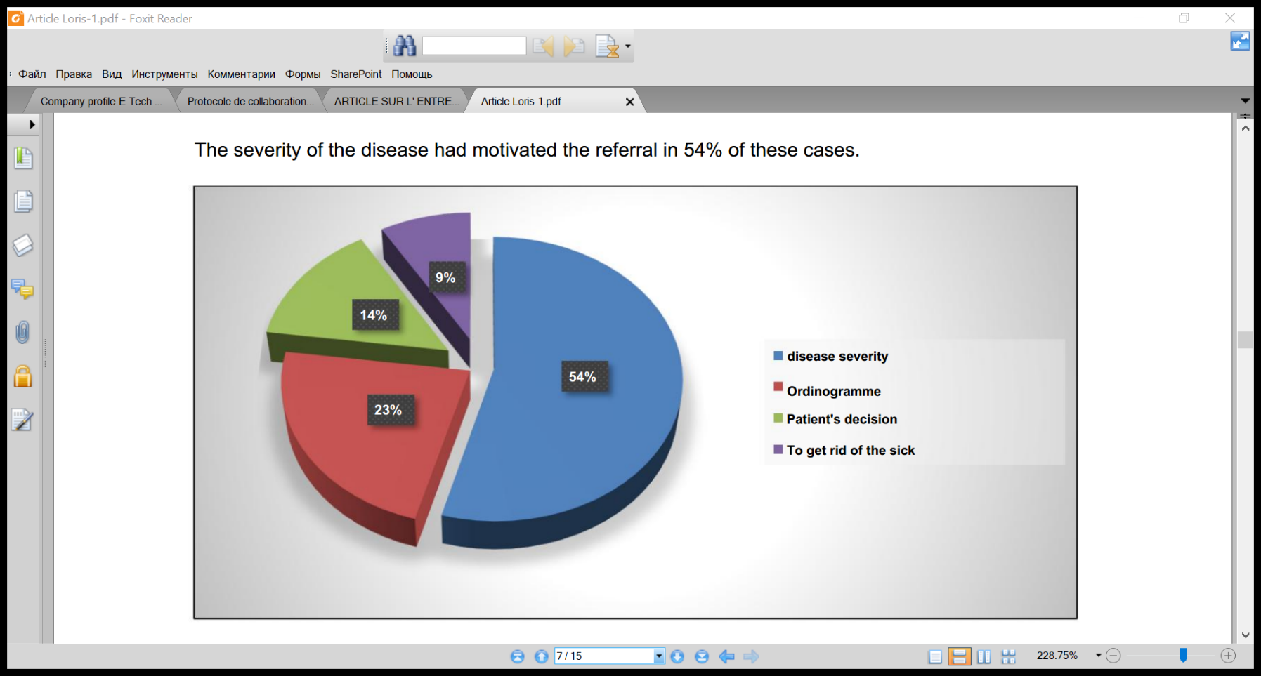

**Figure 1. Distribution of respondents according to the reference base**

Lack of money was the reason cited by the patient for refusing the referral (95%).

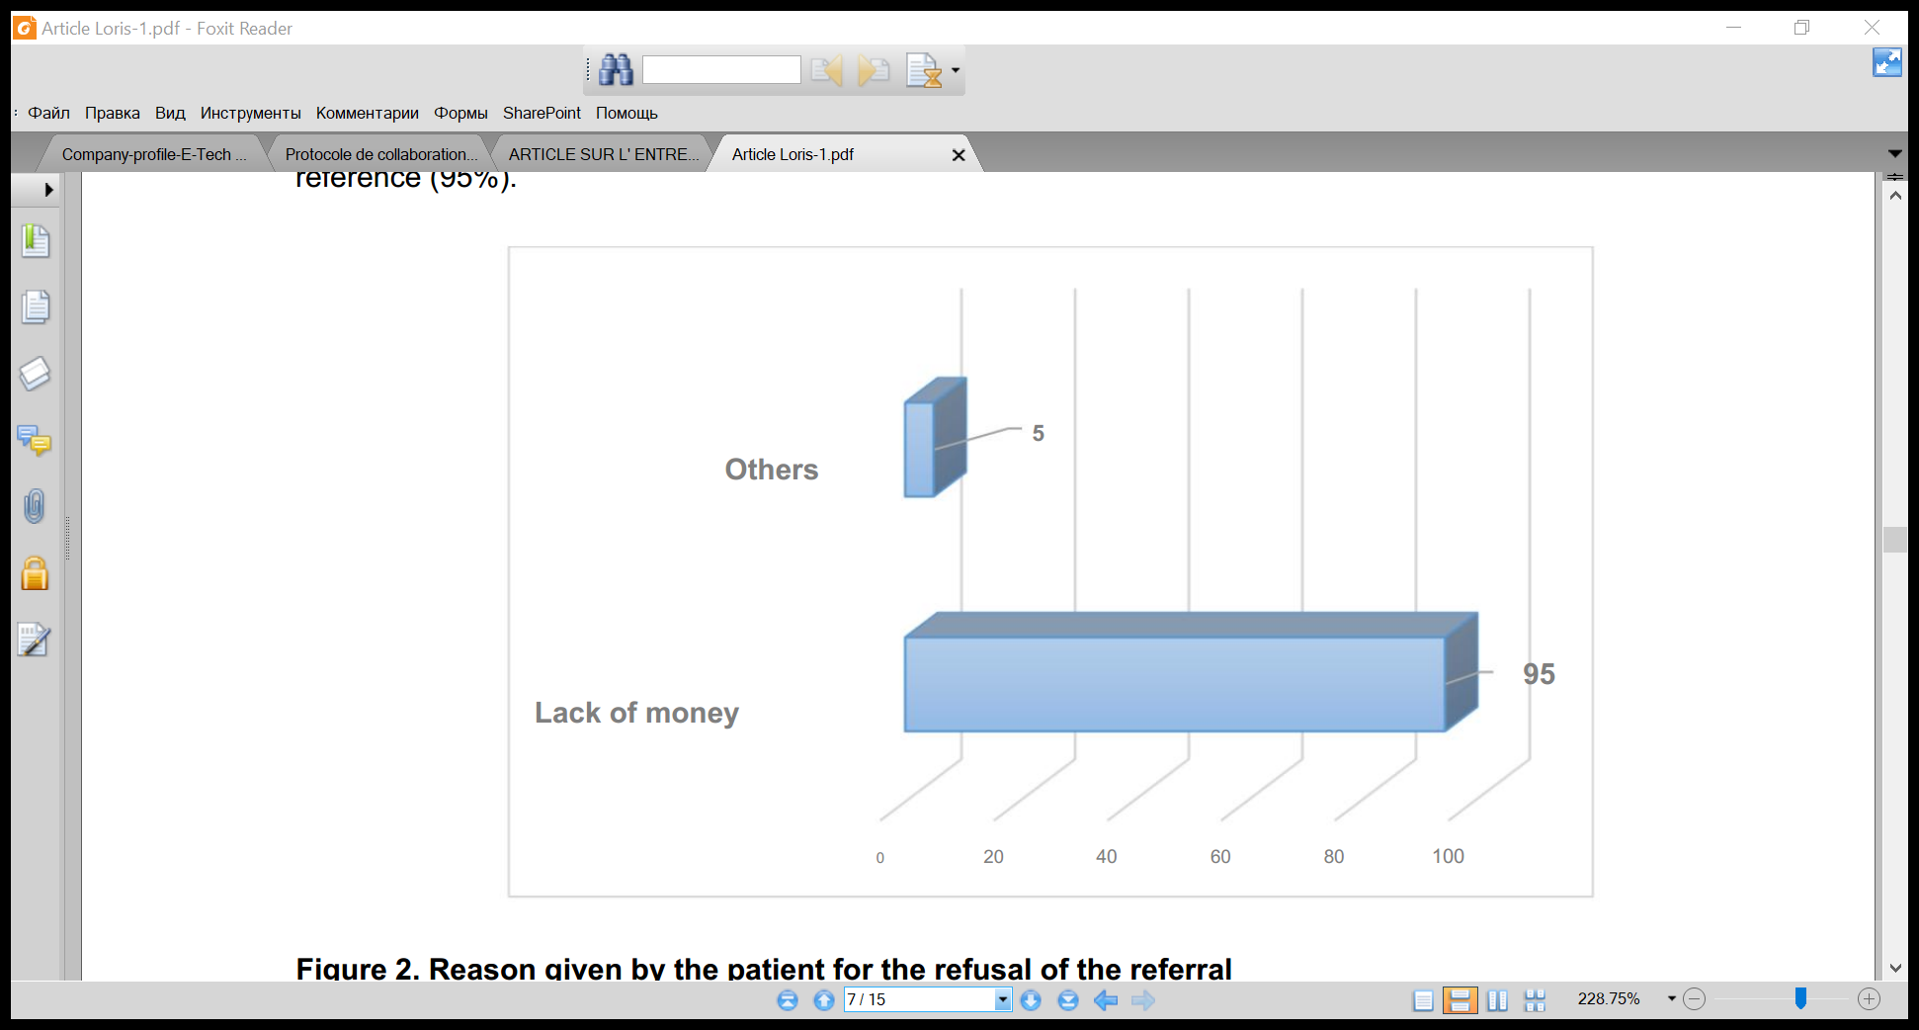

**Figure 2. Reason given by the patient for the refusal of the referral**

**Table V II. Distribution of health areas by distance from the hospital**

|  |  |  |
| --- | --- | --- |
| Distance | Effective | Percentage |
| ≤5Km | 10 | 52.6 |
| >5km | 9 | 47.4 |
| Total | 19 | 100 |

In the majority of cases, health centers were decentralized (52.6%).

**Table VIII. Distribution of health centers according to the availability of reference tickets**

|  |  |  |
| --- | --- | --- |
| Existence of reference tickets | Effective | Percentage |
| Yes | 04 | 21.1 |
| Nope | 15 | 78.9 |
| TOTAL | 19 | 100 |

In 78.9% of cases, a lack of reference tickets was observed in health centers.

**Table IX. Distribution of respondents according to the frequency of the counter-referral of patients**

|  |  |  |
| --- | --- | --- |
| Counter-reference | Effective | Percentage |
| Still | 04 | 21.1 |
| Occasionally | 13 | 68.4 |
| Never | 02 | 10.5 |
| TOTAL | 19 | 100 |

Concerning the counter-reference, the nurses said that it was sometimes observed in 68.4% of cases.

**RESULTS RELATING TO THE GENERAL REFERENCE HOSPITAL**

**Table X. Distribution of patients according to categories**

|  |  |  |
| --- | --- | --- |
| Category | Effective | Percentage |
| Referral | 11 | 31.5 |
| Not referred | 24 | 68.5 |
| TOTAL | 35 | 100 |

At the level of the general referral hospital, the majority of patients were not referred (68.5%).

**Table XI. Distribution of respondents according to the estimate of the price paid to the hospital**

|  |  |  |
| --- | --- | --- |
| Estimate | Effective | Percentage |
| Too high | 09 | 25.7 |
| Suitable | 26 | 74.3 |
| Cheaper | 00 | 00 |
| TOTAL | 35 | 100 |

Nearly 7 patients out of 10 or 74.3% had estimated that the price paid to the hospital was suitable and 25.7% had estimated that the price was too high.

**Table XII. Distribution of respondents according to the means of transport used during the referral**

|  |  |  |
| --- | --- | --- |
| Means of transport used | Effective | Percentage |
| Feet | 02 | 18.2 |
| Bike | 01 | 9.1 |
| Motorbike | 05 | 45.4 |
| Public bus | 02 | 18.2 |
| Ambulance | 01 | 9.1 |
| TOTAL | 11 | 100 |

The motorcycle was the most used means for the reference (45.4%).

**Table XII III. Distribution of respondents according to the estimate of the quality of reception reserved at the General Reference Hospital**

|  |  |  |
| --- | --- | --- |
| Hospitality estimate | Effective | Percentage |
| Very good | 07 | 20 |
| Good | 26 | 74.3 |
| Bad | 02 | 5.7 |
| TOTAL | 35 | 100 |

At the level of the hospital, 74.3%, the patients considered the reception at the hospital to be good.

**Table XIV. Distribution of respondents according to the accompaniment of patients referred, with their information or referral tickets**

|  |  |  |
| --- | --- | --- |
| Accompaniment with information or reference tickets | Effective | Percentage |
| Yes | 07 | 70 |
| Nope | 03 | 30 |
| TOTAL | 10 | 100 |

In most cases, the patients referred were accompanied by information (referral ticket) (70 %).

**Table XV. Distribution of respondents according to the price of malaria treatment**

|  |  |  |
| --- | --- | --- |
| Category | Price (in dollars) | Difference |
| Referred patient | 30 | 2.5 |
| Patient not referred | 32.5 |

With regard to malaria, we note that the patients referred paid more than the non-referred. (32.5 US dollars).

**Table XVI. Distribution of respondents according to the evaluation of the referral and counter-referral system in the health zone.**

|  |  |  |
| --- | --- | --- |
| Evaluation of the reference to the monthly and annual review. | Effective | Percentage |
| Yes | 2 | 20 |
| Nope | 8 | 80 |
| TOTAL | **10** | **100** |

In 80% of cases, the reference system was evaluated during reviews (monthly or annually).

**Table XVII. Distribution of respondents according to the reasons why the hospital does not cross-refer certain patients to health centers**

|  |  |  |
| --- | --- | --- |
| Reasons for not counter-referral | Effective | Percentage |
| Lack of counter-reference ticket | 01 | 10 |
| Some recovering patients prefer to return to their families | 05 | 50 |
| Some patients are afraid to return to the CS as a result of the new pricing of care. | 04 | 40 |
| Total | **10** | **100** |

Most patients prefer to go directly to their family rather than be referred (50%).

**DISCUSSION**

**Sociodemographic characteristics of patients at Health Centers**

Table I indicates that at the level of the first line of care, 48% of the patients at the secondary education level were observed, followed by those at the primary level (40%), while the female patients were in the majority (63.3 %) with an average age of 38.5 years. Regarding the sex of the patients, our results are in line with those found in Goma and Mali (Samake, 2009; Ntibenda, 2012) .

**Origin of the patients before arrival at the Health Center and assessment of the reception by the patients.**

We observed that in 83.3% of cases, the patients received at the health center had been in a medical structure before being received at the health center (Table II) and the majority declared that the reception was good as much at the health center than at the hospital level (68% and s 74.3% (Tables III and XIII). Our results, although slightly lower, are close to those found in China and in other countries of the world (Silva and Valentine, 2000; Wang *et al.* , 2017) .

**Adherence of the patients to the reference decision taken by the nurse of the Health Center.**

Half of the patients in the Health Centers, ie 50%, adhered to the reference decision taken by the titular nurse of the Health Center (Table IV).

**Characteristics of Health Center staff.**

The average age of service providers at the Health Center level was 39.3% with a predominance of the male sex (73.6%). Eight out of ten providers had experience ≥ 5 years78,9 and the majority had a university education (A1) (Table V).

**Reason for non-referral at Health Center level**

According to the opinions of the nurses, the flow charts limit the referral to the level of the health center (50%) whereas the gravity of the disease had motivated the referral in 54% of these cases (Figure 1).

**Reasons for non-referral at health center level.**

In 95% of cases, lack of money was the reason mentioned by the patient at the first line of care for refusing the referral (Figure 1).

On the other hand, JEREMIE has, in his study carried out in Kinshasa, found that the barriers identified for the referral and counter-referral system are among others: the direct cost of care (93.3%), the indirect costs of care (80% ), the distance between CS and HGR (66.7%), lack of means of transport (66.7%), respect for culture or custom or religion (66.7%) and the cost of transport (60%) (Jérémie, 2017) .

**Distribution of health areas according to distance from the General Reference Hospital**

In the health district of Kenya, 52% of the health centers were decentralized (52.6%) against 47.4% which were not as shown in Table VIII. Our results differ from those of the health district of Gombe in Kinshasa, where 66.67% of the population is far from its general reference hospital, that is to say that it is beyond 31 km ( Jeremiah, 2017) . In Bamako, Mali, a study reveals that the average distance traveled by evacuees is 13.35 km. The extremes are 0.3 to 61.4 km (Traore, 2010) .

**GENERAL REFERENCE HOSPITAL**

**Payment method.**

Patients considered the cost of care at the general referral hospital in Kenya to be suitable (affordable) in 74.3% of cases (Table X) and patients referred paid relatively less than those who did not. not been referred (2.5 Dollars difference)XV .

No case of indirect payment (mutualization of care or health insurance) was reported then. For GUINDO, women referred within the framework of the referral system are supported by the solidarity fund (Guindo, 2008) .

**Proportion of patients referred and means of transport used by the patient for the referral.**

During the referral, the motorbike was the most used means of referral (45.4%) versus the ambulance and the bicycle with 9.1% whereas in Burkina-Faso, the ambulance was the most common means of transport. no longer used 75.7 (BARRY, 2011) . In the Health Zone of Kisanga as well as that of Kapolowe in the Democratic Republic of Congo, the means of transport used were respectively public transport vehicles and motorcycles (MIKOMBE, 2016) .

The referral rate was 31.5%, or 11 out of 35 patients seen at the General Reference Hospital. In Kinshasa, in the Gombe Zone Out of 100% of the patients referred from the Health Centers, 35% of patients refused the referral and those who accepted the said referral represent 65%, of which 22% of the patients referred arrived at the General Hospital of Reference and 43% were treated at the Reference Health Centers (Jérémie, 2017) . In Mali, the benchmark rate was 13.38% (Théra *et al.* , 2015) .

**Table XIV. Distribution of respondents according to the accompaniment of patients referred, with their information or referral tickets**

In most cases, patients referred were accompanied by information (referral ticket) (70%) (Table XIV).

**Evaluation of the referral and counter-referral system in the health zone.**

In 80% of cases, the reference system was evaluated during reviews (monthly or annually) (XVI).

**Reasons why the hospital does not cross-refer some patients to health centers**

Most patients prefer to go directly to their family rather than be referred (50%) (XVI).

**FINDINGS**

We conducted a study to assess the referral as well as the counter-referral in the health district of Kenya in the Democratic Republic of Congo and we observed that at the level of the Health Center, female patients were in the majority (63.3 %) the majority were kept under observation (65%); the liberal profession was in the majority (41.7%).

In 83.3%, patients had to attend another health facility before arriving at the health center. Forty-one (41) patients considered that the reception was good at the level of the health center. Half of the patients in the Health Centers, ie 50%, adhered to the reference decision taken by the titular nurse of the Health Center. The flowchart was the element limiting the reference in 50% of cases according to the nurses.

Since the referral is an interface between the first level of care and the Hospital, it is important to encourage it when it proves to be essential.

**REFERENCES**

BARRY, A. (2011) *Analysis of the relevance of indications and maternal-fetal prognosis during the year 2009* .

Denande, M. (2009) *Social inequalities in health in medicine. Access to care and general, France 2009.*

Guindo, SB (2008) *Obstetrical emergencies in the context of referral and counter-referral in the obstetrics gynecology department at Sikasso hospital* .

Jérémie, AV (2017) *Analysis of the referral and counter-referral system in the Gombe health zone.* Kinshasa.

MIKOMBE, K. (2016) *Operational comparative analysis of referral and counter-referral in urban and rural areas (case of Kisanga and Kapolowe Health Zones)* .

MiniSanté-Morocco (2007) *Survey on Health and Reactivity of the Moroccan Health System 2003* .

Ntibenda, RM (2012) *Evaluation of the level of satisfaction of users of the Bethesda hospital center* .

WHO-UNFPA (209AD) *Recommendations for clinical practice in emergency obstetric and neonatal care in Africa* .

Samake, N. (2009) *Evaluation of the quality of care in the community health center of Boulkassoumbougou II* .

Silva, A. and Valentine, N. (2000) *Measuring responsiveness. results of a key informant survey in 35 countries* . Geneva.

Thera *et al.* (2015) 'Problems of the referral and counter-referral system for obstetric emergencies in Bamako', *Mali Médical* , 30(3), pp. 34–37.

Traore, DB (2010) *Problems of the referral system/evacuation of obstetric emergencies at the referral health center of commune VI in the district of Bamako* .

Wang, W. *et al.* (2017) ‘Comparison of patient perceived primary care quality in public clinics , public hospitals and private clinics in rural China’, *International Journal for Equity in Health*. International Journal for Equity in Health, 16, pp. 1–9. doi: 10.1186/s12939-017-0672-1.