**Contribution of internal audit in the good governance of portfolio entities: Case of GECAMINES.**

ILUNGA TSHIKALA Jonathan 1 OMARI ISSA Dıderot 1 Dr. Jeannot MPANYA MPANYA 2

1 PhD Student and Researcher, Higher Technical Institute of Lubumbashi

Corespondent Email : ilungaj361@gmail.com

2 Professor and Director General, Instıtut Technical Superior of Lubumbashi.

ORCID: 0000-0003-0227-2387

**ABSTRACT**

The entity as an organization that produces goods and services; its development requires the proper management of accounting in which the imperative is fixed on the traceability of accounts, regularity, effectiveness, efficiency, monitoring of processes, internal control procedures, accounting organization and financial management. Accounting as a management tool in an entity, it involves efficiency, regularity, reliability and even information security. To detect all these aspects, entrepreneurs are faced with many difficulties in detecting strengths and weaknesses that can allow the entity to achieve its assigned objectives or even cause the latter to go bankrupt.

In the accounting organization, the entity goes through significant risks of bankruptcy or failure, hence the tasks and responsibilities to be assumed pose a crucial problem for several managers and managers. The inevitable tool for controlling and detecting bankruptcies, the audit is a tool for decision support, efficiency, regularity, fair information in order to bring the entity towards the ultimate goal. of his organization.

**Keywords** : Contribution, Audit, Internal Audit, Governance, Entity, Portfolio.

**INTRODUCTION**

The financial crisis that has hit economies around the world calls for particular attention to the governance of certain entities, their risk management and their internal control. To this end, significant progress has been made in these areas. Governance ambitions have grown. Internal control approaches and techniques have progressed. The spectrum covered by risk management has essentially widened and internal audit has asserted itself as a player in corporate governance on the basis of recognized professionalism. internal audit has a role to play in the good governance of entities, as well as in the balance of power through the presence of the audit committee. The internal auditor, through his personal qualities (competence, knowledge, etc.) can contribute to the good governance of the entities. Internal audit plays a fundamental role in the transparency of financial information as well as contributes to the proper functioning of the entity. The success of this mechanism must depend on its attachment, we are talking here about the independence of the internal audit, the higher the level of independence, the more effective the audit activity will be. The objective is therefore, to know the contribution of internal audit in the good governance of the entities of the portfolio, and the problem would be: " ***What is the contribution of*** ***Internal audit in good governance GECAMINES?»***

To achieve the objectives of the research and confirm or refute the hypotheses, We will examine the following hypotheses: Internal audit would improve entity governance through the evaluation of the effectiveness of the internal control system, We can rely on internal audit being a main tool in risk management to improve entity governance, the establishment of adequate control procedure leads to effective good governance . The interest of this article is therefore to first show the conceptual approach of internal audit where we will define and present the notion of internal audit. Then, in a secondly we will take a closer look at the concept of entity governance. And Finally, the study will focus on the contribution of internal audit to the good governance of the General Entity of Quarries and Mines ( **GECAMINES)** .

**LITERATURE REVIEW**

The literature review is a text that gathers, analyzes and organizes several articles or scientific content, in order to provide an overview of the scientific advances in a field. It offers an assessment of the studies carried out: an update on the Questions already asked. In this way, researchers, doctoral students and students can find out about the state of research on the subject they are studying. The literature review is not a simple inventory of scientific sources, it is an exercise that requires reflection and a certain amount of creativity. As part of our work, we consulted books and articles, such as:

* **RANDRIANARIVONY Faniry** Elodie (2014), in his article entitled: "Corporate governance: one of the key factors for the development of companies with participation of the Malagasy state", 2014, his concern was to know How and by which strategies the governance contribute to improving the performance of enterprises with State participation?, he concludes by saying that Good governance contributes to the growth of enterprises with State participation thanks to the various control procedures put in place. in place and by the various economic, social and environmental means implemented by all of the company's stakeholders.
* **HAJAR LAGHRISSI (2021)** in his article entitled: "internal audit and corporate governance" , the author was concerned with the question of how internal audit manages to intervene as an instrument of governance? After his investigations, he concludes by saying that Internal audit enhances governance through missions justified by a risk-based approach that serves as assurance and opinions on the procedures and structures that will generate the success of the organization. As risks increase and evolve more and more, the role of internal audit may cover other areas, such as culture and behaviors, risk governance, sustainability, and other indicators of extra-financial reporting .
* **BENOIT PIGE** (2003) in his article entitled: "the stakes of the audit market", the researcher had the problem of what are the evolutions of the audit market which allowed this rapid provision of the Arthur network andersen and this reduction from five to four in the number of large international networks?, he concludes by saying that the evaluation of the audit networks should be made public and in a form that is accessible to directors and shareholders concerned with selecting their the information asymmetry they have identified.
* **HECHMI ABDELWAHED (2013)** , “guide for the use of international auditing standards in the audit of small and medium-sized enterprises”, the author talks about the use of international auditing standards in small and medium-sized enterprises.

As part of our research we are going to stand out from our predecessors in the sense that we are going to give the contribution of internal audit in the good governance of **GECAMINES** .

**METHOD OLOGY**

The methodology is a sequence of steps through which all research must pass in order to demonstrate rigor. For this, we have adopted a methodology to collect relevant information that will be analyzed and processed in order to obtain results. In the context of our article, we have opted for the analytical method.

1. **ANALYTICAL METHOD**

Is defined as being that which breaks down an object into its constituent elements in order to better study them. It is a method that allowed us to compare two or more sizes, to possibly detect their similarities, their differences that exist. For **GUY ROCHER** , this method constitutes a true indirect experiment since in the experimental operation, the operation also draws a relation between the facts observed. Within the framework of this work, this method will help us to collect the necessary financial data, to analyze them, to process them as well as to interpret them in order to bring out a value judgment with regard to the contribution of internal audit in good governance.

1. **TECHNICAL _**

Technique is defined as a set of processes that belong to an art, a science or a trade. Therefore, we opted for the documentary analysis technique and the interview technique.

* 1. **Literature analysis technique**

It consists in establishing and analyzing the documents in order to determine the facts or phenomena of which the documents are or carry successes. It allowed us to study and identify accounting data in written sources, published works and official documents, articles as well as the internet browsing process.

* 1. **Interview Technique**

It is defined as a technique which aims to organize a verbal communication relationship between two people, the interviewer and the respondent in order to allow the interviewer to collect certain information from the survey concerning a very specific object. Indeed, this one was the best adapted to enter into contact with the agents concerned of the universe of survey, considered as target of our research. Given the difficulties encountered, we took the sample of twenty staff working in the internal audit and internal control department of GECAMINES, to whom we submitted a questionnaire in order to know the contribution of the audit in the good governance of the GECAMINES entity.

**RESULTS**

In this part, we will proceed to the description of the existing facts within **GECAMINES** . It is reserved for the presentation of the information collected during the observation, interview and survey. These results will therefore confirm or invalidate our initial hypotheses. The first point we will talk about Internal audit and entity governance this point will expose the definitions and concepts of internal audit and governance. The second point we will talk about "the contribution of the audit in good governance" we will present the data collected and data processing in order to see the contribution of internal audit in good governance.

1. **INTERNAL AUDIT**
2. **THE CONCEPT OF INTERNAL AUDIT**

Internal audit has seen the succession of various definitions from the IFACI (French institute of audit and internal control) and the same from the IIA (the Institute of internal auditor ). The official definition is that adopted by the IIA (the institute of internal auditor ) on June 22, 1999 and approved by the IFACI (French Institute of Audit and Internal Control) which says: "Internal auditing is an independent and objective activity which gives an organization an assurance on the degree of control of its operations, advises it on how to improve them, and contributes to creating added value. It helps this organization to achieve its objectives by evaluating, through a systematic and methodical approach, its risk management, control and governance processes, and by making proposals to strengthen their effectiveness”.

1. **Internal audit techniques**

The mission of the internal auditor does not apply randomly. There is a set of techniques that the internal auditor adopts during his mission. According to kopp and Lori.S (2000) it is essential to point out that these internal audit techniques have a positive impact on the effectiveness of the internal control system. These techniques can be classified under two main categories, namely the description tools whose objective is to inform the listener and better help him to understand a situation, and the questioning tools which help the listener to establish questions. and to answer it.

**2. GOVERNANCE OF THE ENTITY**

The term “corporate governance” has existed for centuries; but has only been mined for a few decades. Taken from the Anglo-Saxon term " corporate governance", it appeared to foreigners after the bad organizations and practices that companies use to achieve their objectives. In view of its bad application and the bad results that flow from it, reports ; guidelines 5 have been published by the World Bank (1989) and the OECD (2005) to make companies more efficient, more competitive and more transparent.

1. **Attempt at definition**

From the English governance , the term "governance" designates a set of decisions, rules and practices aimed at ensuring the optimal functioning of an organization. Good governance is one that creates value by improving performance and above all by ensuring the sustainability of your entity.

**What do we mean by stakeholders? (Stakeholders)**   
 The entity's stakeholders include all the players who have an interest in the entity's activities. These stakeholders can:

* Participate in its economic life (employees, customers, suppliers, shareholders and managers)
* Influencing its behavior internally and externally (NGO)
* Be affected, directly or indirectly by its activities (public authorities)

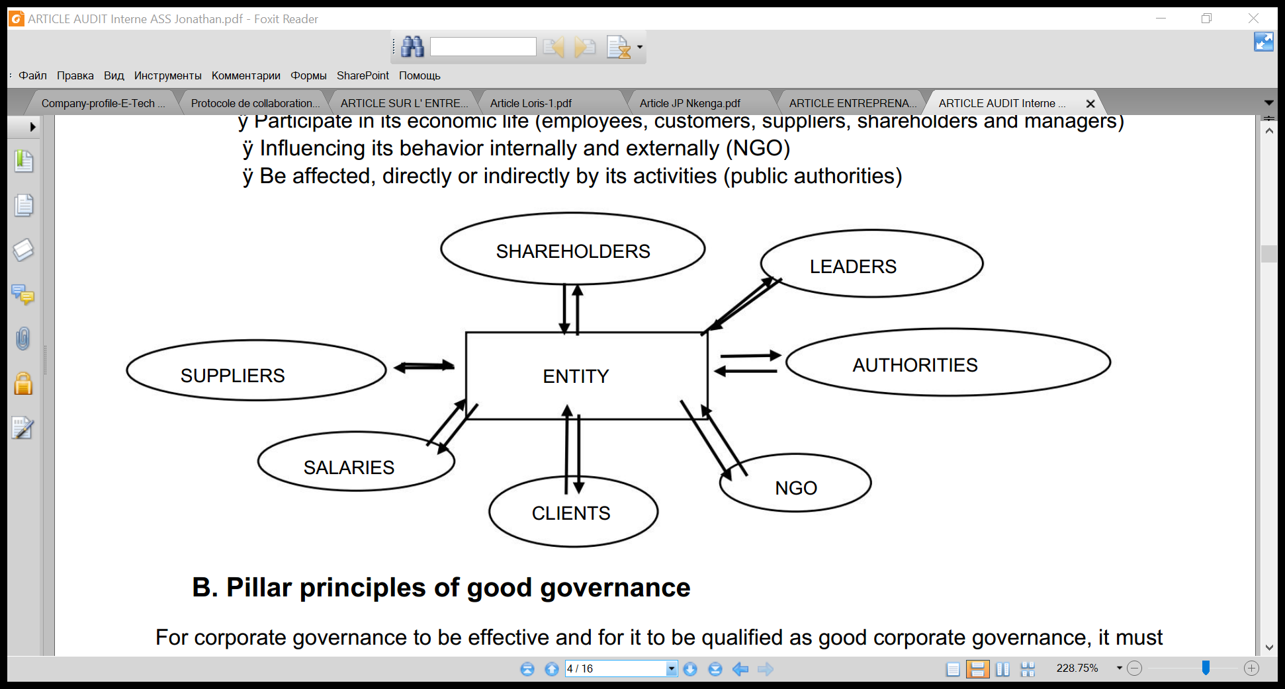

1. **Pillar principles of good governance**

For corporate governance to be effective and for it to be qualified as good corporate governance, it must comply with a few principles and must be made up of several interdependent elements. According to PricewaterhouseCoopers (PWC), the pillars of **good governance are:**

**1°) Honesty**

**Which is translated by good faith in the application of rules and procedures.**

**2°) Transparency**

**Information relevant to its understanding and justification is accessible.**

**3°) Liability**

**Someone is responsible for this decision, subject to oversight involving accountability.**

**4°) Accountability**

**Consists of the presentation of the management accounts by its administrator (accountant or other)**

**5°) Independence**

**No motive or hidden interest was taken into consideration**

**6°) fairness**

**The decision takes into account the interests of the stakeholders.**

1. **CONTRIBUTION OF INTERNAL AUDIT TO GOOD GOVERNANCE WITHIN GECAMINES**

Internal audit is a function likely to facilitate the board of directors in carrying out and maintaining a level of permanent control of the activity of the organization. It also helps in achieving objectives regarding value creation and executive control of corporate governance.

The quality of the internal auditor is measured by several criteria including:

* The competence
* The performance
* Positioning or attachment of the internal audit function

1. **The competence of internal auditors**

According to qualification standard 1210 “internal auditors must possess the knowledge, skills and other competencies necessary to carry out their individual responsibilities. The internal audit team must jointly have or provide the knowledge, skills and other skills essential to the exercise of its responsibilities”. Following this standard, it is assumed that internal audit competence can be assessed either at the individual level or at the overall team level. Relative to the individual level, the Application Practices Modality (MPA 1210-1) informs auditors a double necessity given the ability to communicate and the training professional. Renard (2010) added that continuous training is necessary to real skill, which is why auditors are encouraged by the MPA 1230-1 to obtain appropriate professional certifications (the CIA) or a title issued by the IFACI, i.e. the Professional Internal Auditor Diploma (DPAI).

The competence global as for it admits that the internal audit is a function which covers in itself the whole skills in order to accomplish the various types of mission in the absence of calling upon an external skill. YVON MOUGIN (2003)

1. ***Internal audit performance***

The missions performed on the organization and the fields that cover them have a significant influence on the performance of internal audit. Performance can also be determined by the quality and quantity of auditor working papers and audit reports released. According to Bertin (2007) the internal auditor must adopt different stages to establish a quality report, namely:

* The knowledge that allows the auditor to have a global vision of the activity or the function to be audited, to develop the general audit plan and the work program
* The assessment of internal control which consists in making a judgment on the quality of the organization of the company
* The conclusion phase with the drafting of a report
* The recommendation follow-up phase.

1. ***Reporting to the internal audit function***

To assess the actions of the organization objectively, it seems essential to promote the independence of the internal auditor. Stewart and Subramaniam , (2010) mentioned that the latter is an assistant to the location of internal audit in the organization and its links with governance bodies. It is vital that the internal audit be attached to the highest hierarchical level in addition to being independent in view of the audited activity in order to carry out its work in an objective manner. He must even distend himself from any pressure by accomplishing his audit missions, detecting observations, and expressing opinions and conclusions. With this intention, and in order to achieve a degree of independence and affirm the autonomy of the internal auditor towards the audited activity, a double hierarchical attachment to the general management and functional to the audit committee proves to be a good outcome.

Moreover, to maintain this autonomy, it is inevitable that the internal audit has direct and unimpaired access to the governance bodies, namely the general management, board of directors, audit committee, etc. This facilitates the task. to the internal auditors in the completion of their missions and in good conditions and this by attracting the collaboration of the auditees as well as the resources essential to the implementation of their recommendations.

1. **Internal audit creates added value within GECAMINES**

**TABLE N°1 Added value of internal audit in portfolio entities**

|  |  |  |
| --- | --- | --- |
| **CONTROL OBJECTIVES** | **AUDIT CATEGORY** | **ADDED VALUE** |
| **Execution of Orderly, Economical, Efficient and Effective Operations;** | Compliance and performance | public trust, usefulness, achievement of results and economic growth |
| **Meeting Accountability Obligations** | compliance | Timely publication of reliable financial and non-financial information |
| **Compliance with applicable laws and regulations** | compliance | Compliance with laws, international treaties |
| **Protection of resources against loss, misuse and damage** | performance | Integrated controls in each of the activities relating to the management of the organization's resources, from their acquisition to their ultimate use |

1. **Is there a specialized committee within GECAMINES?**

**CHART N°1 Existence of a specialized committee**

**Source: ourselves based on data collected**

The result of our investigation on the specialized committee of GECAMINES, justifies the role of the board of directors. For the board of directors, the objectives of this committee are to improve the performance of the entity.

**CHART N°2 Attachment of internal audit**

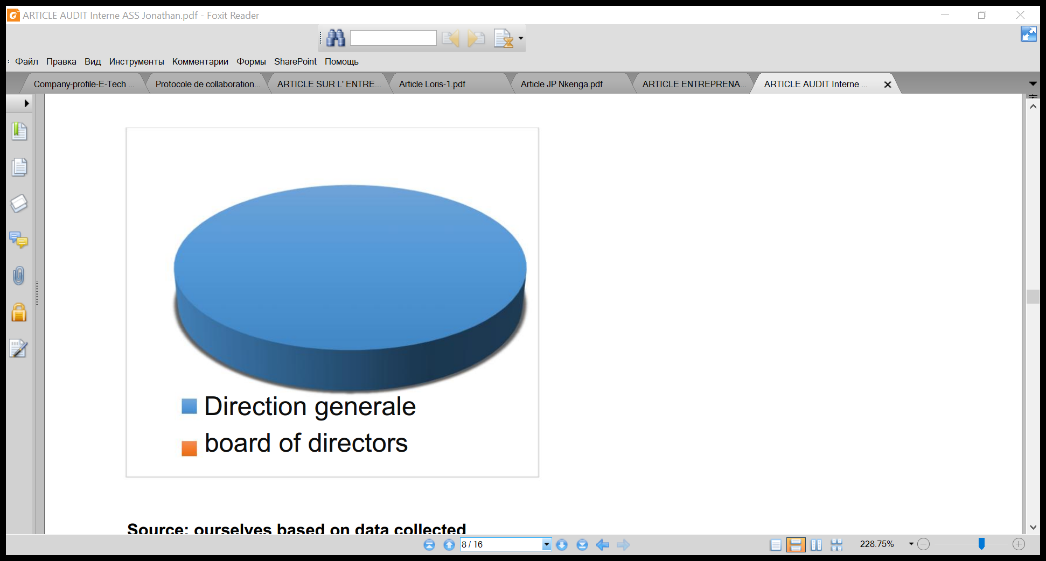

**Source: ourselves based on data collected**

The graph summarizes the survey on the attachment of the internal audit which promotes the Power of the body of the general management in the control of the entity to facilitate the work of the direct managers in the follow-up of their related task.

**CHART N°3 The area of intervention of internal audit**

**Source: ourselves based on data collected**

The result of the survey on the field of intervention shows that until now the intervention of the internal audit service has only been important in the field of accounting and the latter requires more control by compared to others since, according to the people questioned, they consider it more useful in this service, in particular for the transparency and the veracity of the financial information.

**How do you find the internal control system of GECAMINES?**

To answer this question, we interviewed twenty (20) workers in the internal audit department, taken as a sample of our study, and the answers obtained are summarized in the table below:

**TABLE N°2 EVALUATION OF THE INTERNAL CONTROL SYSTEM**

|  |  |  |
| --- | --- | --- |
| **ANSWERS** | **WORKFORCE** | **PERCENTAGE** |
| **Weak** | **3** | **15%** |
| **Medium** | **6** | **30%** |
| **Strong** | **9** | **45%** |
| **Very strong** | **2** | **10%** |
| **TOTAL** | **20** | **100%** |

Sources: ourselves based on the data collected

**CHART N°4 Evaluation of the internal control system of GECAMINES**

**Source: ourselves based on table N°2**

This graph shows us the effectiveness of the internal control system of GECAMINES.

**INTERNAL AUDIT REPORT FOR THE YEAR 2020**

Internal audit in its indicated definition must bring added value and reinforce efficiency and good governance. As for the auditors, they are generally satisfied with the internal audit assignments carried out by the audit department. On average, the GECAMINES audit department conducts seven (7) internal audit missions per year. These assignments may relate to several types of audits. As part of our research, we looked at the internal audit carried out in 2020 on the basis of data collected from the internal audit department.

**1. Production of the AI Department in the 2nd quarter of 2020**

73 audit reports produced, including draft acceptance audit reports. Overall rate of acceptance of audit reports, by the various Departments of the Company, 76.71% as set out, by Department, in the table below:

**TABLE N°3 Production of reports by department in the 2nd quarter of 2020**

|  |  |  |  |  |  |
| --- | --- | --- | --- | --- | --- |
| **Item** | **Direction** | **Number of draft audit reports sent for acceptance** | | **Number of projects accepted** | **Acceptance rate**  **%** |
| **In the month of**  **June** | **Accumulation** |
| 01  02  03  04  05  06  07  08  09  10  11  12  13  14  15  16  17  18 | DG  DFI  GPL  DAA  DCP  DAS  RDG/KIN  WHO  BU/US  BU/ACP  BU/AO  BU/KZI  BU/KZC  UCK  GEO  HSE  SG/DTH  DP | -  -  1  -  -  -  -  -  -  -  -  -  -  -  -  -  -  - | 1  7  3  14  7  11  2  4  7  2  2  2  1  1  5  2  1  1 | 0  1  1  13  3  9  2  4  7  2  2  2  0  1  5  2  1  1 | 0,00  14,28  50,00  92,85  42,85  81,81  100,00  100,00  100,00  100,00  100,00  100,00  00,00  100,00  100,00  100,00  66,67  100,00 |
| **Total** | | **1** | **73** | **56** | **76.71** |

Source: **GECAMINES audit department**

**TABLE N°4 Production of reports by division in the 2nd quarter of 2020**

|  |  |  |  |  |  |  |  |  |
| --- | --- | --- | --- | --- | --- | --- | --- | --- |
| **Division** | Audit reports | | | | Total | | Contribution by Division  (%) | |
| sent in acceptance | | broadcast | |
| Inv | General audits | Inv | General audits | Inv | General audits | Inv | General audits |
| AI/SOUTH  AI/CEN  AI/WEST  AI/FON  AI/CAP  CFA | 4  3  4  2  -  - | -  -  -  3  -  1 | 5  21  17  4  -  - | 1  5  3  -  -  - | 9  24  21  6  -  - | 1  5  3  3  -  1 | **15**  **40**  **35**  **10**  **-**  **-** | 8  38  23  23  -  8 |
| **S/Total** | **13** | **4** | **47** | **9** | **60** | **13** | **100** | **100** |
| **Grand total** | **17** | | **56** | | **73** | |

Source: **GECAMINES audit department**

**Audit recommendations issued in the 2nd quarter of 2020**

21 recommendations with an overall response rate of 4.76% as shown in the table below:

**2. Production of the AI Department in the 3rd quarter of 2020**

82 audit reports produced, including draft acceptance audit reports. Overall rate of acceptance of audit reports, by the various Departments of the Company, 78.05% as set out, by Department, in the table below:

**TABLE N°5 Production of reports by department in the 3rd quarter of 2020**

|  |  |  |  |  |  |
| --- | --- | --- | --- | --- | --- |
| **Item** | **Direction** | **Number of draft audit reports sent for acceptance** | | **Number of projects accepted** | **Acceptance rate**  **%** |
| **In the month of**  **July** | **Accumulation** |
| 01  02  03  04  05  06  07  08  09  10  11  12  13  14  15  16  17  18  19  20 | DG  DFI  DCO  GPL  DAA  DCP  DAS  RDG/KIN  WHO  BU/US  BU/ACP  BU/AO  BU/KZI  BU/KZC  UCK  GEO  HSE  SG/DTH  DP  AI | -  1  1  -  -  -  -  -  -  -  -  -  -  -  -  -  -  -  -  7 | 1  8  1  3  14  7  11  2  4  7  2  2  2  1  1  5  2  1  1  7 | 0  1  1  1  13  3  9  2  4  7  2  2  2  0  1  5  2  1  1  7 | 0,00  12,50  100,00  33,33  92,86  42,85  81.82  100.00  100.00  100.00  100.00  100.00  100.00  00.00  100.00  100.00  100.00  100.00  100.00  100.00 |
| **Total** | | **9** | **82** | **64** | **78.05** |

Source: **GECAMINES audit department**

**TABLE N°6 Production of reports by division in the 3rd quarter of 2020**

|  |  |  |  |  |  |  |  |  |
| --- | --- | --- | --- | --- | --- | --- | --- | --- |
| **Division** | Audit reports | | | | Total | | Contribution by Division  (%) | |
| sent in acceptance | | broadcast | |
| Inv | General Audits | Inv | General Audits | Inv | General Audits | Inv | General audits |
| AI/SOUTH  AI/CEN  AI/WEST  AI/FON  AI/CAP  CFA | 4  3  4  2  -  - | -  -  -  3  -  2 | 5  21  17  4  -  - | 2  6  4  -  1  4 | 9  24  21  6  -  - | 2  6  4  3  1  6 | **15**  **40**  **35**  **10**  **-**  **-** | **9**  **27**  **18**  **14**  **5**  **27** |
| **S/Total** | **13** | **5** | **47** | **17** | **60** | **22** | **100** | **100** |
| **Grand total** | **18** | | **64** | | **82** | |

Source: **GECAMINES audit department**

**Audit recommendations issued in the 3rd quarter of 2020**

24 recommendations with an overall response rate of 4.17% as indicated in the table below:

**3. Production of the AI Department in the 4th quarter of 2020**

86 audit reports produced, including draft acceptance audit reports. Overall rate of acceptance of audit reports, by the various Departments of the Company, 89.39% as set out, by Department, in the table below:

**TABLE N°7 Production of reports by department in the 4th quarter of 2020**

|  |  |  |  |  |  |
| --- | --- | --- | --- | --- | --- |
| **Item** | **Direction** | **Number of draft audit reports sent for acceptance** | | **Number of projects accepted** | **Acceptance rate**  **%** |
| **Monthly**  **August** | **Accumulation** |
| 01  02  03  04  05  06  07  08  09  10  11  12  13  14  15  16  17  18  19  20 | DG  DFI  DCO  GPL  DAA  DCP  DAS  RDG/KIN  GIM  THIS/US  BU/ACP  BU/AO  THIS/THE  BU/KZC  UCK  GEO  HSE  SG/DTH  DP  AI | 3  one  -  -  -  -  -  -  -  -  -  -  -  -  -  -  -  -  -  - | 4  9  1  3  14  7  11  2  4  7  2  2  2  1  1  5  2  1  1  7 | 4  1  1  3  13  3  9  2  4  7  2  2  2  0  1  5  2  1  1  7 | 100,00  12,50  100,00  100,00  92,86  42,85  81,82  100,00  100,00  100,00  100,00  100,00  100,00  00,00  100,00  100,00  100,00  100,00  100,00  100,00 |
| **Total** | | **4** | **86** | **70** | **81.39** |

Source: **GECAMINES audit department**

**DISCUSSION**

Internal audit appears as an unavoidable necessity to clearly define the attributions and responsibilities of each of the leaders, managers..., but also as a tool for control, evaluation and modernization , with a view to seeking efficiency. efficiency and economy, through the search for solutions to dysfunctions that risk hindering good governance. The internal audit is directly linked to the general management, which allows it on the one hand to ensure its independence and its autonomy with regard to the audited function and, on the other hand to have a freedom of its opinion. . Independence is an important determinant that shapes the professionalism of the internal audit function. It is within this framework that the professional standards for internal auditing clearly specify that auditors must be independent of the activities they audit.

Finally, we can see that the effectiveness of the internal audit is conditioned to a large extent by the independence of the auditor and his competence, as well as the mastery of the approach he follows to accomplish his mission.

**CONCLUSION**

By studying the internal audit and governance of **GECAMINES globally** , this study reveals that **GEACMINES** has an internal audit department attached to the general management which carries out seven **(7)** different audit missions per year, the competent auditors and efficient, effective internal control, good accounting organization and a centralizing accounting system that the internal audit is based on, a specialized committee, a board of directors, which shows good governance of **GECAMINES** . Taking into account the results obtained by the analysis of the pillar principles of good governance and the data collected on the ground, we can confirm our hypothesis by saying that the internal audit improves the governance of **GECAMINES** through the evaluation of the effectiveness of the internal control system, **GECAMINES** considers internal audit as a main tool in risk management to improve its governance and that the establishment of adequate control procedure leads to effective good governance.

**BIBLIOGRAPHY**

1. **WORKS**
2. Jacques RENARD, Theory and practice of internal audit, 7th edition, EYROLLE , Paris, 2017 , 46-72.
3. Mohamed HARAKAT, Audit in the public sector in MOROCCO, TOM 2, Rabat, 1994, 42-55.
4. Yvon MOUGIN, **new** QSEP audit management practices . AFNOR EDITION, 2003 , 69-75.
5. HECHMI ABDELWAHED, Guide for the Use of International Standards on Auditing in the Audit of Small and Medium Enterprises, 2013, 32-46.
6. **ITEMS**
7. RANDRIANARIVONY Faniry Elodie, corporate governance: one of the key factors in the development of companies with Malagasy state participation, 2014, 21-31.
8. HAJAR LAGHRISSI, internal audit and corporate governance, international journal of management sciences, 2021, 11-17
9. BENOIT PIGE, the challenges of the audit market, French management review, 2003, 15-20.
10. **WEBSITES**
11. Abdelhak ZIANI, "The role of internal audit in improving corporate governance: Case of Algerian companies" Doctoral thesis in economics, Algeria: Abou Bekr University Belkaid de Tlemcen, 2013/2014, [Online], (Accessed February 12, 2016) URL: [http://dspace.univ-tlemcen.dz/bitstream/112/5942/1/Le-role-de-l- internal-audit.doc.pdf](http://dspace.univ-tlemcen.dz/bitstream/112/5942/1/Le-role-de-l-audit-interne.doc.pdf)
12. Anoh AKOUBA MARINA, "The role of internal audit in corporate governance: the case of LONASE", specialized graduate diploma in Audit and Management Control, 2012. [Online], (Accessed February 20, 2016 ), URL: <http://bibliotheque.cesag.sn/doc_num.php?explnum_id=1746>
13. Christian DE VISSCHER and Laurent PETIT, "internal audit in public administration: an inventory of fixtures in the federal ministries" [On line] ,2002. (Accessed February 11, 2016). URL: pyramids.revues.org/473
14. MONSITE," Operational Audit", [Online], (Accessed April 10, 2016). URL: http://inpbpm.e-monsite.com/pages/definitions/audit-operationnel.html
15. Gérard CHARREAUX, "Definition of corporate governance", [Online], (Accessed February 20, 2016), URL: <http://gouvernancefinanciere.blogspot.com/2009/02/definitions-du-gouvernement-dentreprise.html>
16. IFACI, "Internal Audit Definition", [Online], (Accessed February 10, 2016). URL: [http://www.ifaci.com/...internal-audit/.../definition-of-internal-audit-207.html](http://www.ifaci.com/...audit-interne/.../definition-de-l-audit-interne-207.html)
17. IFACI, "corporate governance", [Online], (Accessed February 19, 2016), URL: