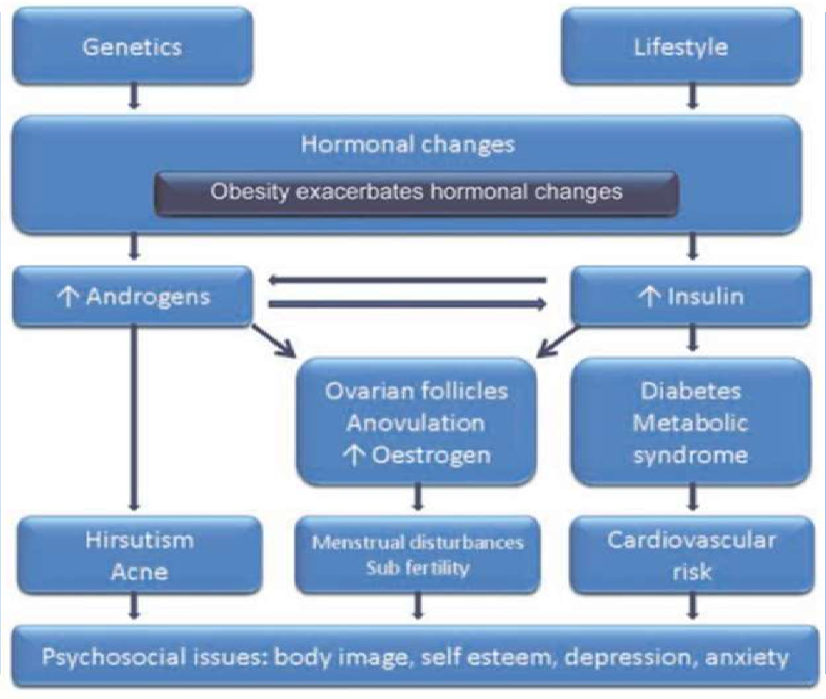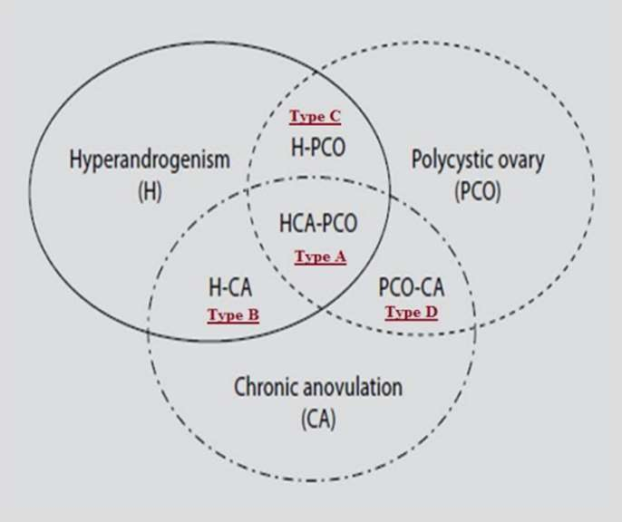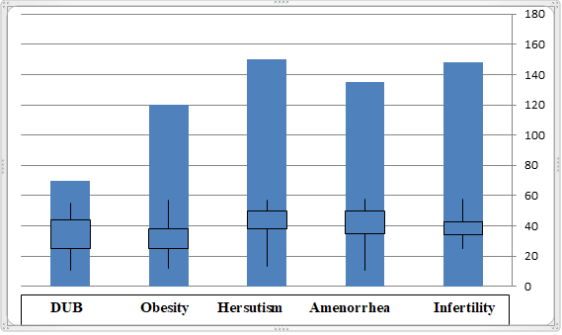

The Genetic Polymorphisms in Polycystic Ovarian Syndrome (PCOS)

BY STUDENT : Shakir Mahmood Salih

# Introduction

|  |  |  |  |
| --- | --- | --- | --- |
| **Diagnostic critera for the Polycystic Ovarian Syndrome (PCOS)** | | | |
|  | **1990 NIH critera** | **Revised rotterdam 2003** | **Androgen Excess PCOS critera** |
| **Hyperandrogenis m** | **A. Clinical and biochemical signs of hyperandrogenis m.** | **A. Clinical and biochemical signs of hyperandrogenis m.** | **A. Clinical and biochemical signs of hyperandrogenism.** |
| **Ovulation** | **B. Chronic anovulation** | **B.**  **Oligomenorrhea anovulation** | **B. Oligomenorrhea anovulation** |
| **Ovarian**  **Morphology** | **_** | **C. Polycystic ovarian morphology** | **C. Polycystic ovarian**  **morphology** |
| **Is exclusion of other endocrinopathi es needed for diagnosis?** | **Yes** | **Yes** | **Yes** |
| **Number of critera needed** | **Both A and B with endocrinopathie s** | **2 of 3 critera A- B-C with endocrinopathie s** | **Critera A plus either B or C with endocrinophaties.** |

Polycystic ovarian syndrome (PCOS) is a clinical picture characterized by the presence of ovaries with small cysts, amenorrhea, hirsutism, which is now also known as functional ovarian hyperandrogenism. In honor of these authors, was called Stein Leventhal syndrome.

This syndrome can be identified by hyperandrogenism and chronic anovulation in the women with no specific cause of adrenal or pituitary dysfunction (non-classical congenital adrenal hyperplasia, hyperprolactinemia, Cushing's syndrome, and androgen-secreting tumors).

# Objectives

My aim in this research is to convey a brief and useful idea about this syndrome, since it has spread recently in most women, for several reasons. Also , this subject is very rare and important to know. Most women should be careful from this syndrome (PCOS).

# Methodology

PCOS can be defined as the most not unusual endocrine abnormality in reproductive-age ladies. It includes heterogeneous aggregate of hyperandrogenism, chronic anovulation and polycystic ovaries.

There are 4 different PCOS phenotypes:

* + Type A: hyperandrogenism, persistent anovulation, and polycystic ovaries.
  + Type B: chronic anovulation and hyperandrogenism.
  + Type C: polycystic ovaries and hyperandrogenism.
  + Type D: persistent anovulation and polycystic ovaries.

Fig2: Aetiological, clinical, and hormonal characteristics of PCOS.

# Results and discussion

As a result of the complexity of PCOS, the lack of knowledge that still existed about its etiology and the great frequency of its presentation.

PCOS was a multi-factorial disease, where various environmental and genetic factors were participated, abnormalities in ovarian steroidogenesis and follicular development had been associated in its appearance, as well as gonadotropin-releasing hormone impulses, to an excess of luteinizing hormone and insufficient secretion of FSH that helped ovarian androgen excess production and ovulatory dysfunctions, this androgen overproduction is also favored by hyperinsulinemia due to insulin resistance.

# Conclusion

The molecular genetics of PCOS, in addition to its clinical aspects, show that it is a complex disease.

PCOS constitutes one of the main endocrine disorders present in reproductive age women, with prevalence that ranges between 8.7 and 17.8%. The phenotype of this disease is very diverse; however, all women who have PCOS present ovaries with polycystic morphology, hyperandrogenism, anovulation, and gonadotropic abnormalities, becoming the most common cause of anovulatory infertility.

# References

1. Allahbadia GN and Merchant R (2011): Polycystic ovary syndrome and impact on health. Middle East Fertility Society Journal 16: 19-37.
2. Desai SS, Roy BS and Mahale SD (2013): Mutations and polymorphisms in FSH receptor: functional implications in human reproduction. Reproduction 146: R235-248.
3. Diamanti-Kandarakis E, Palioniko G, Alexandraki K, Bergiele A, Koutsouba T, Bartzis M. The prevalence of 4G5G polymorphism of plasminogen activator inhibitor-1 (PAI-1) levels. Eur J Endocrinol. 2004;150:793-8.
4. Goodarzi MO (2008): Looking for polycystic ovary syndrome genes: rational and best strategy. Semin Reprod Med 26: 5-13.
5. Walker WH and Cheng J (2005): FSH and testosterone signaling in Sertoli cells. Reproduction 130: 15-28.
6. Jakubowki L. Genetic aspects of polycystic ovary syndrome. Endokrynol

Pol. 2005;56:285-93.

Fig1:The variety of the phenotypes in PCOS