**New Methods and Materials Used in Soil–Related Road Deterioration**

**in the Uluyazı (Çankırı) Campus, Türkiye**

***Muharrem TIRIN1[C:\Users\Abdullah\AppData\Local\Microsoft\Windows\INetCache\Content.Word\ORCID-iD_icon-16x16.gif](https://orcid.org/0000-xxxx-xxxx-xxxx), Ender SARIFAKIOĞLU2[C:\Users\Abdullah\AppData\Local\Microsoft\Windows\INetCache\Content.Word\ORCID-iD_icon-16x16.gif](https://orcid.org/0000-xxxx-xxxx-xxxx)***

*1Department of Construction and Technical Affairs, Çankırı Karatekin University, Çankırı, Türkiye*

*2Faculty of Engineering, Department of Civil Engineering, Çankırı Karatekin University, Çankırı, Türkiye*

|  |
| --- |
| **Abstract**  While the world is experiencing the age of technology at full speed, Turkey is also taking steps to implement innovations by following these technological developments. These technological and industrial innovations have become rapidly widespread in the construction industry. The rapid population growth of countries, which is seen as a problem of the developing world, increases the need for new settlement areas and new roads. With population growth and the slow development of widespread railway networks in public transportation services due to their costs, the vehicle load on the roads also increases and old roads and traditional methods lose their effectiveness in the long term. Therefore, these vehicle loads cause permanent problems on the roads. The main reasons for deterioration in road structures are the same applications in regions with different weather conditions, errors during application, errors in the selection of methods, as well as deformations caused by the type of ground on which the application will be made. Problems that may occur as a result of ground effect are observed as cracks and deformations on the coating surface. The lithological characteristics of the ground of the new road line in the Çankırı Karatekin University, Uluyazı Campus especially the melting–collapse at gypsum levels, the deformations caused by these and the areas with landslide risk were examined. For the improvements that can be made on the new road line and landslide risk area, the contributions of a number of new applications and materials (geosynthetics) suitable for the lithological characteristics of the region have been examined. |
| ***Keywords:*** *Çankırı, Gypsum, Landslide Prevention, New Road Construction Method, Geosynthetics* |

**1. Introduction**

Along with innovations in the field of engineering, the materials used in the manufacturing and construction phases of a job have also developed rapidly. Thanks to the developments in the construction sector, they have increased their quality in production, saved time by shortening work completion times thanks to practical conveniences, and provided advantages in costs with the increase in access opportunities. Geotextiles, which have been used for many years in leading countries in technological development but have become widespread in Turkey in the 21st century, have shown a rapid rise by taking part in many areas in the construction industry. Thanks to the strength parameters of geotextiles increasing in line with technology, their usage area in road construction has rapidly expanded.

The dominant lithological units in the Çankırı basin are gypsum, rock salt, sandstone, mudstone, claystone and limestone, which are frequently encountered in the Central Anatolia region. The most important factor that causes deformation, especially in gypsum levels, is melting when groundwater and surface water come into contact. The magnitude of the deformations caused by the dissolution of gypsum minerals is related to the gypsum layer thickness, the lithology of the other rock units with which it is intercalated (such as mudstone, sandstone), the chemical content of the gypsum and the geological structure of the region (such as folds, faults). Such minerals found in the ground cause structural deformations in buildings and road pavements.

The main reasons for the collapses, slides and cracks in the road superstructure that occurred over time on the ring road built during the construction of the Çankırı Karatekin University, Uluyazı Campus were determined as;

* The campus is on loose ground that is not resistant to abrasion,
* Groundwater and rainwater form a natural bed in the region,
* The slope on the road line, which is at risk of landslide, cannot maintain its stability in this situation.

**1.1. Study Area**

The study area is within the borders of the central district of the Çankırı province (Figure 1). The altitude of Çankırı City Center is 720 meters above the sea level, and the altitude of Uluyazı Hill is 900 meters above the sea level.

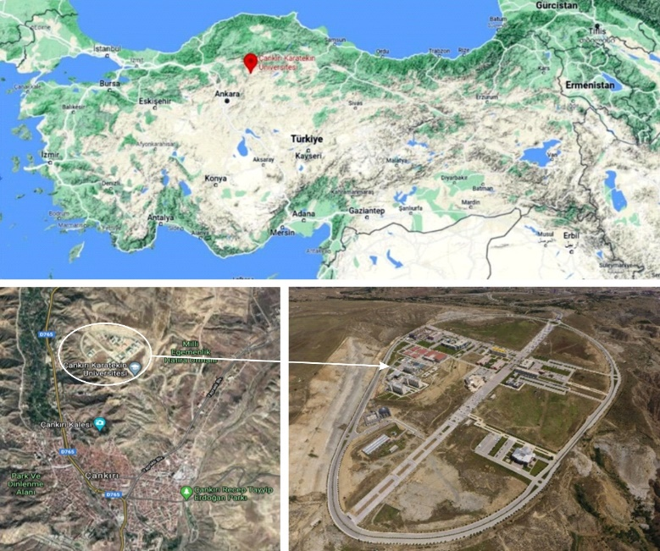

**Figure 1.** Study area layout information [6].

**1.2. Regional Geology**

Around the Çankırı city, from oldest to the youngest unit belonging to the Tertiary period, the İncik, Bayındır, Kızılırmak, Bozkır, Değim formations and Quaternary alluviums and terraces are observed [1–4–5]. The Oligo-Miocene aged İncik formation consists of red-coloured, thick–very thick layered conglomerates and creamy light brown-coloured sandstones and mudstones. The Middle Miocene aged Bayındır formation includes sandstone, mudstone levels and gypsum interlayers (Figure 2a, b). The Bozkır formation consists of mudstone and gypsum levels. The mudstone layers, which are light greenish and light gray in color, are thinner than gypsum layers and generally contain gypsum crystals. The Bozkır formation represents a deposit in a lacustrine evaporative environment.

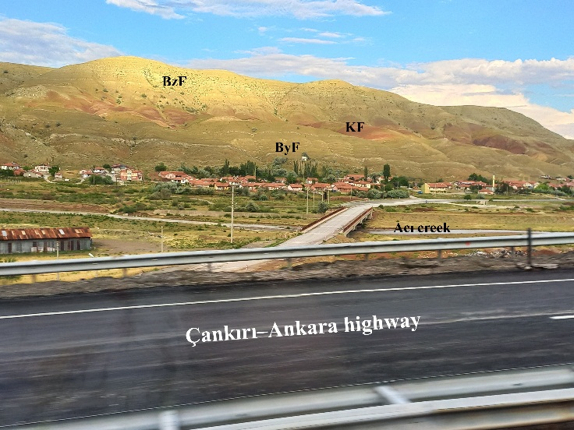 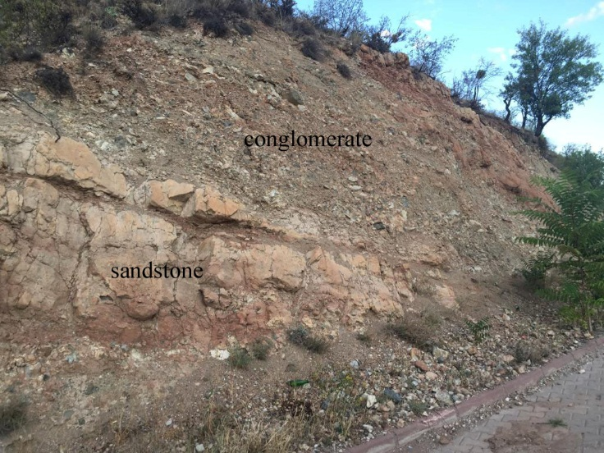

**b**

**a**

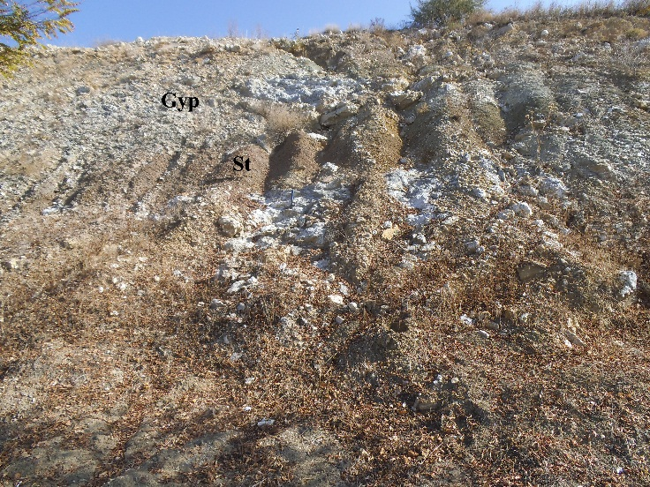

**c**

**Figure 2. a)** TheBayındır (ByF), Kızılırmak (KF), Bozkır (BzF) formations and Acı creek alluviums exposed on the Çankırı–Ankara highway.  **b)** Sandstone–conglomerate intercalated levels belonging to the İncik Formation exposed around the Çankırı Castle. **c)** Gypsum (Gyp) levels and fine-grained, loose sandstone (St) alternations in the Uluyazı Campus area.

**2. Material and Methods**

**2.1. Field Studies**

In this section, the studies carried out in the field to identify the geological units cropping out in the Uluyazı campus, to determine the lateral and vertical changes of the detected units, and to determine the groundwater level are mentioned under 3 headings:

* Determination of Surface Movements
* Landslide Area Drilling Works
* Situation Analysis of the Landslide Area
* New Road Route Drilling Works

**2.1.1. Determination of surface movements**

It has been observed that the slope in an area close to the campus road route line cannot ensure its stability. The movement of the sliding mass in the landslide area was determined by processing the data obtained from the guides placed in order to observe the displacements occurring on the ground surface (Figure 3).



**Figure 3.** Reference points and displacement amounts [6].

The readings made from the placed reference points were repeated with GPS measurements approximately 40 days later and the amounts of surface movement during the elapsed time were determined. In the elapsed time period, displacements of 28 cm in the horizontal direction and 20 cm in the vertical direction were determined between the first and last readings.

**2.1.2. Landslide area drilling works**

Total of 13 basic drillings and 3 observation wells were opened in the landslide area at the border of the campus ring road. When the drilling data and field observations were evaluated, it was determined that the lowest hard layer in the study area contained claystone, sandstone and conglomerate, and the upper levels of this layer consisted of gypsum silty clay, clayey silt and clay layers, and there was filling material at the upper levels (Table 1).

**Table 1.** Drilling Well Data [6].

|  |  |  |
| --- | --- | --- |
| Well No | Depth (m) | Lithology |
| DW–1 | 24 | Clay between 0–2.50 m., clay–mudstone–gypsum between 2.50–7.50 m., mudstone–gypsum between 7.5–15 m., 15–30 m. mudstone–gypsum, sandstone in places, conglomerate alternation. The lowest layer is sandstone, conglomerate intercalation. |
| DW–2 | 18 |
| DW–3 | 39.7 |
| DW–4 | 6.4 |
| DW–5 | 8.3 |
| DW–6 | 4.5 |
| DW–7 | 21.9 |
| DW–8 | 22.1 |
| DW–9 | 22 |
| DW–10 | 13 |
| DW–11 | 38 |
| DW–12 | 11.85 |
| DW–13 | 6.2 |

**2.1.3. Situation analysis of the landslide area**

Using the data obtained from the field investigations and the Slide 2018 software, a comparative analysis was made of the static situation of the landslide area and the risk assessments in the earthquake zone of the region (Figure 4). In the analysis, deformations (mass strength loss) caused by dynamic stresses in the slope under earthquake loads were determined. Deterioration of slope stability due to deterioration in the stress-strain behavior of the material and loss of strength under dynamic loads was examined.

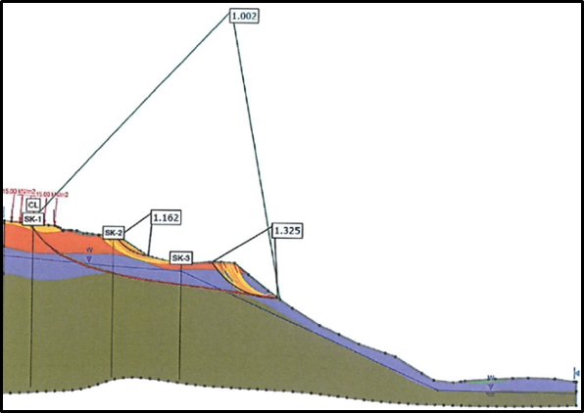 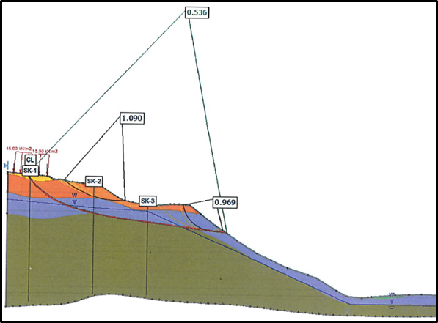

**a**

**b**

**Figure 4. a)** Analysis model showing the current situation screenshot (static situation). **b)** Analysis model showing the current situation screenshot (earthquake situation).

As can be seen from the software analysis, while the safety number of the slope area approaches 1 in static condition, it drops below 1 under dynamic earthquake loads. For this reason, it is seen that permanent deformations will occur with the deterioration of stability (Factor of Safety / F.S. is calculated according to Eurocode 7 and BS 8006 standards) (Figure 5).

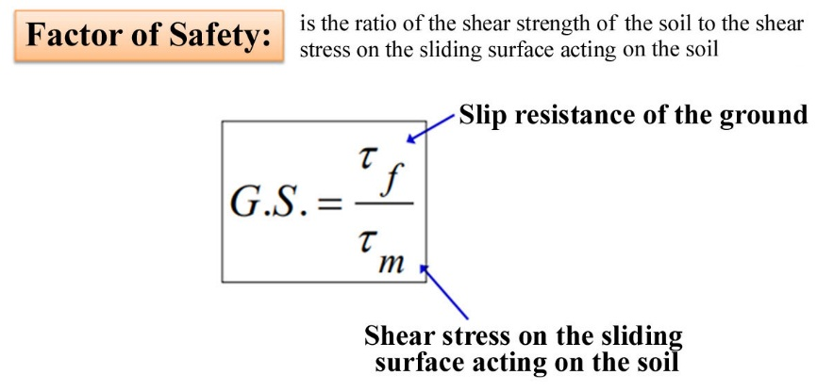

**Figure 5.** Factor of Safety formula of the foundation [2–3].

**2.1.4. New road route drilling works**

The old road route in the study area was changed due to being in a landslide risk area and dissolution due to ground lithology. It was decided to carry out drilling between the starting and ending points of the road, approximately 100 m apart, parallel to the axis of the planned new road route. The aim of the studies is to determine the lithological characteristics of the ground on the road route and to determine the areas where groundwater is concentrated by determining the groundwater level. Drilling studies were carried out at an average depth of 35 m and samples were taken every 1 m (Figure 6).

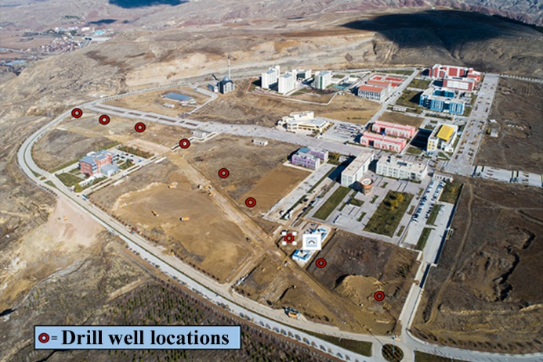 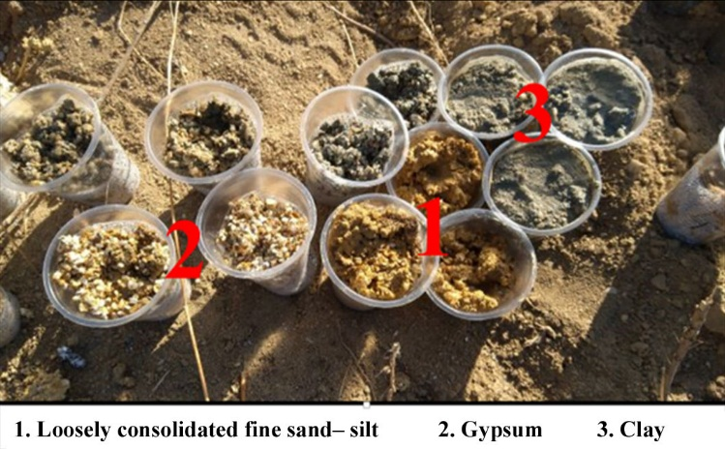

**b**

**a**

**Figure 6. a)** Drilling wells, **b)** Samples obtained from drilling studies [6].

**2.2. Evaluation of Field Data**

* As a result of drilling observations carried out in the campus area, it was observed that groundwater formed a bed near the landslide area.
* As a result of drilling core samples, it was determined that the study area was formed by gypsum–mudstone alternation.
* Due to the dissolution and decomposition of the gypsum unit seen in the field under the influence of underground and surface waters, it created a sensitivity problem on the slopes by digging a deep valley.
* Additionally, the faults around the Çankırı province are seismically active. The active earthquake danger is too high to be ignored.

**2.3. Improvement Practices**

Improvement works carried out on the road route and on slopes at risk of landslides are examined under this section.

**2.3.1. Controlling the groundwater level**

In order to determine the groundwater level in the landslide area and the road route to be constructed, drill wells with a depth of 30–40 m. were opened. In the borehole investigations, it was determined that the underground water level next to the landslide area was 6–7 m. As a result of the observation wells opened, it was determined that groundwater flows by forming a bed near the landslide area. Electric water evacuation pumps were placed in these wells to keep the water level at 35 m. Groundwater discharged from the wells is connected to rainwater lines through surface drainage channels (Figure 7).

**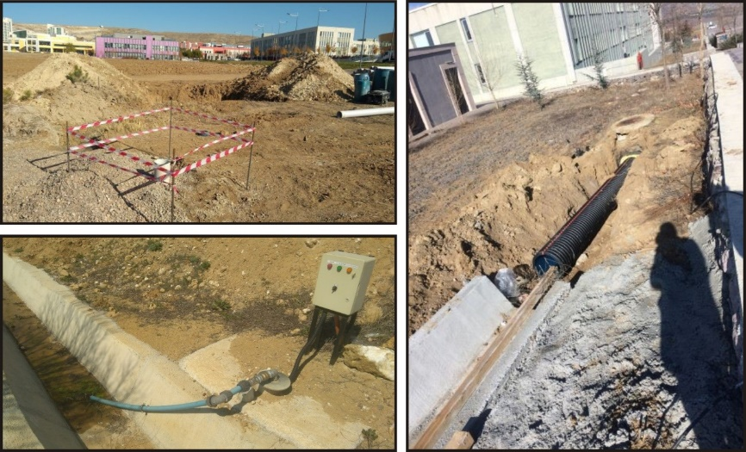**

**Figure 7.** Studies on the detection and discharge of groundwater [6].

**2.3.2. Strengthening road infrastructure**

Lithologically, the intercalation of gypsum with clay or mudstone negatively affects the road infrastructure and coating. When gypsum comes into contact with water, dissolution in these areas causes collapse. Another negative aspect of the gypsum mineral is that it creates a landslide risk as a result of its intercalation with clay layers. As a result of these data and evaluations, it was considered appropriate to replace the natural ground with durable (basalt) filling material before starting the road construction. The natural soil with gypsum along the road route was excavated for an average of 1 m and replaced with coarse-grained filling material by compaction (Figure 8).

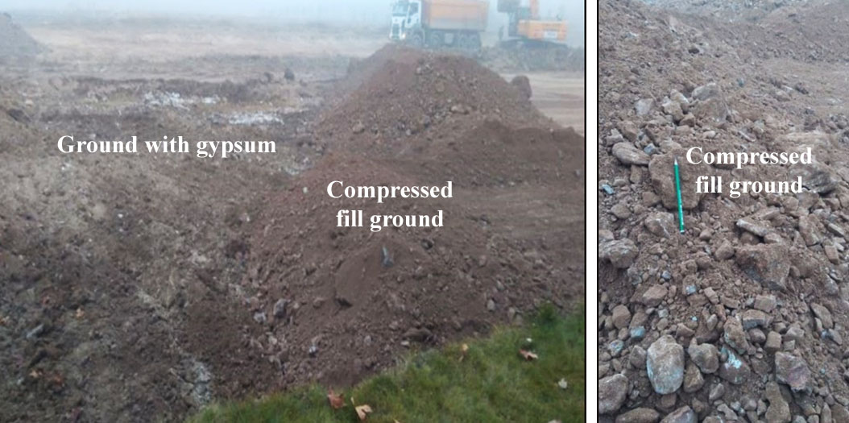

**Figure 8.** Excavation of the gypsum soil and its replacement with compressed fill [6].

The most important task expected from a highway is to avoid deformations in the asphalt layer exposed to dynamic loads. The soft filled soil on the new road line at the Çankırı Karatekin University, Uluyazı campus is one of the biggest problems and exhibits weak behavior under tensile stresses. For this reason, after the road infrastructure works, the stage of strengthening the foundation ground was started and for this purpose, the infrastructure was supported with geosynthetic products. The contribution of geosynthetics in construction areas with their properties such as filtration, reinforcement and separation has been revealed [7]. The most important reason for using geosynthetics in road construction is that the ground behaves in a reinforced manner. Geosynthetic products, geomembrane and geocell, were used together in campus road construction (Figure 9).

**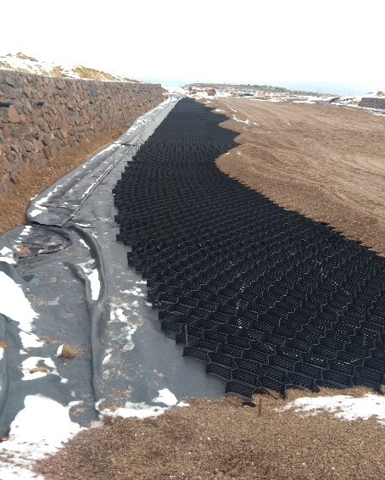** kalıp, desen, düzen, siyah beyaz, gri, kumaş, doku içeren bir resim

Açıklama otomatik olarak oluşturuldu

**d**

**a**

**b**

**c**

**Figure 9. a)** Geomembrane, **b)** Geocell, **c)** Filtration aggregate, **d)** Detailed view of Geocell [6].

**2.3.3. Carrying Out Remediation Studies on Slopes with Landslide Risk**

Although many methods are used to remediate landslides, this study aims to ensure slope stability with cellular filling of the landslide area. As improvement studies, reducing the slope, changing the slope fill soil, strengthening with geocell and afforestation were implemented (Figure 10). Firstly, the inclination of the slope was reduced by filling the road infrastructure with compressed soil. In addition, the negative effects of gypsum–clay alternations on plant growth in the Uluyazı region were eliminated by covering the gypsum land cover with filling material. The cellular filling system to be used with the new filling material will contribute to landslide prevention by increasing vertical rooting by holding plant roots more firmly to the slope. As an additional precaution to these practices, the lines of the drainage discharge water flowing into the landslide area have been changed.

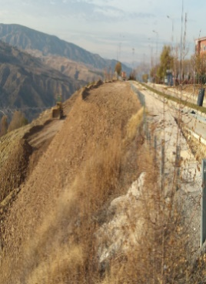 **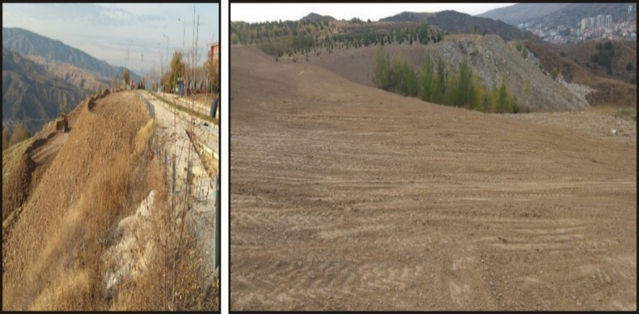** 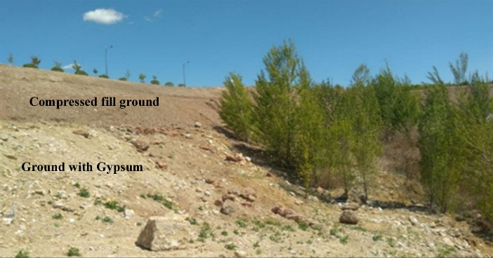

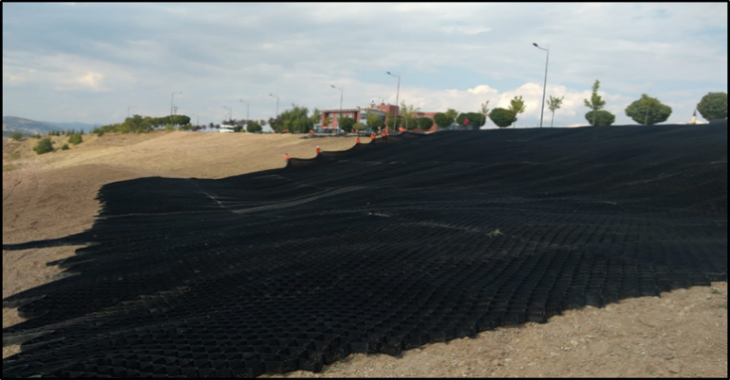 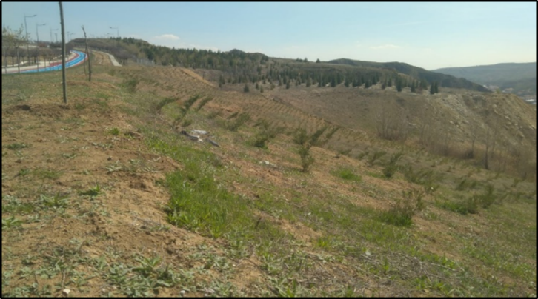

**Figure 10.** Views from improvement studies of the landslide area [6].

**3. Discussion and Conclusion**

Expected results from field observations, laboratory experiments, tectonic activity data in the region and the applications made as a result of these observations–analyses are as follows;

1. Cellular filling system (Geocells) prevents the formation of collapses and cracks in the upper layer of the road route exposed to vertical moving loads,

2. Thanks to its distinctive feature, the geomembrane minimizes the deformations in the upper layer by preventing the passage of groundwater between the asphalt base layer and the route ground,

3. By laying compressed ground fill on the gypsum ground, foundation fill is created and the road is placed on a more solid ground,

4. Keeping water away from the ground as much as possible with underground drainage water pumps and aboveground drainage lines,

5. Slope reduction works are carried out with fillers in the landslide area, and cellular filler is applied to the slope surface with geocells to increase the stability of the slope and reduce the speed of the landslide.

6. Elimination of irregular loads by preventing uncontrolled filling in the landslide area during campus works, these studies aimed to create a safer campus road route and to prevent accidents and loss of life in the landslide area.

**Acknowledgements**

This study is derived from Muharrem Tırın's MSc Thesis. We would like to thank to the Department of Construction and Technical Affairs of the Çankırı Karatekin University, for the opportunities provided and our colleagues working within the scope of the project for their support.

**References**

1. Akyürek, B., Bilginer, E., Çatal, E., Dağer, Z., Soysal, Y. and Sunu, O. 1980. Eldivan–Şabanözü (Çankırı), Hasayaz–Çandır (Kalecik–Ankara) dolayının jeolojisi. MTA Report No: 6741
2. British Standard, BS8006–1, 1995. Code of Practice for Strengthened/Reinforced Soils and Other Fills.
3. EN 1997–1. 2004. Eurocode 7: Geotechnical design – part 1: General rules. European Committee for Standardization, Brussels.
4. Hakyemez, Y., Barkurt, M.Y., Bilginer, E., Pehlivan, Ş., Can, B., Dağer, Z. and Sözeri, B. 1986. Yapraklı–Ilgaz–Çankırı–Çandır dolayının jeolojisi. MTA Report No. 7966
5. Sarıfakıoğlu, E., Sevin, M., Esirtgen, E., Bilgiç, T. Duran, S., Parlak, O., Karabalık, N. N., Alemdar, S., Dilek, Y. and Uysal. İ. 2011. Çankırı–Çorum havzasını çevreleyen ofiyolitik kayaçların jeolojisi: Petrojenezi, tektoniği ve cevher içerikleri. Maden Tetkik ve Arama Genel Müdürlüğü, Report No: 11449, Ankara
6. Tırın, M. 2023. Uluyazı (Çankırı) Kampüsünde Zemin Kaynaklı Yol Bozulmalarında Uygulanan Yeni Metotlar ve Kullanılan Malzemeler. MSc Thesis. Çankırı Karatekin Üniversitesi, Fen Bilimleri Enstitüsü 74 p., Çankırı.
7. Adams, M. and Collin, J. 1997. Large model spread footing load tests on geosynthetic reinforced soil foundations. J. Geotech. Geoenviron. Eng., 123(1), 66–72.