**The Exotic Model in Romanian Interwar Art**

**Out of Love for Balchik**

**Abstract:***The muses of artists began to become more and more diverse, through diversity meaning an increasing acceptance for what is foreign or different. This trend appears in fine arts, but also in literature, especially in the romantic model, which imposes a real fascination for the views, habits and expressive portraits of the inhabitants of the countries of the Far East. The Orient is seen as exotic, colorful and sensual, and the motif of the odalisques confirms the idea of ​​lasciviousness and visual spectacle, offering through the representation of female forms an erotic variant of the Orient. The phenomenon of Balchik, represented by the works of interwar artists, definitively conquered by the undulating landscapes and by the expressiveness and exoticism of the odalisques, represents one of the best moments of modern Romanian painting. The magical universe of the Silver Coast, as well as the typical oriental figures, give the inhabitants and the landscape the possibility to become the favorite subject of the painters.* *Balchik and the oriental motifs discovered here offered for the interwar Romanian artists, almost exclusively, painting subjects. At the Art Museum of Constanța, as well as at the Dinu and Sevasta Vintilă Museum in Toplau, there are some of the most important works with this theme.*

**Key-words:** *Oriental Art; Balcic; Silver Coast; Interwar Romanian Painting; Oriental Motifs; Constanța Art Museum*

**1. Introduction**

Artists has always tried to represent the beauty of the human face and body in different ways, and for this, he sought in the figure of the ethnic those traits that capture a way of life, a culture, a type of sensuality capable of fueling his creativity. Thus, the artists' travels were motivated by the desire to find an earthly paradise, populated by characters full of exoticism and beauty.

The muses of artists began to become more and more diverse, through diversity meaning an increasing acceptance for what is foreign or different. This trend appears in fine arts, but also in literature, especially in the romantic model, which imposes a real fascination for the views, habits and expressive portraits of the inhabitants of the countries of the Far East.

The Orient is seen as exotic, colorful and sensual, and the motif of the odalisques confirms the idea of ​​lasciviousness and visual spectacle, offering through the representation of female forms an erotic variant of the Orient.

**2. The Silver Coast** **- The artists are inspired by ancient symbols**

Originally called Cruni (Kruni, Crunos, Crunoi, Crunon) and consecrated after the ancient foundation of Dionysos, god of wine and partying, vegetation, divine inspiration, exaltation and purification, thanks to a statue thrown by the waves on the shore, attribution taken in toponymy together with the term polis (city-state in ancient Greece), so Dionysopolis, a theophoric fortress, Balchik of modern times manages to achieve after 1913, when it is included in the territory of Romania, an unrepeatable performance; considered “a window open to the enchantments of the Orient, the window through which so far only our painters and artists have seen such a subtle understanding of the beauties of nature… Her Majesty the Queen” (Maria), in the vision of the geographer Gheorghe Vâlsan (1), received under siege of the ruthless sun “with its southern light”, by I. Simionescu (2), suspected by Mihail Sebastian that “it has nothing Mediterranean” (3) described by Gala Galaction as “a splendid place of biblical meditation” (4), considered by Gheorghe Mugur “an earthly spectacle with faces and appearances from the patriarchal beauty of the Old Testament ”(5) and endowed with the“ most evangelical ”donkeys (6), the city -“ of a tragedy that terrifies you ”, according to Tonitza, but which“ this pious and humble iconographer of the coast

"He paints it wrapped in a transparent and transparent light - he created in art, according to Emanoil Bucuţa, his exegete and according to today's certainties," a real current with power close to sheet ”(7), so that, quoting Camil Petrescu, the entire“ Romanian painting at one point had only one subject: Balchik ”(8).

Balchik and the oriental motifs discovered here offered for the interwar Romanian artists, almost exclusively, painting subjects. At the Art Museum of Constanța, as well as at the Dinu and Sevasta Vintilă Museum in Toplau, there are some of the most important works with this theme. Nicolae Tonitza, Iosif Iser, Ştefan Dimitrescu, Ştefan Popescu, are definitely linked to the history and cultural richness of that area, through paintings that feature characters such as Mamut or Ismail, Afize or Luftie. Queen Maria loved this land very much, and the influence that the local population, but also the architecture of oriental origin had on her, are evident in her clothes, but also in architectural elements, visible especially at her castle, which she takes added a minaret.

The muffled face of "Ahmet Ali", painted by Jean Alexandru Steriadi, smiles at us from the Dinu Museum and Sevasta Vintilă in Topalu, and Mamut's presence is only suspected in the cafe that Nicolae Tonitza paints in Balchik, fascinated by the silence he it can be cleared by a corner forgotten by the world and bathed in the silver light of the sea shore. We find the same absence in Osman's Gate painting. The work, located at the Constanța Art Museum, takes us to Tonitza's universe, in its very intimate core, where, from very few touches of ocher, blue and green, a world, a sensation, a masterpiece is recreated.

In Iser Iosif, the female model, whether she appears inside or in the landscape, has the same majestic attitude, carved as if in stone, and in works with a suggestive title “Odaliscă” (Constanța Art Museum) “Tătăroaice” (Constanța), “Turcoaice at rest ”(Dinu Museum and Sevasta Vintilă Toplau),“ Tătăroaice la Silistra ”(Toplau), he does not look for the easy exoticism of embroideries, clothes, external aspects, but captures the calm and monumentality of the human character.

For Nicolae Tonitza, the female model represents a mixture of grace and seduction, and the works at the museum in Toplau: "Tatar with a child", "Tatar's head" or "Tatar in blue", come to confirm this. Rendered in vibrant colors, the Turks and Tartars from Balchik and the Dobrogea coast, in general, appear to us as a standard of beauty, untouchable, frozen as if in time by their attitudes and static positions.

„Discovered by Alexandru Satmary, Iosif Iser, Gheorghe Petraşcu, Ion Theodorescu-Sion and Ipolit Strâmbu [lescu] almost simultaneously, but independently of each other, since 1913, Dobrogea established itself in Romanian art only at the beginning and during the interwar period - through the monotonous or spectacular relief, through the structure of its settlements with characters and objects figured under the stillness of a hallucinatory light, reflected by rebellious geological layers and the sea - to redefine itself through a south of it. The palimpsest of cultures and civilizations, with a fabulous past and settlement, Balchik has allowed any approach, in the name of modernity or tradition, as a temptation of the recovered West or the East finally found, in a limited and probably unrepeatable time. in the name of history, certainly original and unique in the name of painting.(9)

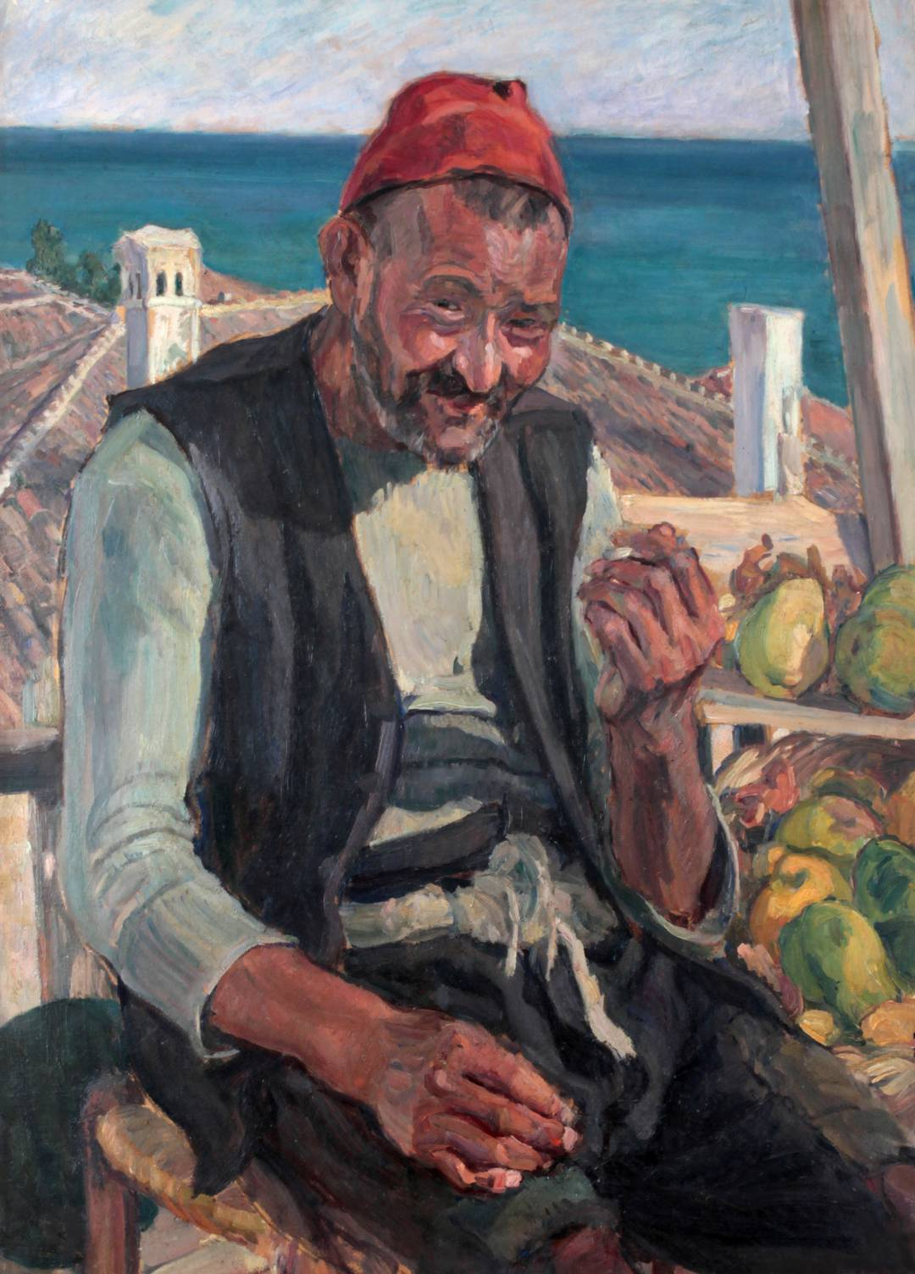 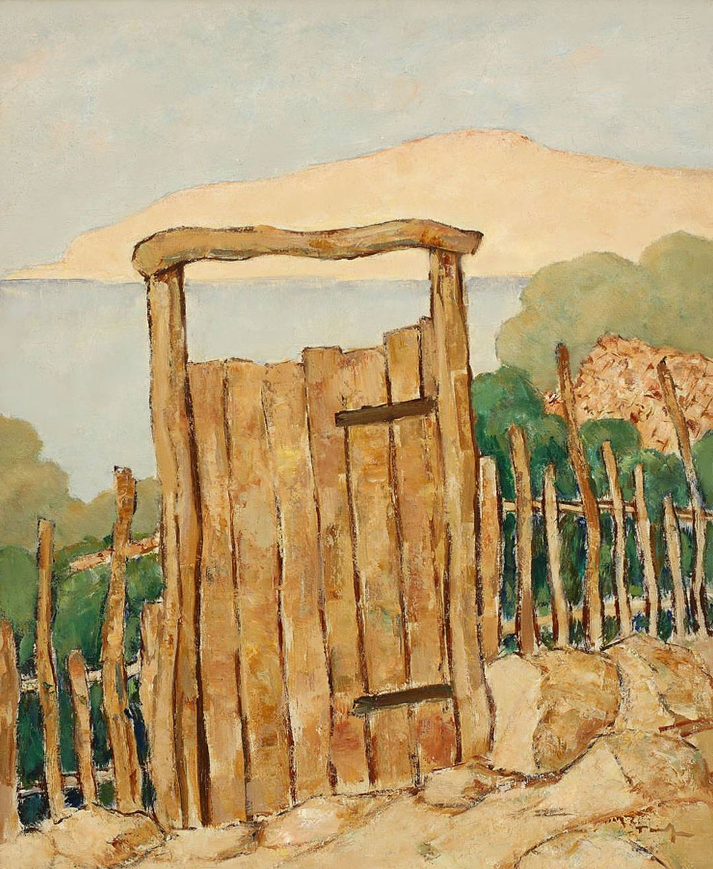

1. Jean Alexandru Steriadi, Ahmet-Ali 2. NicolaeTonitza, Osman's Gate

Photo source: http://miras.gov.ro/1/expozitie-temporara/

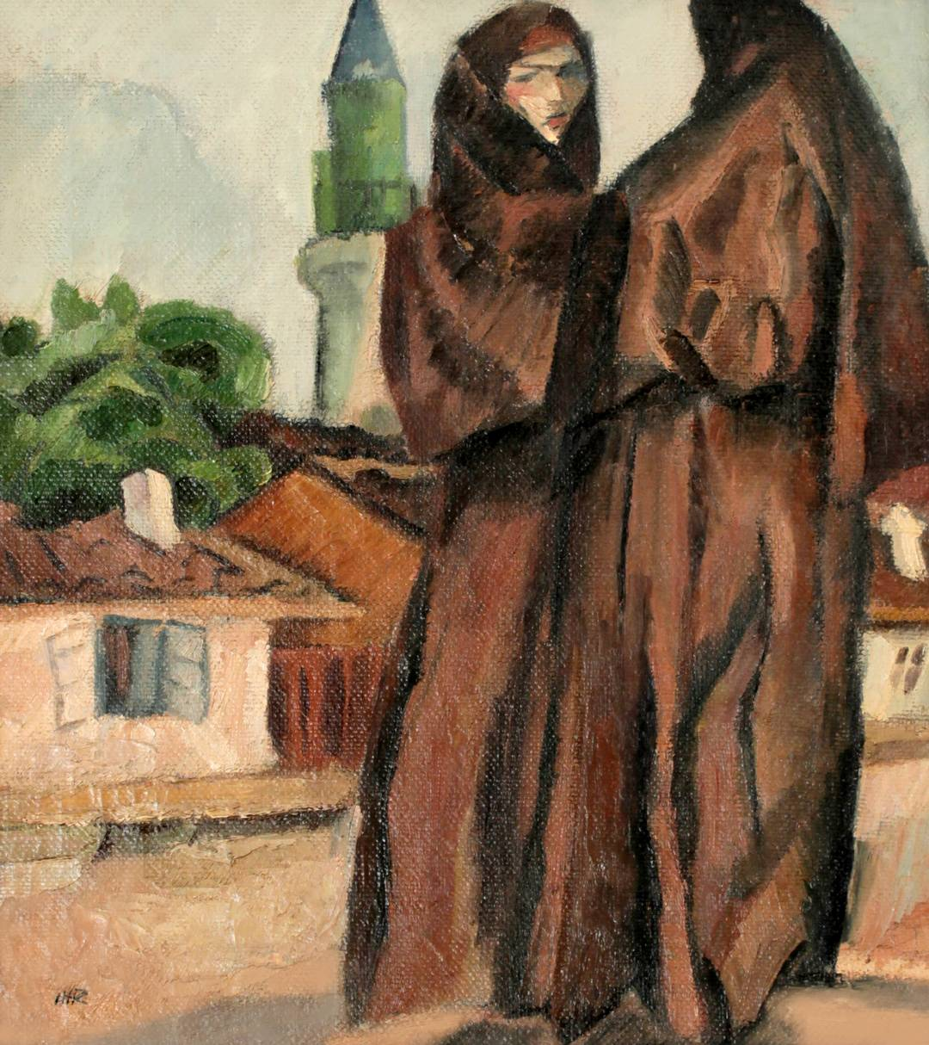 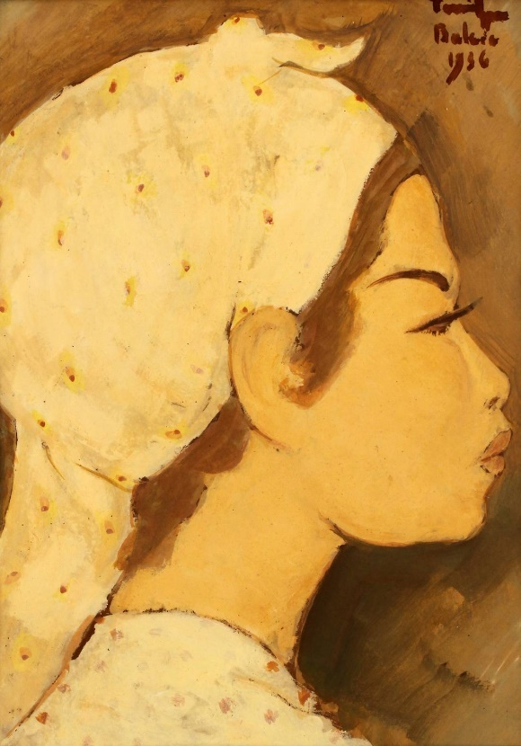

3. Iosif Iser-Tatar women at Silistra 4. NicolaeTonitza- Head of Tatar

Photo source: http://miras.gov.ro/1/expozitie-temporara/

The article On the White Shore of the Black Sea, published by Adrian Maniu (brother of the painter Rodica Maniu Mützner) in 1928, gives an account, in appropriate metaphors and thoughts, of the tireless fascination that Balchik can inspire and maintain: “It seems that the ages also have places resting in the world, as well as migratory birds. How else to interpret the mystery of the city, which for thousands of years, desolate and torn down by wars and invasions, is tirelessly rising to a new life for it?

On the white shore of the Black Sea, where painters and poets gather today and seek inspiration, and where the mourning of Her Majesty Queen Mary seeks her sad relief, there have been poets and painters in other ages, some brought from exile, others for the sake of this land. miraculously and royal steps passed on the same Dobrogean expanse. There are meetings and spaces of thoughts and events that revive. This is told to us to this day by the Chronicle of the Byzantine Porphyrogenites and the organs of the Scythian kings. This earth must be loved. The hour will come, of course, when the church will remember that on the white shore were the first glorious Christian basilicas of the good will. ”(9)

"Later," says Balmanik's exegetical Emanoil Bucuta in 1930, "artists turned it into a great workshop. On all the cracks and at all the crossings, with the blue and moving horizon in the background or the mysterious minaret, you met them, from dawn to dusk, drawing lines and putting colors. A turquoise with a tassel-free fez on the back of its neck and a bare chest from the open ilicum seemed to come out of a canvas of theirs and set among the ruins of clay, like the first inhabitant of a new city, built only by imagination. Since November, Balchik has been moving to Bucharest or other gloomy parts of the country, through exhibition halls. It was the time of the traveling Balchik who left the world, from its scattered coast, to show himself and call ”(10).

The geologist Gh. Munteanu-Murgoci, on the deck of a ship near Balchik in 1913, launches the name of the coast that “looks like advertising, although so far (1925 nn) there are no Palaces, no Casinos, no games of chance justify it ”(the important scientist built a villa“ with a porch of a Greek temple ” (11), oriental echoes and the proper sea view - it still exists today - and the grateful city erected a statue of him in 1938 (12) on the terrace in front of the gymnasium - today an art gallery with museum status. "Our Silver Coast compared to the French Cote d'Azur", says Gh. Vâlsan, professor at the University of Bucharest and member of the Romanian Academy, But if you look at it from the more modest point of view of our country and if you compare it with the much praised Constanta, the "pearl of the Black Sea", then you have to confess that it is much more than you expected… It is our only coastal region, which rises i mountainous heights, on which stretch shady forests full of springs, on which you can enjoy unexpected views, from the slopes with harmonious lines like a swan's neck - from Ecrene, to the landslide suggesting a terrestrial cataclysm - from Balchik - and up to the right precipice wall between Cavarna and Caliacra, a hundred meters high and a whiteness visible from afar, like an escape and shelter for the ships of the stormiest sea.

**3. Conclusion**

The phenomenon of Balchik, represented by the works of interwar artists, definitively conquered by the undulating landscapes and by the expressiveness and exoticism of the odalisques, represents one of the best moments of modern Romanian painting. The magical universe of the Silver Coast, as well as the typical oriental figures, give the inhabitants and the landscape the possibility to become the favorite subject of the painters.

These white ravines, glistening in the sun, between the faded blue of the sky and the deep blue of the sea, made a passenger on a ship once whisper the words "Silver Coast ." Murgoci (quoted by Vâlsan without enthusiasm, n.n.) heard and consecrated the expression. We receive it… but let's not forget that only in part this coast is made of "silver" - that is, of whitewashed marl, grayish white and crumbly. At Caliacra, the coast is bloody red, due to the clay called terra-rosa, and towards Ecrene it is green, being covered by forests. So, if we were to keep Murgoci's hyperbolic style, we should be talking not about one, but about three coasts: the bead coast, the silver coast and the emerald coast. Each of them has its own nuances, which destroy the monotony characteristic of the rest of the Romanian coast, but all together they represent a single harmonic unit, about which we can talk together »(13).

"For scientists, says Camil Petrescu," The Silver Coast is a climatic intercalation, a Mediterranean corner lost and preserved in continental lands, like an atavic heritage, inexplicably rising over many generations, like, if you will, a precious vessel buried and kept for hundreds of years in the deep layers of an arable land. ”(14)

**4. References**

1. VÂLSAN Gh. (1930), The Silver Coast of Romania, Carageale Printing House, Bucharest, pp. 4-5

2. SIMIONESCU I. (1928), Balchik, in “Silver Coast”, I, no.6, July 1, p. 43

3. SEBASTIAN, Mihail, MĂCIUCĂ Balcica, Balcic,(2001), Editura Universalia, București, p. 43

4. GALACTION, Gala,(1928), Capul Caliacra, Almanac of the newspapers Adevarul and Dimineața, Bucharest, p.47

5. MUGUR Gh., (1928), Two Cities. Mangalia and Balchik, Lumea Turistică collection, Bucharest, p.10

6. BUCUȚA Emanoil, (1931), Romanian cities and places of art, Balchik, Apollo collection, Craiova, p.14

7. BUCUȚA, Emanoil, ibidem, p.17

8. PETRESCU Camil, (1928), Balchik, ,, Silver Coast ”, I, no.3, April 23, p.2

9. PĂULEANU Doina, (2003) Balchik in Romanian painting, Arc 2000 Publishing House, Bucharest

10. BUCUȚA, Emanoil, (1930), Free University of Balchik, in “Wheat Grains”, I, no.6, August 6, pp. 373-374

11. MĂCIUCĂ Balcica, Balcic, p.34

12. Ibidem, p.33

13. VÂLSAN Gh. (1930), The Silver Coast of Romania, Carageale Printing House, Bucharest, pp. 5-6

14. PĂULEANU Doina, (2003), Balcicul în pictura românească, Editura Arc 2000, București