**MEDIA AND ENTERTAINMENT INDUSTRY IN THE US & INDIA**

**Didem Nur Yayman[1]**

This paper introduces both the Indian and American media industries by exploring their aspects through several media forms including publishing, film, radio, television. The aim is to compare these huge countries that are heavily populated and are considered to be powerhouses of the world’s general media industry. Both countries are leaning towards digilization as the technological advancements shape the way that customers consume a product. Their different geographical locations does not stop the success they gain, but the financial differences do in fact have an impact on the way these movies spread through the globe*.*

**Key Words:** Media, Entertainment, US, India

**INTRODUCTION**

The Indian Media and Entertainment (M&E) industry is a rapidly growing industry that provides strong profits for the general economy and is significantly becoming stronger by gaining both domestic and international attention. The industry is beginning to show huge growth levels thanks to rising consumer demand and the improvements in the advertisement branch (Brand India 2020). The rising income rates of the public and the evolving daily lifestyle have also helped increase the demand for services in the sector. The younger population has been growing, and rural penetration of media also increased, along with this a contributor to M&E’s growth was the usage of 3G 4G and portable devices. Over the last decade, the industry has benefitted from increasing digitization and higher internet usage. The internet proved itself to be a formidable force and became mainstream media for huge audiences. The M&E industry can be divided into 10 branches – online gaming, music, live events, films, print media, animation, out of home (OOH), radio. India’s government supports the growth of the industry by introducing new, varied initiatives such as the digitization of cable distribution and alleviating institutional finance to enhance profitability (Media Sector Analysis Report, 2021). The Indian Media & Entertainment industry is estimated to reach $34.8 bn by 2022 (Entertainment industry in India, 2021).

In 2020, the M&E industry saw revenue growth of 9%YoY at Rs 1.8 trillion (25.7 billion dollars). Television protected its position as the most powerful media form and advertising platform. The film industry lost its strong spot to digital media entertainment which became the third-largest branch of the M&E industry (Media Sector Analysis Report 2021).

Largest industries by market size include: Television, Print, Digital media, Filmed entertainment (Media and Entertaınment: Make in India 2020).

**metin, poz içeren bir resim

Açıklama otomatik olarak oluşturuldu**

**India’s highest grossing film is Bahubali 2- The conclusion with over 7 billion Indian rupees in box office revenue -equal to 340 million or more dollars.** **("Bollywood: highest grossing movies in India | Statista", 2021)**

**U.S.**

United States media and entertainment (M&E) industry is made out of businesses is the largest in the world with 717 billion dollars (33% of the global industry), and is made out of businesses that produce and distribute films, commercials, TV programs, radio, book publishing, video games and so on ( Nead, 2018) (Media and entertainment spotlight 2018). Estimates show that the U.S industry will exceed 825 billion dollars by 2023. The main branches of the M&E industry are as follows: Publishing (newspapers, books, magazines), radio, Filmed entertainment (tv shows, movies, streaming platform content). The U.S has major entertainment companies that are globally important. Some of these companies are Warner Media, Netflix, Disney, Amazon, Sony. Reports in 2020 show that 90% of US media is overseen by 4 conglomerates such as Disney, Warner media, Comcast, ViacomCBS (US Media & Entertainment Industry Overview, 2020).

**metin, kitap içeren bir resim

Açıklama otomatik olarak oluşturuldu**

**Gone with the Wind (1939) is the highest grossing film in history. When adjusted for inflation its box office revenue is close to 3.4 billion dollars.** **(Produced by: Selznick International Pictures,Metro-Goldwyn-Mayer)** **(O'Neill, 2021)**

1. **Publıshıng**
   1. **Indıa**

There are more than 70.000 newspapers printed in India, and 90% of them are published in Hindu and the rest in varied languages. In 2020, digital media (with advertising and subscription) grew 31% YoY and reached Rs 221 billion. Following this, digital advertising also saw a growth of 24% YoY to Rs 192 billion (Media Sector Analysis Report 2021). This growth was mostly backed by increasing content consumption on digital platforms which incentivized advertisers to invest. Subscription revenue in digital media grew 106%YoY to Rs 29 billion in 2019 (Media Sector Analysis Report 2021). Compared to Western markets, news publishing in India remains to be a strong force and is trying to benefit from online opportunities (PricewaterhouseCoopers, 2020). Yet only about 20 publications reach a circulation of more than 1 million (Media industry in India and abroad 2020). The largest newspapers are Hindi daily Dainik Bhaskar with 3.6 million copies and The Times of India with 3.3 million (Media industry in India and abroad 2020). In recent years, subscription-only journalism has increased significantly (Pti, 2020).

* 1. **U.S**

Newspapers have always been quite important to US citizens, but as citizens start to consume news digitally, the print industry has been hit quite hard. The industry has been dealing with declining numbers since the mid-2000s, and in 2018 both the weekday print circulation and Sunday print circulation decreased, respectively by 12% and 13% (Barthel, 2019).

In the U.S estimates show that the total daily newspaper circulation was an estimated (print and digital) number of 28.6 million for weekdays, and 30.8 million for Sundays in 2018. (These numbers are down compared to 2017) (Barthel,2019). The biggest newspaper in the US is The New York Times (NYT), although there has been a general decline in the print newspaper industry, NYT managed to stay formidable and has a Sunday circulation of more than 1 million copies, which is the highest for any newspaper in the US. This company on its own has a revenue of 880 million U.S dollars (2016 report) (Watson, 2020). They have managed to adapt themselves to the growing digital market and thanks to that have been able to capitalize on that heavily. Their digital-only segment has 1.6 million subscribers, and the number keeps increasing which shows true potential for the future. (Watson, 2020) With that, digital circulation overall has also risen, weekdays are up 6% and Sundays are up 8% in 2018. The aforementioned NYT saw a growth of 27% whilst The Wall Street Journal saw 23% in digital circulation (Barthel, 2019).

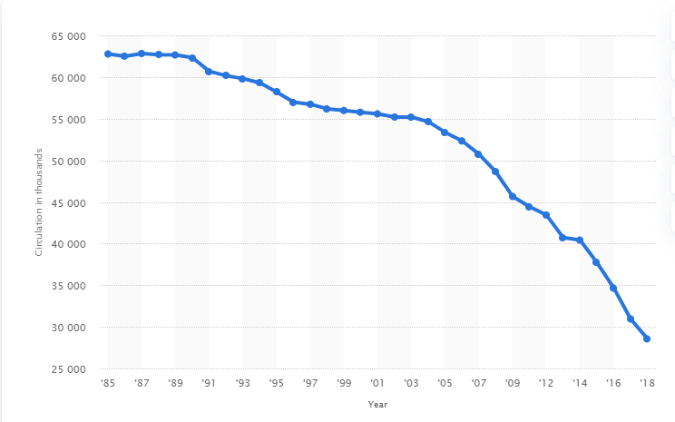

**Circulation of daily newspapers (paid) between 1985-2018 in the U.S** (Watson, 2020).

1. **Fılm**

The film industry is largely operated by huge multinational corporations that control several M&E divisions. These divisions create a huge variety of content by producing films and tv shows, and also video games. The top film companies around the world belong to the US and are as follows: Fox Entertainment Group, Paramount Pictures, DreamWorks Animation, Walt Disney Motion Pictures Group, and Time Warner (Media İndustry in India and Abroad, 2020).

* 1. **Indıa**

It is estimated that the Indian film industry will grow by 7.6% until 2023, and is expected to reach 3.4 billion dollars by that year (Media Sector Analysis Report 2021). India is the biggest market in terms of film admissions, but it is not a top cinema market when compared to other countries due to its box office revenue levels (PricewaterhouseCoopers, 2020). This is due to the currency rates as the average ticket price in India is below USD 1. Bollywood movies dominate this industry and international movies cannot compare well enough. Local content is high and can be made in a variety of languages across India (PricewaterhouseCoopers, 2020).

In the US, Hollywood manages to earn almost 50 percent of its theatrical revenues from outside the country. In contrast, in India, this number is close to only 10-12 percent (Pti, 2020).

* 1. **U.S**

Hollywood is where the U.S. film industry mainly operates, and most prominent studios are situated. Disney, Paramount Pictures, Warner Bros, and Universal Pictures started in Hollywood (Britannica, Hollywood).

Before the pandemic in 2020, the box office revenue in the U.S was growing steadily because film entertainment has always been a huge business for this country. This is proven by the fact that this business managed to bring in about 35.3 billion amount of dollars in revenue in a single year (2019) (Watson,2020). Currently, Disney, an American company has the highest box office market share ( 30%) in the North American continent (Watson,2020). The world's 3 biggest movies also belong to the Disney company: “Avatar”, “Titanic” (both previously owned by 20th Century Fox, which was acquired by Disney in 2019), “Avengers: Endgame” (Stoll, 2020).

Along with being amongst the biggest film industries, the US has a high number of tickets sold annually compared to many other countries. In terms of tickets, the US is third behind China and India. (population level should be noted) (Stoll, 2020). In 2019 Us managed to exceed 1 billion tickets sold, and research shows that watching films remains a pleasurable activity for most Americans. (Stoll, 2020) Adults between 25-39 represent the majority of the U.S film theater audience. More than 10 million people between these ages visit theaters frequently (Watson,2020). The evolving lifestyles have created a powerful competition for theaters, as video streaming services begin to broaden their scope and capture the public’s attention with constantly new products to “binge-watch”.

1. **Radıo**

The radio is one of the oldest media forms and is known as the cheapest source of news and entertainment. The first commercial radio station belongs to The United States and was opened in 1920 (Media industry in India and Abroad, 2020).

* 1. **Indıa**

The Indian radio industry is expected to have a growth of 10.2%, therefore reaching US$ 628 million by 2023. Advertising in radio is also projected to see growth, as it is the sole driver of the emerging radio market (Media Sector Analysis Report 2021). Mobile plays a huge part in these projections as mobile phones mostly have built-in FM receivers, and allow digital online listening. As mobile phone ownership grows, radio revenue also grows (Radio India 2019). In recent years, companies were allowed to own more than one radio station in a city, but for competition’s sake, they can’t own more than 40% of channels in a city (Media Sector Analysis Report, 2021). Despite these changes, globally India has one of the lowest radio revenue per capita rates. This lack of development is mostly because of the government’s over-regulation of the medium till the 90s (Radio India, 2019).

* 1. **U.S**

Radio is amongst the most powerful media forms in the U.S with a weekly reach of 90% of adults (Watson, 2019). Currently, an estimated number of more than 244.5 million Americans listen to the radio every month (Nielsen, 2020). An average American listens to the radio for 106 minutes daily. There are approximately 16 thousand radio stations in the country. Pew Research center argues that the radio remains steady in its revenue. A radio station called WTOP is the biggest earner with yearly revenue of 68 million dollars (Watson, 2019). Younger Americans, aged 12 or older mostly choose to listen to online radio (Nielsen, 2020).

Consequently, online radio’s reach has grown significantly over the last 10 years with the changing demographic and technology. In 2019, a reported 67 percent of Americans listened to online radio in a month, compared to 2009’s 27 percent. Weekly online radio consumption has also grown from 12% to %60 between 2007-2019.

In 2018, radio stations in the U.S. had total revenue of more than 14 billion dollars. (920 million came in thanks to online radio streaming) (Watson, 2019).

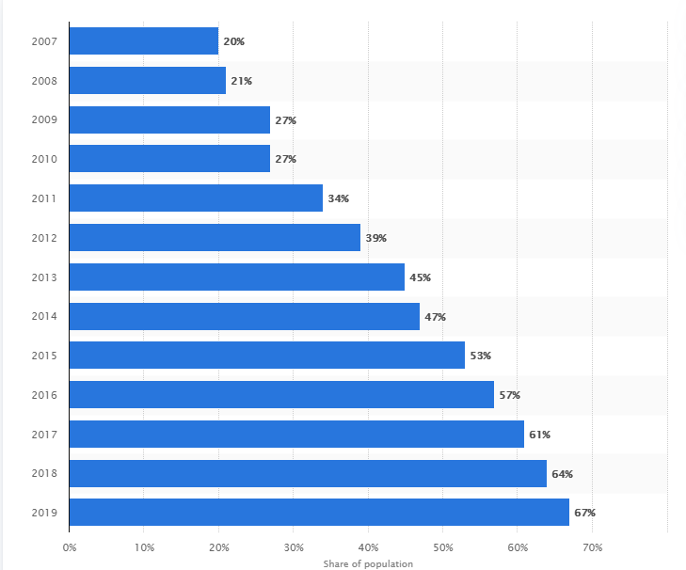

**Monthly online radio listeners increase between 2007-2019 U.S**

1. **Televısıon**
   1. **Indıa**

India is the second-largest television market in the world and it has a huge broadcasting and distribution sector that includes 800 or more satellite TV channels (Media and ENTERTAINMENT: Make In India 2020). Television is projected to see a growth of 14.7% in the upcoming years due to increasing rates in advertisement and subscription revenues. In India, TV is the most popular medium in regards to reach and engagement. Television’s strong engagement coupled with its weekly reach of 780 million individuals makes it a powerful source for advertisement revenue (Media and entertainment industry in India 2020).

2020’s New Tariff Order reduced the amount of time spent watching TV by %6 and this caused channels to see a decrease in their audience levels. Yet regional channels managed to see an increase in subscription revenue. The TV industry achieved a general revenue of Rs 788 billion this year, which also increased TV advertising by 5% YoY to Rs 320 billion. Subscriptions also saw increases this whole year (Media Sector Analysis Report 2021). Yet since TV and SmartPhone Penetration is low in India, a huge chunk of the public has no way of consuming content daily. With 66% TV penetration and 35% smartphone penetration, there’s still a huge need for sustainable growth. (Media and entertainment industry in India 2020). It is estimated that one-third of the market cannot access TV as they don’t have it in their households. (Pti, 2020) Consequently, TV and streaming platforms' average revenue per user in India is much lower when compared to Western markets such as the US market (Pti, 2020).

* 1. **U.S**

An estimated amount of 120.6 million TV homes exist in the U.S. (Stoll, TV households in U.S. 2021) The number of TV households are increasing, but pay-TV is losing its popularity – it saw a 10% drop in numbers in the last 5 years (Stoll, TV households in U.S. 2021) -decreasing from 100 million in 2010 to 95.7 million in 2016 (Stoll,2021). Younger customers are choosing online viewing and streaming services which is the contributor of the damage. Regardless, research shows that watching terrestrial TV is an extremely popular pastime for Americans because the U.S has the world’s highest daily TV watching time, with 274 minutes (more than four and a half hours) (Stoll,2021). In a survey, 33% of adults between 55 -64 years, and 37% aged 65 or above declared terrestrial TV as their favorite media form whilst their younger counterparts majorly preferred streaming platforms over TV (Stoll, TV Households in U.S, 2021)

A huge chunk of the public is now turning to increasingly popular streaming services, and households that have no television are seemingly higher compared to the past years (Stoll,2021). The number of subscribers who choose to buy a subscription from more than 3 streaming services has increased from 9% in 2014 to 19% in 2016 (Stoll,2021). Streaming services like Amazon, Netflix, Hulu, Disney+ are changing the way customers consume shows and this will go on to have a profound impact on the TV industry.

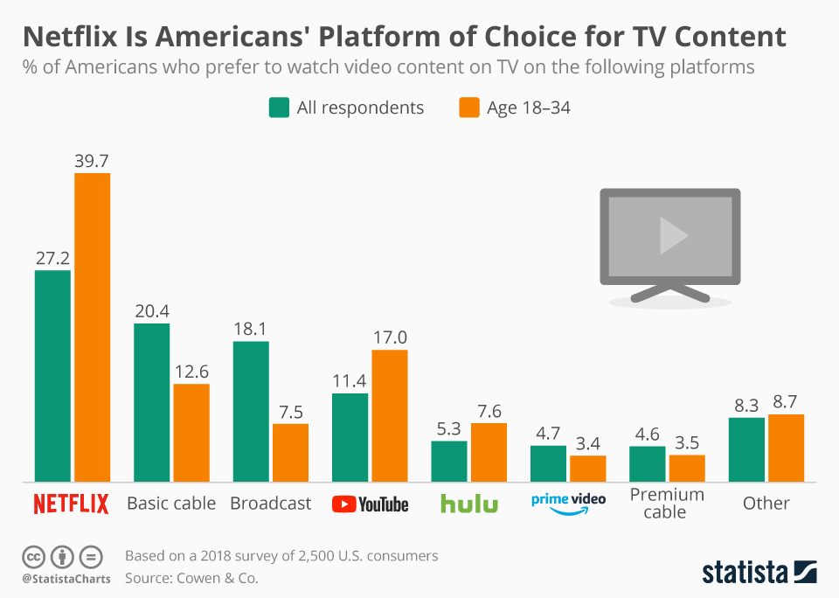

**REFERENCES**

**Barthel**, M. (2019). Trends and Facts on Newspapers | State of the News Media. Retrieved 1 April 2021, from <https://www.journalism.org/fact-sheet/newspapers/>

**Brand** **India** (2020). Retrieved April 27, 2021, from <https://www.ibef.org/industry/media-entertainment-india.aspx>

**Bollywood: Highest Grossing Movies in India** | Statista. (2021). Retrieved 2 April 2021, from https://www.statista.com/statistics/247533/box-office-revenue-of-the-highest-grossing-bollywood-movies-in-india/

**Britannica** (n.d.). Hollywood. Retrieved April 01, 2021, from <https://www.britannica.com/place/Hollywood-California>

**Emma Bowen Foundation** (2020). US Media & Entertainment Industry Overview [Ebook]. Retrieved from https://d3n8a8pro7vhmx.cloudfront.net/emmanbowenfoundation/pages/3898/attachments/original/1612473686/Media_Industry_Overview_01.18.20.pdf?1612473686

**Entertainment İndustry in India** (2021). Retrieved March 27, 2021, from <https://www.investindia.gov.in/sector/media>

**Here**, N., & **Here,** P. (2020). Media and Entertainment İndustry in India 2020. Retrieved April 01, 2021, from https://indiancompanies.in/media-entertainment-industry-india/

**Media and Entertaınment** (2020). Make in India, Retrieved April 01, 2021, from <https://www.makeinindia.com/sector/media-and-entertainment>

**Media and ENTERTAİNMENT Spotlight** (2018). Retrieved April 01, 2021, from https://www.selectusa.gov/media-entertainment-industry-united-states

**Media İndustry in India and Abroad** (2020). Retrieved April 01, 2021, from https://www.careerizma.com/industries/media/

**Media Sector Analysis Report** (2021). Retrieved March 27, 2021, from https://www.equitymaster.com/research-it/sector-info/media/Media-Sector-Analysis-Report.asp

**N.** (2020). Radio Facts and Figures: News Generatıon: Broadcast Media Relations, Retrieved April 26, 2021, from <https://newsgeneration.com/broadcast-resources/radio-facts-and-figures/>

**Nead**, N. (2018, February 11). Media and Entertainment Industry Overvıew, Retrieved April 01, 2021, from <https://investmentbank.com/media-and-entertainment-industry-overview>

**O'Neill,** A. (2021). Highest Grossing Movie Worldwide 1915-2020 | Statista. Retrieved 1 April 2021, from https://www.statista.com/statistics/1072778/highest-grossing-movie-annually-historical/#:~:text=Before%20Avatar%2C%20the%20record%20had,dollars%20in%

**PricewaterhouseCoopers** (2019). Radio India, Retrieved April 01, 2021, from https://www.pwc.in/industries/entertainment-and-media/radio.html

**PricewaterhouseCoopers** (2020). Cinema India, Retrieved April 01, 2021, from <https://www.pwc.in/industries/entertainment-and-media/cinema.html>

**PricewaterhouseCoopers** (2020). Publishing India, Retrieved April 01, 2021, from https://www.pwc.in/industries/entertainment-and-media/publishing.html

**Pti.** (2020). 'Media İndustry Has Potential To Grow To $100 Billion in 10 Years', Retrieved April 01, 2021, from https://www.livemint.com/news/india/-media-industry-has-potential-to-grow-to-100-billion-in-10-years-11608309646423.html

**Stoll,** J. (2020). Topic: Box Office in the U.S. Retrieved March 26, 2021, from https://www.statista.com/topics/852/box-office/

**Stoll,** J. (2021). Average Tv Viewing Time by Country and Age, Retrieved March 26, 2021, from <https://www.statista.com/statistics/276748/average-daily-tv-viewing-time-per-person-in-selected-countries/>

**Stoll**, J. (2021). TV Households in U.S. Retrieved March 26, 2021, from https://www.statista.com/statistics/243789/number-of-tv-households-in-the-us/

**Watson,** A. (2019). Topic: Radio Industry, Retrieved 27 March 2021, from <https://www.statista.com/topics/1330/radio/>

**Watson,** A. (2020). Paid Circulation of Daily Newspapers in the U.S. Statista, Retrieved 26 March 2021, from https://www.statista.com/statistics/183422/paid-circulation-of-us-daily-newspapers-since-1975/

**Watson,** A. (2020). Topic: Movie İndustry, Retrieved March 26, 2021, from https://www.statista.com/topics/964/film/

1. Kadir Has Üniversitesi, Radyo Televizyon ve Sinema Bölümü, 1.sınıf öğrencisi, e-mail: [nuryayman00@gmail.com](mailto:nuryayman00@gmail.com), Orcid Number: 0000-0001-5076-0065