**THE EFFECTS OF PANDEMICS ON CITY AND HOUSING DESIGN: WHAT HAVE WE LEARNED FROM THE 19TH-20TH CENTURY?**

Asst. Prof. Dr. Fatma Kürüm Varolgüneş**\***

**\***Bingöl University, Department of Architecture, Bingöl

**Abstract**

The close relationship between healthcare and architecture has come to the forefront once again with the onset of the COVID-19 pandemic. There have been great physical, social, and economic losses during outbreaks. The solution proposals and studies presented in order to eliminate these losses and to rebuild public health in the process are the issues that need to be reconsidered today. Unhealthy living spaces increased in cities with the industrial revolution and outbreaks causing great destruction were observed in the process. Housings benefiting from the sun, natural ventilation, reducing the number of users, and other improvements in housings have contributed greatly to overcoming outbreaks. In addition, “new city” ideas were put forward by theorists in order to create a rural-urban balance, to offer better living conditions to people, and to provide rights and freedoms to individuals. Urban/architectural design suggestions developed for outbreak diseases and healthy life after the industrial revolution were investigated in this study with the help of the literature. The designs of urban and living spaces were considered to be directly related to public health while discussing the health problems that emerged with the industrial revolution. Efforts have begun to create ideal living environments, which are the areas that will restore the social and physical health that the city lost in the process of finding solutions to the problems of the cities. Increasing environmental awareness, protecting the natural environment, ensuring the sustainability of natural resources, leaving a liveable world for future generations were the main objectives of producing designs in the fight against 19th- and 20th-century outbreaks. It is thought that the examination of the outbreak diseases and resolution processes that have occurred in the past years will shed light on today.

**Keywords:** Pandemics/Epidemics, 19th-20th century outbreaks, city design, housing design, covid-19

**SALGINLARIN ŞEHİR VE KONUT TASARIMINA ETKİLERİ: 19. VE 20. YÜZYIL SALGINLARINDAN NELER ÖĞRENDIK?**

**Özet**

COVID-19 salgınının başlamasıyla birlikte sağlık ve mimarlık disiplini arasındaki yakın ilişki tekrar gündeme gelmiştir. Salgın hastalıkların gerçekleştiği dönemlerde fiziksel, sosyal ve ekonomik açıdan büyük kayıplar yaşanmıştır. Süreç içerisinde bu kayıpları gidermek ve toplum sağlığını yeniden inşa etmek için sunulan çözüm önerileri ve yapılan çalışmalar bugün yeniden ele alınması gerekli konulardır. Sanayi devrimiyle birlikte yoğunlaşan kentlerde sağlıksız yaşam alanları artmış ve süreç içerisinde büyük yıkımlara neden olan salgınlar görülmüştür. Konutların güneşten faydalanması, doğal havalandırma, kullanıcı sayısının azaltılması ve konuttaki diğer iyileştirmelerin salgınların üstesinden gelme konusunda büyük katkısı olmuştur. Ayrıca sanayi devrimi sonrası kuramcılar tarafından kır-kent dengesinin oluşturulması, insanlara daha iyi yaşam koşulları sunulması ve bireylere hak ve özgürlüklerin sağlanması amacı ile “yeni şehir” fikirleri ortaya atılmıştır. Yapılan bu çalışma ile sanayi devrimi sonrası yaşanan salgın hastalıklar ve sağlıklı yaşam için geliştirilen kent/mimarlık tasarım önerileri literatür yardımıyla araştırılmıştır. Sanayi devrimiyle birlikte ortaya çıkan sağlık sorunları tartışılırken kent ve yaşam alanlarının tasarımlarının halk sağlığıyla doğrudan ilişkili olduğu kabul edilmiştir. Kentlerin sorunlarına çözüm bulma sürecinde kentin kaybettiği sosyal ve fiziksel sağlığı geri verecek alanlar olan ideal yaşam ortamları oluşturma çabaları başlamıştır. Çevresel farkındalığı artırmak, doğal çevreyi korumak, doğal kaynakların sürdürülebilirliğini sağlamak, gelecek nesillere yaşanabilir bir dünya bırakmak 19th ve 20th yüzyıl salgınlarıyla mücadelede tasarım üretiminin temel hedefi olmuştur. Geçmiş yıllarda meydana gelen salgın hastalık ve çözüm süreçlerinin incelenmesinin günümüze ışık tutacağı düşünülmektedir.

**Anahtar kelimeler:** Salgın hastalıklar, 19. ve 20 yy. da yaşanan salgınlar, şehir tasarımı, konut tasarımı, COVID-19

**Introduction**

Outbreaks, which have a history as old as the human history, have found new areas of spread with the contacts of societies, and caused numerous deaths, weakening, and even the destruction of powerful states in areas they have never been seen before. Commercial relations, wars, and migrations have spread outbreaks all over the world without realizing it and have taken place as horrific periods in the minds of societies (Yılmaz, 2017). Outbreaks have had significant effects on urban planning and architecture as well as negative effects on human health (Berg, 2020). It is seen that there are very few studies in the literature on the relationship between outbreaks and urbanization and architecture despite this effect. For this reason, the effects of outbreaks experienced after the industrial revolution on housing change and development were investigated in the study conducted.

The density of people in cities has made living conditions increasingly difficult with the industrial revolution. Employees were sheltered in extremely poor conditions, and old single-family housings were replaced by rental huts where there is a room for each family. An increasing physical deterioration was observed in the low-income group during this period. Capitalist production relations, poor working conditions, and unhealthy living conditions made cities uninhabitable. Workers had to shelter in places where they could not see the sun and had no open spaces. Diseases started to increase because the use of water in the industry prevented daily water user (Dönmez, 2019). The poor built their windowless cabins with undried timber, using straw on the roofs during the Black Death. They used soil or clay mixed with ten-year-old haystacks on the floor. What distinguished rich houses from those of the poor was the robustness and abundant use of timber. The hay ceilings in the Middle Ages provided a good home for black rats and a ground for fleas from which they could easily fall onto the people below. The rats easily reproduced in the hay on the floor, reeds filling the walls, and sacks of grain (Fig. 1) (Billur & Billur, 2020).

Ragon (1986) explained this situation in his book as follows: “*Workers were being stuffed into buildings built with inferior materials. The foundations were not dug deep enough, causing the walls to rot from moisture. There was a family in every room. Most of the houses in Britain were built in an adjacent order to save the land. So two of the four rooms did not have windows; that is, the rooms did not breathe and were not naturally illuminated. Each building only had one cesspit, and it was in the basement. Garbage was thrown out of the windows and it was the duty of pigs walking around in cities like today's dogs to eliminate the garbage*” (Ragon, 1986).

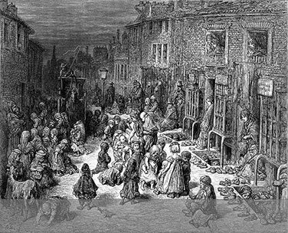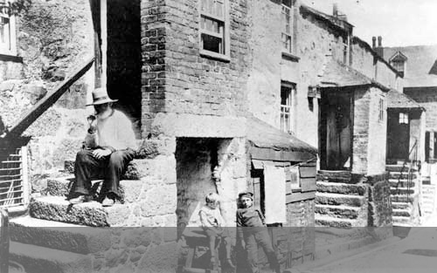

**Figure 1**. a)A scene of squalor in Victorian London b)An example of the typically poor accommodation of the time (URL2)

Outbreaks had reached frightening proportions with the population attracted to cities by the industry in many parts of Europe. This situation began to affect not only the working class but also the bourgeois. The housings built for newcomers to the cities was in extremely bad condition. These structures, which did not receive sunlight and have no open areas, did not even have a sewage system.

It was not different in America, either. The inadequacy of the importance given to public health and the inefficiency of sewage systems led to the spread of cholera, typhoid, and malaria outbreaks. The cholera outbreak that occurred in New York in the 19th century reached an unavertable extent with the rapid growth of the population, especially in poor neighbourhoods (Rice, Butts, Miller, & Shenoi, 2010). It was an inevitable necessity to find solutions to the outbreaks that emerged as a result of the rapidly increasing population and therefore, poor living conditions in cities. Harvey (2020) stated that with the cholera outbreaks experienced in the 19th century, the necessity of sewage systems, and the importance of the balanced spread of the population were understood, outbreaks shaped modern cities and paved the way for the birth of public health and hygiene movement (Harvey, 2020). People were encouraged to use sunny high places, open and resting areas, where there was more fresh air, as well as measures taken in the field of healthcare and medicine to combat the cholera outbreak that spread in the Ottoman Empire in the same period. Studies were carried out to ensure the hygiene of the housings and neighbourhoods and to create new sewage systems (Yıldırım, 2010). The hygiene movement had an important place in the development of 19th and 20th century city planning. Garden city settlements started to develop in different parts of the world and the human-nature relationship was given more place in designs later on. Access to green space, orientation to the sun, and providing natural ventilation were considered important parameters in the housing designs. The designs of urban and living spaces were considered to be directly related to public health while discussing the health problems that emerged with the industrial revolution. It was seen in the process of finding solutions to the problems of the cities that the green areas were the areas that would restore the social and physical health that the city had lost and efforts to create ideal living environments, in other words, paradise gardens, isolated from the city began.

**Materials and Methods**

In the study, the causes of infectious and outbreak diseases that cost the lives of millions of people in the process from the end of the 18th century to the end of the 20th century and the solution proposals developed were examined specifically in urbanism and architecture. The designs of urban and living spaces were considered to be directly related to public health while discussing the health problems that emerged with the industrial revolution. Therefore, many disciplines need to address the issue in the process of overcoming outbreaks. It is thought that the examination of the outbreak diseases and resolution processes that have occurred in the past years will shed light on today. A literature review (books, articles, websites, etc.) of the keywords related to the subject is the material of the study in this context. The architectural characteristics of cities and living spaces during outbreaks, the approaches developed during the process, and the success and failure of the solutions produced were first examined in the study. Therefore this study aims to raise awareness that infectious and outbreak diseases are a part of human history and lesson should be learned from past outbreaks and to contribute to the development of architectural strategies for infectious and outbreak diseases that are expected in the future.

**Results**

A great wave of migration started from rural areas to cities in Europe with the industrial revolution. Standard houses in the form of recurring houses without sunlight and green spaces were produced from the late 18th century to the early 19th century as a solution to the housing problem that occurred with migration (Muthesius, 1982). The first row of houses in England was called “back-to-back”. Two housing units that shared a common wall and were identical also required a new social life (Fig. 2, Fig. 3). The first row of houses with services outside the housing, cooking and living spaces intertwined, had very low standards (Ravetz, 2013). Back-to-back houses produced in the city could not fully solve the domicile problem and the city center became increasingly uninhabitable. The general character of the settlements consisting of these units was excessive density as well as lack of light and fresh air (Muthesius, 1982). The absence of backyards, the absence of external toilets or the common use of toilets, and the lack of sewerage and city water supply caused the rapid spread of diseases even though it was previously argued that the outer wall temperature was maintained with these housing designs arranged side by side. Around the mid-19th century, this form of housing was considered unsatisfactory and a hazard to health. Public Health Act 1875 allowed municipal corporations to ban new back-to-backs, replaced in the next phase of buildings by byelaw-terraced houses (URL1., 2018). However, the outbreaks could not be prevented with this change.

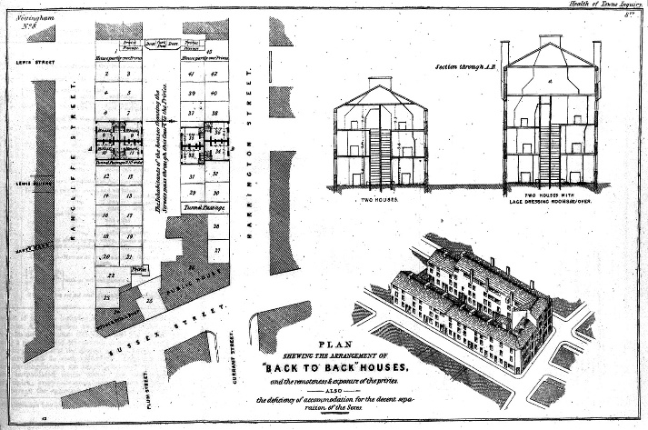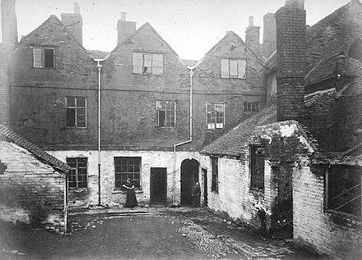

**Figure 2** a) Plans for houses in Nottingham, 1844 b) Back-to-back housing courtyard, 1883(URL1., 2018)

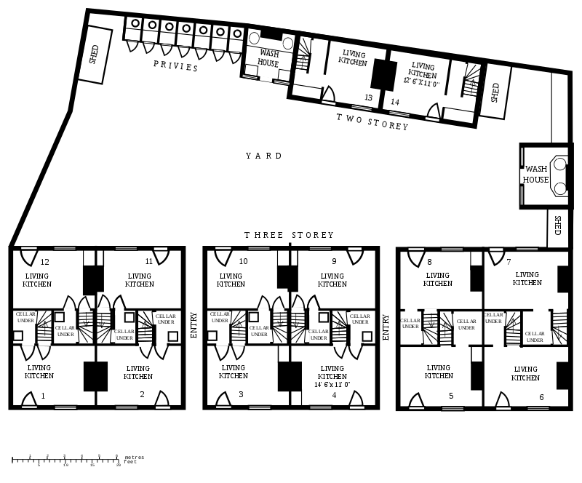

**Figure 3**. A typical yard of 14 back-to-back houses. Note the shared "privies" (outdoor toilets) and "wash houses" (URL1., 2018)

Narrow and tall apartment buildings, called Mietskasernen, housed people from different social strata, were built in Germany, too. It was thought that housing different strata under the same roof would increase social peace during this period. The middle class lived on the side facing the street, the worker class on the side facing the courtyard, and the poorer people in the cellar and in the attic. Some rooms could only breathe through a window. They are called the “Berlin Room”. These structures with such negative qualities were applied until new suggestions were developed. People from different social strata were housed in the same building in Paris. Workers lived in the attic whereas the upper and middle classes lived on the normal floors. There was an argument that the coexistence of people from different strata would fuel privileges in society when the discussions about housing started. Finally, separate housings were built for the workers. These housings were built in very narrow spaces due to the high demand and expensive land.

Solutions were tried to be produced to the problem of accumulation, pollution, and increasingly deteriorating housing in cities in response to this physical deterioration and unhealthy living conditions. British industrialists moved their factories out of the city and started to build healthy housing areas for their workers. Utopian suggestions were also presented, arguing that the new lifestyle required by industrial developments, as well as ideas that cities should be improved by applying health and hygiene laws to the current city, could not be maintained in existing cities; therefore, the new industrial city should be replanned with everything. The utopias of researchers such as Owen, Fourier, Godin, and Cabet, Morris, and Howard developed during this period (Türkmen & Tekkanat, 2018). All living conditions were defined and limited in these approaches, unlike the extreme individuality of the industrial city. These utopias not only designed a society but also proposed a settlement. Common characteristics of 19th-century utopias can be listed as: Returning to nature, establishing a meaningful relationship between humans and nature, saving cities from unhealthy living conditions, the desire to improve the living conditions of people in a restricted economy, hygiene, and efficiency (Sekman, 2017). The application areas were generally in rural areas far from the cities based on these desires. It is not possible in this article to include the comprehensive and complex thoughts of all of these utopians, who were the first urban theorists. Owen and Fourier's societies are briefly mentioned for this reason.

Robert Owen (1771-1858) aimed to build small agricultural communities in England away from the city. He began his dream with a labor town in New Lanark. He ensured that the streets of the worker city were swept every day and created a mechanism that supervises the cleanliness of all houses (Donnachie, 2000). Owen later bought land in America in 1824 to form the community at “new harmony” (Leopold, 2011). Owen's “new harmony” design was a self-sufficient city, where the people living in it could meet all their needs, where children did not have to work until a certain age and received a good education (Royle, 1998). Places were created where workers could continue their lives in a healthy way and produce efficiently in this city (Fig. 4).

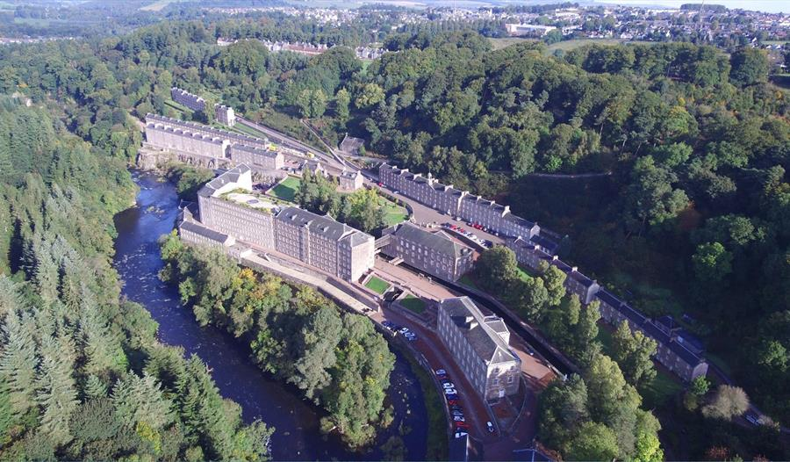 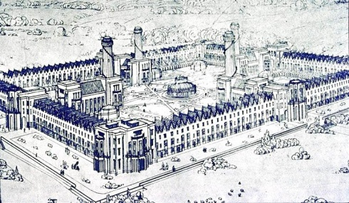

**Figure 4.** New Lanark and New Harmony Robert Owen (URL3; URL4, 2010)

Fourier created “Phalanstère”. Phalanstère (phalanstery) is founded on three main green parts. One of these parts consists of an autonomous city, the second consists of neighbourhoods and factories, and the third consists of large streets and suburbs (Ertan Akkoyunlu, 2004). Fourier's proposal for this three-part city includes common living spaces on the ground floors, as well as public spaces such as dining halls, libraries, and guesthouses in the three blocks he called the caravansary. Fourier, who thought that it was not economical to make individual housing units for everyone, solved this problem by establishing houses on the upper floors of these buildings (Ertan Akkoyunlu, 2004). Fourier designed industrial facilities, theatres, cafeterias, and sightseeing areas in addition to these buildings. A relationship is established between all spaces with the closed circulation network. It is not felt cold inside the phalansteries (Fig. 5). All of the housings have covered and low-heated gateways. One can reach anywhere without being exposed to bad weather conditions thanks to these. One can go to workshops, cafeterias, balls, and meetings without the risk of a cold or pneumonia. Access from the phalanstery to stables can be provided from inside thanks to durable underground passages or hallways raised to the first floor with columns. The settlement designs accompanying Robert Owen and Charles Fouriers' social utopias claimed to highlight justice and solidarity rather than efficiency and rationality. It is assumed that equality and justice can be achieved through strict physical and social regulations in all utopias produced until the beginning of the 20th century. Creating an isolated society in the rest of the world, considering a working life based on the principles of speed and economy, rest, and collective actions, and spatial arrangements that support these features are some of them (Erdem, 2005).



**Figure 5.** Charles Fourier, Phalanstère (Phalanstery) (URL5., 2016)

Governments also developed some healthcare approaches in light of the suggestions put forward by researchers for the solution to the increasing bad living conditions due to the industrial revolution. The first healthcare law passed in England in 1848 introduced new regulations, including intervention in the forms of urban blocks. The cholera outbreak in France in 1849 led to the adoption of the health law in 1850. The utopian and healthcare approach seen before 1848 in the formation of cities affected each other. Utopian plans have also changed as health anxiety in urban areas has increased (Tekeli, 2010; Türkmen & Tekkanat, 2018). One of the quests for a healthy life in the 19th century is the efforts of hygiene to adopt it as a way of life. The effect lasted until the 1940s. It influenced western societies in all areas and brought innovations in medicine, architecture, and urbanism. The sewerage enabled the development of garbage collection and wastewater treatment systems. It has also had great effects on social life. The transformation of medical practice was achieved by the introduction of disease-causing germ theory, which developed in the 19th century and Louis Pasteur and Robert Koch stated that small microbes were responsible for many diseases. Controlling the reproduction and transmission of these microbes was one of the milestones of modern medicine (Canan & Kürüm Varolgüneş, 2017). Benjamin Ward Richardson introduced the utopia “Hygeia: A City of Health” in 1876. Richardson's plans ranged from the architectural blueprints and interior décor of the middle-class home to the minimum width of residential streets (Platt, 2007). Hygeia is an ideal city based on strict compliance with public health principles. As known, the health issue was one of the most important concerns in cities as a result of the cholera outbreaks affecting Europe in this period. The balanced distribution of population density in the city was ensured by the character of the housings. High-floor housings shade the streets. In addition, it is strictly forbidden to give single entry to buildings with a large number of rental housings. There are three- and four-floor buildings in the streets where the workplaces are located. The housings on these streets also have four (4) floors whereas the housings on the west-facing streets are detached buildings. The height of the housings does not exceed 18 meters (Richardson, 1876). All streets are wide enough to allow airflow and sunlight. Trees and bushes are planted around the pedestrian paths. The common areas behind the housings consist of gardens. Church, theatre, bank, educational areas, and other public structures, as well as trade structures, stand alone, forming a part of the streets. These structures are surrounded by gardens not only for aesthetic reasons but also for the health of the city.

Urban utopias were replaced by ecological utopias where nature and the city were combined as the ideal place of living at the beginning of the 20th century. The garden city model, first proposed by Ebenezer Howard in England in 1902, created a wide range of influence on housing and residential areas (Platt, 2007).

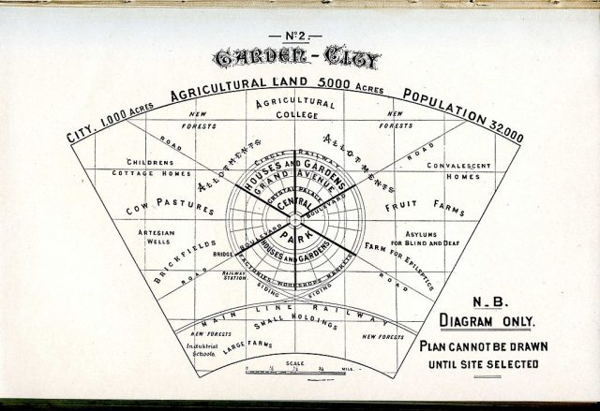

**Figure 6. Diagram of Garden City (İkiz, 2016)**

Howard designed a settlement model that combines garden city thought with positive characteristics of urban and rural areas (Fishman, 1982). The garden city (city of houses with garden) ideal emerged within the context of British intellectual history, which made evaluations on both industrialization and rural-urban dialectics (Williams, 1975). Howard studied in detail the dilemma between the countryside and the city, which he described as the “two polar/gravitational area” that attracted people: the countryside symbolizes the past in which people were happier and the first area of attraction that was natural and authentic in contrast to the city; the city was first perceived as the source of unrest, but later represented hopes for the future, liberation, progress, and modernization (Fig. 6). Garden city would be a planned, self-sufficient, affordable residential area that would rebuild the relationship of city residents with nature by being built from scratch on empty lands (Richert & Lapping, 1998). Howard eventually drew attention to London as the “biggest and most powerless” city in 19th-century cities. He suggested that this model could dramatically change London, reduce the population, and clean up the city. Ebenezer Howard's suggestions can be considered within the scope of the Ecotopia approach as they aim to keep nature and the city together (İkiz, 2016). The balance of housing and human density with green areas was considered in the designs to be made (Rabaça, 2016). Typologies began to be produced in which natural light and green spaces that breathe are at the forefront with the spread of this idea. Howard's garden city plan has been implemented in different parts of the world. Settlement suggestions such as Frank Lloyd Wright's “Broadacre City” and Le Corbusier's “La Ville Radieuse” apart from Howard are ecological utopias where nature and the city are combined as ideal living spaces (Fishman, 1982).

**Conclusion and Recommendation**

It has been accepted that public health is related to the improvement of cities and housing for more than a century and studies are being developed for this purpose (Jacobs et al., 2010). Epidemic experiences in the early 19th and early 20th centuries showed that the development of solutions such as ensuring basic cleanliness, ventilation, sunbathing, and reducing the number of space users as well as improving living spaces contributes strongly to overcoming outbreaks. One of the important reasons why Europe survives outbreaks such as the Black Death and cholera is the improvement of existing building stocks and the production of healthy new building stocks. Outbreaks have significantly changed architecture and the techniques and basic building materials used in buildings in Europe. Testing the prefabrication construction system, using new building materials, planning in line with daylight and ventilation criteria, and in accordance with the conditions of modern life shows that there are many new searches for housing. It is seen that solutions for many urban and housing designs have been developed to protect public health after outbreaks. “New city” ideas have been put forward by theorists in order to provide better living conditions for societies by maintaining the rural-city balance in parallel with these developments. The garden city model proposed by Ebenezer Howard created a wide range of influences on housing and residential areas. Howard designed a settlement model that combines garden city thought with positive characteristics of urban and rural areas. The disconnection from nature, which came with the industrial revolution, was seen as the reason for the increase in unhealthy living conditions and outbreaks of the city people.

Outbreaks (the Black Death, smallpox, cholera, tuberculosis, leprosy, and rabies, etc.) have left permanent traces on societies from past to present. Cities and housings shaped by epidemics and the process of fighting outbreaks were examined within the scope of the study. The results of this study, which includes the information and resources obtained in the 19th and 20th centuries in order to develop strategies for infectious and outbreak diseases that are being experienced today and envisaged to be experienced in the future, can be summarized as follows in this context;

* The density of people in cities has made living conditions increasingly difficult with the industrial revolution. Increased physical deterioration has accelerated the spread of outbreaks.
* Outbreaks have had significant effects on urban planning and architecture as well as negative effects on human health
* Sewerage and drinking water systems have been established in cities to reduce diseases and more emphasis has been placed on infrastructure issues.
* Awareness has been raised for the start of the public health and hygiene movement with the increase in outbreaks.
* Utopias have been presented arguing that the new lifestyle required by industrial developments cannot be sustained in existing cities; therefore, the new industrial city should be replanned with everything.
* The hygiene movement had an important place in the development of 19th- and 20th-century city planning.
* Garden city settlement models have been designed to reintegrate people into rural areas.
* Urban utopias were replaced by ecological utopias where nature and the city were combined as the ideal place of living at the beginning of the 20th century.
* Garden city settlements started to develop in different parts of the world and the human-nature relationship was given more place in designs later on.
* Access to green space, orientation to the sun, and providing natural ventilation were considered important parameters in the housing designs.
* Increasing environmental awareness, protecting the natural environment, ensuring the sustainability of natural resources, and leaving a liveable world to future generations were the main objectives of 19th- and 20th-century design production.

It is seen that outbreaks still affect large masses and continue to be an important threat in the 21st century. Full solutions to problems such as climate change, ecological changes, population growth, and migration cannot be produced and this facilitates the emergence of new generation pandemics as the price of uncontrolled intervention in the order of nature. The COVID-19 outbreak caused by the novel coronavirus (SARS-CoV-2) spread all over the world from Wuhan, China, reported in December 2019, has become a real threat to societies today with the presence of unpredictably designed common living spaces where there is no strategy for urbanization (WHO, 2020).

All disciplines must find solutions by establishing relationships with each other in combating outbreaks and infectious diseases considering the advancement of humanity and technology today. Architecture is of particular importance as one of the disciplines that guide human life in this context. Making a predictive design for the future will be possible with comprehensive, sustainable, and conscious studies specific to infectious and outbreak diseases. Studies to improve the quality of urban life should include social, cultural, and political elements and processes. Therefore, urban transformation, which is one of the important elements in improving the quality of life, should develop a comprehensive vision and action to provide a permanent solution to the economic, physical, social, and environmental conditions of a region that provides solutions to urban problems and undergoes change. The current architectural structure stock should be examined, transformed, and the program for infectious diseases and epidemic disasters that may occur in the future should be constructed with multidimensional aspects as a product of “interdisciplinary cooperation” during this period of COVID-19 outbreak.

**References**

Ziegler, Philip. “Veba.” Tarih Mecmuası, İstanbul: Hayat Yayınları, S. 3, Nisan 1972

Billur, D., & Billur, İ. (2020). COVID-19 Pandemisi Bağlamında Sağlık Mekanları Üzerine Bir Değerlendirme. *Mimarlık Bilimleri ve Uygulamaları Dergisi, 5*(2), 269-292.

Canan, F., & Kürüm Varolgüneş, F. (2017). Bringing Architecture and Sun Together. *Yapı dergisi, 430*.

Donnachie, I. (2000). Robert Owen: Owen of New Lanark and New Harmony. *Tuckwell Press*.

Dönmez, G. (2019). Sanayileşmenin Batı Merkezli Mimarlığın Biçimlenişine Etkileri. *Paradoks: The Journal of Economics, Sociology & Politics, 15*(1).

Erdem, E. (2005). Tarihte Ütopya ve Mimarlık İlişkisi. *Mimar-ist Dergisi, Dosya: Ütopyalar Anti-Ütopyalar, 4*, 78-83.

Ertan Akkoyunlu, K. (2004). 20. yüzyıl kent ütopyaları. *Çağdaş Yerel Yönetimler, 13*(3), 5-21.

Fishman, R. (1982). *Urban utopias in the twentieth century: Ebenezer Howard, Frank lloyd wright, and Le Corbusier*: MIT Press.

Harvey, D. (2020). Política anticapitalista em tempos de COVID-19. *Sin Permiso, 22*, 1-11.

İkiz, S. U. (2016). Ebenezer Howard’ın Bahçe Şehri. Retrieved from <https://www.arkitektuel.com/ebenezer-howard-bahce-sehir/>

Jacobs, D. E., Brown, M. J., Baeder, A., Sucosky, M. S., Margolis, S., Hershovitz, J., . . . Morley, R. L. (2010). A systematic review of housing interventions and health: introduction, methods, and summary findings. *Journal of Public Health Management and Practice, 16*(5), S5-S10.

Leopold, D. (2011). Education and utopia: Robert Owen and Charles Fourier. *Oxford Review of Education, 37*(5), 619-635.

Muthesius, S. (1982). *The English terraced house* (Vol. 140): Yale University Press New Haven, CT.

Platt, H. L. (2007). From Hygeia To the Garden City: Bodies, Houses, and the Rediscovery of the Slum in Manchester, 1875—1910. *Journal of Urban History, 33*(5), 756-772.

Rabaça, A. (2016). Le Corbusier, the city, and the modern utopia of dwelling. *Journal of Architecture and Urbanism, 40*(2), 110-120.

Ragon, M. (1986). *Histoire de l'architecture et de l'urbanisme modernes: De Brasilia au post-modernisme (1940-1991)*: Casterman.

Ravetz, A. (2013). *Remaking cities (Routledge revivals): Contradictions of the recent urban environment*: Routledge.

Rice, M., Butts, J., Miller, R., & Shenoi, S. (2010). Applying public health strategies to the protection of cyberspace. *International Journal of Critical Infrastructure Protection, 3*(3-4), 118-127.

Richardson, B. W. (1876). *Hygeia: a city of health* (Vol. 12036): Macmillan.

Richert, E. D., & Lapping, M. B. (1998). Ebenezer Howard and the garden city. *Journal of the American Planning Association, 64*(2), 125-127.

Royle, E. (1998). *Robert Owen and the Commencement of the Millennium: The Harmony Community at Queenwood Farm, Hampshire, 1839-1845*: Manchester University Press.

Sekman, A. (2017). Kentsel formların ütopya ve distopya kavramları bağlamında irdelenmesi. *TOPLUM VE DEMOKRASİ DERGİSİ, 11*(23).

Tekeli, İ. (2010). *Sanayi toplumu için sanayi yazıları* (Vol. 11): Tarih Vakfı Yurt Yayınları.

Türkmen, S. N., & Tekkanat, S. S. (2018). Tarih boyunca kent formlarının biçimlenişi üzerine bir inceleme. *Aksaray Üniversitesi İktisadi ve İdari Bilimler Fakültesi Dergisi, 10*(4), 107-124.

URL1. (2018). Back-to-back house.

URL2. Cities of Tomorrow. In (Vol. 2020).

URL3. New Lenark. Retrieved from <https://www.visitheritage.co.uk/whats-on/new-lanark-mills-world-heritage-site>

URL4. (2010). New Harmony, Robert Owen. Retrieved from <https://v3.arkitera.com/h49893-delilerimiz-olmayacak-herkes-zeki-ve-akli-basinda-insanlar-olarak-bicimlenecek.html>

URL5. (2016). A phalanstère (or phalanstery). Retrieved from <https://www.wikiwand.com/en/Phalanst>ère

WHO. (2020). Global surveillance for human infection with coronavirus disease (COVID-19). *World Health Organization, Geneva, Switzerland.* Retrieved from <https://www.who.int/publications-detail/global-surveillance-for-human-infection-with-novel-coronavirus-(2019-ncov>).

Williams, R. (1975). *The country and the city* (Vol. 423): Oxford University Press, USA.

Yıldırım, N. (2010). Salgın Afetlerinde İstanbul. *Afetlerin Gölgesinde İstanbul içinde (ss. 109-184). İstanbul, İST: İBB Kültür AŞ*.

Yılmaz, Ö. (2017). 1847-1848 Kolera Salgını Ve Osmanlı Coğrafyasındaki Etkileri. *Avrasya İncelemeleri Dergisi, 6*(1), 23-55.