**Finite Element Solution of Contact Problem For The Functionally Graded Orthotropic Layer Resting On A Half Plane.**

***Pembe Merve KARABULUT1,\*[C:\Users\Abdullah\AppData\Local\Microsoft\Windows\INetCache\Content.Word\ORCID-iD_icon-16x16.gif](https://orcid.org/0000-xxxx-xxxx-xxxx), İsa ÇÖMEZ2[C:\Users\Abdullah\AppData\Local\Microsoft\Windows\INetCache\Content.Word\ORCID-iD_icon-16x16.gif](https://orcid.org/0000-xxxx-xxxx-xxxx)***

*1Faculty of Engineering, Civil Enginering Department, 1Çankırı Karatekin University, Çankırı, Turkey*

*2Faculty of Engineering, Civil Enginering Department, 2Karadeniz Technical University, Trabzon, Turkey*

|  |
| --- |
| **Abstract**  In this study, the receding contact problem between a functionally graded orthotropic layer and a homogeneous half space is considered using finite element method. The functionally graded orthotropic layer pressed by two rectangular rigid stamps placed symmetrically. It is assumed that the contact surfaces are frictionless, only normal tractions can be transmitted through the contact areas. The finite element solution of the problem is constituted using ANSYS software. The main objective of this paper is the study the effect of inhomogeneity parameters and orthotropic material properties on the functionally graded orthotropic layer mismatch on the contact pressure and the size of the contact regions. |
| Keywords: Finite element method, Functionally Graded Material, Receding Contact, Mechanic. |

1. **Introduction**

Since the contact problems have possible application to a variety of structures of practical interest such as foundation grillages, pavements in roads and runways, railway ballats and other structures consisting of layered media, there is large body of literature concerned with contact problems.

Chen et al. studied frictional contact problem of a rigid punch on an arbitrarily oriented gradient half-plane. [2] Receding contact problem for two-layer functionally graded media pressed by a rigid punch is investigated Çömez et al. [3]. Frictional receding contact problem for a graded bilayer system intented by a rigid punch and sliding frictional contact analysis of a monoclinic coating/isotropic substrate system investiagted Yılmaz et al. [4]. Continuos and discontinuous contact problem of a functionally graded orthotrop layer lying on an isotropic layer bonded to a rigid substrate is solved Karabulut [6].

In the present study, we aimed to show effect of inhomogeneity parameters and orthotropic material properties on the functionally graded orthotropic layer mismatch on the contact pressure and the size of the contact regions. The finite element solution of the problem is constituted using ANSYS software. Finally the results obtained from FEM are verified by comprasion of the analytical results for the special isotropic case in Karabulut et al. [7].

1. **Definition of the Problem**

In this paper receding contact problem between functionally graded orthotropic layer and homogeneous half space is considered. The layer pressed by two rectangular rigid stamps placed symmetrically. It is assumed that the contact surfaces are frictionless and only compressive traction can be transmitted through the contact surfaces. In addition, the effect of body forces is neglected.

As shown in Figure 1, the functionally graded orthotropic layer is subjected to concentrated loads by two rectangular rigid stamps placed symmetrically. The thickness of functionally graded layer is h and the stiffness of the layer changes exponentially from the bottom surfaces of the layer.

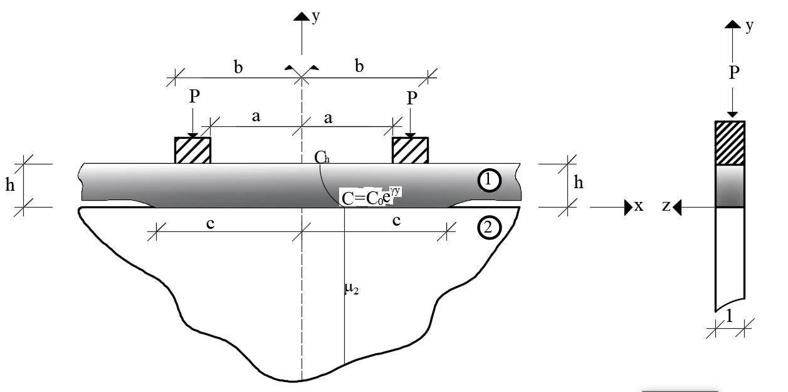

**Figure 1**. Geometry of the receding contact problem

1. **The Finite Element Solution**

The finite element method is a numerical method for solving problems of engineering and mathematical pysics. In this method, problem divides into simpler parts that are called finite elements and the model transform into large system of equations. With the recent developments in computer technology, large system of equation is fullfilled.

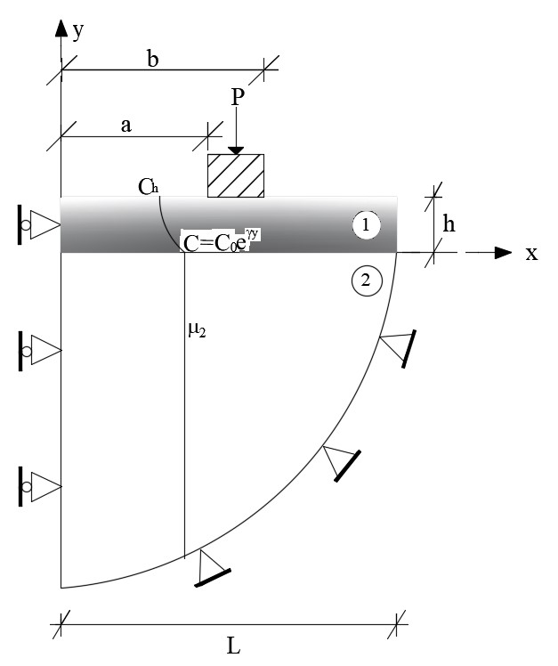 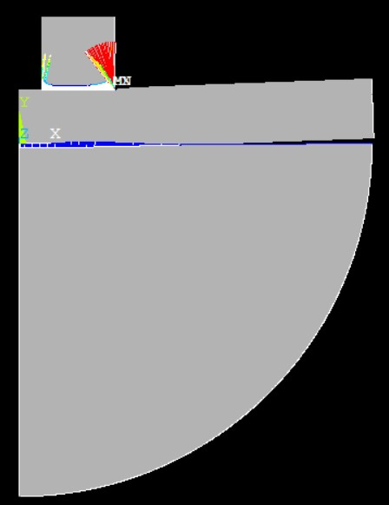

**Figure 2**. Geometry of the finite element model. **Figure 3**. Deformed shape after the analysis.

In this paper, receding contact problem of functionally graded orthotropic layer resting on a half plane pressed by two rectangular rigid stamps is solved using the ANSYS package program. Because of the problem exhibits symmetry in geometry, material properties and geometry, only half of the problem is modeled. Geometry of the finite element model is shown in Figure 2. In the analysis, geometric proporties are taken as L=6 m (length of the layer in x direction) and h=1 m (thickness of the layer in y direction). PLANE 183 structural element type is used finite element analysis of the problem. TARGE 169 and CONTA 172 elements are used and SURFACE to SURFACE contact model is created. Augmented Lagrange Method was used with SURFACE to SURFACE elements. After the analysis, contact lengths and contact pressures are obtained. In the finite element model (FEM), 1668625 nodes, 776827 elements and 2725 contact elements are used and the deformed shape after the analysis is given in Figure 3.

1. **Results and Discussion**

**Table 1.** Orthotropic material properties (Binienda and Pindera, 1994)

|  |  |  |  |  |  |
| --- | --- | --- | --- | --- | --- |
|  | Material Name | | | | |
| Parameter Name | A(Gr/Ep P75/934) | B(Tr/Ep T300/934) | C(Gl/Ep) | D(Gr/Al) | E(B/Al) |
| Exx (GPa) | 243.000 | 144.800 | 42.70 | 402.600 | 227.500 |
| Eyy (GPa) | 7.200 | 10.300 | 11.70 | 24.100 | 137.900 |
| Ezz (GPa) | 7.200 | 10.300 | 11.70 | 24.100 | 137.900 |
| µxy (GPa) | 3.929 | 5.515 | 8.238 | 16.750 | 55.150 |
| µxz (GPa) | 3.929 | 5.515 | 8.238 | 16.750 | 55.150 |
| µyz (GPa) | 2.406 | 3.447 | 3.778 | 8.340 | 49.240 |
| ʋxy | 0.33 | 0.30 | 0.27 | 0.29 | 0.24 |
| ʋxz | 0.33 | 0.30 | 0.27 | 0.29 | 0.24 |
| ʋyz | 0.49 | 0.50 | 0.55 | 0.45 | 0.40 |

**Table 2.** Dimensionless contact lengths between the FG layer and homogeneous half-plane with different stiffness ratios and stiffness parameters. (Isotropic special case; , )

|  |  |  |  |  |  |
| --- | --- | --- | --- | --- | --- |
|  | c/h | | | | |
|  |  |  |  |  |  |
| 0.2 Analytical [7] | 2.512500 | 2.511000 | 2.561000 | 2.665625 |  |
| **FEM** | **2.587500** | **2.587500** | **2.625000** | **2.700000** |  |
| Difference(%) | 2.98 | 3.00 | 2.50 | 1.28 |  |
| 0.4 Analytical [7] | 2.568750 | 2.597200 | 2.684700 | 2.84500 |  |
| **FEM** | **2.660000** | **2.662500** | **2.737500** | **2.88250** |  |
| Difference(%) | 3.55 | 2.51 | 1.9 | 1.3 |  |
| 1 Analytical [7] | 2.718750 | 2.809900 | 2.972400 | 3.203125 |  |
| **FEM** | **2.737500** | **2.850000** | **3.037500** | **3.187500** |  |
| Difference(%) | 0.7 | 1.42 | 2.19 | 0.48 |  |
| 2 Analytical [7] | 2.912500 | 3.073900 | 3.315450 | 3.622656 |  |
| **FEM** | **2.909500** | **3.150000** | **3.300000** | **3.632500** |  |
| Difference(%) | 0.10 | 2.47 | 0.47 | 0.27 |  |
| 4 Analytical [7] | 3.187500 | 3.433300 | 3.764550 | 4.168750 |  |
| **FEM** | **3.185000** | **3.450000** | **3.750000** | **4.125000** |  |
| Difference(%) | 0.08 | 0.486 | 0.386 | 1 |  |
|  |  |  |  |  |  |

In Table 2, dimensionless contact lengths between the FG layer and homogeneous half-plane with different stiffness ratios and stiffness parameters for the isotropic special case is given. As can be seen from the table, the half contact lengths between the functionally graded orthotropic layer and the half plane increase with the increasing  stiffness parameter and stiffness ratio of the botttom surface of the layer to the half plane. It is also seen that results obtained from the finite element approach are quite close from the analytical results from Karabulut et al. [7]

In Figure 4, variations of contact stress distrubutions under the stamp and between functionally graded ortotropic layer and a half plane for five different materials is shown. The greatest half contact length between the funtionally greded orthotropic layer and the half plane is seen in the Material D with the highest modulus of elasticity in the x direction. The maximum value of the contact stresses under the stamps is observed in the Material C with the lowest stiffness values.

****

**Figure 4**. Variations of contact stress distributions under the stamp and between functionally graded orthotropic layer and half plane for five different materials (,, , , , ).

****

**Figure 5**. Variations of contact stress distributions under the stamp and between functionally graded orthotropic layer and half-plane by the  (,, , , , , Material C).

Figures 5, 6 and 7 show the variation of the contact stresses under the stamps and between the functionally graded orthotropic layer and homogeneous half plane according to modulus of elasticity ,  and  respectively. As can be seen from the figures, the half contact lengths between the layer and half plane increase with the increase of the  (modulus of elasticity in the x direction). The variation of  and  (modulus of elasticity in the y and z directions) does not affect the half contact lengths between the layer and the half plane. In addition, the contact stresses under the stamps are not affected by the changes in the modulus of elasticity ,  and .

****

**Figure 6**. Variations of contact stress distributions under the stamp and between functionally graded orthotropic layer and half-plane by the  (,, , , , , Material C).

****

**Figure 7**. Variations of contact stress distributions under the stamp and between functionally graded orthotropic layer and half-plane by the  (,, , , , , Material C).

Variations of contact stress distrubution under the stamp and between the functionally graded orthotropic layer and half-plane by the different stamp distances from the y axis is shown in Figure 8. With the increasing stamp distances from the y axis, the half contact lengths between the functionally graded orthotropic layer and half plane increase and the value of the contact stresses on the y axis decrease.

Finally, based of the comprasion of numerical values in the literature [7], difference with the finite element solution and the analytical solution is an acceptable range.

****

**Figure 8**. Variations of contact stress distributions under the stamp and between functionally graded orthotropic layer and half-plane by the different stamp distances () from the symmetry axis ( , , , , , Material C).

**References**

1. Binidia, W. & Pindera, M., Frictionless contact of Layered Metal-Matrix and Polymer-matrix Composite Half-Planes, *Composite Science and Technology*, *50(1)*, 119-128.
2. Chen, P., Chen, S. & Peng, J., (2012), Frictional Contact of A Rigid Punch on An Arbitrarily Oriented Gradient Half-Plane, *Acta Mechanica*, *226*, 4207-4221.
3. Çömez, İ., El-Borgi, S., Kahya, V. & Erdöl, R. (2016). Receding contact problem for two-layer functionally graded media intended by a rigid punch. *Acta Mechanica*, *227*, 2493-2504.
4. Yilmaz, K. B., Çömez, İ., Guler M. A., Yildirim, B. & El-Borgi, S. (2018). Frictional receding contact problem for a graded bilayer system intented by a rigid punch. *International Journal of Mechanical Sciences*, *141*, 127-142.
5. Yilmaz, K. B., Çömez, İ., Guler M. A. & Yildirim, B. (2019). Sliding frictional contact analysis of a monoclinic coating/isotropic substrate system. *Mechanics of Materials*, *137*, 103132.
6. Karabulut P. M., Continuos and Discontinuous Contact Problem of A Functionally Graded Orthotrop Layer Lying On An Isotropic Layer Bonded to A Rigid Substrate, PD thesis, Karadeniz Technical University, Institue of Natural and Applied Sciences, 2021.
7. Karabulut P. M., Yaylacı, M., & Birinci, A., Fonksiyonel derecelendirilmiş tabaka ve yarım düzlem arasındaki sürtünmesiz ve ayrılmalı temas problemi, 20. Ulusal Mekanik Kongresi, Bursa, 2017, 196-204.