**Hot Mıx Asphalt Desıgn Wıth The Usage Of Andesıte And Lımestone Between Korgun-Kurşunlu Dıstrıcts Of Çankırı**

***Mine ŞİMŞEK1,\*[C:\Users\Abdullah\AppData\Local\Microsoft\Windows\INetCache\Content.Word\ORCID-iD_icon-16x16.gif](https://orcid.org/0000-xxxx-xxxx-xxxx) , Başak VARLİ BİNGÖL2[C:\Users\Abdullah\AppData\Local\Microsoft\Windows\INetCache\Content.Word\ORCID-iD_icon-16x16.gif](https://orcid.org/0000-xxxx-xxxx-xxxx)***

*1Faculty of Engineering, Department of Civil Engineering, Cankiri Karatekin University, Cankiri, Türkiye*

*2**Faculty of Engineering, Department of Civil Engineering, Cankiri Karatekin University, Cankiri, Türkiye*

|  |
| --- |
| **Abstract**  Transportation structures generally require large costs and therefore the needs must be controlled meticulously. The construction of road networks must be designed in line with today’s needs and future demands to ensure that projects are economical and profitable. Additionally, it should be built with sustainability and environmental awareness in mind. While this approach ensures that costs are kept under control, it also aims to use the transportation infrastructure effectively and efficiently during long time. This combines the principles of cost-effectiveness and sustainability, ensuring that transport projects respond to the needs of society and protect the environment. In the road construction process, selection of aggregates with different properties for different road layers is of great importance, as seen in the example of Korgun-Kurşunlu Road. Here, the combined use of Andesite and Limestone aggregates has been important in terms of balancing supply costs and technical requirements. This decision represents an economically effective solution while ensuring compliance with technical standards. The quality and suitability of the materials used in the design process are determined through a series of experiments and analyses. In this study, sieve analysis, specific gravity and water absorption tests were applied to determine the suitability of andesite and limestone. Additionally, methylene blue peeling and penetration tests were conducted in Los Angeles to measure the durability of the material. The specific gravity of bitumen was also applied and the stability and durability of the material was determined by the Marshall test. These comprehensive tests and experiments were conducted to evaluate the suitability and performance of andesite and limestone for on-road use. The data that achieved after the tests are milestone to determine the quality and suitability of the materials to be used in the road construction process. |
| ***Keywords:*** *Flexible pavement design, Andesit, Limestone, Hot mix asphalt* |

1. **Introduction**

Road networks are crucial for Turkey's economic growth, providing essential transportation infrastructure that enhances urban and intercity development, fostering economic and social progress. As of December 2022, the General Directorate of Highways manages a total road network of 68,761 kilometers, with a substantial portion dedicated to bituminous hot mix and surfaced roads. The emphasis on sustainability and environmental sensitivity in road construction is essential to balance economic growth with environmental protection. Notably, 42% of the road network consists of divided roads and 3,633 km of highways. Ensuring economic and functional efficiency in engineering structures for transportation is imperative, meeting both current needs and future demands. This comprehensive approach ensures long-term cost control and effective utilization of transportation infrastructure, thereby contributing to the overall well-being and quality of life for communities across the country.

**1.1. General Information**

Although it has been claimed that fillers have no effect on mix performance in bituminous hot mixes, in reality fillers do have an effect on the plastic behavior and fatigue of the mix. Determination of the bituminous binder and aggregate to be used in the mix, together with the care to be taken in the application of the mix, is important to obtain a bituminous pavement that is robust against deformations [1]. In aggregate production, the physico-mechanical properties of the aggregate are examined along with the crushing and screening processes, and in order to maximize the efficiency and quality of crushing and screening plants, it is important that the design takes into account the geo-mechanical, geological, structural and technological characteristics of the material to be crushed and the selection of crushers, screens and conveyor belts [2]. The main purpose of foundation and sub-base layers in road construction is to transfer loads safely to the ground, provide effective drainage and create a stable base that is resistant to environmental and traffic influences. The aggregates used are the materials needed in large quantities and make a significant contribution to stability fit for purpose. The majority of unbound foundation and sub-base layers consist of aggregates that make up the majority of bituminous hot mixes and concrete pavements. Therefore, the use of aggregates with physical properties suitable for the conditions prolongs the service life and improves the overall quality of the road [3]. Asphalt-aggregate interactions directly affect the adhesion between aggregate and asphalt on asphalt road surfaces. These interactions include physico-chemical phenomena that take place at the asphalt-aggregate interface and determine the durability of the asphalt-aggregate bond. It is also important for the longevity and high quality of different asphalt road surfaces [4]. He stated that weathering is important in the use of rocks as aggregates. He stated that the impact strength of aggregates together with the characteristic properties of rocks is the determining factor in the properties of aggregates [5]. He mentioned that the abrasion properties of aggregates differ according to the type of rocks. He emphasized the effect of different aggregates with different abrasion on the performance of hot mixes. In addition, the abrasion criteria of aggregates have been the subject of many researchers [6].

1. **Materials and Methods**

In the studies related to the thesis subject, information and document support was obtained under the control of the 15th Regional Directorate of the General Directorate of Highways. For Kurşunlu-Korgun Road Km: 0+000-28+957,20, the most suitable and profitable road design was made by the Highways and the aggregate tests carried out in accordance with the design were found to be in accordance with the standards of the Highways technical specifications. Based on the results of the tests and measurements carried out by the General Directorate of Highways, the road design was decided and in accordance with this decision, the road was constructed by using Andesite and Limestone aggregate as the product of two different quarries.

**2.1. Geological structure of the study area**

The geographical location of Çankırı is shown in the figure 1. The andesite quarry used for the construction of the road between Korgun-Kursunlu, which is the subject of my thesis study, is located within the borders of Kursunlu Çukurca village, at the 12th kilometer of the 28 km construction road adjacent to the road subject to the thesis, and the limestone quarry is located within the borders of Ilgaz Musa village, approximately 50 km from the new construction road.



**Figure 1.** Location map of study area

**2.2. Information on Study Route and Project Design**

The study area where the project studies were carried out is given in the locator map. The road subject to the thesis study is located within the borders of the 15th Regional Directorate of the General Directorate of Highways.

Çankırı province Kurşunlu-Korgun Road Km: 0+000-28+957.20 was constructed with bituminous hot mix. Figure 2 shows the project start and end points The bituminous hot mix project of Kurşunlu-Korgun Road starts from Kurşunlu district and ends in Korgun district. The flexible pavement design determines the distribution of the wheel load to the layers in a trapezoidal shape and determines the thickness of each layer according to its resistance, taking into account the economic conditions. When calculating the layer heights, thermal effects, rainfall and snow can affect the foundation and subgrade and cause damage by creating water reserves. Due to the permeability of pavements, structures that cause water seepage can deteriorate asphalt pavements. Hollow structures that deteriorate due to freeze-thaw may occur. Marshall Tests were used to determine the bearing capacity of wearing course, binder and bituminous base courses, while CBR tests were performed for base materials of water-based binders. Taking into account traffic counts and vehicle equivalent factors, the traffic data for 2016 was re-determined for the years 2018 and 2038, taking into account the project duration. The project form calculated the 20-year traffic count as 3,007,640 and the layer thicknesses were determined as 5 cm wearing course, 6 cm binder, 8 cm bituminous base and 15 cm PMT according to the flexible pavements design. (Figure 3).

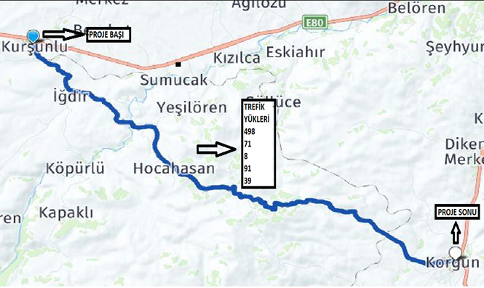

**Figure 2.** Kurşunlu-Korgun road and traffic loads

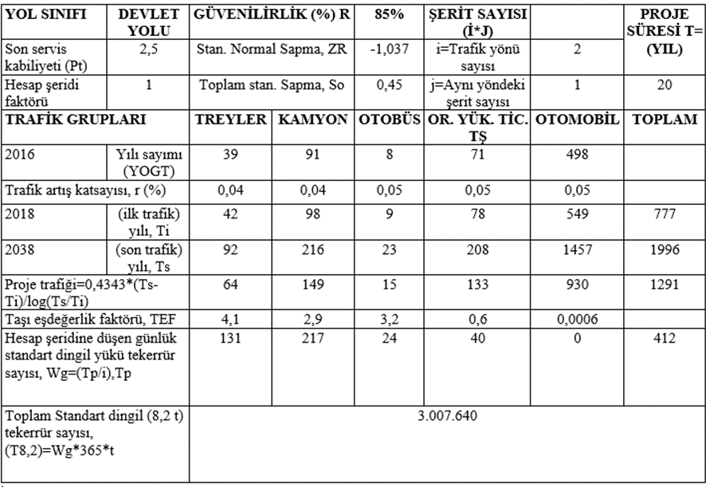

**Figure 3.** Kursunlu-Korgun road project design form

According to the project MR=5124,017, the recommended sub-base thickness was found to be 20 cm. (Figure 4).

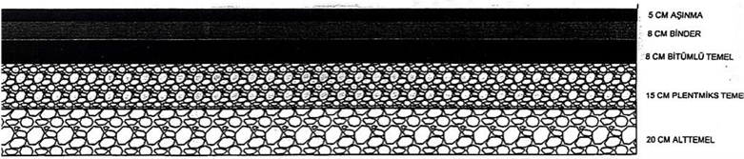

**Figure 4.** Superstructure thicknesses between Kurşunlu-Korgun Road km: 0+000-28+957.20

**2.3. Solutions to problems in design**

As some of the physical tests performed on the andesite aggregate to be used in Korgun-Kursunlu Road exceeded the criteria, samples taken from quarries close to the construction area were examined and it was seen that the tests performed on the limestone material of the quarry located in Ilgaz Musa Köy met the criteria. It was decided by the authorities of the General Directorate of Highways to procure the aggregate to be used in the road construction from this quarry. However, the General Directorate of Highways officials decided to use the material from both quarries since the quarry distance is approximately 50 km from the road center of gravity, which increases the cost considerably.

As a result of the experiments performed on the mixture formed with the material taken from the two quarries, it was determined that the mixture complied with the criteria.

1. **Results**

**3.1. Results of Aggregate and Bitumen Tests**

The gradation of the layers is shown separately in the figure. It meets the lower and upper limits determined by the highways (Figure 5).

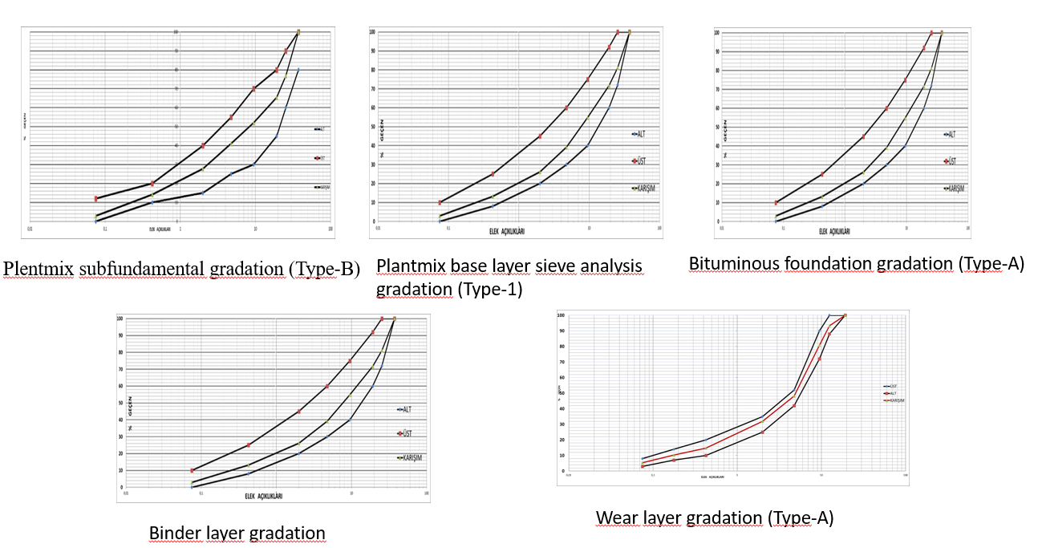

**Figure 5.** Graduation curves

Specific gravity and water absorption values were found( Figure 6).

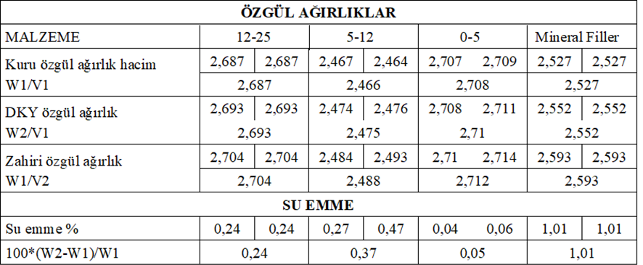

**Figure 6.** Specific gravity and water absorption values

Andesite Los Angeles result 16 and Limestone Los Angeles result 21,57. According to this, limestone has a high shrinkage and andesite is a durable aggregate (Fıgure 7).



**Figure 7.** Los Angeles test results

It is use for policion measuring. Limestone pollution value is 0.6 and andesite pollution value is 4.5. Since andesite is very polluted, its use in bituminous mixtures should be limited (Figure 8).

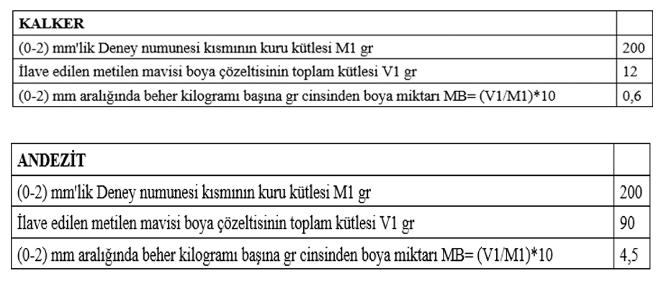

**Figure 8.** Methylene Blue test Result

It is the measure of interlocking of bitumen and aggregate. It is different for Andesite and Limestone. For Limestone, this value is very low and has been improved at the design stage by using additives (Fıgure 9).

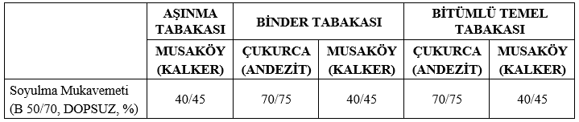

**Figure 9.** Peeling test Result

Penetration test gives information about the consistency of bitumen.

Penetration results of the layers are given in the figure 10.

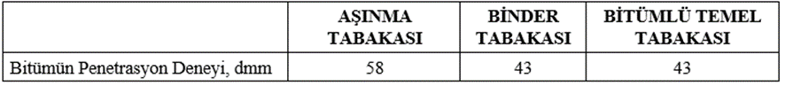

**Figure 10.** Penetration test Result

Layer stability values are appropriate according to the design (Figure 11).

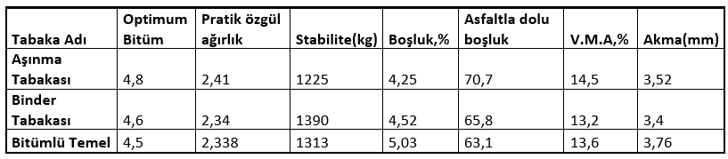

**Figure 11.** Marshall test Result

1. **Conclusion and Recommendations**

Since the los angeles value of andesite is smaller, it is more durable. For this reason, we made the sub-base and foundation layer completely with andesite.

We used limestone and aggregate jointly because it interacts less with bitumen due to the contamination of andesite.

The wear layer has to be made of smaller grains and it has to bond well with the bitumen, so we made the limestone layer entirely of limestone.

A road that is both durable, economical and suitable for durability has been built.

**Acknowledgment**

We would like to thank Murat BİNGÖL, the 52nd Branch Manager of Çankırı, affiliated to the 5th Regional Directorate of State Hydraulic Works, and Murat ÇAVDAR, Assistant Manager, for their contributions to our work.

**References**

1. Curtis, C.W. 1992. Investigation of Asphalt-Aggregate Interactions in Asphalt Pavements. American Chemical Society, Fuel, 37: 1292-1297.
2. Fookes, P. 1991. Geomaterials. Quarterly Journal of Engineering Geology and Hydrogeology, 24(1): 3-15.
3. Halili A, 2003. The Importance of Crushing and Screening and Physico-Mechanical Properties of Stone in Aggregate Production. III. National Crushed Stone Symposium, Istanbul.
4. Mogawer, W.S. ve Stuart, K.D. 1996. Effects of mineral fillers on properties of stone matrix asphalt mixtures. Transportation Research Record, 1530(1): 86-94.
5. Senior, S. ve Rogers, C. 1991. Laboratory Tests for Predicting Coarse Aggregate Performance in Ontario. Transportation Research Record, 1301: 97-106.
6. Turabi, A. and Okucu, A. 2016. Properties and Specification Compliance of Aggregates Used in Road Works in Balıkesir Province. Balıkesir University Journal of Institute of Science and Technology, 9(1): 45-51.