Kuralay Urazayeva
Gulnur Yerik
L.N. Gumilyov Eurasian National University, Astana, Kazakhstan
Karlygash Abylkhassova
Quantum STEM School, Astana, Kazakhstan

THE HERITAGE OF KAZAKH BIYS IN THE ASPECT OF VALUE CONCEPTS.
LEGAL PROVERBS AS A REFLECTION OF KAZAKH CASE LAW

The article was written within the framework of the project «Scientific concept of Kazakh rhetoric: rhetorical ideal, identity, argumentation and speech practice»
Abstract
The Institute of biys was based on basic values combining ontological and phenomenological concepts and ideas: the idea of procreation, the ideal of a real man, social and generic hierarchy, on the other hand, the trinity of the Earth (State) ‒ The People are the Word. The tools of persuasive communication rhetoric are hidden methods of influence that activate the value consciousness of the listener, educated by proverbs, sayings, moral norms, as well as since the era of Islam's penetration into the Kazakh steppes – the Koran. The purpose of the report is to establish the typology of solutions of Kazakh biys and legal proverbs as an object of legal mastery of the Task: 1) analysis of the picture of the world in the aspect of case law, 2) systematization of the rhetorical statuses of utterance ‒ knowledge, opinion, understanding and beliefs as processes of thinking of the Kazakh biya, 3) analysis of the rhetorical statuses of utterance in the aspect of the world pictures hidden behind them, 4) description of the national specifics of Kazakh legal rhetoric on the material of Kazakh legends about biy and typologically legal proverbs close to them. As an object of typological analysis, the legends of the Kazakh biy were chosen. For example, a story about the punishment of a teenager who killed a man. In making a decision, biy is guided by using such a method of influencing the listener as persuasion, activating ideas about a person's piety, his belief in punishment in case of deception, as well as popular value ideas about the deception of the people, the multiple and integral image of which is embodied by the audience, plaintiffs, biy, also sin. "Adamdy aldau – arynyn aldynda kune, agany aldau – ananyn aldynda kune" (literally: Deceiving a person is a sin before conscience, deceiving a brother is a sin before a mother). The imperative picture of the world is based on the concept of honor, which the defendant possesses. "To retreat from the word Dzhigit, as if to accept death" ‒ "Er zhigittin eki soylegeni – olgeni", - says the Kazakh proverb. In the legend of Kazybek biy and the punishment of the man who stole the tripod, the "knowledge" and precedent picture of the world is the patriarchal picture of the world. Activating the concept of a male defender in the listener's unconscious, biy acts in accordance with the proverb: "Shider at saktaydy, at er saktaydy, er el saktaydy" (literally: The tripod protects the horse, the horse protects the man, and the man protects his community). An interesting example is the reflection of case law in the proverbs about the role of a woman ‒ spouse and mother, keeper of the hearth and the application of case law in the legend "Two contenders for one woman". Allusive discourse brings biya and the audience together with the ideas developed by the people about marriage. The consolidation of the clan, tribe defines the boundaries of the expected union. The poetics of omissions and the system of enthymemes that form the algorithm for controlling the presence of the listener's consciousness are illustrated by Kazakh proverbs about the family. For example: "You are aǵanmen syilaspasan, ken dunyege syimassin" (literally: if you do not respect your origin, you will not fit into the big world), "Ayel - uidin korki, erkek ‒ tuzdin korki" (literally: "A woman is the beauty of the house, a man is the beauty of the straight").
Keywords: Kazakh rhetoric, case law, Kazakh biy, legal proverbs, axiology

Introduction

The Institute of Kazakh justice, established in the XIX century, is known as the Institute of biys. The basis of the legal practice of biys and the law, known in science as customary or case law, were ethical values developed by the people. The concepts of "ar" (honor) and "uyat" (shame) regulated the norms of the Kazakh law and order. At the same time, these values reflect ontological and phenomenological concepts and ideas: ideas of procreation, the ideal of a real man, social and generic hierarchy, on the other hand, the trinity of the Earth (State) ‒ The People are the Word.
The scientific idea of Kazakh legal rhetoric as the art of persuasive communication is based on the use of hidden methods of influencing the plaintiff, the defendant, the entire audience of listeners (the practice of the law court was public). By methods of influence, we understand the techniques of rhetorical argumentation. They activate the listener's consciousness ‒ to a certain extent ‒ with Kazakh proverbs, sayings, moral norms, as well as, since the era of Islam's penetration into the Kazakh steppes, with the Koran. In this report, attention is drawn to proverbs that can serve as illustrations of the practice of biys and their decisions. Note that the name of the proverbs, which are called legal, is due to the norms of law and order contained in them.

Relevance and problem statement

The relevance of the topic is due to the preservation of the oral heritage of the Kazakh people, the study of the rhetoric of biys as part of the Kazakh rhetoric that creates the rhetorical ideal of the people. In addition, Kazakh legal rhetoric did not become an object of description from the position of the biy's verbal impact on the listener. The purpose of the report is to establish the typology of decisions of Kazakh biys and Kazakh proverbs as an object of legal skill of Kazakh judges. The achievement of the goal is conditioned by the solution of such tasks: 1) analysis of the picture of the world from the position of case law, 2) systematization of the rhetorical statuses of utterance ‒ knowledge, opinion, understanding and belief as processes of thinking of the Kazakh biy, 3) analysis of the rhetorical statuses of utterance in the aspect of the world pictures hidden behind them, 4) description of the national identity of Kazakh legal rhetoric.
As an object of typological analysis, legends about Kazakh biy were chosen, telling about the ways they make decisions that should convince the listener of both the objectivity of his verdict and the only true ending of the event of a dispute or litigation, as well as Kazakh proverbs (URL 1).

Literary review

The stated topic requires an appeal to scientific sources devoted to the problems of rhetoric and non-rhetoric, as well as the theory of utterance. In this regard, the methodology of the report is based on such works. The first group of works is devoted to the problem of rhetorical modality and rhetorical statuses of utterance. These are V. Tyupa's works on the rhetorical modalities of utterance and the precedent picture of the world (Tyupa, 2008: 278). Tyupa's ideas about the precedent picture of the world, considered from the position of rhetorical modality, are fruitful for the concept of Kazakh legal rhetoric. V. Tyupa defines the precedent picture of the world as "the foundation of the narrative strategy of a heroic tale, and subsequently a literary epic" (Tyupa, 2018: 20). According to the scientist, behind each rhetorical status of the statement lies a concealed or explicit picture of the world. Secondly, it is the research of Kazakh scientists devoted to the history and theory of Kazakh justice, including in connection with the norms of international law. Thus, B. Shagirbayeva in the article «The customary law of Kazakhs and the byi’s institution. The role in implementation of the right to fair trial in modern Kazakhstan» focuses on the socio-legal and cultural foundations of nomadic Kazakhs, which contain the prerequisites of legal norms and principles that remain relevant for modern social relations. We are talking about the Institute of Biys (XIII-XIX centuries) (Shangirbayeva, 2016). The author also examines the practice of modern judicial proceedings in the aspect of applying the principles of the traditional Kazakh institute of biys. This approach helps to understand the depth, universality and practical value of the Kazakh national legal heritage. Analyzing the relevance and advantages of the traditional biy court, the researcher establishes them, in particular, in the norms of taking the oath as an intermediary procedure in cases where there was no clear evidence and evidence. The scientist also draws attention to the fact that the advantages of a nomadic lifestyle made it possible to have an open and accessible justice without any formal and bureaucratic requirements. Due to the nomadic lifestyle and awareness of freedom as the most important factor in human life, Kazakh customary law is characterized by humanism, in which the absence of places of imprisonment and prisons and, accordingly, criminal law is one of the evidences of a special attitude to human dignity.
For K. Urazayeva, the practice of justice of Kazakh biys is relevant from the standpoint of the mechanism of persuasion and the system of linguistic manipulation of listeners. This view allows us to explore the Kazakh identity in the aspect of thinking procedures, namely, the logic of decision-making and ways to inspire the listener with their objectivity. The systematization of legal decisions and ethical value categories is based on the differentiation of moral and legal procedural categories (Urazayeva, 2018). In another work of the scientist, an overview of the most typical allegories is undertaken, reflecting the three essences of allegory, the decoding of which is provided by knowledge of the national conceptual sphere (Urazayeva, 2016).
More in the works of J. Serle and J. The development of the theory of speech acts (TRA) ‒ speech act theory), the definition of illocutionary, locutive and perlocutionary acts led to the establishment of the main purpose of language. According to Searle, it does not consist in describing the objects of reality, but in carrying out purposeful actions. Hence the establishment of a connection not so much with a single word, but rather the allocation of an illocutionary act as a unit of communication for the implementation of a separate action (Searle, 1999). Since then, TRA has been enriched by a number of scientific schools, directions, research methods.
The connection of biy's perlocutionary influence on the listener with argumentation required an appeal to works devoted to the theory of argumentation. Here we have highlighted the works of A.V. Kolmogorova on the phenomenological context of argumentation, when a subject of communicative activity transmits to another subject a fragment of his picture of the world (Kolmogorova, 2009). This is also the work of A.G. Gurochkina on argumentative discourse and the ability to correct the opponent's worldview (Gurochkina, 1999). Common to Russian scientists is the modern understanding of the argument in terms of the condition for correcting the opponent's world and the sign of argumentative discourse. The basis of such a representation is intersecting fragments of pictures of the world of communication subjects.

Discussion

The rhetorical status of the utterance and the rhetorical modality

The analysis of biy's communicative strategies, behind which certain manipulative techniques of controlling the listener's consciousness are hidden, is based on the connection between the rhetorical status of the utterance and the rhetorical modality. Having identified the following modalities according to V. Tyupa's classification: "knowledge", "opinions", "understanding", "beliefs", we determine the choice of the only correct solution by the Kazakh biy in the presence of a plurality of perception of the subject of dispute/ litigation by listeners. Biy's ability to form the modality of knowledge and understanding through the modalities of opinion and beliefs characterizes, in our opinion, biy's rhetorical skill. The practice of judicial proceedings in the system of correlation of rhetorical modalities reflects Figure 1.

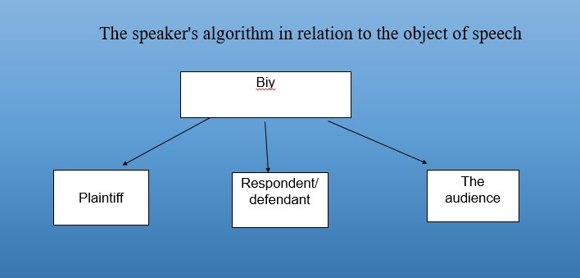
Picture 1. The speaker's algorithm in relation to the object of speech

However, the correlation of rhetorical modalities is the result of the correlation of the rhetorical statuses of the utterance. This connection and the algorithm of biy's decision-making and the belief in the correctness of the decision is reflected in Figure 2.

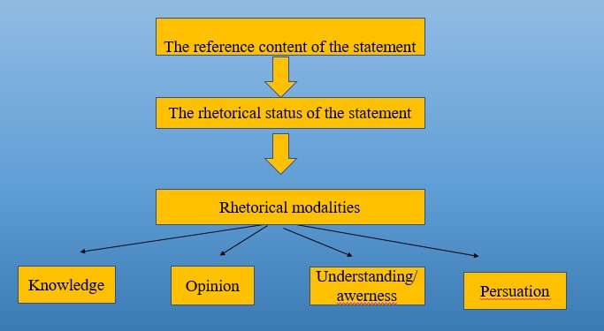
Picture 2. Biy's statement and the rhetorical statuses of the statement
In the light of the stated topic, the connection of the worldview and the rhetorical status of the utterance is also important for the concept of Kazakh legal rhetoric. It is reflected in Figure 3.
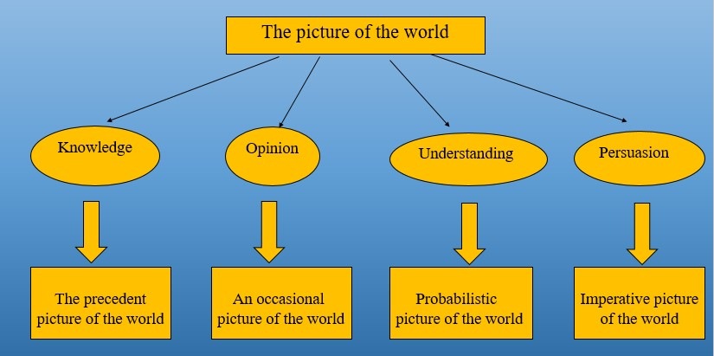
Picture 3. The picture of the world in the aspect of the rhetorical statuses of the biy's statement

The rhetorical status of the utterance and the rhetorical modality as manifestations of the picture of the world. Legal skills of biy

The plot of any legend about biy is a violation of the precedent picture of the world, its balance, which the judge must restore. He must either prove guilt and, accordingly, punish the culprit, or, on the contrary, prove innocence and acquit the suspect.
Legend 1. Consider the legend of the punishment of a teenager who killed a man. In making a decision, the biy is guided by using such a method of influencing the listener as persuasion, activating ideas about the God-fearing of a person, his belief in punishment in case of deception, as well as popular value ideas about the deception of the people, the multiple and integral image of which is embodied by the audience, plaintiffs, biy, also sin. «Адамды алдау – арыңын алдында күнә, ағаны алдау – ананың алдында күнә» (literally: "Deceiving a man is a sin in the eyes of his conscience, deceiving a brother is a sin in the eyes of a mother"). The imperative picture of the world is based on the concept of honor, which the defendant possesses. «Jigit from the words to leave, as if to take» - «Ер жігіттің екі сөйлегені – өлгені», - says the Kazakh proverb
Highlighting the rhetorical modality of "knowledge" reproduces a precedent picture of the world. Her balance is disturbed by the murder of a man. The assessment of the murder of a person as a grave crime is accompanied by Quranic wisdom. "Prophet Muhammad (peace and blessings of Allaah be upon him) he said: "The sin of killing a person without rights falls not only on the murderer himself [to the "extent" similar to if he had killed all of humanity], but also on the one who was the ancestor of this [terrible] crime ‒ one of the two sons of the progenitor Adam. After all, it was he who put this Sunnah into practice (paved the way for this atrocity. Prophet Muhammad (may the Creator bless and greet him) He said: "Whoever kills an ordinary citizen [who has all the rights for temporary or permanent residence in a given territory, regardless of his nationality and religion], without having the right to do so, will [never] feel the fragrance of paradise [will be removed from Paradise after Judgment Day for such a pernicious crime]. And truly, [if compared with earthly distances and the laws of physics, then] the smell of Paradise (heavenly fragrance) is fully felt at a distance of a hundred years' journey!" (Hadis, URL 2).
The rhetorical status of biy's "opinion" reflects occasionality, i.e. subjectivity and randomness. So, bi tests the defendant with a decision that cannot be objectively verified. It is impossible to count on the thunder to overthrow the defendant if he is lying. The Koran, like bread, plays a ritual role due to the requirement of taking an oath. Fear of God's punishment ‒ this is a sign of the general knowledge of the biya and the audience, the plaintiff and the defendant. The precedent picture of the world is based on submission to the requirements of Islam: "And We have left a sign there for those who fear a painful punishment." (Krachkovsky, 1963: 51, 37). Let's give another example. There is the following kind of oath among the people: "Nan ursyn" (literally: let the bread hit me) (Collection of Kazakh proverb).
Legend 2. Popular among the people is the legend associated with the name of Tole bi "Shider at saktaydy, at er saktaydy, er el saktaydy" (The tripod protects the horse, the horse protects the man, and the man protects (guards, protects) the land, the people). Tole bi brought a thief for stealing a tripod (shider), caught trying to remove it from the legs of a horse grazing near the yurt of a cattle owner and asked biya to determine his punishment according to the laws of his ancestors.
A suspected thief must put tripods with three ends on three horses so that each has one hind leg hobbled. Then he has to drive these horses in different directions. If at the same time the tripod breaks and at least one of the horses gets rid of it, then the thief is relieved of responsibility altogether. The tripod was so strong that it held all three horses. Then Tole bi turns to the plaintiff: "The thief must pay the cost of the tripod. It is defined by a folk proverb that builds an algorithm for increasing value, from utilitarian to social (the role of men in society): “Шідер ат сақтайды, ат ер сақтайды, ер ел сақтайды” (The tripod protects the horse. The horse protects the man, and the man protects the land, the people). A metaphor in the mouth of biy: «Бұл шідер ‒ үш ер» (The tripod represents three men) has a figurative meaning: "The tripod is equal in strength to three strongmen, therefore, the thief pays a fine (aip), which is equal to three five‒year-old horses".
Tole biy's argumentation traces a formal logic based on everyday ideas. Extreme concreteness, measurability of punishment formed the practical rhetoric of the Kazakh people in the practice of justice. The argumentation is of an empirical nature, based on observation and understanding of the perlocutionary consequence. It remains for the biy to convince the listeners and work out the only correct one in the context and against the background of multiple solutions.
Legend 3. The specifics of case law can be seen in the proverbs about the role of a woman ‒ spouse and mother, keeper of the hearth and in the legend "Two contenders for one woman". The ideas of the Kazakh people about marriage are illustrated by Kazakh proverbs about the family. For example: «Týǵanyńmen syılaspasań, keń dúnıege syımassyń » (literally: If you do not respect your birth, you will not fit into a wide world), «Áıel - úıdiń kórki, erkek ‒ túzdiń kórki » (literally: "А woman is the beauty of the house, a man is the beauty of the straight"). The precedent picture of the world is based on the modality of knowledge. Such a picture, which served in favor of the decision made by the bey, was the way of life of an educated person. At the same time, not only the skills of a woman, but also the satisfaction of personal growth needs formed the basis of the biy's decision. Biy's suggestion is based on the prevention of conflicts that depend on the unity of habits, views on living together. Although the legend reflects the time when the norms of Islam were rooted in Kazakh society (after all, the first plaintiff posed as a mullah), respect for the opinion of a woman whom none of the plaintiffs asked, and her fate was actually in the hands of the biy, makes it possible to understand the value orientations of Kazakh steppe democracy. The basis of the biy's agreement with the plaintiffs and the decision-making by the entire audience of listeners is provided by an inclusive-symbolic discourse as a model of a successful marriage.

Conclusion

So, the analysis of Kazakh legends about biy allows us to describe the process of biy decision-making from the standpoint of rhetorical statuses of utterance, rhetorical modality, their swarms in reproducing the world picture. This way it becomes possible to characterize the ways of influencing listeners. In other words, these are manipulative biy techniques for achieving understanding with the audience. The second conclusion is as follows. in each of the four rhetorical statuses of biy's utterance (in the legends examined), objective and subjective beginnings are hidden. The objective principle is a way of influencing the listener. This is achieved by activating proverbs familiar to the people, surahs of the Quran. The mechanism of action is subjective, because it is physically impossible to check the test. Techniques of manipulation are techniques of activating the ideas embedded in the system of education of ideas about ethical norms. Thirdly, the analysis of biy's communicative strategies and his methods of influence shows the predominance of such methods of rhetorical argumentation as the technique of rhetorical improvisation, the technique of changing the rhetorical mask, the technique of attracting and retaining attention, the technique of presenting information in accordance with the dominant representative system of the audience, the technique of highlighting keywords, the technique of forming rhetorical emotion, etc. And, finally, the analysis of biy's communicative strategies from the position of speech influence seems relevant in the aspect of conflict prevention at various levels, solving issues of social, family and civil law, as well as ensuring the domestic and foreign policy of the country.
References
Collection of Kazakh proverbs, URL 1: https://www.balakai.kz/makal_matelder/ [date of access 21.11.2022]
Gurochkina, A.G. Argumentative discourse of parliamentary debates, http://filologija.vukhf.lt/7-12/8%20gurochkina%20new.doc [date of access 15.11.2022]
Kolmogorova, A.V. (2009). Argumentation in everyday speech. Мoscow, «Flinta», ISSN 2542-1085
Krachkovsky, I.YU. (1963), «First edition: Quran. Translation and comments by I. Yu. Krachkovsky». Editor V.I. Belyaev. Foreword by V.I. Belyaev and P. A. Gryaznevich. Moscow.
Muslim Club. Hadis. URL 2: http://muslimclub.ru/hadis/sabr.html [date of access 10.10.2022]
SEARLE, J. (1999). What is a speech act? In: Foreign Linguistics. II: Translated from English / General ed. V.A. Zvegintseva, B.A. Uspensky, B.Y. Gorodetsky. M.: Publishing group "Progress".
Shangirbayeva, B. (2016), The customary law of Kazakhs and the byi’s institution. The role in implementation of the right to fair trial in modern Kazakhstan. In: VIA EVRASIA, No5 (37), http://www.viaevrasia.com/documents/37.%20BEIBIT%20SHANGIRBAYEVA,%20VIA%20EVRASIA,%202016,%205.pdf. ISSN ONLINE 1314-6645 [date of access 05.10.2022]
Tyupa, I.V. (2008), «Discourse analysis [Diskursivnyy analiz]» // I.V. Tyupa. Analiz khudozhestvennogo teksta, Academia, Moscow. ISBN 78-5-7695-4632-7
Urazayeva, K.B. (2018), «Kazakh medieval justice: the mechanism of cultural security and preservation of national identity»/ In: International Forum "Language, Culture and National Security", Guangzhou – Yekaterinburg, 2018, pp. 86-92.
Urazayeva, K.B. (2016), Imagery of Mentality and Statement Allegory as an Expression of the Kazakh Identity. Ensuring Social and National Stability in the Practice of the Kazakh Jurisdiction. In: VIA EVRASIA, No5 (17), http://www.viaevrasia.com/documents/17.%20KURALAY%20URAZAEVA,%20VIA%20 EVRASIA,%202016,%205.pdf [date of access 25.09.2022]

